1. Copy jbpm4.4 (installer) to Driver D
2. unzip Tomcat6 to D:\jbpm-4.4
3. config Database
- copye ojdbc6.jar to jbpm-4.4\lib
- modify jbpm-4.3\install\jdbc\oracle.properties and set database name, username and password:
jdbc.driver=oracle.jdbc.driver.OracleDriver
jdbc.url=jdbc:oracle:thin:@localhost:1521:xe
jdbc.username=test
jdbc.password=test
- open d:\jbpm-4.4\install\build.xml, and modify property:
<property name="database" value="oracle" />
- create table:
sqlplus username/password@localhost:1521/xe
@D:\jbpm-4.4\install\src\db\create\jbpm.oracle.create.sql
4. Config eclipse
4.1 install jBPM software in eclipse
  - Help -> Install New Software:
  - In “Available Software” popup window, click “Add” to add repository.
  - In “Add Repository” popup window, click “Archive” button and choose “D:/jbpm-4.4/install/src/gpd/jbpm-gpd-site.zip”
  - Then choose jBPM jPDL4 N201007071649
  - Switch off network
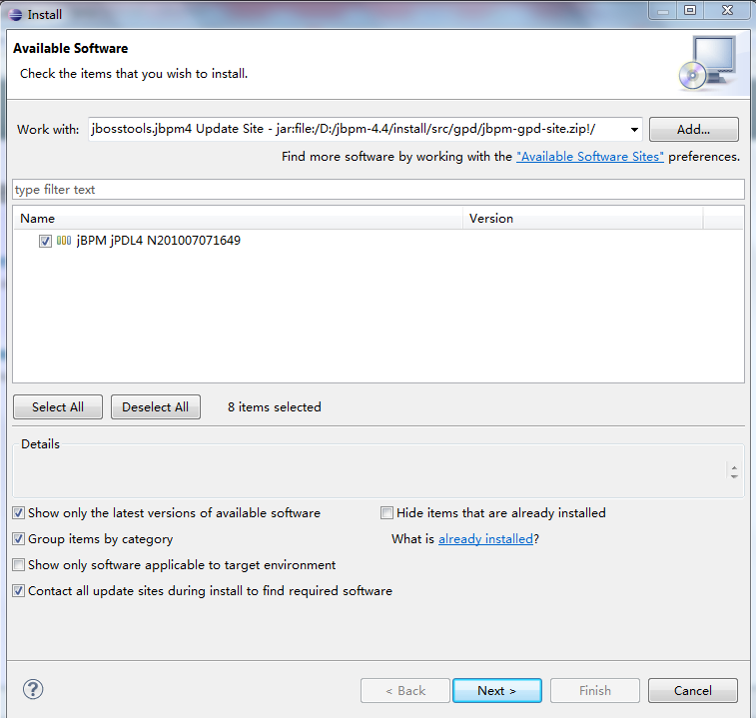
  - Click Next
  - Verify the install details, and click “Next”
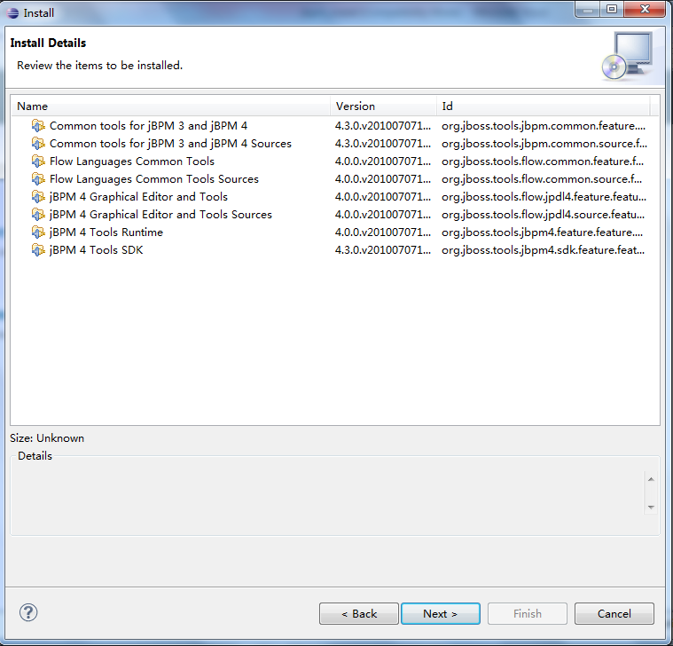
  - In review licenses window, choose “I accept the terms of license agreement” and click “Finish”
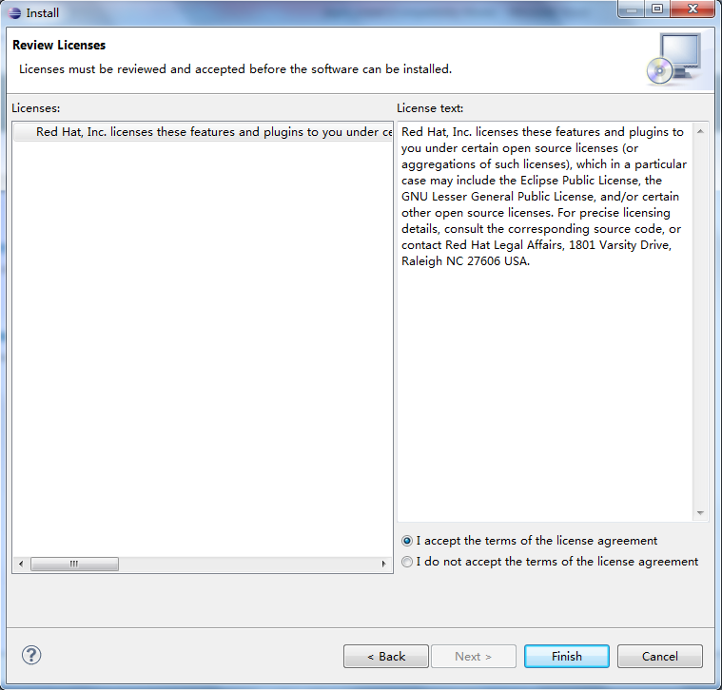
  - Restart eclipse when it requires
4.2 Set jBPM runtime location
- In eclipse menu, choose Window -> Preference
- In “Preferences” popup window, click JBoss jPM -> Runtime Locations
- At the right part panel, click “Add”
- In “Add Location” window, set Name to BPM4.4, Location to D:\jbpm-4.4, click “OK” to add runtime location
- Click “OK” to close Preferences window
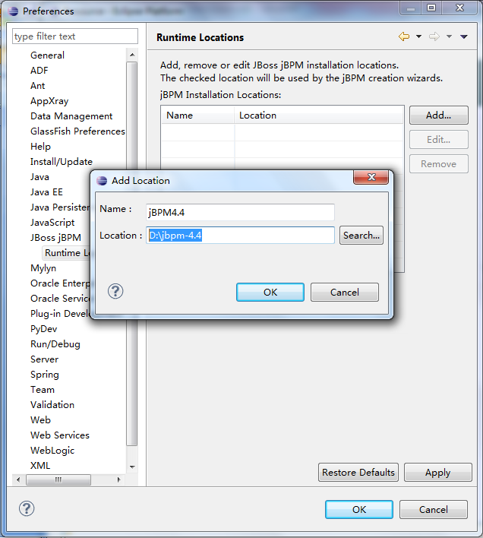
4.3 define user library
- In eclipse menu, choose Window -> Preference
- In “Preferences” popup window, click Java -> Build Path -> User Libraries
- Click “New” and in the popup “New User Library” window, set Name to jBPM library and click “OK” to close this window
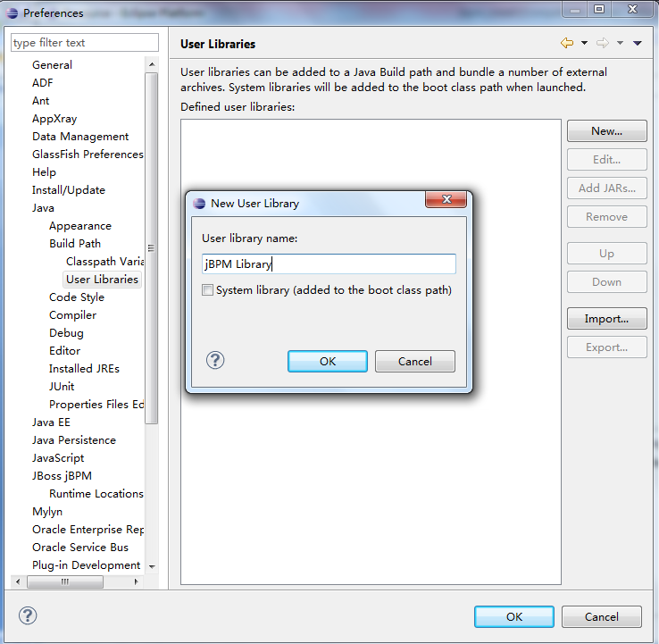
- Click “Add JARs…”
- In the popup “JAR Selection” choose all the jars under directory: D:\jbpm-4.4\lib, except juel-impl.jar, juel-engine.jar, junit.jar,ojdbc6.jar.
- Click OK, and jBPM Library should be like:
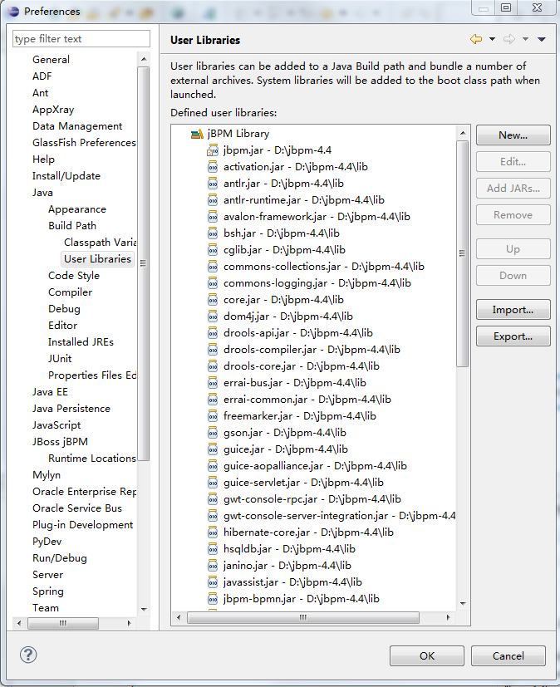
- Choose “jBPM Library” again and add jar: D:\jbpm-4.4\jbpm.jar
- Choose “Source attachment” under jbpm.jar – D:\jbpm-4.4 ->
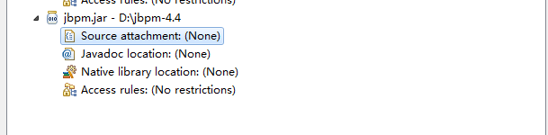
- Click “Edit”
- In “Source attachment configuration” window, click “External Folder”
- Choose “D:/jbpm-4.4/src” folder
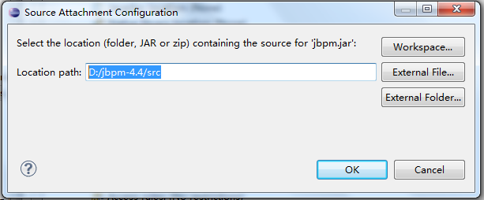
- Click “OK” twice to close windows.
- Add schema jpdl schema

- JBoss jPM -> Runtime Locations
  - In eclipse menu, choose Window -> Preference
  - In “Preferences” popup window, click XML -> catalog
  - In the popup “XML Catalog” window, click “Add”
  - In the popup “Add XML Catalog Element” window, click File System button and choose: D:\jbpm-4.4\src\jpdl-4.4.xsd
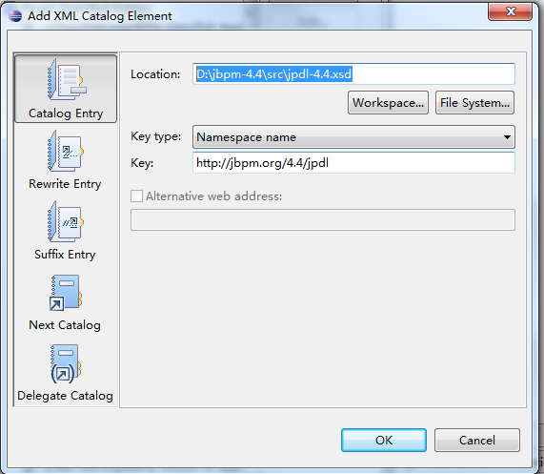
  - Click OK twice to close this window and preference window
- Verify if bpm plugin added to eclipse correctly:
  - In Project Explorer workspace, right click blank part and in the dropdown menu choose New -> Others..
  - Make sure that there was JBoss jBPM -> jBPM 4 Process Definition catalog.
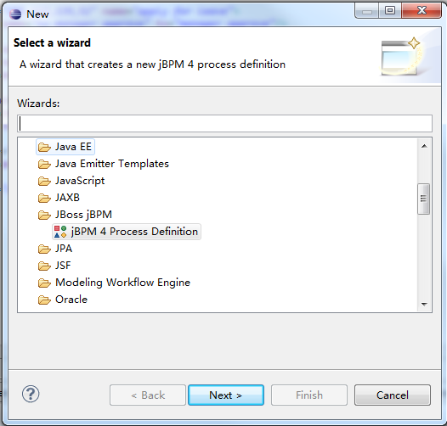

- Create a Web Project in Eclipse: JBPMPro
- Configure DataBase
  - Copy following configuration files under D:\jbpm-4.4\src to project’s src folder in eclipse
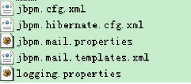
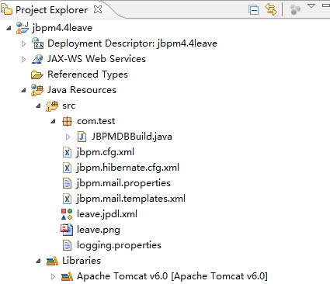
  - Modify jbpm.hibernate.cfg.xml as following (if you use other database, please modify related property according to your environment):
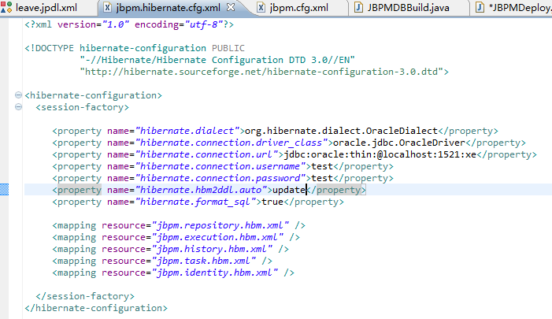
  - Create a class as following:
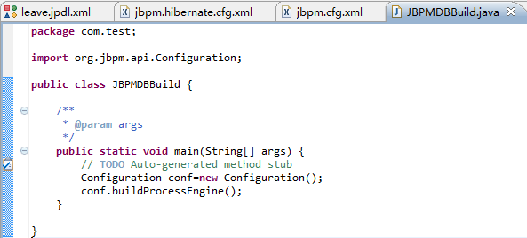
  - Run class as Java Application and it would set Database configuration in DB.

- In

)

http://wenku.baidu.com/link?url=7LhnymEnPjmj4EggZXiliKV5o-yN5SJ3GUoIejg4dOVXNBlf668zou7u5vSVabQYoVaAo81oxZV49tl-5Id_L9lan6aqdEaxuH3au4BxP8u

http://wenku.baidu.com/view/143ace3343323968011c92cb.html

http://blog.csdn.net/loverooney/article/details/8295221

