4.1)

We settled on implementing chess with optional features such as blindchess, rapidchess and simultaneous chess.

4.2)

https://play.chessbase.com

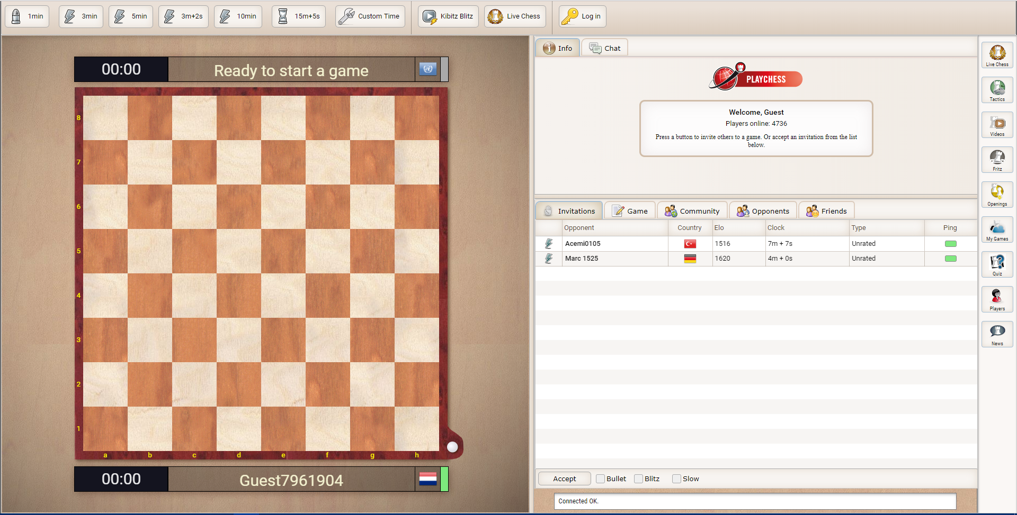

Good: Its clear what the application is about and there is an clear distinction between different parts of the app.

Bad: Quite a lot of clutter and buttons to start a game are unclear. “press a button to invite others to a game”. Which?

https://www.chessanytime.com/simplechess.html

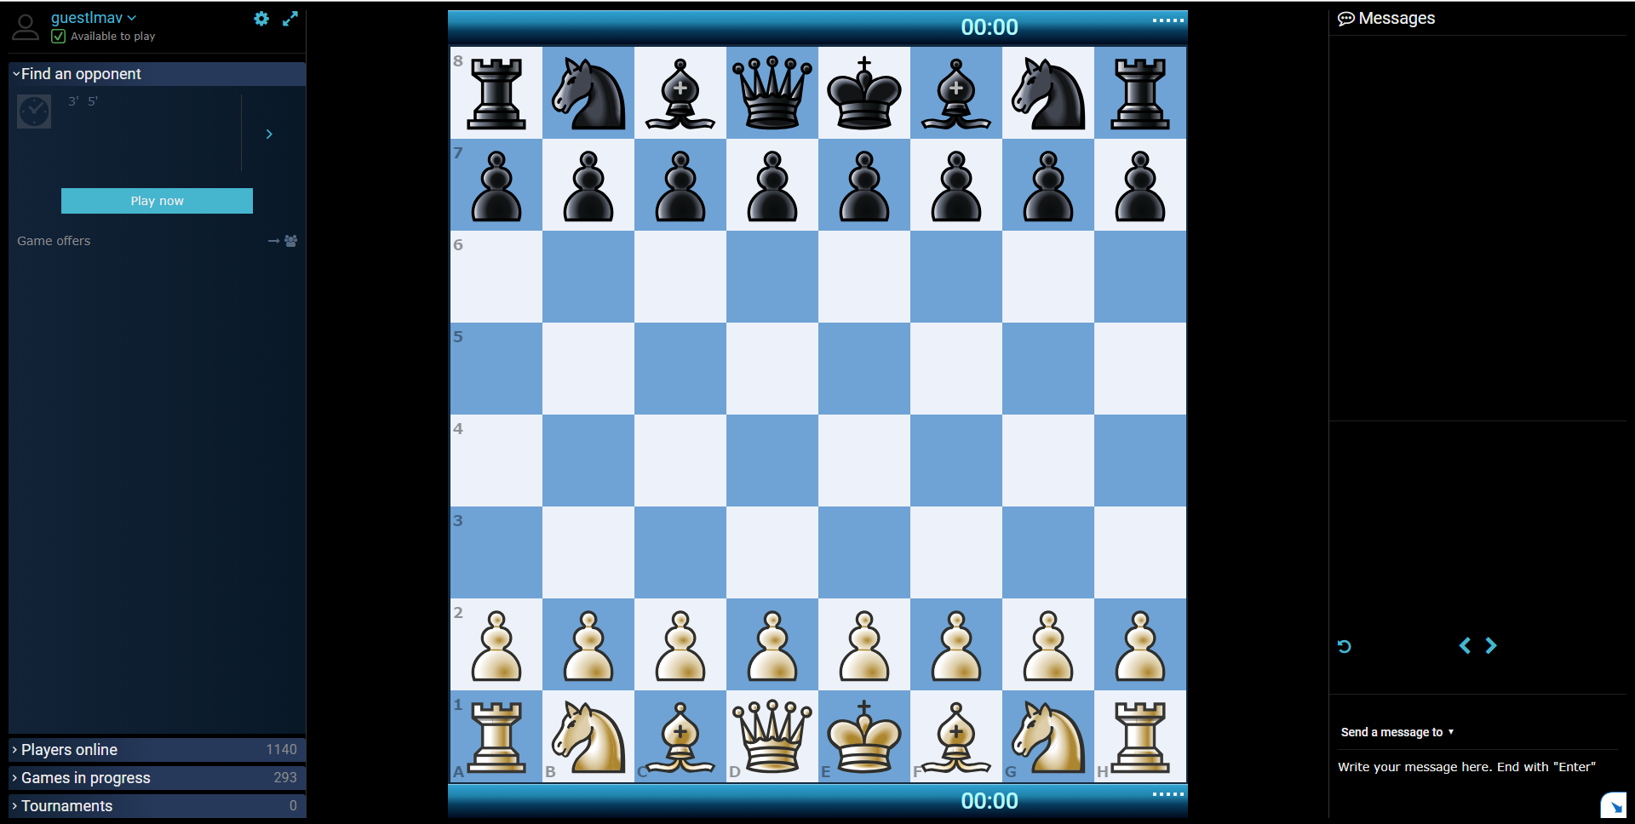

Good: This app has not much noise/clutter and has clear distinctions of different parts of the app

Bad: Play button is too small and does not stand out.

<https://play.chessclub.com/>

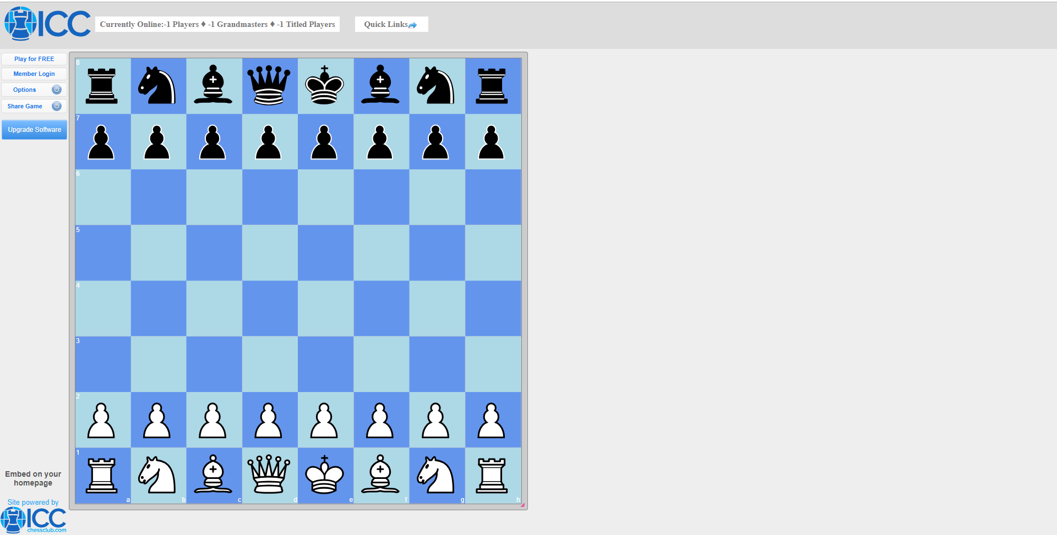

Good: Different parts are separated well, not much noise

Bad: The button that stands out the most is not what starts a game and instead redirects to downloads.

<https://www.shredderchess.net/>

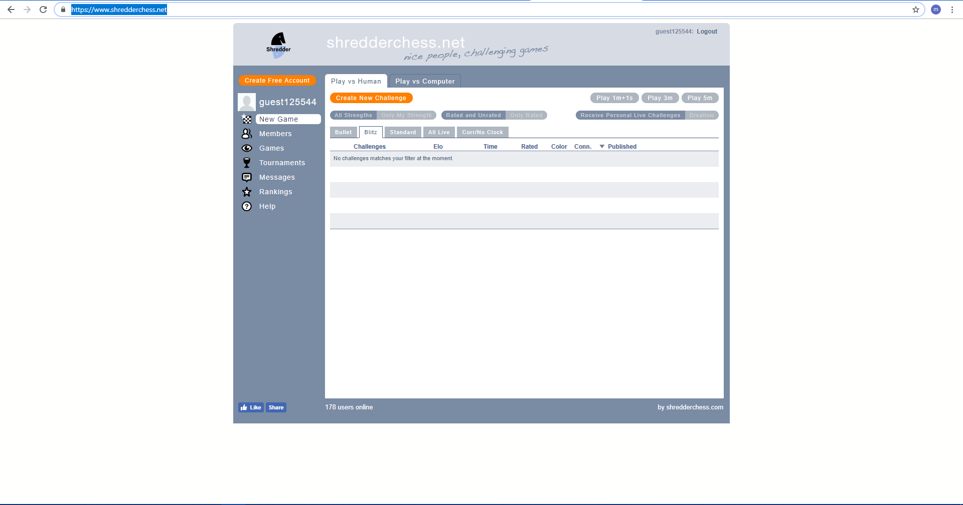

Good: The button to create a new game stands out due to the color contrast.

Bad: Easily to get lost between all the tabs.

4.3)

Positive features:

Clear distinct sound effects when the enemy makes a move or captures one of your pieces, it makes it easier to recognise what happened in the game and when its your turn.

The last played move is highlighted, this is another way to recognise what happened.

Highlighting the play button to make it easy to start a new game.

Negative features:

Having a lot of tabs with more tabs in it, it makes it really easy to get lost and can be difficult to navigate through.

No indication for check’s, this can be really confusing as you may try to move a chess piece while your king is checked and it will simply cancel the move while you’re left wondering why it doesn’t move.

Displaying unclear highlighted buttons such as “upgrade software”, it gives the impression its an malicious ad.