ELEC 3300 Project Summary Sheet
This is a ONE Page Summary Sheet, Content more than 1 page will be deleted.
All the fonts used in this Sheet should be in Times New Roman at 12 points

Group Number | 11
Project Title | Intelligent Flower Pot
Name of Student 1 | Fu Xiaohan
Name of Student 2 | Wong Hi Hong

Please attach ONE photo of your project here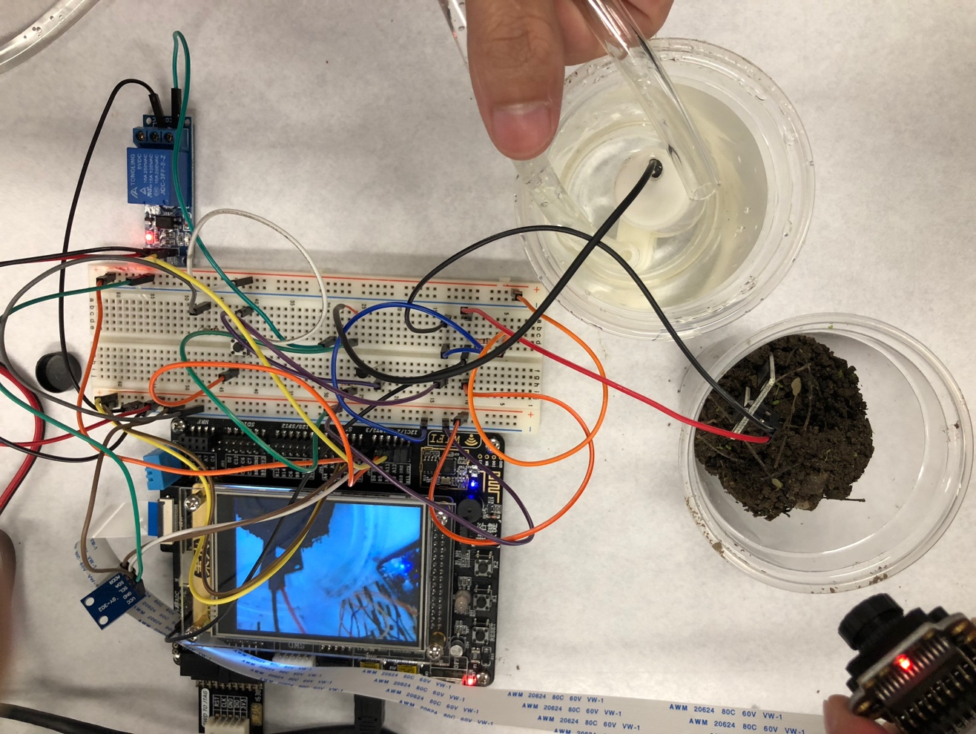
Please list the functions of your project in point form

- Let the plant owner choose the type of the plant when start the intelligent flower pot at the first time.
- Measure air temperature and humidity by using DHT-11 sensor
- Measure luminance by using GY-30
- Measure soil moisture by moisture sensor in real time.
- Use OV-7725 camera to monitor plant
- Show the real-time monitoring record and parameter of temperature, humidity, luminance and soil moisture on the LCD
- Take a picture of the plants when press the button and store it in the Micro SD card.
- Can Store parameter of temperature, humidity, luminance and soil moisture in the Micro SD card
- Alert owner when the soil moisture is under a certain level or the temperature is higher than a certain level
- Water the plant by the water pump automatically when above condition is fulfill and can manually water the plant by press a button

