ELEC 3300 Project Summary Sheet

This is a ONE Page Summary Sheet, Content more than 1 page will be deleted.

All the fonts used in this Sheet should be in Times New Roman at 12 points

|  |  |
| --- | --- |
| Group Number | 11 |
| Project Title | Intelligent Flower Pot |
| Name of Student 1 | Fu Xiaohan |
| Name of Student 2 | Wong Hi Hong |

Please attach ONE photo of your project here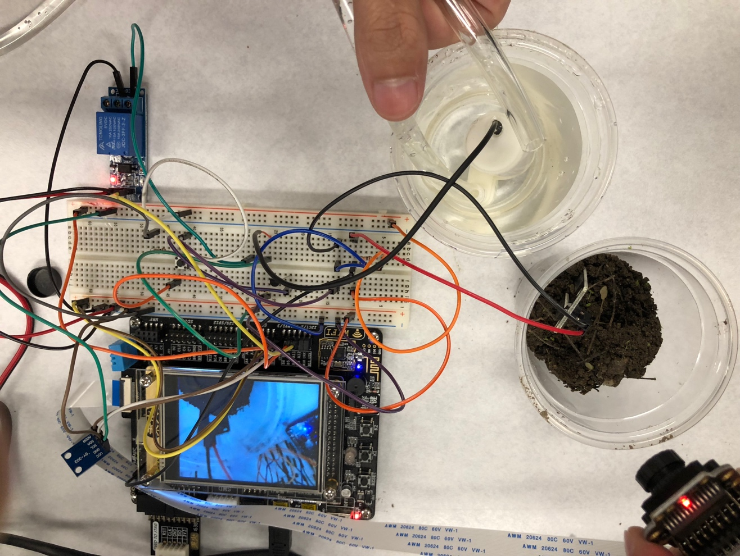

Please list the functions of your project in point form

* Let the plant owner choose the type of the plant when start the intelligent flower pot at the first time.
* Measure air temperature and humidity by using DHT-11 sensor
* Measure luminance by using GY-30
* Measure soil moisture by moisture sensor in real time.
* Use OV-7725 camera to monitor plant
* Show the real-time monitoring record and parameter of temperature, humidity, luminance and soil moisture on the LCD
* Take a picture of the plants when press the button and store it in the Micro SD card.
* Can Store parameter of temperature, humidity, luminance and soil moisture in the Micro SD card
* Alert owner when the soil moisture is under a certain level or the temperature is higher than a certain level
* Water the plant by the water pump automatically when above condition is fulfill and can manually water the plant by press a button