**EECE 8395**

**Project 8**

**Active Shape Model**

**Tahsin Reasat**

**ID: 000614908**

Task 8c i

Screenshot of 3D result

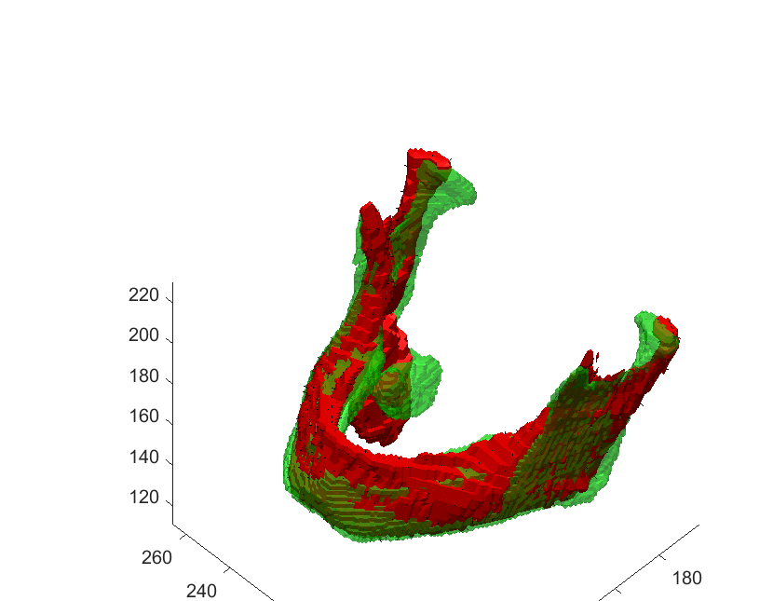

Task 8c ii

Could not do task 8c ii.

Task 8c iii

Code for Createshapemodel

function pca=createshapemodel(d,w)

mn=mean(d,2);

V=d-mn;

T=V'*V/size(V,2);

[eig_vec,eig_val] = eig(T);

eig_val=sum(eig_val);

[~,ind] = sort(eig_val,'descend');

e=eig_val(ind(1:end-1));

eig_vec=eig_vec(:,ind(1:end-1));

U=[];

for i=1:size(eig_vec,2)

U(:,i)=V*eig_vec(:,i);

U(:,i)=U(:,i)/norm(U(:,i));

end

phi=(U'*(w'*w)*U)\(U'*(w'*w));

pca=struct;

pca.e=e;

pca.U=U';

pca.mn=mn;

pca.w=w;

pca.phi=phi;