Top 10 values in each field

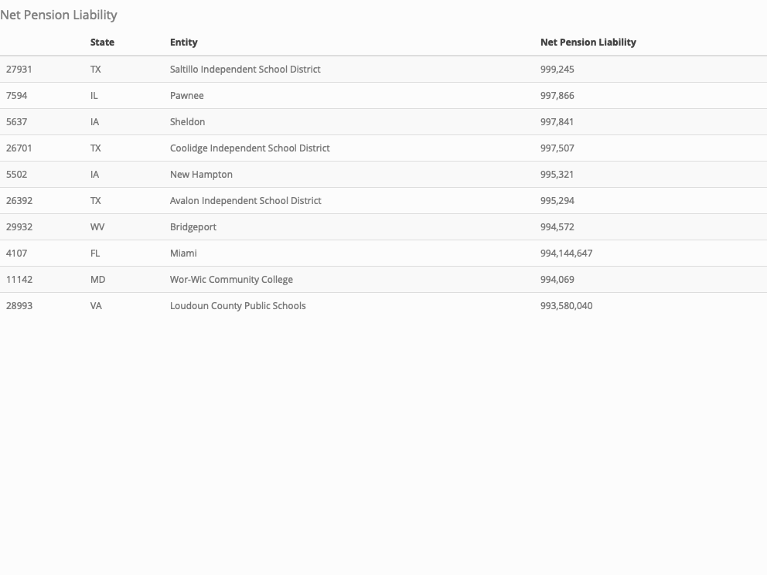

Net OPEB Assets

State

Entity

Net OPEB Assets

20775

OH

Polaris Career Center

998,217

20339

OH

Keystone Local School District

997,969

19869

OH

Central Ohio Technical College

995,400

20020

OH

Deer Park Community City School District

992,388

20328

OH

Johnstown-Monroe Local School District

990,663

19898

OH

Citizens Leadership Academy East

99,983

16655

NC

Richmond County Board of Education

99,763

20361

OH

Lake Erie Preparatory School

99,739

4900

GA

Unison Behavioral Health

99,135

20445

OH

Mahoning County

99,091

Net OPEB Liability

State

Entity

Net OPEB Liability

5018

IA

Bcluw Community School District

999,829

4692

GA

Laurens County Public Health Center

999,818

26245

TN

Washington County Emergency Communications District

999,502

5751

IA

Wapsie Valley Community School District

999,444

5093

IA

Central Springs Community School District

999,370

12399

MI

Croswell

999,154

27319

TX

Jayton-Girard Independent School District

997,568

18796

NV

Housing Authority of the City of Reno

997,235

21077

OH

United Local School District

996,996

1254

CA

Borrego Springs Unified School District

996,953

Bonds Outstanding

State

Entity

Bonds Outstanding

19306

NY

New York

99,455,082,000

28055

TX

State of Texas

59,721,954,000

19274

NY

Metropolitan Transportation Authority

51,013,000,000

10711

MA

Commonwealth of Massachusetts

41,939,680,000

7954

IL

State of Illinois

31,531,895,000

3681

CT

State of Connecticut

29,166,415,000

2082

CA

Los Angeles

29,056,349,000

29474

WA

State of Washington

26,732,746,000

18529

NJ

The Port Authority of New York and New Jersey

26,310,244,000

18517

NJ

State of New Jersey

25,401,600,000

Notes Outstanding

State

Entity

Notes Outstanding

27499

TX

Lower Colorado River Authority

4,055,000,000

14624

MI

State of Michigan

3,349,760,000

260

AL

Jefferson County

2,518,608,000

6310

IL

Chicago

1,648,820,000

7954

IL

State of Illinois

1,545,193,000

18517

NJ

State of New Jersey

1,500,000,000

18401

NJ

New Jersey Transit Corporation

1,288,077,000

16860

ND

State of North Dakota

1,142,684,000

16151

MS

State of Mississippi

1,080,809,000

904

AZ

Grand Canyon University

1,045,362,000

Leases

State

Entity

Leases

4842

GA

State of Georgia

3,023,377,000

29103

VA

Virginia Port Authority

2,253,021,808

19306

NY

New York

1,547,326,000

2082

CA

Los Angeles

1,333,166,000

4157

FL

Orange County District School Board

1,101,976,781

12918

MI

Great Lakes Water Authority

1,026,208,454

8297

IN

Capital Improvement Board of Managers

850,379,782

11128

MD

State of Maryland

770,343,000

8426

IN

Marion County

705,790,781

28992

VA

Loudoun County

643,363,204

Loans Outstanding

State

Entity

Loans Outstanding

15392

MN

New Millennium Academy

999,600

2255

CA

Mountain Empire Unified School District

997,229

13946

MI

Northville Charter Township

996,805

10620

LA

Zachary

995,812

25025

SD

Huron School District No.2-2

995,640

15527

MN

Washington County

995,401

15529

MN

Washington Minnestoa County

995,401

19688

OH

Archbold

995,187

16244

MT

Great Falls

995,171

3959

FL

Graceville

994,599

Compensated Absences

State

Entity

Compensated Absences

24551

PA

West Jefferson Hills School District

999,649

19469

NY

Scotia-Glenville Central School District

999,382

27783

TX

Pflugerville

999,315

23816

PA

Big Spring School District

999,224

20820

OH

Ridgewood Local School District

999,219

21139

OH

Waterloo Local School District

999,076

28330

UT

American Fork

998,731

21392

OK

Cameron University

998,709

18669

NM

Lea County

998,494

27877

TX

Richardson Independent School District

998,259

Total Liabilities

State

Entity

Total Liabilities

15412

MN

Northwest Suburban Integration District

999,053

26957

TX

Frisco

999,024,599

25382

TN

East End Preparatory School

998,980

6266

IL

Cary Fire Protection District

998,773

7

AK

Anchorage School District

998,762,854

26681

TX

Comal Independent School District

998,555,775

17659

NE

Sanitary and Improvement District No. 288

998,159

28506

UT

Ignite Entrepreneurship Academy

997,917

8020

IL

Thomasboro

997,367

1848

CA

Housing Authority of the County of Humboldt

996,681

Bonds Outstanding

State

Entity

Bonds Outstanding

19306

NY

New York

99,455,082,000

28055

TX

State of Texas

59,721,954,000

19274

NY

Metropolitan Transportation Authority

51,013,000,000

10711

MA

Commonwealth of Massachusetts

41,939,680,000

7954

IL

State of Illinois

31,531,895,000

3681

CT

State of Connecticut

29,166,415,000

2082

CA

Los Angeles

29,056,349,000

29474

WA

State of Washington

26,732,746,000

18529

NJ

The Port Authority of New York and New Jersey

26,310,244,000

18517

NJ

State of New Jersey

25,401,600,000

Revenues

State

Entity

Revenues

11992

MI

Boyne City Housing Commission

999,946

17579

NE

Otoe County Rural Water District 3

999,706

25536

TN

Hardin County Emergency Communications District

998,910

13416

MI

Lenawee Conservation District

998,340

26023

TN

River Road Utility District

998,103

11334

ME

Jackson

997,409

8421

IN

Linton Housing Authority

997,258

26001

TN

Quebeck-Walling Utility District

996,664

22568

OR

Aumsville Rural Fire Protection District

996,439

25972

TN

Pittman Center

996,008