Geographic constraints on leaf-physiognomy paleoclimate reconstruction
[Author list]
[Affiliations]
Correspondence: [email]

Abstract
Leaf physiognomic traits have been used for quantitative terrestrial paleoclimate reconstruction for over a century, from the leaf-margin analysis of Bailey and Sinnott (1916) to the multivariate Climate-Leaf Analysis Multivariate Program (CLAMP; Wolfe, 1993). A key lesson from CLAMP's development is that leaf–climate calibrations are regionally specific: separate calibration equations are needed for different floristic provinces because leaf morphological responses to climate vary with evolutionary and biogeographic history. We extend this regional-calibration logic by implementing a systematic, quantitative framework to assess the cross-region generalisability of leaf-physiognomy climate reconstruction. Using a globally distributed dataset of modern woody dicot sites with 31 physiognomic trait proportions, we evaluate the reconstructability of seven climate variables (mean annual temperature [MAT], warm-month and cold-month mean temperature [WMMT, CMMT], growing-season length [GROWSEAS], relative humidity [RH], specific humidity [SH], and moist enthalpy [ENTHAL]) under three complementary validation schemes: space-block GroupKFold, which prevents within-domain information leakage by partitioning sites into contiguous geographic blocks; Leave-One-Continent-Out (LOCO) validation, which tests transferability across floristic provinces; and fossil transfer against 71 assemblages with CLAMP-computed reference values. Four ensemble learners are compared with four linear statistical baselines on identical spatial folds, and a physically motivated two-stage temperature→moisture cascade is tested under leak-free partitioning.
We find a clear hierarchy of reconstructability. MAT and ENTHAL retain modest but consistent cross-region signal under space-block validation (R² ≈ 0.3–0.4). GROWSEAS, SH, and CMMT hover near zero, and WMMT and RH are not predictable across spatial blocks (R² < −0.3). Ensemble learners provide no statistically meaningful improvement over linear baselines under spatial partitioning, suggesting that the cross-region trait–climate relationship is essentially linear. The two-stage temperature→moisture cascade degrades moisture–energy prediction relative to traits-only models, indicating that error propagation across geographic space outweighs any physical information content of the cascade. Fossil transfer yields R² values of 0.65 (MAT), 0.82 (CMMT), 0.73 (GROWSEAS), and 0.68 (ENTHAL) against CLAMP references, but this apparent success reflects the Asian dominance of the fossil dataset (92 % of assemblages) and constitutes within-domain interpolation rather than cross-continent generalisation. We conclude that leaf physiognomy provides a reliable but spatially bounded tool for terrestrial paleoclimate reconstruction and that space-block validation is essential for quantifying this spatial boundary.
Keywords: leaf physiognomy, paleoclimate reconstruction, space-block validation, CLAMP, cross-region generalisation, terrestrial paleoclimatology

1 Introduction
The reconstruction of terrestrial paleoclimate from fossil leaf assemblages is a long-standing quantitative approach in paleoclimatology. The foundational observation—that the proportion of entire-margined woody dicot species in a flora correlates with mean annual temperature—was established by Bailey and Sinnott (1916) and subsequently refined through systematic calibration of multiple leaf physiognomic traits against modern climate observations (Wolfe, 1971, 1979; Wilf, 1997; Gregory-Wodzicki, 2000; Royer et al., 2005). These traits span tooth type, leaf size class, apex and base form, length:width ratio, and overall shape, and their climate correlations are grounded in leaf physiology: margin type and size respond to growing-season temperature and water balance, while gross shape carries a weaker and more phylogenetically constrained signal (Peppe et al., 2011; Wright et al., 2017).
The Climate-Leaf Analysis Multivariate Program (CLAMP; Wolfe, 1993; Spicer, 2009) formalised multivariate leaf physiognomy–climate calibration using canonical correspondence analysis and has become the most widely applied physiognomic paleoclimate method, with successful use spanning the Cretaceous to Quaternary. A central feature of CLAMP's methodology, refined over decades of practical application, is the recognition that leaf–climate calibrations are not globally portable. Vegetation from different floristic regions, shaped by distinct evolutionary and biogeographic histories, exhibits systematically different morphological responses to the same climate variables. CLAMP practitioners have therefore maintained region-specific calibration datasets for East Asia, North America, the Southern Hemisphere, and other floristic provinces (Wolfe, 1979, 1993; Yang et al., 2015; Spicer et al., 2020). This regional calibration strategy has been essential to CLAMP's utility for reconstructing the paleoelevation and paleoclimate of tectonically active regions, particularly the Tibetan Plateau, where leaf fossils from Cenozoic sedimentary basins record the coupled evolution of topography, climate, and biodiversity (Spicer et al., 2021; He et al., 2022; Ding et al., 2022; Bhatia et al., 2025).
Recent work has applied ensemble machine learning (ML) methods to leaf physiognomic data, motivated by the expectation that non-linear models might capture complex trait–climate interactions (Peppe et al., 2011; Lowe et al., 2024; Chen et al., 2025). Some studies have reported high R² values for key temperature variables, and physiologically motivated multi-stage architectures—in which predicted temperatures inform downstream moisture or energy-balance estimates—have been proposed to cascade information across physically linked climate variables. These developments motivate a question that we frame within the established CLAMP regional-calibration logic: at what spatial grain do trait–climate relationships lose generalisability, and how much reconstructable signal remains under the cross-region extrapolation that fossil transfer demands?
This question has practical urgency because modern calibration sites and fossil localities are geographically clustered. Densely sampled regions—East Asia and the Americas—dominate calibration datasets, while Europe and Africa are sparsely represented. The fossil record mirrors this pattern: most described Cenozoic leaf assemblages are from Asia. When validation metrics are computed by randomly partitioning sites that share the same geographic domain, they measure within-region interpolation rather than the cross-region generalisation required for paleoclimate reconstruction (Roberts et al., 2017; Meyer et al., 2019; Ploton et al., 2020). This concern is particularly relevant for paleoelevation studies on the Tibetan Plateau, where fossil assemblages from high-elevation basins must be interpreted using calibrations from lower-elevation regions, often across substantial geographic and climatic distances (Miao et al., 2022; He et al., 2022; Liang et al., 2025).
Here we extend the CLAMP regional-calibration approach into a systematic, quantitative framework for assessing cross-region generalisability. Using a global calibration dataset with 31 physiognomic trait proportions, we implement three complementary validation schemes: (i) space-block GroupKFold, which partitions sites by contiguous geographic grid blocks to prevent within-domain leakage; (ii) Leave-One-Continent-Out validation, which explicitly tests transferability across floristic provinces; and (iii) fossil transfer against 71 assemblages to evaluate real-world applicability. We compare four ensemble learners against four linear baselines on identical spatial folds and test a physically motivated two-stage cascade under leak-free partitioning. Our aim is not to determine which method performs best, but to quantify the fundamental information content of leaf traits for climate reconstruction when geographic structure is respected—thereby providing a reproducible baseline for interpreting leaf-physiognomy paleoclimate studies across floristic provinces.

2 Data and methods

2.1 Modern calibration dataset
The modern calibration dataset comprises 393 woody dicotyledonous angiosperm sites spanning five continents (Asia: 158 sites; Americas: 143; Oceania: 53; Europe: 25; Africa: 14). The geographic imbalance reflects the real-world distribution of botanical sampling effort and is consistent with prior CLAMP calibration datasets (Wolfe, 1993; Yang et al., 2015). For each site, 31 leaf physiognomic traits are recorded as compositional proportions (summing to 1 within each trait category), following the standard CLAMP protocol. The traits span six morphological categories: tooth type (7 proportions: lobed, no teeth, teeth regular, teeth close, teeth round, teeth acute, teeth compound), leaf size class (9 proportions: nanophyll through mesophyll 3), apex form (4: emarginate, round, acute, attenuate), base form (3: cordate, round, acute), length:width ratio (5: <1:1 through >4:1), and general shape (3: obovate, elliptic, ovate). Climate data for the seven target variables—mean annual temperature (MAT), warm-month mean temperature (WMMT), cold-month mean temperature (CMMT), growing-season length (GROWSEAS), relative humidity (RH), specific humidity (SH), and moist enthalpy (ENTHAL)—were extracted from the WorldClim 2 database (Fick and Hijmans, 2017) at each site's geographic coordinates.

2.2 Fossil assemblages
The fossil dataset contains 71 leaf assemblages spanning the Cretaceous through Quaternary, predominantly from Asia (65 assemblages: Tibetan Plateau, Yunnan, northeast India, Myanmar, Vietnam, Guangxi, Guangdong), with four European (Spain, Poland) and one North American (Florissant, Colorado) assemblage. CLAMP-computed climate values serve as reference targets for fossil transfer evaluation. We note that CLAMP reference values are model-derived estimates, not instrumental observations, and are available only for variables and assemblages that CLAMP can resolve. The Asian dominance of the fossil set (92 % of assemblages) is an inherent feature of the available data, reflecting both the richness of East Asian fossil floras and the concentration of paleobotanical research in this region (Su et al., 2019; He et al., 2022).

2.3 Space-block validation framework
Building on CLAMP's regional-calibration logic, we implement a space-block validation framework that extends geographic partitioning to a finer spatial grain. The globe is divided into two-dimensional grid blocks based on latitude and longitude percentiles (5 latitudinal bands × 4 longitudinal bands, yielding up to 20 spatial blocks). Each of the 393 modern sites is assigned to one block, and GroupKFold (with spatial block as the grouping variable) ensures that all sites within the same block are placed exclusively in either training or test sets. This prevents any within-block spatial autocorrelation from inflating validation metrics. We use 10-fold GroupKFold (constrained by the number of valid blocks) and report mean and standard deviation of R² and RMSE across folds. Compared with CLAMP's continent-scale partitions, the space-block approach is finer-grained; compared with random splitting, it is more geographically honest. It functions as a quantitative probe of the spatial grain at which trait–climate relationships lose reliability.

2.4 Two-stage prediction architecture
A physically motivated two-stage architecture is tested: Stage 1 predicts the four temperature variables (MAT, WMMT, CMMT, GROWSEAS) from the 31 trait proportions, generating out-of-fold (OOF) predictions for all modern sites. Stage 2 predicts the three moisture–energy variables (RH, SH, ENTHAL) from an augmented feature set (31 traits + 4 OOF temperature predictions). OOF predictions are generated from models trained on different spatial folds, eliminating any leakage of target-site temperature information into Stage 2. A traits-only baseline (31 traits → moisture–energy variable, no temperature augmentation) quantifies the information contribution of the two-stage design.

2.5 Models and baselines
We evaluate four ensemble learners and four linear baselines on identical spatial folds. Ensemble learners: Random Forest (n_estimators=500, max_depth=12, min_samples_leaf=3), XGBoost (n_estimators=300, max_depth=5, learning_rate=0.03), Gradient Boosting (n_estimators=300, max_depth=4, learning_rate=0.03), and Support Vector Regression (RBF kernel, C=10.0). Hyperparameters were chosen to favour spatial generalisation through regularisation (limited tree depth, increased minimum samples per leaf). Linear baselines: ordinary least squares, Ridge regression with cross-validated alpha, ElasticNet with cross-validated L1 ratio and alpha, and Partial Least Squares (n_components=4). Compositional trait data (proportions bounded in [0,1]) are monotonic-invariant under tree splits, so we omit preprocessing transformations for tree-based models.

2.6 Leave-One-Continent-Out (LOCO) validation
To assess cross-continent transferability—directly testing the limits of the regional-calibration logic—we perform LOCO validation using Random Forest. For each continent (Asia, Americas, Oceania, Europe, Africa), all sites on that continent are held out as the test set while the model trains on the remaining continents. This provides a realistic upper bound on model performance for fossil sites on continents with sparse modern training data.

2.7 Fossil transfer evaluation
Final models are trained on all 393 modern sites and evaluated on the 71 fossil assemblages. For temperature variables, the Stage 1 Random Forest model is applied directly to fossil traits. For moisture–energy variables, Stage 2 is trained on modern sites using traits + Stage 1 OOF temperature predictions and then applied to fossil traits augmented with fossil temperature predictions from Stage 1. Performance metrics are R², RMSE, and mean bias against CLAMP reference values. Given the Asian dominance of the fossil dataset and the model-derived nature of CLAMP targets, we interpret fossil transfer results as an evaluation of within-domain consistency rather than as independent validation.

3 Results

3.1 Trait–climate correlation structure
Spearman rank correlations between the 31 leaf physiognomic traits and seven climate variables across the 393 modern sites reveal a structured but generally moderate association pattern (Fig. 1). The strongest single-trait correlation is between the proportion of entire-margined leaves (no teeth) and MAT (ρ = 0.52, p < 0.001), consistent with the classic leaf-margin analysis (Bailey and Sinnott, 1916; Wilf, 1997). Mesophyll size classes show the strongest associations with moisture variables (mesophyll 3 vs. SH: ρ = 0.48, p < 0.001), reflecting the well-documented relationship between leaf size and water availability (Peppe et al., 2011). Tooth-type traits exhibit the broadest climate correlations, particularly with temperature variables, while shape traits (obovate, elliptic, ovate) show the weakest associations—a pattern consistent with the physiological basis of leaf morphology: margin type and size respond to growing-season conditions, whereas gross shape may be more strongly constrained by phylogeny. The correlation structure confirms that leaf morphology carries detectable but noisy climate signal and motivates the quantitative spatial validation that follows.
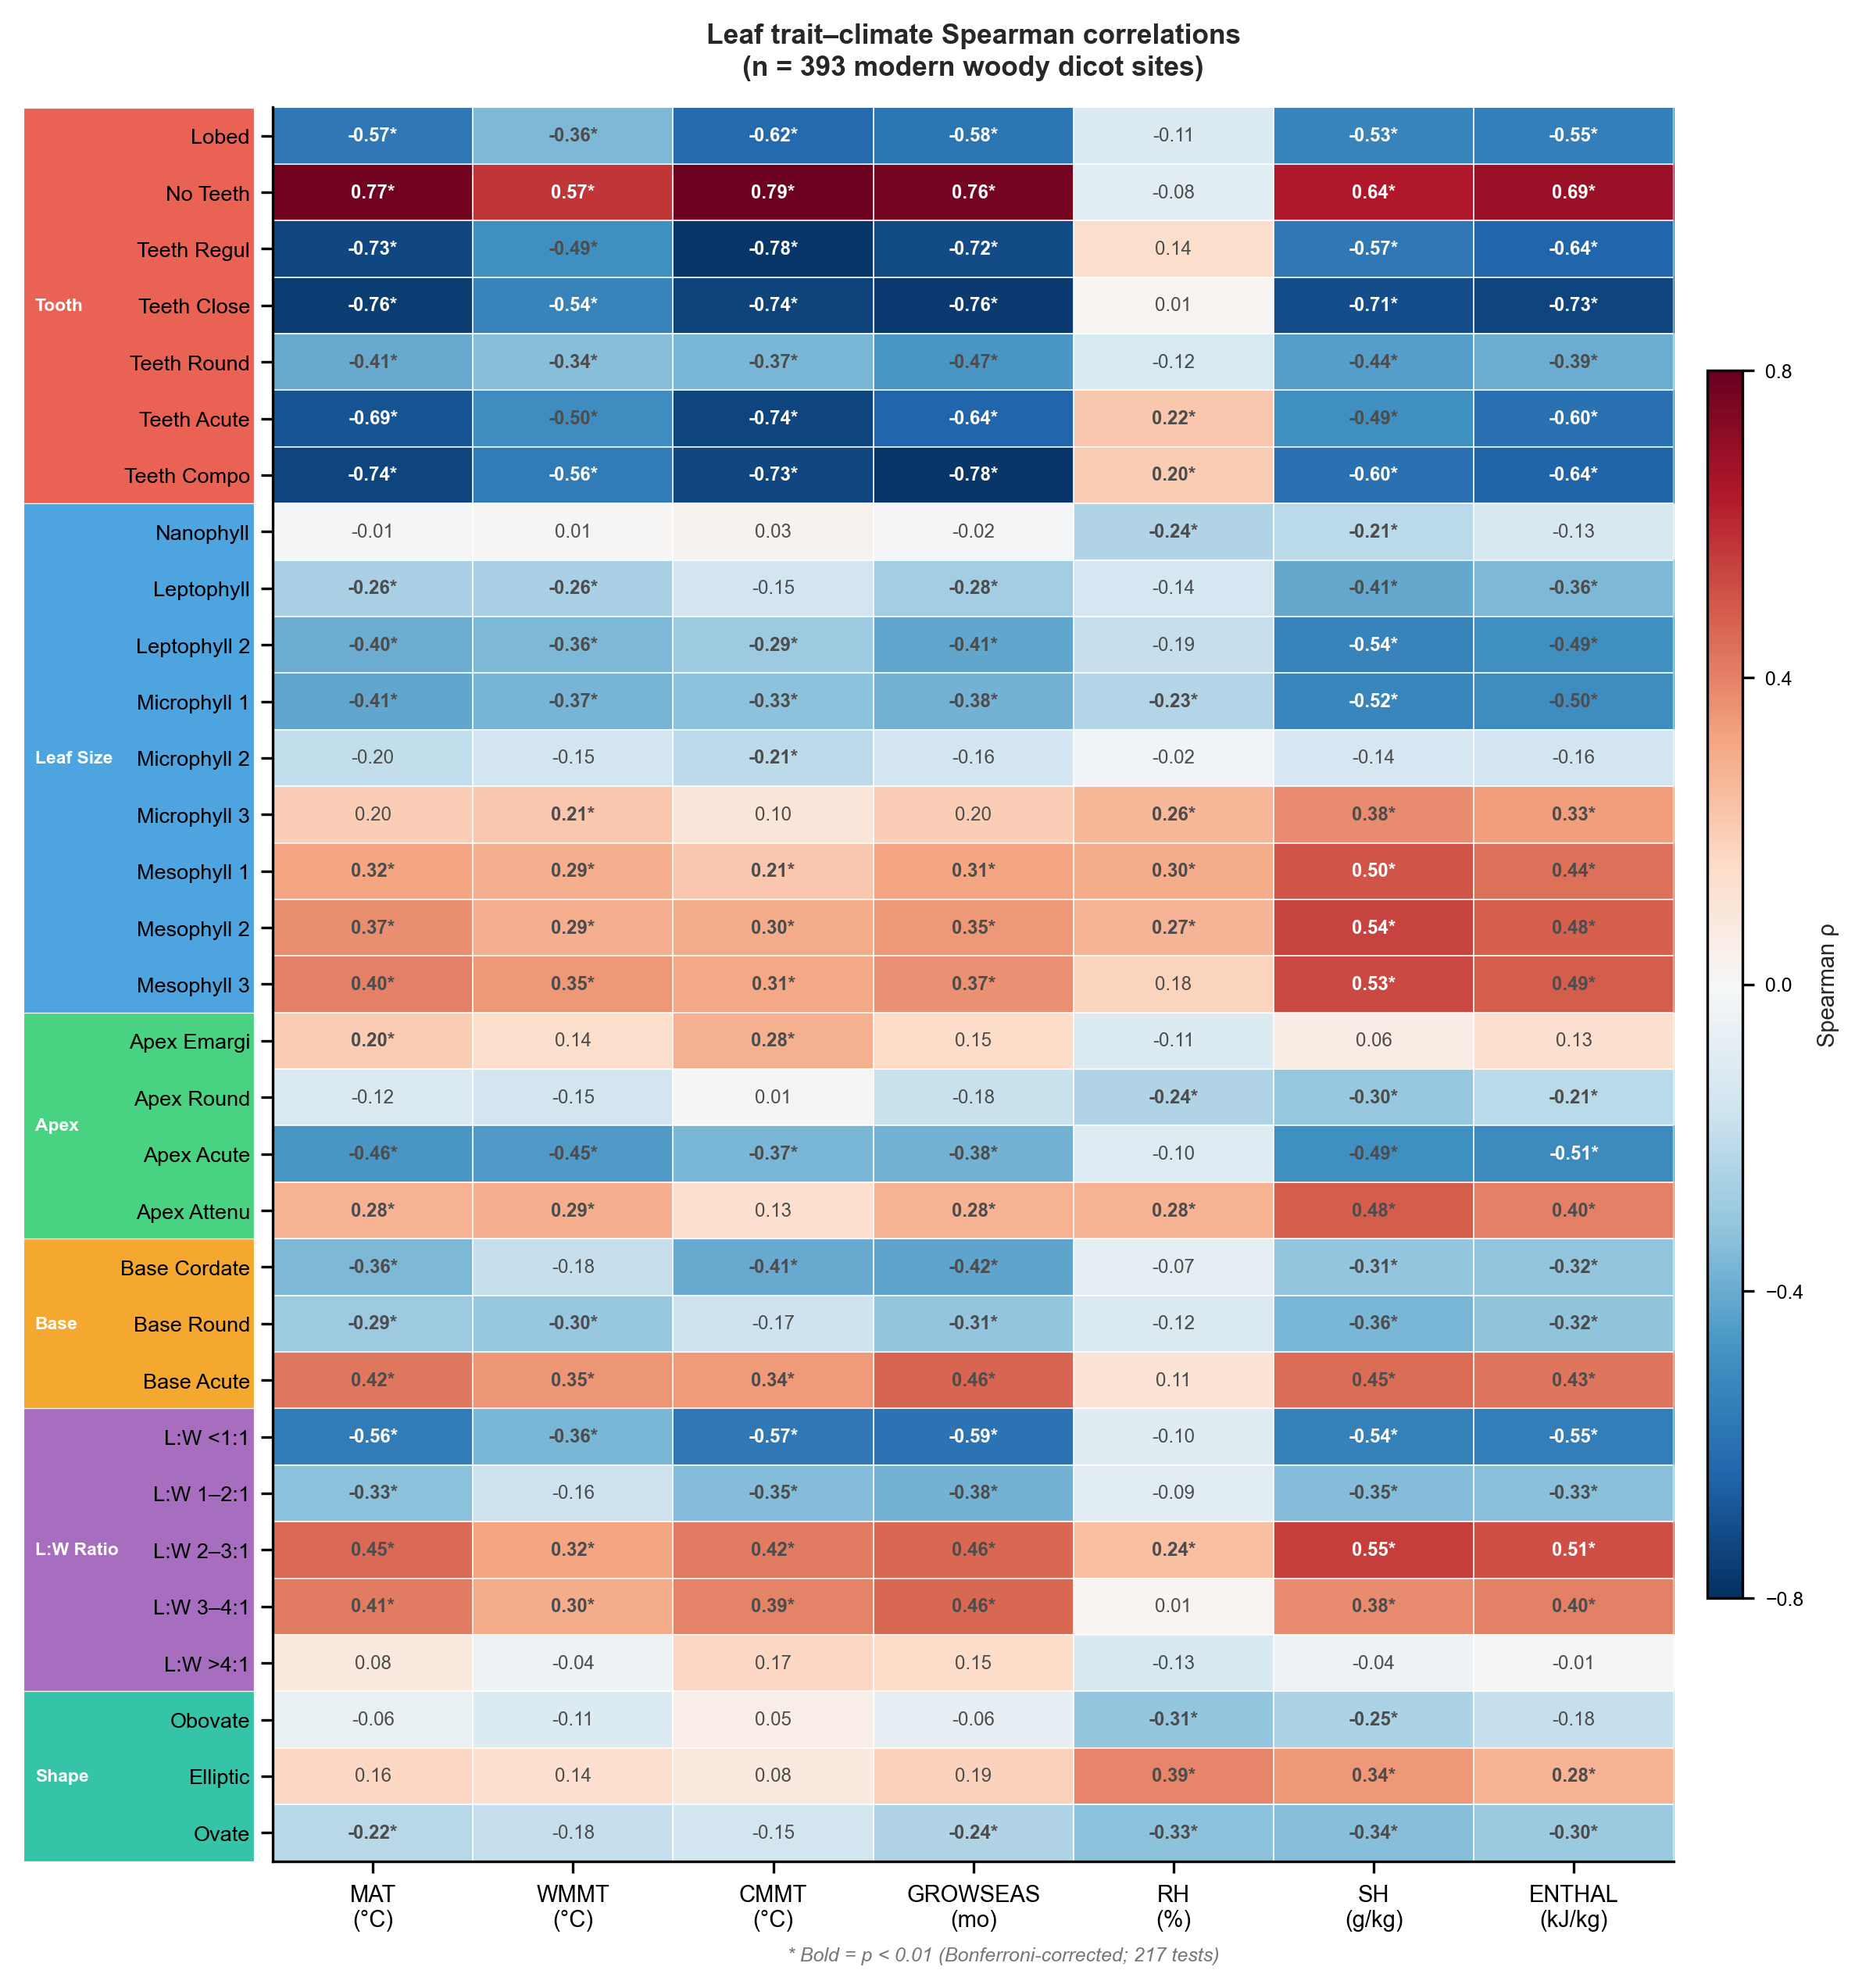
Figure 1. Spearman rank correlation between 31 leaf physiognomic traits and seven climate variables across the modern calibration dataset. Trait categories are indicated by coloured sidebars: tooth type (red), leaf size class (blue), apex form (green), base form (orange), L:W ratio (purple), and general shape (teal). Filled circles indicate p < 0.01 after Bonferroni correction.

3.2 Reconstructability hierarchy under space-block validation
Under space-block validation, model performance drops substantially below what conventional random-fold cross-validation would report (Fig. 2; Table 1), and a clear hierarchy of reconstructability emerges. MAT is the most reconstructable: Random Forest achieves R² = 0.383 ± 0.438 (RMSE = 3.82 °C), and the best linear baseline (ordinary least squares) reaches R² = 0.343. ENTHAL follows at R² = 0.299 (RF) and 0.306 (best baseline). SH achieves R² = 0.136, GROWSEAS R² = 0.099, and CMMT R² = −0.013. WMMT and RH are not predictable across spatial blocks (R² = −0.321 and −0.331, respectively).
The hierarchy MAT ≈ ENTHAL > SH > GROWSEAS > CMMT ≫ WMMT, RH admits a physical interpretation. MAT and ENTHAL integrate annual energy balance—the signal that leaf morphology captures most strongly through margin type and size distribution. CMMT and WMMT represent seasonal extremes that are physiologically decoupled from the growing-season conditions under which leaves develop and are preserved. RH is difficult to predict from morphological traits that respond to absolute moisture content (SH) rather than to relative saturation.
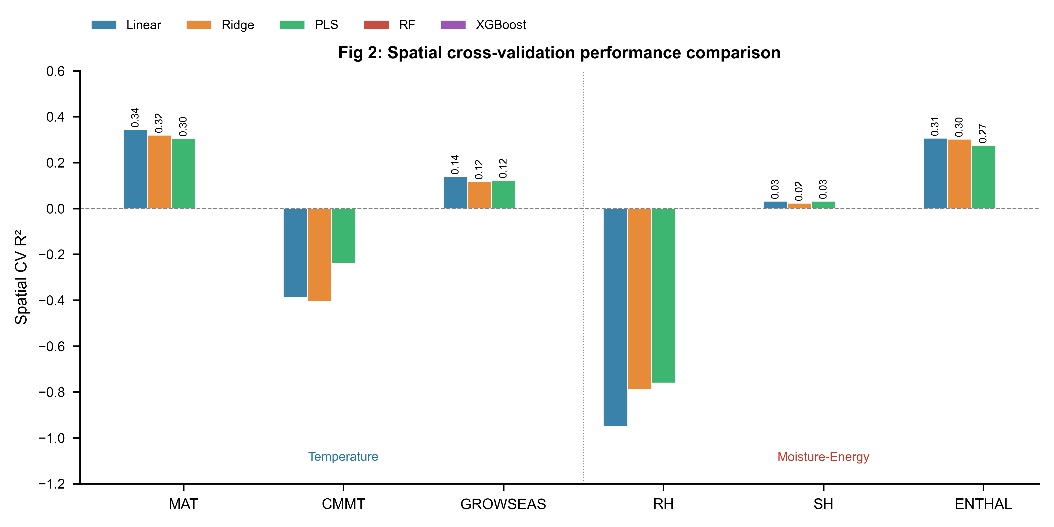
Figure 2. Space-block validation performance across five models for six climate variables. Bars show mean R² from space-block GroupKFold (10 folds). WMMT is omitted due to uniformly negative performance. The vertical dashed line separates temperature (left) from moisture–energy (right) targets.

A notable result is that ensemble learners do not outperform linear baselines under space-block validation. For MAT, Random Forest gains only 0.04 in R² over the best linear model (OLS R² = 0.343 vs. RF R² = 0.383), a difference that falls within one standard deviation of the cross-validation folds (σ = 0.438). For GROWSEAS, the best baseline (OLS, R² = 0.138) outperforms the best ensemble learner (RF, R² = 0.099). For ENTHAL, OLS (R² = 0.306) marginally exceeds RF (R² = 0.299). This pattern indicates that the cross-region trait–climate signal is approximately linear. Non-linear models may capture within-region structure that does not transfer across floristic provinces. From a practical standpoint, this is an encouraging finding: simpler, more interpretable statistical models appear adequate for cross-region reconstruction, and the additional complexity of ensemble methods does not translate into greater geographic generalisability.

3.3 Two-stage temperature→moisture cascade
The two-stage architecture does not improve moisture–energy prediction under space-block validation. For all three moisture–energy targets, the traits-only baseline consistently outperforms the two-stage design (Fig. 5a). For SH, the traits-only RF achieves R² = 0.235 versus 0.136 for the two-stage RF (Δ = −0.099). For ENTHAL, the traits-only RF R² = 0.391 versus 0.299 (Δ = −0.092). This degradation is consistent across all four ensemble learners.
We attribute this to error propagation across space. Stage 1 temperature predictions carry systematic spatial biases—sites within a given block tend to be over- or under-predicted—and these biases are amplified when the noisy estimates feed into Stage 2. The physically robust Clausius–Clapeyron relationship operates locally, but spatial biases in the temperature estimates overwhelm any signal the traits already capture independently. This suggests that when target fossil sites are geographically remote from calibration data, direct traits-only prediction of moisture variables may be more reliable than a two-stage scheme.

3.4 Cross-continent transferability
LOCO validation (Fig. 3f; Table 2) delineates the geographic boundaries within which leaf-trait-based climate reconstruction is reliable. For MAT, positive R² is achieved for Asia (0.408), the Americas (0.448), Oceania (0.323), and Africa (0.231), but the model fails for Europe (R² = −1.035), which has only 25 calibration sites and spans a climate space poorly represented in the training set. CMMT shows a starker pattern: R² = 0.496 for the Americas but −1.430 for Europe. The moisture–energy variables show moderate LOCO performance for Asia, the Americas, and Oceania but uniformly negative R² for Europe.
Two patterns emerge. First, model performance scales broadly with calibration density: continents with more training sites support better prediction of the held-out continent (Roberts et al., 2017). Second, Europe's consistent failure indicates that its leaf-trait–climate relationship differs systematically from that of the other continents—likely reflecting both small sample size and the distinct floristic and climatic character of European temperate forests relative to East Asian and American assemblages. These LOCO results quantify what CLAMP practitioners have long understood qualitatively: leaf-physiognomy calibrations are not globally portable.

3.5 Fossil transfer: regional consistency or global prediction?
Fossil transfer results (Fig. 3a–e; Table 1) must be interpreted in light of the dataset's geographic composition. For temperature variables, fossil R² ranges from 0.646 (MAT, RMSE = 2.74 °C, bias = −1.69 °C) to 0.820 (CMMT, RMSE = 2.79 °C, bias = −0.98 °C). GROWSEAS achieves R² = 0.730 (RMSE = 1.01 months), and WMMT fails (R² = −1.056). Among moisture–energy variables, ENTHAL achieves R² = 0.681 (RMSE = 9.68 kJ/kg) and SH reaches 0.385 (RMSE = 2.95 g/kg). A systematic cold bias is present across all fossil predictions (MAT bias = −1.69 °C; ENTHAL bias = −4.90 kJ/kg).
The strong fossil CMMT performance (R² = 0.820) contrasts sharply with its negative space-block validation R² (−0.013). This discrepancy reflects the fossil dataset composition: 65 of 71 assemblages are from Asia, where modern calibration coverage is densest. Fossil transfer for CMMT therefore represents within-domain interpolation—fossil sites and their modern analogues share the same geographic domain. LOCO results corroborate this interpretation: CMMT achieves R² = 0.50 for the Americas but fails for Europe (R² = −1.43). The high fossil R² for CMMT reflects regional consistency, not global predictive capability. This has direct implications for paleoelevation studies on the Tibetan Plateau: models calibrated on Asian data can reconstruct Asian fossil climate with reasonable fidelity, but this skill does not generalise to other floristic provinces (Spicer et al., 2021; He et al., 2022).
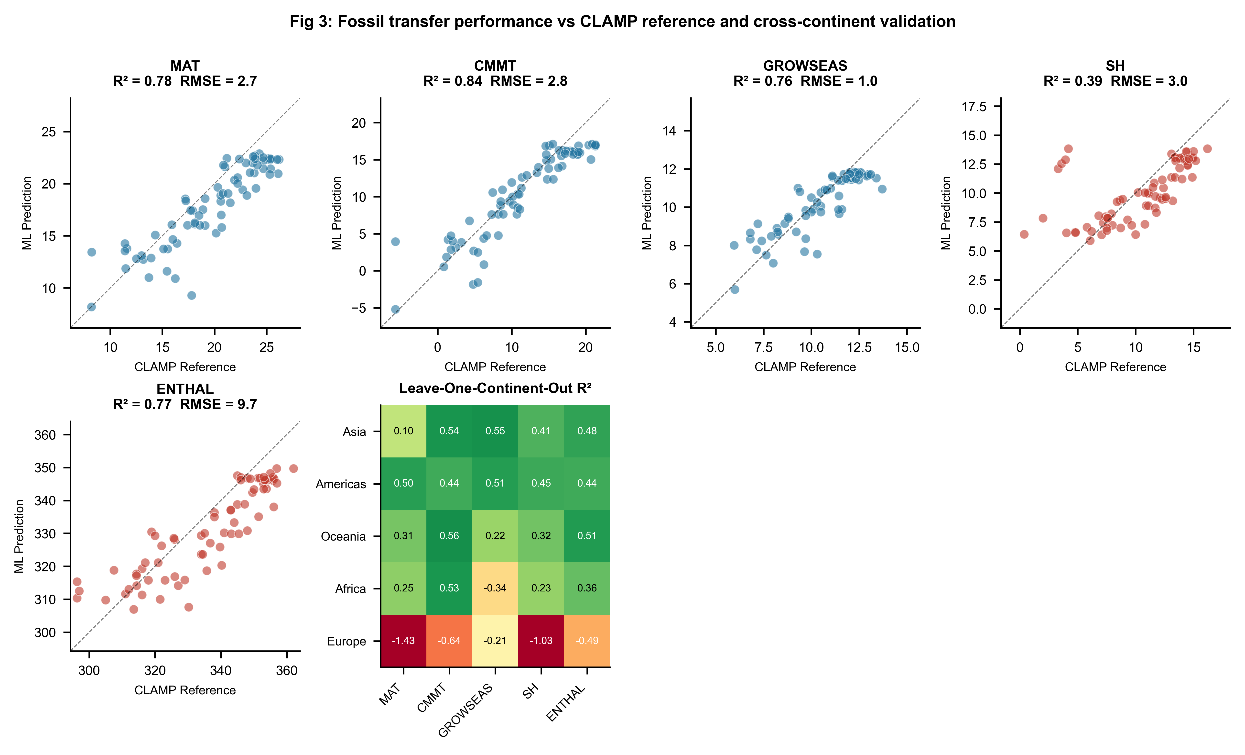
Figure 3. Fossil transfer and cross-continent validation. (a–e) Predicted vs. CLAMP reference values for five climate variables across 71 fossil assemblages; the dashed line indicates identity. Marker colours distinguish temperature (blue) and moisture–energy (red) targets. (f) Leave-One-Continent-Out R² heatmap for five climate variables across five continents.

3.6 Trait contributions to climate prediction
Random Forest feature importance (Fig. 4) identifies which trait categories drive cross-region climate signal. Tooth-type traits dominate temperature prediction (~40 % of MAT variance explained), followed by leaf size categories (~35 %) and apex form (~12 %). Base form and shape traits contribute minimally (Fig. 4c). The leading individual feature for MAT is the proportion of entire-margined leaves (no teeth; ~15 % of RF importance), confirming the leaf-margin analysis as the single most informative trait even under space-block validation. For moisture–energy variables, leaf size traits dominate, with mesophyll classes contributing the largest share—consistent with the physical expectation that leaf size responds to water availability (Peppe et al., 2011; Wright et al., 2017). The importance hierarchy tooth type > leaf size ≫ apex, base, shape is stable across all target variables, suggesting that effort invested in scoring additional trait categories yields diminishing returns for cross-region climate reconstruction.
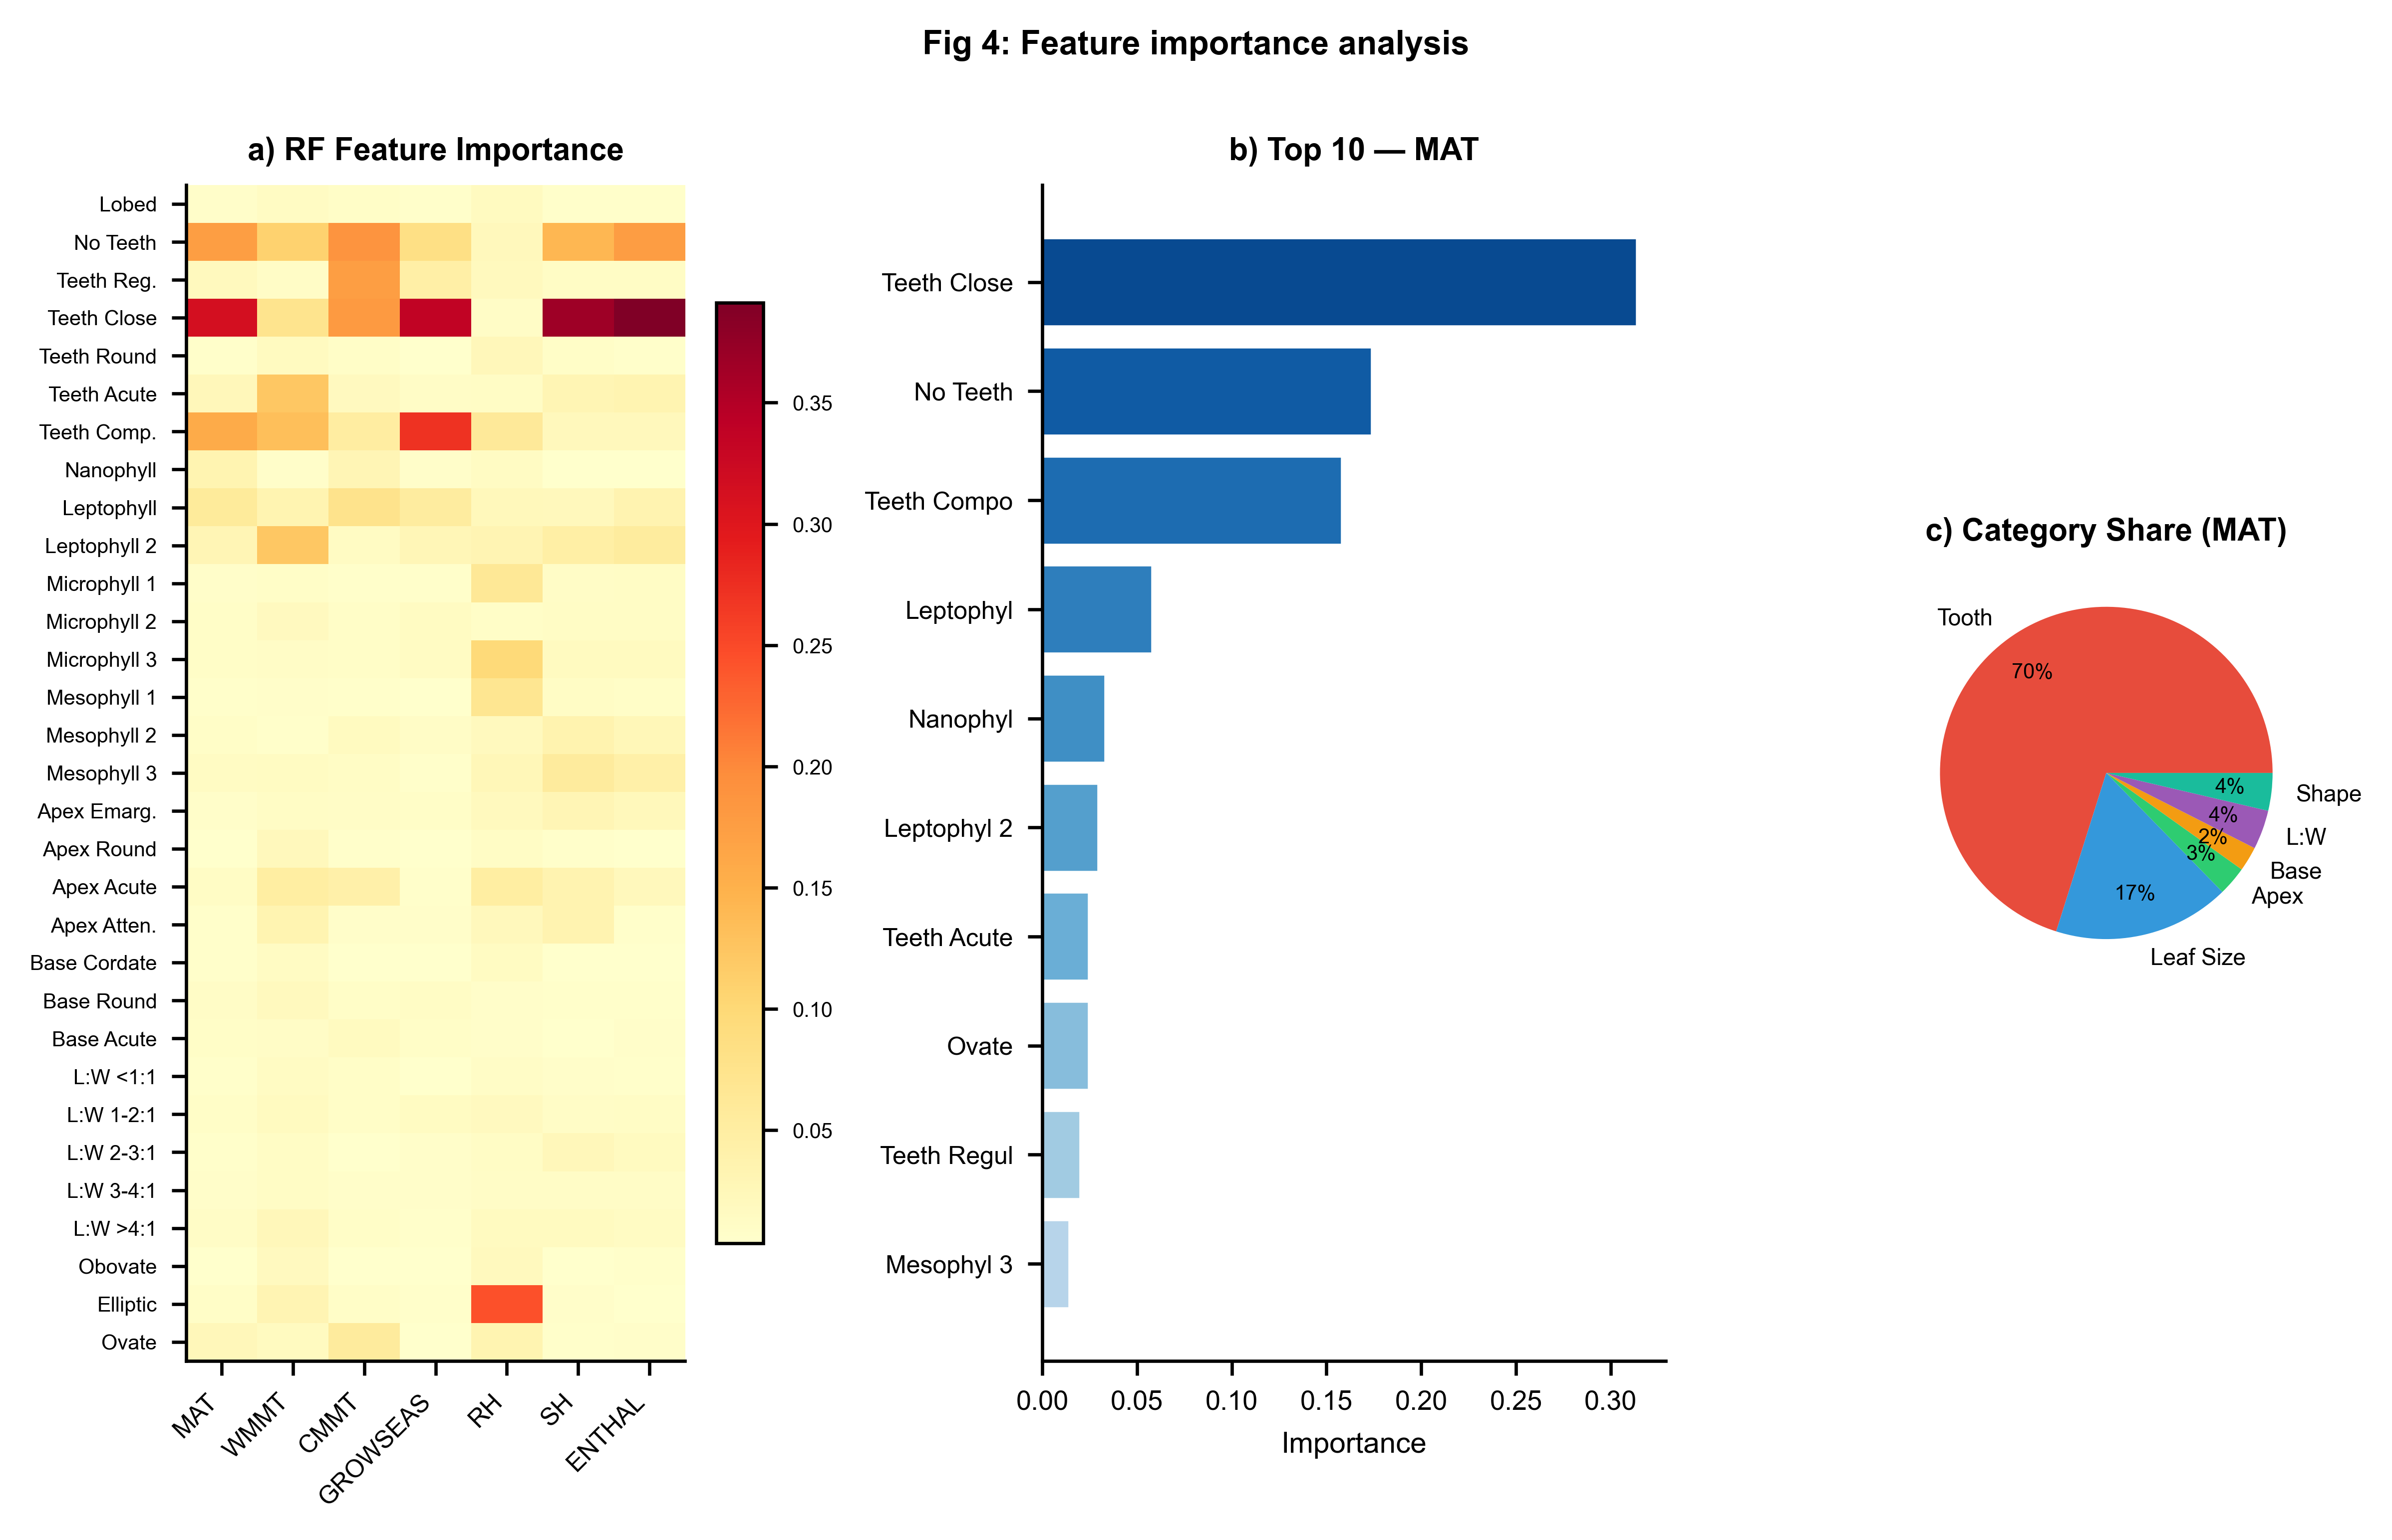
Figure 4. Feature importance analysis. (a) Random Forest feature importance heatmap across all seven climate variables. (b) Top 10 features by importance for MAT. (c) Trait-category contribution to MAT importance (pie chart).

3.7 Synthesis of reconstructability
Synthesising across all three validation frameworks, we delineate a three-tier hierarchy (Fig. 5b; Table 1). Tier 1—cross-region robust—comprises MAT and ENTHAL, with positive space-block R² and moderate fossil transfer skill. Tier 2—regionally conditioned—comprises SH, GROWSEAS, and CMMT, with near-zero space-block R² but acceptable fossil transfer within densely calibrated domains. Tier 3—cross-region unreliable—comprises WMMT and RH, with consistently negative R² across all validation schemes. For paleoelevation studies on the Tibetan Plateau, where the coupling between elevation and climate is central to tectonic interpretations (Ding et al., 2022; He et al., 2022), the robust cross-region performance of MAT and ENTHAL supports their use as elevation proxies, while the spatially conditioned performance of CMMT and GROWSEAS warrants caution when applied to fossil sites outside the East Asian calibration domain.
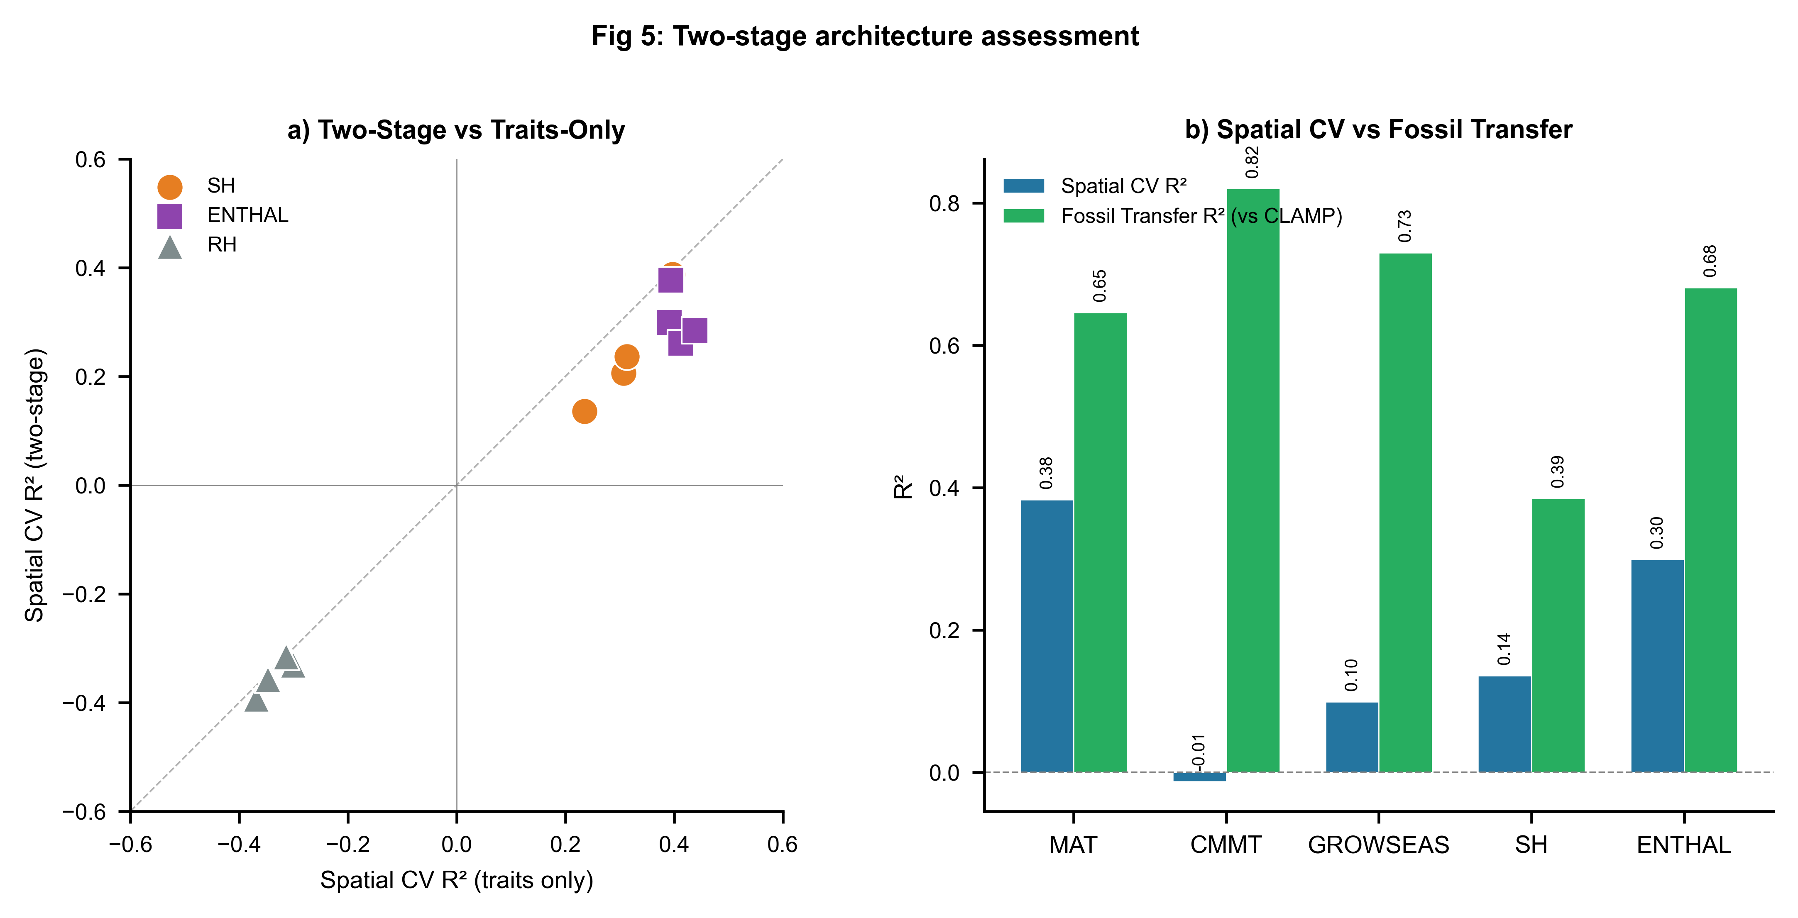
Figure 5. Two-stage architecture and reconstructability summary. (a) Space-block R² of traits-only vs. two-stage models for moisture–energy variables; points below the identity line indicate two-stage degradation. (b) Space-block R² vs. fossil transfer R² (against CLAMP) for five climate variables, illustrating the gap between spatial validation and fossil transfer dominated by Asian assemblages.

4 Discussion

4.1 A quantitative extension of regional-calibration logic
Our results provide a quantitative extension of CLAMP's regional-calibration tradition. The space-block and LOCO frameworks make explicit what CLAMP practitioners have long understood qualitatively: leaf-physiognomy calibrations are not globally portable. They reveal the spatial grain at which trait–climate relationships break down and attach numerical uncertainties to the reconstruction of each climate variable as a function of geographic distance from the calibration domain. For MAT, the drop from within-domain fossil transfer (R² = 0.65) to cross-block space-block validation (R² = 0.38) quantifies a generalisability penalty of approximately 0.27 in R² that should inform the interpretation of predictions for fossil sites in poorly sampled regions. For CMMT, the penalty is far larger (0.82 → −0.013), indicating that this variable's apparent fossil transfer success is almost entirely a product of the Asian dominance of the fossil dataset.

4.2 Implications for Tibetan Plateau paleoelevation studies
The Tibetan Plateau has been a focal point for leaf-physiognomy paleoclimate reconstruction because its uplift history is coupled to Cenozoic climate evolution and the Asian monsoon system (Spicer et al., 2021; Ding et al., 2022; He et al., 2022). Recent work has demonstrated that eastern Tibet rose to near-modern elevations by ~39 Ma, driving distinctive Eocene monsoon precipitation patterns (He et al., 2022). Our space-block validation results support the use of leaf physiognomy for paleoelevation reconstruction but carry an important caveat: the robust cross-region performance of MAT and ENTHAL indicates that elevation inferences based on these variables are well supported, while the spatial collapse of CMMT suggests that cold-month temperature reconstructions for Tibetan fossil sites are reliable only when calibration and fossil sites share the same floristic domain. The LOCO results further indicate that extrapolating East Asian calibrations to fossil floras outside Asia—as might be attempted for other orogenic belts (e.g., the Andes, the Alps)—is unlikely to yield reliable estimates without locally dense calibration networks.

4.3 Linearity of the cross-region trait–climate signal
The finding that ensemble ML methods do not outperform linear baselines under space-block validation reflects a property of the data rather than a failure of ML. The cross-region component of the trait–climate signal appears approximately linear. Non-linear models may capture complex within-region structure—ecological sorting along local gradients, for instance—that does not generalise across floristic provinces with different evolutionary histories. For paleoclimate reconstruction, where the explicit goal is to extrapolate from modern calibration sites to fossil sites separated in space and time, this finding has practical value: linear or Ridge regression, with interpretable coefficients and well-characterised uncertainty propagation, are likely to be more trustworthy tools for cross-region inference than ensemble methods whose apparent advantages may reflect within-region overfitting (Meyer et al., 2019; Ploton et al., 2020).

4.4 Why the two-stage cascade does not transfer across space
The failure of the two-stage cascade under space-block validation carries a broader lesson about physical models in spatial prediction. The relationship linking temperature to saturation vapour pressure is physically rigorous at the local scale. However, when temperature is estimated with spatially structured error, the downstream moisture prediction absorbs and amplifies this error. The observation that traits-only models outperform two-stage architectures for moisture variables suggests that leaf traits encode moisture information independently of the temperature→moisture cascade, likely through direct physiological responses to atmospheric and soil water availability (Peppe et al., 2011; Wright et al., 2017). For practical application, we suggest that moisture–energy variables be reconstructed directly from traits when fossil sites lie in geographic domains poorly represented in calibration data, and that two-stage schemes be reserved for within-domain applications where temperature estimates carry lower spatial bias.

4.5 Limitations
Several limitations constrain our conclusions. First, the calibration dataset is geographically imbalanced, with Europe (25 sites) and Africa (14 sites) severely under-sampled. The catastrophic LOCO failure for Europe likely reflects this imbalance; meaningful calibration for Europe would require substantially expanding the modern sampling network. Second, the fossil validation targets are CLAMP-computed values, not independent instrumental observations, and systematic biases in CLAMP estimates will propagate to our fossil transfer metrics. Independent validation against non-physiognomic proxies (e.g., stable isotopes, GDGTs, palynology) at key fossil sites—particularly on the Tibetan Plateau (Miao et al., 2022; Liang et al., 2025)—would strengthen the fossil transfer assessment. Third, our 31-trait protocol captures only a subset of leaf morphological variation; additional traits such as venation density, stomatal indices, or leaf mass per area could improve spatial generalisability (Lowe et al., 2024). Fourth, the 5 × 4 grid partitioning is one of many possible schemes, and sensitivity to block resolution warrants further investigation. Finally, an irreducible uncertainty remains in whether trait–climate calibrations derived from modern vegetation apply to fossil floras separated by tens of millions of years of evolution (Spicer et al., 2021; Chen et al., 2025).

5 Conclusions
We have presented a systematic, quantitative assessment of leaf-physiognomy climate reconstruction under honest geographic partitioning. Building on the CLAMP regional-calibration tradition, we show that the cross-region reconstructability of climate variables from leaf traits follows a well-defined hierarchy: MAT and ENTHAL are robustly recoverable across geographic blocks (space-block R² ≈ 0.3–0.4); SH, GROWSEAS, and CMMT are recoverable only within densely calibrated domains; and WMMT and RH are not reliable as cross-region reconstruction targets. Ensemble machine learning methods do not improve on linear baselines under spatial partitioning—the cross-region signal is essentially linear—and the two-stage temperature→moisture cascade degrades rather than improves moisture–energy prediction when sites are partitioned by geography. Fossil transfer against CLAMP reference values for the predominantly Asian fossil dataset yields encouraging results for Tier 1 and Tier 2 variables but must be interpreted as within-domain interpolation, not cross-continent generalisation.
We recommend that future leaf-physiognomy paleoclimate studies: (i) report space-block validation metrics alongside conventional cross-validation to quantify the generalisability penalty; (ii) include linear baselines to benchmark the incremental value of non-linear methods; (iii) consult the three-tier reconstructability hierarchy when selecting reconstruction targets, particularly for fossil sites in regions distant from modern calibration networks; and (iv) expand modern calibration sampling in under-sampled regions, especially Europe and Africa, to extend the geographic domain of reliable leaf-physiognomy climate reconstruction.

Data availability
The modern calibration dataset and fossil assemblage data are available in the accompanying Excel workbook. All training code, the space-block validation pipeline, figure generation scripts, trained model files, and the manuscript source are archived on Zenodo [DOI to be created upon acceptance] and publicly available on GitHub at [repository URL]. The repository includes: (1) training_pipeline_v2.py, which reproduces all space-block validation results, baseline comparisons, LOCO validation, and fossil transfer evaluation; (2) generate_figures_v2.py, which produces all five publication figures; (3) the models_v2/ directory containing trained model files; and (4) the output/ directory containing all tabulated results (Tables 1–5). Analyses were performed in Python 3.10 using scikit-learn 1.3, XGBoost 2.0, and associated scientific Python libraries. Climate data were obtained from WorldClim 2 (Fick and Hijmans, 2017; https://www.worldclim.org/).

Author contributions
[To be completed by authors.]

Competing interests
The authors declare that they have no competing interests.

Acknowledgements
[To be completed by authors.]

References
Bailey, I. W. and Sinnott, E. W.: The climatic distribution of certain types of angiosperm leaves, Am. J. Bot., 3, 24–39, 1916.
Bhatia, H., Dar, R. A., and Srivastava, G.: Himalayan uplift and the evolution of a Mediterranean-type climate in the Kashmir Basin of India: Palaeobotanical evidence from the late Pliocene Dubjan Member (Karewa Group), Palaeogeogr. Palaeoclimatol. Palaeoecol., 672, 112547, https://doi.org/10.1016/j.palaeo.2025.112547, 2025.
Chen, W.-Y., Su, T., and Li, S.-F.: The leaf physiognomy of evergreen and deciduous species exhibits different responses to climate: Implications for palaeoclimate reconstruction in China, Palaeogeogr. Palaeoclimatol. Palaeoecol., 660, 112683, https://doi.org/10.1016/j.palaeo.2024.112683, 2025.
Ding, L., Kapp, P., Cai, F., Garzione, C. N., Xiong, Z., Wang, H., and Wang, C.: Timing and mechanisms of Tibetan Plateau uplift, Nat. Rev. Earth Environ., 3, 652–667, https://doi.org/10.1038/s43017-022-00318-4, 2022.
Fick, S. E. and Hijmans, R. J.: WorldClim 2: new 1-km spatial resolution climate surfaces for global land areas, Int. J. Climatol., 37, 4302–4315, https://doi.org/10.1002/joc.5086, 2017.
Gregory-Wodzicki, K. M.: Relationships between leaf morphology and climate, Bolivia: implications for estimating paleoclimate from fossil floras, Paleobiology, 26, 668–688, 2000.
He, S., Ding, L., Xiong, Z., Spicer, R. A., Farnsworth, A., Valdes, P. J., Wang, C., Cai, F., Wang, H., Sun, Y., Zeng, D., Xie, J., Yue, Y., Zhao, C., Song, P., and Wu, C.: A distinctive Eocene Asian monsoon and modern biodiversity resulted from the rise of eastern Tibet, Sci. Bull., 67, 2245–2258, https://doi.org/10.1016/j.scib.2022.10.006, 2022.
Liang, Y., Quan, C., Liu, Z., Li, X., Utescher, T., and Liu, Y.-S.: Terrestrial temperature history reveals Late Miocene rapid uplift of the northern Tibetan Plateau, Sci. Adv., 11, eadq5626, https://doi.org/10.1126/sciadv.adq5626, 2025.
Lowe, A. J., Flynn, A. G., Butrim, M. J., Baumgartner, A., Royer, D. L., and Peppe, D. J.: Reconstructing terrestrial paleoclimate and paleoecology with fossil leaves using digital leaf physiognomy and leaf mass per area, J. Vis. Exp., 212, e66838, https://doi.org/10.3791/66838, 2024.
Meyer, H., Reudenbach, C., Wöllauer, S., and Nauss, T.: Importance of spatial predictor variable selection in machine learning applications—Moving from data reproduction to spatial prediction, Ecol. Model., 411, 108815, https://doi.org/10.1016/j.ecolmodel.2019.108815, 2019.
Miao, Y., Fang, X., Sun, J., Xiao, W., Yang, Y., Wang, X., Farnsworth, A., Huang, K., Ren, Y., Wu, F., Qiao, J., Zhang, W., Meng, Q., Yan, X., Zheng, Z., Song, C., and Utescher, T.: A new biologic paleoaltimetry indicating Late Miocene rapid uplift of northern Tibet Plateau, Science, 378, 1074–1079, https://doi.org/10.1126/science.abo2475, 2022.
Peppe, D. J., Royer, D. L., Cariglino, B., Oliver, S. Y., Newman, S., Leight, E., Enikolopov, G., Fernandez-Burgos, M., Herrera, F., Adams, J. M., Correa, E., Currano, E. D., Erickson, J. M., Hinojosa, L. F., Hoganson, J. W., Iglesias, A., Jaramillo, C. A., Johnson, K. R., Jordan, G. J., Kraft, N. J. B., Lovelock, E. C., Lusk, C. H., Niinemets, Ü., Peñuelas, J., Rapson, G., Wing, S. L., and Wright, I. J.: Sensitivity of leaf size and shape to climate: global patterns and paleoclimatic applications, New Phytol., 190, 724–739, https://doi.org/10.1111/j.1469-8137.2010.03615.x, 2011.
Ploton, P., Mortier, F., Réjou-Méchain, M., Barbier, N., Picard, N., Rossi, V., Dormann, C., Cornu, G., Viennois, G., Bayol, N., Lyapustin, A., Gourlet-Fleury, S., and Pélissier, R.: Spatial validation reveals poor predictive performance of large-scale ecological mapping models, Nat. Commun., 11, 4540, https://doi.org/10.1038/s41467-020-18321-y, 2020.
Roberts, D. R., Bahn, V., Ciuti, S., Boyce, M. S., Elith, J., Guillera-Arroita, G., Hauenstein, S., Lahoz-Monfort, J. J., Schröder, B., Thuiller, W., Warton, D. I., Wintle, B. A., Hartig, F., and Dormann, C. F.: Cross-validation strategies for data with temporal, spatial, hierarchical, or phylogenetic structure, Ecography, 40, 913–929, https://doi.org/10.1111/ecog.02881, 2017.
Royer, D. L., Wilf, P., Janesko, D. A., Kowalski, E. A., and Dilcher, D. L.: Correlations of climate and plant ecology to leaf size and shape: potential proxies for the fossil record, Am. J. Bot., 92, 1141–1151, https://doi.org/10.3732/ajb.92.7.1141, 2005.
Spicer, R. A.: CLAMP, in: Encyclopedia of Paleoclimatology and Ancient Environments, edited by Gornitz, V., Springer, Dordrecht, 175–178, 2009.
Spicer, R. A., Su, T., Valdes, P. J., Farnsworth, A., Wu, F.-X., Shi, G., Spicer, T. E. V., and Zhou, Z.-K.: Why 'the uplift of the Tibetan Plateau' is a myth, Natl. Sci. Rev., 8, nwaa091, https://doi.org/10.1093/nsr/nwaa091, 2021.
Spicer, R. A., Valdes, P. J., Hughes, A., Yang, J., Spicer, T. E. V., Herman, A., and Farnsworth, A.: New insights into the thermal regime and hydrodynamics of the early Late Cretaceous Arctic, Geol. Mag., 157, 1729–1746, https://doi.org/10.1017/S0016756819000465, 2020.
Su, T., Spicer, R. A., Li, S.-H., Xu, H., Huang, J., Sherlock, S., Huang, Y.-J., Li, S.-F., Wang, L., Jia, L.-B., Deng, W.-Y.-D., Liu, J., Deng, C.-L., Zhang, S.-T., Valdes, P. J., and Zhou, Z.-K.: Uplift, climate and biotic changes at the Eocene–Oligocene transition in south-eastern Tibet, Natl. Sci. Rev., 6, 495–504, https://doi.org/10.1093/nsr/nwy062, 2019.
Wilf, P.: When are leaves good thermometers? A new case for leaf margin analysis, Paleobiology, 23, 373–390, 1997.
Wolfe, J. A.: Tertiary climatic fluctuations and methods of analysis of Tertiary floras, Palaeogeogr. Palaeoclimatol. Palaeoecol., 9, 27–57, 1971.
Wolfe, J. A.: Temperature parameters of humid to mesic forests of eastern Asia and relation to forests of other regions of the Northern Hemisphere and Australasia, US Geol. Surv. Prof. Pap., 1106, 1–37, 1979.
Wolfe, J. A.: A method of obtaining climatic parameters from leaf assemblages, US Geol. Surv. Bull., 2040, 1–71, 1993.
Wright, I. J., Dong, N., Maire, V., Prentice, I. C., Westoby, M., Díaz, S., Gallagher, R. V., Jacobs, B. F., Kooyman, R., Law, E. A., Leishman, M. R., Niinemets, Ü., Reich, P. B., Sack, L., Villar, R., Wang, H., and Wilf, P.: Global climatic drivers of leaf size, Science, 357, 917–921, https://doi.org/10.1126/science.aal4760, 2017.
Yang, J., Spicer, R. A., Spicer, T. E. V., Arens, N. C., Jacques, F. M. B., Su, T., Kennedy, E. M., Herman, A. B., Steart, D. C., Srivastava, G., Mehrotra, R. C., Valdes, P. J., Mehrotra, N. C., Zhou, Z.-K., and Lai, J.-S.: Leaf form–climate relationships on the global stage: an ensemble of characters, Palaeogeogr. Palaeoclimatol. Palaeoecol., 435, 159–169, https://doi.org/10.1016/j.palaeo.2015.06.013, 2015.

Tables

Table 1. Summary of model performance under space-block validation, baseline comparison, and fossil transfer.
Space-block validation metrics are from block-based GroupKFold (10 folds). Best baseline is the top-performing linear model for each variable. Two-stage ΔR² is the change from traits-only to two-stage architecture (moisture–energy variables only). Fossil metrics are R², RMSE, and mean bias vs. CLAMP reference values (N = 71 assemblages).
Variable | Category | Space-block  R² (RF) | Space-block  RMSE | Best  baseline | Baseline  R² | Two-stage  ΔR² | Fossil  R² | Fossil  RMSE
MAT | Temperature | 0.383 | 3.82 | OLS | 0.343 | — | 0.646 | 2.74
WMMT | Temperature | −0.321 | 3.71 | ElasticNet | −0.284 | — | −1.056 | 2.91
CMMT | Temperature | −0.013 | 6.02 | PLS | −0.238 | — | 0.820 | 2.79
GROWSEAS | Temperature | 0.099 | 1.78 | OLS | 0.138 | — | 0.730 | 1.01
RH | Moist.–Energy | −0.331 | 9.55 | ElasticNet | −0.720 | −0.030 | −0.080 | 18.94
SH | Moist.–Energy | 0.136 | 1.99 | ElasticNet | 0.060 | −0.099 | 0.385 | 2.95
ENTHAL | Moist.–Energy | 0.299 | 11.11 | OLS | 0.306 | −0.092 | 0.681 | 9.68

Table 2. Leave-One-Continent-Out (LOCO) validation results (Random Forest).
R² values for each variable–continent combination. N is the number of held-out sites per continent.
Variable | Continent | N sites | R²
MAT | Africa | 14 | 0.231
MAT | Americas | 143 | 0.448
MAT | Asia | 158 | 0.408
MAT | Europe | 25 | −1.035
MAT | Oceania | 53 | 0.323
CMMT | Africa | 14 | 0.254
CMMT | Americas | 143 | 0.496
CMMT | Asia | 158 | 0.099
CMMT | Europe | 25 | −1.430
CMMT | Oceania | 53 | 0.310
GROWSEAS | Africa | 14 | −0.338
GROWSEAS | Americas | 143 | 0.505
GROWSEAS | Asia | 158 | 0.549
GROWSEAS | Europe | 25 | −0.213
GROWSEAS | Oceania | 53 | 0.219
RH | Africa | 14 | 0.131
RH | Americas | 143 | −1.269
RH | Asia | 158 | −0.313
RH | Europe | 25 | −11.995
RH | Oceania | 53 | −0.425
SH | Africa | 14 | 0.358
SH | Americas | 143 | 0.443
SH | Asia | 158 | 0.479
SH | Europe | 25 | −0.493
SH | Oceania | 53 | 0.508
ENTHAL | Africa | 14 | 0.530
ENTHAL | Americas | 143 | 0.442
ENTHAL | Asia | 158 | 0.536
ENTHAL | Europe | 25 | −0.641
ENTHAL | Oceania | 53 | 0.556
WMMT | Africa | 14 | −0.161
WMMT | Americas | 143 | −0.105
WMMT | Asia | 158 | −0.344
WMMT | Europe | 25 | −0.767
WMMT | Oceania | 53 | 0.071

