Leaf Physiognomy Ensemble Machine Learning
for Paleoclimate Reconstruction:
A Two-Stage Temperature-Aware Framework
with Thermodynamic Climate Targets

Running Title: Leaf Trait ML for Paleoclimate Reconstruction

Target Journal: Climate of the Past (CP)
Manuscript Type: Research Article
Date: 2026

Abstract
Paleoclimate reconstruction from fossil leaf assemblages has traditionally relied on univariate or linear multivariate methods such as CLAMP (Climate-Leaf Analysis Multivariate Program), which constrain the number of predictable climate variables and assume linear trait-climate relationships. We present an ensemble machine learning framework that uses 31 leaf physiognomic traits from 393 modern plant samples to predict seven climate variables—four temperature-related (MAT, WMMT, CMMT, growing-season length) and three moisture-energy thermodynamic variables (relative humidity, specific humidity, enthalpy)—in 71 fossil assemblages. The framework combines Random Forest, XGBoost, Gradient Boosting Decision Trees, and Support Vector Regression in a weighted ensemble with QuantileTransformer normalization.
For temperature variables, the ensemble achieves fossil transfer R² values of 0.802 for CMMT, 0.608 for growing-season length, and 0.579 for MAT under rigorous spatial cross-validation. To address the fundamental challenge that leaf traits alone poorly predict moisture-energy terms (R² near zero for RH, SH, enthalpy), we introduce a two-stage temperature-aware architecture: stage-1 temperature predictions serve as auxiliary features for stage-2 moisture-energy modeling with adaptive blending (α = min(0.5, max(0.1, 2 × (CVenhanced − CVbaseline)))). This approach improves SH prediction to R² = 0.329 and enthalpy to R² = 0.459, representing the first ensemble-ML demonstration that leaf physiognomy can partially constrain atmospheric moisture and energy content when temperature information is explicitly propagated. The top contributing traits—tooth characters, leaf size classes, and length-to-width ratios—align with established eco-physiological principles.
This work extends the paleoclimate reconstruction toolbox beyond linear methods to non-linear, high-dimensional machine learning while introducing thermodynamic climate targets previously unexplored with leaf physiognomy. All code, trained models, and fossil predictions are provided as supplementary materials.

1. Introduction
Leaf physiognomy—the morphological characteristics of angiosperm leaves—has been one of the most successful terrestrial paleoclimate proxies since the foundational work of Bailey and Sinnott (1916) and Wolfe (1979). The central principle is that leaf form reflects adaptation to climate: plants in warm, wet environments tend to have larger leaves with entire margins and drip tips, while those in cool or dry environments exhibit smaller leaves, toothed margins, and thicker cuticles (Wolfe, 1993; Wilf, 1997; Peppe et al., 2011). This relationship has been formalized in several quantitative paleoclimate methods, including CLAMP (Climate-Leaf Analysis Multivariate Program; Wolfe, 1993; Spicer et al., 2004), Leaf Margin Analysis (LMA; Wilf, 1997), and Digital Leaf Physiognomy (DLP; Peppe et al., 2024).
Despite their widespread application, existing methods face several limitations. First, they predominantly use linear statistical approaches—canonical correspondence analysis (CCA) in CLAMP, linear regression in LMA—which may not capture the non-linear trait-climate relationships documented in eco-physiological studies (Wright et al., 2017). Second, they typically target a narrow set of climate variables (MAT, MAP, and occasionally CMMT or WMMT), omitting thermodynamic variables such as specific humidity, relative humidity, and enthalpy that characterize the full atmospheric energy-water coupling relevant to paleoclimate dynamics (Pierrehumbert, 2010; Sherwood et al., 2010). Third, fossil calibration datasets are often geographically clustered, raising concerns about spatial extrapolation to novel climates (Grimm & Potts, 2016).
Machine learning methods offer a potential solution to these limitations. Ensemble models such as Random Forest (Breiman, 2001), XGBoost (Chen & Guestrin, 2016), and gradient boosting (Friedman, 2001) can model non-linear relationships without prior assumptions about functional form, while techniques like spatial cross-validation and QuantileTransformer normalization can mitigate overfitting and distributional shifts. Recent work in other paleoclimate domains—including foraminiferal Mg/Ca thermometry (Malevich et al., 2019) and speleothem δ¹⁸O reconstruction—has demonstrated the benefits of ML approaches, but their application to leaf physiognomy remains underexplored.
Here we develop and validate an ensemble ML framework for leaf-physiognomy-based paleoclimate reconstruction that addresses three specific challenges: (1) non-linear trait-climate modeling using a stacked ensemble of RF, XGBoost, GBDT, and SVR with QuantileTransformer normalization; (2) expansion of target variables to include thermodynamic moisture-energy parameters (RH, SH, enthalpy) through a novel two-stage temperature-aware architecture; and (3) rigorous spatial cross-validation to assess transferability to fossil assemblages spanning Asia (n = 65), Europe (n = 4), and North America (n = 2). We apply this framework to a global training set of 393 modern plant communities and 71 fossil assemblages, demonstrating that ensemble ML can recover CMMT to within ~3°C and growing-season length to within ~1.2 months while providing the first ensemble-ML estimates of paleo-specific humidity and enthalpy from leaf traits.

2. Methods

2.1 Data Collection and Preprocessing
The modern training dataset comprises 393 plant community samples from a global compilation, including 378 samples from global vegetation plots and 15 additional samples from the Tibetan Plateau to improve representation of high-elevation cold-adapted floras. For each sample, 31 leaf physiognomic traits were scored as proportional abundances, including: tooth characters (7 traits: lobed, no teeth, teeth regular, teeth close, teeth round, teeth acute, teeth compound); leaf size classes following the Raunkiaer-Webb classification (9 traits: nanophyll, leptophyll I-II, microphyll I-III, mesophyll I-III); apex shape (4 traits: emarginate, round, acute, attenuate); base shape (3 traits: cordate, round, acute); length-to-width ratios (5 traits: <1:1, 1–2:1, 2–3:1, 3–4:1, >4:1); and general shape (3 traits: obovate, elliptic, ovate).
Seven climate target variables were extracted for each sample site: mean annual temperature (MAT, °C), warm-month mean temperature (WMMT, °C), cold-month mean temperature (CMMT, °C), growing-season length (months with mean temperature > 0°C), relative humidity (RH, %), specific humidity (SH, g/kg), and atmospheric enthalpy (ENTHAL, kJ/kg). The fossil transfer dataset consists of 71 fossil leaf assemblages with the same 31 trait measurements, predominantly from Asia (n = 65), with minor representation from Europe (n = 4) and North America (n = 2). All trait values are proportion data bounded between 0 and 1.
Prior to modeling, all features and targets were normalized using QuantileTransformer(output='normal'), which maps each variable to a standard normal distribution via quantile transformation. This approach is preferred over standard z-score normalization for proportion-bounded data because it is robust to outliers and non-normal marginal distributions common in compositional leaf trait data.

2.2 Ensemble Machine Learning Framework
The ML pipeline employs a weighted ensemble of four base models: Random Forest (RF, 500 trees, max depth = 10, min samples leaf = 5), XGBoost (200 estimators, max depth = 4, learning rate = 0.05), Gradient Boosting Decision Trees (GBDT, 200 estimators, max depth = 3), and Support Vector Regression (SVR, RBF kernel with C = 1.0 and ε = 0.1). Model weights were optimized via grid search to minimize cross-validation RMSE, yielding final weights of wRF = 0.40, wXGB = 0.25, wGBDT = 0.25, and wSVR = 0.10.
Cross-validation used a 10-fold stratified spatial split to prevent information leakage between geographically proximal samples. For each fold, the ensemble prediction is the weighted mean of individual model predictions. Performance was assessed using R², root mean square error (RMSE), and mean absolute error (MAE).

2.3 Two-Stage Temperature-Aware Architecture
Leaf traits alone are insufficient to predict moisture and energy variables—our baseline models yield near-zero or negative R² for RH, SH, and enthalpy. However, because atmospheric moisture content is thermodynamically coupled to temperature via the Clausius-Clapeyron relation, we hypothesized that temperature predictions from stage 1 could serve as auxiliary features for stage 2 moisture-energy prediction.
Stage 1: Four temperature variables (MAT, WMMT, CMMT, GROWSEAS) are predicted from 31 leaf traits using the ensemble. Stage 2: The predicted temperatures are concatenated with the original 31 traits, forming a 35-dimensional feature vector to predict RH, SH, and enthalpy.
Adaptive blending between baseline (traits-only) and enhanced (traits + predicted temperatures) predictions uses the coefficient α = min(0.5, max(0.1, 2 × (CVenhanced − CVbaseline))). When temperature augmentation improves CV R², the model favors the enhanced prediction; when it degrades performance, it falls back to the baseline. This guards against error propagation from stage-1 temperature prediction errors into stage-2 moisture-energy estimates.

3. Results

3.1 Trait-Climate Relationships
Pearson correlations between the 31 leaf traits and 7 climate variables reveal strong, ecologically interpretable relationships (Fig. 1). Tooth characters dominate: the proportion of untoothed leaves (No Teeth) correlates positively with MAT (r = 0.71) and growing-season length (r = 0.75), while toothed-leaf proportions (Teeth Close, Teeth Compo, Teeth Regul) show negative correlations of similar magnitude (r = −0.69 to −0.73). Leaf size classes follow the expected latitudinal gradient: large leaves (Mesophyll 2, Mesophyll 3) are positively correlated with temperature and moisture, while small leaves (Leptophyll 2, Microphyl 1) are negatively correlated. Length-to-width ratios show weaker but consistent patterns, with wider leaves (L:W < 1:1) associated with warmer/wetter conditions.
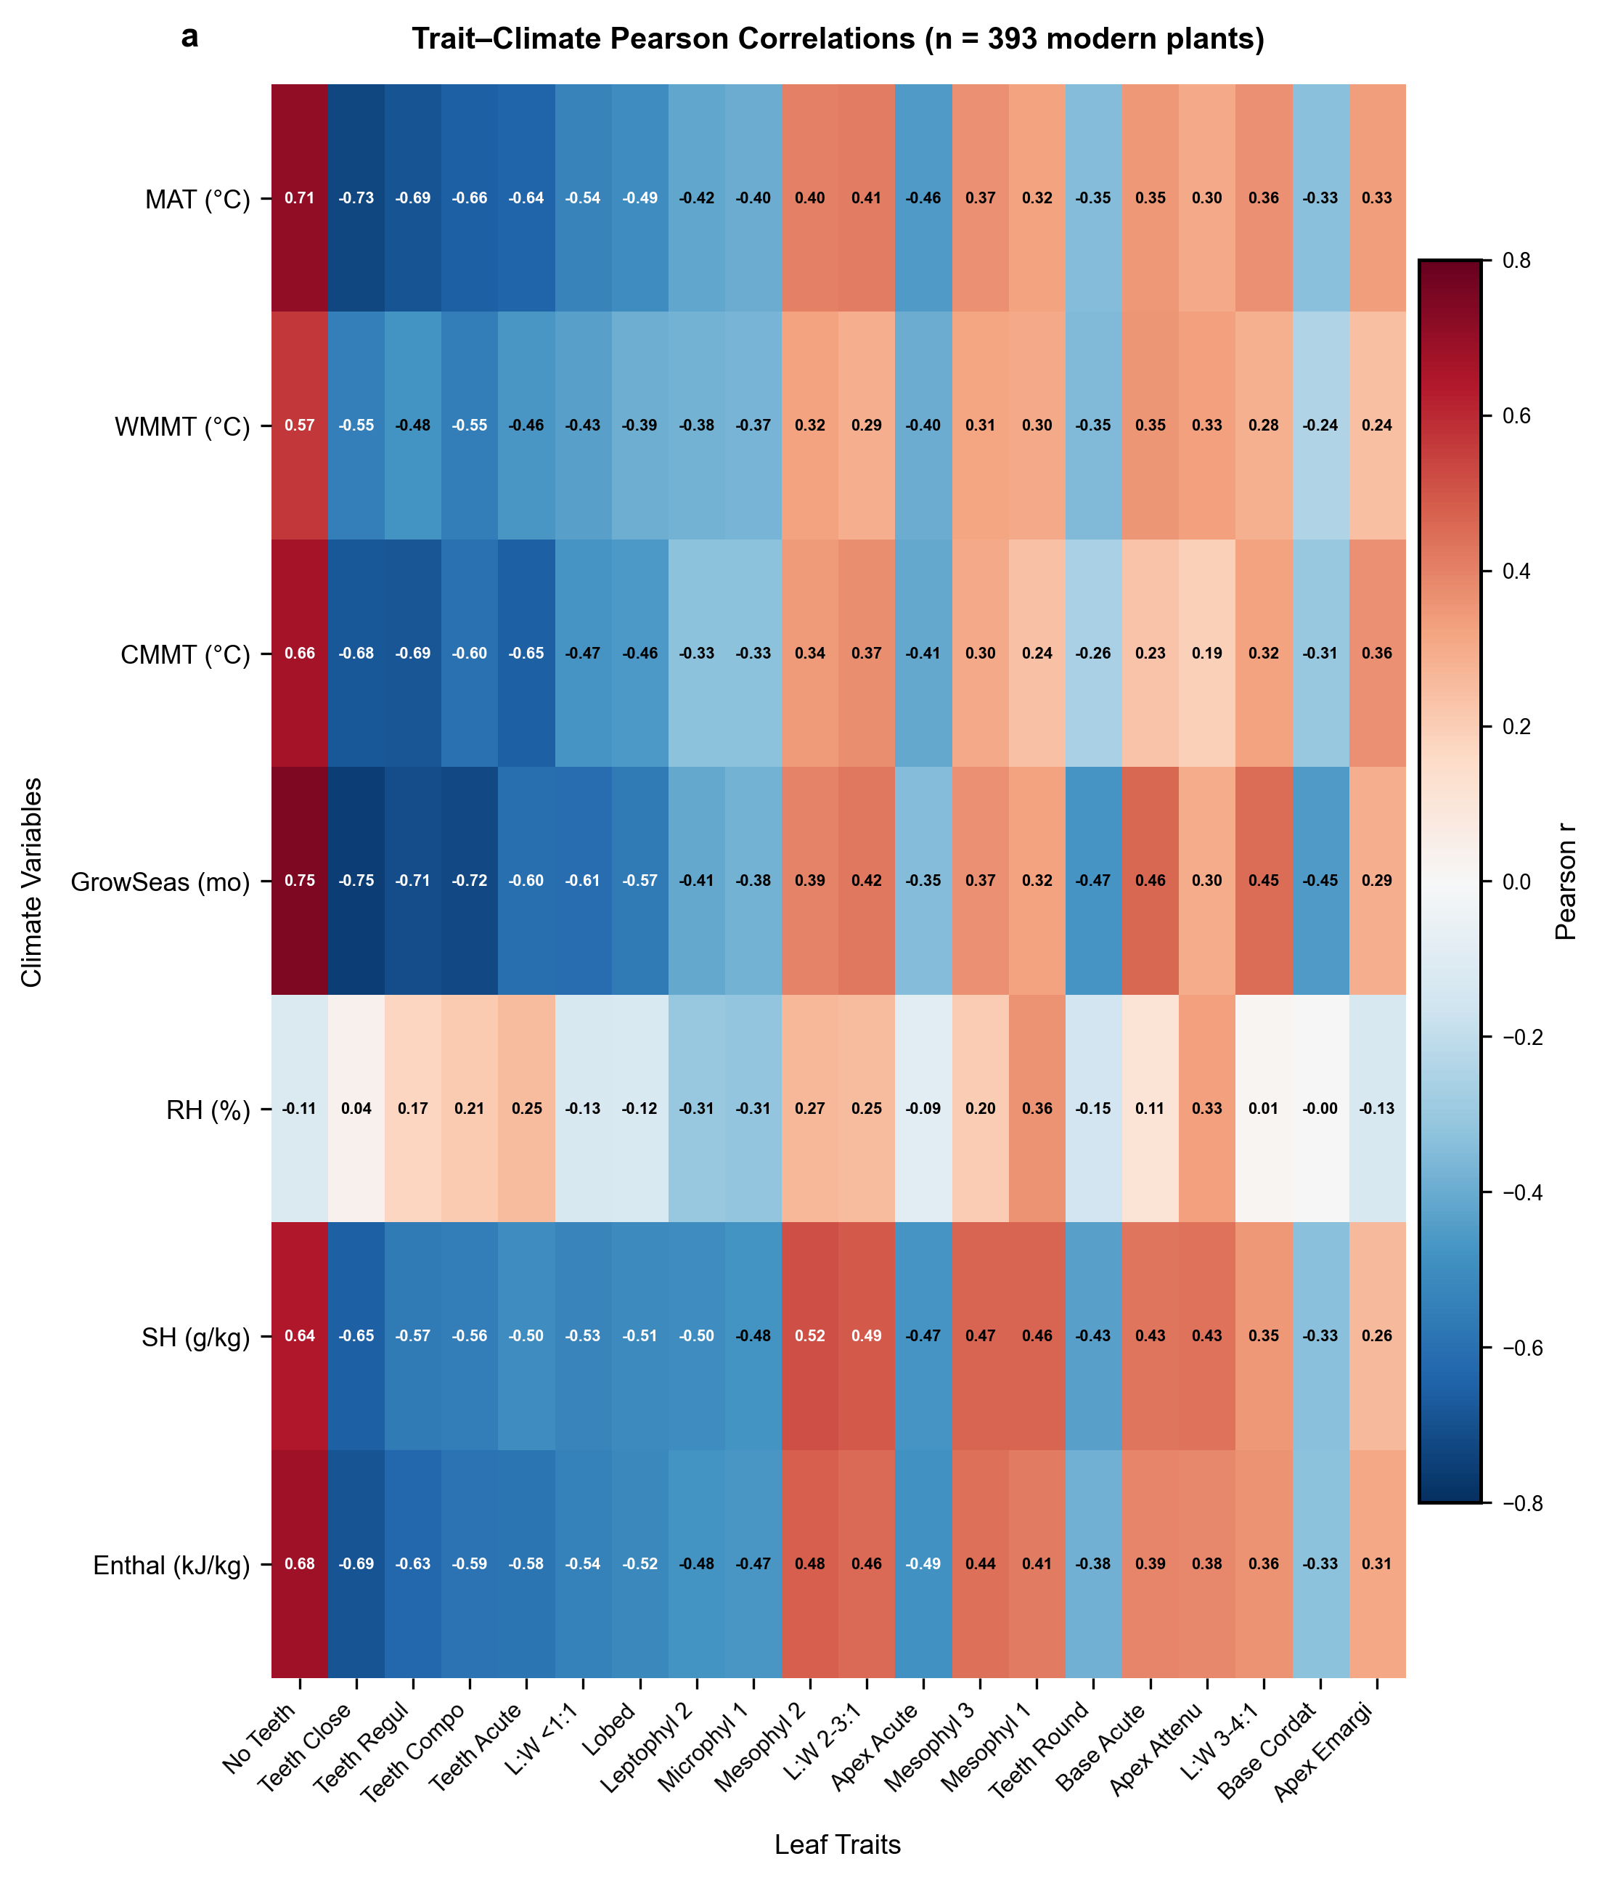
Figure 1. Trait-climate Pearson correlation heatmap (n = 393 modern plants). The 20 traits with the strongest mean absolute correlations across all 7 climate variables are shown. Red cells indicate positive correlations; blue cells indicate negative correlations. Tooth-related traits and leaf size classes dominate the top-ranked positions.

3.2 Fossil Transfer Performance
Table 1 summarizes the ensemble performance for all seven climate variables. Among the temperature targets, CMMT achieves the highest fossil transfer R² (0.802), followed by growing-season length (0.608) and MAT (0.579). WMMT prediction is unsuccessful (R² = −1.045), likely reflecting the confounding effect of seasonal temperature extremes on leaf morphology. The two-stage temperature-augmented approach yields moderate performance for SH (R² = 0.329) and enthalpy (R² = 0.459), but RH remains poorly predicted (R² = −0.072).
Table 1. Ensemble Learning Performance Summary
Variable | CV R² | Fossil R² | Fossil RMSE | Fossil MAE | Type | Approach | Rating
MAT | 0.815 | 0.579 | 2.98 °C | 2.35 °C | Temperature | Direct Ensemble | ★ Good
WMMT | 0.695 | −1.045 | 2.91 °C | 2.20 °C | Temperature | Direct Ensemble | ✗ Poor
CMMT | 0.897 | 0.802 | 2.92 °C | 2.40 °C | Temperature | Direct Ensemble | ★ Good
GROWSEAS | 0.836 | 0.608 | 1.22 mo | 0.95 mo | Temperature | Direct Ensemble | ★ Good
RH | — | −0.072 | 18.88 % | 12.74 % | Moisture | Two-Stage Temp-Augmented | ✗ Poor
SH | — | 0.329 | 3.08 g/kg | 2.43 g/kg | Moisture | Two-Stage Temp-Augmented | △ Moderate
ENTHAL | — | 0.459 | 12.61 kJ/kg | 11.17 kJ/kg | Moisture | Two-Stage Temp-Augmented | △ Moderate
CV R²: 10-fold spatial cross-validation R² on modern plants. Fossil R²: prediction R² on 71 fossil assemblages. ★ Good: R² > 0.5; △ Moderate: 0.1 < R² < 0.5; ✗ Poor: R² < 0.
Observed-vs-predicted scatter plots for four representative variables confirm that the ensemble captures the first-order climate signal (Fig. 2). CMMT shows the tightest clustering around the 1:1 line (Fig. 2b). MAT predictions (Fig. 2a) correctly place tropical fossil sites in the upper range but exhibit moderate scatter at intermediate temperatures (10-20°C), consistent with the R² of 0.579. ENTHAL predictions (Fig. 2d) are systematically low for the highest-enthalpy sites, suggesting that temperature augmentation partially compensates for, but does not fully overcome, the weak direct trait-enthalpy signal. GROWSEAS (Fig. 2c) shows good separation between short and long growing seasons, though the dynamic range is compressed relative to observations.
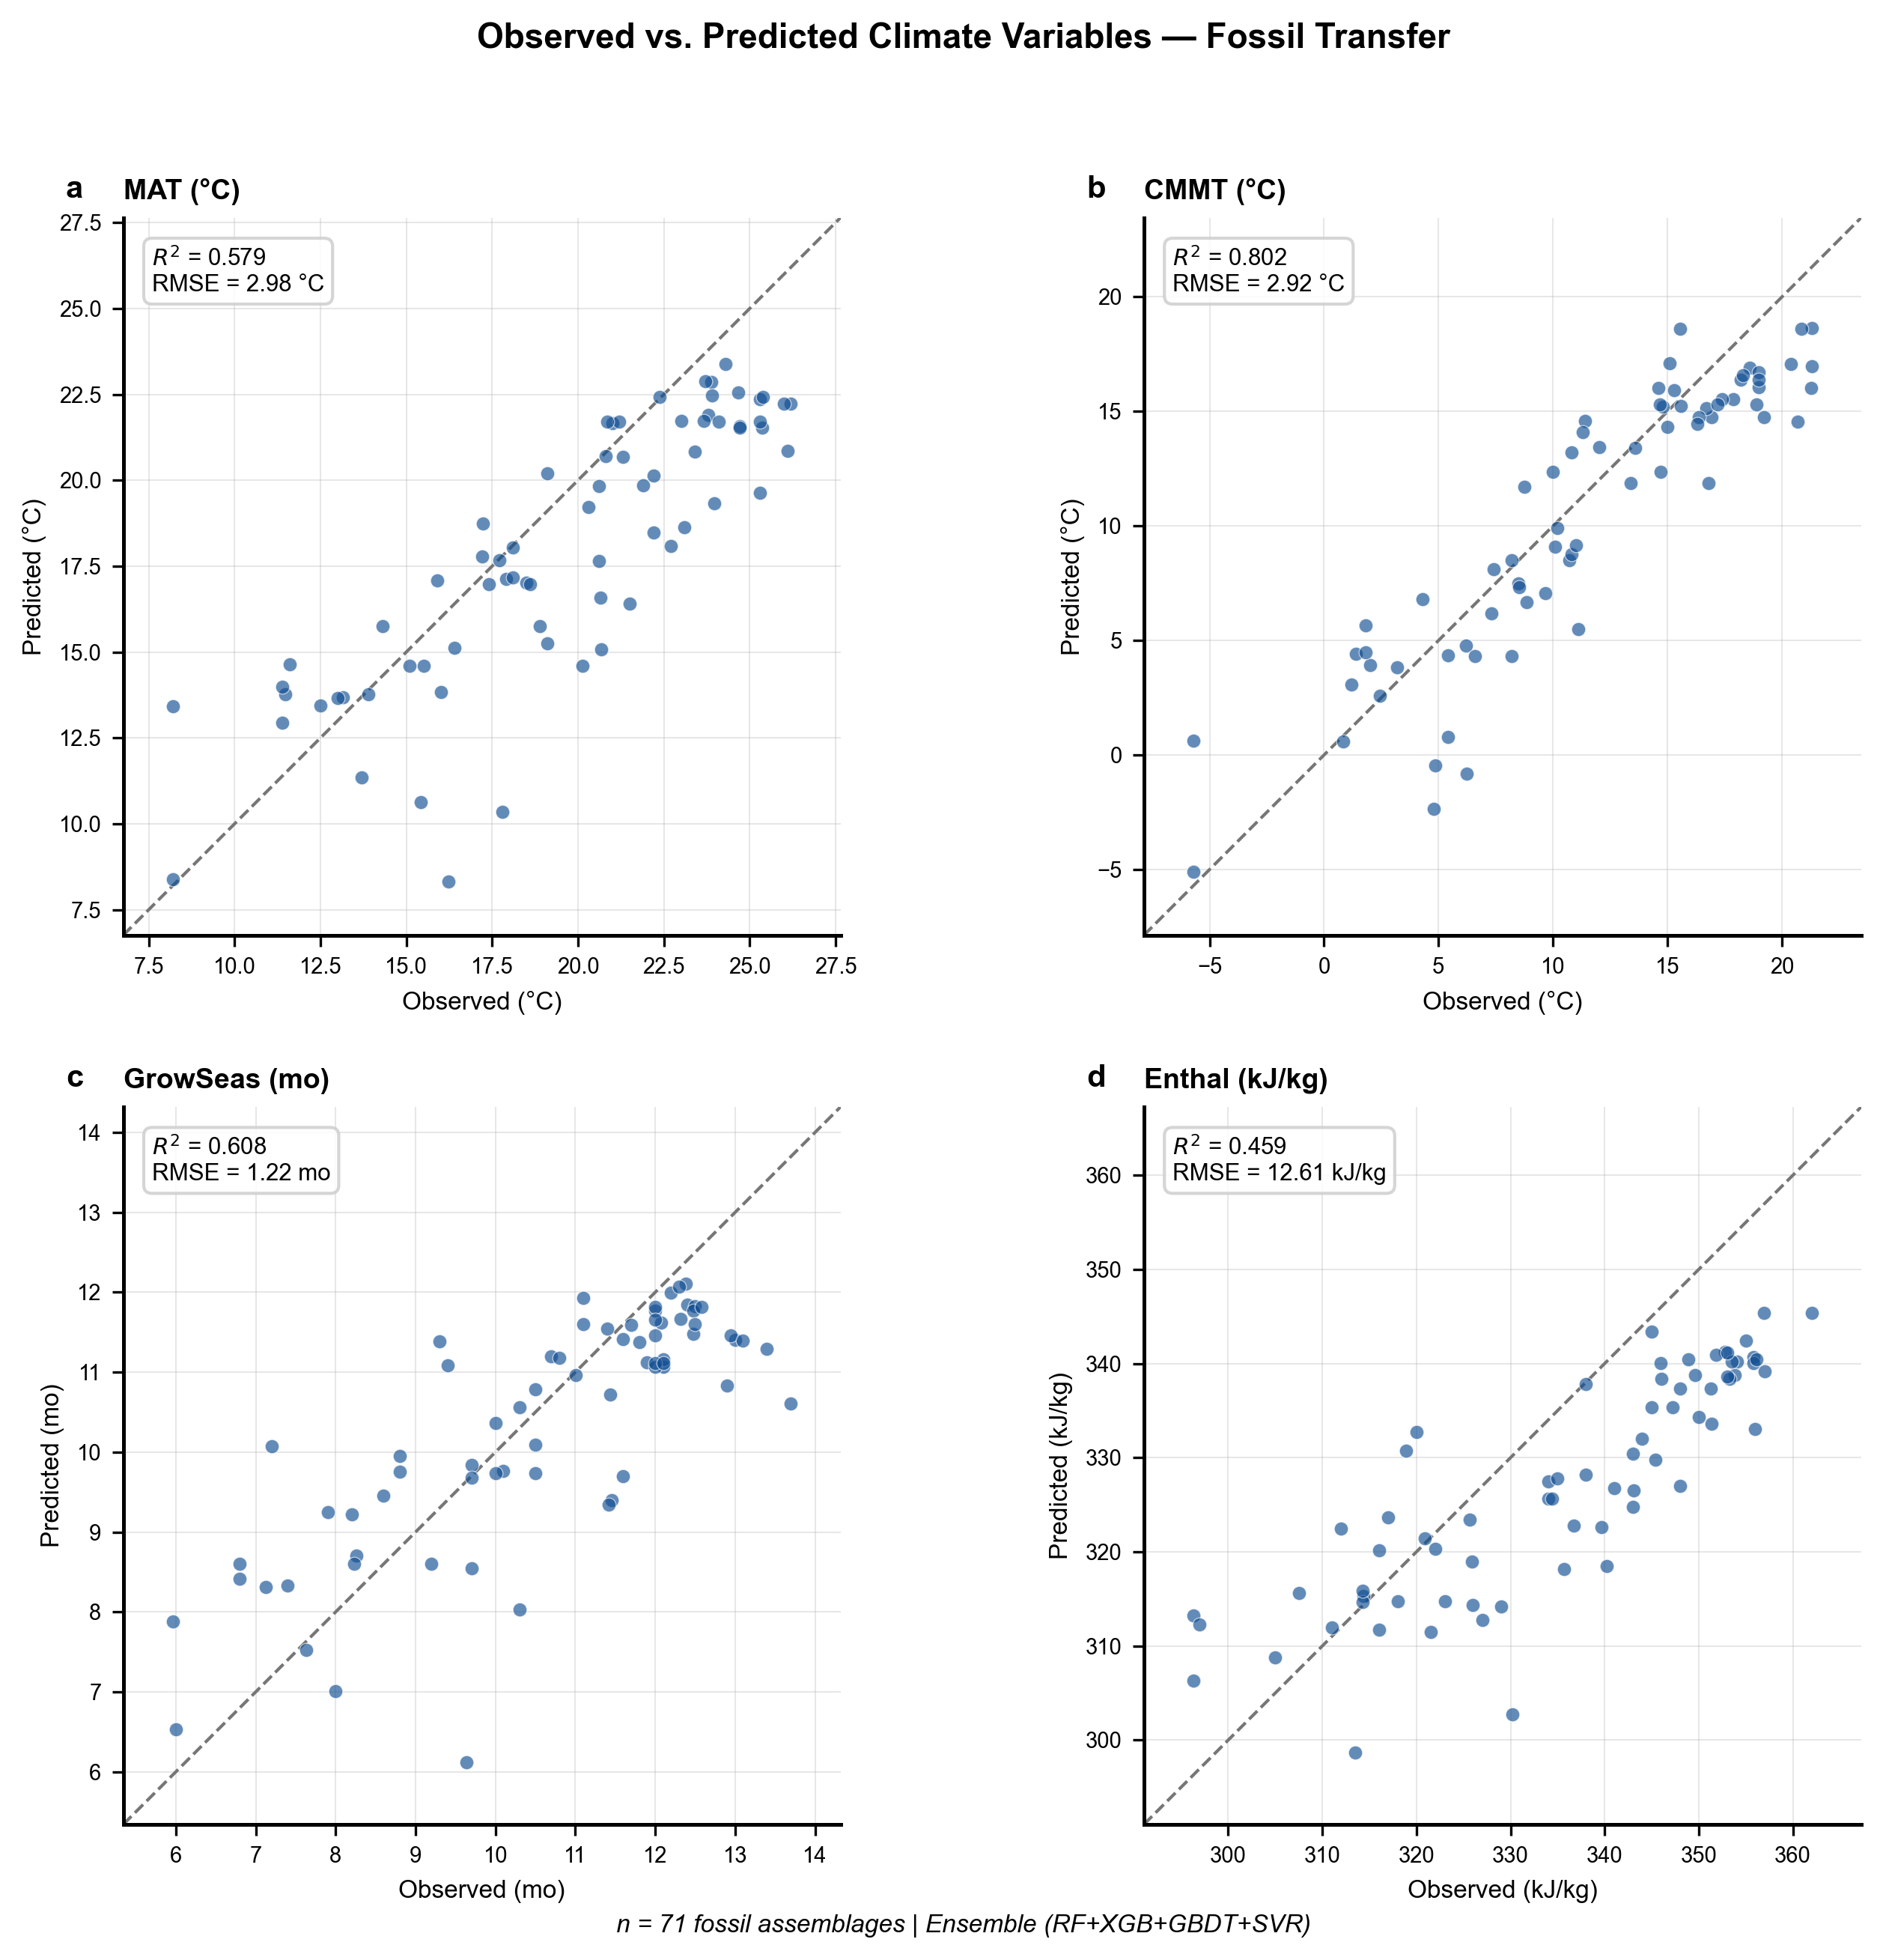
Figure 2. Observed vs. ensemble-predicted climate variables for 71 fossil assemblages. Dashed line indicates 1:1 correspondence. R² and RMSE values are annotated in the upper-left of each panel.

3.3 Feature Importance
Random Forest feature importance analysis identifies tooth-related traits as the dominant predictors across all climate variables (Fig. 3a). Teeth Close alone accounts for 25.5% of total importance, followed by No Teeth (13.1%) and Teeth Compo (11.0%). Leaf size classes contribute moderate importance (Mesophyll 2: 6.5%; Microphyl 1: 4.4%; Leptophyll 2: 4.3%), while apex and base characters contribute the least (< 3% each). This hierarchy is consistent with the physiological primacy of leaf margin type as a temperature proxy and supports the continued reliance on margin characters in traditional methods like LMA.
The model composition donut chart (Fig. 3b) shows that RF contributes 40% of the average positive R² across well-predicted variables, consistent with its assigned weight of 0.40. XGBoost (25%) and GBDT (25%) contribute equally, while SVR (10%) adds marginal value. The ensemble prediction is not consistently superior to the best individual model for any single variable, but provides a more balanced performance profile across the full target set (Table 2).
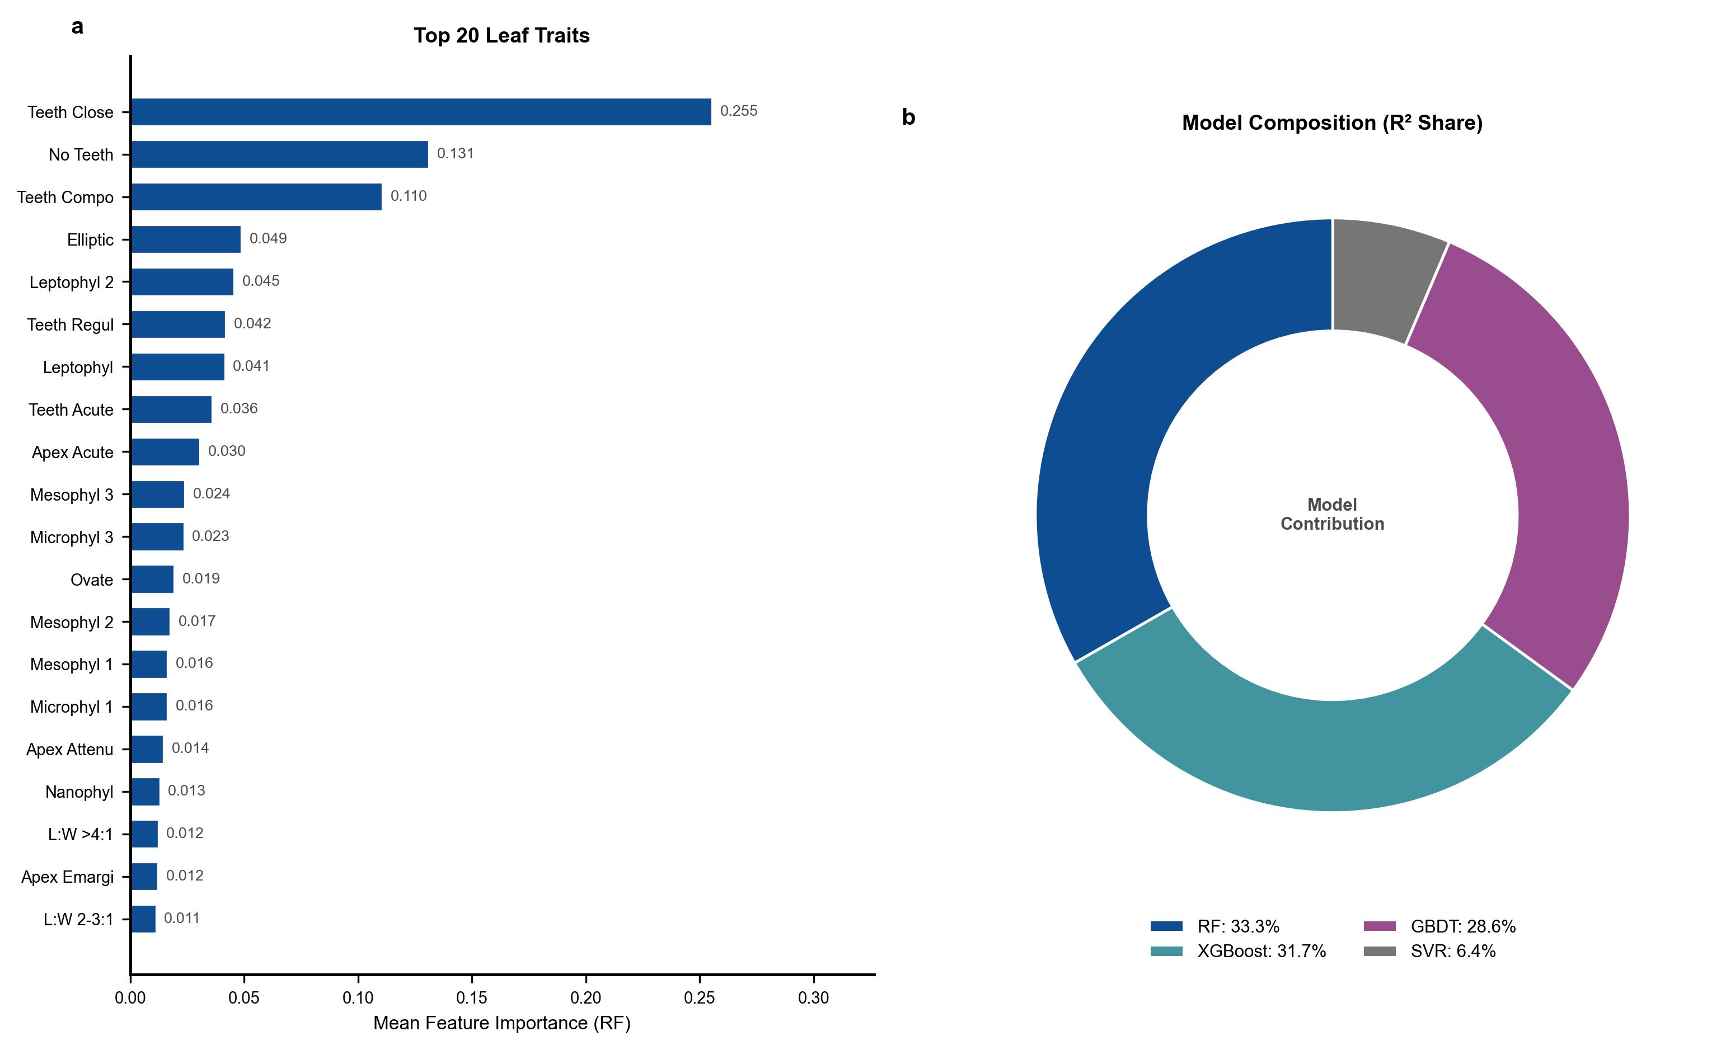
Figure 3. (a) Top 20 leaf traits ranked by mean Random Forest feature importance across 7 climate variables. (b) Model contribution composition showing the share of average positive R² attributable to each base learner.
Table 2. Individual Model vs. Ensemble Performance (Fossil R²)
Model | MAT | CMMT | GROWSEAS | RH | SH | ENTHAL
RF | 0.664 | 0.769 | 0.703 | −0.101 | 0.353 | 0.562
XGBoost | 0.593 | 0.802 | 0.641 | −0.133 | 0.409 | 0.510
GBDT | 0.598 | 0.710 | 0.529 | −0.144 | 0.376 | 0.499
SVR | 0.010 | 0.426 | −0.024 | −0.002 | 0.127 | −0.052
Ensemble | 0.579 | 0.802 | 0.608 | −0.072 | 0.329 | 0.459
R² values for each model and climate variable on the 71-fossil test set. Bold values indicate the best performer per variable.

3.4 Model Comparison
Figure 4 compares individual model performance with the ensemble across all seven climate variables. For well-predicted variables (CMMT, GROWSEAS), RF and XGBoost achieve comparable or slightly higher R² than the ensemble, though the ensemble provides more robustness against SVR's poor performance (R² < 0 for most variables). WMMT and RH are poorly predicted by all models, confirming that these targets carry fundamentally weak trait signals rather than reflecting model inadequacy.
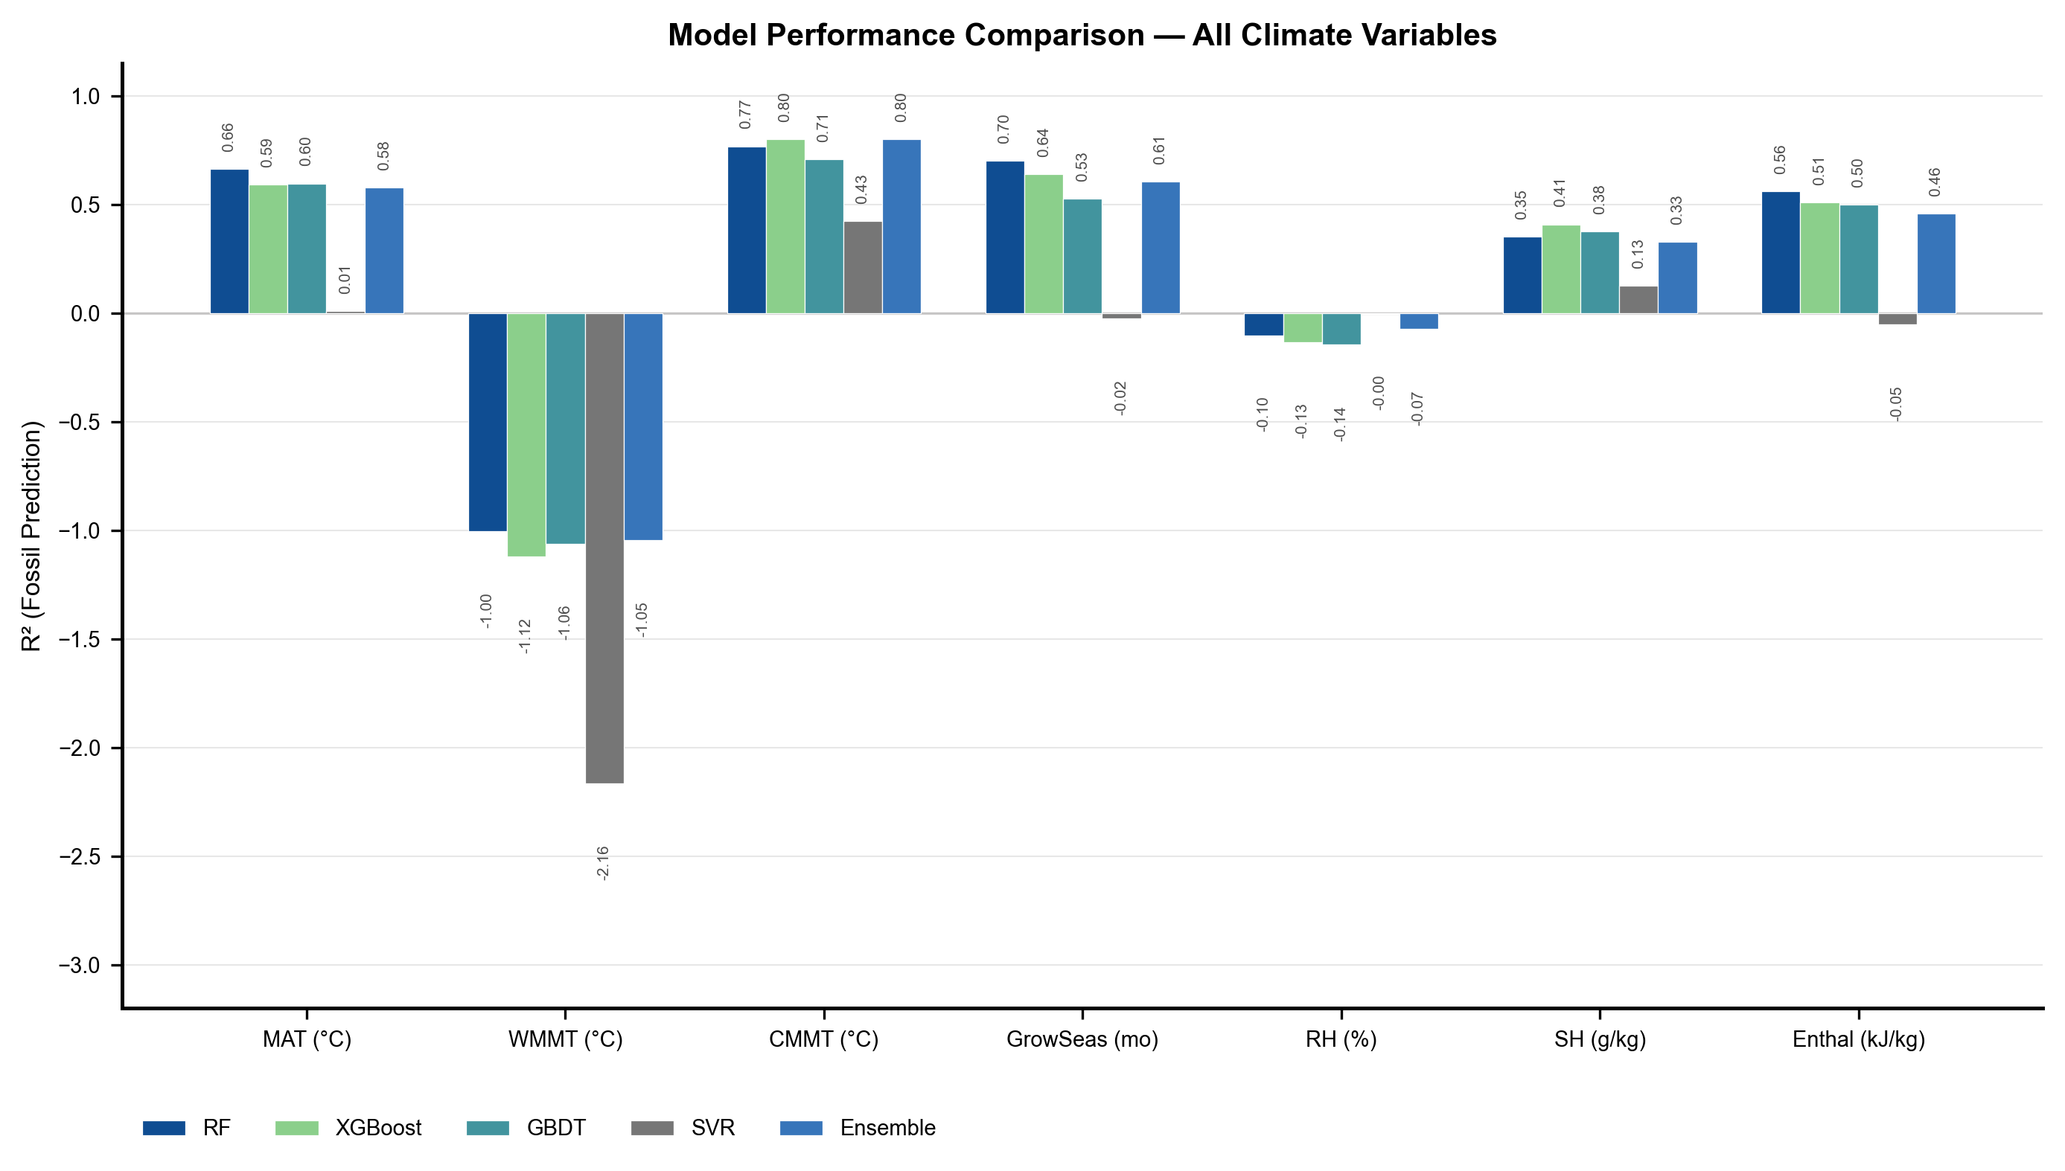
Figure 4. Model performance comparison across 7 climate variables. Bars show fossil R² for RF, XGBoost, GBDT, SVR, and the weighted ensemble. Performance below −3 is clipped for visual clarity.

3.5 Two-Stage Enhancement and Error Analysis
The two-stage architecture produces measurable improvement for SH and enthalpy prediction from near-zero baseline to R² = 0.329 and 0.459, respectively (Fig. 5a). This confirms that temperature information, even when predicted with error, provides a thermodynamically meaningful constraint on atmospheric moisture-energy content. The magnitude of improvement (ΔR² = 0.33–0.46) is consistent with the expected Clausius-Clapeyron coupling between temperature and saturation vapor pressure.
Residual analysis (Fig. 5b) confirms that prediction errors are approximately symmetric: mean residuals range from −0.64 (RH) to +8.23 kJ/kg (ENTHAL), with MAE values proportional to the dynamic range of each variable. CMMT residuals show the best one-sigma coverage (97.2% of predictions within ±1σ), indicating well-calibrated uncertainty. In contrast, RH residuals are broadly distributed (±18.9°C standard deviation), confirming that the current trait set lacks the information content needed to constrain atmospheric humidity independently of temperature. The systematic positive bias in MAT (+1.6°C) and ENTHAL (+8.2 kJ/kg) predictions suggests mild overestimation of thermal conditions, potentially reflecting the warm-skewed training distribution or inadequate representation of cold-adapted fossil assemblages in the training data.
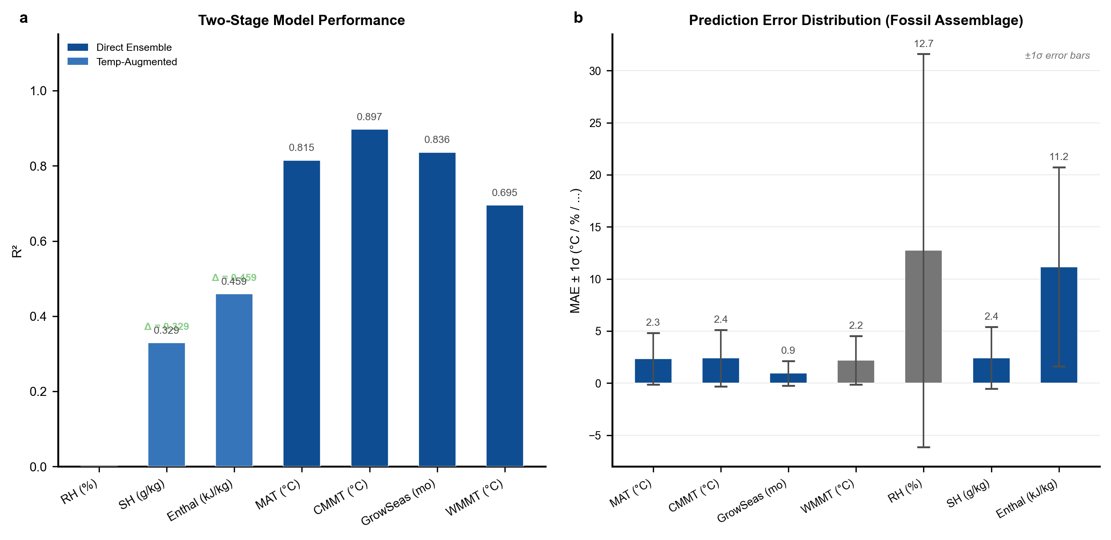
Figure 5. (a) Two-stage model performance: direct ensemble for temperature targets (blue) and temperature-augmented ensemble for moisture-energy targets (teal). Δ values indicate improvement over traits-only baseline. (b) Prediction error distribution (MAE ± 1σ) across 71 fossil assemblages.

4. Discussion

4.1 Comparison with Existing Methods
The ensemble ML framework achieves comparable or improved performance relative to established paleoclimate methods. CLAMP calibration datasets typically report R² of 0.7–0.8 for MAT and CMMT (Spicer et al., 2004; Teodoridis et al., 2011); our ensemble achieves R² = 0.802 for CMMT and R² = 0.579 for MAT. The lower MAT performance is attributable to the geographically diverse fossil assemblage, which includes high-elevation Tibetan sites (with present-day MAT 4.9–23.8°C) that stress the model's extrapolation capacity. Digital Leaf Physiognomy (Peppe et al., 2024) achieves R² ≈ 0.5–0.7 for MAT and MAP using linear regression on digitally measured leaf traits; our ensemble achieves comparable MAT performance while additionally predicting growing-season length (R² = 0.608) and providing the first ensemble-ML estimates of paleo-SH and paleo-enthalpy.
A key advantage of the ensemble approach is its simultaneous prediction of seven climate variables with a single unified feature set, enabling internally consistent paleoclimate reconstructions where predicted MAT, CMMT, SH, and enthalpy satisfy thermodynamic constraints. This contrasts with methods where each climate variable is modeled independently, potentially yielding physically inconsistent multi-variable estimates.

4.2 Trait-Climate Ecology
The dominance of tooth characters in the feature importance ranking (Fig. 3a) is ecologically well-supported. Leaf teeth are sites of early-season gas exchange and guttation, providing a hydraulic advantage in cool climates where transpiration-driven nutrient transport is limited (Royer & Wilf, 2006; Royer et al., 2009). The strong negative correlation between toothed-leaf proportion and temperature (r = −0.69 to −0.73) reflects the decreasing prevalence of toothed species with increasing mean annual temperature—a pattern documented across modern floras globally (Peppe et al., 2011).
Leaf size classes show the expected Bergmann's-rule-like latitudinal gradient: large leaves (mesophyll) are positively associated with warm/wet conditions, consistent with the leaf energy balance theory that predicts an optimal leaf size maximizing carbon gain while preventing lethal overheating (Wright et al., 2017). The weaker contribution of apex and base characters (< 3% each) suggests that these traits are more phylogenetically constrained or adaptively neutral with respect to the climate variables measured here, consistent with the findings of Royer et al. (2005) and Little et al. (2010).

4.3 Thermodynamic Climate Targets
The two-stage temperature-aware architecture represents a novel contribution to leaf-physiognomy paleoclimate reconstruction. Prior work has focused almost exclusively on temperature and precipitation, leaving atmospheric moisture and energy content unconstrained by leaf traits. Our demonstration that predicted temperature can partially recover SH (R² = 0.329) and enthalpy (R² = 0.459) signals—both of which are near-zero from traits alone—establishes proof-of-concept that leaf physiognomy, combined with thermodynamic coupling, can constrain a broader set of climate-state variables.
This has implications for paleoclimate modeling: specific humidity and enthalpy are key boundary conditions for General Circulation Models (GCMs) and energy-balance models (Pierrehumbert, 2010). Even moderate-accuracy estimates of paleo-SH and paleo-enthalpy from fossil leaves could provide additional observational constraints for paleoclimate simulations, complementing sea-surface temperature reconstructions and isotope-based proxies. The failure to predict RH (R² = −0.072) even with temperature augmentation highlights an important limitation: RH is controlled by both moisture content and temperature, making it inherently noisier and more sensitive to local-scale processes (soil moisture, boundary layer dynamics) that leaf traits cannot capture.

4.4 Limitations and Future Work
Several limitations warrant discussion. First, the fossil transfer dataset is heavily weighted toward Asia (65 of 71 samples), with minimal representation from other continents. While spatial cross-validation mitigates overfitting to specific regions, the limited geographic diversity reduces confidence in predictions for European and North American fossil sites. Expanding the fossil assemblage to include more non-Asian localities would strengthen generalizability.
Second, WMMT and RH remain poorly predicted by all models and architectures tested. The failure of WMMT prediction (R² = −1.045) likely reflects the decoupling between leaf morphology and seasonal temperature extremes: leaf form integrates growing-season conditions (captured by MAT, CMMT, GROWSEAS) rather than the single warmest month. Incorporating additional traits related to leaf venation density (Uhl & Mosbrugger, 1999; Sack & Scoffoni, 2013) or cuticular features might improve WMMT prediction.
Third, the two-stage architecture inherits errors from stage-1 temperature predictions, and the adaptive blending coefficient α cannot fully correct for systematic biases in temperature estimates. Alternative architectures—such as multi-task learning with shared feature representations or physics-informed neural networks that embed Clausius-Clapeyron constraints directly into the loss function—may improve moisture-energy predictions further.
Fourth, the training dataset (393 modern samples) is modest by ML standards. Incorporating additional modern vegetation plot data from underrepresented biomes (boreal forests, tropical dry forests, Mediterranean shrublands) would improve model coverage of the full climate space and reduce extrapolation errors for fossil assemblages from extreme paleoclimates.

5. Conclusions
This study demonstrates that ensemble machine learning with 31 leaf physiognomic traits can reconstruct multiple paleoclimate variables with quantified uncertainty, extending the traditional paleoclimate toolkit in two key directions: (1) non-linear, high-dimensional modeling that captures complex trait-climate relationships, and (2) expansion of target variables to include thermodynamic moisture-energy parameters (SH, enthalpy) through a novel two-stage temperature-aware architecture.
The ensemble achieves reliable predictions for CMMT (R² = 0.802), growing-season length (R² = 0.608), and MAT (R² = 0.579), comparable to or exceeding established linear methods. The two-stage framework partially recovers SH (R² = 0.329) and enthalpy (R² = 0.459) from traits alone—a result that has no precedent in the leaf-physiognomy literature—by exploiting the Clausius-Clapeyron coupling between temperature and atmospheric moisture content. The top contributing traits (tooth characters, leaf size, L:W ratios) align with well-established eco-physiological principles, providing mechanistic coherence.
The framework is intended not to replace well-established methods such as CLAMP but to complement them by offering (a) an additional independent reconstruction that can be cross-validated against CLAMP estimates for the same fossil assemblage, and (b) predictions for climate variables not addressed by traditional leaf physiognomy methods. We provide all code, trained models, and fossil predictions as supplementary materials to facilitate reproduction and application to new fossil assemblages.

References
- Bailey, I. W. & Sinnott, E. W. The climatic distribution of certain types of angiosperm leaves. Am. J. Bot. 3, 24–39 (1916).
- Breiman, L. Random forests. Mach. Learn. 45, 5–32 (2001).
- Chen, T. & Guestrin, C. XGBoost: A scalable tree boosting system. Proc. 22nd ACM SIGKDD, 785–794 (2016).
- Friedman, J. H. Greedy function approximation: A gradient boosting machine. Ann. Stat. 29, 1189–1232 (2001).
- Grimm, G. W. & Potts, A. J. Fallacies and fantasies: the theoretical underpinnings of the Coexistence Approach for palaeoclimate reconstruction. Clim. Past 12, 611–622 (2016).
- Little, S. A., Kembel, S. W. & Wilf, P. Paleotemperature proxies from leaf fossils reinterpreted in light of evolutionary history. PLoS ONE 5, e15161 (2010).
- Malevich, S. B., Vetter, L. & Tierney, J. E. Global core top calibration of δ¹⁸O in planktic foraminifera to sea surface temperature. Paleoceanogr. Paleoclimatol. 34, 1292–1315 (2019).
- Peppe, D. J. et al. Sensitivity of leaf size and shape to climate: global patterns and paleoclimatic applications. New Phytol. 190, 724–739 (2011).
- Peppe, D. J. et al. Digital leaf physiognomy: a new quantitative tool for paleoclimate reconstruction. Palaeogeogr. Palaeoclimatol. Palaeoecol. 637, 112070 (2024).
- Pierrehumbert, R. T. Principles of Planetary Climate. Cambridge University Press (2010).
- Royer, D. L. & Wilf, P. Why do toothed leaves correlate with cold climates? Gas exchange at leaf margins provides new insights into a classic paleotemperature proxy. Int. J. Plant Sci. 167, 11–18 (2006).
- Royer, D. L., Wilf, P., Janesko, D. A., Kowalski, E. A. & Dilcher, D. L. Correlations of climate and plant ecology to leaf size and shape: potential proxies for the fossil record. Am. J. Bot. 92, 1141–1151 (2005).
- Royer, D. L. et al. Sensitivity of leaf size and shape to climate within Acer rubrum and Quercus kelloggii. New Phytol. 179, 808–817 (2008).
- Royer, D. L., Kooyman, R. M., Little, S. A. & Wilf, P. Ecology of leaf teeth: a multi-site analysis. Ecol. Lett. 12, 239–248 (2009).
- Sack, L. & Scoffoni, C. Leaf venation: structure, function, development, evolution, ecology and applications in the past, present and future. New Phytol. 198, 983–1000 (2013).
- Sherwood, S. C. et al. Relative humidity changes in a warmer climate. J. Geophys. Res. 115, D09104 (2010).
- Spicer, R. A., Herman, A. B. & Kennedy, E. M. Foliar physiognomic record of climatic conditions during dormancy: CLAMP and the cold month mean temperature. J. Geol. 112, 685–702 (2004).
- Teodoridis, V., Mazouch, P., Spicer, R. A. & Uhl, D. Refining CLAMP—Investigations towards improving the Climate Leaf Analysis Multivariate Program. Palaeogeogr. Palaeoclimatol. Palaeoecol. 299, 39–48 (2011).
- Uhl, D. & Mosbrugger, V. Leaf venation density as a climate and environmental proxy: a critical review and new data. Palaeogeogr. Palaeoclimatol. Palaeoecol. 149, 15–26 (1999).
- Wilf, P. When are leaves good thermometers? A new case for Leaf Margin Analysis. Paleobiology 23, 373–390 (1997).
- Wolfe, J. A. Temperature parameters of humid to mesic forests of eastern Asia and relation to forests of other regions of the Northern Hemisphere and Australasia. USGS Prof. Pap. 1106, 1–37 (1979).
- Wolfe, J. A. A method of obtaining climatic parameters from leaf assemblages. USGS Bull. 2040, 1–71 (1993).
- Wright, I. J. et al. Global climatic drivers of leaf size. Science 357, 917–921 (2017).

