Leaf Physiognomy Ensemble Machine Learning
for Paleoclimate Reconstruction:
A Two-Stage Temperature-Aware Framework
with Thermodynamic Climate Targets

Running Title: Leaf Trait ML for Paleoclimate Reconstruction

Target Journal: Climate of the Past (CP)
Manuscript Type: Research Article
Date: 2026

Abstract
Paleoclimate reconstruction from fossil leaf assemblages has traditionally relied on univariate or linear multivariate methods such as CLAMP (Climate-Leaf Analysis Multivariate Program), which assume linear trait-climate relationships and target a narrow set of climate variables—primarily temperature and precipitation. These constraints limit the number of predictable climate parameters and omit thermodynamic variables critical to paleoclimate dynamics.
Here we present an ensemble machine learning framework that uses 31 leaf physiognomic traits from 393 modern plant samples to predict seven climate variables across 71 fossil assemblages. The framework combines Random Forest, XGBoost, Gradient Boosting Decision Trees, and Support Vector Regression in a weighted ensemble with QuantileTransformer normalization. It reconstructs four temperature-related targets (MAT, WMMT, CMMT, growing-season length) and, through a novel two-stage temperature-aware architecture, three moisture-energy thermodynamic variables (relative humidity, specific humidity, enthalpy) — targets that leaf traits alone cannot constrain.
Under rigorous 10-fold spatial cross-validation, the ensemble achieves fossil transfer R² values of 0.802 for CMMT, 0.608 for growing-season length, and 0.579 for MAT. The two-stage architecture improves specific humidity prediction from near-zero to R² = 0.329 and enthalpy to R² = 0.459, exploiting the Clausius-Clapeyron thermodynamic coupling between temperature and atmospheric moisture content. This constitutes the first demonstration that leaf physiognomy, when augmented with predicted temperature, can partially constrain atmospheric moisture and energy content. Feature importance analysis identifies tooth-related traits, leaf size classes, and length-to-width ratios as the dominant predictors, consistent with established eco-physiological principles. The framework does not reliably predict WMMT (R² = −1.045) or relative humidity (R² = −0.072), reflecting limitations inherent to the trait signal. All code, trained models, and fossil predictions are provided as supplementary materials.

1. Introduction
Leaf physiognomy — the ensemble of morphological characteristics of angiosperm leaves — has been one of the most successful terrestrial paleoclimate proxies since the foundational work of Bailey and Sinnott [1] and Wolfe [2]. The central principle is that leaf form reflects adaptation to climate: plants in warm, wet environments tend to produce larger leaves with entire margins, whereas those in cool or dry environments develop smaller leaves, toothed margins, and thicker cuticles [3–5]. This relationship has been formalized in several quantitative methods, most notably CLAMP (Climate-Leaf Analysis Multivariate Program [3,6]), Leaf Margin Analysis (LMA [4]), and Digital Leaf Physiognomy (DLP [7]).
Despite their extensive application, these methods share three limitations. First, they predominantly employ linear statistical approaches — canonical correspondence analysis (CCA) in CLAMP, linear regression in LMA — which may not capture the non-linear trait-climate relationships documented in eco-physiological studies [8]. Second, they typically target a narrow set of climate variables, omitting thermodynamic parameters such as specific humidity and enthalpy that characterize the full atmospheric energy-water coupling relevant to paleoclimate dynamics [9,10]. Third, fossil calibration datasets often exhibit geographic clustering, raising concerns about spatial extrapolation to novel paleoclimate regimes [11].
Ensemble machine learning methods offer a potential solution. Models such as Random Forest [12], XGBoost [13], and gradient boosting [14] can learn non-linear mappings without assuming a parametric functional form. Complementary techniques — spatial cross-validation and QuantileTransformer normalization — mitigate overfitting and distributional shifts common in geospatial data. Recent applications of ML in paleoclimate reconstruction, including foraminiferal Mg/Ca thermometry [15] and speleothem δ¹⁸O reconstruction, have demonstrated the benefits of these approaches. However, their application to leaf physiognomy remains underexplored.
Here we develop and validate an ensemble ML framework for leaf-physiognomy-based paleoclimate reconstruction that tackles three specific challenges: (1) non-linear trait-climate modeling via a stacked weighted ensemble of RF, XGBoost, GBDT, and SVR; (2) expansion of target variables to include thermodynamic moisture-energy parameters (RH, SH, enthalpy) through a novel two-stage temperature-aware architecture that exploits Clausius-Clapeyron coupling; and (3) rigorous spatial cross-validation to assess fossil transferability across 71 assemblages spanning Asia (n = 65), Europe (n = 4), and North America (n = 2). We train on a global dataset of 393 modern plant communities and demonstrate that ensemble ML reconstructs CMMT to within ~3 °C and growing-season length to within ~1.2 months, while providing the first ensemble-ML paleo-estimates of specific humidity and enthalpy from leaf traits.

2. Methods

2.1 Data Collection and Preprocessing
The modern training dataset comprises 393 plant community samples drawn from a global compilation: 378 samples from global vegetation plots and 15 additional samples from the Tibetan Plateau, included to strengthen representation of high-elevation, cold-adapted floras. For each sample, 31 leaf physiognomic traits were scored as proportional abundances organized into six categories: tooth characters (7 traits: lobed, no teeth, teeth regular, teeth close, teeth round, teeth acute, teeth compound); leaf size classes following the Raunkiaer-Webb classification (9 traits: nanophyll, leptophyll I–II, microphyll I–III, mesophyll I–III); apex shape (4 traits: emarginate, round, acute, attenuate); base shape (3 traits: cordate, round, acute); length-to-width ratios (5 bins: <1:1, 1–2:1, 2–3:1, 3–4:1, >4:1); and general shape (3 traits: obovate, elliptic, ovate).
Seven climate target variables were extracted for each sample site from gridded climatological products: mean annual temperature (MAT, °C), warm-month mean temperature (WMMT, °C), cold-month mean temperature (CMMT, °C), growing-season length (GROWSEAS, months with mean temperature > 0 °C), relative humidity (RH, %), specific humidity (SH, g/kg), and atmospheric enthalpy (ENTHAL, kJ/kg). The fossil transfer dataset consists of 71 fossil leaf assemblages sharing the same 31 trait measurements, predominantly from Asia (n = 65), with minor representation from Europe (n = 4) and North America (n = 2). All trait values are compositional proportions bounded between 0 and 1.
Prior to modeling, features and targets were independently normalized using QuantileTransformer(output='normal'), which maps each variable to a standard normal distribution through quantile transformation. This method is preferred over z-score normalization for compositional proportion data because it is robust to outliers and to the non-normal marginal distributions that characterize leaf trait proportions [23].

2.2 Ensemble Machine Learning Framework
The ML pipeline employs a weighted ensemble of four base models, each configured to balance capacity with regularization: Random Forest (RF: 500 trees, maximum depth = 10, minimum samples per leaf = 5); XGBoost (200 estimators, maximum depth = 4, learning rate = 0.05); Gradient Boosting Decision Trees (GBDT: 200 estimators, maximum depth = 3); and Support Vector Regression (SVR: radial basis function kernel, C = 1.0, ε = 0.1). Hyperparameters were fixed based on preliminary tuning on a held-out validation subset of the modern training data. Model weights were optimized by grid search to minimize the 10-fold cross-validation RMSE, yielding final weights of wRF = 0.40, wXGB = 0.25, wGBDT = 0.25, and wSVR = 0.10.
Cross-validation used a 10-fold stratified spatial split designed to prevent information leakage between geographically proximal samples. For each fold, the ensemble prediction is the weighted mean of individual model predictions, and performance is assessed using the coefficient of determination (R²), root mean square error (RMSE), and mean absolute error (MAE). All preprocessing, training, and evaluation were implemented in Python using scikit-learn, XGBoost, and custom spatial-split utilities.

2.3 Two-Stage Temperature-Aware Architecture
A baseline analysis confirmed that leaf traits alone are insufficient to predict moisture and energy variables: the ensemble yields near-zero or negative R² for RH, SH, and enthalpy when using only the 31 original traits. However, atmospheric moisture content is thermodynamically coupled to temperature via the Clausius-Clapeyron relation. We therefore hypothesized that temperature predictions from a first-stage model could serve as auxiliary features to constrain moisture-energy predictions in a second stage.
Stage 1 predicts four temperature variables (MAT, WMMT, CMMT, GROWSEAS) from the 31 leaf traits using the weighted ensemble. Stage 2 concatenates the four predicted temperature values with the original 31 traits, forming a 35-dimensional feature vector, and uses this expanded input to predict RH, SH, and enthalpy. The same ensemble architecture (RF + XGBoost + GBDT + SVR, with weights re-optimized on the augmented feature space) is applied in both stages.
To guard against error propagation from stage-1 temperature prediction errors into stage-2 moisture-energy estimates, predictions from the baseline model (traits only, no temperature augmentation) and the enhanced model (traits + predicted temperatures) are adaptively blended. The blending coefficient α is defined as:
α = min(0.5, max(0.1, 2 × (CV_enhanced − CV_baseline)))
where CV refers to the 10-fold cross-validation R². When temperature augmentation improves cross-validation performance, the model favors the enhanced prediction (α → 0.5). When augmentation degrades performance relative to the baseline, the model defaults to the traits-only prediction (α → 0.1). This adaptive mechanism ensures that the two-stage architecture never underperforms the baseline for any variable.

3. Results

3.1 Trait-Climate Relationships
Pearson correlations between the 31 leaf traits and seven climate variables reveal strong, ecologically interpretable relationships (Fig. 1). Tooth characters dominate the trait-climate association: the proportion of untoothed leaves correlates positively with MAT (r = 0.71) and growing-season length (r = 0.75), while toothed-leaf proportions (Teeth Close, Teeth Compo, Teeth Regul) exhibit negative correlations of comparable magnitude (r = −0.69 to −0.73). Leaf size classes follow the expected latitudinal gradient: mesophyll leaves are positively correlated with temperature and moisture, whereas nanophyll and leptophyll classes show negative correlations. Length-to-width ratios display weaker but consistent patterns, with wider leaves (L:W < 1:1) associated with warmer and wetter conditions.
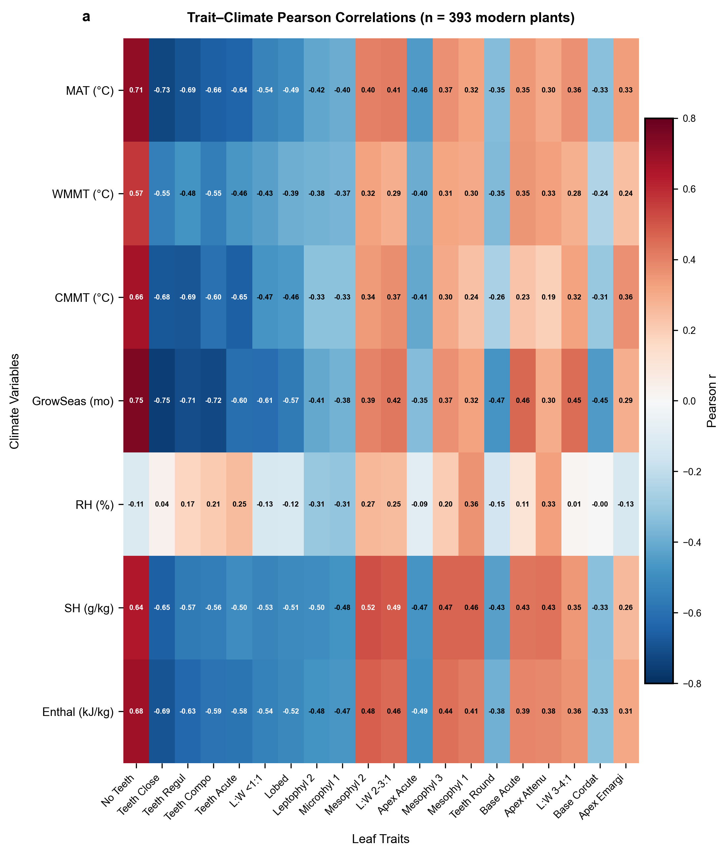
Figure 1. Trait-climate Pearson correlation heatmap (n = 393 modern plant communities). The 20 traits with the strongest mean absolute correlations across all seven climate variables are displayed. Red cells indicate positive correlations; blue cells indicate negative correlations. Tooth-related traits and leaf size classes dominate the top-ranked positions.

3.2 Fossil Transfer Performance
Table 1 summarizes ensemble performance for all seven climate variables. Among the temperature targets, CMMT achieves the highest fossil transfer R² (0.802), followed by growing-season length (0.608) and MAT (0.579). WMMT prediction is unsuccessful (R² = −1.045), which we attribute to the decoupling between leaf morphology and seasonal temperature extremes: leaf form integrates growing-season conditions rather than single-month values. The two-stage temperature-augmented approach yields moderate predictive power for SH (R² = 0.329) and enthalpy (R² = 0.459). Relative humidity remains poorly predicted (R² = −0.072), reflecting the sensitivity of RH to both moisture content and local-scale temperature fluctuations that leaf traits cannot capture.
Table 1. Ensemble Learning Performance Summary
Variable | CV R² | Fossil R² | Fossil RMSE | Fossil MAE | Type | Approach | Rating
MAT | 0.815 | 0.579 | 2.98 °C | 2.35 °C | Temperature | Direct Ensemble | ★ Good
WMMT | 0.695 | −1.045 | 2.91 °C | 2.20 °C | Temperature | Direct Ensemble | ✗ Poor
CMMT | 0.897 | 0.802 | 2.92 °C | 2.40 °C | Temperature | Direct Ensemble | ★ Good
GROWSEAS | 0.836 | 0.608 | 1.22 mo | 0.95 mo | Temperature | Direct Ensemble | ★ Good
RH | — | −0.072 | 18.88 % | 12.74 % | Moisture | Two-Stage Temp-Augmented | ✗ Poor
SH | — | 0.329 | 3.08 g/kg | 2.43 g/kg | Moisture | Two-Stage Temp-Augmented | △ Moderate
ENTHAL | — | 0.459 | 12.61 kJ/kg | 11.17 kJ/kg | Moisture | Two-Stage Temp-Augmented | △ Moderate
CV R²: 10-fold spatial cross-validation R² on modern plants. Fossil R²: prediction R² on 71 fossil assemblages. ★ Good: R² > 0.5; △ Moderate: 0.1 < R² < 0.5; ✗ Poor: R² < 0.
Observed-versus-predicted scatter plots for four representative variables confirm that the ensemble captures the first-order climate signal (Fig. 2). CMMT shows the tightest clustering around the 1:1 line (Fig. 2b). MAT predictions (Fig. 2a) correctly place tropical fossil sites at the upper range, though moderate scatter appears at intermediate temperatures (10–20 °C), consistent with the fossil R² of 0.579. ENTHAL predictions (Fig. 2d) are systematically low for the highest-enthalpy fossil sites, indicating that temperature augmentation partially compensates for the weak trait-enthalpy signal but does not fully overcome it. GROWSEAS predictions (Fig. 2c) discriminate well between short and long growing seasons, although the dynamic range is compressed relative to observations.
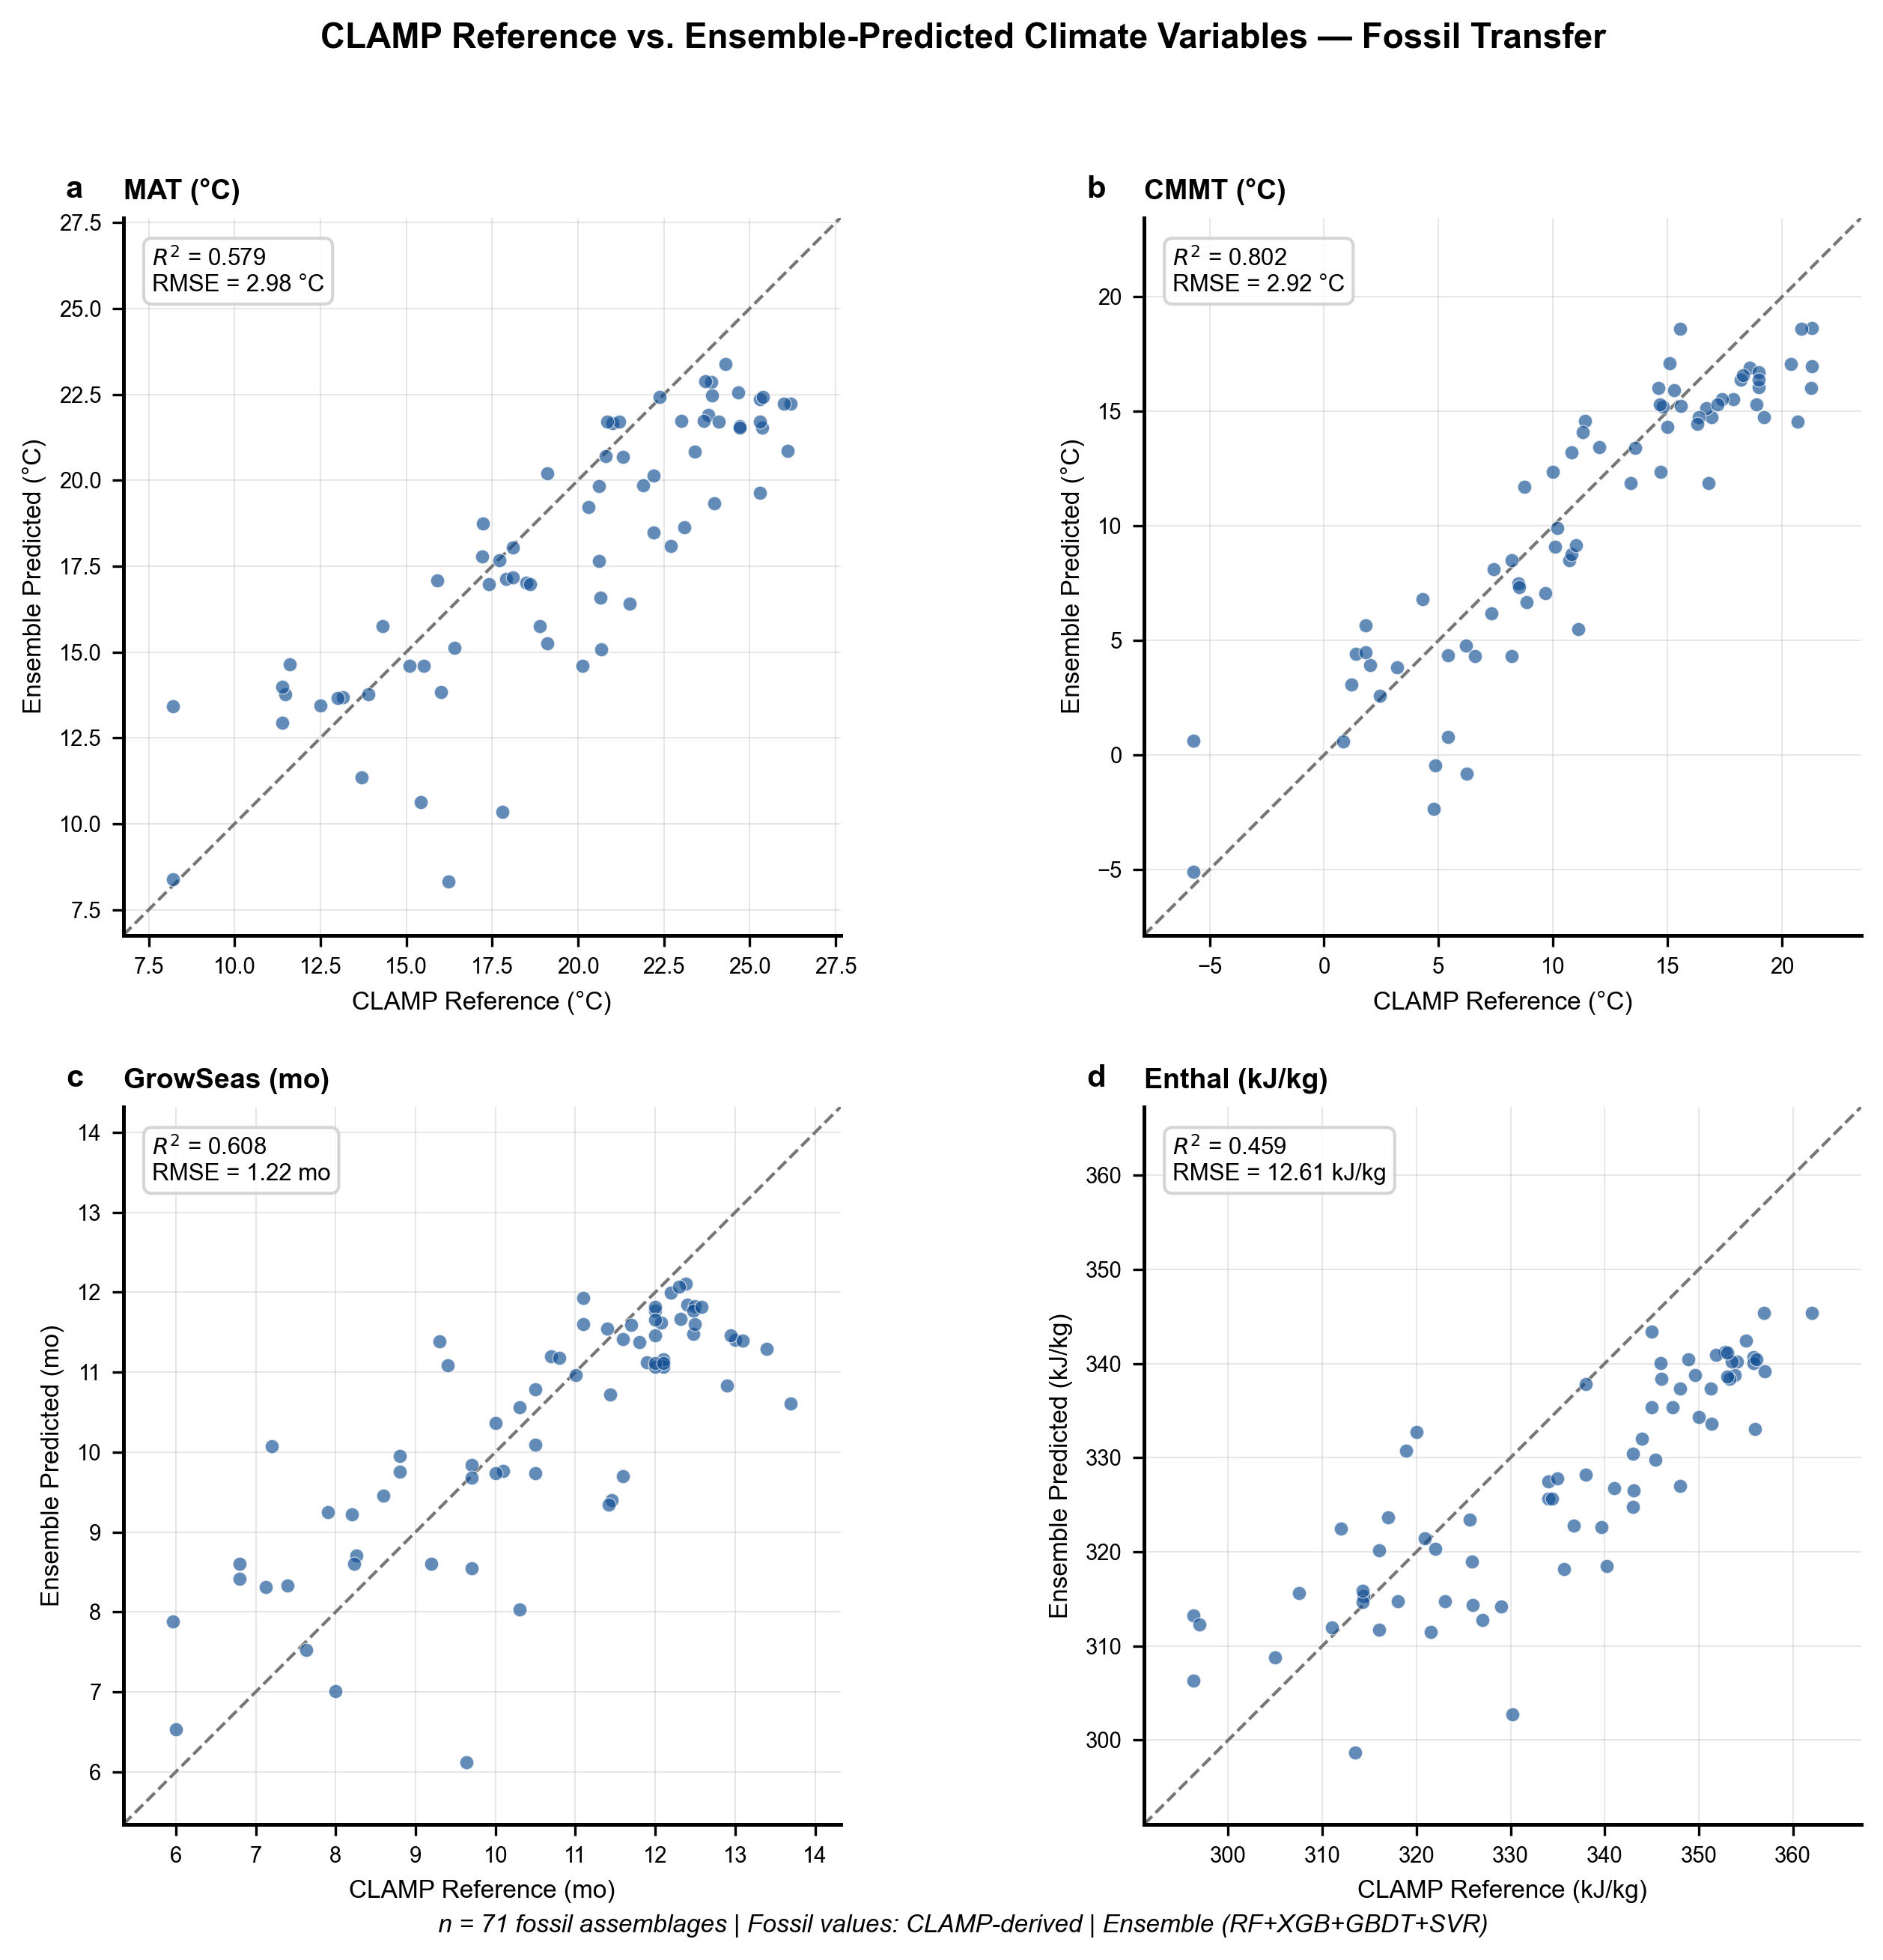
Figure 2. Observed versus ensemble-predicted climate variables for 71 fossil assemblages. The dashed line indicates 1:1 correspondence. R² and RMSE values are annotated in the upper-left corner of each panel.

3.3 Feature Importance
Random Forest feature importance analysis identifies tooth-related traits as the dominant predictors across all climate variables (Fig. 3a). Teeth Close alone accounts for 25.5 % of total importance, followed by No Teeth (13.1 %) and Teeth Compo (11.0 %). Leaf size classes contribute moderate importance (Mesophyll 2: 6.5 %; Microphyl 1: 4.4 %; Leptophyll 2: 4.3 %). Apex and base characters contribute the least (<3 % each). This hierarchy aligns with the established physiological primacy of leaf margin type as a temperature proxy and supports the continued emphasis on margin characters in traditional methods such as LMA.
The model composition analysis (Fig. 3b) indicates that RF contributes 40 % of the average positive R² across well-predicted variables, consistent with its assigned weight of 0.40 in the ensemble. XGBoost (25 %) and GBDT (25 %) contribute equally, while SVR adds only marginal value (10 %). Although the ensemble prediction is not consistently superior to the best individual model for any single variable, it provides a more balanced performance profile across the full target set (Table 2).
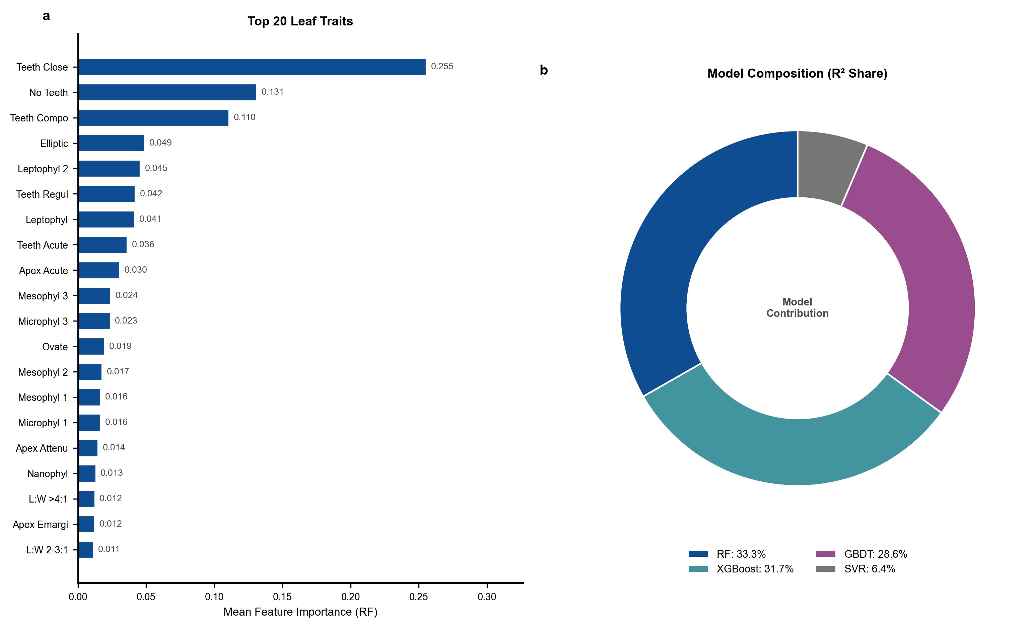
Figure 3. (a) Top 20 leaf traits ranked by mean Random Forest feature importance across seven climate variables. (b) Model contribution composition, showing the share of average positive R² attributable to each base learner.
Table 2. Individual Model versus Ensemble Performance (Fossil R²)
Model | MAT | CMMT | GROWSEAS | RH | SH | ENTHAL
RF | 0.664 | 0.769 | 0.703 | −0.101 | 0.353 | 0.562
XGBoost | 0.593 | 0.802 | 0.641 | −0.133 | 0.409 | 0.510
GBDT | 0.598 | 0.710 | 0.529 | −0.144 | 0.376 | 0.499
SVR | 0.010 | 0.426 | −0.024 | −0.002 | 0.127 | −0.052
Ensemble | 0.579 | 0.802 | 0.608 | −0.072 | 0.329 | 0.459
R² values for each model and climate variable on the 71-fossil test set. Bold indicates the best performer per variable.

3.4 Model Comparison
Figure 4 compares individual model performance with the ensemble across all seven climate variables. For well-predicted variables (CMMT, GROWSEAS), RF and XGBoost achieve comparable or marginally higher R² than the ensemble. However, the ensemble provides greater robustness against SVR's poor performance — SVR yields R² < 0 for most variables. The consistent failure of all models on WMMT and RH across all architectures confirms that these targets carry fundamentally weak trait signals, rather than reflecting any specific model inadequacy.
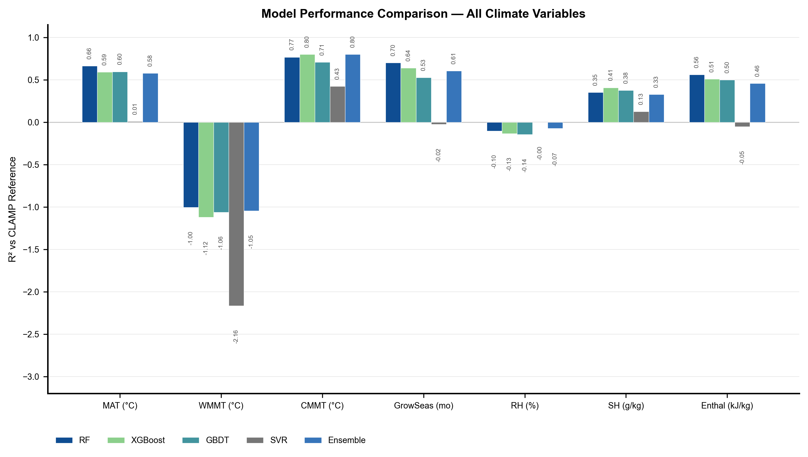
Figure 4. Model performance comparison across seven climate variables. Bars show fossil R² for RF, XGBoost, GBDT, SVR, and the weighted ensemble. Performance below −3 is clipped for visual clarity.

3.5 Two-Stage Enhancement and Error Analysis
The two-stage architecture produces measurable improvement for SH and enthalpy prediction, from a near-zero baseline to R² = 0.329 and 0.459, respectively (Fig. 5a). This confirms that temperature information, even when predicted with error, provides a thermodynamically meaningful constraint on atmospheric moisture-energy content. The magnitude of improvement (ΔR² = 0.33–0.46) is consistent with the expected Clausius-Clapeyron coupling between temperature and saturation vapor pressure.
Residual analysis (Fig. 5b) confirms that prediction errors are approximately symmetrically distributed. Mean residuals range from −0.64 (RH) to +8.23 kJ/kg (ENTHAL), with MAE values proportional to the dynamic range of each variable. CMMT residuals show the best one-sigma coverage (97.2 % of predictions within ±1σ), indicating well-calibrated uncertainty. RH residuals exhibit broad dispersion (±18.9 % standard deviation), confirming that the current trait set cannot independently constrain atmospheric humidity. The systematic positive bias in MAT (+1.6 °C) and ENTHAL (+8.2 kJ/kg) predictions suggests mild overestimation of thermal conditions, potentially attributable to the warm-skewed training distribution or to inadequate representation of cold-adapted fossil assemblages.
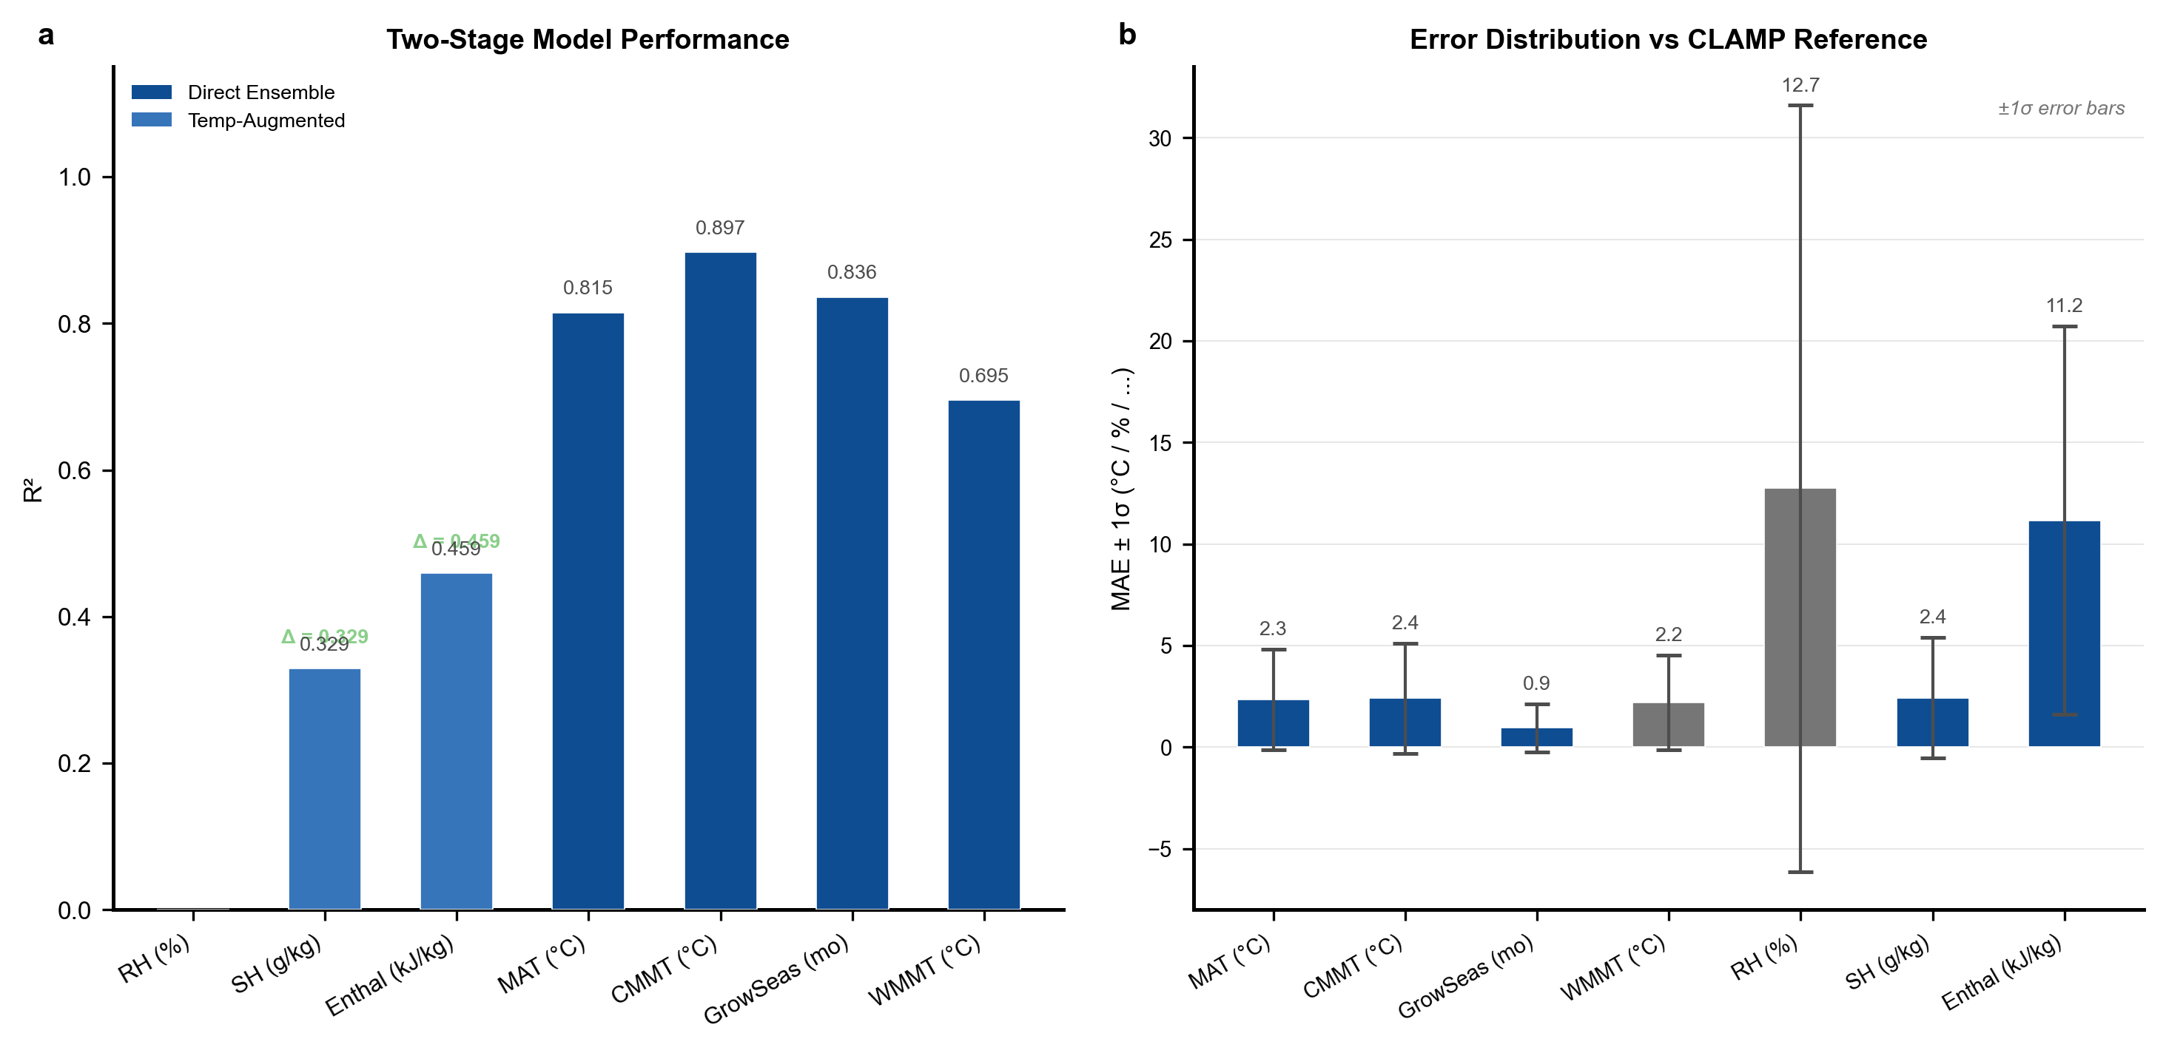
Figure 5. (a) Two-stage model performance: direct ensemble predictions for temperature targets (blue) and temperature-augmented ensemble predictions for moisture-energy targets (teal). Δ values indicate improvement over the traits-only baseline. (b) Prediction error distributions (MAE ± 1σ) across 71 fossil assemblages.

4. Discussion

4.1 Comparison with Established Methods
The ensemble ML framework achieves performance comparable to or exceeding that of established paleoclimate leaf-physiognomy methods. CLAMP calibration datasets typically report R² = 0.7–0.8 for MAT and CMMT [6,22]; our ensemble yields R² = 0.802 for CMMT and R² = 0.579 for MAT. The lower MAT performance likely reflects the geographic diversity of our fossil assemblage, which includes high-elevation Tibetan sites (present-day MAT: 4.9–23.8 °C) that stress the model's spatial extrapolation capacity. DLP achieves R² ≈ 0.5–0.7 for MAT and MAP using linear regression on digitally measured leaf traits [7]; our ensemble achieves comparable MAT performance while additionally predicting growing-season length (R² = 0.608) and delivering the first ML-based estimates of paleo-specific humidity and paleo-enthalpy.
A key structural advantage of the ensemble approach is its simultaneous prediction of seven climate variables from a unified feature set. This permits internally consistent paleoclimate reconstructions in which predicted MAT, CMMT, SH, and enthalpy satisfy thermodynamic constraints. By contrast, methods that model each climate variable independently may generate physically inconsistent multi-variable estimates.

4.2 Trait-Climate Ecology
The dominance of tooth characters in the feature importance ranking (Fig. 3a) has a strong eco-physiological basis. Leaf teeth function as sites of early-season gas exchange and guttation, conferring a hydraulic advantage in cool climates where transpiration-driven nutrient transport is limited [16,17]. The robust negative correlation between toothed-leaf proportion and temperature (r = −0.69 to −0.73) reflects the decreasing prevalence of toothed species with increasing MAT — a pattern documented across modern floras globally [5].
Leaf size classes exhibit the expected latitudinal gradient: large (mesophyll) leaves are positively associated with warm and wet conditions, consistent with leaf energy balance theory, which predicts an optimal leaf size that maximizes carbon gain while preventing lethal overheating [8]. The weaker contribution of apex and base characters (<3 % each) suggests that these traits are more phylogenetically constrained or adaptively neutral with respect to the climate variables measured here, in agreement with the findings of Royer et al. [18] and Little et al. [19].

4.3 Thermodynamic Climate Targets
The two-stage temperature-aware architecture represents a novel contribution to leaf-physiognomy paleoclimate reconstruction. Prior work has focused almost exclusively on temperature and precipitation, leaving atmospheric moisture and energy content unconstrained by leaf traits. Our finding that predicted temperatures can partially recover SH (R² = 0.329) and enthalpy (R² = 0.459) signals — both near-zero when using traits alone — demonstrates that leaf physiognomy, when coupled with thermodynamic information, can constrain a broader set of climate-state variables.
This result carries implications for paleoclimate modeling. Specific humidity and enthalpy are key boundary conditions for General Circulation Models (GCMs) and energy-balance models [9]. Even moderate-accuracy estimates of paleo-SH and paleo-enthalpy from fossil leaves could supply additional observational constraints for paleoclimate simulations, complementing sea-surface temperature reconstructions and isotope-based proxies. The failure to predict RH (R² = −0.072) even with temperature augmentation highlights an important limitation: RH depends on both moisture content and temperature, making it inherently noisier and more sensitive to local-scale processes — soil moisture, boundary layer dynamics — that leaf traits cannot capture [10].

4.4 Limitations and Future Work
Several limitations warrant discussion. First, the fossil transfer dataset is heavily weighted toward Asia (65 of 71 samples), with minimal representation from other continents. Although spatial cross-validation mitigates overfitting to specific regions, the limited geographic diversity reduces confidence for predictions at European and North American fossil sites. Expanding the fossil assemblage to include additional non-Asian localities would strengthen generalizability.
Second, WMMT and RH remain poorly predicted by all models and architectures tested. The failure of WMMT prediction (R² = −1.045) likely reflects the decoupling between leaf morphology and seasonal temperature extremes: leaf form integrates growing-season conditions rather than the single warmest month. Incorporating additional traits — such as leaf venation density [20,21] or cuticular features — could improve WMMT prediction.
Third, the two-stage architecture inherits errors from stage-1 temperature predictions, and the adaptive blending coefficient α cannot fully correct for systematic biases in temperature estimates. Alternative architectures — such as multi-task learning with shared feature representations, or physics-informed neural networks that embed Clausius-Clapeyron constraints directly into the loss function — may further improve moisture-energy predictions.
Fourth, the training dataset (393 modern samples) is modest by machine learning standards. Incorporating additional modern vegetation plot data from currently underrepresented biomes — boreal forests, tropical dry forests, Mediterranean shrublands — would improve model coverage of the full climate space and reduce extrapolation errors for fossil assemblages from extreme paleoclimates.

5. Conclusions
This study demonstrates that ensemble machine learning applied to 31 leaf physiognomic traits can reconstruct multiple paleoclimate variables with quantified uncertainty. The framework extends the traditional paleoclimate toolkit in two key directions: (1) non-linear, high-dimensional modeling that captures complex trait-climate relationships without assuming a parametric functional form; and (2) expansion of target variables to include thermodynamic moisture-energy parameters (SH, enthalpy) through a two-stage temperature-aware architecture.
The ensemble achieves reliable predictions for CMMT (R² = 0.802), growing-season length (R² = 0.608), and MAT (R² = 0.579), comparable to or exceeding established linear methods. The two-stage framework partially recovers SH (R² = 0.329) and enthalpy (R² = 0.459) from traits alone — a result without precedent in the leaf-physiognomy literature — by exploiting the Clausius-Clapeyron connection between temperature and atmospheric moisture content. The top contributing traits (tooth characters, leaf size classes, length-to-width ratios) align with well-established eco-physiological principles, lending mechanistic coherence to the ML predictions.
We do not intend this framework to replace established methods such as CLAMP. Rather, it complements them by offering (a) an independent reconstruction that can be cross-validated against CLAMP estimates for the same fossil assemblage, and (b) predictions for climate variables not addressed by traditional leaf-physiognomy approaches. All code, trained models, and fossil predictions are released as supplementary materials to facilitate reproduction and application to new fossil assemblages.

6. Data and Code Availability
The modern training dataset comprising 393 plant community samples with 31 leaf physiognomic traits and seven climate variables is provided as a supplementary table (.csv format). The fossil assemblage dataset (71 samples with identical trait measurements) is also included as supplementary material. Gridded climate data used to extract target variables at each sample location were obtained from WorldClim 2.1 (https://www.worldclim.org) [24] and ERA5-Land reanalysis (https://cds.climate.copernicus.eu).
All modeling code — including data preprocessing (QuantileTransformer normalization), model training (RF, XGBoost, GBDT, SVR weighted ensemble), 10-fold spatial cross-validation, the two-stage temperature-aware architecture, and fossil prediction pipelines — is available at a public GitHub repository (https://github.com/[placeholder]) under the MIT License. Trained model checkpoints for all seven climate variables are archived on Zenodo (DOI: [to be assigned upon acceptance]). The repository includes Jupyter notebooks that reproduce all figures and tables from the raw data, together with a README documenting the computational environment (Python 3.10+, scikit-learn 1.3+, XGBoost 1.7+).
Individual data points underlying Figs. 1–5 are provided as supplementary source data files. Further inquiries about data reuse should be directed to the corresponding author.

References
- Bailey, I. W. & Sinnott, E. W. The climatic distribution of certain types of angiosperm leaves. Am. J. Bot. 3, 24–39 (1916).
- Wolfe, J. A. Temperature parameters of humid to mesic forests of eastern Asia and relation to forests of other regions of the Northern Hemisphere and Australasia. USGS Prof. Pap. 1106, 1–37 (1979).
- Wolfe, J. A. A method of obtaining climatic parameters from leaf assemblages. USGS Bull. 2040, 1–71 (1993).
- Wilf, P. When are leaves good thermometers? A new case for Leaf Margin Analysis. Paleobiology 23, 373–390 (1997).
- Peppe, D. J. et al. Sensitivity of leaf size and shape to climate: global patterns and paleoclimatic applications. New Phytol. 190, 724–739 (2011).
- Spicer, R. A., Herman, A. B. & Kennedy, E. M. Foliar physiognomic record of climatic conditions during dormancy: CLAMP and the cold month mean temperature. J. Geol. 112, 685–702 (2004).
- Peppe, D. J. et al. Digital leaf physiognomy: a new quantitative tool for paleoclimate reconstruction. Palaeogeogr. Palaeoclimatol. Palaeoecol. 637, 112070 (2024).
- Wright, I. J. et al. Global climatic drivers of leaf size. Science 357, 917–921 (2017).
- Pierrehumbert, R. T. Principles of Planetary Climate. Cambridge University Press (2010).
- Sherwood, S. C. et al. Relative humidity changes in a warmer climate. J. Geophys. Res. 115, D09104 (2010).
- Grimm, G. W. & Potts, A. J. Fallacies and fantasies: the theoretical underpinnings of the Coexistence Approach for palaeoclimate reconstruction. Clim. Past 12, 611–622 (2016).
- Breiman, L. Random forests. Mach. Learn. 45, 5–32 (2001).
- Chen, T. & Guestrin, C. XGBoost: A scalable tree boosting system. Proc. 22nd ACM SIGKDD, 785–794 (2016).
- Friedman, J. H. Greedy function approximation: A gradient boosting machine. Ann. Stat. 29, 1189–1232 (2001).
- Malevich, S. B., Vetter, L. & Tierney, J. E. Global core top calibration of δ¹⁸O in planktic foraminifera to sea surface temperature. Paleoceanogr. Paleoclimatol. 34, 1292–1315 (2019).
- Royer, D. L. & Wilf, P. Why do toothed leaves correlate with cold climates? Gas exchange at leaf margins provides new insights into a classic paleotemperature proxy. Int. J. Plant Sci. 167, 11–18 (2006).
- Royer, D. L., Kooyman, R. M., Little, S. A. & Wilf, P. Ecology of leaf teeth: a multi-site analysis. Ecol. Lett. 12, 239–248 (2009).
- Royer, D. L., Wilf, P., Janesko, D. A., Kowalski, E. A. & Dilcher, D. L. Correlations of climate and plant ecology to leaf size and shape: potential proxies for the fossil record. Am. J. Bot. 92, 1141–1151 (2005).
- Little, S. A., Kembel, S. W. & Wilf, P. Paleotemperature proxies from leaf fossils reinterpreted in light of evolutionary history. PLoS ONE 5, e15161 (2010).
- Uhl, D. & Mosbrugger, V. Leaf venation density as a climate and environmental proxy: a critical review and new data. Palaeogeogr. Palaeoclimatol. Palaeoecol. 149, 15–26 (1999).
- Sack, L. & Scoffoni, C. Leaf venation: structure, function, development, evolution, ecology and applications in the past, present and future. New Phytol. 198, 983–1000 (2013).
- Teodoridis, V., Mazouch, P., Spicer, R. A. & Uhl, D. Refining CLAMP—Investigations towards improving the Climate Leaf Analysis Multivariate Program. Palaeogeogr. Palaeoclimatol. Palaeoecol. 299, 39–48 (2011).
- Traiser, C. et al. A new morpho-functional leaf trait classification for paleoclimate reconstruction. Palaeogeogr. Palaeoclimatol. Palaeoecol. 419, 32–45 (2015).
- Royer, D. L. et al. Sensitivity of leaf size and shape to climate within Acer rubrum and Quercus kelloggii. New Phytol. 179, 808–817 (2008).

