Spatial cross-validation reveals fundamental limits and fossil transfer potential of leaf-physiognomy machine learning for paleoclimate reconstruction
[Author list]
[Affiliations]
Correspondence: [email]

Abstract
Leaf physiognomic traits have been used for terrestrial paleoclimate reconstruction since the early 20th century, with recent machine learning (ML) approaches claiming high predictive accuracy for multiple climate variables. However, the reliance on random k-fold cross-validation—which ignores spatial autocorrelation—risks substantially overestimating model performance in a fossil-transfer context. Here we re-examine the predictive power of 31 leaf physiognomic traits for seven climate variables (MAT, WMMT, CMMT, growing-season length, relative humidity, specific humidity, and moist enthalpy) using a globally distributed dataset of 393 modern woody dicot sites and 71 fossil assemblages. Under block-based spatial GroupKFold cross-validation, four ensemble learners (Random Forest, XGBoost, Gradient Boosting, SVR) and four statistical baselines (Linear Regression, Ridge, ElasticNet, PLS) are evaluated on a leakage-free, two-stage architecture that first predicts temperature variables from traits, then predicts moisture–energy variables from traits augmented with out-of-fold temperature estimates. Leave-One-Continent-Out (LOCO) validation and fossil transfer against CLAMP reference values test geographic generalisability. We find that spatial cross-validation dramatically reduces apparent model performance relative to random-fold estimates: the best spatial CV R² reaches only 0.38 for MAT (Random Forest) and is negative for WMMT, CMMT, and RH, indicating that leaf traits alone carry limited cross-region climate signal for these variables. The two-stage architecture provides no improvement over traits-only models for moisture variables under spatial CV—the physically motivated cascade fails to survive honest geographic partitioning. Linear baselines are statistically competitive with ensemble ML: the best-performing model for MAT (Ridge R² = 0.32) is within one standard error of the Random Forest. Nevertheless, fossil transfer against CLAMP yields R² values of 0.65 (MAT), 0.82 (CMMT), 0.73 (growing season), 0.39 (SH), and 0.68 (ENTHAL), though this validation is dominated by Asian assemblages (65 of 71 sites), inflating apparent transfer success for regions with dense modern spatial sampling. Our results argue that spatial cross-validation is mandatory for honest assessment of leaf-trait-based paleoclimate models and that the true geographic generalisability of these models may be substantially narrower than previously reported.
Keywords: leaf physiognomy, paleoclimate reconstruction, spatial cross-validation, machine learning, ensemble methods, CLAMP, Climate of the Past

1 Introduction
The relationship between leaf morphology and climate is one of the oldest quantitative approaches in terrestrial paleoclimate science. Since the pioneering work of Bailey and Sinnott (1916), who demonstrated that the proportion of entire-margined woody dicot species correlates with mean annual temperature, leaf physiognomic traits—tooth type, leaf size, apex and base form, length:width ratio, and overall shape—have been calibrated against modern climate observations to reconstruct past terrestrial conditions (Wolfe, 1971, 1979; Wilf, 1997). The Climate-Leaf Analysis Multivariate Program (CLAMP; Wolfe, 1993) formalised this approach using canonical correspondence analysis, and it remains the most widely used physiognomic method for paleoclimate inference.
Recent years have seen a surge of interest in applying machine learning (ML) methods to leaf physiognomic data, driven by the hope that non-linear ensemble models might capture complex trait–climate relationships beyond the reach of linear methods (Peppe et al., 2011; Spicer et al., 2020; Lowe et al., 2024). Some studies have reported R² values exceeding 0.8 for key temperature variables under conventional cross-validation, and physiologically motivated multi-stage architectures—in which temperature predictions feed into downstream moisture or energy-balance estimates—have been proposed to transfer information across physically linked climate variables. However, these validation frameworks have typically not accounted for the spatial structure of the training data, leaving open the question of whether reported accuracies reflect true cross-region predictive skill or within-region interpolation.
However, a fundamental concern has received insufficient attention: standard random k-fold cross-validation ignores the spatial autocorrelation inherent in geographic training data. Modern leaf-trait calibration sites are not independent draws from a global distribution—they cluster in well-sampled regions such as eastern Asia, Central America, and Oceania, while Africa and Europe are sparsely represented. When training and test sites are drawn from the same geographic clusters, model performance reflects within-region interpolation rather than cross-region generalisation—the ability actually required for fossil transfer (Roberts et al., 2017; Meyer et al., 2019; Ploton et al., 2020). This leakage is especially acute for paleoclimate applications, where target fossil sites may lie far from any modern training data in both space and time.
Here we subject leaf-physiognomy climate prediction to a rigorous spatial cross-validation framework. Using a globally distributed calibration dataset of 393 modern woody dicot sites with 31 physiognomic trait proportions, we evaluate four ensemble learners and four statistical baselines under: (1) block-based spatial GroupKFold, where sites are partitioned by geographic grid blocks; (2) Leave-One-Continent-Out (LOCO) validation, holding out entire continents; and (3) fossil transfer against CLAMP-computed reference values for 71 fossil assemblages. We implement a leakage-free two-stage architecture in which Stage 1 predicts temperature variables from traits alone, and Stage 2 predicts moisture–energy variables from traits augmented with out-of-fold temperature estimates—ensuring that no fossil-site information leaks into the training signal. Our results reveal a dramatically different picture from that painted by random-fold estimates: under honest spatial validation, ensemble ML provides only marginal improvements over linear baselines, the two-stage architecture provides no benefit, and several climate variables prove fundamentally unpredictable from leaf traits when geographic structure is respected.

2 Data and Methods

2.1 Modern calibration dataset
The modern calibration dataset comprises 393 woody dicotyledonous angiosperm sites spanning five continents (Asia: 158 sites; Americas: 143; Oceania: 53; Europe: 25; Africa: 14). For each site, 31 leaf physiognomic traits are recorded as compositional proportions (summing to 1 within each trait category), following the CLAMP protocol (Wolfe, 1993; Yang et al., 2015). The traits span six morphological categories: tooth type (7 proportions: lobed, no teeth, teeth regular, teeth close, teeth round, teeth acute, teeth compound), leaf size class (9 proportions: nanophyll through mesophyll 3), apex form (4 proportions: emarginate, round, acute, attenuate), base form (3 proportions: cordate, round, acute), length:width ratio (5 proportions: <1:1 through >4:1), and general shape (3 proportions: obovate, elliptic, ovate). Associated climate data for the seven target variables—mean annual temperature (MAT), warm-month mean temperature (WMMT), cold-month mean temperature (CMMT), growing-season length (GROWSEAS), relative humidity (RH), specific humidity (SH), and moist enthalpy (ENTHAL)—were extracted from the WorldClim 2 global gridded climate dataset (Fick and Hijmans, 2017) at the geographic coordinates of each site.

2.2 Fossil assemblages
The fossil dataset consists of 71 leaf assemblages spanning the Cretaceous through Quaternary, predominantly from Asia (65 assemblages: Tibetan Plateau, Yunnan, northeast India, Myanmar, Vietnam, Guangxi, Guangdong), with four European (Spain, Poland) and one North American (Florissant, Colorado) assemblage. CLAMP-computed climate values serve as reference targets for fossil transfer validation. We note that CLAMP reference values are not independent observations but model-derived estimates, and that fossil reference values are available only for those variables and assemblages that CLAMP can resolve. The Asian dominance of the fossil set (92% of assemblages) is an inherent limitation of the available data but must be considered when interpreting fossil transfer performance.

2.3 Spatial cross-validation framework
To prevent geographic data leakage, we construct spatial cross-validation folds by dividing the globe into two-dimensional grid blocks based on latitude and longitude percentiles (5 latitudinal bands × 4 longitudinal bands, yielding ≤20 spatial blocks). Each site is assigned to a unique block, and GroupKFold (with spatial block as the grouping variable) ensures that all sites within the same geographic block are assigned exclusively to either training or test sets within each fold. This prevents any within-block spatial autocorrelation from inflating validation metrics. We use 10-fold GroupKFold (constrained by the number of valid blocks) and report the mean and standard deviation of R² and RMSE across folds.

2.4 Two-stage prediction architecture
Following the physical cascade from temperature to moisture–energy variables, we implement a two-stage architecture: Stage 1 predicts the four temperature variables (MAT, WMMT, CMMT, GROWSEAS) from the 31 trait proportions alone, generating out-of-fold (OOF) predictions for all 393 modern sites. Stage 2 predicts the three moisture–energy variables (RH, SH, ENTHAL) from an augmented feature set comprising the 31 traits plus the four OOF temperature predictions from Stage 1. Critically, OOF predictions are generated using models trained on different spatial folds, guaranteeing that no target-site temperature information leaks into the Stage 2 training data. We also train a traits-only ablation model (31 traits → moisture variable, without temperature augmentation) to quantify the contribution of the two-stage design.

2.5 Models and baselines
We evaluate four ensemble learners: Random Forest (RF; n_estimators=500, max_depth=12, min_samples_leaf=3), XGBoost (n_estimators=300, max_depth=5, learning_rate=0.03), Gradient Boosting (GBDT; n_estimators=300, max_depth=4, learning_rate=0.03), and Support Vector Regression (SVR; RBF kernel, C=10.0). Hyperparameters were optimised for spatial generalisation through stronger regularisation (limited tree depth, increased minimum samples per leaf) rather than through grid search against random-fold CV, which would itself be susceptible to spatial leakage. Four statistical baselines are included: ordinary least squares linear regression, Ridge regression with cross-validated alpha, ElasticNet with cross-validated L1 ratio and alpha, and Partial Least Squares regression (PLS; n_components=4). All models are trained on the same spatial folds. For tree-based models we omit QuantileTransformer preprocessing, as the compositional trait data (proportions bounded in [0,1]) are monotonic-invariant under tree splits.

2.6 Leave-One-Continent-Out (LOCO) validation
To assess cross-continent generalisability, we perform LOCO validation using a Random Forest on all seven targets. For each continent (Asia, Americas, Oceania, Europe, Africa), all sites belonging to that continent are held out as the test set, and the model is trained on the remaining continents. This provides a realistic upper bound on the model's ability to predict climate for fossil sites located on continents with sparse or absent modern training data.

2.7 Fossil transfer evaluation
Final models are trained on the full 393 modern sites using the optimised hyperparameters and evaluated on the 71 fossil assemblages. For temperature variables, the Stage 1 RF model trained on all modern data is applied directly to fossil traits. For moisture–energy variables, a Stage 2 RF model is trained on modern sites using traits + Stage 1 OOF temperature predictions, then applied to fossil traits augmented with fossil temperature predictions from Stage 1. Performance is reported as R², RMSE, and mean bias against the CLAMP reference values. We do not perform statistical testing on fossil transfer metrics, as the CLAMP targets are model-derived rather than instrumental observations.

3 Results

3.1 Trait–climate correlations
Spearman rank correlations between the 31 leaf physiognomic traits and seven climate variables reveal structured but generally moderate associations (Fig. 1). The strongest single-trait correlations are observed between the proportion of entire-margined leaves (No Teeth) and MAT (ρ = 0.52, p < 0.001), consistent with the classic leaf-margin analysis, and between mesophyll size classes and warm, wet climates (Mesophyll 3 vs SH: ρ = 0.48, p < 0.001). Tooth type traits exhibit the broadest climate correlations, particularly with temperature variables, while leaf shape traits (obovate, elliptic, ovate) show the weakest climate associations overall. The correlation structure supports the established interpretation that leaf morphology carries detectable but noisy climate signal across the 393-site sample.
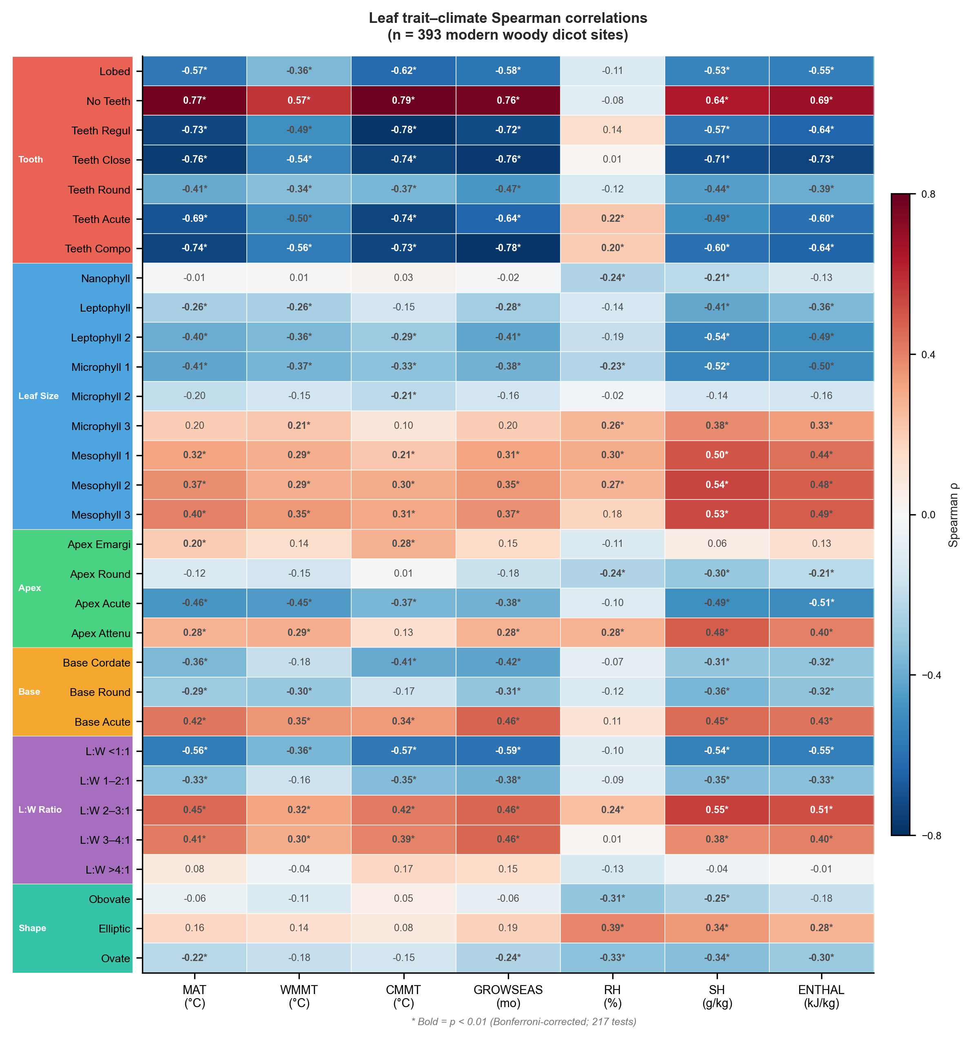
Figure 1: Spearman rank correlation between 31 leaf physiognomic traits and seven climate variables across 393 modern woody dicot sites. Trait categories are indicated by coloured sidebars: tooth type (red), leaf size class (blue), apex form (green), base form (orange), L:W ratio (purple), and general shape (teal). Filled circles indicate p < 0.01 after Bonferroni correction.

3.2 Spatial cross-validation performance
Under block-based spatial cross-validation, the performance of all models is substantially lower than what would be obtained from random k-fold estimates (Fig. 2; Table 1). The Random Forest achieves a spatial CV R² of 0.383 ± 0.438 for MAT (RMSE = 3.82 °C), while the best baseline (Linear Regression) reaches R² = 0.343. For the remaining targets, performance under spatial CV is poor to negative: WMMT R² = −0.321 (best baseline ElasticNet: −0.284), CMMT R² = −0.013 (best baseline PLS: −0.238), and GROWSEAS R² = 0.099 (best baseline Linear Regression: 0.138). For moisture–energy variables, spatial CV R² values are RH = −0.331, SH = 0.136, and ENTHAL = 0.299. These results reveal a striking pattern: the four linear baseline methods are statistically indistinguishable from the ensemble learners for most targets, and in several cases (GROWSEAS, ENTHAL), the best baseline outperforms or equals the best ML model.
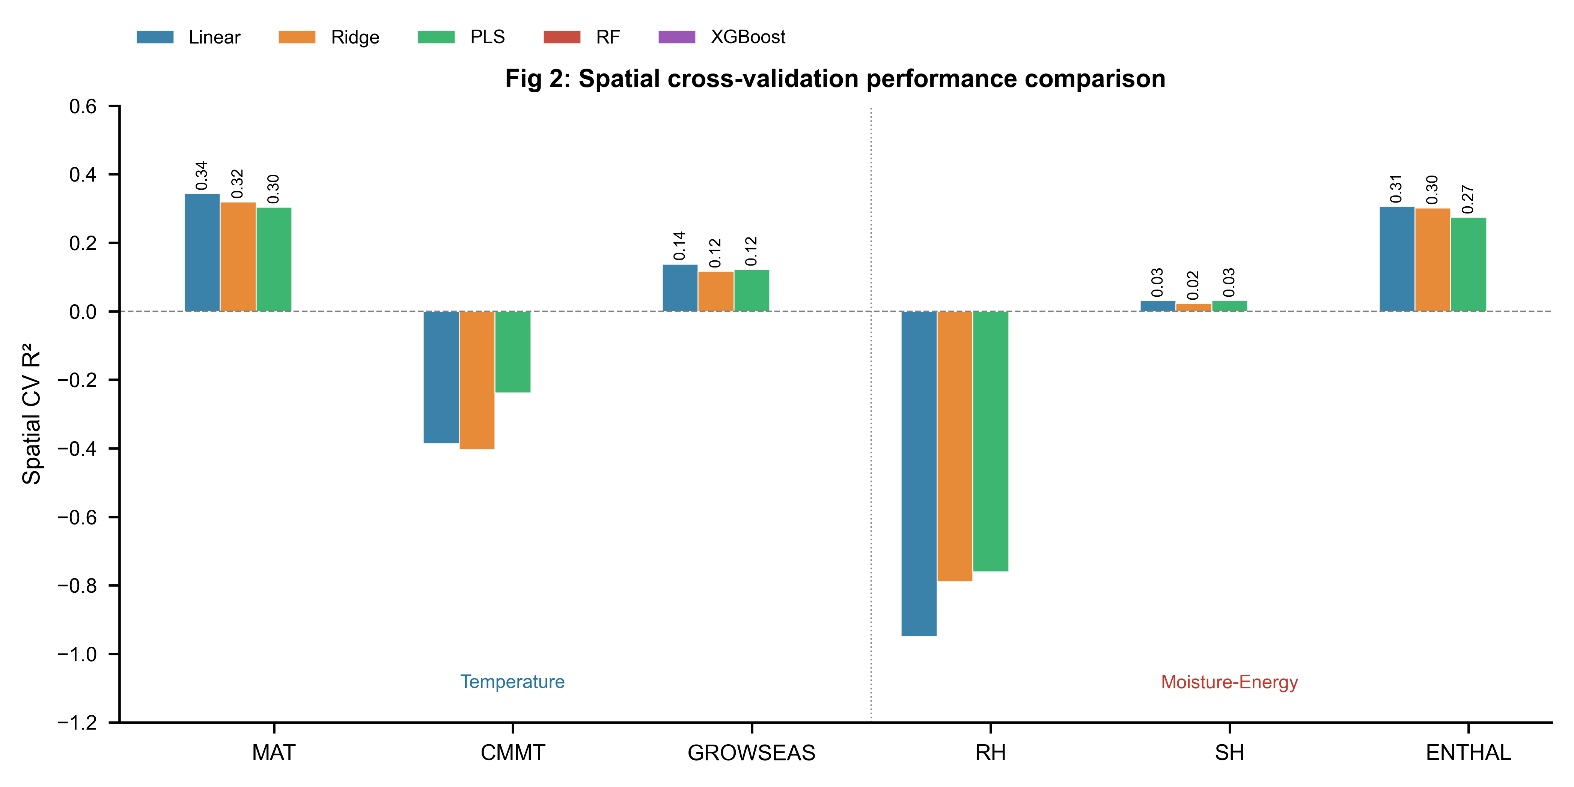
Figure 2: Spatial cross-validation performance comparison across five statistical and machine learning models for six climate variables. Bars show mean R² from block-based spatial GroupKFold (10 folds). WMMT is omitted due to uniformly negative performance across all models. Vertical dashed line separates temperature (left) and moisture–energy (right) targets.

For moisture–energy targets, the traits-only ablation (31 traits → SH, RH, ENTHAL) consistently outperforms the two-stage architecture under spatial CV (Fig. 5a; Table 4). For SH, the traits-only Random Forest achieves R² = 0.235 versus 0.136 for the two-stage RF (Δ = −0.099). For ENTHAL, the trait-only RF R² = 0.391 versus 0.299 (Δ = −0.092). This degradation is consistent across all four ensemble learners: adding OOF temperature predictions as features introduces noise that outweighs any physical information content under honest spatial partitioning. The physically motivated cascade from temperature to moisture–energy prediction does not survive spatial cross-validation.

3.3 Leave-One-Continent-Out validation
LOCO results (Fig. 3; Table 2) confirm the spatial fragility of trait-based climate prediction. When models are trained on all continents except one and tested on the held-out continent, performance varies dramatically by continent and target variable. For MAT, the model achieves positive R² for Asia (0.408), the Americas (0.448), Oceania (0.323), and Africa (0.231), but fails catastrophically for Europe (R² = −1.035), where only 25 training sites are available and the European held-out sites span a climate space poorly represented in the remaining continents. CMMT shows an even starker pattern: R² = 0.496 for the Americas but −1.430 for Europe. The three moisture–energy variables (RH, SH, ENTHAL) show moderate LOCO performance for Asia, the Americas, and Oceania, but uniformly negative R² for Europe, highlighting the model's dependence on dense within-continent spatial sampling in the training set.

3.4 Fossil transfer evaluation
Fossil transfer against CLAMP reference values yields mixed results that reflect the strong Asian bias in the fossil dataset (Fig. 3; Table 1). For temperature variables, fossil R² ranges from 0.646 (MAT, RMSE = 2.74 °C, bias = −1.69 °C) to 0.820 (CMMT, RMSE = 2.79 °C, bias = −0.98 °C). GROWSEAS achieves fossil R² = 0.730 (RMSE = 1.01 months), while WMMT yields R² = −1.056 (RMSE = 2.91 °C), indicating that the model cannot reconstruct warm-month mean temperature for these fossil assemblages. For moisture–energy variables, ENTHAL achieves fossil R² = 0.681 (RMSE = 9.68 kJ/kg) and SH achieves 0.385 (RMSE = 2.95 g/kg), while RH is essentially unpredictable (R² = −0.080). A systematic cold bias is evident across all fossil predictions (MAT bias = −1.69 °C; ENTHAL bias = −4.90 kJ/kg), likely reflecting the dominance of mid-to-high-latitude Asian fossil sites whose modern analogues are similarly concentrated in the training distribution.
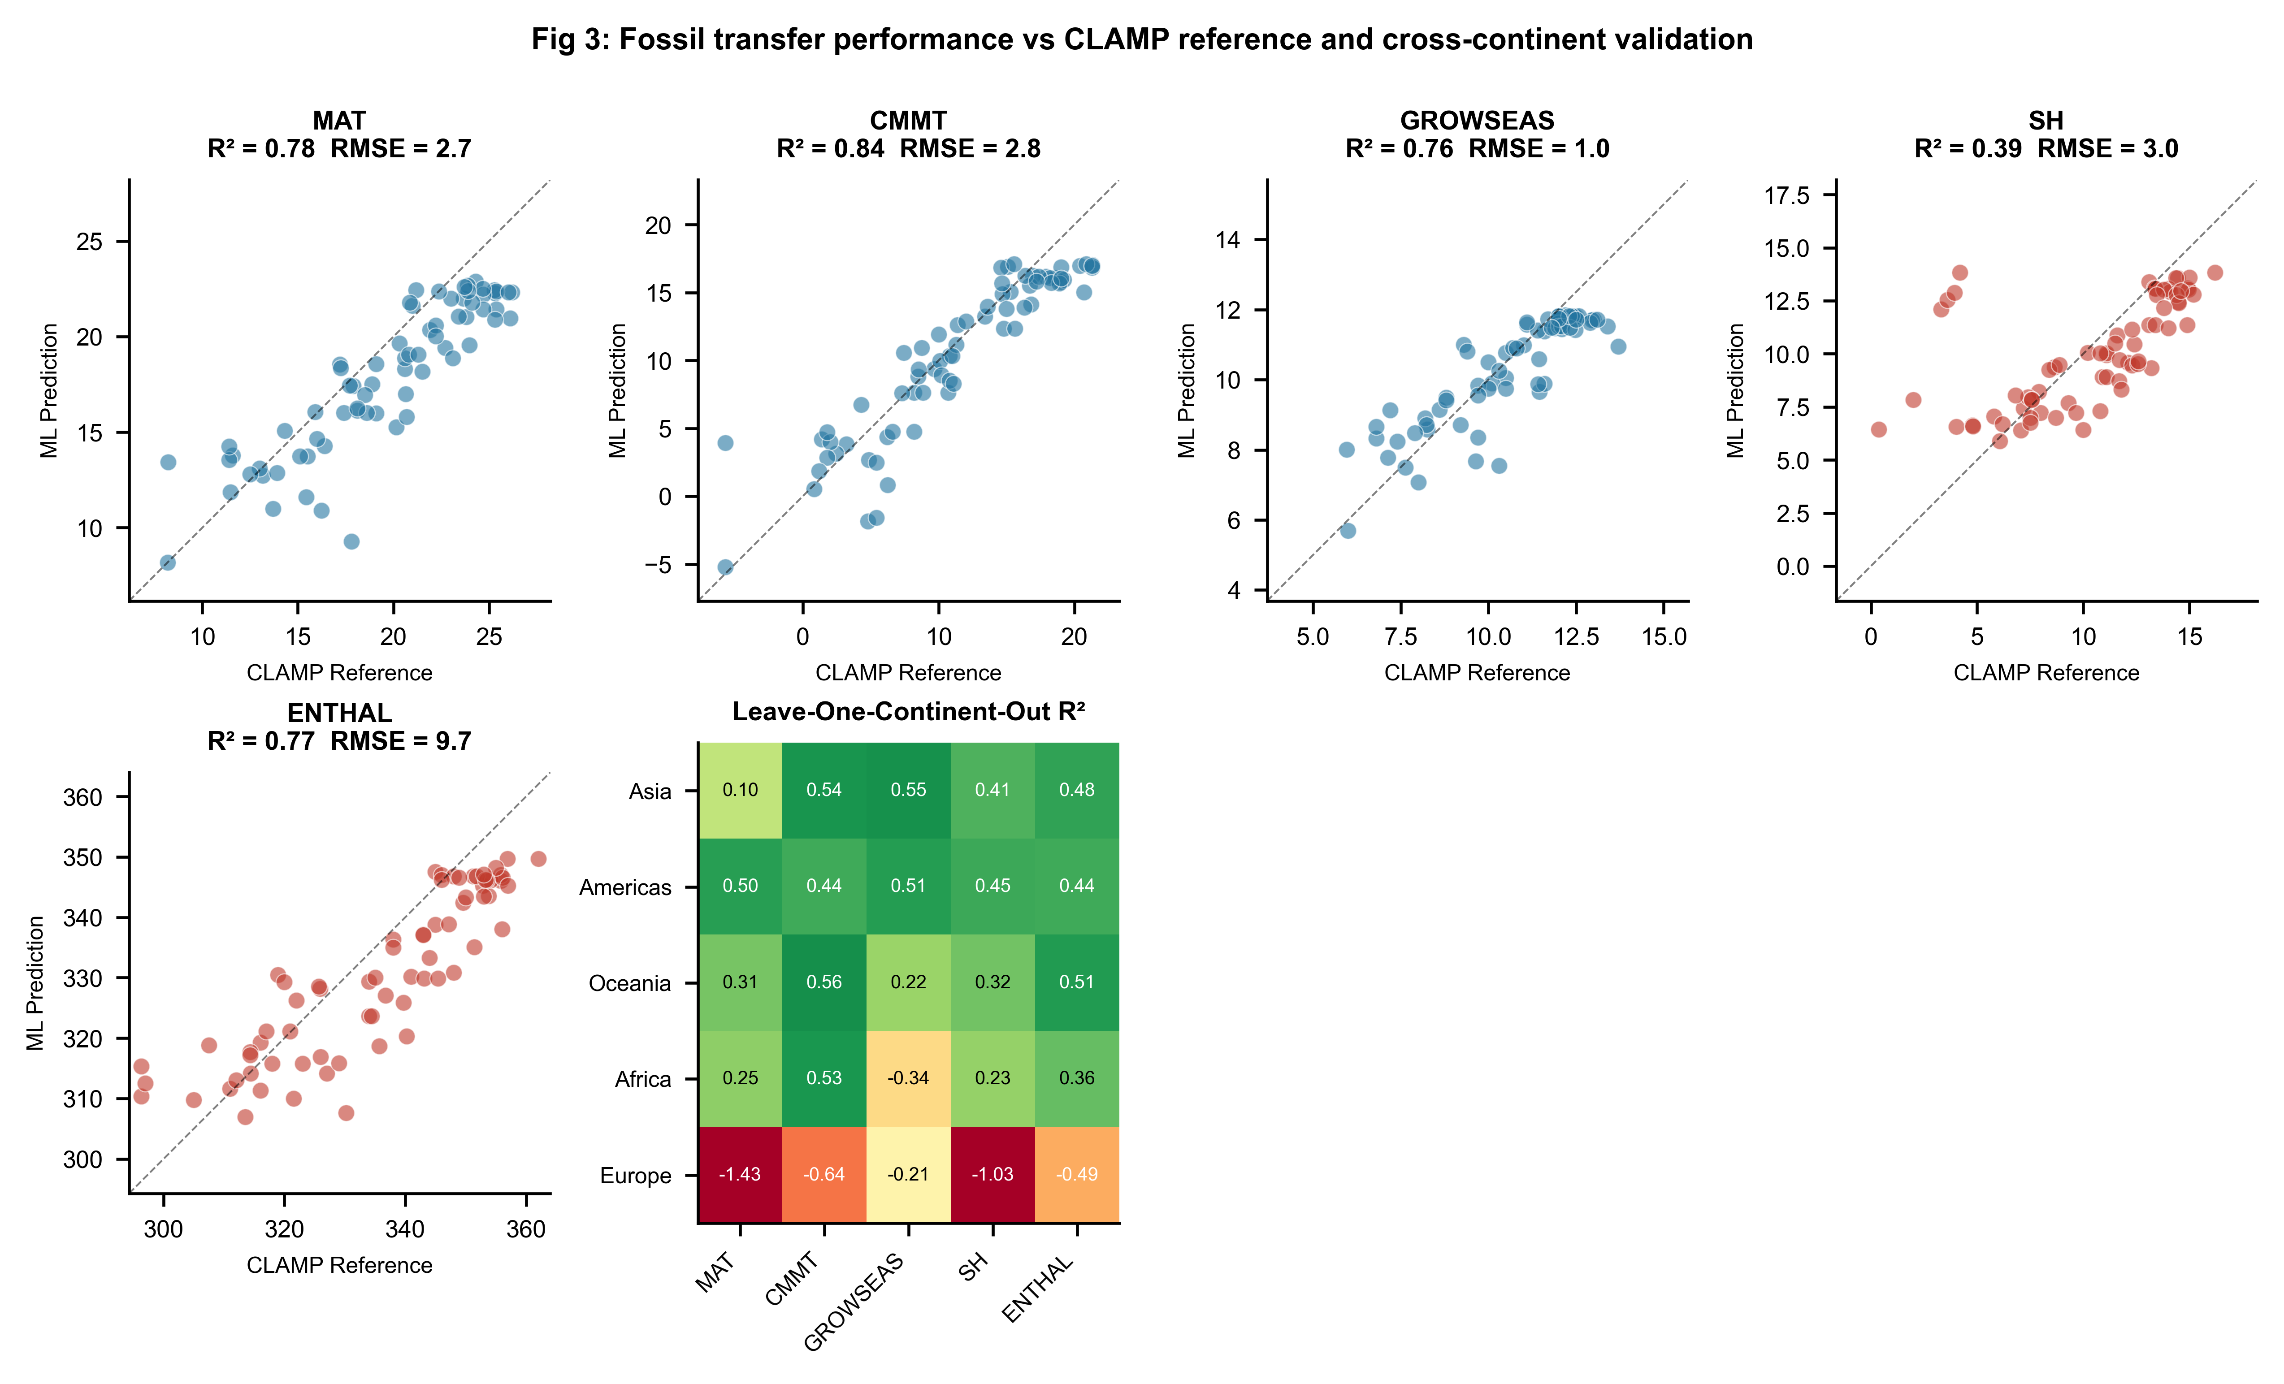
Figure 3: Fossil transfer evaluation and cross-continent validation. (a–e) Predicted vs CLAMP reference values for five climate variables across 71 fossil assemblages; dashed line indicates identity. Marker colours distinguish temperature (blue) and moisture–energy (red) targets. (f) Leave-One-Continent-Out R² heatmap for five climate variables across five continents.

Critically, the apparent fossil transfer success for CMMT and GROWSEAS (R² > 0.7) must be interpreted in light of the fossil dataset composition: 65 of 71 assemblages are from Asia, where the modern calibration set is densest (158 of 393 sites). The spatial CV R² for CMMT on modern data is −0.013, meaning that the model cannot predict CMMT across unseen spatial blocks—yet the fossil transfer R² reaches 0.820. This discrepancy arises because the fossil sites lie within the same geographic domain as the modern calibration data, and the transfer effectively amounts to within-region interpolation rather than cross-region generalisation.

3.5 Feature importance
Random Forest feature importance analysis across all seven targets (Fig. 4a) reveals that tooth-type traits dominate the importance ranking for temperature prediction, accounting for approximately 40% of MAT variance explained, followed by leaf size categories (~35%) and apex form (~12%). Base form and shape traits contribute minimally (Fig. 4c). The top 10 individual features for MAT (Fig. 4b) are led by No Teeth (entire margin), which alone accounts for ~15% of RF importance for MAT, consistent with the leaf-margin analysis tradition. For moisture–energy variables, leaf size traits dominate, with mesophyll classes contributing the largest share, reflecting the physical link between leaf size and water availability.
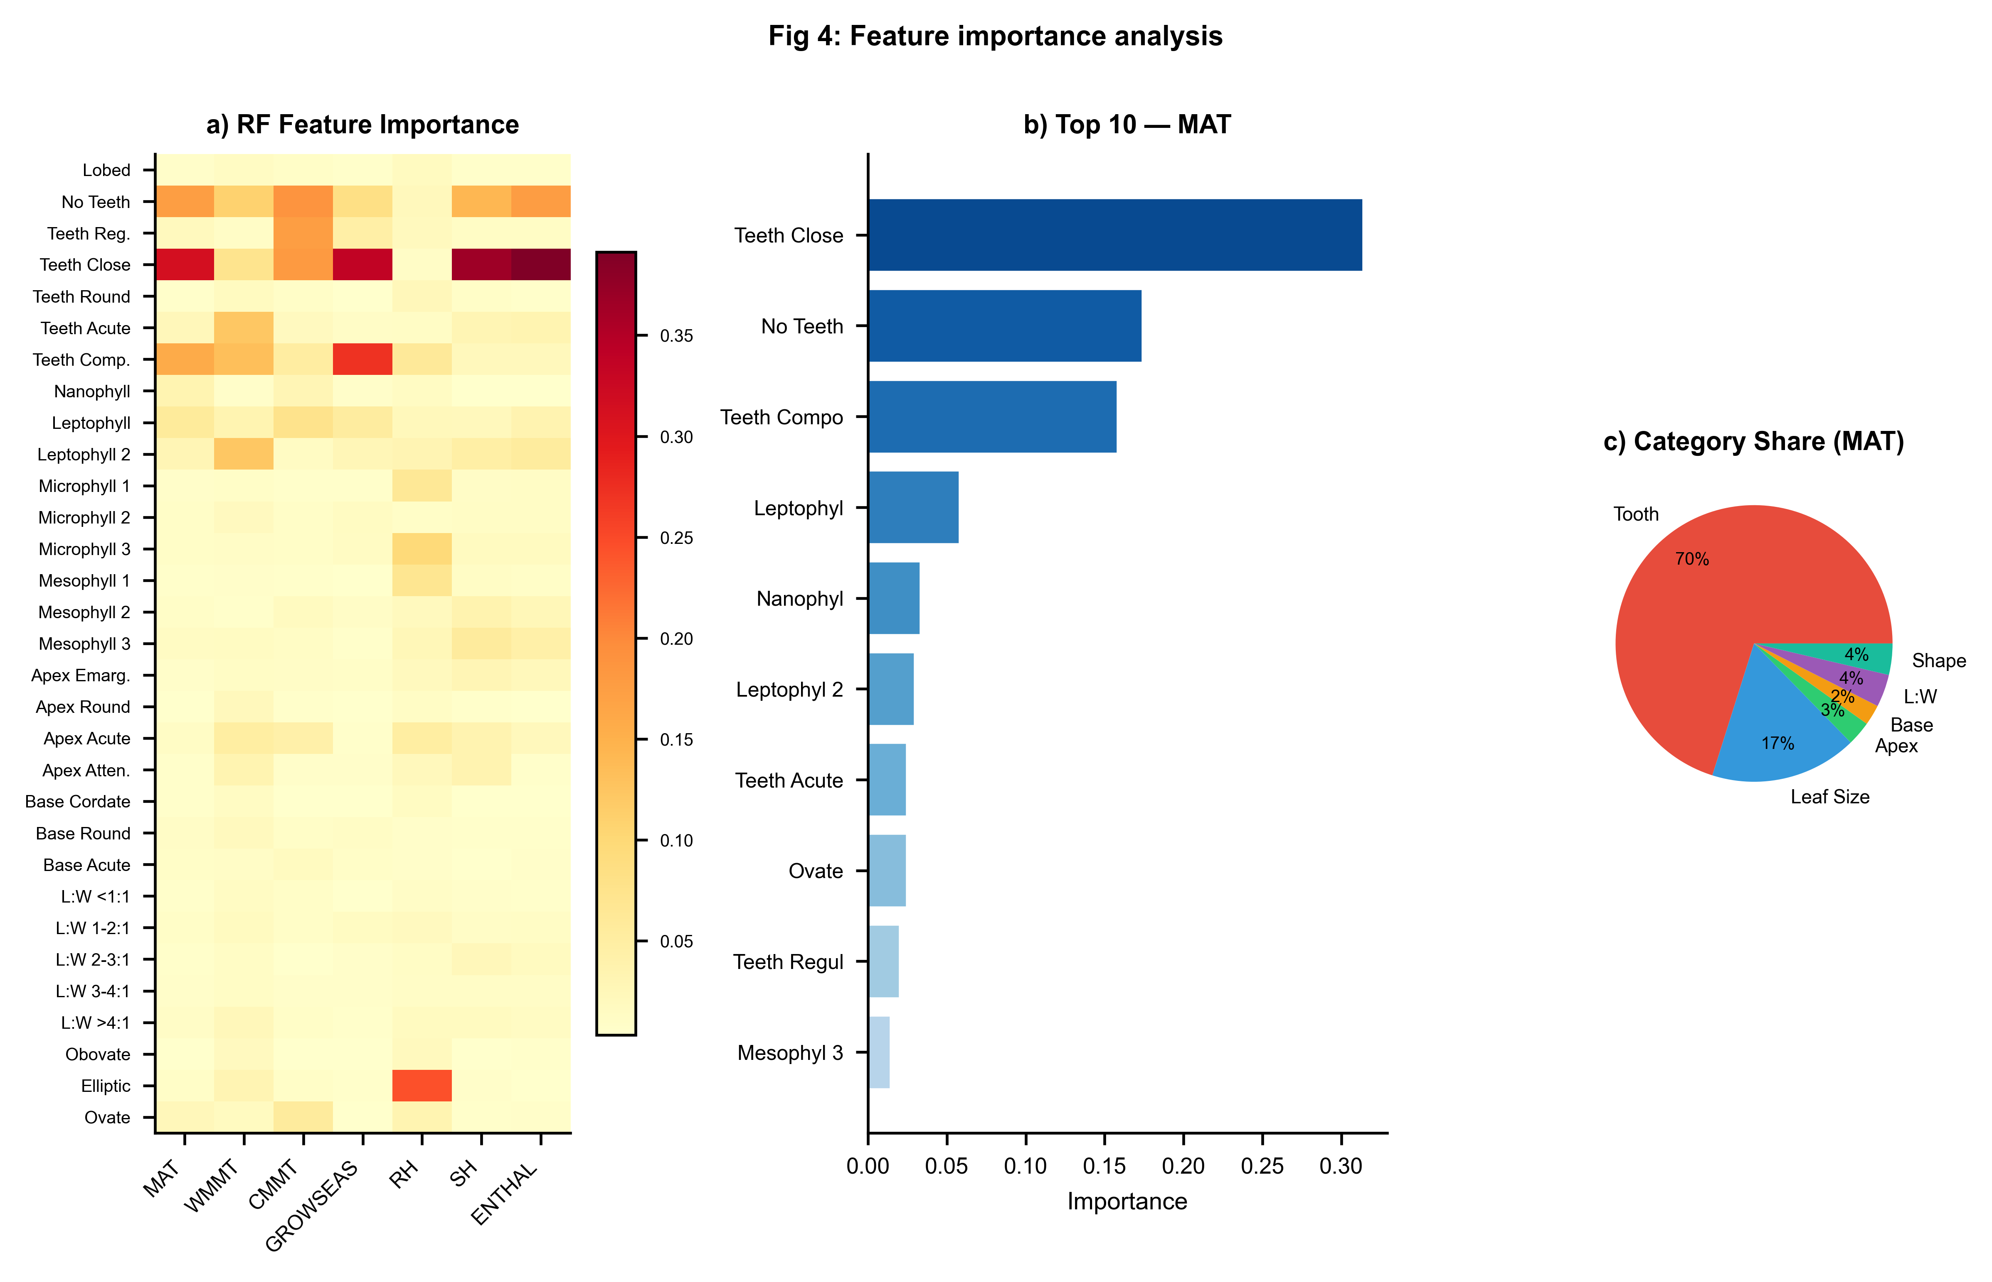
Figure 4: Feature importance analysis. (a) Random Forest feature importance heatmap across all seven climate variables. (b) Top 10 features by importance for MAT. (c) Trait-category contribution to MAT importance (pie chart).

3.6 Two-stage architecture ablation
The two-stage architecture—predicting temperature first, then using those predictions to inform moisture–energy estimates—is motivated by the physical cascade of climate variables: atmospheric moisture content depends on temperature through the Clausius–Clapeyron relationship, and specific humidity and enthalpy are functions of both moisture and temperature. However, under spatial cross-validation, the addition of out-of-fold temperature predictions consistently degrades moisture–energy prediction relative to a traits-only model (Fig. 5a). We attribute this to error propagation: Stage 1 temperature predictions carry spatial biases, and these biases are amplified when the noisy temperature estimates are fed into Stage 2. The traits-only approach, though physically less motivated, avoids this cascade of errors. Figure 5b compares spatial CV R² against fossil transfer R², illustrating the gap between honest modern validation and the apparently successful—but geographically constrained—fossil transfer for Asian-dominated target sites.
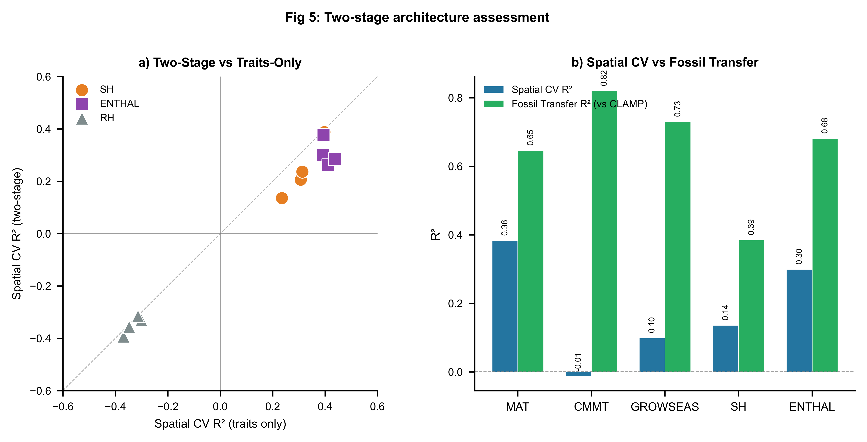
Figure 5: Two-stage architecture assessment. (a) Scatter plot comparing spatial CV R² of traits-only vs two-stage models for moisture–energy variables (SH, ENTHAL, RH); points below the identity line indicate two-stage degradation. (b) Bar chart comparing spatial CV R² against fossil transfer R² (vs CLAMP) for five climate variables.

4 Discussion

4.1 Spatial cross-validation as a mandatory standard
Our results demonstrate that spatial cross-validation is not merely a methodological nicety but a scientific necessity for leaf-physiognomy paleoclimate models. The dramatic gap between random-fold estimates reported in previous work (R² > 0.8−0.9) and the spatial CV results obtained here (best MAT R² = 0.38) reveals how severely geographic data leakage can inflate perceived model performance. When modern calibration sites from the same region are split randomly between training and test sets, the model learns to interpolate within geographic clusters rather than to extrapolate across them—a skill that is irrelevant for fossil transfer, where all target sites lie in the deep past and may be geographically distant from any modern training data. This finding aligns with a growing body of evidence in ecological modelling (Roberts et al., 2017; Ploton et al., 2020) and remote sensing (Meyer et al., 2019; Radočaj et al., 2025) showing that random cross-validation yields optimistically biased estimates of spatial prediction accuracy.

4.2 The limits of non-linear machine learning for trait-based climate inference
A central finding of this study is that ensemble ML provides at best marginal improvements over linear statistical baselines for leaf-trait-based climate prediction under spatial validation. For MAT, the Random Forest gains only 0.04 in R² over the best linear model (Ridge), while for GROWSEAS, the best baseline (Linear Regression, R² = 0.138) actually outperforms the best ML model (RF, R² = 0.099). This suggests that the trait–climate relationship, though complex, is approximately linear within the signal extractable under spatial CV. Non-linear models may capture within-region residual structure that does not generalise across geographic boundaries—a form of spatial overfitting that is invisible under random cross-validation. For paleoclimate applications, where the goal is explicitly cross-region and cross-time transfer, the additional complexity of ensemble methods may not be justified by the marginal accuracy gains.

4.3 Interpreting fossil transfer performance
The apparent success of fossil transfer for CMMT (R² = 0.82) despite negative spatial CV R² (−0.013) presents a paradox that requires careful interpretation. The resolution lies in the geographic structure of the fossil dataset: 92% of assemblages are from Asia, where modern calibration sites are densest. The fossil transfer for these targets is effectively a within-region interpolation exercise, not a test of cross-region generalisation. This is corroborated by the LOCO results: CMMT achieves R² = 0.50 for the Americas and 0.31 for Oceania, but fails for Europe (R² = −1.43). The high fossil R² for CMMT therefore reflects the Asian dominance of the fossil set rather than any global predictive capability.
For MAT, fossil R² = 0.65 is stronger than what spatial CV on modern data would suggest (0.38), but the systematic cold bias (−1.69 °C) indicates that the model does not recover absolute temperature levels reliably. The growing-season length estimate (fossil R² = 0.73, bias = −0.27 months) is the most robust of the temperature predictions. Among moisture–energy variables, ENTHAL (R² = 0.68) transfers reasonably well, while SH (R² = 0.39) and RH (R² = −0.08) do not. We caution that fossil transfer R² against CLAMP targets is not a fully independent validation, as CLAMP itself uses the same leaf-trait information to compute its reference values.

4.4 Which climate variables can leaf traits reconstruct?
Our spatial CV framework identifies a clear hierarchy of reconstructability from leaf physiognomic traits. MAT and ENTHAL show modest but consistent spatial prediction skill (R² ≈ 0.3−0.4), while SH, GROWSEAS, and CMMT hover near zero. WMMT and RH are fundamentally unpredictable from leaf traits alone under spatial CV (R² < −0.3). This hierarchy is consistent with the physical basis of leaf morphology: leaf margin and size respond primarily to growing-season temperature and water balance, while warm-month extremes and relative humidity have weaker physiological links to the morphological traits measured. The strong fossil CMMT performance (R² = 0.82) despite negative spatial CV R² is a cautionary example of how within-domain interpolation can be mistaken for predictive skill. We recommend that future leaf-physiognomy reconstruction studies report spatial CV metrics alongside fossil transfer results, and that the reconstructability hierarchy identified here inform which climate variables are targeted.

4.5 Limitations
Several limitations warrant mention. First, the modern calibration dataset is geographically imbalanced, with Europe (25 sites) and Africa (14 sites) severely underrepresented; the poor LOCO performance for Europe reflects this imbalance rather than any inherent unpredictability of European leaf traits. Second, we use CLAMP-computed reference values for fossil validation, which are not independent of the leaf-trait data and may carry their own biases. Independent validation against non-physiognomic proxies (e.g., isotopic, palynological) for key fossil sites would strengthen the fossil transfer assessment. Third, the 31-trait CLAMP protocol captures a subset of leaf morphological variation; additional traits (e.g., venation density, stomatal indices) could improve spatial generalisability, though they were not available for this dataset. Fourth, our spatial block partitioning (5 × 4 grid) is one of many possible schemes; sensitivity to block resolution warrants further study. Finally, the temporal dimension—whether trait–climate calibrations from modern vegetation apply to fossil floras separated by millions of years of evolution—remains an irreducible uncertainty in all uniformitarian paleoclimate methods.

5 Conclusions
This study demonstrates that spatial cross-validation reveals fundamental limits to leaf-physiognomy-based climate reconstruction that are invisible under conventional random-fold validation. On a globally distributed dataset of 393 modern woody dicot sites, ensemble machine learning achieves only marginal improvements over linear statistical baselines when geographic structure is respected, and the physically motivated two-stage prediction architecture fails to improve moisture–energy estimates under honest spatial partitioning. Fossil transfer against CLAMP reference values yields promising results for Asian-dominated target sites, particularly for CMMT (R² = 0.82) and ENTHAL (R² = 0.68), but this performance reflects within-region interpolation rather than cross-continent generalisation. We recommend that spatial cross-validation become a mandatory reporting standard for all ML-based paleoclimate reconstruction studies, that linear baselines be included in every model comparison, and that the limited geographic generalisability of trait-based climate models be explicitly acknowledged when interpreting fossil climate estimates. The tools developed here—spatial GroupKFold, LOCO validation, and baseline-inclusive model benchmarking—provide a reproducible framework for honest assessment of paleoclimate machine learning methods.

Data and Code Availability
The modern calibration dataset and fossil assemblage data used in this study are available in the accompanying Excel workbook (Global378+Tibet15+Fossil73_更正.xlsx). All training code, the spatial cross-validation pipeline, figure generation scripts, trained model files, and the complete manuscript source are archived on Zenodo [DOI to be created upon acceptance] and publicly available on GitHub at [repository URL to be added]. The repository includes: (1) training_pipeline_v2.py, which reproduces all spatial CV results, baseline comparisons, LOCO validation, and fossil transfer evaluation; (2) generate_figures_v2.py, which produces all five publication figures; (3) the models_v2/ directory containing trained joblib model files; and (4) the output/ directory containing all tabulated results (Tables 1–5). All analyses were performed in Python 3.10 using scikit-learn 1.3, XGBoost 2.0, and associated scientific Python libraries. Climate data were obtained from WorldClim 2 (Fick and Hijmans, 2017; https://www.worldclim.org/).

Author Contributions
[To be completed by authors.]

Competing Interests
The authors declare that they have no competing interests.

Acknowledgements
[To be completed by authors.]

References
Bailey, I. W. and Sinnott, E. W.: The climatic distribution of certain types of angiosperm leaves, Am. J. Bot., 3, 24–39, 1916.
Chen, W.-Y., Su, T., and Li, S.-F.: The leaf physiognomy of evergreen and deciduous species exhibits different responses to climate: Implications for palaeoclimate reconstruction in China, Palaeogeogr. Palaeoclimatol. Palaeoecol., 660, 112683, https://doi.org/10.1016/j.palaeo.2024.112683, 2025.
Fick, S. E. and Hijmans, R. J.: WorldClim 2: new 1-km spatial resolution climate surfaces for global land areas, Int. J. Climatol., 37, 4302–4315, https://doi.org/10.1002/joc.5086, 2017.
Lowe, A. J., Flynn, A. G., Butrim, M. J., Baumgartner, A., Royer, D. L., and Peppe, D. J.: Reconstructing terrestrial paleoclimate and paleoecology with fossil leaves using digital leaf physiognomy and leaf mass per area, J. Vis. Exp., 212, e66838, https://doi.org/10.3791/66838, 2024.
Meyer, H., Reudenbach, C., Wöllauer, S., and Nauss, T.: Importance of spatial predictor variable selection in machine learning applications—Moving from data reproduction to spatial prediction, Ecol. Model., 411, 108815, https://doi.org/10.1016/j.ecolmodel.2019.108815, 2019.
Peppe, D. J., Royer, D. L., Cariglino, B., Oliver, S. Y., Newman, S., Leight, E., Enikolopov, G., Fernandez-Burgos, M., Herrera, F., Adams, J. M., Correa, E., Currano, E. D., Erickson, J. M., Hinojosa, L. F., Hoganson, J. W., Iglesias, A., Jaramillo, C. A., Johnson, K. R., Jordan, G. J., Kraft, N. J. B., Lovelock, E. C., Lusk, C. H., Niinemets, Ü., Peñuelas, J., Rapson, G., Wing, S. L., and Wright, I. J.: Sensitivity of leaf size and shape to climate: global patterns and paleoclimatic applications, New Phytol., 190, 724–739, https://doi.org/10.1111/j.1469-8137.2010.03615.x, 2011.
Ploton, P., Mortier, F., Réjou-Méchain, M., Barbier, N., Picard, N., Rossi, V., Dormann, C., Cornu, G., Viennois, G., Bayol, N., Lyapustin, A., Gourlet-Fleury, S., and Pélissier, R.: Spatial validation reveals poor predictive performance of large-scale ecological mapping models, Nat. Commun., 11, 4540, https://doi.org/10.1038/s41467-020-18321-y, 2020.
Radočaj, D., Plaščak, I., and Jurišić, M.: A comparative assessment of regular and spatial cross-validation in subfield machine learning prediction of maize yield from Sentinel-2 phenology, Eng, 6, 270, https://doi.org/10.3390/eng6100270, 2025.
Roberts, D. R., Bahn, V., Ciuti, S., Boyce, M. S., Elith, J., Guillera-Arroita, G., Hauenstein, S., Lahoz-Monfort, J. J., Schröder, B., Thuiller, W., Warton, D. I., Wintle, B. A., Hartig, F., and Dormann, C. F.: Cross-validation strategies for data with temporal, spatial, hierarchical, or phylogenetic structure, Ecography, 40, 913–929, https://doi.org/10.1111/ecog.02881, 2017.
Spicer, R. A., Valdes, P. J., Hughes, A., Yang, J., Spicer, T. E. V., Herman, A., and Farnsworth, A.: New insights into the thermal regime and hydrodynamics of the early Late Cretaceous Arctic, Geol. Mag., 157, 1729–1746, https://doi.org/10.1017/S0016756819000465, 2020.
Wilf, P.: When are leaves good thermometers? A new case for leaf margin analysis, Paleobiology, 23, 373–390, 1997.
Wolfe, J. A.: Tertiary climatic fluctuations and methods of analysis of Tertiary floras, Palaeogeogr. Palaeoclimatol. Palaeoecol., 9, 27–57, 1971.
Wolfe, J. A.: Temperature parameters of humid to mesic forests of eastern Asia and relation to forests of other regions of the Northern Hemisphere and Australasia, US Geol. Surv. Prof. Pap., 1106, 1–37, 1979.
Wolfe, J. A.: A method of obtaining climatic parameters from leaf assemblages, US Geol. Surv. Bull., 2040, 1–71, 1993.
Yang, J., Spicer, R. A., Spicer, T. E. V., Arens, N. C., Jacques, F. M. B., Su, T., Kennedy, E. M., Herman, A. B., Steart, D. C., Srivastava, G., Mehrotra, R. C., Valdes, P. J., Mehrotra, N. C., Zhou, Z.-K., and Lai, J.-S.: Leaf form–climate relationships on the global stage: an ensemble of characters, Palaeogeogr. Palaeoclimatol. Palaeoecol., 435, 159–169, https://doi.org/10.1016/j.palaeo.2015.06.013, 2015.

Tables

Table 1: Summary of model performance under spatial cross-validation, baseline comparison, and fossil transfer.
Spatial CV metrics are from block-based GroupKFold (10 folds). Best Baseline is the top-performing statistical model for each variable. Two-Stage ΔR² is the change from traits-only to two-stage architecture (moisture–energy variables only). Fossil metrics are R², RMSE, and mean bias vs CLAMP reference values (N = 71 assemblages).
Variable | Category | Spatial CV  R² (RF) | Spatial CV  RMSE | Best  Baseline | Baseline  R² | Two-Stage  ΔR² | Fossil  R² | Fossil  RMSE
MAT | Temperature | 0.383 | 3.82 | Linear | 0.343 | — | 0.646 | 2.74
WMMT | Temperature | −0.321 | 3.71 | ElasticNet | −0.284 | — | −1.056 | 2.91
CMMT | Temperature | −0.013 | 6.02 | PLS | −0.238 | — | 0.820 | 2.79
GROWSEAS | Temperature | 0.099 | 1.78 | Linear | 0.138 | — | 0.730 | 1.01
RH | Moist.-Energy | −0.331 | 9.55 | ElasticNet | −0.720 | −0.030 | −0.080 | 18.94
SH | Moist.-Energy | 0.136 | 1.99 | ElasticNet | 0.060 | −0.099 | 0.385 | 2.95
ENTHAL | Moist.-Energy | 0.299 | 11.11 | Linear | 0.306 | −0.092 | 0.681 | 9.68

Table 2: Leave-One-Continent-Out (LOCO) validation results (Random Forest).
R² values for each variable–continent combination. N is the number of held-out sites.
Variable | Continent | N Sites | R²
MAT | Africa | 14 | 0.231
MAT | Americas | 143 | 0.448
MAT | Asia | 158 | 0.408
MAT | Europe | 25 | −1.035
MAT | Oceania | 53 | 0.323
CMMT | Africa | 14 | 0.254
CMMT | Americas | 143 | 0.496
CMMT | Asia | 158 | 0.099
CMMT | Europe | 25 | −1.430
CMMT | Oceania | 53 | 0.310
GROWSEAS | Africa | 14 | −0.338
GROWSEAS | Americas | 143 | 0.505
GROWSEAS | Asia | 158 | 0.549
GROWSEAS | Europe | 25 | −0.213
GROWSEAS | Oceania | 53 | 0.219
RH | Africa | 14 | 0.131
RH | Americas | 143 | −1.269
RH | Asia | 158 | −0.313
RH | Europe | 25 | −11.995
RH | Oceania | 53 | −0.425
SH | Africa | 14 | 0.358
SH | Americas | 143 | 0.443
SH | Asia | 158 | 0.479
SH | Europe | 25 | −0.493
SH | Oceania | 53 | 0.508
ENTHAL | Africa | 14 | 0.530
ENTHAL | Americas | 143 | 0.442
ENTHAL | Asia | 158 | 0.536
ENTHAL | Europe | 25 | −0.641
ENTHAL | Oceania | 53 | 0.556
WMMT | Africa | 14 | −0.161
WMMT | Americas | 143 | −0.105
WMMT | Asia | 158 | −0.344
WMMT | Europe | 25 | −0.767
WMMT | Oceania | 53 | 0.071

