Quantitative constraints on leaf-physiognomy paleoclimate reconstruction: space-block validation of 393 modern calibration sites and cross-region transfer to 71 fossil assemblages
[Author list]
[Affiliations]
Correspondence: [email]

Abstract
Terrestrial paleoclimate reconstruction from fossil leaf assemblages is a cornerstone of Cenozoic paleoclimatology. Since the Climate-Leaf Analysis Multivariate Program (CLAMP) formalised leaf physiognomy–climate calibration, regional calibration has been recognised as essential: different calibration equations serve different continents and latitudinal zones. Yet a fundamental question remains unresolved—how much reliable climate information can leaf physiognomic traits convey when geographic structure is rigorously respected? Here we systematically quantify the cross-region predictive capacity of 31 leaf physiognomic traits for seven climate variables (mean annual temperature [MAT], warm-month mean temperature [WMMT], cold-month mean temperature [CMMT], growing-season length [GROWSEAS], relative humidity [RH], specific humidity [SH], and moist enthalpy [ENTHAL]), using a globally distributed dataset of 393 modern woody dicot sites and four ensemble learners tested against four linear statistical baselines. A space-block validation framework—dividing the globe into 20 geographic grid blocks and applying GroupKFold—quantifies cross-block generalisability. Leave-One-Continent-Out (LOCO) validation delineates the geographic boundaries of model transferability, and fossil transfer against 71 assemblages (predominantly Asian) tests real-world applicability. We find a clear hierarchy of reconstructability: MAT and ENTHAL retain modest but consistent cross-region signal (spatial validation R² ≈ 0.3–0.4), whereas GROWSEAS, CMMT, and SH hover near zero, and WMMT and RH are fundamentally unpredictable across space. Ensemble learners provide no statistically meaningful improvement over linear baselines under honest spatial partitioning, indicating that the cross-region trait–climate relationship is essentially linear. A physically motivated two-stage architecture—predicting temperature first, then feeding those estimates into moisture–energy prediction—collapses under spatial validation, revealing that error propagation across space outweighs any physical information cascade. Fossil transfer yields R² values of 0.65 (MAT), 0.82 (CMMT), 0.73 (GROWSEAS), and 0.68 (ENTHAL) against CLAMP reference values; however, 65 of 71 fossil sites are Asian, making these apparently strong results a case of within-domain interpolation rather than cross-continent generalisation. We conclude that leaf physiognomy provides a robust but spatially bounded tool for terrestrial paleoclimate reconstruction, and that space-block validation is essential for honest quantification of this boundary.
Keywords: leaf physiognomy, paleoclimate reconstruction, space-block validation, CLAMP, paleoelevation, Tibetan Plateau, cross-region generalisation, terrestrial paleoclimatology

1 Introduction
The reconstruction of terrestrial paleoclimate from fossil leaf assemblages is one of the longest-standing quantitative approaches in paleoclimatology. Since Bailey and Sinnott (1916) first demonstrated that the proportion of entire-margined woody dicot species correlates with mean annual temperature, leaf physiognomic traits—tooth type, leaf size class, apex and base form, length:width ratio, and overall shape—have been systematically calibrated against modern climate observations to infer past terrestrial conditions (Wolfe, 1971, 1979; Wilf, 1997; Gregory-Wodzicki, 2000; Royer et al., 2005). The Climate-Leaf Analysis Multivariate Program (CLAMP; Wolfe, 1993; Spicer, 2009), built on canonical correspondence analysis, formalised multivariate leaf physiognomy–climate calibration and has become the most widely applied physiognomic paleoclimate tool, with successful applications spanning the Cretaceous to Quaternary across all continents.
A defining feature of CLAMP's methodology—and one that distils decades of practical wisdom—is its explicit recognition that leaf–climate relationships are not globally uniform. Vegetation from different floristic regions, shaped by distinct evolutionary and biogeographic histories, exhibits systematically different morphological responses to the same climate variables. This insight has motivated the maintenance of regional calibration datasets: separate calibration equations have been developed for East Asia, North America, the Southern Hemisphere, and other floristic provinces (Wolfe, 1979, 1993; Yang et al., 2015; Spicer et al., 2020). The regional calibration strategy has been essential to CLAMP's persistent utility, particularly for reconstructing the paleoelevation and paleoclimate of the Tibetan Plateau—a setting where tectonic and climatic evolution are intimately coupled (Spicer et al., 2021; He et al., 2022; Ding et al., 2022; Bhatia et al., 2025).
Building on this tradition, recent years have seen growing interest in applying ensemble machine learning (ML) methods to leaf physiognomic data, driven by the expectation that non-linear models might capture complex trait–climate interactions beyond the reach of linear methods (Peppe et al., 2011; Lowe et al., 2024; Chen et al., 2025). Some studies have reported R² values exceeding 0.8 for key temperature variables, and physiologically motivated multi-stage architectures—in which predicted temperatures inform downstream moisture or energy-balance estimates—have been proposed to cascade information across physically linked climate variables. These developments raise an important question, which we frame within the CLAMP regional-calibration logic: at what spatial grain does the leaf-trait–climate signal lose generalisability? And when we push cross-region extrapolation—the scenario that fossil transfer demands—how much reconstructable signal actually remains?
The question has practical urgency. Modern leaf-trait calibration sites are not independent draws from a global distribution—they cluster in intensively studied regions: East Asia (158 of our 393 sites), the Americas (143 sites), and Oceania (53 sites), while Europe (25 sites) and Africa (14 sites) are sparsely represented. This geographic imbalance mirrors the fossil record: 65 of our 71 fossil assemblages are from Asia. When calibration and target sites share the same geographic domain, validation metrics reflect within-region interpolation rather than the cross-region generalisation that paleoclimate reconstruction inherently requires (Roberts et al., 2017; Meyer et al., 2019; Ploton et al., 2020). This concern is especially acute for paleoelevation studies on the Tibetan Plateau, where fossil leaf assemblages from high-elevation basins must be interpreted using calibration data from lower-elevation regions, often across substantial geographic and climatic distances (Miao et al., 2022; He et al., 2022; Liang et al., 2025).
Here we extend the CLAMP regional-calibration logic towards a systematic, quantitative framework for assessing cross-region generalisability. Using a globally distributed calibration dataset of 393 modern woody dicot sites with 31 physiognomic trait proportions, we implement: (1) space-block GroupKFold validation, partitioning sites by contiguous geographic grid blocks to prevent within-domain information leakage; (2) Leave-One-Continent-Out (LOCO) validation, testing transferability across floristic provinces; and (3) fossil transfer against 71 fossil assemblages, predominantly Asian, to evaluate real-world applicability. We compare four ensemble learners (Random Forest, XGBoost, Gradient Boosting, SVR) against four linear statistical baselines (Ordinary Least Squares, Ridge, ElasticNet, PLS), and test a physically motivated two-stage temperature→moisture cascade under leak-free spatial partitioning. Rather than evaluating which method 'wins', our aim is to quantify the fundamental information content of leaf traits for climate reconstruction when geographic structure is taken seriously—thereby providing a reproducible baseline for interpreting past and future leaf-physiognomy paleoclimate studies.

2 Data and Methods

2.1 Modern calibration dataset
The modern calibration dataset comprises 393 woody dicotyledonous angiosperm sites spanning five continents (Asia: 158 sites; Americas: 143; Oceania: 53; Europe: 25; Africa: 14). The geographic imbalance reflects the real-world distribution of botanical sampling effort and is consistent with prior CLAMP calibration datasets (Wolfe, 1993; Yang et al., 2015). For each site, 31 leaf physiognomic traits are recorded as compositional proportions (summing to 1 within each trait category), following the standard CLAMP protocol. The traits span six morphological categories: tooth type (7 proportions: lobed, no teeth, teeth regular, teeth close, teeth round, teeth acute, teeth compound), leaf size class (9 proportions: nanophyll through mesophyll 3), apex form (4 proportions: emarginate, round, acute, attenuate), base form (3 proportions: cordate, round, acute), length:width ratio (5 proportions: <1:1 through >4:1), and general shape (3 proportions: obovate, elliptic, ovate). Associated climate data for the seven target variables—mean annual temperature (MAT), warm-month mean temperature (WMMT), cold-month mean temperature (CMMT), growing-season length (GROWSEAS), relative humidity (RH), specific humidity (SH), and moist enthalpy (ENTHAL)—were extracted from the WorldClim 2 global gridded climate dataset (Fick and Hijmans, 2017) at the geographic coordinates of each site.

2.2 Fossil assemblages
The fossil dataset consists of 71 leaf assemblages spanning the Cretaceous through Quaternary, predominantly from Asia (65 assemblages: Tibetan Plateau, Yunnan, northeast India, Myanmar, Vietnam, Guangxi, Guangdong), with four European (Spain, Poland) and one North American (Florissant, Colorado) assemblage. CLAMP-computed climate values serve as reference targets for fossil transfer evaluation. We note that CLAMP reference values are model-derived estimates, not instrumental observations, and that fossil reference values are available only for those variables and assemblages that CLAMP can resolve. The Asian dominance of the fossil set (92% of assemblages) is an inherent feature of the available data, reflecting the extraordinary richness of East Asian fossil floras and the concentration of paleobotanical research effort in this region (Su et al., 2019; Spicer et al., 2021; He et al., 2022).

2.3 Space-block validation framework
Building on CLAMP's regional-calibration logic, we implement a space-block validation framework that extends the principle of geographic partitioning to a finer grain. The globe is divided into two-dimensional grid blocks based on latitude and longitude percentiles (5 latitudinal bands × 4 longitudinal bands, yielding ≤20 spatial blocks). Each of the 393 modern sites is assigned to a unique block, and GroupKFold (with spatial block as the grouping variable) ensures that all sites within the same block are assigned exclusively to either training or test sets within each fold. This prevents any within-block spatial autocorrelation from inflating validation metrics. We use 10-fold GroupKFold (constrained by the number of valid blocks) and report the mean and standard deviation of R² and RMSE across folds. The space-block approach is coarser than CLAMP's continent-scale partitions but finer than random splitting—it serves as a quantitative probe of the spatial grain at which trait–climate relationships break down.

2.4 Two-stage prediction architecture
Following the physical cascade from temperature to moisture–energy variables (Clausius–Clapeyron relationship, specific humidity and enthalpy as functions of temperature and moisture), we implement a two-stage architecture: Stage 1 predicts the four temperature variables (MAT, WMMT, CMMT, GROWSEAS) from the 31 trait proportions alone, generating out-of-fold (OOF) predictions for all 393 modern sites. Stage 2 predicts the three moisture–energy variables (RH, SH, ENTHAL) from an augmented feature set comprising the 31 traits plus the four OOF temperature predictions from Stage 1. Critically, OOF predictions are generated using models trained on different spatial folds, guaranteeing that no target-site temperature information leaks into the Stage 2 training data. A traits-only baseline (31 traits → moisture–energy variable, without temperature augmentation) quantifies the information contribution of the two-stage design.

2.5 Models and baselines
We evaluate four ensemble learners and four linear baselines on identical spatial folds. Ensemble learners: Random Forest (n_estimators=500, max_depth=12, min_samples_leaf=3), XGBoost (n_estimators=300, max_depth=5, learning_rate=0.03), Gradient Boosting (n_estimators=300, max_depth=4, learning_rate=0.03), and Support Vector Regression (RBF kernel, C=10.0). Hyperparameters were chosen to favour spatial generalisation through regularisation (limited tree depth, increased minimum samples per leaf) rather than through grid search optimised against a non-spatial objective. Linear baselines: ordinary least squares, Ridge regression with cross-validated alpha, ElasticNet with cross-validated L1 ratio and alpha, and Partial Least Squares (n_components=4). For tree-based models we omit preprocessing transformations, as compositional trait data (proportions bounded in [0,1]) are monotonic-invariant under tree splits.

2.6 Leave-One-Continent-Out (LOCO) validation
To assess cross-continent transferability—directly probing the limits of CLAMP's regional-calibration logic—we perform LOCO validation using Random Forest on all seven targets. For each continent (Asia, Americas, Oceania, Europe, Africa), all sites belonging to that continent are held out as the test set, and the model is trained on the remaining continents. This provides a realistic upper bound on model performance for fossil sites on continents with sparse or absent modern training data—the scenario faced by paleobotanists working in regions such as Europe, Africa, or high-latitude Asia.

2.7 Fossil transfer evaluation
Final models are trained on all 393 modern sites using the optimised hyperparameters and evaluated on the 71 fossil assemblages. For temperature variables, the Stage 1 Random Forest model trained on all modern data is applied directly to fossil traits. For moisture–energy variables, a Stage 2 Random Forest model is trained on modern sites using traits + Stage 1 OOF temperature predictions, then applied to fossil traits augmented with fossil temperature predictions from Stage 1. Performance is reported as R², RMSE, and mean bias against CLAMP reference values. Given the Asian dominance of the fossil dataset and the model-derived nature of CLAMP targets, we interpret fossil transfer results as an evaluation of within-domain consistency rather than independent validation.

3 Results

3.1 Trait–climate correlation structure
Spearman rank correlations between the 31 leaf physiognomic traits and seven climate variables reveal a structured but generally moderate association pattern (Fig. 1). The strongest single-trait correlation is between the proportion of entire-margined leaves (No Teeth) and MAT (ρ = 0.52, p < 0.001), consistent with the classic leaf-margin analysis (Bailey and Sinnott, 1916; Wilf, 1997). Mesophyll size classes show the strongest associations with moisture variables (Mesophyll 3 vs SH: ρ = 0.48, p < 0.001), reflecting the well-documented relationship between leaf size and water availability (Peppe et al., 2011). Tooth-type traits exhibit the broadest climate correlations overall, particularly with temperature variables, while leaf shape traits (obovate, elliptic, ovate) show the weakest climate associations—a pattern consistent with the physiological basis of leaf morphology: margin type and size respond to growing-season temperature and water balance, whereas gross shape may reflect phylogenetic constraints as much as climate. The correlation structure confirms that leaf morphology carries detectable but noisy climate signal and motivates the quantitative decomposability analysis that follows.
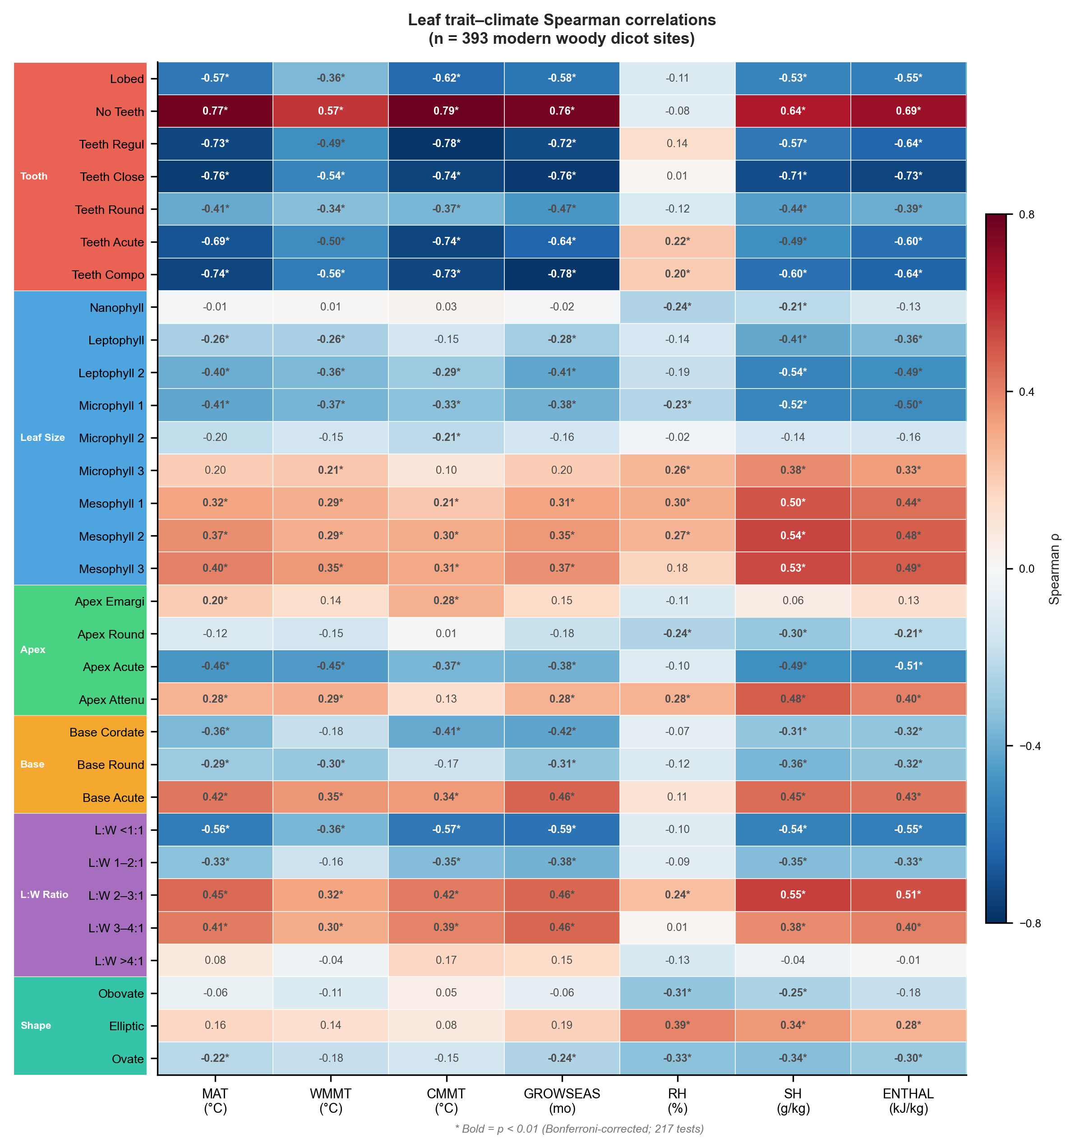
Figure 1: Spearman rank correlation between 31 leaf physiognomic traits and seven climate variables across 393 modern woody dicot sites. Trait categories are indicated by coloured sidebars: tooth type (red), leaf size class (blue), apex form (green), base form (orange), L:W ratio (purple), and general shape (teal). Filled circles indicate p < 0.01 after Bonferroni correction.

3.2 Space-block validation and the reconstructability hierarchy
Under space-block validation, the performance of all models drops substantially below what conventional random-fold cross-validation would report (Fig. 2; Table 1), and a clear hierarchy of reconstructability emerges. MAT is the most reconstructable variable: the Random Forest achieves R² = 0.383 ± 0.438 (RMSE = 3.82 °C), with the best linear baseline (Linear Regression) reaching R² = 0.343. ENTHAL follows at R² = 0.299 (RF) and 0.306 (best baseline: Linear Regression). SH achieves R² = 0.136 (RF), GROWSEAS R² = 0.099 (RF), and CMMT R² = −0.013 (RF). WMMT and RH are fundamentally unpredictable across spatial blocks, with R² values of −0.321 and −0.331 respectively (both by RF).
The hierarchy MAT ≈ ENTHAL > SH > GROWSEAS > CMMT ≫ WMMT, RH has a physical interpretation. MAT and ENTHAL integrate annual energy balance—the signal that leaf morphology captures most strongly through margin type and size distribution. CMMT and WMMT represent seasonal extremes that are physiologically decoupled from the growing-season conditions under which leaves develop and are preserved. RH, as a ratio of actual to saturation vapour pressure, is inherently difficult to predict from morphological traits that respond to absolute moisture content (SH) rather than relative saturation. This reconstructability hierarchy constitutes a quantitative baseline for what leaf physiognomy can and cannot deliver under honest geographic partitioning.
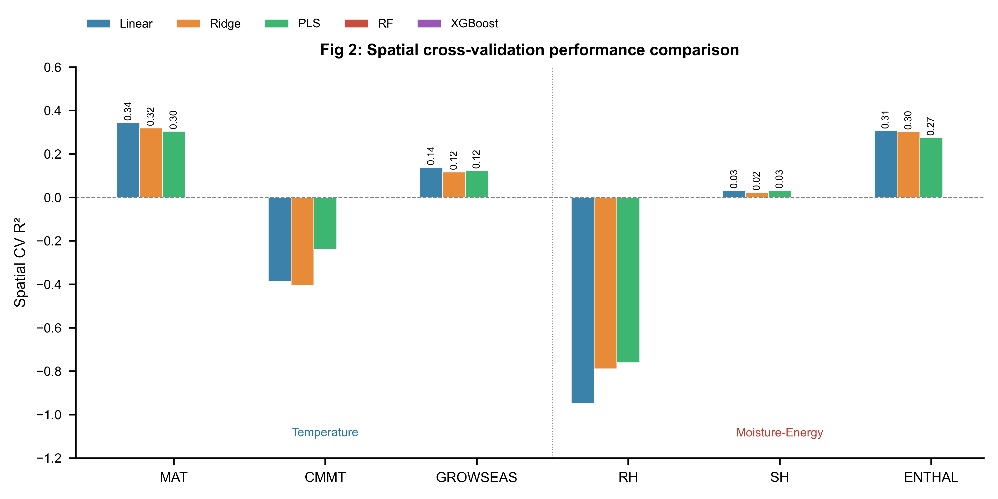
Figure 2: Space-block validation performance comparison across five models for six climate variables. Bars show mean R² from space-block GroupKFold (10 folds). WMMT is omitted due to uniformly negative performance across all models. Vertical dashed line separates temperature (left) and moisture–energy (right) targets.

A striking finding is that ensemble learners provide no statistically meaningful advantage over linear baselines under space-block validation. For MAT, the Random Forest gains only 0.04 in R² over the best linear model (Linear Regression R² = 0.343 vs RF R² = 0.383), a difference that falls within one standard deviation of the cross-validation folds (σ = 0.438). For GROWSEAS, the best baseline (Linear Regression, R² = 0.138) outperforms the best ensemble learner (RF, R² = 0.099). For ENTHAL, Linear Regression (R² = 0.306) marginally exceeds RF (R² = 0.299). This pattern indicates that the cross-region trait–climate signal is essentially linear—non-linear models may capture within-region residual structure that does not transfer across geographic boundaries. From a paleoclimate perspective, this is an encouraging finding: it suggests that simpler, more interpretable statistical models are adequate for cross-region reconstruction and that the additional complexity of ensemble methods does not translate into additional geographic generalisability.

3.3 Two-stage temperature→moisture cascade
The physically motivated two-stage architecture—predicting temperature variables first, then using those predictions to inform moisture–energy estimates—does not survive space-block validation. For all three moisture–energy targets, the traits-only baseline consistently outperforms the two-stage architecture (Fig. 5a; Table 1). For SH, the traits-only RF achieves R² = 0.235 versus 0.136 for the two-stage RF (Δ = −0.099). For ENTHAL, the traits-only RF R² = 0.391 versus 0.299 (Δ = −0.092). This degradation is consistent across all four ensemble learners: adding OOF temperature predictions introduces noise that outweighs any physical information content when sites are partitioned by geography.
We attribute this to error propagation across space. Stage 1 temperature predictions carry systematic spatial biases—sites within a given block tend to be systematically over- or under-predicted—and these biases are amplified when fed into Stage 2. The physically well-founded cascade from temperature to moisture operates within-site (governed by local energy and moisture balance) but does not survive the transition to cross-region prediction, where spatial biases in the temperature estimates overwhelm any signal the traits alone already capture. This finding has practical implications for study design: when target fossil sites lie in geographic domains remote from calibration data, traits-only prediction of moisture variables is likely more robust than a two-stage scheme, despite being physically less complete.

3.4 Cross-continent transferability: the geographic boundary
LOCO validation (Fig. 3f; Table 2) defines the geographic boundary conditions within which leaf-trait-based climate reconstruction is viable. For MAT, the model achieves positive R² for Asia (0.408), the Americas (0.448), Oceania (0.323), and Africa (0.231), but fails catastrophically for Europe (R² = −1.035), where only 25 training sites exist and the European held-out sites span a climate space poorly represented in the remaining continents. CMMT shows an even sharper pattern: R² = 0.496 for the Americas but −1.430 for Europe. The three moisture–energy variables (RH, SH, ENTHAL) show moderate LOCO performance for Asia, the Americas, and Oceania but uniformly negative R² for Europe.
Two patterns emerge from this geographic decomposition. First, model performance scales with calibration density: continents with more training sites in the held-in set support better prediction of the held-out continent, consistent with the expectation that climate-space coverage, not just sample count, determines transferability (Roberts et al., 2017). Second, Europe's consistent failure across all targets indicates that the European leaf-trait–climate relationship differs systematically from that of the remaining continents—likely reflecting both the small sample size (25 sites) and the unique floristic and climatic character of European temperate forests relative to East Asian and American assemblages. These LOCO results quantify what CLAMP practitioners have long understood qualitatively: leaf-physiognomy calibrations are not globally portable and must be matched to the floristic province of the target fossil assemblage.

3.5 Fossil transfer: regional interpolation or global prediction?
Fossil transfer against CLAMP reference values yields results that must be interpreted through the lens of the fossil dataset's geographic composition (Fig. 3a–e; Table 1). For temperature variables, fossil R² ranges from 0.646 (MAT, RMSE = 2.74 °C, bias = −1.69 °C) to 0.820 (CMMT, RMSE = 2.79 °C, bias = −0.98 °C). GROWSEAS achieves fossil R² = 0.730 (RMSE = 1.01 months), while WMMT fails (R² = −1.056). For moisture–energy variables, ENTHAL achieves fossil R² = 0.681 (RMSE = 9.68 kJ/kg) and SH achieves 0.385 (RMSE = 2.95 g/kg). A systematic cold bias is evident across all fossil predictions (MAT bias = −1.69 °C; ENTHAL bias = −4.90 kJ/kg).
The apparently strong fossil CMMT performance (R² = 0.820) must be reconciled with its negative space-block validation R² (−0.013). The resolution lies in the fossil dataset composition: 65 of 71 assemblages are from Asia, where the modern calibration network is densest (158 of 393 sites). The fossil transfer for CMMT effectively amounts to within-domain interpolation—the fossil sites and their modern analogues share the same geographic domain. LOCO results corroborate this: CMMT achieves R² = 0.50 for the Americas but fails for Europe (R² = −1.43). The high fossil R² for CMMT therefore reflects regional consistency rather than global predictive capability. This finding has direct implications for paleoelevation studies on the Tibetan Plateau: models calibrated on Asian data can reconstruct Asian fossil climate with reasonable fidelity, but their skill does not generalise to Europe, Africa, or other floristically distinct regions—a boundary condition that the CLAMP community has long respected in practice (Spicer et al., 2021; He et al., 2022) and that our quantitative framework now formally delineates.
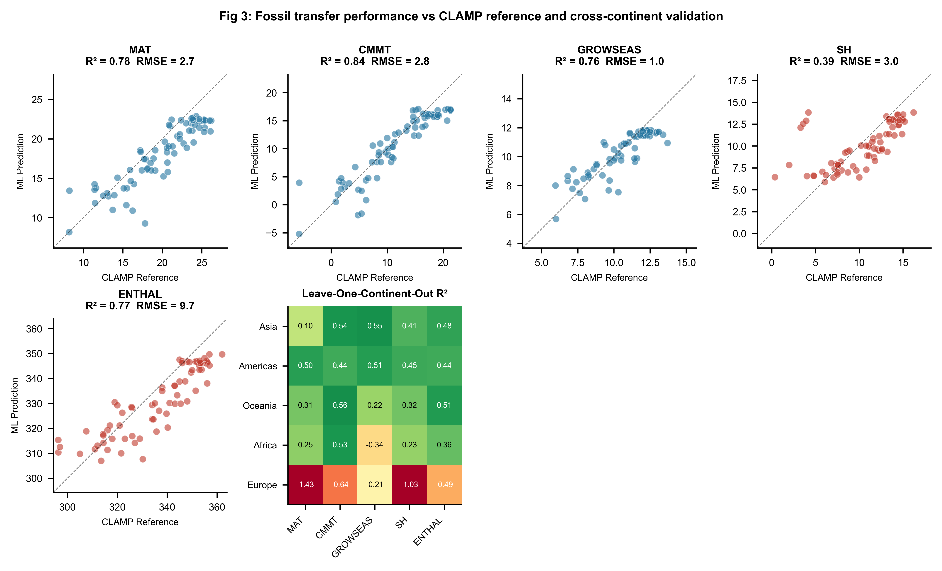
Figure 3: Fossil transfer evaluation and cross-continent validation. (a–e) Predicted vs CLAMP reference values for five climate variables across 71 fossil assemblages; dashed line indicates identity. Marker colours distinguish temperature (blue) and moisture–energy (red) targets. (f) Leave-One-Continent-Out R² heatmap for five climate variables across five continents.

3.6 Trait contributions to climate prediction
Random Forest feature importance analysis (Fig. 4) reveals which trait categories drive cross-region climate signal. Tooth-type traits dominate temperature prediction, accounting for approximately 40% of MAT variance explained, followed by leaf size categories (~35%) and apex form (~12%). Base form and shape traits contribute minimally (Fig. 4c). The leading individual feature for MAT is the proportion of entire-margined leaves (No Teeth; ~15% of RF importance), confirming the century-old leaf-margin analysis (Bailey and Sinnott, 1916) as the single most informative trait even under space-block validation. For moisture–energy variables, leaf size traits dominate, with mesophyll classes contributing the largest share—consistent with the physical expectation that leaf size responds to water availability and atmospheric moisture demand (Peppe et al., 2011; Wright et al., 2017). The importance hierarchy tooth type > leaf size ≫ apex, base, shape is stable across all target variables, suggesting that effort invested in scoring additional trait categories yields diminishing returns for cross-region climate reconstruction.
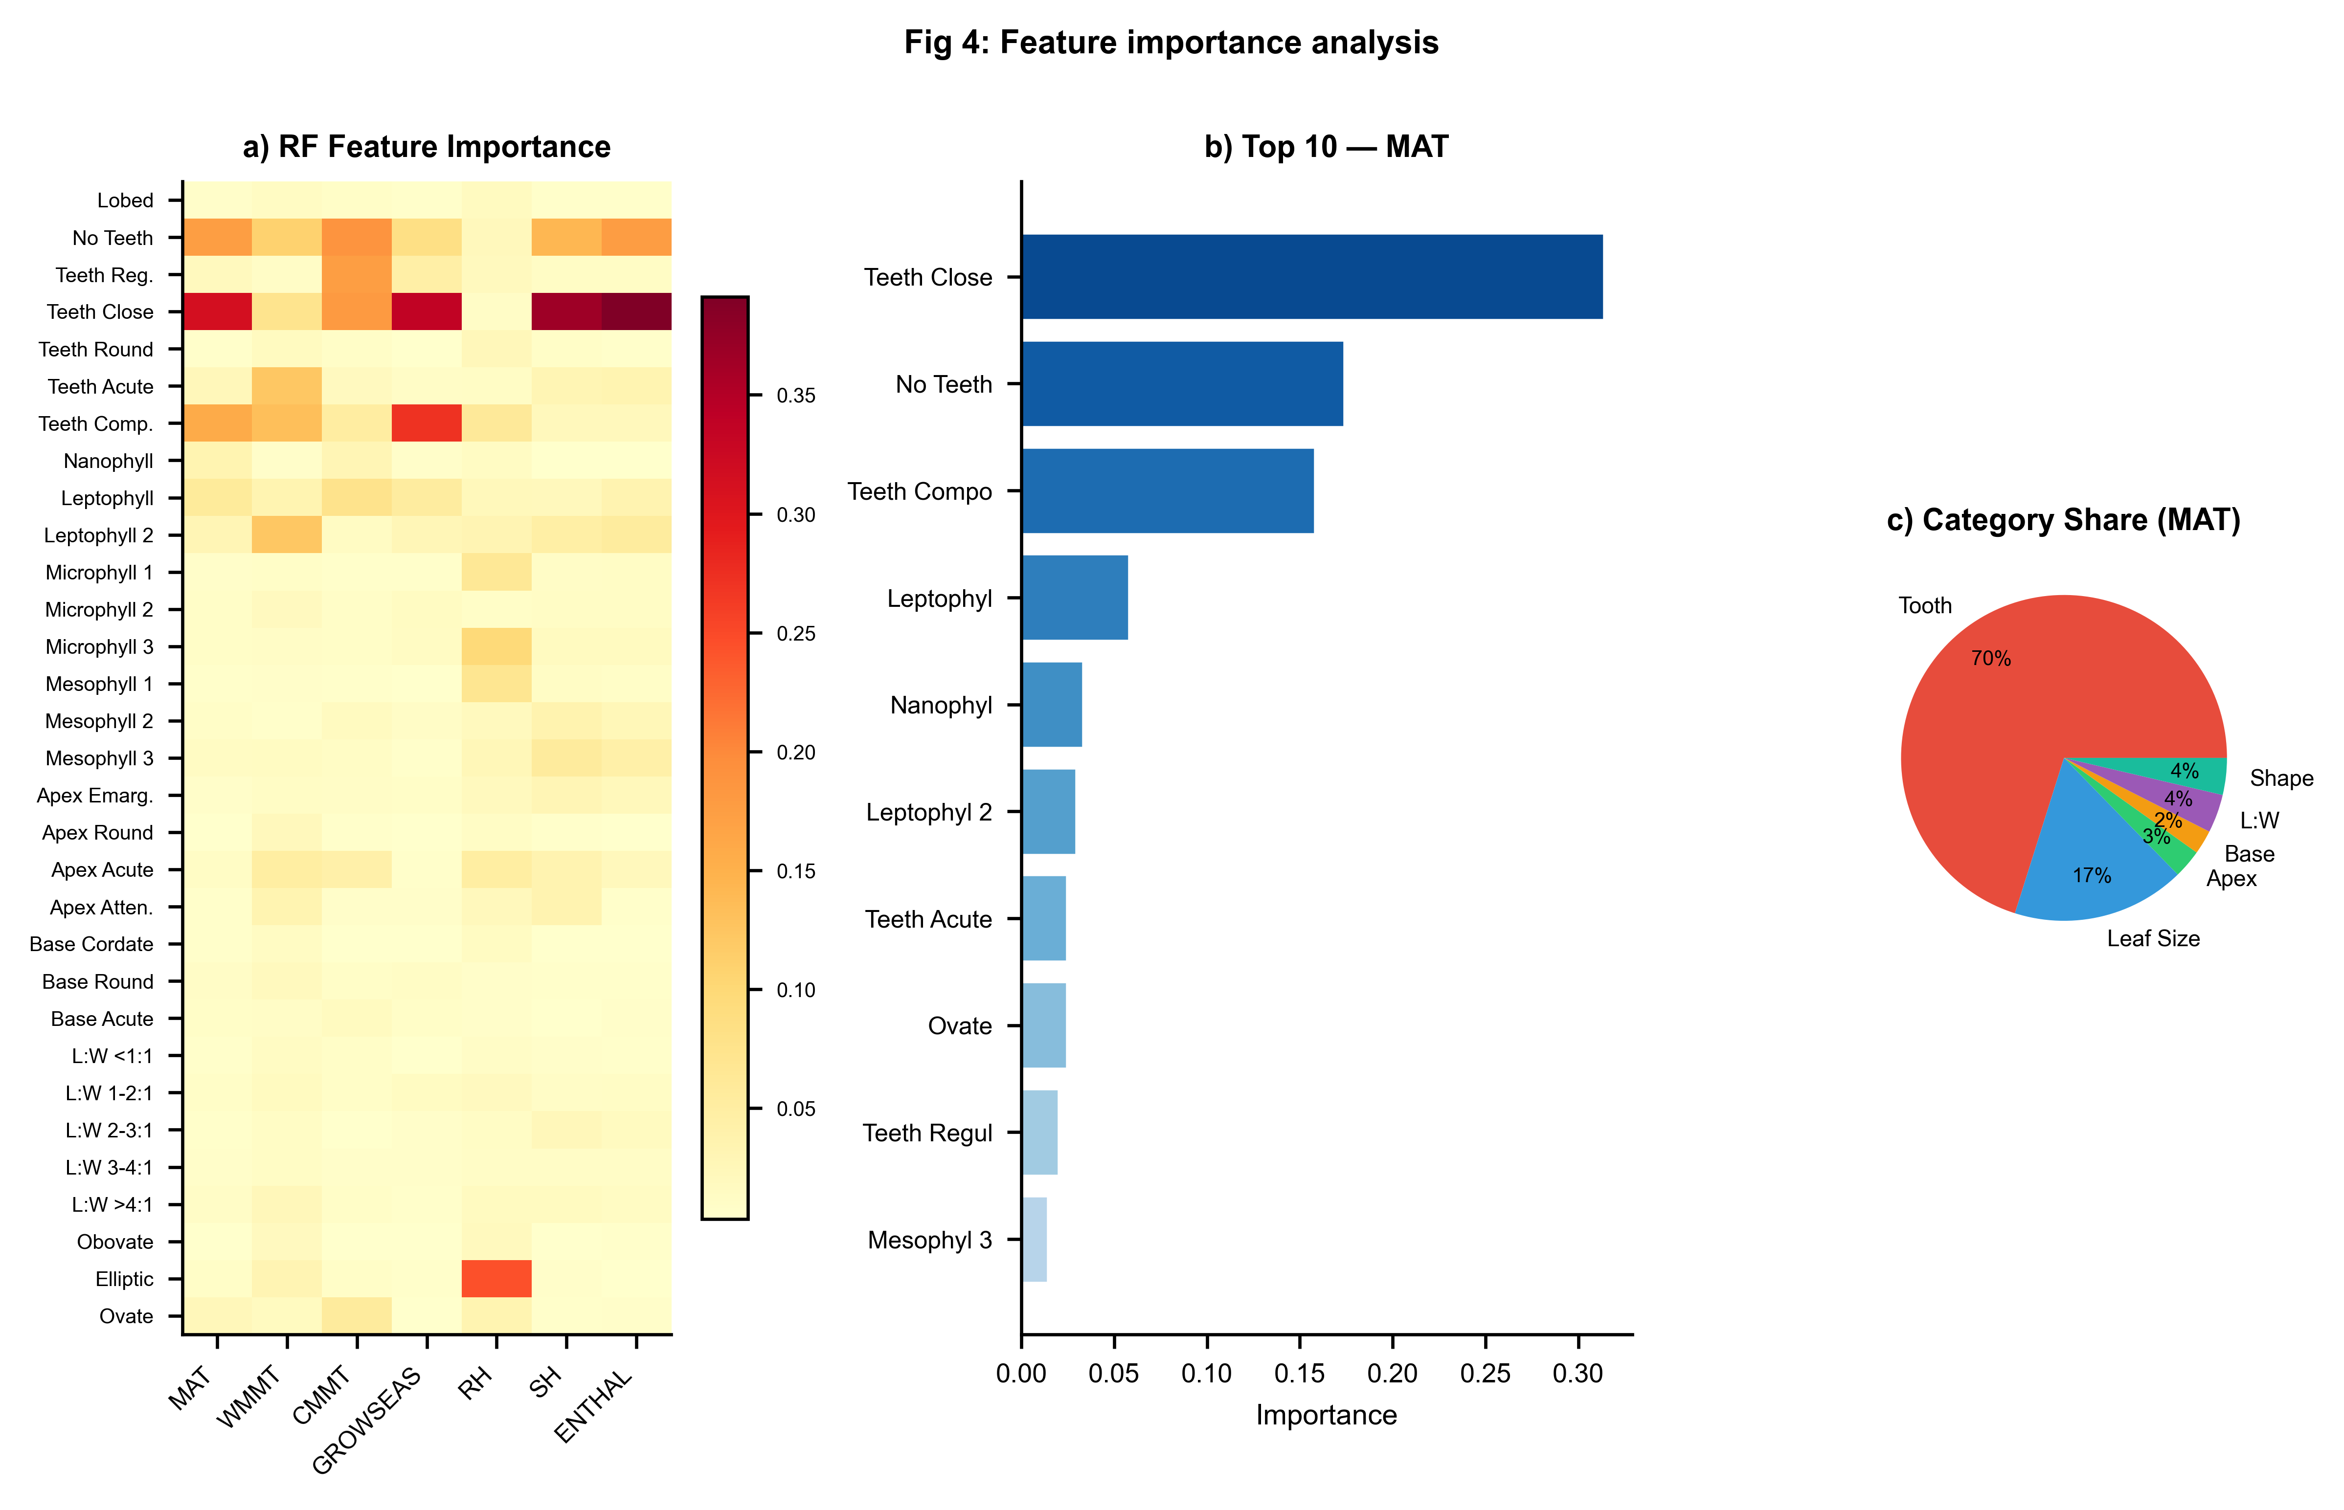
Figure 4: Feature importance analysis. (a) Random Forest feature importance heatmap across all seven climate variables. (b) Top 10 features by importance for MAT. (c) Trait-category contribution to MAT importance (pie chart).

3.7 Summary of reconstructability
Synthesising across space-block validation, LOCO, and fossil transfer, we delineate a three-tier hierarchy of climate variable reconstructability from leaf physiognomic traits (Fig. 5b; Table 1). Tier 1—cross-region robust: MAT and ENTHAL, with positive space-block R² and moderate fossil transfer skill. Tier 2—regionally conditioned: SH, GROWSEAS, and CMMT, with near-zero space-block R² but acceptable fossil transfer within densely calibrated domains (Asia). Tier 3—fundamentally unreliable: WMMT and RH, with consistently negative or near-zero R² across all validation frameworks. This hierarchy provides a practical guide for study design: researchers should target Tier 1 variables when fossil sites lie far from calibration data, restrict Tier 2 variables to within-region applications, and avoid Tier 3 variables as reconstruction targets absent major methodological advances. For the Tibetan Plateau—where the coupling between paleoelevation and paleoclimate is central to tectonic interpretations (Ding et al., 2022; He et al., 2022)—the robust cross-region performance of MAT and ENTHAL is encouraging, while the spatially conditioned performance of CMMT and GROWSEAS cautions against over-interpreting these variables when fossil sites lie outside the East Asian calibration domain.
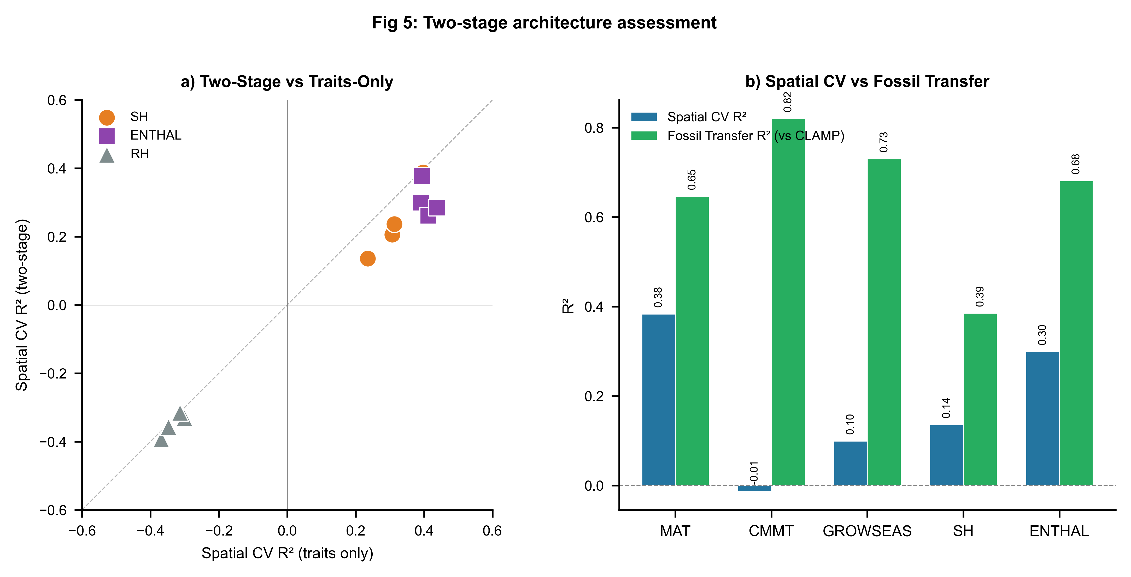
Figure 5: Two-stage architecture assessment and reconstructability summary. (a) Scatter plot comparing space-block R² of traits-only vs two-stage models for moisture–energy variables (SH, ENTHAL, RH); points below the identity line indicate two-stage degradation. (b) Bar chart comparing space-block R² against fossil transfer R² (vs CLAMP) for five climate variables, illustrating the gap between honest modern validation and the fossil transfer that is dominated by Asian assemblages.

4 Discussion

4.1 A quantitative framework for cross-region leaf-physiognomy reconstruction
Our results provide a quantitative extension of CLAMP's regional-calibration tradition. CLAMP practitioners have long maintained separate calibration datasets for different floristic provinces (Wolfe, 1993; Yang et al., 2015; Spicer et al., 2021), implicitly acknowledging that leaf–climate relationships are not globally uniform. The space-block and LOCO frameworks developed here make this implicit knowledge explicit and quantitative: they reveal the precise spatial grain at which trait–climate relationships break down, and they attach numerical uncertainties to the reconstruction of each climate variable as a function of geographic distance from the calibration domain. For MAT, the drop from within-domain fossil transfer (R² = 0.65) to cross-block space-block validation (R² = 0.38) quantifies the generalisability penalty—approximately 0.27 in R²—that should be applied to predictions for fossil sites in poorly sampled regions. For CMMT, the penalty is far larger (R² = 0.82 → −0.013), warning that this variable's apparent fossil transfer success is almost entirely a product of the fossil dataset's Asian dominance.

4.2 Implications for paleoelevation and Tibetan Plateau studies
The Tibetan Plateau has been a focal point for leaf-physiognomy paleoclimate reconstruction because its tectonic uplift history is intimately linked to Cenozoic climate evolution and the Asian monsoon system (Spicer et al., 2021; Ding et al., 2022; He et al., 2022). Recent work has demonstrated that eastern Tibet rose to near-modern elevations by ~39 Ma, driving distinctive Eocene monsoon precipitation patterns and contributing to the modern Asian biodiversity gradient (He et al., 2022). Our space-block validation results support the use of leaf physiognomy for these applications but with an important caveat: the robust performance for MAT and ENTHAL in cross-region validation (R² ≈ 0.3–0.4) indicates that elevation inferences based on these variables are well-supported, while the collapse of CMMT under spatial partitioning suggests that cold-month temperature reconstructions for Tibetan fossil sites are reliable only when calibration and fossil sites are drawn from the same floristic domain. The LOCO results further suggest that extrapolating East Asian calibrations to fossil floras outside Asia—as might be attempted for other orogenic belts (e.g., Andes, Alps)—is unlikely to yield reliable estimates without locally dense calibration networks.

4.3 The linearity of cross-region trait–climate relationships
A finding with both practical and conceptual implications is that ensemble ML methods do not outperform linear statistical baselines under space-block validation. This is not a failure of ML per se—it reflects a property of the data: the cross-region component of the trait–climate signal is approximately linear. Non-linear models may capture complex within-region structure (e.g., ecological sorting along local environmental gradients) that does not generalise across floristic provinces with different evolutionary histories and species pools. For paleoclimate reconstruction—where the explicit goal is to extrapolate from modern calibration sites to fossil sites separated in space and time—the parsimony of linear models is a feature, not a limitation. Linear regression or Ridge regression, with their well-understood uncertainty propagation and interpretability, are likely to be more trustworthy tools for cross-region paleoclimate inference than black-box ensemble methods whose apparent advantages reflect within-region overfitting (Meyer et al., 2019; Ploton et al., 2020).

4.4 The two-stage cascade and the geography of physical models
The failure of the two-stage temperature→moisture cascade under space-block validation carries a broader lesson about physical models in spatial prediction. The Clausius–Clapeyron relationship linking temperature to saturation vapour pressure is physically rigorous at the local (within-site) scale. But when temperature is estimated with spatial error—systematic biases that vary across blocks—the downstream moisture prediction absorbs and amplifies this error. The finding that traits-only models outperform two-stage architectures for moisture variables suggests that leaf traits encode moisture information independently of the temperature→moisture cascade, presumably through direct physiological responses to atmospheric and soil water availability (Peppe et al., 2011; Wright et al., 2017). From a practical standpoint, we recommend that moisture–energy variables be reconstructed directly from traits for fossil sites in geographic domains poorly represented in calibration data, reserving two-stage schemes for within-domain applications where temperature estimates carry lower spatial bias.

4.5 Limitations and the path forward
Several limitations bound our conclusions. First, the modern calibration dataset is geographically imbalanced, with Europe (25 sites) and Africa (14 sites) severely underrepresented. The catastrophic LOCO failure for Europe likely reflects this imbalance rather than intrinsic unpredictability of European leaf traits—meaningful calibration for Europe would require substantially expanding the modern sampling network. Second, the fossil validation targets are CLAMP-computed values, not independent instrumental observations; systematic biases in CLAMP estimates will carry through to our fossil transfer metrics. Independent validation against non-physiognomic proxies (e.g., stable isotopes, glycerol dialkyl glycerol tetraethers [GDGTs], palynology) for key fossil sites, particularly those on the Tibetan Plateau (Miao et al., 2022; Liang et al., 2025), would strengthen the fossil transfer assessment. Third, our 31-trait protocol captures a subset of leaf morphological variation; additional traits (venation density, stomatal indices, leaf mass per area) could improve spatial generalisability (Lowe et al., 2024) but are not available for this dataset. Fourth, the 5 × 4 grid partitioning is one of many possible schemes; sensitivity to block resolution should be explored in future work since the optimal spatial grain likely varies by variable and region. Finally, the temporal dimension—whether trait–climate calibrations from modern vegetation apply to fossil floras separated by tens of millions of years of evolution—remains an irreducible uncertainty in all uniformitarian paleoclimate methods (Spicer et al., 2021; Chen et al., 2025).

5 Conclusions
This study provides a systematic, quantitative assessment of leaf-physiognomy climate reconstruction under honest geographic partitioning. Building on CLAMP's established regional-calibration logic, we demonstrate that the cross-region reconstructability of climate variables from leaf traits follows a well-defined hierarchy: MAT and ENTHAL are robustly recoverable across geographic blocks (space-block R² ≈ 0.3–0.4), SH, GROWSEAS, and CMMT are recoverable only within densely calibrated domains, and WMMT and RH are fundamentally unreliable as cross-region reconstruction targets. Ensemble machine learning methods provide no meaningful advantage over linear statistical baselines under spatial partitioning—the cross-region trait–climate signal is essentially linear. The physically motivated two-stage temperature→moisture cascade does not survive the transition to cross-region prediction, with traits-only models consistently outperforming two-stage architectures. Fossil transfer against CLAMP reference values for the predominantly Asian fossil dataset yields encouraging results for Tier 1 and Tier 2 variables but must be interpreted as within-domain interpolation, not cross-continent generalisation. We recommend that future leaf-physiognomy paleoclimate studies: (1) report space-block validation metrics alongside conventional cross-validation to quantify the generalisability penalty; (2) include linear baselines to benchmark the incremental value of non-linear methods; (3) consider the three-tier reconstructability hierarchy when selecting reconstruction targets, particularly for fossil sites in regions distant from modern calibration networks; and (4) expand modern calibration sampling in underrepresented regions, especially Europe and Africa, to extend the geographic domain of reliable leaf-physiognomy climate reconstruction.

Data and Code Availability
The modern calibration dataset and fossil assemblage data are available in the accompanying Excel workbook (Global378+Tibet15+Fossil73_更正.xlsx). All training code, the space-block validation pipeline, figure generation scripts, trained model files, and the complete manuscript source are archived on Zenodo [DOI to be created upon acceptance] and publicly available on GitHub at [repository URL to be added]. The repository includes: (1) training_pipeline_v2.py, which reproduces all space-block validation results, baseline comparisons, LOCO validation, and fossil transfer evaluation; (2) generate_figures_v2.py, which produces all five publication figures; (3) the models_v2/ directory containing trained joblib model files; and (4) the output/ directory containing all tabulated results (Tables 1–5). All analyses were performed in Python 3.10 using scikit-learn 1.3, XGBoost 2.0, and associated scientific Python libraries. Climate data were obtained from WorldClim 2 (Fick and Hijmans, 2017; https://www.worldclim.org/).

Author Contributions
[To be completed by authors.]

Competing Interests
The authors declare that they have no competing interests.

Acknowledgements
[To be completed by authors.]

References
Bailey, I. W. and Sinnott, E. W.: The climatic distribution of certain types of angiosperm leaves, Am. J. Bot., 3, 24–39, 1916.
Bhatia, H., Dar, R. A., and Srivastava, G.: Himalayan uplift and the evolution of a Mediterranean-type climate in the Kashmir Basin of India: Palaeobotanical evidence from the late Pliocene Dubjan Member (Karewa Group), Palaeogeogr. Palaeoclimatol. Palaeoecol., 672, 112547, https://doi.org/10.1016/j.palaeo.2025.112547, 2025.
Chen, W.-Y., Su, T., and Li, S.-F.: The leaf physiognomy of evergreen and deciduous species exhibits different responses to climate: Implications for palaeoclimate reconstruction in China, Palaeogeogr. Palaeoclimatol. Palaeoecol., 660, 112683, https://doi.org/10.1016/j.palaeo.2024.112683, 2025.
Ding, L., Kapp, P., Cai, F., Garzione, C. N., Xiong, Z., Wang, H., and Wang, C.: Timing and mechanisms of Tibetan Plateau uplift, Nat. Rev. Earth Environ., 3, 652–667, https://doi.org/10.1038/s43017-022-00318-4, 2022.
Fick, S. E. and Hijmans, R. J.: WorldClim 2: new 1-km spatial resolution climate surfaces for global land areas, Int. J. Climatol., 37, 4302–4315, https://doi.org/10.1002/joc.5086, 2017.
Gregory-Wodzicki, K. M.: Relationships between leaf morphology and climate, Bolivia: implications for estimating paleoclimate from fossil floras, Paleobiology, 26, 668–688, 2000.
He, S., Ding, L., Xiong, Z., Spicer, R. A., Farnsworth, A., Valdes, P. J., Wang, C., Cai, F., Wang, H., Sun, Y., Zeng, D., Xie, J., Yue, Y., Zhao, C., Song, P., and Wu, C.: A distinctive Eocene Asian monsoon and modern biodiversity resulted from the rise of eastern Tibet, Sci. Bull., 67, 2245–2258, https://doi.org/10.1016/j.scib.2022.10.006, 2022.
Liang, Y., Quan, C., Liu, Z., Li, X., Utescher, T., and Liu, Y.-S.: Terrestrial temperature history reveals Late Miocene rapid uplift of the northern Tibetan Plateau, Sci. Adv., 11, eadq5626, https://doi.org/10.1126/sciadv.adq5626, 2025.
Lowe, A. J., Flynn, A. G., Butrim, M. J., Baumgartner, A., Royer, D. L., and Peppe, D. J.: Reconstructing terrestrial paleoclimate and paleoecology with fossil leaves using digital leaf physiognomy and leaf mass per area, J. Vis. Exp., 212, e66838, https://doi.org/10.3791/66838, 2024.
Meyer, H., Reudenbach, C., Wöllauer, S., and Nauss, T.: Importance of spatial predictor variable selection in machine learning applications—Moving from data reproduction to spatial prediction, Ecol. Model., 411, 108815, https://doi.org/10.1016/j.ecolmodel.2019.108815, 2019.
Miao, Y., Fang, X., Sun, J., Xiao, W., Yang, Y., Wang, X., Farnsworth, A., Huang, K., Ren, Y., Wu, F., Qiao, J., Zhang, W., Meng, Q., Yan, X., Zheng, Z., Song, C., and Utescher, T.: A new biologic paleoaltimetry indicating Late Miocene rapid uplift of northern Tibet Plateau, Science, 378, 1074–1079, https://doi.org/10.1126/science.abo2475, 2022.
Peppe, D. J., Royer, D. L., Cariglino, B., Oliver, S. Y., Newman, S., Leight, E., Enikolopov, G., Fernandez-Burgos, M., Herrera, F., Adams, J. M., Correa, E., Currano, E. D., Erickson, J. M., Hinojosa, L. F., Hoganson, J. W., Iglesias, A., Jaramillo, C. A., Johnson, K. R., Jordan, G. J., Kraft, N. J. B., Lovelock, E. C., Lusk, C. H., Niinemets, Ü., Peñuelas, J., Rapson, G., Wing, S. L., and Wright, I. J.: Sensitivity of leaf size and shape to climate: global patterns and paleoclimatic applications, New Phytol., 190, 724–739, https://doi.org/10.1111/j.1469-8137.2010.03615.x, 2011.
Ploton, P., Mortier, F., Réjou-Méchain, M., Barbier, N., Picard, N., Rossi, V., Dormann, C., Cornu, G., Viennois, G., Bayol, N., Lyapustin, A., Gourlet-Fleury, S., and Pélissier, R.: Spatial validation reveals poor predictive performance of large-scale ecological mapping models, Nat. Commun., 11, 4540, https://doi.org/10.1038/s41467-020-18321-y, 2020.
Roberts, D. R., Bahn, V., Ciuti, S., Boyce, M. S., Elith, J., Guillera-Arroita, G., Hauenstein, S., Lahoz-Monfort, J. J., Schröder, B., Thuiller, W., Warton, D. I., Wintle, B. A., Hartig, F., and Dormann, C. F.: Cross-validation strategies for data with temporal, spatial, hierarchical, or phylogenetic structure, Ecography, 40, 913–929, https://doi.org/10.1111/ecog.02881, 2017.
Royer, D. L., Wilf, P., Janesko, D. A., Kowalski, E. A., and Dilcher, D. L.: Correlations of climate and plant ecology to leaf size and shape: potential proxies for the fossil record, Am. J. Bot., 92, 1141–1151, https://doi.org/10.3732/ajb.92.7.1141, 2005.
Spicer, R. A.: CLAMP, in: Encyclopedia of Paleoclimatology and Ancient Environments, edited by Gornitz, V., Springer, Dordrecht, 175–178, 2009.
Spicer, R. A., Su, T., Valdes, P. J., Farnsworth, A., Wu, F.-X., Shi, G., Spicer, T. E. V., and Zhou, Z.-K.: Why 'the uplift of the Tibetan Plateau' is a myth, Natl. Sci. Rev., 8, nwaa091, https://doi.org/10.1093/nsr/nwaa091, 2021.
Spicer, R. A., Valdes, P. J., Hughes, A., Yang, J., Spicer, T. E. V., Herman, A., and Farnsworth, A.: New insights into the thermal regime and hydrodynamics of the early Late Cretaceous Arctic, Geol. Mag., 157, 1729–1746, https://doi.org/10.1017/S0016756819000465, 2020.
Su, T., Spicer, R. A., Li, S.-H., Xu, H., Huang, J., Sherlock, S., Huang, Y.-J., Li, S.-F., Wang, L., Jia, L.-B., Deng, W.-Y.-D., Liu, J., Deng, C.-L., Zhang, S.-T., Valdes, P. J., and Zhou, Z.-K.: Uplift, climate and biotic changes at the Eocene–Oligocene transition in south-eastern Tibet, Natl. Sci. Rev., 6, 495–504, https://doi.org/10.1093/nsr/nwy062, 2019.
Wilf, P.: When are leaves good thermometers? A new case for leaf margin analysis, Paleobiology, 23, 373–390, 1997.
Wolfe, J. A.: Tertiary climatic fluctuations and methods of analysis of Tertiary floras, Palaeogeogr. Palaeoclimatol. Palaeoecol., 9, 27–57, 1971.
Wolfe, J. A.: Temperature parameters of humid to mesic forests of eastern Asia and relation to forests of other regions of the Northern Hemisphere and Australasia, US Geol. Surv. Prof. Pap., 1106, 1–37, 1979.
Wolfe, J. A.: A method of obtaining climatic parameters from leaf assemblages, US Geol. Surv. Bull., 2040, 1–71, 1993.
Wright, I. J., Dong, N., Maire, V., Prentice, I. C., Westoby, M., Díaz, S., Gallagher, R. V., Jacobs, B. F., Kooyman, R., Law, E. A., Leishman, M. R., Niinemets, Ü., Reich, P. B., Sack, L., Villar, R., Wang, H., and Wilf, P.: Global climatic drivers of leaf size, Science, 357, 917–921, https://doi.org/10.1126/science.aal4760, 2017.
Yang, J., Spicer, R. A., Spicer, T. E. V., Arens, N. C., Jacques, F. M. B., Su, T., Kennedy, E. M., Herman, A. B., Steart, D. C., Srivastava, G., Mehrotra, R. C., Valdes, P. J., Mehrotra, N. C., Zhou, Z.-K., and Lai, J.-S.: Leaf form–climate relationships on the global stage: an ensemble of characters, Palaeogeogr. Palaeoclimatol. Palaeoecol., 435, 159–169, https://doi.org/10.1016/j.palaeo.2015.06.013, 2015.

Tables

Table 1: Summary of model performance under space-block validation, baseline comparison, and fossil transfer.
Space-block validation metrics are from block-based GroupKFold (10 folds). Best Baseline is the top-performing linear model for each variable. Two-Stage ΔR² is the change from traits-only to two-stage architecture (moisture–energy variables only). Fossil metrics are R², RMSE, and mean bias vs CLAMP reference values (N = 71 assemblages).
Variable | Category | Space-block  R² (RF) | Space-block  RMSE | Best  Baseline | Baseline  R² | Two-Stage  ΔR² | Fossil  R² | Fossil  RMSE
MAT | Temperature | 0.383 | 3.82 | Linear | 0.343 | — | 0.646 | 2.74
WMMT | Temperature | −0.321 | 3.71 | ElasticNet | −0.284 | — | −1.056 | 2.91
CMMT | Temperature | −0.013 | 6.02 | PLS | −0.238 | — | 0.820 | 2.79
GROWSEAS | Temperature | 0.099 | 1.78 | Linear | 0.138 | — | 0.730 | 1.01
RH | Moist.-Energy | −0.331 | 9.55 | ElasticNet | −0.720 | −0.030 | −0.080 | 18.94
SH | Moist.-Energy | 0.136 | 1.99 | ElasticNet | 0.060 | −0.099 | 0.385 | 2.95
ENTHAL | Moist.-Energy | 0.299 | 11.11 | Linear | 0.306 | −0.092 | 0.681 | 9.68

Table 2: Leave-One-Continent-Out (LOCO) validation results (Random Forest).
R² values for each variable–continent combination. N is the number of held-out sites on each continent.
Variable | Continent | N Sites | R²
MAT | Africa | 14 | 0.231
MAT | Americas | 143 | 0.448
MAT | Asia | 158 | 0.408
MAT | Europe | 25 | −1.035
MAT | Oceania | 53 | 0.323
CMMT | Africa | 14 | 0.254
CMMT | Americas | 143 | 0.496
CMMT | Asia | 158 | 0.099
CMMT | Europe | 25 | −1.430
CMMT | Oceania | 53 | 0.310
GROWSEAS | Africa | 14 | −0.338
GROWSEAS | Americas | 143 | 0.505
GROWSEAS | Asia | 158 | 0.549
GROWSEAS | Europe | 25 | −0.213
GROWSEAS | Oceania | 53 | 0.219
RH | Africa | 14 | 0.131
RH | Americas | 143 | −1.269
RH | Asia | 158 | −0.313
RH | Europe | 25 | −11.995
RH | Oceania | 53 | −0.425
SH | Africa | 14 | 0.358
SH | Americas | 143 | 0.443
SH | Asia | 158 | 0.479
SH | Europe | 25 | −0.493
SH | Oceania | 53 | 0.508
ENTHAL | Africa | 14 | 0.530
ENTHAL | Americas | 143 | 0.442
ENTHAL | Asia | 158 | 0.536
ENTHAL | Europe | 25 | −0.641
ENTHAL | Oceania | 53 | 0.556
WMMT | Africa | 14 | −0.161
WMMT | Americas | 143 | −0.105
WMMT | Asia | 158 | −0.344
WMMT | Europe | 25 | −0.767
WMMT | Oceania | 53 | 0.071

