
Imagine you've just joined a software consultancy in London. One of your first clients is the British Museum (Bloomsbury area, London), located around 3.5 miles from Northeastern University London.

The museum is investing heavily in digital experiences and has thousands of assets including:
- Historical artefacts
- Paintings
- Interactive digital exhibits
- Roman archaeological collections

The software team has built an application to manage and analyse these collections.

Task 1 - Pseudocode

class painting():  def __init__(self):  self.base_value = 10000 |  | class sculpture():  def __init__(self):  self.base_value = 25000 |  | class digitalExhibit():  def __init__(self):  self.base_value = 5000 |  | class romanCollection():  def __init__(self):  self.base_value = 40000
1 |  | 1 |  | 1 |  | 1 | 
2 |  | 2 |  | 2 |  | 2
3 |  | 3 |  | 3 |  | 3
4 |  | 4 |  | 4 |  | 4
5 |  | 5 |  | 5 |  | 5
6 |  | 6 |  | 6 |  | 6
7 |  | 7 |  | 7 |  | 7
8 |  | 8 |  | 8 |  | 8
9 |  | 9 |  | 9 |  | 9
10 |  | 10 |  | 10 |  | 10
11 |  | 11 |  | 11 |  | 11
12 |  | 12 |  | 12 |  | 12
13 |  | 13 |  | 13 |  | 13
14 |  | 14 |  | 14 |  | 14
15 |  | 15 |  | 15 |  | 15

Task 2 – What Problems do we encounter?


3-Step Implementation

- Introduce the ‘Visitor’ class
- Define a new class for the Visitor – this can be specific to the type of Visitor e.g., InsuranceVisitor, or more generalised, such as a MuseumVisitor where interactions extend beyond a single element (e.g., Sculpture, Painting, etc..)
- Define the behaviors (methods) for how the ‘Visitor’ class interacts with the elements

- Implement an ‘accept’ method
- For each elements that requires a visitor to interact with them (e.g., Painting, Sculpture, etc..), define an accept method

- Implementation of an interface
- …as we add more visitors…)

Task 3
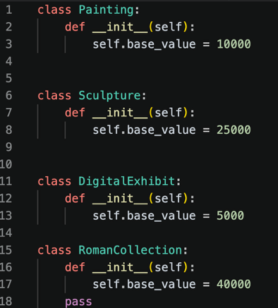
A new requirement has arrived from the Accessibility Team.

They want every exhibit to be assigned an accessibility score between 0 and 100.

Your challenge is to add this new functionality without modifying any of the exhibit classes with this specific functionality (i.e., implement an accessibility visitor).

visitor class |  |  | visitor interface
1 |  | 1 | 
2 |  | 2
3 |  | 3
4 |  | 4
5 |  | 5
6 |  | 6
7 |  | 7
8 |  | 8
9 |  | 9
10 |  | 10
11 |  | 11
12 |  | 12
13 |  | 13
14 |  | 14
15 |  | 15

class painting():  def __init__(self):  self.base_value = 10000 |  | class sculpture():  def __init__(self):  self.base_value = 25000 |  | class digitalExhibit():  def __init__(self):  self.base_value = 5000 |  | class romanCollection():  def __init__(self):  self.base_value = 40000
1 |  | 1 |  | 1 |  | 1 | 
2 |  | 2 |  | 2 |  | 2
3 |  | 3 |  | 3 |  | 3
4 |  | 4 |  | 4 |  | 4
5 |  | 5 |  | 5 |  | 5

