Project Report

Design and Implementation of A Simple DNS System

Course: Internet Applications
Name: 刘斯宸 (2020213323)
万国龙 (2020213294)
Date: 2023.6.7

Overview
In the project, we completed a DNS system based on Linux command line terminal (including client and server) to realize English domain name resolution.
The user can perform a DNS query on the client side, and the query process is automatically carried out on several servers. Eventually, the results will be sent back to the client side and displayed on the client's window. We can also capture these packets in above process in Wireshark.

Requirements Analysis
2.1 Development Environment
Linux system as operating system, C as language. Some others tools including gcc compiler, Wireshark are also needed.

2.2 Functional requirements:
1. The system can implement the resolution of English domain name.
2. At least four top-level domains are supported, and at least three level domain names can be resolved. The entities that the program needs to implement are: client, 6 DNS servers(at least).The 4. TLDs are: com, cn, edu, org. The relation can refer to the picture below.
3. Supported Resource Record types: A, MX, CNAME. For MX queries, the requirements are in
the Additional Section contains the corresponding IP address.
4. Supported parsing methods: iterative parsing.
5. The protocols of transport layers: The connection between the client and the local DNS server: UDP. The connection between DNS servers: UDP.
6. The protocols of application layers: DNS. All of the connection process can be captured by the Wireshark.
7. The data maintenance method of server can be based on files.
8. (Extension function) Cache function, PTR resource records, display the trace records。

Preliminary Design
3.1 Decomposition of functional modules
The low layer of architecture：
Data stream processing module：
getHeader, getQuery, getRRs, head2buf, query2buf, rr2buf, add2buf
Data processing module：
cmpTypeClass, cmpDomainName, comRR, splitOneDomainName, splitTwoDomainName
Utils：
isequal, init_sockaddr_in, blocklen, write2cache,

The high layer of architecture：
Client: client.c
The client side is responsible for sending DNS packet to local server and receive response from it. The result will be then shown to the user.
Servers: local_server.c, root.c, cnus.c, comorg.c, edu.c, gov.c
At start, the local server receives the packets from the client side. If the query name and type are not in local cache. It will sends the packets to the root sever. After receiving the packet from the root server, it will send packet to other servers which is indicated by the root server. If local server obtain the correct answer, it will send the packet back to the client. Otherwise it will keep on searching for the answer on the other server. If it still can not get the correct, it will tell client that the not found message.
The other servers basically have the same function, which they receive packet from the local server, and reply to the query. They can be treated as one group of servers.

3.2 Relationship and interfaces between the modules
The client side connects with the local server via UDP. The local server communicates with all the servers via TCP.
All servers and client can call the interface to use the low layer function. All of these code will call data stream processing module to realize the resolution of buffer and writing into buffer. They also call init_sockaddr_in to initialize their their socket address.
Local server can call write2cache function to implement the increment of cache records.
Server comorg.c, edu.c, gov.c, local_server.c need to call the cmpTypeClass, cmpDomainName, cmpRR function in data processing module to compare the packet contents with their own maintenance resource records.
Server root.c, cnus.c call splitOneDomainName, splitTwoDomainName function respectively to get their second-level domain and their third-level domain name.

3.3 Overall flow chart

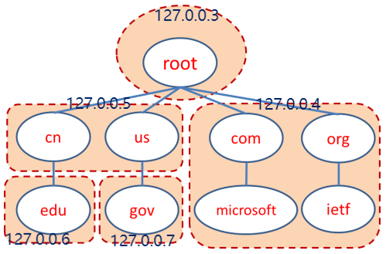
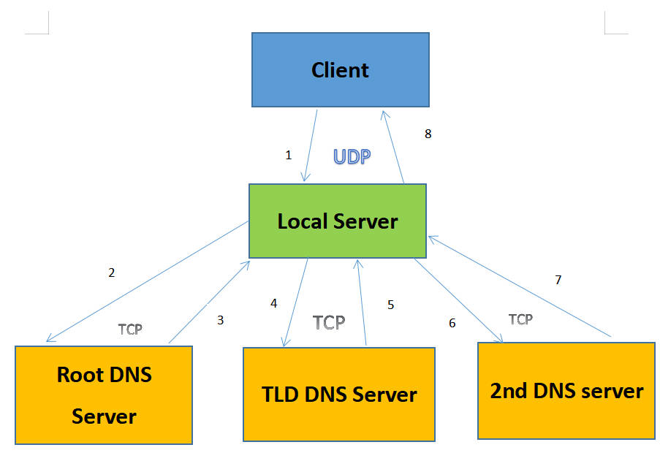
3.4 Design of data structures
The structure of DNS header:
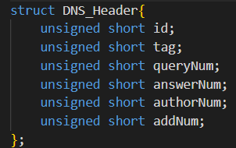
The structure of DNS query:
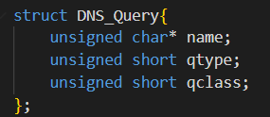

The structure of DNS resource records:
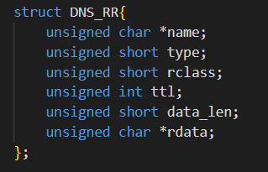

Detailed Design
4.1 Client Side
1.Receive the query message from the command line.
2.Initialize the socket on the client side.
3.Assemble the DNS packet, the query type and query name are given by the user.
4.Send the packet to local server.
5.Wait for the reply from the server.
6.Unpacked the package and display the message in the command line.
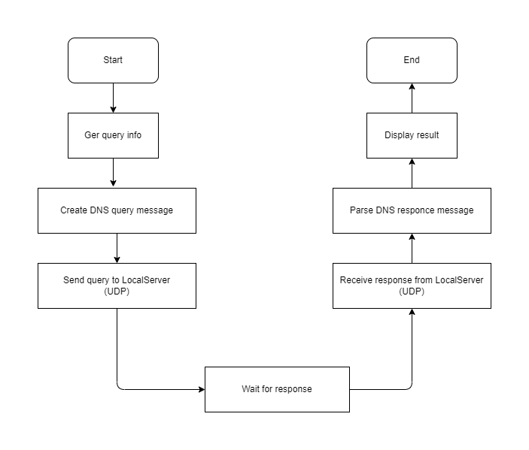

4.2 LocalServer Side
1. Initialize the local server.
2. Listen on the port of UDP
3. Receive the packet from the client side.
4. Unpack the packet.
5. Assemble the packet which will be sent away.
6. Search from the local cache.
7. If get the result, go to 14.
8. If no result from cache, the packet is sent to the root server
9. Wait for the reply from the root server
10. Send the original packet to the suggested server n.
11. Wait for the reply from server n.
12. Unpack the packet to check the answer.
13. If the answer is the required one, then stop iteration and go to 14. If another IP of the server is returned, then keep searching and go to 10.
14. Send the result to Client.

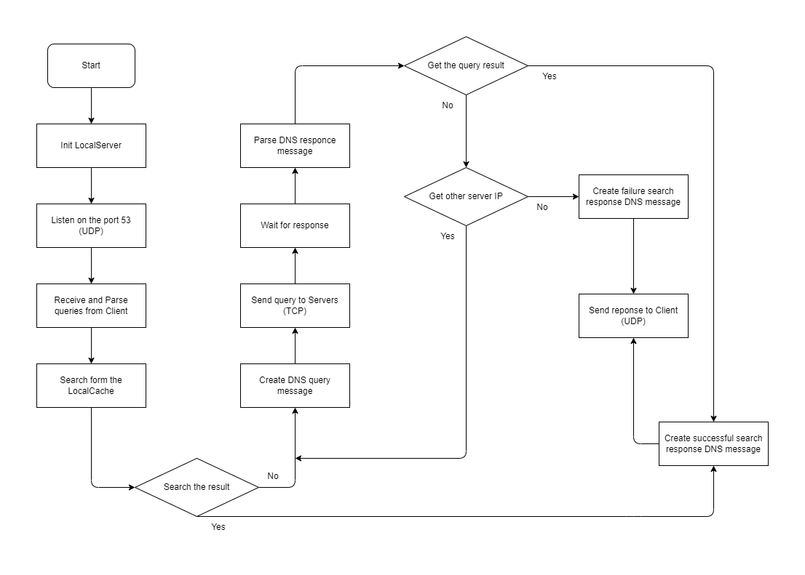

Results
5.1 Search domain name of type A (not in local server cache)
Client command: ./c lsc.gov.us A

A. Client side
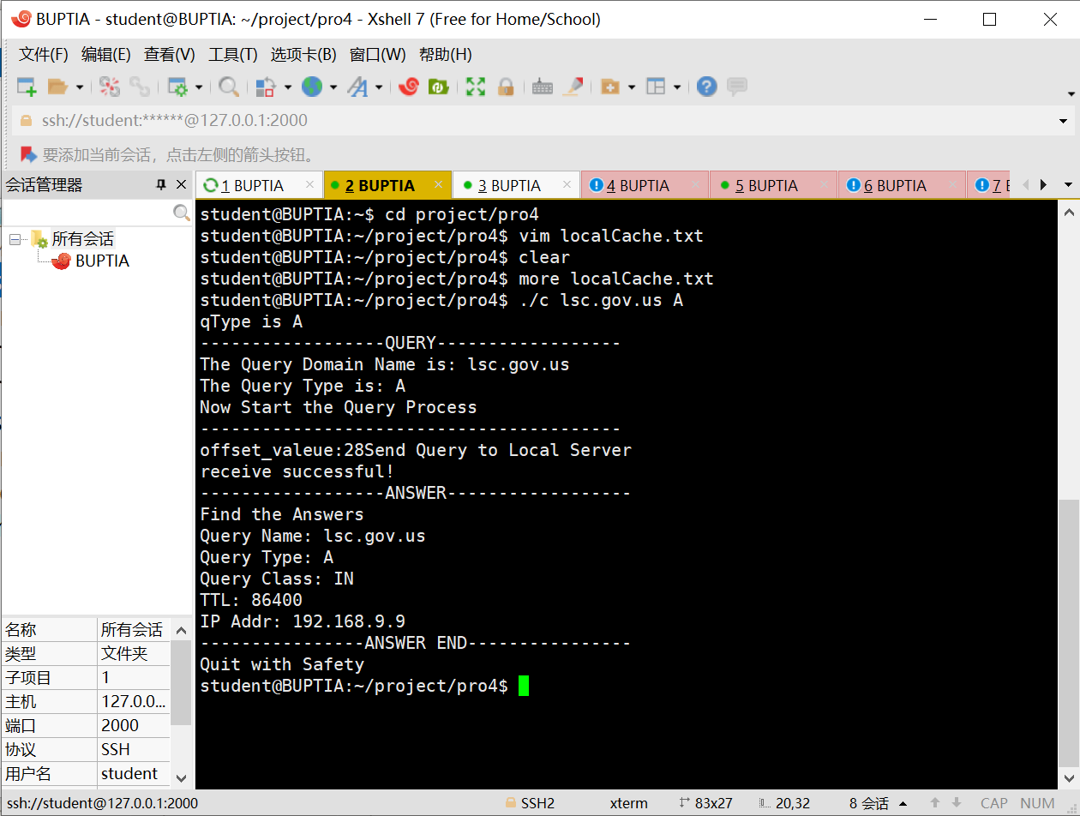

B. Local Server side
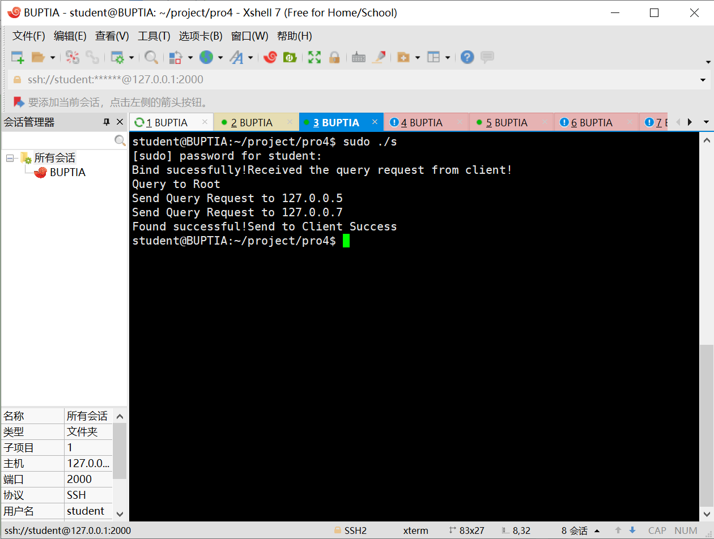

C. DNS packet
DNS packet list:
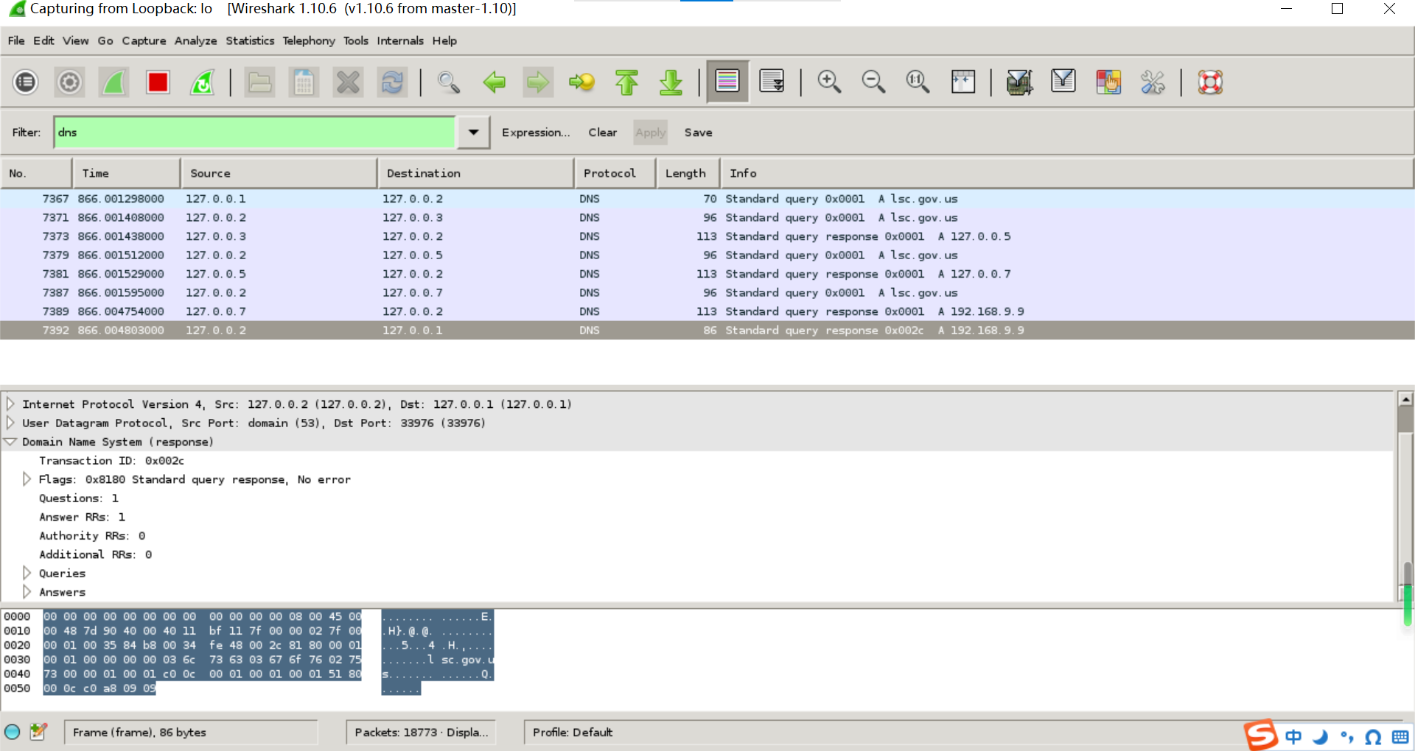
DNS packet that Local server respond to Client:
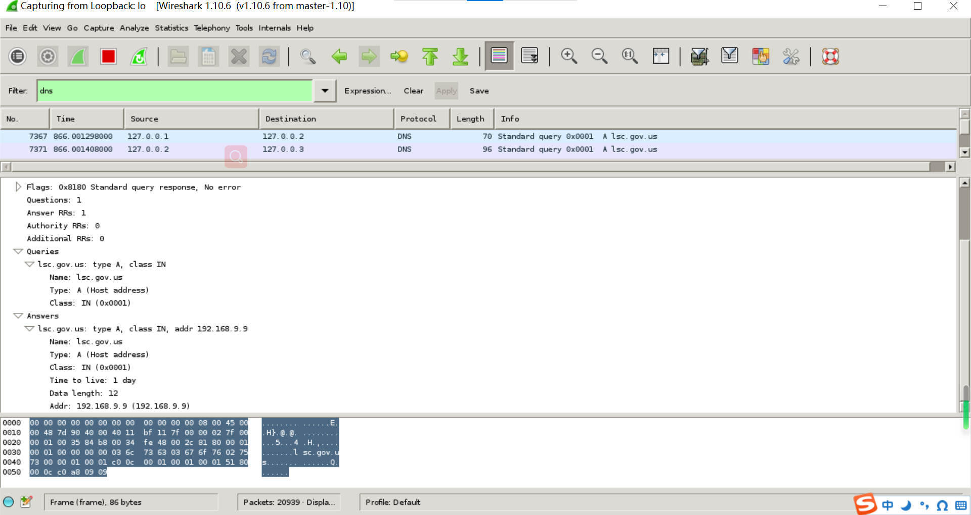

5.2 Search domain name of type CNAME (not in local server cache)
Client command: ./c wgl.edu.cn CNAME

A. Client side
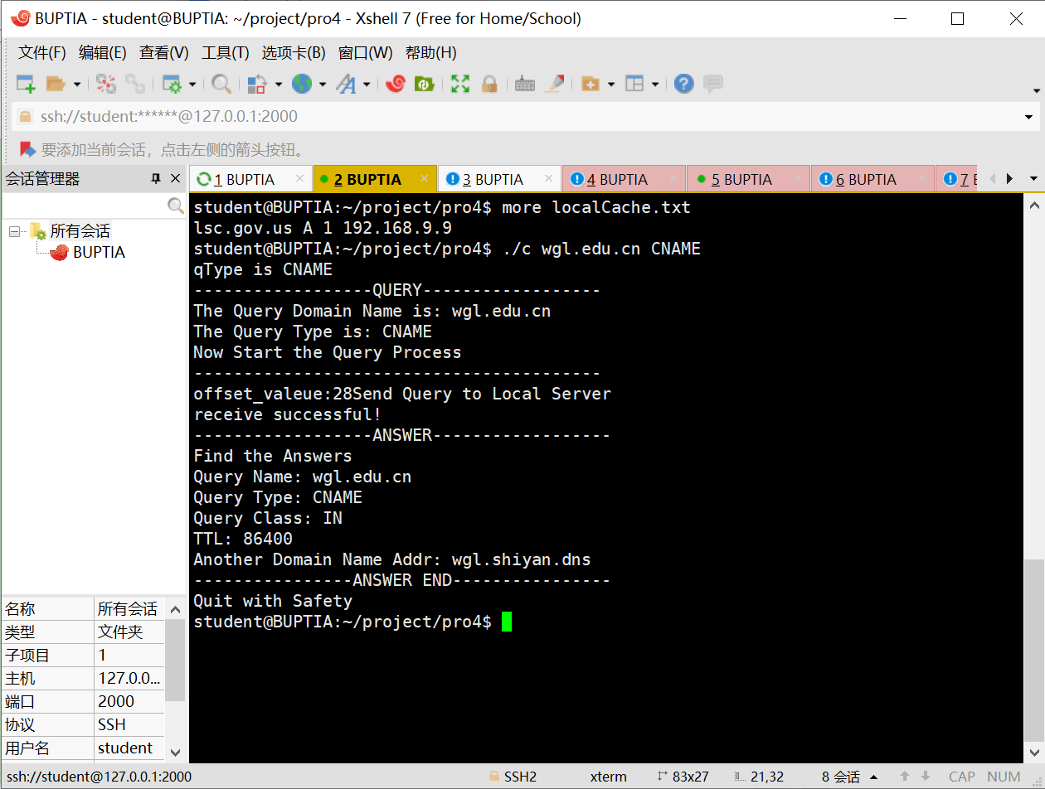

B. Local Server side
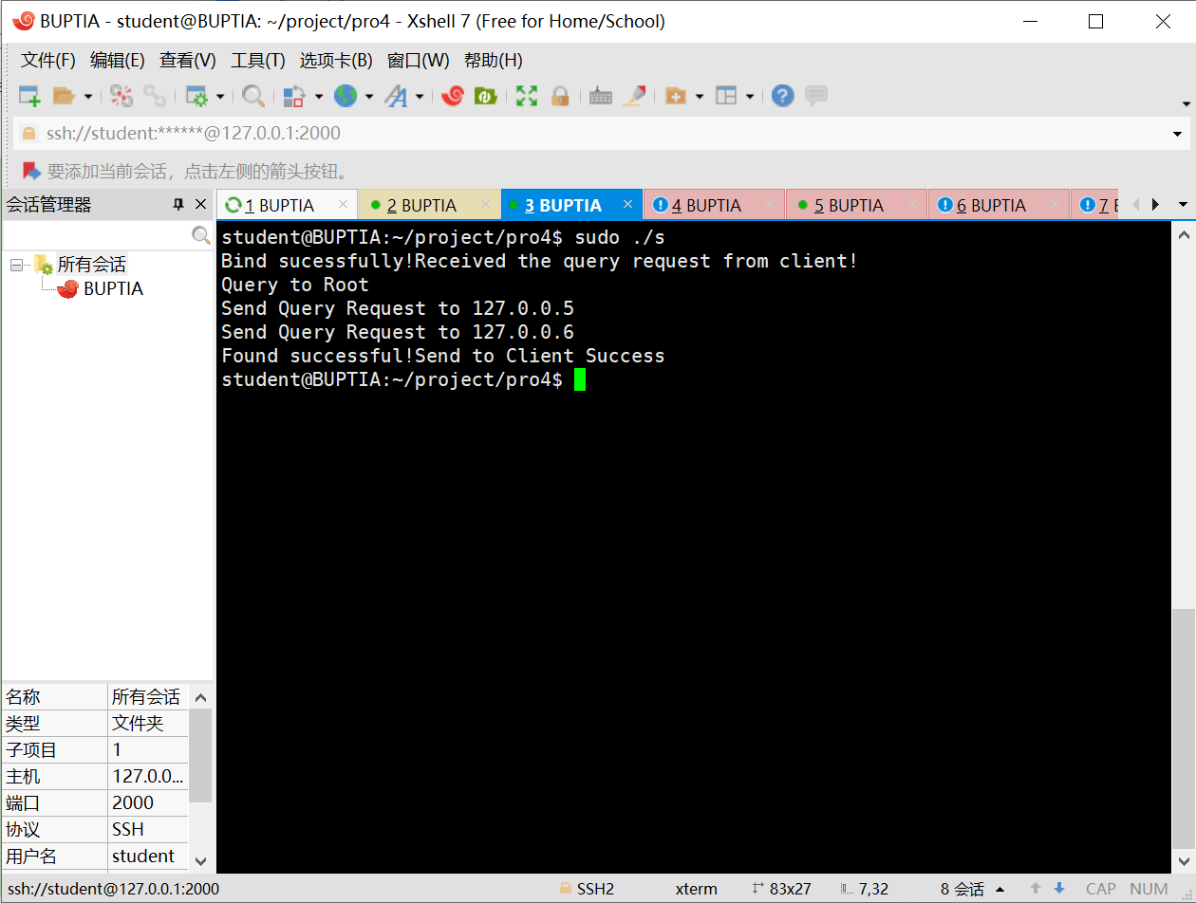

C. DNS packet
DNS packet list:
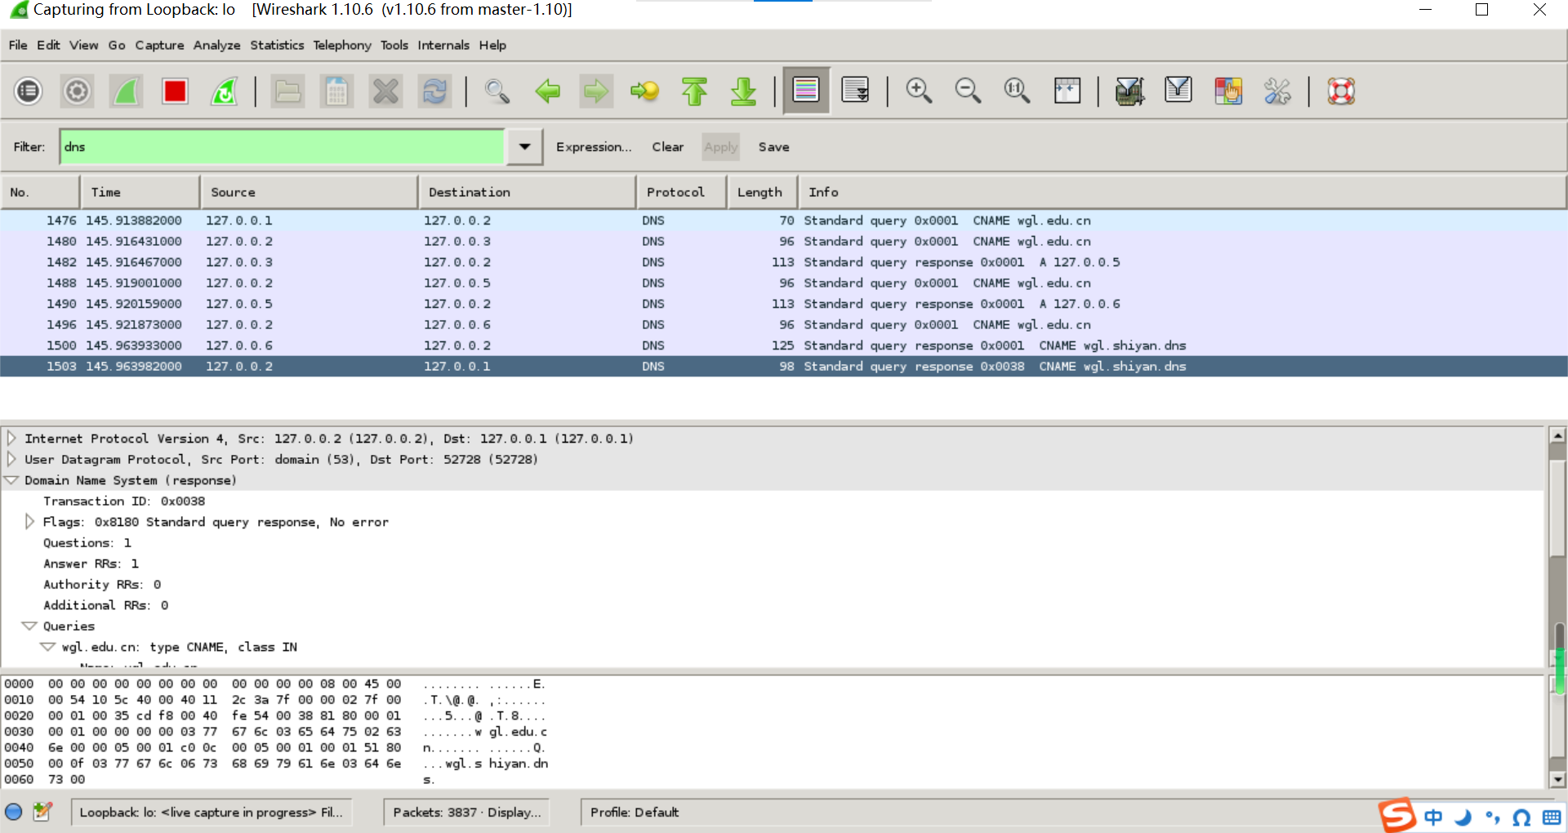
DNS packet that Local server respond to Client:
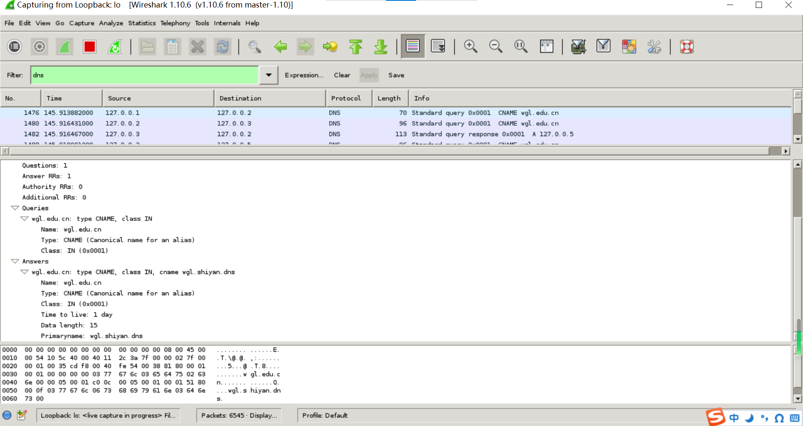

5.3 Search domain name of type MX (not in local server cache)
Client command: ./c test.microsoft.com MX

A. Client side
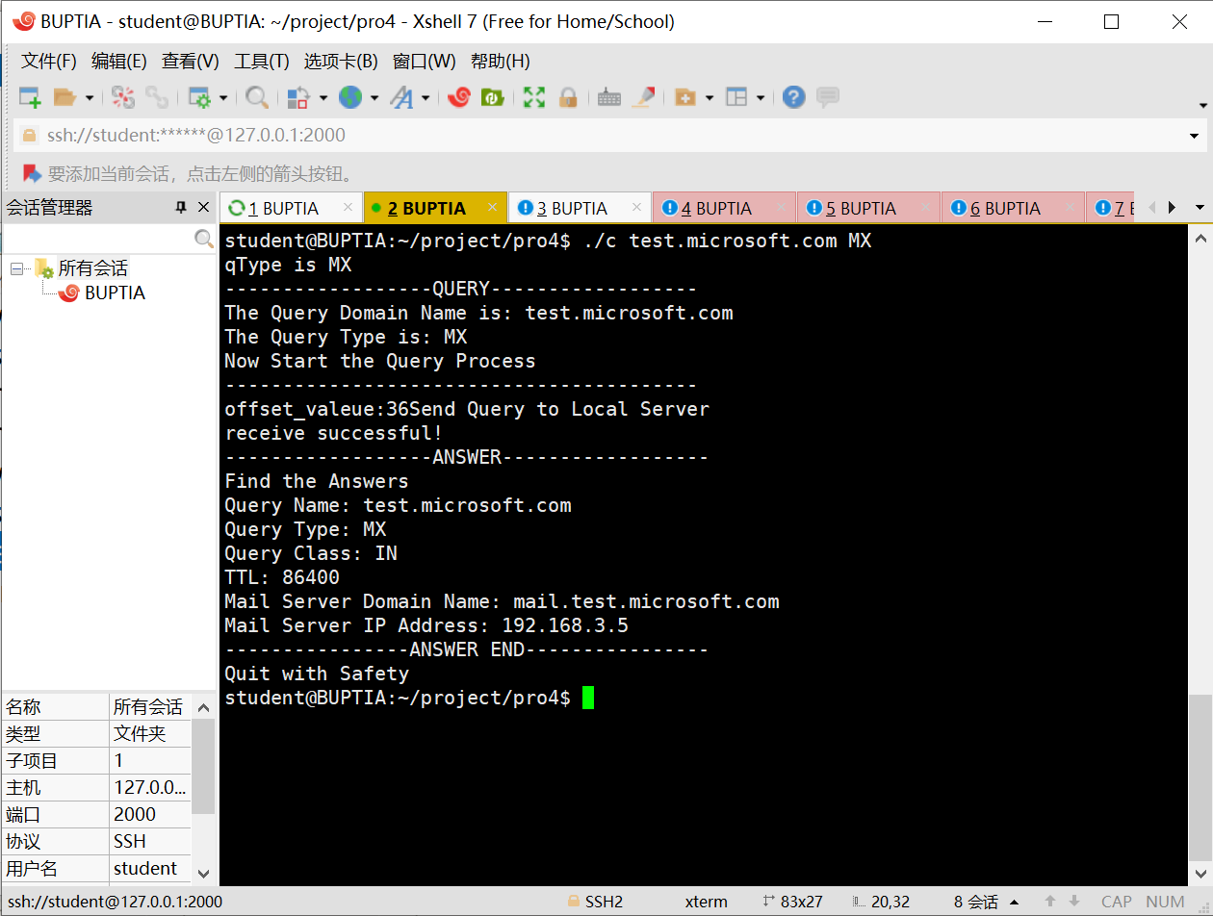

B. Local Server side
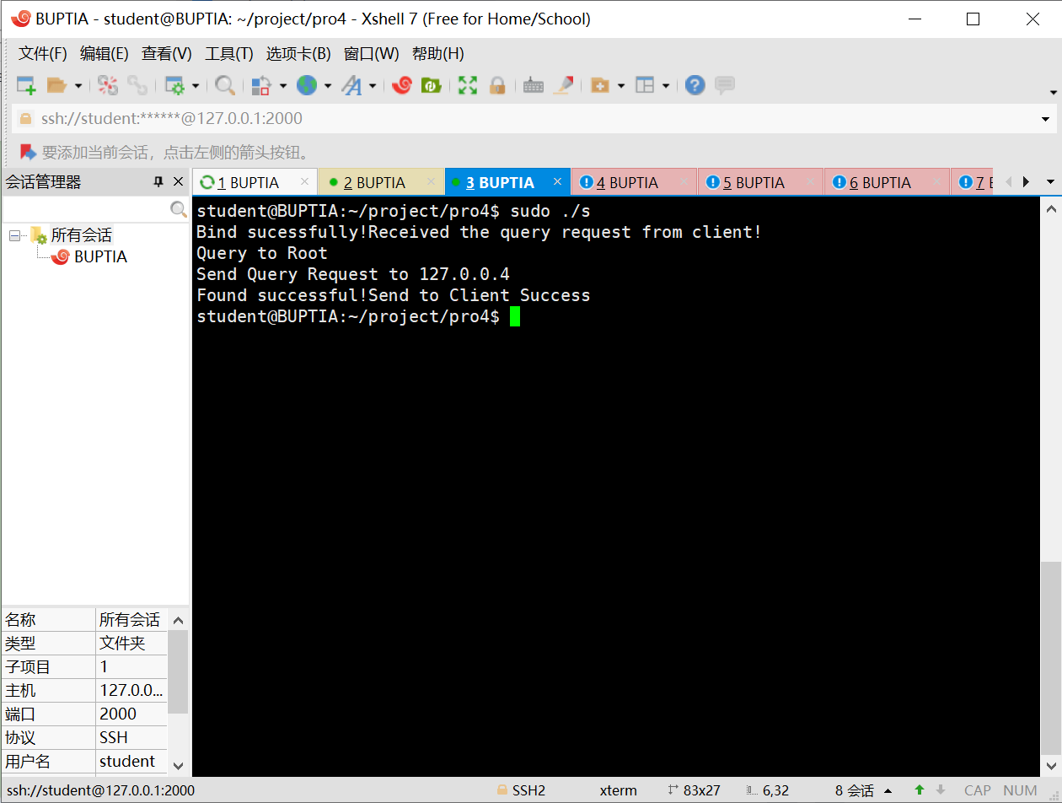

C. DNS packet
DNS packet list:
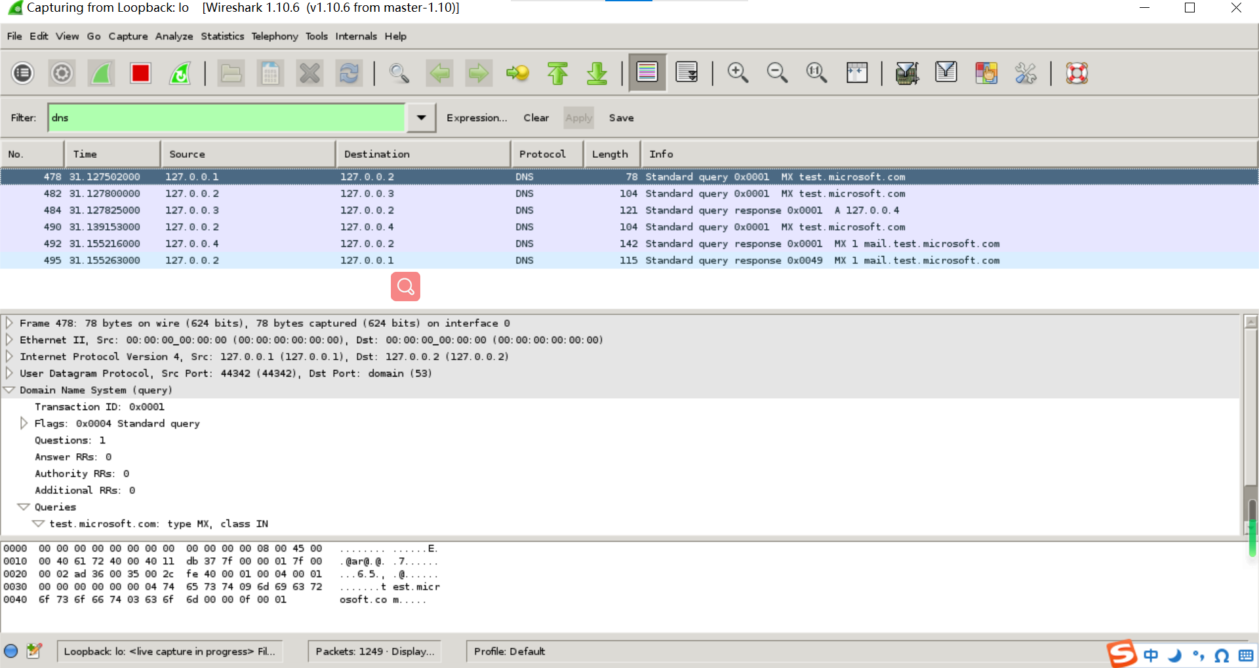
DNS packet that Local server respond to Client:
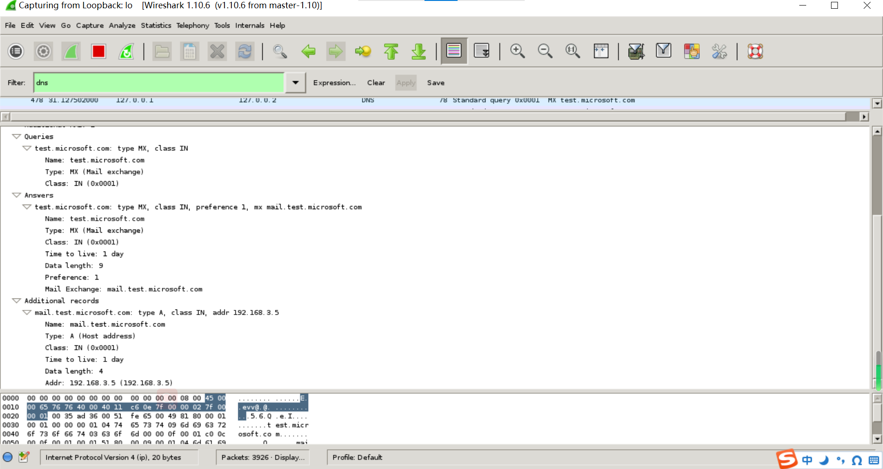

5.4 Search domain name from local server cache
Client command: ./c lsc.gov.us A

A. Client side
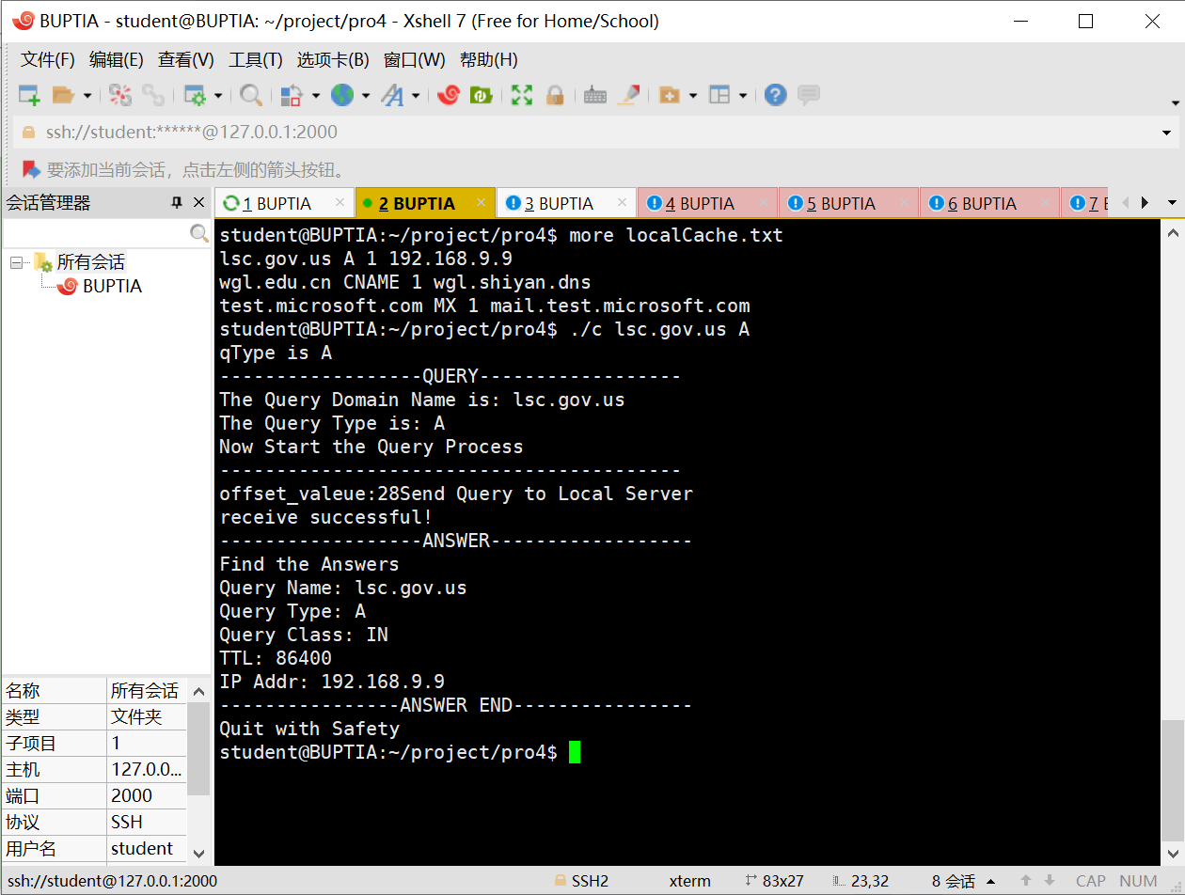
B. Local Server side
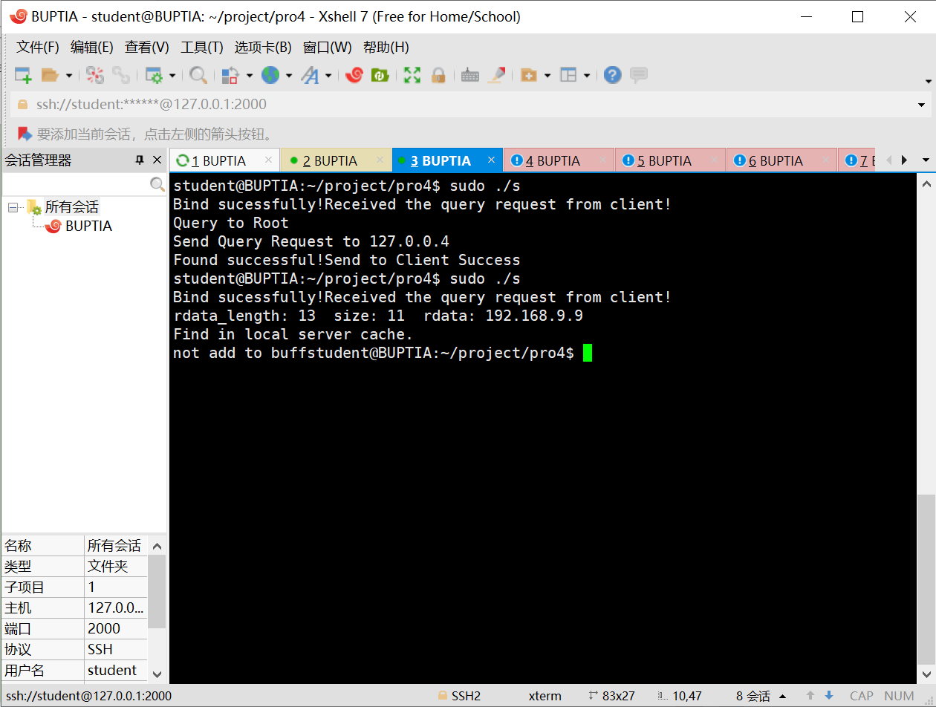

C. DNS packet
DNS packet list & DNS packet that Local server respond to Client:
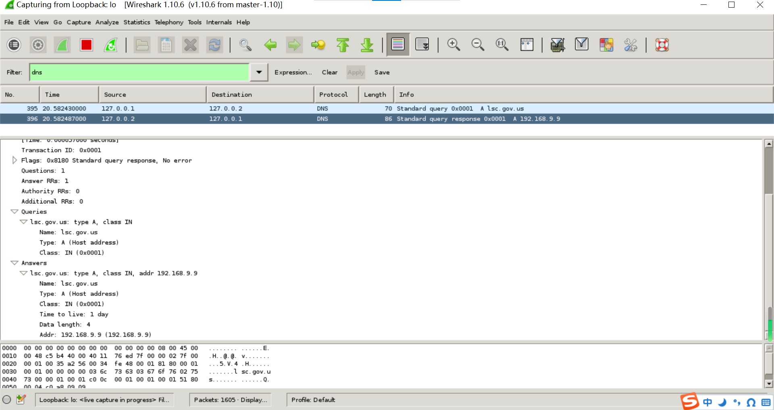

5.5 Write to cache in Local Server
Localcache in 5.1
Localcache in 5.4
We can find the cache of local server has changed after search of 5.1/5.2/5.3.

5.6 Trace
In local server side, we can find the trace of Iterative query.

Summary and Conclusion
Job division:
As for code, Liu Sichen is mainly responsible for the code of client and local server and part of the other servers like root, comorg, cnus. Wan Guolong is also join in the design and implementation of the client and local server and part of the servers like edu, gov. After coding, we always debug together. It is beneficial for us to familiar with the structure of the whole system.
As for report, Liu Sichen is mainly responsible for the first three part, Overview, Requirement Analysis, and Preliminary Design. Wan Guolong is mainly responsible for the second three part, Detail Design, Results and Summary&Conclusion.

Self-evaluation:
It is truly difficulty for us to design and implementation a DNS system though it is a simplified software. In the coding, how to change the message to the byte stream which satisfied the format of the DNS packet puzzle us long time. But finally we solve it. It is pity for us that we did not implement the search of PTR.

Appendix: Source Codes

