**User guide**

1. How can we run the code ?
2. By the command line

Firstly, we have to get into the **“src”** under “WordleGame” file via the command line. Then we need to compile the **“Gaming.java”** file and run it again.

1. By the Java IDE(take Eclipse as an example)a

In Eclipse IDE, we need to import project “WordleGame” from File system or archive by the method of “file” choice in menu bar. Then, we open the **“Gaming.java”** file in the “src” file and run it.

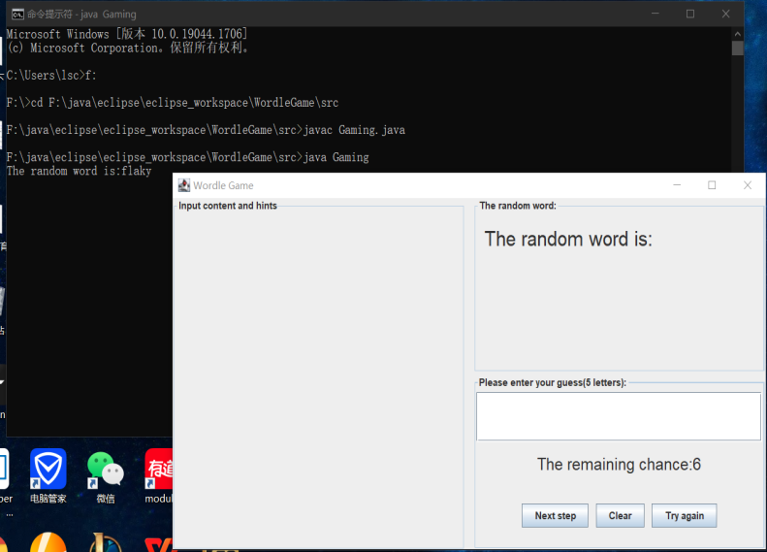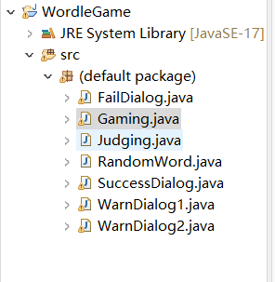

1. How can we play the game?

All you have to do is enter your guess in the text field. If you want to take the next step, click the "Next step" button. If you want to clear the text field, click the "Clear" button. If you want to restart the game, click the "Try again" button.

For your every action of clicking ”Next step”, you can get the remaining chance and the hints in the left panel. You can also know whether the format of input is right. If there isn’t remaining chance, the interface will show you the guess word in the upper-right panel.

