DETECTION OF PARKINSON’S AND
ALZHEIMER’S DISEASE USING EEG SIGNALS

Abstract—In this study, a new approach is proposed to the detection of Parkinson’s and Alzheimer’s diseases by using Electroencephalography (EEG) signals and the Principal Component Analysis (PCA) method and training via Convolutional Neural Networks (CNN) model. In the proposed method, EEG-based signal values are applied separately to the generated 1D CNN model, and the classification results are compared. The classification results showed that the EEG signals obtained from EEG signals were successful in diagnosing Parkinson’s and Alzheimer’s. The highest classifier accuracy was obtained from these data by 95%.
Keywords: Electroencephalography, Parkinson, Alzheimer, Principal Component Analysis, Convolutional Neural Networks.

Introduction

A. Background of the study
Parkinson's Disease (PD) is a neurological disease affecting a lot of humans [1]. It is distinguished by powerful movements because neurons that produce dopamine in the substantia nigra pars compacta are lost [1],[2]. Speech and cognitive control are lost as a result. There are two categories of symptoms associated with Parkinson's disease: motor and non-motor symptoms [3],[4].

Due to their strong relationship to neuroimaging techniques [5], which use pictures and data to evaluate brain changes to explain motor activities, motor symptoms play a vital role in diagnosis or prognosis [6],[7].
Alzheimer's disease is a neurodegenerative disorder causing progressive loss of neurological, mental, and cognitive functions, including memory, judgment, behavior, and emotions [8],[9],[10]. It is the major cause of dementia due to brain neurodegeneration, particularly axons, which destroy neurotransmitters crucial for memory storage and message transmission [11].

A. Aim of the study
This project will use strong machine learning algorithms to differentiate between Parkinson's and Alzheimer's diseases using EEG data. Researchers will collect EEG data from both healthy and sick people, clean the data to reduce noise and create reliable algorithms. These models will be thoroughly tested across many datasets to assure their reliability and safety.

The goal is to create EEG-based prediction models to enhance patient care by enabling early detection and better treatment outcomes for certain neurological disorders.

B. Objectives of the study
- Develop a machine learning model for the detection of Alzheimer's and Parkinson's using electroencephalography (EEG) signals.
- Explore deep learning architectures to improve the accuracy and robustness of disease detection algorithms.
- Investigate feature extraction methods to capture relevant patterns indicative of disease states.
- Implement real-time monitoring systems for continuous state of disease detection and prediction.
- Evaluate the performance of the proposed models on diverse EEG datasets to assess generalizability and reliability.

DATASET

A. Data Description:
This dataset contains the EEG electrode recordings from 585 subjects in total. A total of 195 of them were diagnosed with Alzheimer’s disease (AD group), 195 were diagnosed with Parkinson’s disease (PD group), and 195 were Healthy, storing them in a ‘.csv’ file. Recordings include the EEG signal from 18 scalp electrodes (Fp1, Fp2, F3, F4, F7, F8, T3, T4, C3, C4, T5, T6, P3, P4, T6, O1, and O2) and 1 target. This dataset is trained by Convolutional Neural Networks (CNN) and uses Principal Component Analysis (PCA) for dimensionality reduction.
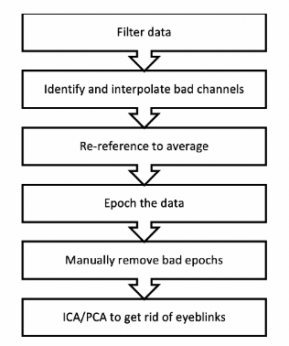

Fig-1: Pre-processing pipelines

B.Implementation of dataset:

This work aims to apply advanced machine learning methods, specifically concentrating on EEG signals from patients. Before putting into practice an EEG signal-based prediction system for Parkinson's and Alzheimer's diseases, a significant data collection phase is necessary. To establish a robust dataset, this involves enrolling a diverse group of patients, including both healthy controls and those with Parkinson's or Alzheimer's disease
.
To provide a comprehensive view of brain function, EEG data is collected under specified conditions, gathering both resting-state and task-based neural activity.

The gathered EEG data passes through a thorough preprocessing stage that improves the quality. Different methods, such as Principal Component Analysis (PCA), are used to remove noise coming from muscular and visual scanning processes. The signals are divided into appropriate epochs, such as 2-second intervals, to aid in analysis. Key frequency zones, which are typically 0.5–50 Hz, are then separated using band-pass filtering.

The next step is featuring extraction from the pre-processed EEG data to identify relevant biomarkers. This allows for the computation of the power spectral density (PSD) for each of the following frequency bands: delta, theta, alpha, beta, and gamma, in addition to the time-domain features: mean, variance, and Hjorth parameters.

To identify Alzheimer's or Parkinson's diseases, a structured dataset is created, and machine learning models are trained using convolutional neural networks (CNNs) and other methods. To ensure robustness, the datasets are divided into training and validation sets using cross-validations and are evaluated using requirements like AUC-ROC, sensitivity, specificity, and accuracy.

For increased accuracy, EEG data can be combined with information from other sources like MRIs, genetics, or medical records. This method provides a precise knowledge of the variations in the brain linked to various disorders.

The models are included in a clinical decision support system that is extensively tested in real-world settings and generates predictions in real time.

METHODOLOGY
Hereafter, we took steps to derive the results from the raw data. The split EEG signal recordings produced by the primary pre-processing pipeline were plotted using Python.

After that, these plots are fed into a 1D-CNN to provide a classification. Here is the suggested methodology's general outline as shown below (Fig-2):

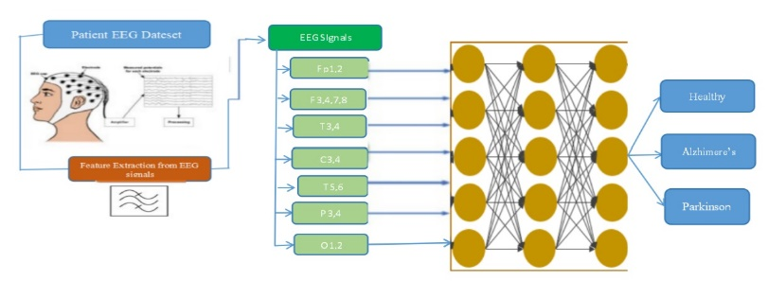

Fig-2: Model Architecture

A. Convolution Neural Networks

A neural network that focuses on detecting patterns in data is called a convolutional neural network (CNN), which is particularly beneficial for graphical or pictorial representations. Neurons connected to each layer of these networks behave similarly to those in human brains, which means they process inputs in grids modeled like the visual cortex of animals as well.
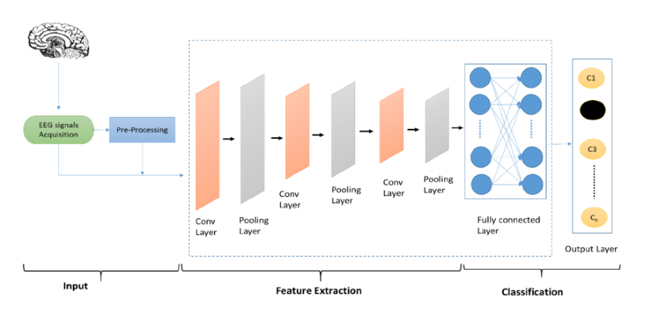Fig-3: Typical CNN architecture employed for EEG signal analysis

Neurons in a CNN react to components within the field of view, a limited region of the visible domain. CNN is composed of several layers, such as pooling, convolutional, and fully connected layers. Additional layers include batch normalization and dropout layers. The top layer, the layer known as convolutional, extracts features as activations. The basic functionality of the layers is enlightened concisely in Equation (1).
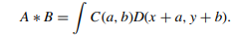 (1)

The convolutional layer convolutions the filter size by the image size (given by Equation (1)) to produce a feature map when the model's parameters are changed. By utilizing all four convolutional layers, the total number of filters is increased from 32 to 256. When a model performs badly on new or test data, it is said to be overfitting. This is why the dropout layer was created. There is a 0.21 dropout rate. Nonnormalized data, on the other hand, could be skewed toward higher values. To avoid this, results are kept on a constant scale without sacrificing quality by using a batch normalizing layer. This layer is used with each convolutional layer to ensure that the model is trained as efficiently as possible, given by Equations (2), (3), (4), and (5).

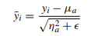 (2)
were,
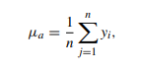
(3)
is the batch mean, and

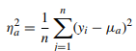

(4)
is the batch variance, hence the scaled and shifted activations are given by the equation

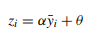
(5)
where α and θ are the learnable parameters. In addition, the ReLU activation function is used, followed by the Max-Pooling operation. The ReLU function increases the non-linearity for proper feature extraction expressed by Equation (6). Finally, the dense layer and softmax layers are used, followed by the classification layer

(6)

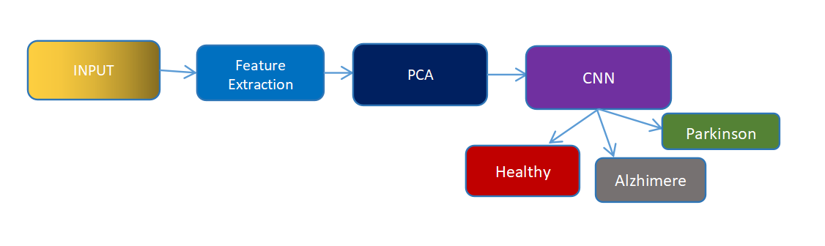

Fig-4: Block Diagram

A. Proposed Methodology
EEG signals contain electrical activities from the brain as well as artifacts from other sources such as muscle movements and physical interference from the equipment. Therefore, the need for preprocessing those signals before analyzing them is crucial. Digital filtering has become the most popular method of rejecting unwanted information in certain EEG frequencies. Discrete Fourier Transform (DFT) has shown itself as a powerful tool in developing digital filters, once it generates the spectrum of a given signal. The spectrum represents the original signal in the frequency domain and denotes the power of each frequency band present in it. Thus, it is possible to attenuate the effect of a given frequency band in the spectra and, through the Inverse Fourier Transform, to return to the time domain without that band. Nevertheless, DFT has limitations when it is applied to non-stationary (e.g. EEG) signals. Stationary signals are those whose statistical measures, such as mean, variance, and covariance remain constant over time in any sample of the input data. Many of the DFT limitations were overcome using wavelets, which consist of mathematical functions that can decompose a signal into various time-frequency scales by convolution operations. The employment of wavelets in each signal decomposition generates coefficients that keep the signal information; therefore, these coefficients can be used to reconstruct the signal through the inverse operation.
The partition of given EEG components is useful for many specialists since each known EEG rhythm is related to specific brain stages and can be used to investigate the action of drugs, stimuli, and diseases on neuronal dynamics. In this sense, previous studies have shown a decrease in high-frequency and an increase in low-frequency component activity in AD patients’ signals.

RESULTS

A. Experimental setup


The input has been given from the dataset. It is going to detect the type and range of disease. This has been done through FLASK
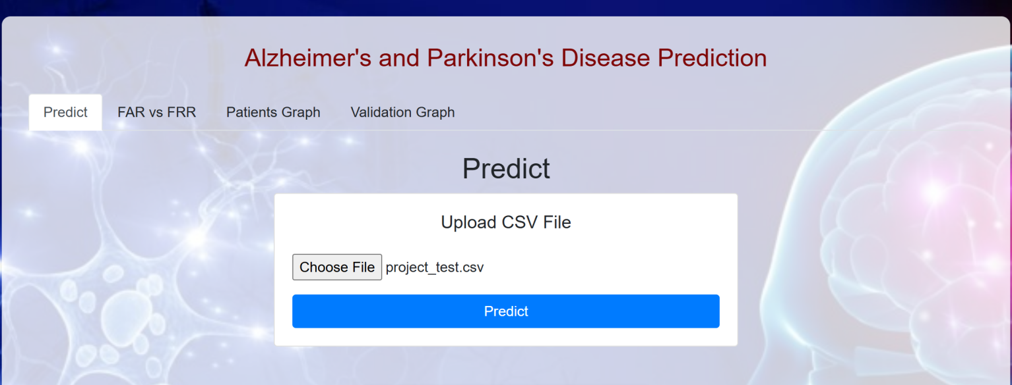

A. Representation of Data
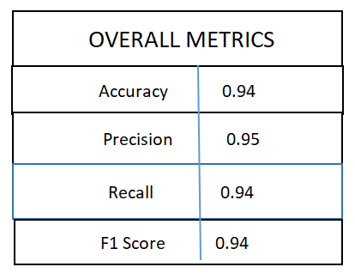

Fig-5: Performance Metrics
In the above image, we can see the performance metrics of the project. We have got the accuracy 0.94, Precision 0.95.
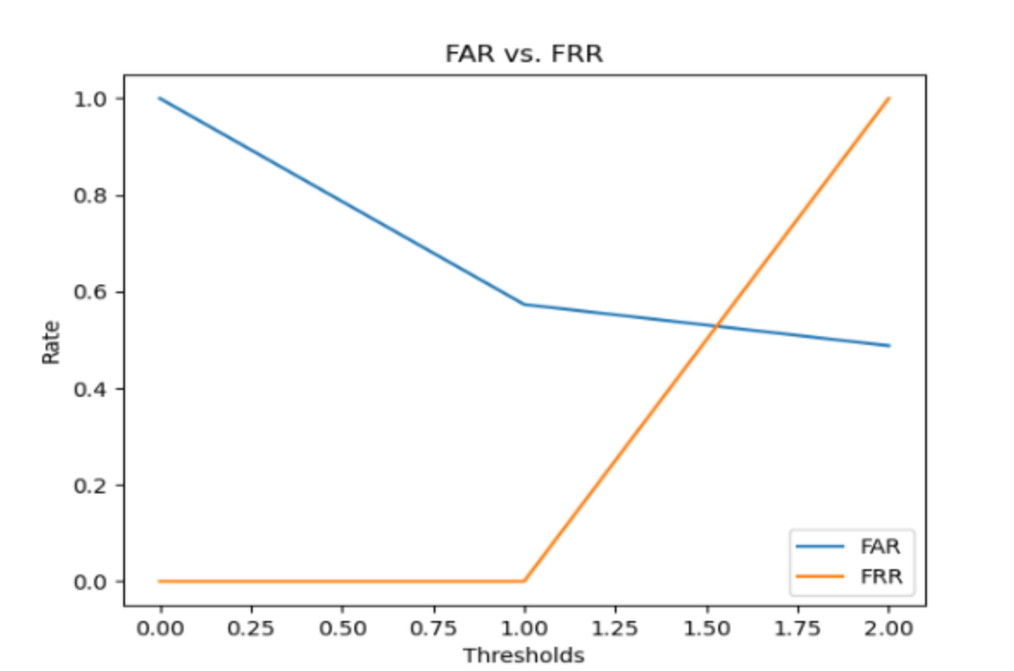
Fig-6: FAR VS FAR
This is the FRR (False Rejection Rate) and FAR (False Acceptance Rate).
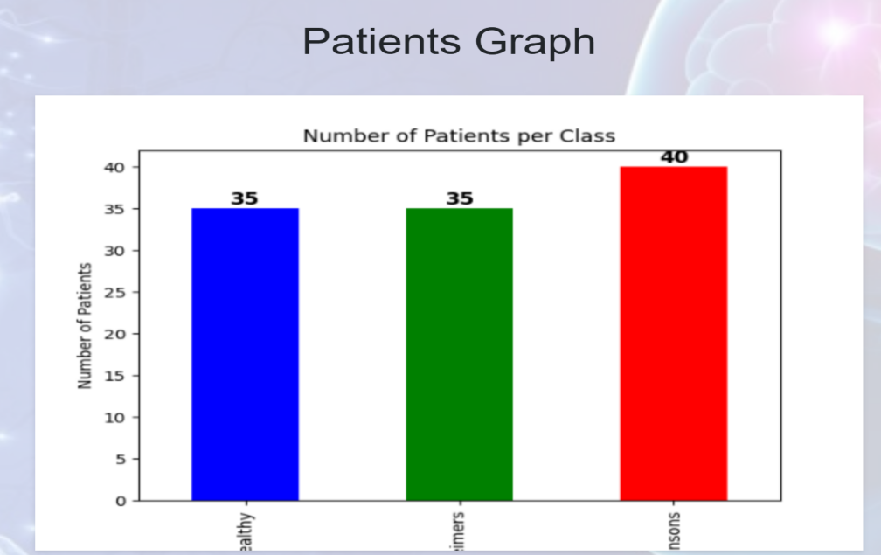

Fig-7: Graphical Representation
In the above image, we can see the Graphical representation of how many number of patients suffering with Alzheimer, Parkinson and healthy.
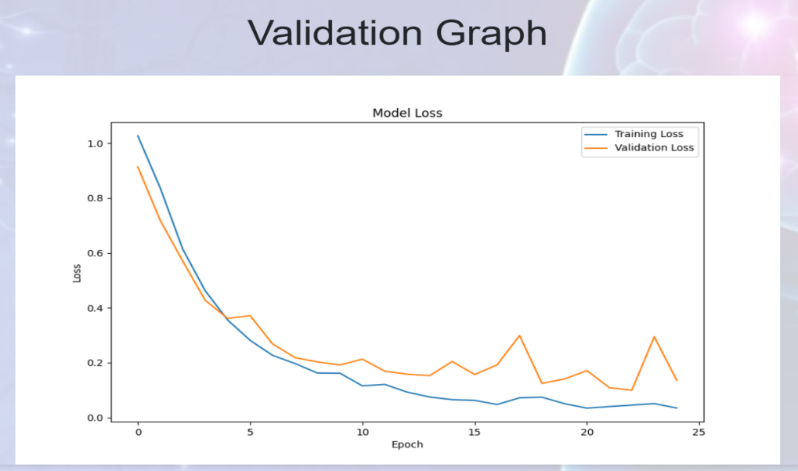
Fig-8: Validation Graph

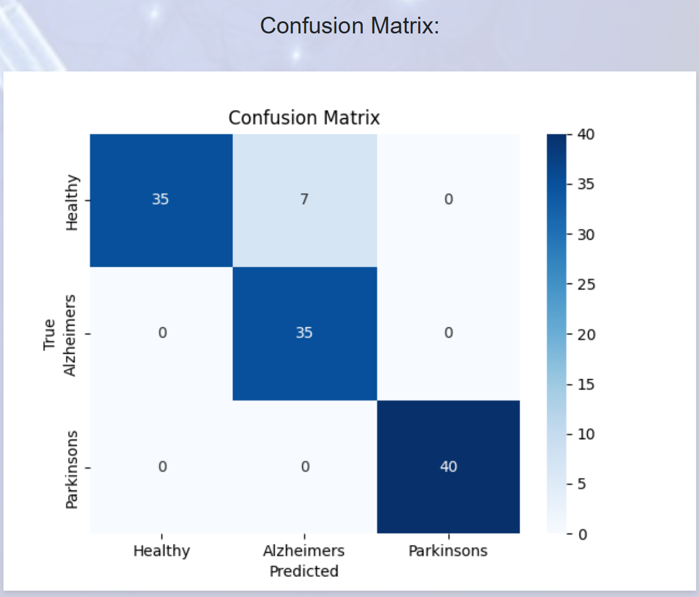
Fig-9: Confusion Matrix
A confusion matrix is a table used to evaluate the performance of a classification model. It allows you to see how well your model is performing by showing the actual versus predicted classifications.

CONCLUSION AND FUTURE SCOPE
In conclusion, the field of research exploring the use of EEG signals for determining the start of Alzheimer's and Parkinson's diseases has great potential for early detection and treatment. The first stage is to carefully collect data from a range of populations, including both health controls and patients with specified disorders. Preprocessing techniques ensure accuracy and dependability, whereas feature extraction methods extract a wide range of information from EEG signals. Machine learning algorithms improve the predictive ability of subsequent models by identifying discriminative characteristics associated with disease stages. Convolutional Neural Networks (CNNs) are crucial in this field because they learn spatial patterns from EEG data using successive layers of convolution and pooling.
Because these prediction models give medical professionals early disease symptoms that traditional diagnostic techniques could overlook, they have important treatment implications. These developments may result in specific treatment plans tailored to the individual neurological profile of each patient, which is encouraging for customized medicine. These models facilitate the development of tailored healthcare treatments that can improve patient outcomes and quality of life while also assisting us in understanding how diseases progress. Prediction models built using EEG technology and machine learning suggest that neurology is about to undergo a revolution.

References
- G. E. Alexander, ‘‘Biology of Parkinson’s disease: Pathogenesis and pathophysiology of a multisystem neurodegenerative disorder,’’ Dialogues Clin. Neurosci., vol. 6, no. 3, pp. 259–280, Sep. 2004.
- S. Q. A. Rizvi, G. Wang, and X. Xing, ‘‘Early detection of Parkinson disease using wavelet transform along with Fourier transform,’’ in Proc. Int. Conf. Smart City Informatization. Cham, Switzerland: Springer, 2019, pp. 323–333.
- T. Sood and P. Khandnor, ‘‘Classification of Parkinson’s disease using various machine learning techniques,’’ in Int. Conf. Adv. Comput. Data Sci. Cham, Switzerland: Springer, 2019, pp. 296–311.
- H. C. Verma, T. Ahmed, S. Rajan, M. K. Hasan, A. Khan, H. Gohel, and A. Adam, ‘‘Development of LR-PCA based fusion approach to detect the changes in mango fruit crop by using Landsat 8 OLI images,’’ IEEE Access, vol. 10, pp. 85764–85776, 2022.
- R. He, X. Yan, J. Guo, Q. Xu, B. Tang, and Q. Sun, ‘‘Recent advances in biomarkers for Parkinson’s disease,’’ Frontiers Aging Neurosci., vol. 10, p. 305, Oct. 2018.
- M. K. Hasan, T. M. Ghazal, A. Alkhalifah, K. A. Abu Bakar, A. Omidvar, N. S. Nafi, and J. I. Agbinya, ‘‘Fischer linear discrimination and quadratic discrimination analysis–based data mining technique for Internet of Things framework for healthcare,’’ Frontiers Public Health, vol. 9, Oct. 2021, Art. no. 737149.
- M. K. Hasan, S. Islam, I. Memon, A. F. Ismail, S. Abdullah, A. K. Budati, and N. S. Nafi, ‘‘A novel resource-oriented DMA framework for Internet of Medical Things devices in 5G network,’’ IEEE Trans. Ind. Informat., vol. 18, no. 12, pp. 8895–8904, Dec. 2022.
- A. Caruso, F. Nicoletti, D. Mango, A. Saidi, R. Orlando, and S. Scaccianoce, ‘‘Stress as risk factor for Alzheimer’s disease,’’ Pharmacol. Res., vol. 132, pp. 130–134, Jun. 2018.
- H. M. Fonteijn, M. Modat, M. J. Clarkson, and J. Barnes, ‘‘An eventbased model for disease progression and its application in familial Alzheimer’s disease and Huntington’s disease,’’ NeuroImage, vol. 60, no. 3, pp. 1880–1889, 2012.
- A. Ghanemi, ‘‘Alzheimer’s disease therapies: Selected advances and future perspectives,’’ Alexandria J. Med., vol. 51, no. 1, pp. 1–3, 2015.
- A. Burns and S. Iliffe, ‘‘Alzheimer’s disease,’’ Bmj, vol. 338, no. 7692, pp. 467–471, 2009.

