Options Tree Question

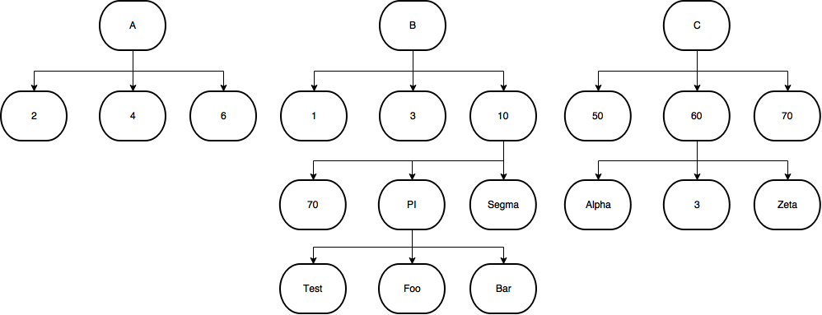

The client has provided you with a tree of compatible options for a product, so that

- Each level of the tree represent a select box so for example: options "A, B, C" go on a single selectbox

- Selecting an option from a specific level of the tree hides all incompatible options

What you should do:

- Build a data structure to hold such a tree

- Write the code to parse the data structure to generate all select boxes for each level of the tree "the code needs to be generic supporting any number of levels in the tree"

- Selecting an option in the first select boxes will hide all the incompatible options down the tree and so on with second, third,.. selectboxes

- When the user select an option from a specific level and there's no compatible options down the tree, the selectbox of all below levels should be disabled

Bonus points:

- Use no libraries, just pure DOM API

- Allow the user to select from any selectbox not necessarily the first and apply the restrictions to above and below nodes

