***Extra Credit Lab***

**Mobile Application Development – 2**

**Rebecca Moses Dmello**

**300322984**



I am confirming that I have completed this classwork assignment completely based on the requirements and it is working and fully functional.

**Step 1: Create a New Project and Select Empty Activity**

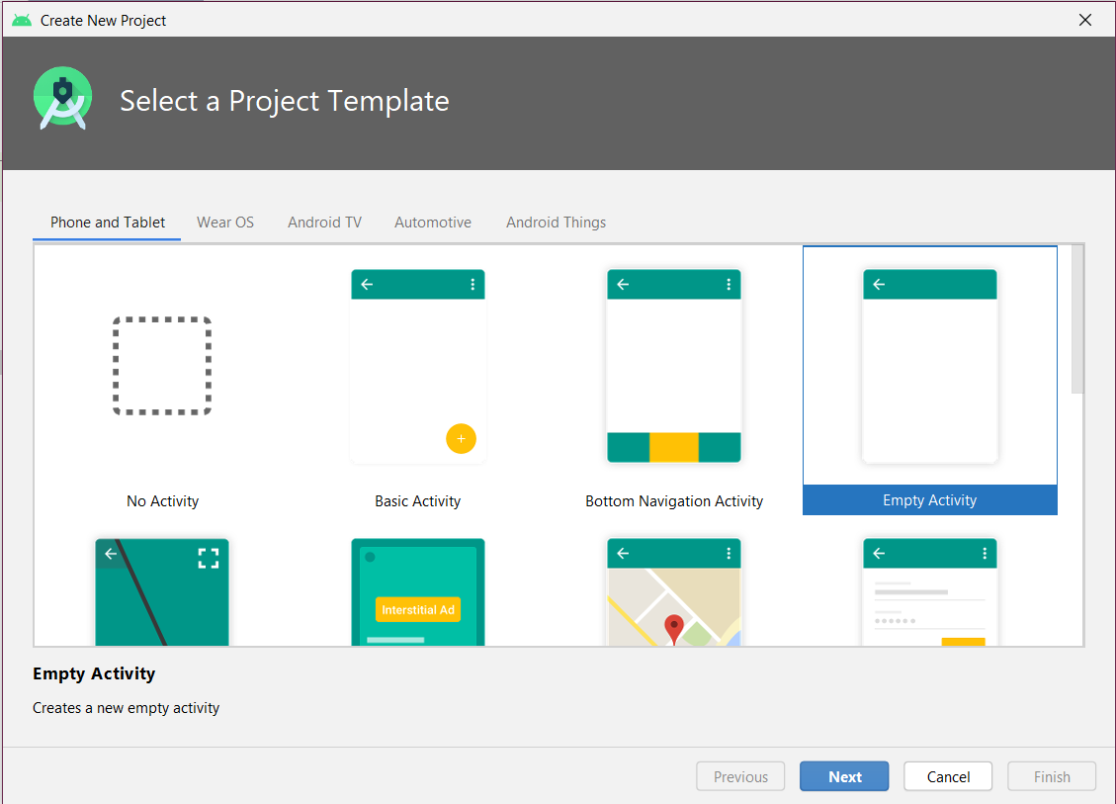

**Step 2: Open build.gradle file inside the Gradle Scripts folder and add following line in order to allow your application to use retrofill and gson converter and click sync now.**

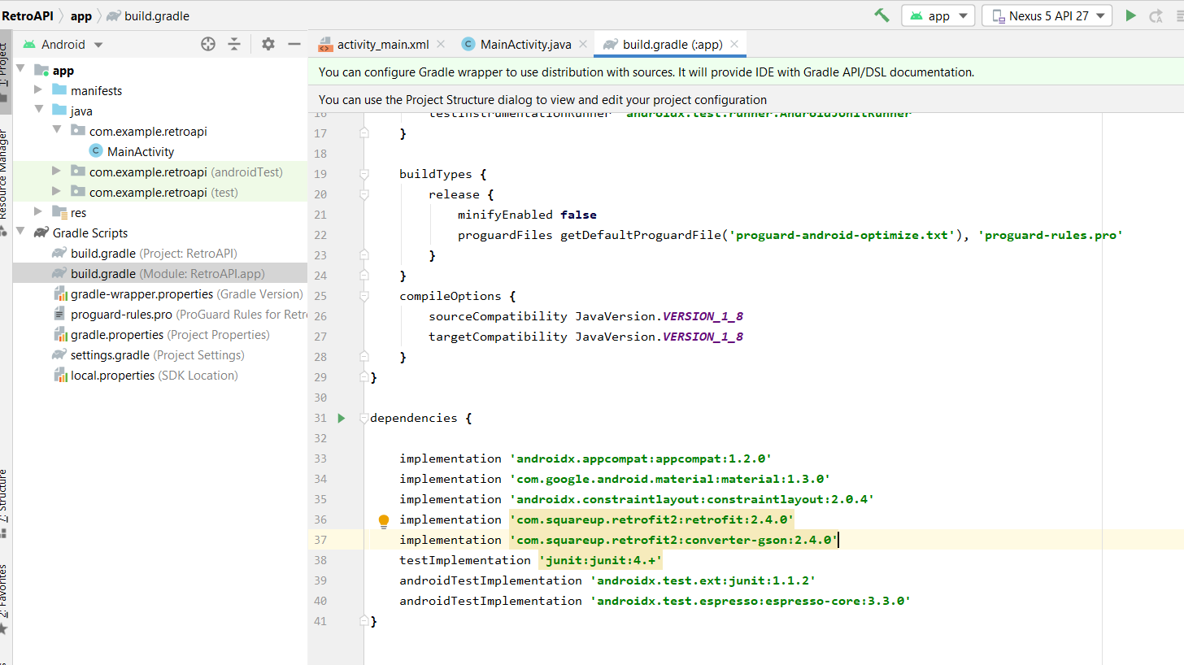

**Step 3: Create a new Java class by right clicking on the package -> new -> java class and name it as Post and add the following code in it.**

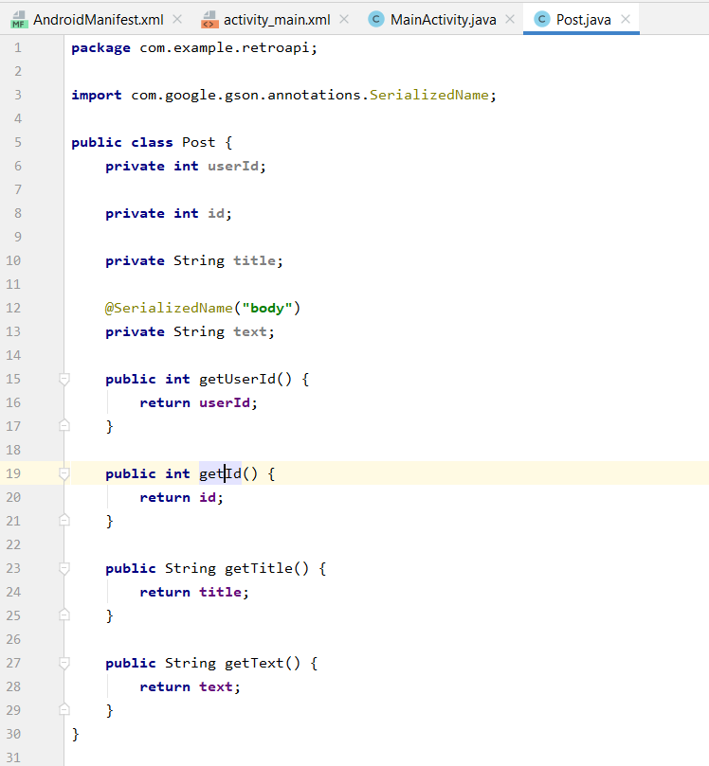

**Step 4: Create a new Interface by right clicking on the package -> new -> class and name it as JsonPlaceHolderApi and select interface add the following code in it.**

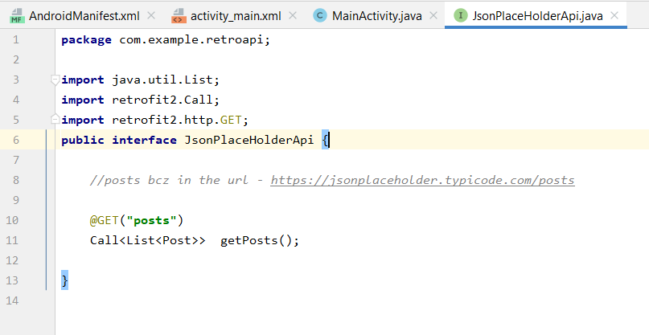

**Step 5: Add following code in MainActivity.java class and select** 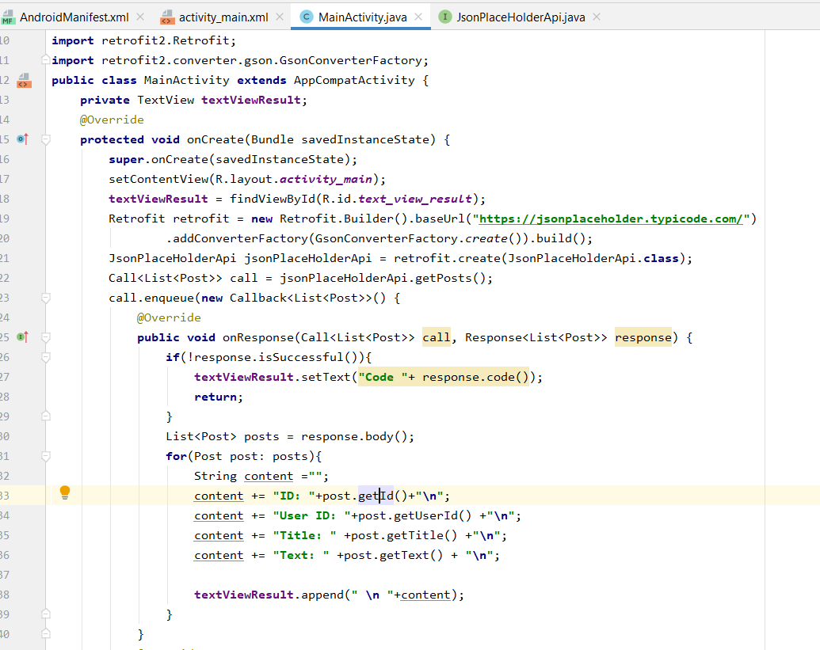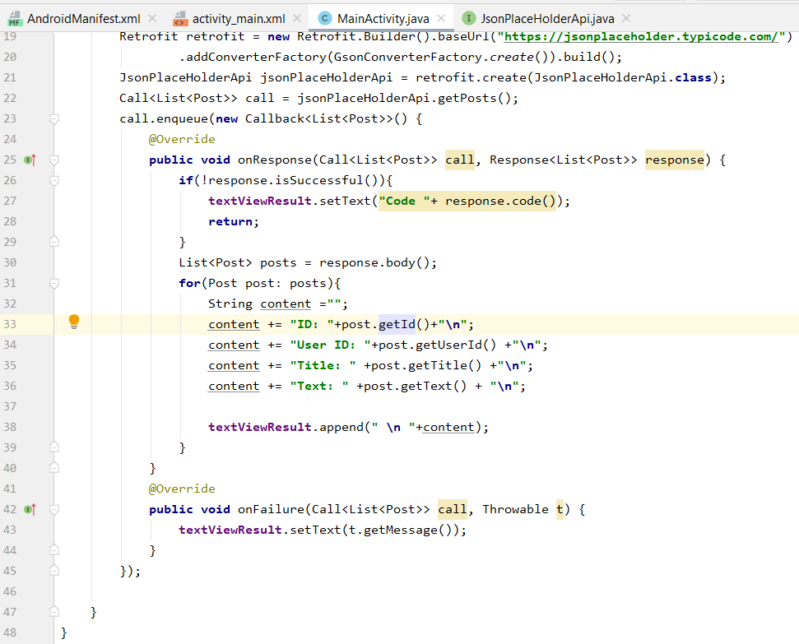

**Step 6: Run your emulator to observe the animations**

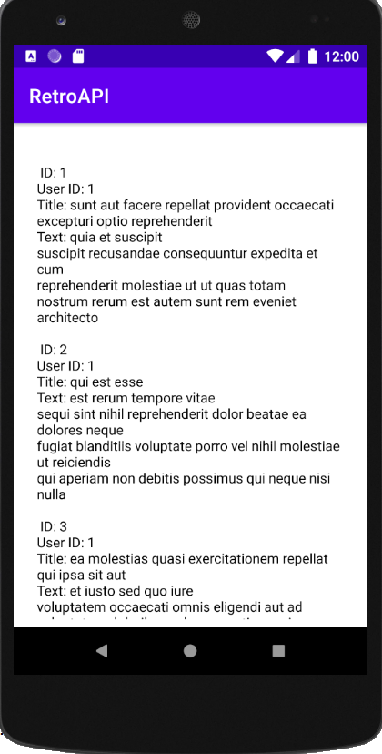

**References:**

**Retrofit Tutorial**

https://www.youtube.com/watch?v=4JGvDUlfk7Y

http://jsonplaceholder.typicode.com/posts