***Lab 4***

**Mobile Application Development – 2**

**Rebecca Moses Dmello**

**300322984**



I am confirming that I have completed this classwork assignment completely based on the requirements and it is working and fully functional.

**Step 1: Create a New Project and Select Empty Activity**

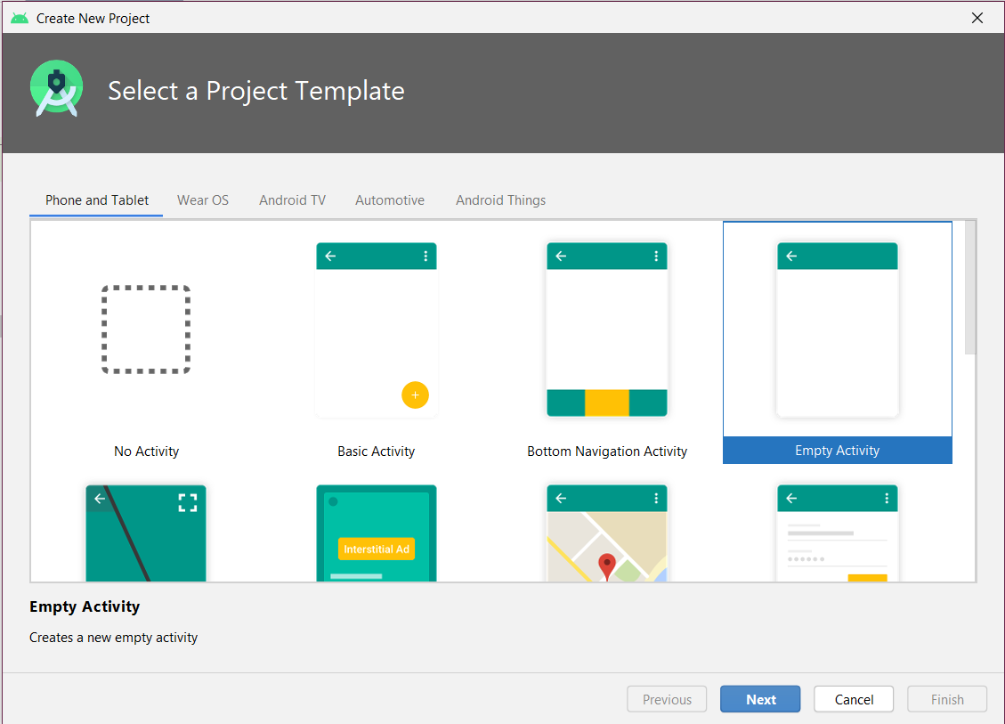

**Step 2: Open AndroidManifest.xml and add the uses-feature tag**

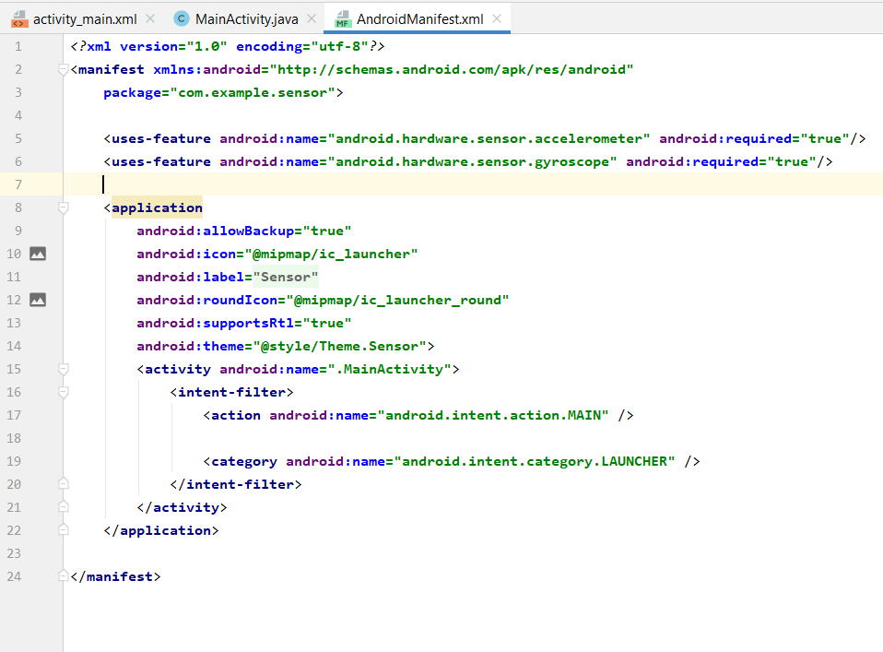

**Step 3: Create a new Java class by right clicking on the package -> new -> java class and name it as Accelerometer and add the following code in it.**

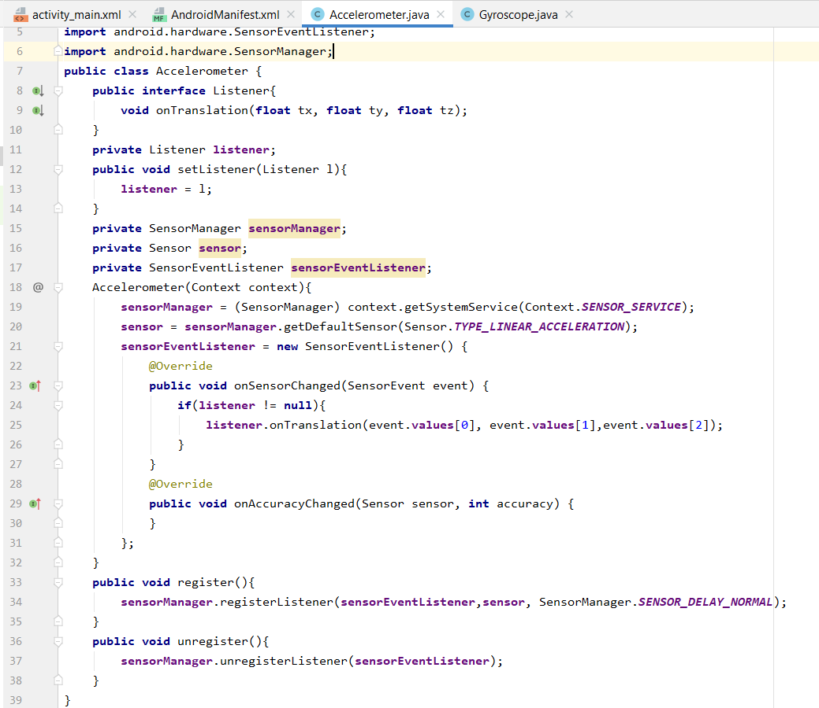

**Step 4: Create a new Java class by right clicking on the package -> new -> java class and name it as Gyroscope and add the following code in it.**

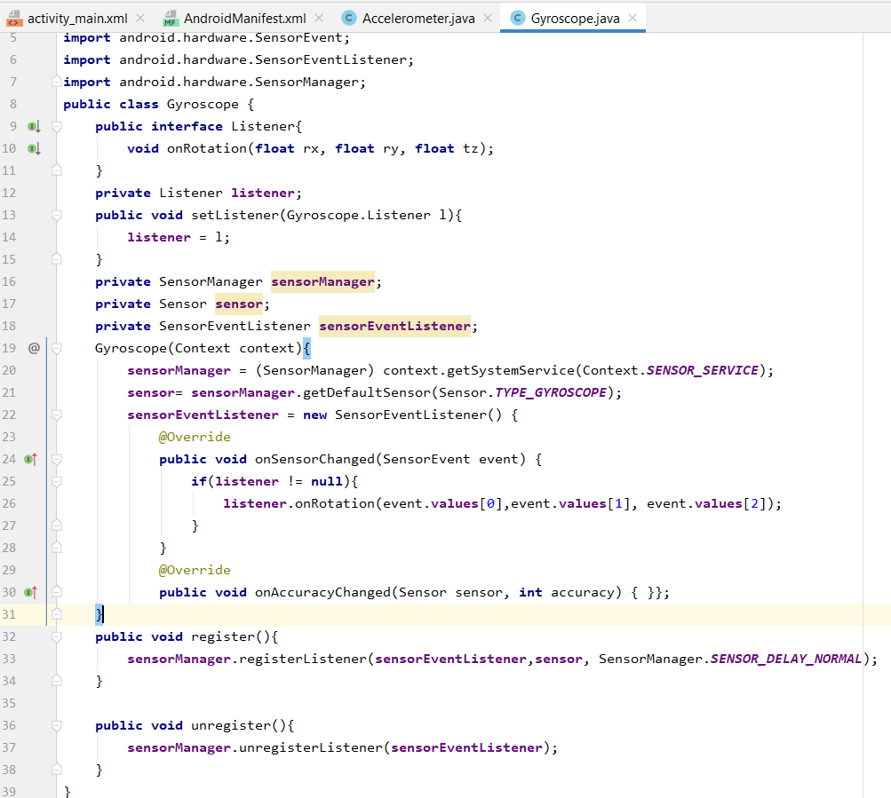

**Step 5: Go to MainActivity.class and Instantiate an object of Accelerometer and Gyroscope.**

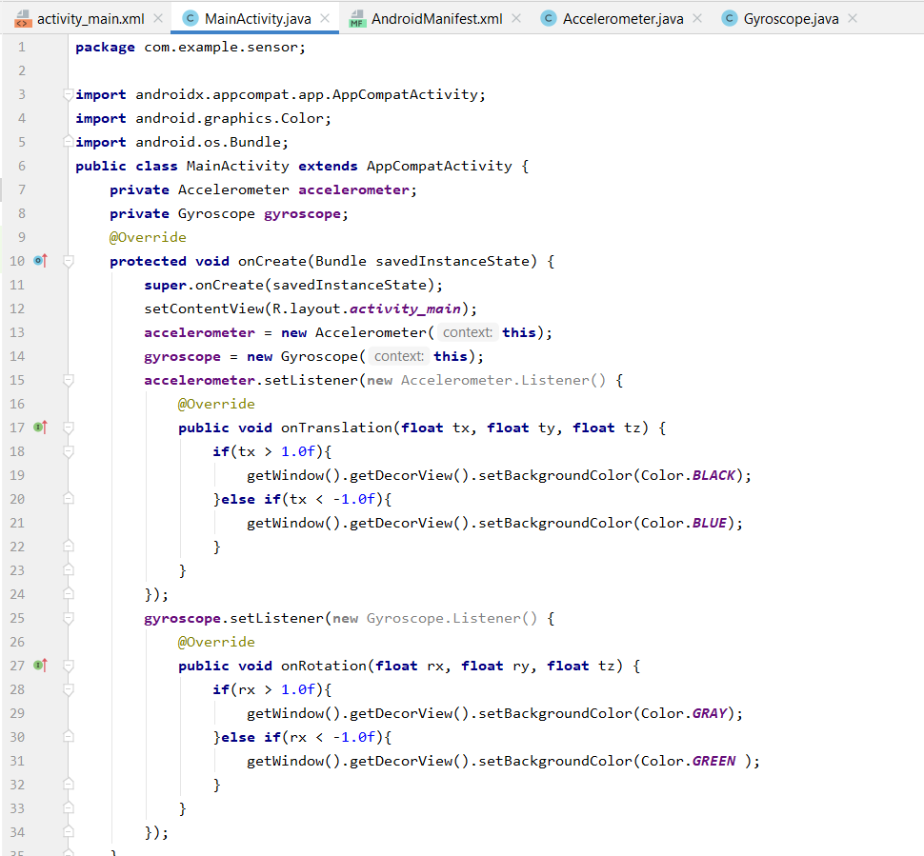

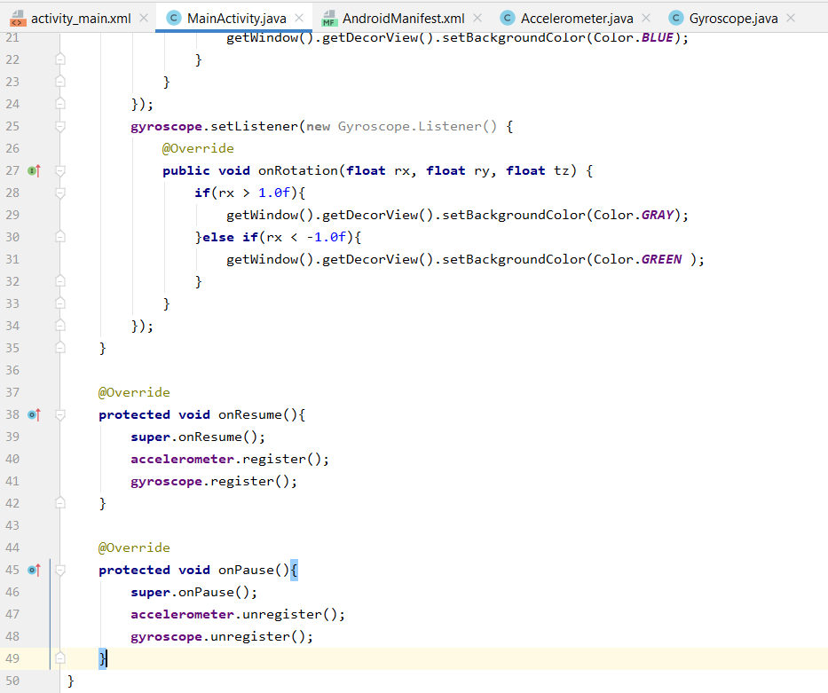

**Step 6: Run your emulator to observe the animations**

**Click on the 3 dots on the right of the emulator and select virtual sensors option**

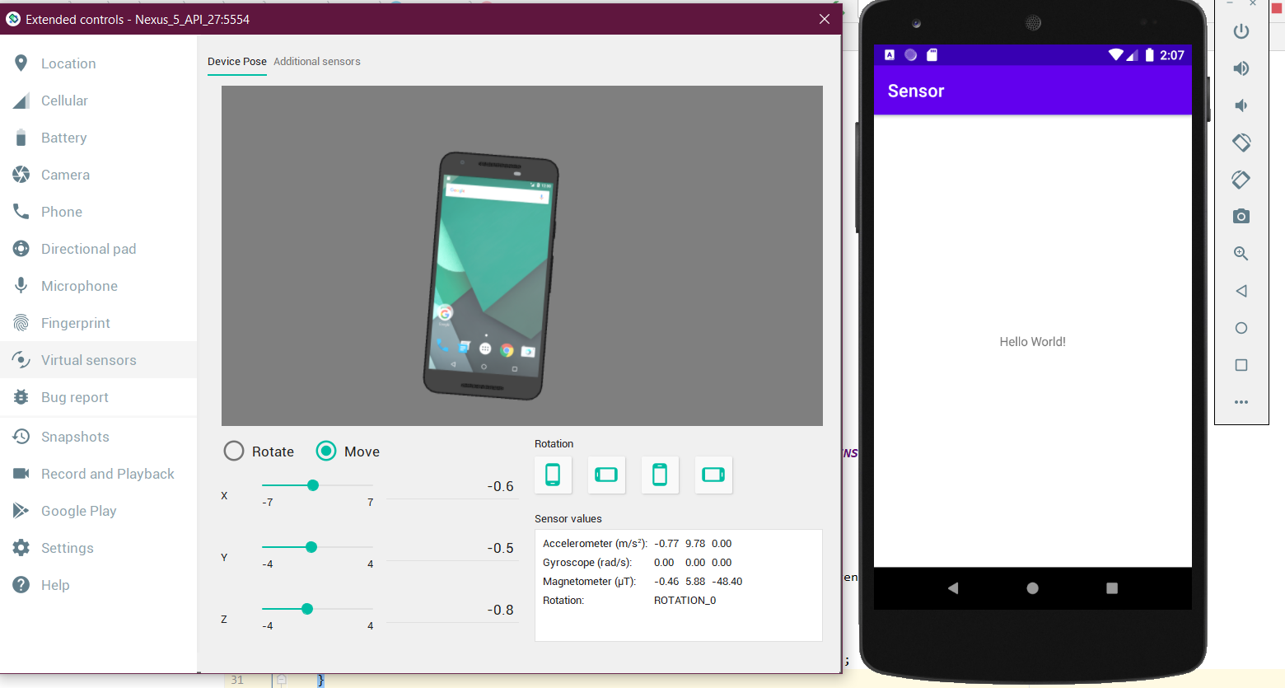

**Click on rotate and change the “Z” value**

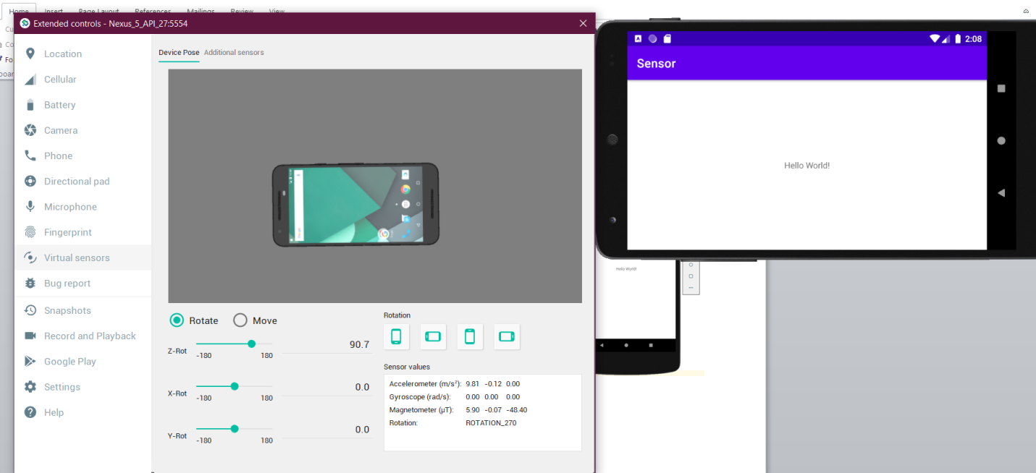

**Click on Move and change the “Y” value, you will notice the change in color of the background as specified in the code.**

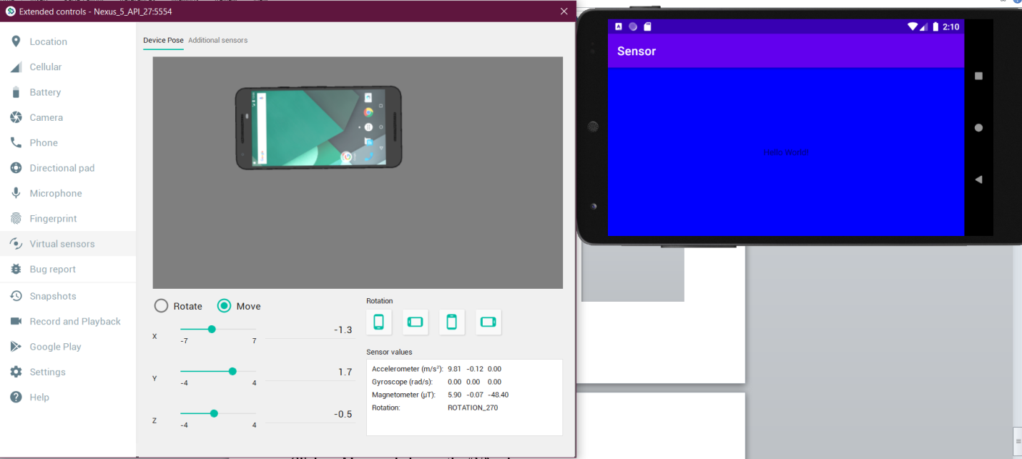

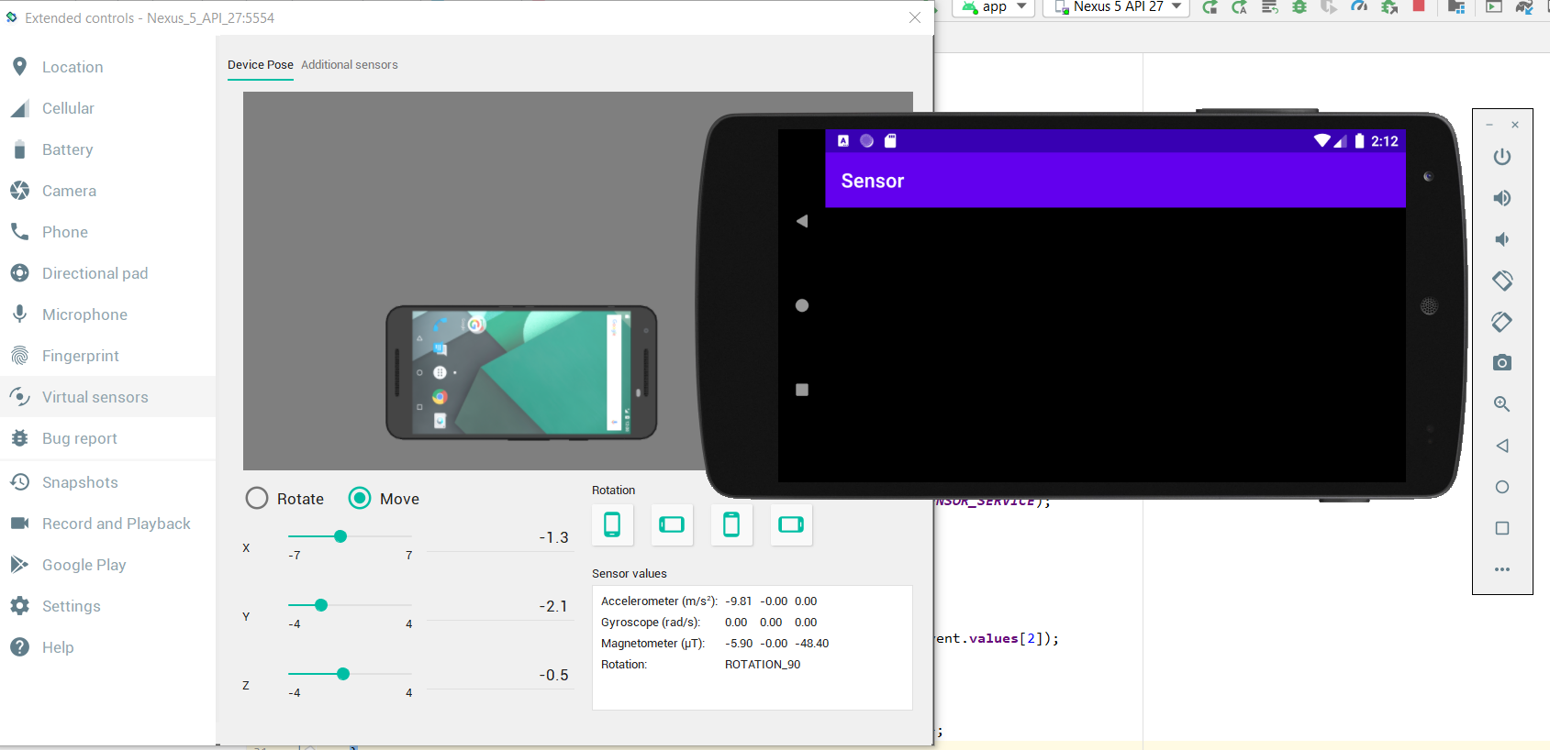

**References:**

**Programming Android Motion Sensors**

https://www.youtube.com/watch?v=OPsVr44uCb8