Intro to Java Week 6 Coding Assignment

**Points possible:** 70

|  |  |  |
| --- | --- | --- |
| Category | Criteria | % of Grade |
| Functionality | Does the code work? | 25 |
| Organization | Is the code clean and organized? Proper use of white space, syntax, and consistency are utilized. Names and comments are concise and clear. | 25 |
| Creativity | Student solved the problems presented in the assignment using creativity and out of the box thinking. | 25 |
| Completeness | All requirements of the assignment are complete. | 25 |

**Instructions:** In Eclipse, or an IDE of your choice, write the code that accomplishes the objectives listed below. Ensure that the code compiles and runs as directed. Take screenshots of the code and of the running program (make sure to get screenshots of all required functionality) and paste them in this document where instructed below. Create a new repository on GitHub for this week’s assignments and push this document, with your Java project code, to the repository. Add the URL for this week’s repository to this document where instructed and submit this document to your instructor when complete.

**Coding Steps:**

For the final project you will be creating an automated version of the classic card game *WAR.*

1. Create the following classes.
   1. Card
      1. Fields
         1. **value** (contains a value from 2-14 representing cards 2-Ace)
         2. **name** (e.g. Ace of Diamonds, or Two of Hearts)
      2. Methods
         1. Getters and Setters
         2. **describe** (prints out information about a card)
   2. Deck
      1. Fields
         1. **cards** (List of Card)
      2. Methods
         1. **shuffle** (randomizes the order of the cards)
         2. **draw** (removes and returns the top card of the Cards field)
         3. In the constructor, when a new Deck is instantiated, the Cards field should be populated with the standard 52 cards.
   3. Player
      1. Fields
         1. **hand** (List of Card)
         2. **score** (set to 0 in the constructor)
         3. **name**
      2. Methods
         1. **describe** (prints out information about the player and calls the describe method for each card in the Hand List)
         2. **flip** (removes and returns the top card of the Hand)
         3. **draw** (takes a Deck as an argument and calls the draw method on the deck, adding the returned Card to the hand field)
         4. **incrementScore** (adds 1 to the Player’s score field)
2. Create a class called App with a main method.
3. Instantiate a Deck and two Players, call the shuffle method on the deck.
4. Using a traditional for loop, iterate 52 times calling the Draw method on the other player each iteration using the Deck you instantiated.
5. Using a traditional for loop, iterate 26 times and call the flip method for each player.
   1. Compare the value of each card returned by the two player’s flip methods. Call the incrementScore method on the player whose card has the higher value.
6. After the loop, compare the final score from each player.
7. Print the final score of each player and either “Player 1”, “Player 2”, or “Draw” depending on which score is higher or if they are both the same.

Screenshots of Code:

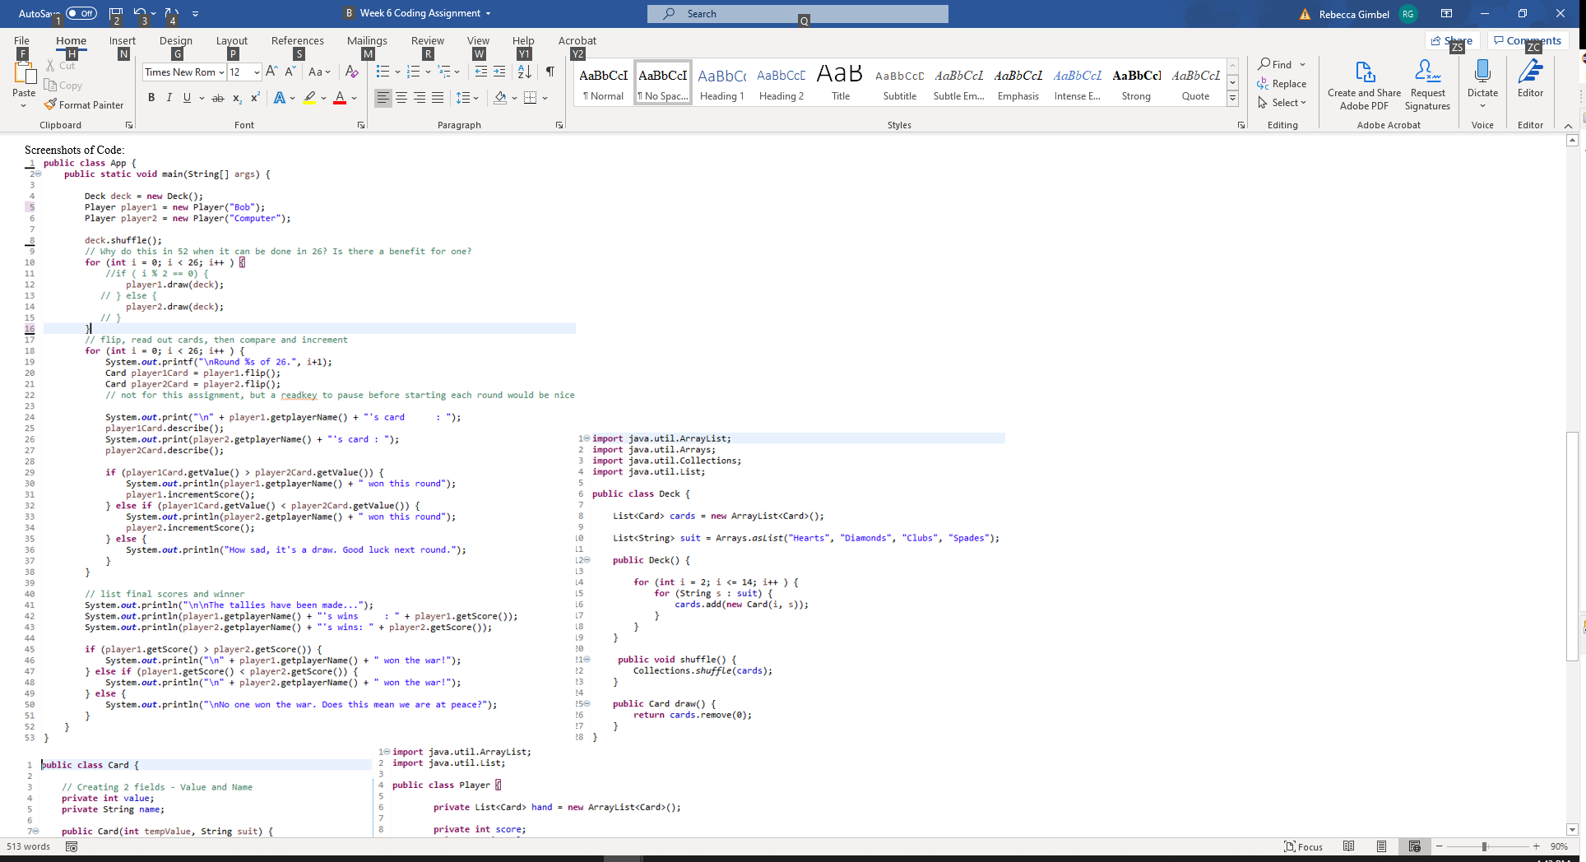

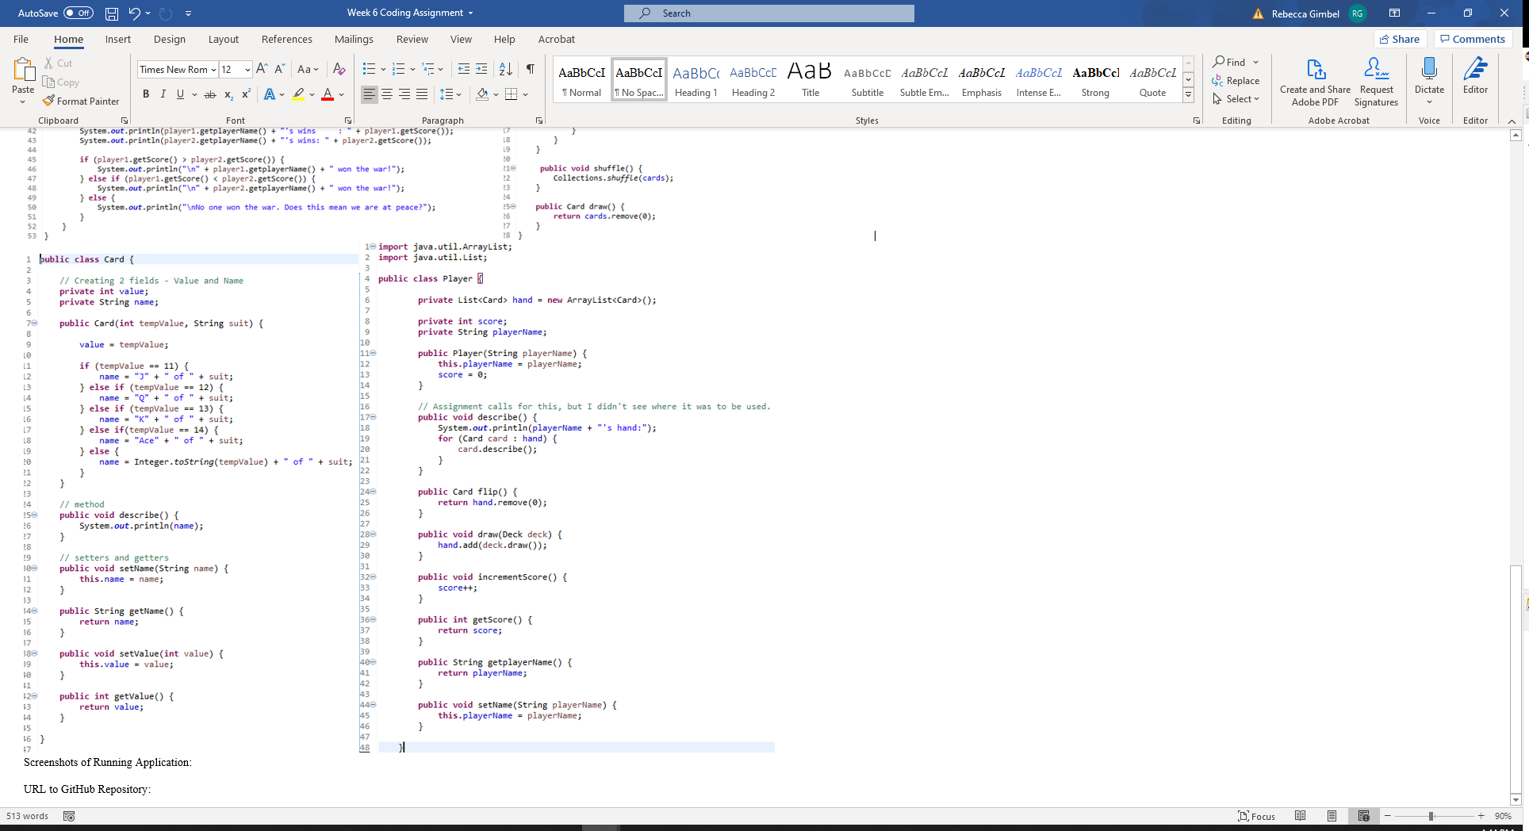

Screenshots of Running Application:

Game 1

|  |  |  |  |
| --- | --- | --- | --- |
| Round 1 of 26.  Bob's card : 3 of Clubs  Computer's card : 6 of Hearts  Computer won this round  Round 2 of 26.  Bob's card : 10 of Hearts  Computer's card : 3 of Diamonds  Bob won this round  Round 3 of 26.  Bob's card : 9 of Clubs  Computer's card : 4 of Hearts  Bob won this round  Round 4 of 26.  Bob's card : 10 of Diamonds  Computer's card : K of Hearts  Computer won this round  Round 5 of 26.  Bob's card : 8 of Hearts  Computer's card : 9 of Diamonds  Computer won this round  Round 6 of 26.  Bob's card : 3 of Spades  Computer's card : 6 of Clubs  Computer won this round  Round 7 of 26.  Bob's card : 4 of Clubs  Computer's card : 7 of Diamonds  Computer won this round | Round 8 of 26.  Bob's card : Q of Spades  Computer's card : 7 of Spades  Bob won this round  Round 9 of 26.  Bob's card : 6 of Diamonds  Computer's card : 4 of Diamonds  Bob won this round  Round 10 of 26.  Bob's card : 2 of Diamonds  Computer's card : Ace of Diamonds  Computer won this round  Round 11 of 26.  Bob's card : 2 of Spades  Computer's card : J of Clubs  Computer won this round  Round 12 of 26.  Bob's card : K of Clubs  Computer's card : 7 of Hearts  Bob won this round  Round 13 of 26.  Bob's card : K of Diamonds  Computer's card : K of Spades  How sad, it's a draw. Good luck next round.  Round 14 of 26.  Bob's card : J of Spades  Computer's card : 9 of Hearts  Bob won this round | Round 15 of 26.  Bob's card : 7 of Clubs  Computer's card : J of Diamonds  Computer won this round  Round 16 of 26.  Bob's card : 10 of Spades  Computer's card : J of Hearts  Computer won this round  Round 17 of 26.  Bob's card : Q of Hearts  Computer's card : 8 of Diamonds  Bob won this round  Round 18 of 26.  Bob's card : 4 of Spades  Computer's card : Q of Diamonds  Computer won this round  Round 19 of 26.  Bob's card : 8 of Clubs  Computer's card : 2 of Hearts  Bob won this round  Round 20 of 26.  Bob's card : 5 of Hearts  Computer's card : 3 of Hearts  Bob won this round  Round 21 of 26.  Bob's card : 5 of Spades  Computer's card : Ace of Hearts  Computer won this round | Round 22 of 26.  Bob's card : 8 of Spades  Computer's card : Ace of Clubs  Computer won this round  Round 23 of 26.  Bob's card : 5 of Diamonds  Computer's card : Q of Clubs  Computer won this round  Round 24 of 26.  Bob's card : 2 of Clubs  Computer's card : 9 of Spades  Computer won this round  Round 25 of 26.  Bob's card : 5 of Clubs  Computer's card : 6 of Spades  Computer won this round  Round 26 of 26.  Bob's card : Ace of Spades  Computer's card : 10 of Clubs  Bob won this round  The tallies have been made...  Bob's wins : 10  Computer's wins: 15  Computer won the war! |

Game2

|  |  |  |  |
| --- | --- | --- | --- |
| Round 1 of 26.  Bob's card : Ace of Hearts  Computer's card : 2 of Clubs  Bob won this round  Round 2 of 26.  Bob's card : 4 of Spades  Computer's card : J of Diamonds  Computer won this round  Round 3 of 26.  Bob's card : K of Clubs  Computer's card : 7 of Clubs  Bob won this round  Round 4 of 26.  Bob's card : Ace of Diamonds  Computer's card : 8 of Diamonds  Bob won this round  Round 5 of 26.  Bob's card : 4 of Hearts  Computer's card : 9 of Spades  Computer won this round  Round 6 of 26.  Bob's card : 4 of Diamonds  Computer's card : Q of Diamonds  Computer won this round  Round 7 of 26.  Bob's card : Q of Hearts  Computer's card : 10 of Hearts  Bob won this round | Round 8 of 26.  Bob's card : 5 of Hearts  Computer's card : Ace of Clubs  Computer won this round  Round 9 of 26.  Bob's card : 5 of Diamonds  Computer's card : 7 of Hearts  Computer won this round  Round 10 of 26.  Bob's card : 10 of Diamonds  Computer's card : 4 of Clubs  Bob won this round  Round 11 of 26.  Bob's card : Q of Spades  Computer's card : 6 of Clubs  Bob won this round  Round 12 of 26.  Bob's card : 5 of Clubs  Computer's card : 3 of Diamonds  Bob won this round  Round 13 of 26.  Bob's card : K of Spades  Computer's card : 10 of Spades  Bob won this round  Round 14 of 26.  Bob's card : 3 of Hearts  Computer's card : 2 of Spades  Bob won this round | Round 15 of 26.  Bob's card : 6 of Spades  Computer's card : 3 of Spades  Bob won this round  Round 16 of 26.  Bob's card : Q of Clubs  Computer's card : 2 of Diamonds  Bob won this round  Round 17 of 26.  Bob's card : 9 of Diamonds  Computer's card : 9 of Hearts  How sad, it's a draw. Good luck next round.  Round 18 of 26.  Bob's card : 9 of Clubs  Computer's card : 7 of Spades  Bob won this round  Round 19 of 26.  Bob's card : 8 of Clubs  Computer's card : 8 of Hearts  How sad, it's a draw. Good luck next round.  Round 20 of 26.  Bob's card : J of Hearts  Computer's card : K of Hearts  Computer won this round  Round 21 of 26.  Bob's card : 5 of Spades  Computer's card : J of Clubs  Computer won this round | Round 22 of 26.  Bob's card : 6 of Diamonds  Computer's card : 6 of Hearts  How sad, it's a draw. Good luck next round.  Round 23 of 26.  Bob's card : 7 of Diamonds  Computer's card : J of Spades  Computer won this round  Round 24 of 26.  Bob's card : 10 of Clubs  Computer's card : 3 of Clubs  Bob won this round  Round 25 of 26.  Bob's card : Ace of Spades  Computer's card : K of Diamonds  Bob won this round  Round 26 of 26.  Bob's card : 8 of Spades  Computer's card : 2 of Hearts  Bob won this round  The tallies have been made...  Bob's wins : 15  Computer's wins: 8  Bob won the war! |

URL to GitHub Repository:

https://github.com/RebeccaGimbel/JavaWeek6Final.git