Select * From employees where birth_date < '1965-01-01';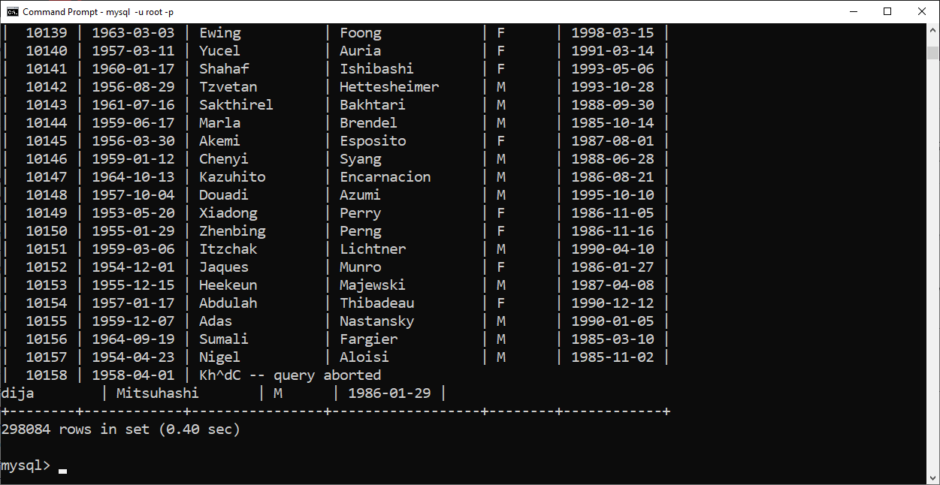

Select * from employees where gender = 'F' and hire_date > '1990-01-01';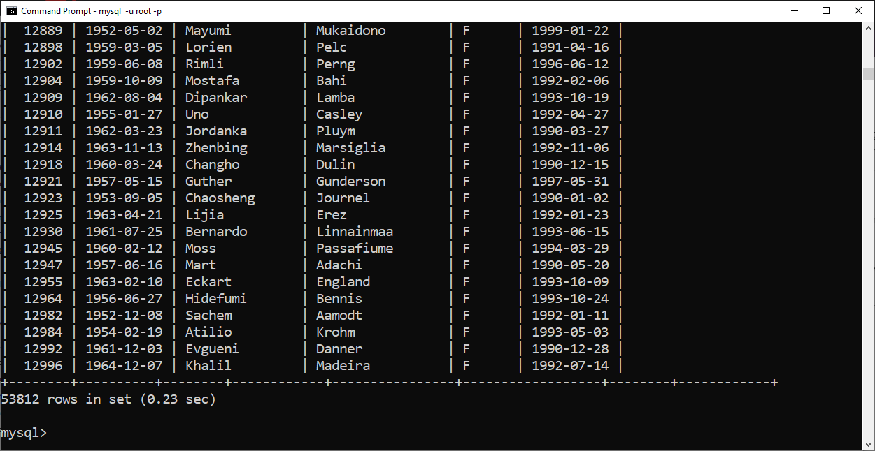

Select first_name, last_name from employees Where last_name LIKE 'a%' limit 50;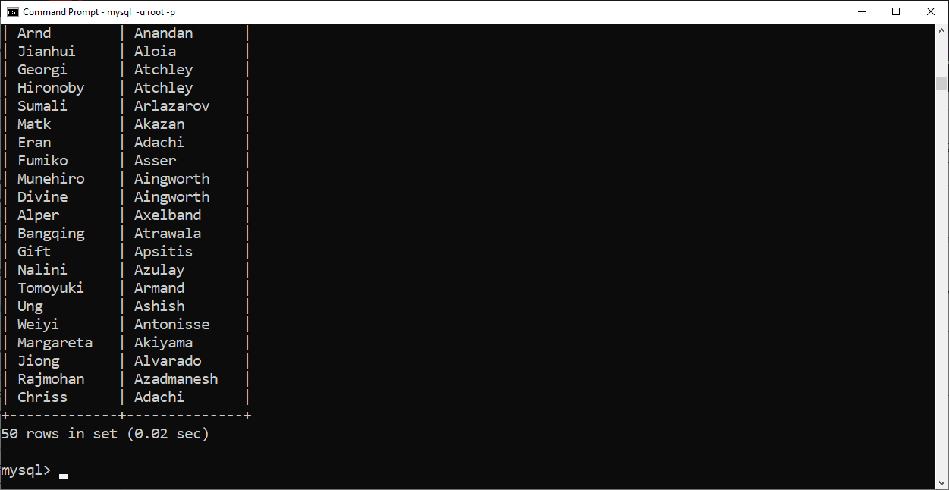

Insert into employees values(100, '1975-01-30', 'Ann', 'Anderson', 'F', '2020-06-07'),

(101, '1970-02-20', 'Bruce', 'Becker', 'M', '2019-10-10'),

(102, '1966-08-12', 'Carol', 'Carter', 'F', '1998-02-15');

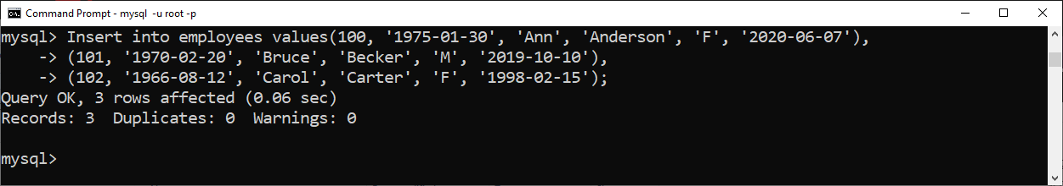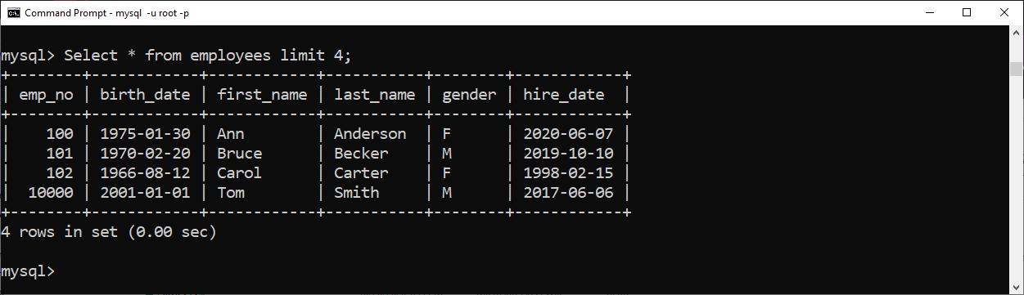

Update employees set first_name = 'Bob' where emp_no = 10023;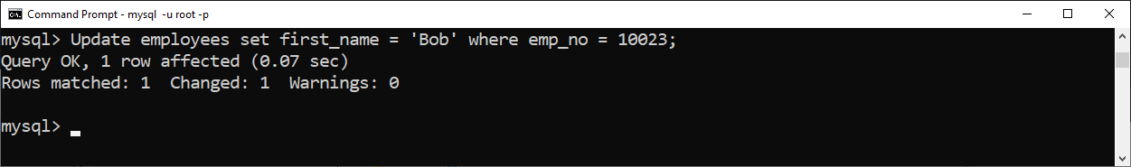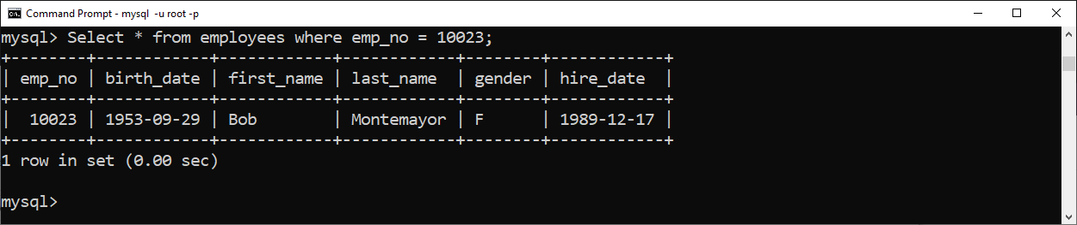

Update employees set hire_date to '2002-01-01' where first_name like 'P%' or last_name like 'P%';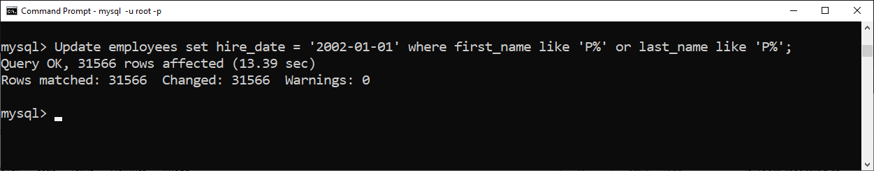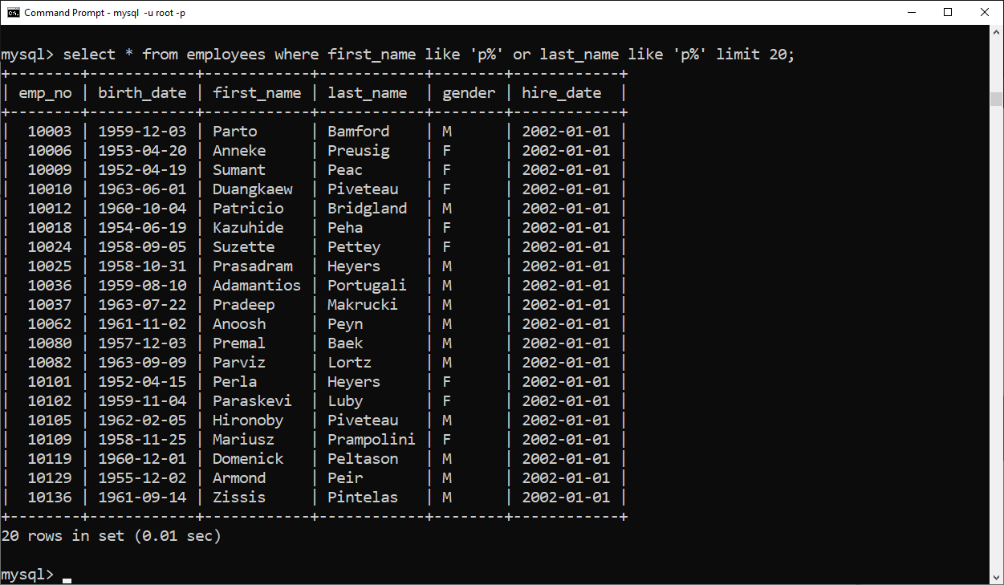

Delete from employees where emp_no < 10000;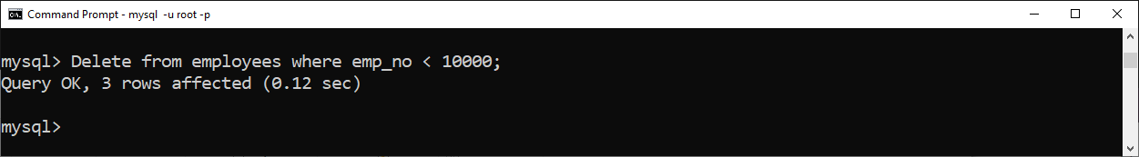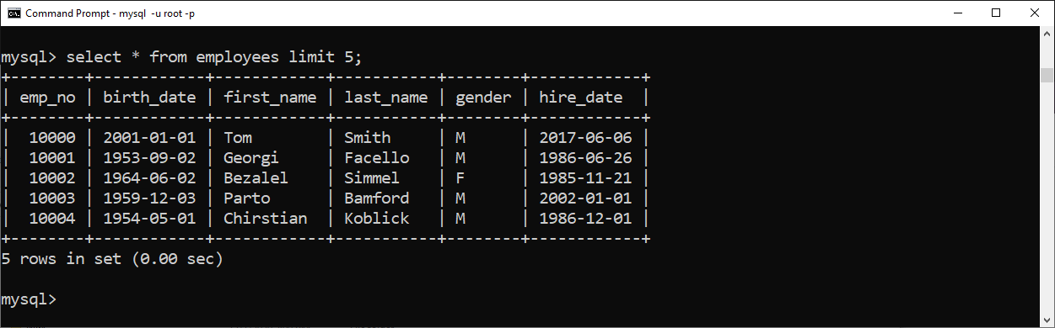

Delete from employees where emp_no in (10048, 10099, 10234, 20089);