**MSDM 5001 Assignment 1**

Operation environment:

Operating system: Windows 11 专业版 21H2 22000.2295

Ubuntu: Ubuntu 22.04.1 LTS

Bash: 版本 5.1.16(1)-release (x86_64-pc-linux-gnu)

Python: Python 3.10.6

Q1：

1. Figure below shows the result of command “top”.

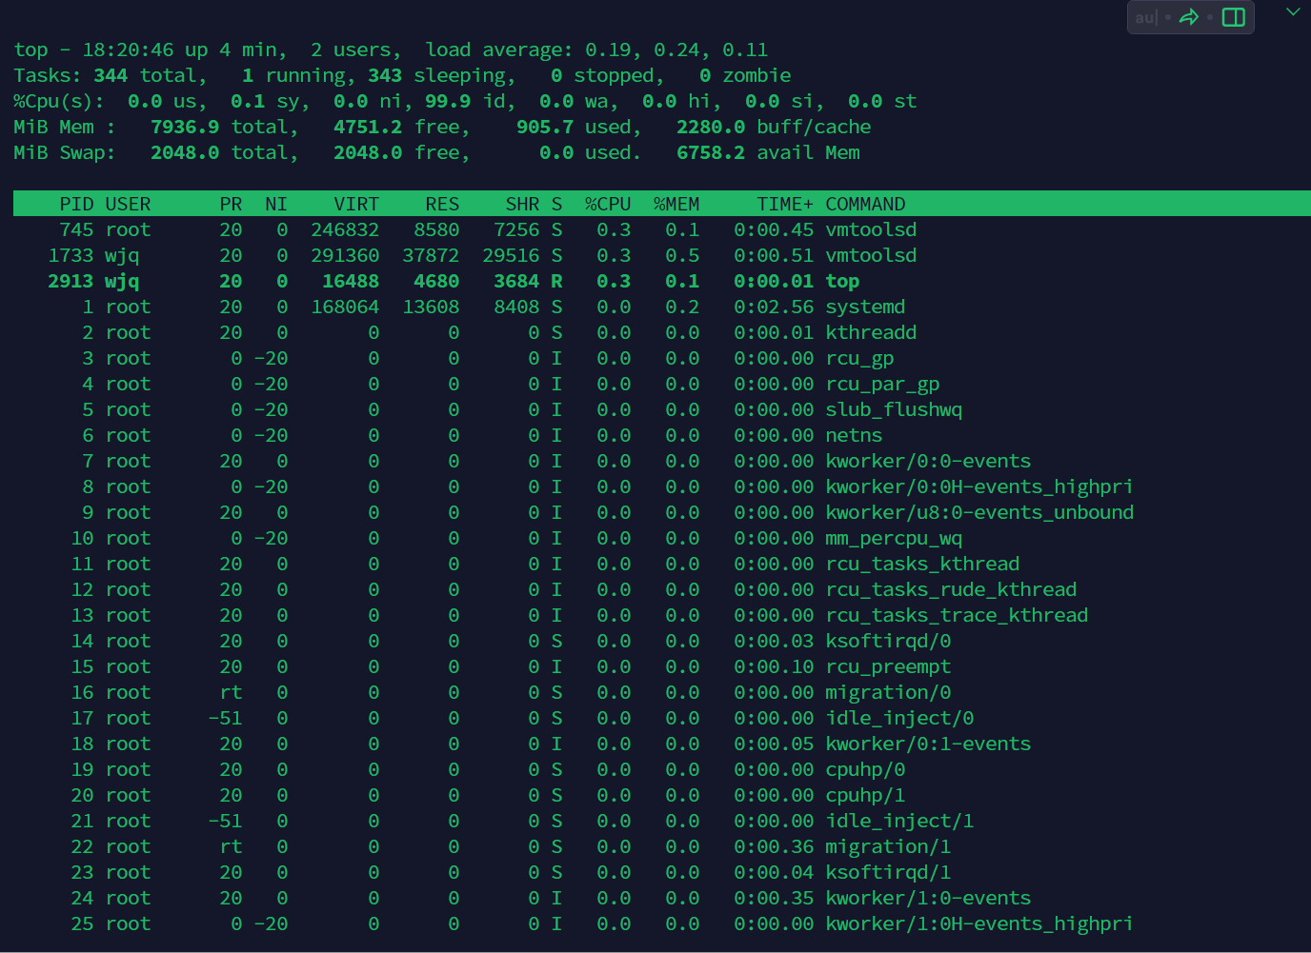

1. Use commands to collect hardware information
2. lscpu：Displays information about the CPU (central processing unit), such as architecture, number of cores, number of threads, and so on

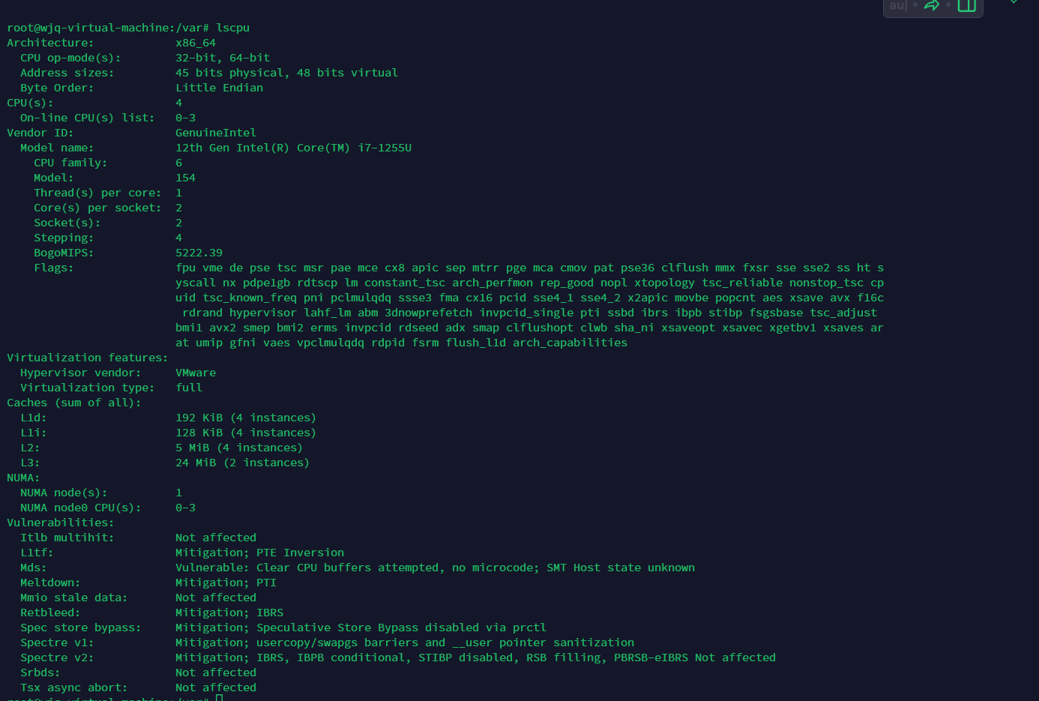

1. lshw：Lists the computer's detailed hardware information, including processor, memory, disks, network cards, and so on

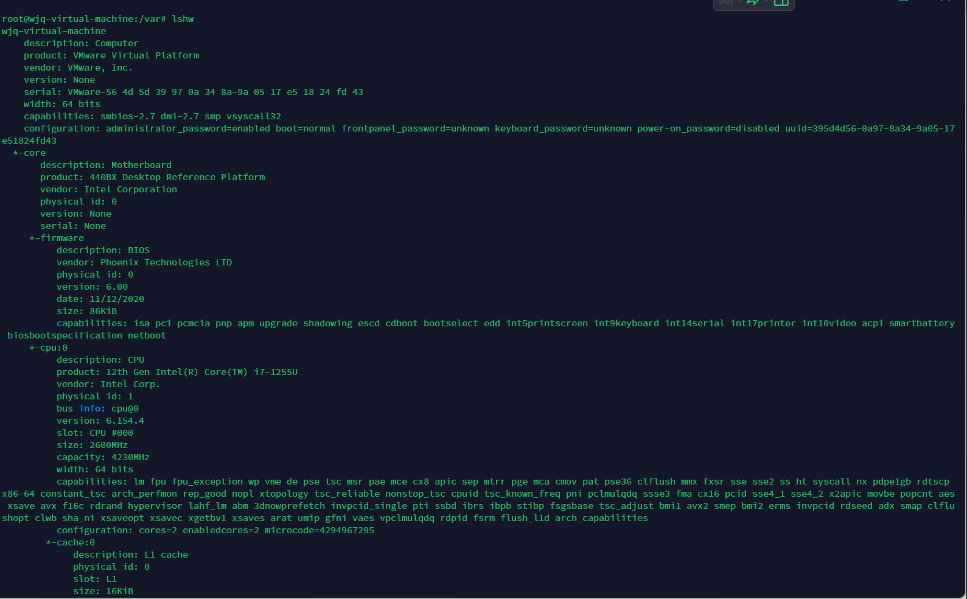

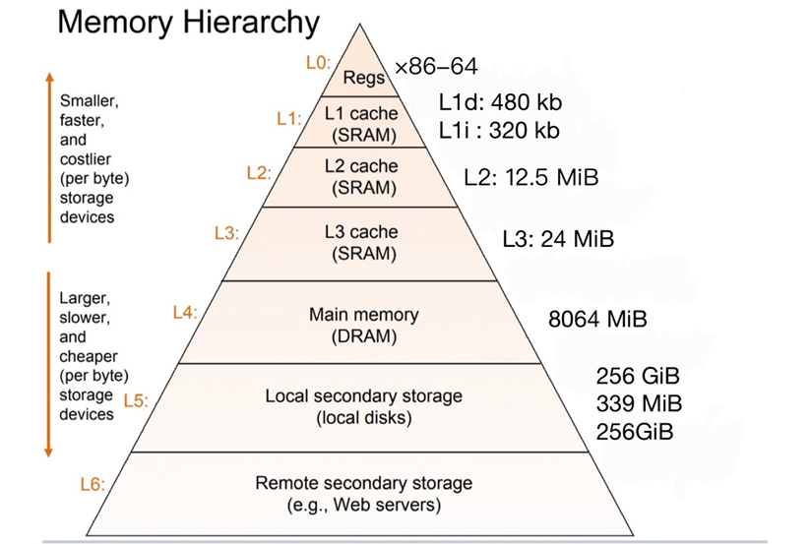

Tre command：

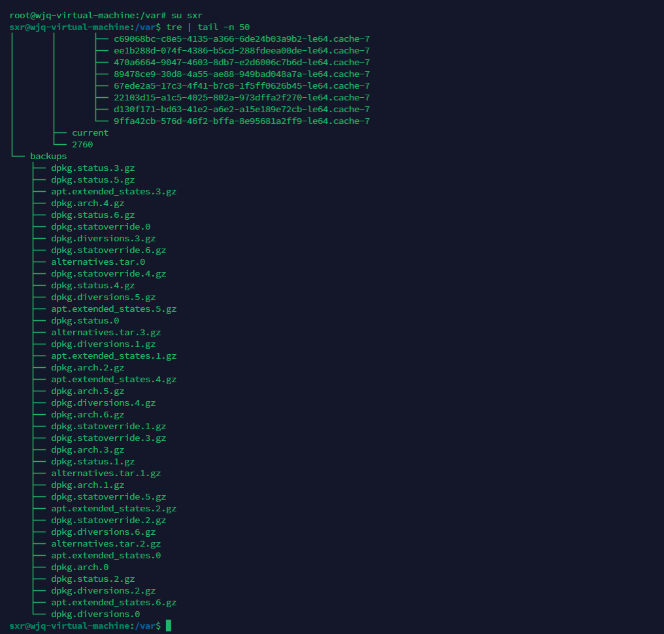

Q2：New directory

Code run result: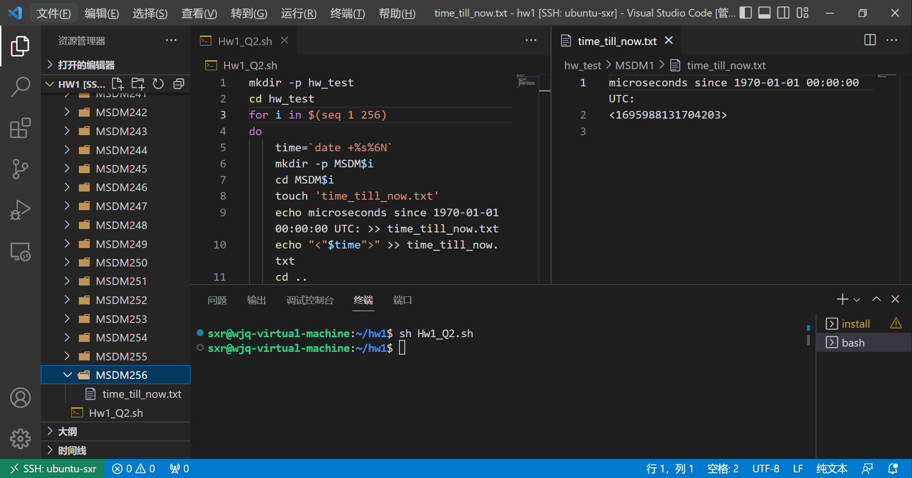

Q3：Regular Expression

Code run result: