## Hospital Charge Markup Paper: Title TBD

## Author: Rebecca Stubbs

## Date: May 3, 2017

**Introduction**

For the uninsured and the underinsured in the United States, the choice to seek medical care in a critical health emergency is often one between their life, and debt. [1],[2] Out of the 3 trillion dollars spent on health care in the United States in 2015, 338.1 billion were paid out of pocket[3], and medical bills have been implicated as a major cause of bankruptcy.[4],[5] Despite the magnitude of health care spending, and the universal need for health care, hospital pricing structures are opaque, and the way charges are constructed often remains a mystery to patients and their families. The pricing structures generated by hospitals have been described as “chaos behind a veil of secrecy”, in which hospitals determine charges without a rigorous methodology.[6]

From the moment a patient first arrives at a hospital, the facility tracks the services rendered, equipment used, and drugs administered to treat or diagnose a patient’s conditions. A hospital’s master charge list, or ‘chargemaster list’, describes the full menu of tens of thousands of procedures and goods available at a given facility, along with a price for that treatment or item. The prices for the care and commodities used are added up to generate the total bill for the services rendered. However, even when presented with a bill containing the full details of the items included from the chargemaster list, the naming conventions and significance of different line items may be difficult or impossible for consumers to understand. Filled with acronyms, abbreviations, and medical jargon, the list of “services rendered” by the hospital may be unrecognizable to the patient. Different hospitals distribute revenue or profit margin on items used for the same procedure differently, which makes comparisons of the “list price” of individual goods (for example, the cost of a syringe) less meaningful.

Furthermore, most patients and insurance providers receive discounts that are a fraction of the supposed ‘cost’ of treatment. Mediated by insurance and co-pays, the ‘chargemaster’ price of a hospital stay often does not reflect the amount paid by the patient. Insurance companies and hospitals use the chargemaster list as a starting point, but negotiate rates far below the full ‘list price’. For the uninsured, however, the chargemaster price is a more accurate reflection of the bill- although some hospitals offer discounts for those paying out of pocket, those unaware or ineligible for such programs may be facing substantial debt as a result of their care. Although the number of uninsured has declined in recent years, nearly one in ten people still do not have health insurance in the United States. [7]

When permanent residents and citizens of the United States turn 65, they become eligible for the largest insurance program in the country—Medicare. Run by the United States government and serving 57 million persons,[8] Medicare follows an alternate process to determine how much hospitals are paid for services rendered to patients. The Inpatient Prospective Payment System (IPPS) is the foundation for how Medicare determines payments to for inpatient stays, which are covered under Medicare part A. The base price for Medicare Severity Diagnosis Related Group (MS-DRG) is supplemented to account for the area’s cost of living (requiring higher staff costs), whether the hospital has a medical education program, and is utilized by a disproportionate share of low-income and uninsured patients from the surrounding community. For unusually complex or resource-intensive cases, additional payment is disbursed to the hospital though the use of ‘outlier payments’. Through these adjustments, the Inpatient Prospective Payment System seeks to pay hospitals a fair price that will compensate for both the procedure, and the associated overhead of treating the patient.

**Markup as a standard pricing metric for causes and facilities**

The gap between what hospitals charge (the chargemaster price) and what a procedure costs (often measured as the Medicare-allowable cost of the same procedure) is better represented by a multiplier than a difference. In 1984, hospital charges were 135 percent of Medicare-allowable costs,[9]  and the ratio between charges and costs has risen further-- in 2012, US Hospitals charged a staggering 3.4 times the Medicare-allowable costs, up from 1.35 in 1984.[10] Hospital pricing is far from spatially uniform-- it has been established that hospital prices vary markedly across the United States, such that out of the top 50 most expensive hospitals, over half were in the state of Florida.[11] Although the notion that where you live may determine the pricing structure of health services is far from new,[12] the extent to which there are spatial inequities in hospital charges is garnering increasing media attention.

In May of 2013, the Center for Medicare and Medicaid Services (CMS) began to publish the Provider Utilization and Payment Data Inpatient Public Use File (Inpatient PUF). An unprecedented data release, the Inpatient PUF contains hospital-specific information on how much hospitals were compensated through Medicare’s payment system (payments) compared to the amount billed to Medicare based on chargemaster list pricing (charges) for any disease reporting group with over 10 discharges. This data set presents an opportunity to compare chargemaster pricing structures to the relatively fixed prices set by Medicare at a granular level, by disease reporting group, at each facility between the years of 2011-2014.

Past research utilizing the Inpatient PUF focused on associations between the average charges (the chargemaster list pricing for services) at each hospital without using Medicare payments as a frame of reference.[13] The work of Park et al. examined hospital charges at the facility level as the outcome variable, requiring the authors to generate a standardized metric for each facility that was not dependent on the types of patients seen at each facility. To achieve this, the authors generated “condition-aggregated” charges for each facility, calculating average charges across six conditions. This approach restricts the data to only certain conditions, which reduces the sample size, and may mask some of the variation occurring in hospital pricing structures.

Using a “markup measure” such that hospital prices are measured in units of Medicare payments or allowable costs has been used to investigate hospital pricing structures in past research. [14],[15] Unlike examining charges directly, or generating condition-aggregated charges, using a markup measure allows the relative cost of each facility to be compared across disease reporting groups, since both the charges and payment measurements are derived from the same patients.

**Lack of Insurance as a Driver for Higher Hospital Charges**

One of the reasons cited by hospitals for high prices is the theory of ‘cost shifting’ such that private insurers and the self-paying patients bear a higher financial burden in order to compensate for care provided at rate too cheap for the hospital to sustain. The population driving this need varies by hospital-- some hospitals purport that Medicare and Medicaid do not cover costs adequately, while others have cited the uninsured, whose high medical bills are rarely paid in full.[16] However, the motives for higher chargemaster prices may not be entirely pure. High chargemaster pricings may incentivize insurance companies to include hospitals within their insurance networks in order to avoid the high costs incurred by patients receiving medical care at an un-discounted facility, and add value to their insurance plan. [17] Increases in chargemaster price have been recognized as a mechanism for increased hospital revenue, and a study that examined the fifty US hospitals with the highest charge-to-cost ratios found that nearly all of them were for-profit. [18],[19]

**Exploring the relationships between socioeconomic factors and markup**

Examining the relationships between condition-aggregated charges and a variety of socioeconomic factors in 2011, Park et al. concluded that “hospital charges lacked a relationship with population health indicators”. Incorporating information on health outcomes, health behaviors, access to and quality of outpatient care, the physical environment, and demographic factors, researchers Park et al. found that only the percent of children in poverty, and the percentage of the population that is uninsured had statistically significant effects on hospital charges. [20] The model presented by Park et al. included a wide range of covariates (29 in total), but potentially influential variables such as the income level, as well as the racial and ethnic composition of the counties were not included.

With three more years of data added to the Inpatient Public Use Data File after 2011, and the use of markup measures as a standardized point of comparison across space and disease category, deeper insights into the distribution of hospital price markup are within reach. How does markup vary across disease reporting group? Is the amount that hospitals charge linked to the incomes of the facility’s surrounding county? Is the relationship between hospital pricing structure and the uninsured population of an area borne out when a larger sample size, including more years, and a wider range of disease reporting groups are considered? If so, how might the hospital charges be different if the uninsured population were a far smaller proportion of the US population?

**Study Methods**

**Data**

Records of the average total Medicare payments, and the total charges (chargemaster list price) for each disease reporting group (DRG) with over 10 discharges at each hospital registered with Medicare were obtained from the Centers for Medicare and Medicaid Services.[21] The data set is based on information from the Medicare Provider Analysis and Review (MEDPAR) data. Only the top 100 DRGs by number of discharges were included in the data set in 2011-2013, while all DRGs with adequate discharges were included in 2014. The latitude and longitude, county and census tract associated with each facility was determined by geolocating each hospital using the Google Maps API to generate coordinate positions based on the facility address[22]. 29 facilities that did not contain adequate location information to generate coordinates were excluded from the study, and resulting in a total of 3416 facilities in the final data set, and 670,707 observations. There were facilities located in 1527 out of 3,141 counties or county equivalents within the United States. The data set represents charges and payments for 27,185,017 inpatient discharges from October 1st, 2011 through September 30th, 2014. Markup was calculated by dividing the total average charges by the total Medicare payments for each disease reporting group in each facility-year.

Information on county-level education, household income, unemployment, rural status, and race were obtained from the American Community Survey via the National Historical Geographic Information System. [23] The proportion of the population below the poverty line, and the proportion of uninsured within each county were procured from the Small Area Income and Poverty Estimates (SAIPE), and the Small Area Health Insurance Estimates (SAIHE) produced by the Census bureau.[24],[25] Age-standardized, all-cause mortality estimates at the county level were estimated by Dwyer-Lindgren et al..[26]

**Methods**

The relationships between community socioeconomic factors and hospital markup for each disease reporting group in each facility in the years of 2011-2014 were modeled using a linear mixed-effect regression. The model included random effects on state, county, facility, and year to account for the impact of spatial processes and unobserved variables that may influence hospital pricing structures. Markup was log-transformed, and covariates were transformed to z-scores, where the measurement for each county represented the difference in standard deviations from the mean of the observations from all counties within the time period of the data set. The model is specified such that:

s) f) g)

Where $m_{fyg}$ is the log-transformed markup in facility *f*, year *y*, and disease reporting group *g*, respectively; $β_{0}$ is a fixed intercept; $β_{1}$ are fixed covariate effects; $γ_{s}$ are state-level random effects; $γ_{c}$ are county-level random effects, and $γ_{f}$ are facility-level random effects. Analysis was conducted in R version 3.3.2[27], using the Template Model Builder package.[28]

To make the policy ramifications of these relationship between the proportion of the population that is uninsured, and hospital charge markups more clear, a counterfactual scenario was established in which only 1 percent of any given county’s population was uninsured. To construct this scenario, the fraction of every county’s population that does not have insurance was artificially set to 1 in 100 persons, while all other socioeconomic factors were held constant. The coefficients, fit parameters, and residuals from the above model were used to generate a set of estimates for hospital charge markup given a far lower population of uninsured.

**Results**

**Descriptive Statistics**

Average chargemaster markup in relation to Medicare payment ranged from 1.22 in Maryland to 8.38 in New Jersey, and was 5.00 times the Medicare payment on average within the United States as a whole in 2014 (eTable 1 and 2). Markup was highly spatially variable below the state level, with areas of extremely average high markups in counties within New Jersey, Florida, and coastal California (Figure 1). Out of the 16 counties with average markups over 10, over half were in Florida and New Jersey alone, with five in Florida (Hernando, Okaloosa, Clay, Charlotte, and Saint Lucie Counties), and another five in New Jersey (Sussex, Somerset, Hudson, Mercer, and Warren counties).

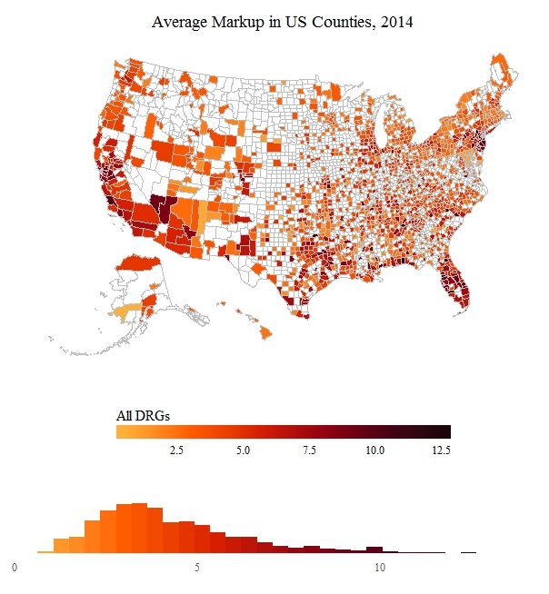

Figure 1: Markup on average in US Counties, 2014, for all Disease Reporting Groups

At the facility level, markups tended to be more variable in hospitals with high markup on average across all disease reporting groups. The standard deviation of a facility’s markup was strongly associated with the median markup, producing a Pearson’s correlation coefficient of 0.904 (95% UI 0.898-0.911; p<0.0001) (eFigure1).

Within the top 15 disease reporting groups (in terms of total discharges), markup ranged from 4.01 (Mental Diseases and Disorders), to 5.42 (Diseases and Disorders of the Nervous System) (eTable1) in 2014. For all DRGs in the top 15, the mean was consistently higher than the median, but the difference between the two measures of center was never greater than one. This indicates consistently right-skewed data, where relatively rare high values raised the average compared to the mean. Given that each observation for charges and Medicare payments represents the average of the discharges in the DRG for that year, it is worth noting that individual patients may have experienced markup ratios much higher than what is represented by the mean in any given State, County, Facility, or DRG.

**Regression Analysis**

Out of all of the variables supplied to the regression model, only household median income and the proportion of persons below the poverty line were not statistically significant at an alpha level of 0.005. Variables associated with racial and ethnic composition (percent Black, and Hispanic), as well as rural status, and unemployment levels were associated with lower markups. All-cause mortality rate, the proportion of the county’s population with a Bachelor’s degree, and the proportion of the population that is uninsured were all associated with rising hospital charges relative to Medicare payments.

|  |  |  |  |
| --- | --- | --- | --- |
| Parameter | Estimate | 95% Conf. Int. | P-Value |
| Intercept* | 0.993914 | ( 0.90273, 1.08510) | 2.88E-101 |
| Percent Black* | -0.085435 | (-0.10593,-0.06494) | 3.05E-16 |
| Percent Below Poverty Line | -0.000764 | (-0.00486, 0.00334) | 7.15E-01 |
| Household Median Income | 0.003476 | (-0.00180, 0.00875) | 1.97E-01 |
| Mortality Rate* | 0.036579 | ( 0.02800, 0.04516) | 6.58E-17 |
| Percent With Bachelor’s Degree* | 0.020819 | ( 0.00948, 0.03215) | 3.18E-04 |
| Percent Hispanic* | -0.073955 | (-0.09365,-0.05426) | 1.86E-13 |
| Percent Rural* | -0.247602 | (-0.27009,-0.22511) | 2.97E-103 |
| Percent Unemployed* | -0.006832 | (-0.00990,-0.00377) | 1.25E-05 |
| Percent Uninsured* | 0.013764 | ( 0.01020, 0.01733) | 3.85E-14 |

Table 1 Fixed-Effect Coefficients from Regression Analysis; * represents statistically significant below critical value of 0.005.

As a representation of the unobserved, county- and state-level variables that impact hospital markups, the maps of random effect values are also of interest. Evident in the map of random effect values are large spatial patterns present in hospital markup that are unexplained by sociodemographic variables. Of special note is the magnitude of the spatial random effects—while the coefficients of the sociodemographic variables included in the model may be significant, their contribution towards hospital markup is relatively small compared to the impact of regional differences. Most of this spatial effect is at the state level rather than the county level, indicating that larger-scale processes such as state legislation may play a larger role than local dynamics (see eFigures 4 and 5 for maps of County and State random effect values).

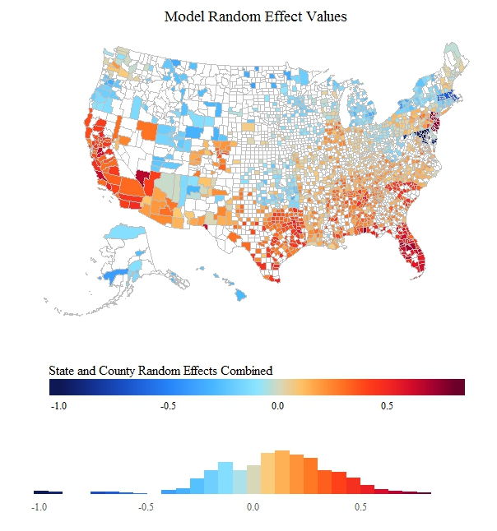

Figure 2: Plot of random effect values from regression analysis. State random effect and county random effect were combined together to generate a map of the combination of the effects of State and County.

**Study and Data Limitations**

A variety of policies and events that may impact the pricing structure of hospitals (both in terms of Medicare payments and charges) occurred preceding and during the time period of this analysis, which may impact the generalizability of these results. The release of the Inpatient Public Use Data File by the Centers for Medicare Services could have had an impact on hospital pricing, as facilities could easily compare themselves to their peers. A variety of changes to insurance requirements resulted from the Affordable Care Act (ACA), which passed in 2010. In addition, ACA enacted some changes in how Medicare reimbursed hospitals for care based on metrics of performance. Starting in fiscal year 2014, hospitals in the worst quartile in terms of hospital-acquired conditions were penalized by 1 percent as an incentive to reduce hospital-acquired cases of diseases such as MRSA, or clostridium difficile.[29] In addition, for discharges beginning in October of 2012, hospitals with excess readmissions also had their payments reduced up to 3 percent. [30] Given that hospital charges differ from Medicare payments on the order of multipliers, not percentage points, these effects are likely to be minor. The sample of hospitals within the study was limited to only facilities with over 11 discharges for a given disease reporting group, which may have censored the data to exclude hospitals with smaller patient populations, such as rural areas. The disease reporting groups captured within the dataset may not represent the conditions and injuries faced by more youthful populations.

**Discussion**

According to a recent poll in 2015, close to half (46%) of the uninsured in the United States were uninsured due to the high costs of health insurance.

Private insurance companies negotiate their rates with hospitals annually based on some combination of flat rates, adaptations of Medicare DRG payment structures, and discounts from the chargemaster prices.[31]

If the charges set by hospitals are directly or indirectly related to the proportion of the uninsured

If hospital chargemaster data is, at least in part, manifesting this burden…

It is fundamentally inequitable that the potential financial penalty for medical treatment while uninsured is so spatially variable within the United States. This work does not seek explain the drivers of cost, but rather suggests that ….. … should be investigated further.

Unlike other services governed by consumer choice and a free market, patients rarely have the ability to make informed choices about where they receive medical care—even if information on pricing structures were readily available, a life-threatening emergency is not a convenient time for price shopping.

Section 9007 of the Patient Protection and Affordable Care Act revokes non-profit hospitals’ tax-exempt status if they are found to be charging self-pay patients more than the insured. However, the language of the bill is ambiguous and lacks definitive guidelines for which hospitals can be evaluated, and patients who find themselves at for-profit hospitals have little protection from these charges.

Given that the uninsured are often without health coverage due to the financial cost of insurance itself

If Medicare is paying providing reasonable amount for inpatient hospital services, it would stand to reason that prices for the uninsured, who are often financially vulnerable, potentially without would be similar to the amount paid by Medicaid.

<http://kff.org/uninsured/fact-sheet/key-facts-about-the-uninsured-population/>

Evidence of market power[32] A complex mosaic of factors

Magnified amplified expanded

Medicare is a special case of this phenomenon--

Rising healthcare costs[33]

As the largest insurance provider in the United States, Medicare services over

Not all doctors will take new

Higher costs of care would be understandable if paying more equated to better treatment. However, research linking the costs of care and patient success rates have shown the opposite relationship, such that less expensive facilities often offer better outcomes. [34]

The reasons behind why some hospitals charge more than others are purely academic for the millions of Americans faced with high medical bills.

Health care bills and their contribution to financial insolvency

**SUPPLEMENTARY MATERIAL**

eTable 1: Summary Statistics of the top 15 DRG categories in 2014, all States Combined

|  |  |  |  |  |  |  |  |  |
| --- | --- | --- | --- | --- | --- | --- | --- | --- |
| Disease Reporting Group | Mean | Std. | Min | Q1 | Median | Q3 | Max | N |
| All Combined | 5.00 | 2.60 | 0.15 | 3.24 | 4.44 | 6.18 | 33.00 | 7216853 |
| Diseases & Disorders Of The Circulatory System | 5.22 | 2.67 | 0.30 | 3.40 | 4.66 | 6.44 | 30.97 | 1666746 |
| Diseases & Disorders Of The Respiratory System | 4.87 | 2.57 | 0.51 | 3.08 | 4.29 | 6.08 | 26.50 | 1086318 |
| Diseases & Disorders Of The Musculoskeletal System & Connective Tissue | 4.87 | 2.32 | 0.49 | 3.28 | 4.41 | 5.96 | 21.67 | 900426 |
| Diseases & Disorders Of The Digestive System | 5.00 | 2.55 | 0.58 | 3.28 | 4.44 | 6.13 | 33.00 | 750694 |
| Infectious & Parasitic Diseases, Systemic Or Unspecified Sites | 4.46 | 2.28 | 0.56 | 2.91 | 3.99 | 5.51 | 22.60 | 680529 |
| Diseases & Disorders Of The Kidney & Urinary Tract | 4.79 | 2.56 | 0.37 | 3.07 | 4.20 | 5.94 | 31.63 | 592717 |
| Diseases & Disorders Of The Nervous System | 5.42 | 2.82 | 0.65 | 3.52 | 4.79 | 6.71 | 29.78 | 521966 |
| Endocrine, Nutritional & Metabolic Diseases & Disorders | 4.86 | 2.55 | 0.63 | 3.17 | 4.31 | 6.02 | 32.97 | 249920 |
| Diseases & Disorders Of The Skin, Subcutaneous Tissue & Breast | 4.67 | 2.52 | 0.49 | 2.94 | 4.09 | 5.80 | 24.84 | 156402 |
| Diseases & Disorders Of The Hepatobiliary System & Pancreas | 5.22 | 2.65 | 0.74 | 3.47 | 4.67 | 6.42 | 23.58 | 125272 |
| Mental Diseases & Disorders | 4.01 | 2.36 | 0.68 | 2.40 | 3.43 | 5.10 | 17.44 | 104030 |
| Diseases & Disorders Of Blood, Blood Forming Organs, Immunologic Disorders | 4.94 | 2.50 | 0.65 | 3.24 | 4.43 | 6.12 | 26.44 | 103864 |
| Injuries, Poisonings & Toxic Effects Of Drugs | 4.87 | 2.55 | 0.56 | 3.17 | 4.29 | 5.98 | 20.25 | 58953 |
| Factors Influencing Health Status & Other Contacts With Health Services | 5.25 | 2.79 | 0.66 | 3.39 | 4.71 | 6.62 | 24.75 | 46081 |
| Alcohol/Drug Use & Alcohol/Drug Induced Organic Mental Disorders | 4.41 | 2.91 | 0.15 | 2.39 | 3.80 | 5.59 | 20.25 | 45217 |

eTable 2: Summary Statistics of Markup by State in 2014, all DRGs

|  |  |  |  |  |  |  |  |  |
| --- | --- | --- | --- | --- | --- | --- | --- | --- |
| **STATE** | **MEAN** | **STD.** | **MIN** | **Q1** | **MEDIAN** | **Q3** | **MAX** | **N** |
| New Jersey | 8.38 | 3.39 | 0.78 | 6.05 | 7.73 | 10.02 | 33.00 | 258611 |
| Nevada | 7.73 | 3.07 | 1.88 | 4.90 | 7.91 | 9.88 | 20.37 | 46252 |
| Florida | 7.19 | 3.01 | 1.03 | 5.06 | 6.57 | 8.78 | 29.78 | 594009 |
| California | 6.54 | 2.53 | 0.36 | 4.79 | 6.18 | 7.94 | 22.10 | 494022 |
| Texas | 6.23 | 2.57 | 0.53 | 4.35 | 5.82 | 7.68 | 22.73 | 495345 |
| Colorado | 6.19 | 2.24 | 1.31 | 4.61 | 5.86 | 7.48 | 17.06 | 66216 |
| Pennsylvania | 5.77 | 2.82 | 0.15 | 3.57 | 5.32 | 7.47 | 24.18 | 316731 |
| Alabama | 5.75 | 3.29 | 0.65 | 3.65 | 4.90 | 6.65 | 26.03 | 152111 |
| South Carolina | 5.68 | 2.37 | 1.25 | 4.01 | 5.07 | 6.87 | 24.28 | 113939 |
| Arizona | 5.44 | 2.27 | 0.37 | 3.98 | 5.09 | 6.41 | 24.75 | 111269 |
| Illinois | 5.18 | 1.87 | 0.56 | 3.93 | 4.91 | 6.20 | 19.49 | 351597 |
| Kansas | 5.16 | 1.89 | 0.65 | 3.94 | 5.02 | 6.20 | 14.79 | 71273 |
| Mississippi | 5.03 | 2.61 | 0.83 | 3.27 | 4.24 | 6.17 | 20.25 | 91670 |
| Louisiana | 4.87 | 2.07 | 0.30 | 3.51 | 4.60 | 5.91 | 15.16 | 109571 |
| Tennessee | 4.77 | 2.05 | 0.56 | 3.37 | 4.41 | 5.77 | 24.01 | 200056 |
| Virginia | 4.75 | 2.40 | 1.28 | 3.18 | 4.07 | 5.43 | 23.20 | 214416 |
| Oklahoma | 4.72 | 2.29 | 0.49 | 3.31 | 4.23 | 5.59 | 18.69 | 99552 |
| Missouri | 4.70 | 1.95 | 0.80 | 3.40 | 4.26 | 5.57 | 17.41 | 175765 |
| Georgia | 4.63 | 1.71 | 0.79 | 3.41 | 4.31 | 5.49 | 14.97 | 195162 |
| Washington | 4.49 | 1.54 | 1.04 | 3.38 | 4.24 | 5.37 | 13.37 | 117004 |
| Indiana | 4.44 | 1.42 | 0.88 | 3.50 | 4.23 | 5.14 | 15.17 | 182826 |
| Nebraska | 4.40 | 1.31 | 1.12 | 3.51 | 4.22 | 5.08 | 12.21 | 44448 |
| Ohio | 4.40 | 1.60 | 1.12 | 3.27 | 4.19 | 5.29 | 14.64 | 284040 |
| Arkansas | 4.38 | 1.96 | 0.95 | 3.15 | 4.14 | 5.25 | 16.27 | 86213 |
| District of Columbia | 4.36 | 1.17 | 1.21 | 3.60 | 4.41 | 5.05 | 9.56 | 26278 |
| Kentucky | 4.28 | 1.46 | 1.36 | 3.30 | 4.04 | 4.99 | 17.12 | 148772 |
| Alaska | 4.27 | 1.32 | 0.47 | 3.49 | 4.32 | 5.12 | 8.03 | 6515 |
| New Mexico | 4.16 | 1.98 | 0.72 | 2.76 | 3.67 | 5.47 | 12.13 | 27867 |
| South Dakota | 4.03 | 1.19 | 0.67 | 3.20 | 3.85 | 4.79 | 10.21 | 23575 |
| Iowa | 3.94 | 1.19 | 0.62 | 3.06 | 3.81 | 4.66 | 10.53 | 69970 |
| North Carolina | 3.91 | 1.30 | 1.15 | 2.99 | 3.69 | 4.59 | 13.70 | 235267 |
| Wisconsin | 3.88 | 1.27 | 0.86 | 3.03 | 3.68 | 4.54 | 11.60 | 106722 |
| New Hampshire | 3.87 | 1.36 | 1.52 | 2.89 | 3.54 | 4.58 | 10.12 | 38381 |
| New York | 3.87 | 1.72 | 0.47 | 2.59 | 3.60 | 4.84 | 14.64 | 430086 |
| Connecticut | 3.60 | 1.08 | 0.83 | 2.87 | 3.53 | 4.25 | 9.87 | 100251 |
| Rhode Island | 3.59 | 1.01 | 0.89 | 2.94 | 3.49 | 4.19 | 7.58 | 24572 |
| Idaho | 3.59 | 0.99 | 1.62 | 2.92 | 3.38 | 4.03 | 7.77 | 20765 |
| Utah | 3.52 | 1.11 | 1.22 | 2.71 | 3.38 | 4.06 | 9.89 | 28512 |
| West Virginia | 3.42 | 1.00 | 0.71 | 2.73 | 3.35 | 4.00 | 8.51 | 56323 |
| Minnesota | 3.41 | 1.01 | 0.30 | 2.69 | 3.30 | 4.01 | 11.02 | 117759 |
| Delaware | 3.36 | 1.11 | 1.15 | 2.58 | 3.11 | 3.95 | 8.11 | 35510 |
| Hawaii | 3.33 | 1.06 | 0.76 | 2.56 | 3.17 | 3.86 | 7.21 | 12211 |
| Oregon | 3.30 | 0.97 | 1.04 | 2.61 | 3.17 | 3.84 | 8.45 | 47557 |
| Wyoming | 3.29 | 1.21 | 1.10 | 2.36 | 3.18 | 3.97 | 9.18 | 7100 |
| Montana | 3.27 | 0.78 | 1.17 | 2.72 | 3.21 | 3.68 | 6.66 | 18205 |
| Michigan | 3.17 | 0.95 | 0.68 | 2.49 | 3.07 | 3.72 | 13.65 | 310619 |
| North Dakota | 3.05 | 0.81 | 1.26 | 2.52 | 2.96 | 3.42 | 10.20 | 19220 |
| Maine | 3.02 | 0.73 | 1.03 | 2.55 | 2.96 | 3.41 | 6.71 | 33873 |
| Vermont | 2.56 | 0.63 | 1.12 | 2.12 | 2.54 | 2.94 | 5.68 | 10393 |
| Massachusetts | 2.39 | 1.10 | 0.45 | 1.65 | 2.07 | 2.76 | 8.86 | 199370 |
| Maryland | 1.22 | 0.09 | 1.09 | 1.16 | 1.21 | 1.26 | 2.29 | 189082 |

eFigure 3: Correlation between the median and standard deviation of markup

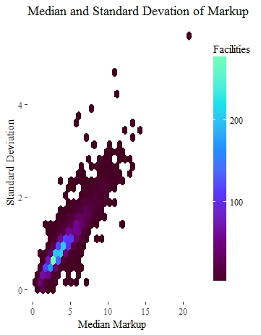

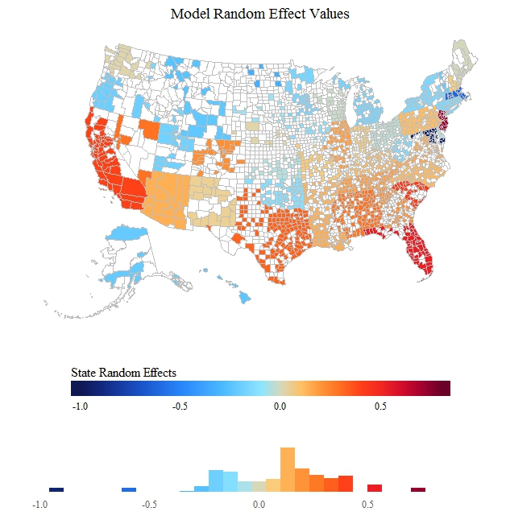

eFigure 4: Map of State Random Effects Alone; Color scale standardized to map of combined state and county random effects.

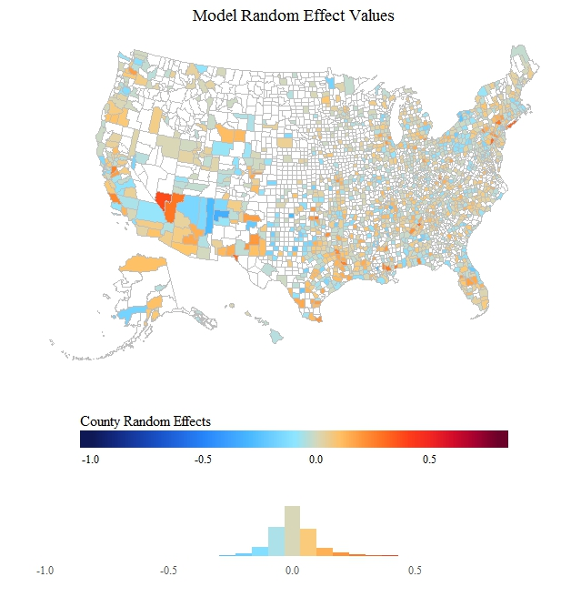

eFigure 5: Map of County Random Effects Alone; Color scale standardized to map of combined state and county random effects.

1. Woolhandler S, Himmelstein DU. Life or Debt: Underinsurance in America. Journal of General Internal Medicine. 2013;28(9):1122–4.
2. Dusetzina SB, Basch E, Keating NL. For Uninsured Cancer Patients, Outpatient Charges Can Be Costly, Putting Treatments Out Of Reach. Health Affairs. 2015Jan;34(4):584–91.
3. Martin AB, Hartman M, Washington B, Catlin A. National Health Spending: Faster Growth In 2015 As Coverage Expands And Utilization Increases. Health Affairs. 2016Feb;36(1):166–76.
4. Himmelstein DU, Thorne D, Warren E, Woolhandler S. Medical Bankruptcy in the United States, 2007: Results of a National Study. The American Journal of Medicine. 2009;122(8):741–6.
5. Ramsey S, Blough D, Kirchhoff A, Kreizenbeck K, Fedorenko C, Snell K, et al. Washington State Cancer Patients Found To Be At Greater Risk For Bankruptcy Than People Without A Cancer Diagnosis. Health Affairs. 2013;32(6):1143–52.
6. Reinhardt UE. The Pricing of U.S. Hospital Services: Chaos Behind A Veil Of Secrecy. Health Affairs. 2006Jan;25(1):57–69.
7. National Center for Health Statistics, U.S. Census Bureau. Comparison of the Prevalence of Uninsured Persons from the National Health Interview Survey and the Current Population Survey, 2015 and 2016. September 2016. Available from: http://www.cdc.gov/nchs/data/nhis/health_insurance/NCHS_CPS_Comparison092016.pdf.
8. National Health Expenditure Fact Sheet [Internet]. CMS.gov. Centers for Medicare & Medicaid Services; 2017 [cited 2017Apr13]. Available from: http://www.cms.gov/Research-Statistics-Data-and-Systems/Statistics-Trends-and-Reports/NationalHealthExpendData/NHE-Fact-Sheet.html
9. Anderson G. From 'Soak the Rich' To 'Soak the Poor': Recent Trends in Hospital Pricing. Health Affairs. 2007May;26(3):780–9.
10. Bai G, Anderson GF. Extreme Markup: The Fifty US Hospitals With The Highest Charge-To-Cost Ratios. Health Affairs. 2015Jan;34(6):922–8.
11. Bai G, Anderson GF. Extreme Markup: The Fifty US Hospitals With The Highest Charge-To-Cost Ratios. Health Affairs. 2015Jan;34(6):922–8.
12. Welch WP, Miller ME, Welch HG, Fisher ES, Wennberg JE. Geographic variation in expenditures for physicians' services in the United States N Engl J Med 1993 328621-7.
13. Park JD, Kim E, Werner RM. Inpatient Hospital Charge Variability of U.S. Hospitals. Journal of General Internal Medicine. 2015Jan;30(11):1627–32.
14. Ginsburg PB. Wide variation in hospital and physician payment rates evidence of provider market power. [Internet]. Research brief. U.S. National Library of Medicine; 2010 [cited 2017Apr30]. Available from: https://www.ncbi.nlm.nih.gov/pubmed/21117341
15. Bai G, Anderson GF. US Hospitals Are Still Using Chargemaster Markups To Maximize Revenues. Health Affairs. 2016Jan;35(9):1658–64.
16. Anderson G. From 'Soak the Rich' To 'Soak the Poor': Recent Trends in Hospital Pricing. Health Affairs. 2007May;26(3):780–9.
17. Reinhardt UE. The Pricing of U.S. Hospital Services: Chaos Behind A Veil Of Secrecy. Health Affairs. 2006Jan;25(1):57–69.
18. Bai G, Anderson GF. Extreme Markup: The Fifty US Hospitals With The Highest Charge-To-Cost Ratios. Health Affairs. 2015Jan;34(6):922–8.
19. Cite recent paper on medicare data where chargemasters increase payents etc.
20. Park JD, Kim E, Werner RM. Inpatient Hospital Charge Variability of U.S. Hospitals. Journal of General Internal Medicine. 2015Jan;30(11):1627–32.
21. Centers for Medicare and Medicaid Services. Inpatient Public Use Data Files [Internet]. Medicare Provider Charge Data. Centers for Medicare and Medicaid Services; 2016 [cited 2017Apr30]. Available from: https://www.cms.gov/research-statistics-data-and-systems/statistics-trends-and-reports/medicare-provider-charge-data/inpatient.html
22. Google. Google API Console [Internet]. Google API Console. Google; [cited 2017Apr30]. Available from: https://console.developers.google.com/
23. Minnesota Population Center. National Historical Geographic Information System: Version 11.0 [Database]. Minneapolis: University of Minnesota. 2016. http://doi.org/10.18128/D050.V11.0.
24. Bowers, Lauren, C. Gann, and S. Elser, Small Area Health Insurance Estimates: 2015, U.S. Census Bureau, Washington, DC, 2017.
25. U.S. Census Bureau, Small Area Income and Poverty Estimates (SAIPE): 2015 Highlights, U.S. Government Publishing Office Washington, D.C.
26. Dwyer-Lindgren L, Bertozzi-Villa A, Stubbs RW, et al. US county-level trends in mortality rates for major causes of death, 1980-2014. *JAMA*. 2016;316(22):2385-2401. doi:10.1001/jama.2016.13645.
27. R Core Team. *R: A Language and Environment for Statistical Computing.* Vienna, Austria: R Foundation for Statistical Computing; 2016. http://www.R-project.org/. Accessed March 31, 2016.
28. Kristensen K, Nielsen A, Berg CW, Skaug H, Bell B. TMB: automatic differentiation and Laplace approximation. *Journal of Statistical Software*. 2016;70(5):1-21. doi:10.18637/jss.v070.i05.
29. Hospital-Acquired Condition Reduction Program (HACRP) [Internet]. CMS.gov Centers for Medicare & Medicaid Services. Centers for Medicare and Medicaid Services; 2016 [cited 2017Apr30]. Available from: http://www.cms.gov/Medicare/Medicare-Fee-for-Service-Payment/AcuteInpatientPPS/HAC-Reduction-Program.html
30.
31. Reinhardt UE. The Pricing Of U.S. Hospital Services: Chaos Behind A Veil Of Secrecy. Health Affairs. 2006Jan;25(1):57–69.
32. Ginsburg PB. Wide variation in hospital and physician payment rates evidence of provider market power. [Internet]. Research brief. U.S. National Library of Medicine; 2010 [cited 2017Apr30]. Available from: https://www.ncbi.nlm.nih.gov/pubmed/21117341
33. Burke LA, Ryan AM. The Complex Relationship between Cost and Quality in US Health Care. Virtual Mentor. 2014;16(2):124–30.
34. Info on formatting: <http://www.healthaffairs.org/1410i_for_authors_prep_and_review.php>

    Note: Paper will need to be converted into 12 pt Courier New font with double-spacing and a minimum of 1-inch margins. This applies to all main text, abstract, and notes.