Figure 1. Comparing Big Moose and G crustacean amount.

Main Takeaway: G lake has a higher total crustacean mean average compared to that of Big Moose. G has a higher average of about 0.35.

Figure 1. Comparing the Big Moose and G crustacean amount.

Main takeaway:

I updated the x and y axis to not just be inputted from the R script and manually changed them. I changed the background so it contrasts the graph more. Moreover, I adjusted the size of the graph, so one can grasp the difference in data more accruately from when the graph was incremented differently. Also, I added a more clear Y axis label in order to allow those looking at the data to have a better understand of what the graph is measuring.

Article Link [Effects of comorbid chronic kidney disease on mortality in idiopathic pulmonary fibrosis patients and influence of pirfenidone | Scientific Reports (nature.com)](https://www.nature.com/articles/s41598-023-46506-0)

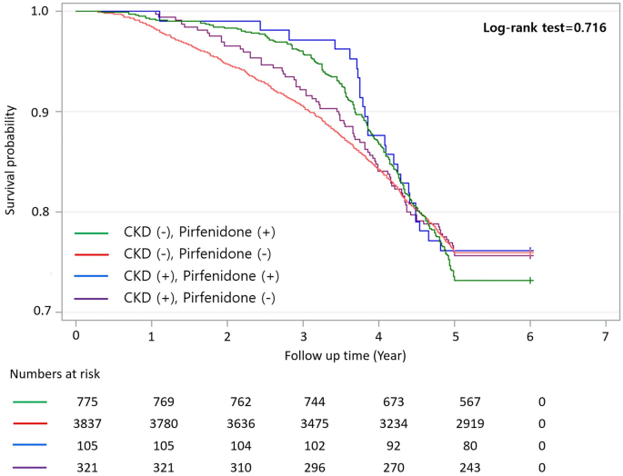

Figure Caption:

Survival curve of all-cause mortality in IPF patients with or without CKD based on pirfenidone use. CKD, chronic kidney disease; IPF, idiopathic pulmonary fibrosis.

Place in study where it references figure 3:

Death occurred in 103 of 426 (24.2%) IPF patients with CKD and 1129 of 4612 (24.5%) IPF patients without CKD. Death was observed in 24.3% of IPF patients with CKD who were not prescribed pirfenidone, 23.8% of IPF patients with CKD who were prescribed pirfenidone, 24% of IPF patients without CKD who were not prescribed pirfenidone, and 26.8% of IPF patients without CKD who were prescribed pirfenidone. Significant difference was not observed in mortality between IPF patients with or without CKD (log-rank test 0.809; Fig. [2](https://www.nature.com/articles/s41598-023-46506-0#Fig2)). Furthermore, significant differences were not observed among the four groups when comparing mortality based on pirfenidone treatment (log-rank test, 0.716; Fig. [3](https://www.nature.com/articles/s41598-023-46506-0#Fig3)).