**Software Engineering Bootcamp**

**Level 3 task 8**

**Compulsory Task 1**

1. After logging on to MySQL - I first created the PoisePM Database:

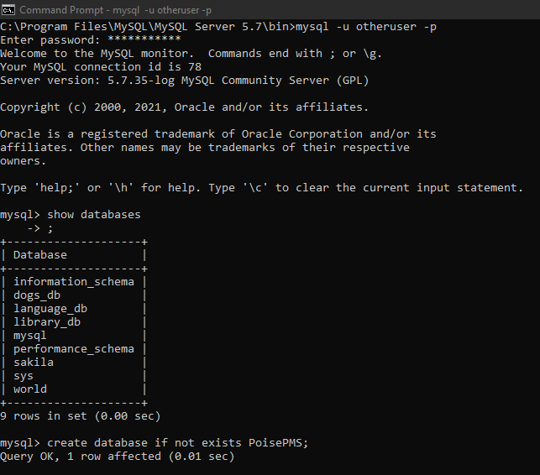

1. Thereafter I created three Tables to hold information for the Architect, Contractor and Customer – with each table containing information for the person’s name, telNumber, email and address:

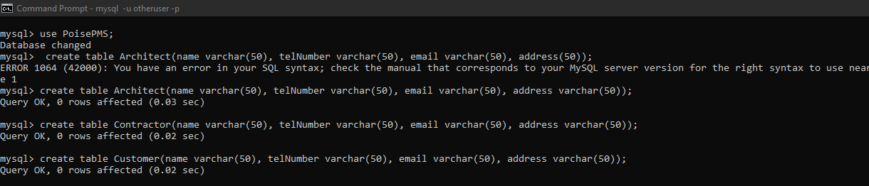

1. After creating the tables, I then populated the tables with two records of each person:

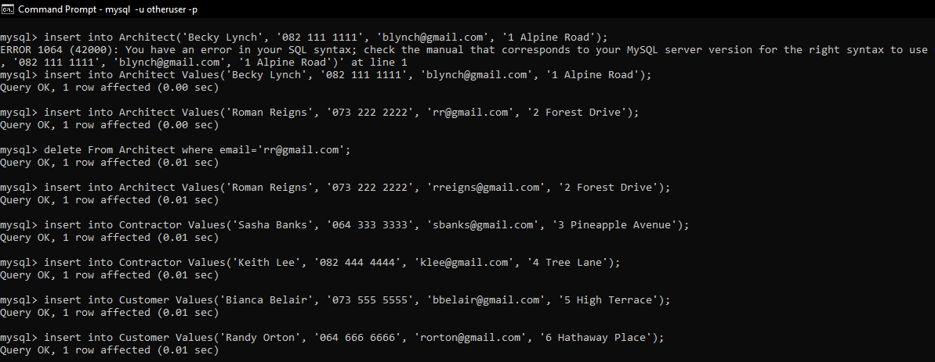

1. Next I created the Project Table – and here I stored information on the project. I added/used the ***name*** of the architect, contractor and customer as the key or link to the previous tables created. So for example, the name of the architect is stored in the Project table and is used as the key to link to the Architect table. Similarly for the Contractor and Customer tables:

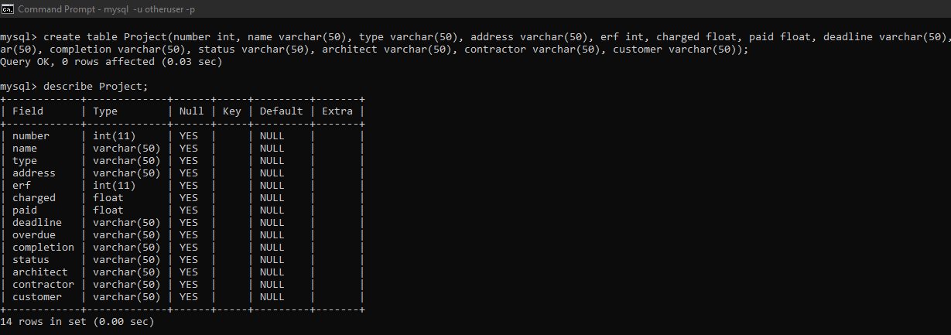

1. Lastly I populated the Project Table with two entries or project entries:

