**Software Engineering**

**Level 3 Task 8**

**Dependency Diagram for PoisePMS Database Tables:**

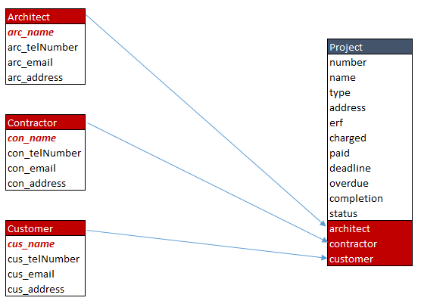

**Relationship between Tables in the PoisePMS Database:**

