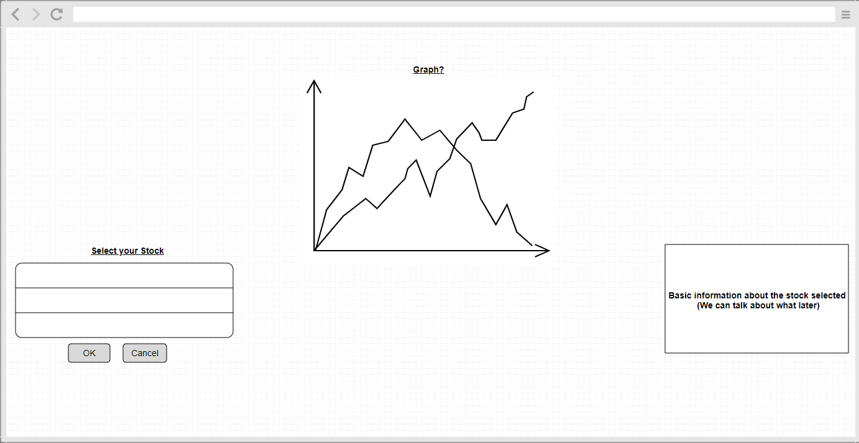

**Select your Stock**

* Can be a drop down menu of the most common stocks (SMP 500 stocks)
* Remove the Cancel button
* Search or Drop Down (Search seems favored)

**Graph**

* Show the closing price of the company

**Basic Information**

* Basic information of the company itself