Stock Market Prediction Algorithms

**Simple Moving Average (SMA)** – This is an arithmetic moving average that is calculated by adding recent prices and then dividing that figure by the number of time periods in the calculation average.

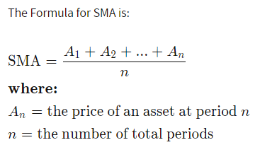

The SMA can be rewritten as

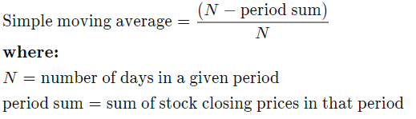

**Exponential Moving Average (EMA)** – This is a type of moving average that places greater weight and significant on the most recent data points. Common EMA lengths are 10-day, 50-day, and 200-day moving averages. EMA reacts more significantly to recent price changes than a simple moving average, which instead applies an equal weight to all observations in the period.

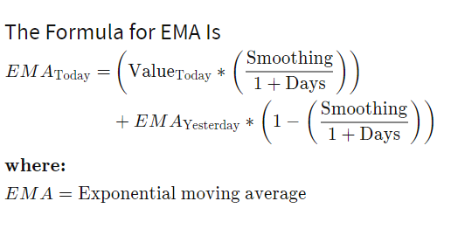

The most common choice for the smoothing factor is 2. Increase in the smoothing factor will result in more influence on recent observations on EMA.

Smoothing can be calculated as



The full formula rewritten as



LSTM Recurrent Neural Network

LSTM – Long-Short-Term Memory is an RNN that belongs to a family of deep learning algorithms. An RNN is a type of artificial neural network that uses sequential or time series data. These neural networks are typically used for ordinal (order related) or temporal (time related) problems, such as language translation, natural language processing, speech recognition, and image captioning. RNNs are separate from their CNN counterparts due to their “memory” as they take information from past input to influence current input and output.

The architecture of an LSTM comprises of the Cell, input gate, output gate, and forget gate. The cell is responsible for keeping track of dependencies between elements in the input sequence. The forget gate is a sigmoid layer that determines how much of a cells previous outputs will influence the current one. Input gates are added to the previous cell’s output after being multiplied by the forget gate. The input gate is the dot product of two different layers’ outputs. The output gate is what the next cell will receive as input, along with the current cell’s hidden state.