**Stonks go brrr**

**Daniel Masarsky & Tommy Thongsythavong**

**11/16/2020**

Table of Contents

* Problem Specification
* Solution Processes and Design
  + Requirement Collection and Analysis
  + General Design Concepts
    - Architectural Design
    - Abstract Solution Design
    - Prototype of the final product (initial version)

Problem Specification

**(Less Technical):**

With the stock market as volatile as it is, wouldn’t it be nice to have an application that could predict (within a modicum of success) said market?

**(Technical Variant):**

Machine learning stock market predictor based on various algorithms.The application will display the predicted closing prices of the next year on various stocks. This application instead of being one you need to download and run off your own machine will be hosted on an AWS server allowing ease of access and allowing a broader range of people to be able to use this application.

Solution Process and Design

Requirement Collection and Analysis

**Requirement List:**

* If purchased what functions will the software provide?
* An online stock market predictor
* How useful is the software for the User?
* It is useful to make predictions on the stock market for users who do not have any other knowledge of the stock and do not have time to learn about it
* What benefit does the software possess?
* Allows Users to make more informed decisions when deciding on which Stocks to invest in

General Design Concepts

Architectural Design

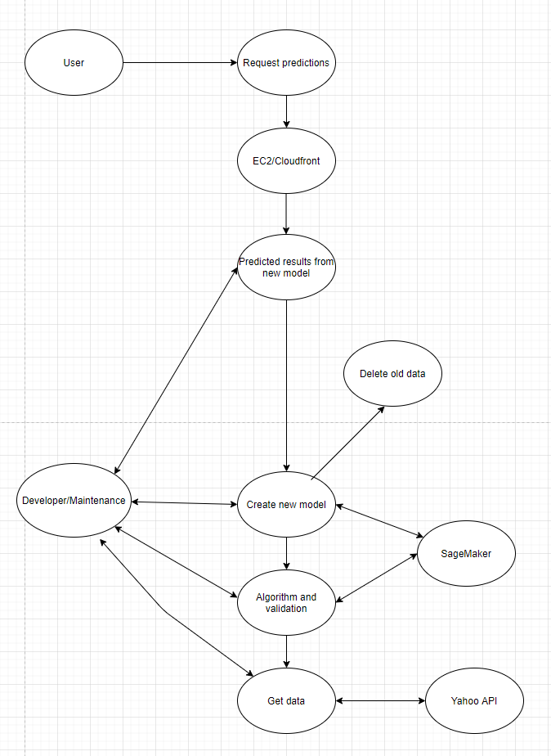

Use Case Diagram

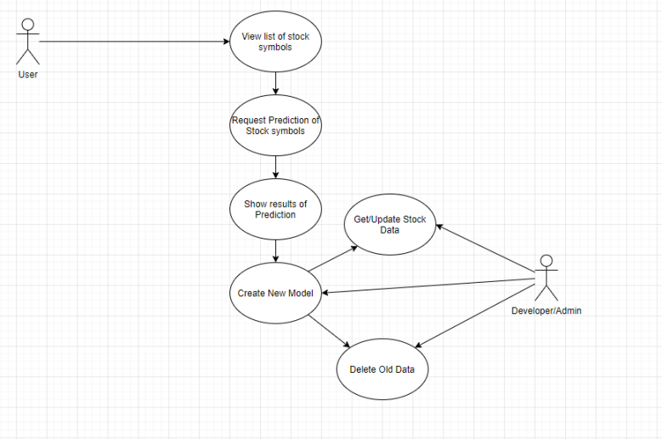

Prototype of the final product (initial version)

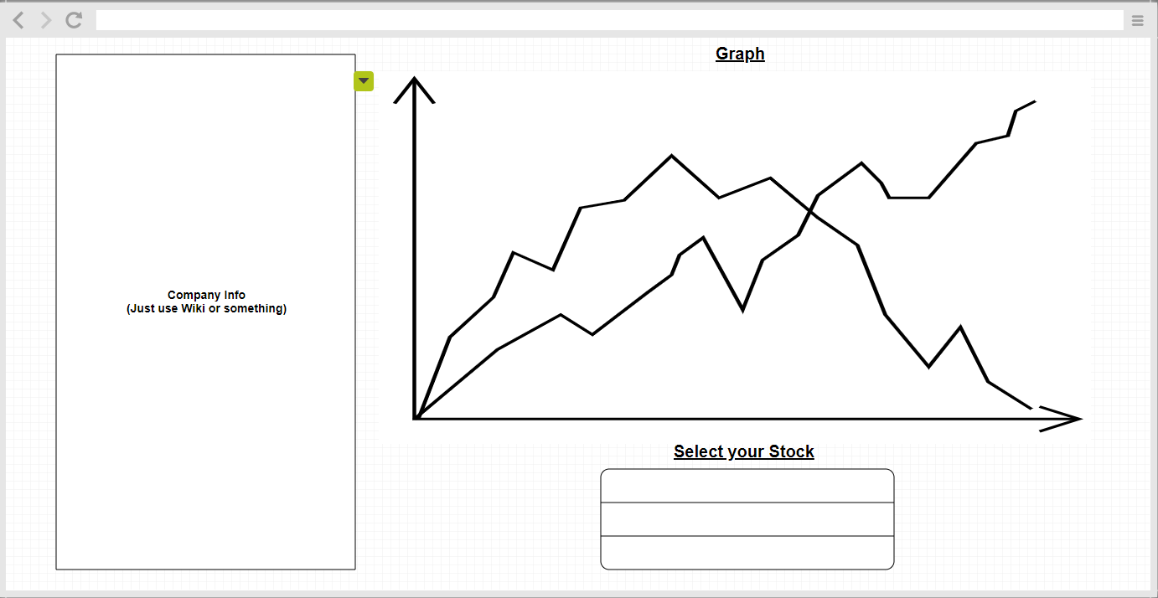

Our application will take the shape of browser-based application. This application will display a graph with the closing price of the selected company. Selecting the company, you which to see information of will be done with the search feature known as ‘Select your Stock’. Finally, this application will also display some rudimentary information about said company. Information that can easily be found on websites such as Wikipedia.