7 Storage Connector – Project Report

Alexandro Bolfa 331500
Steen Krøyer

12345 characters
Software Technology Engineering
Semester 7
01.12.2025

Table of content

1. Abstract 1
2. Introduction 2
3. Main section 3
4. Discussion 4
5. Conclusion and Recommendations 5
6. References 6

Abstract
Storage Connector is a secure, microservice-based web application that integrates Google Drive and OneDrive into a unified, read-only file browser. The system architecture consists of two independently deployable .NET9 services, IdentityService and LinkingService, a YARP-based API Gateway with resilience policies, and a React frontend utilizing TanStack Query. The platform supports user registration, email verification, authentication, password management, and account linking for Google and Microsoft accounts through OAuth2.0 with PKCE. Users are able to monitor connection status and browse or open files from both providers. Security features include JWT authentication, token introspection, encryption of OAuth tokens at rest, IP rate limiting, CORS restrictions, and the use of security headers.

Introduction
Frequent transitions between cloud storage providers can create inefficiencies for users. To mitigate these issues, this project integrates Google Drive and OneDrive into a unified interface, prioritizing user privacy through OAuth authentication and minimal permission scopes. The current implementation offers read-only access to both Google and Microsoft services, while excluding Dropbox, iCloud, and functionalities such as downloading, deleting and sharing. Advanced encryption methods beyond OAuth and token-based protection, as well as write operations, are outside the scope of this phase.

Analysis

Requirements
Based on the project’s goal, 13 functional requirements have been defined and implemented.

Functional requirements
- As a user, I want to create an account with email and password so I can use the app.
- As a user, I want to verify my email, so my account is activated.
- As a user, I want to log in with my email and password so I can access my account.
- As a user, I want to reset my password so that I can regain access if I forget it.
- As a user I want to log out, so that this device no longer has access.
- As a user, I want to link my provider account (Google/Microsoft) so the app can read my Drive files.
- As a user, I want to see each provider’s connection state so that I know what is available.
- As a user I want expired connections to recover so that I can keep using the app.
- As a user, I want to disconnect a provider so the app stops accessing it.
- As a user, I want one dashboard listing files from all connected providers so that I don’t switch apps.
- As a user, I want to search by file name across providers so that I can find files quickly.
- As a user, I want to see the file’s metadata (size, last modified date, file type), so that I can quickly verify it is the correct item before opening it.
- As a user, I want to open a file in its native web app in a new tab so I can view it there.

Non-functional requirements
- The system must be split into independently deployable services with isolated databases.
- The system must include an authentication mechanism for users and services.
- The system must include authenticated server-to-server communication between services.
- The system must rely on a defined protocol for all inter-service and client-service communication.
- The system must include a GUI for client-facing interactions.

Use case
The previously listed functional requirements have been merged into eleven use cases:
- Register an account
- Verify email
- Log in
- Reset password
- Log out
- Link provider’s account
- Manage provider’s connection
- Browse unified files
- Cross-provider search
- See item’s metadata
- Open item in provider
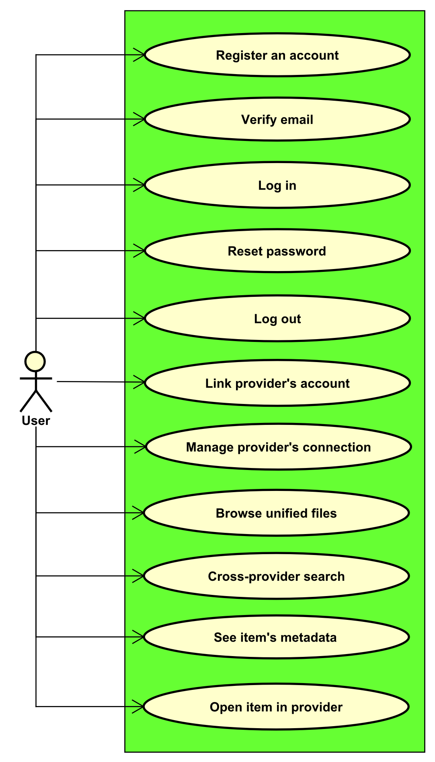
The use case diagram illustrates the interactions between the user and the system's use cases. Only one actor, the user, is included. Additional actors, such as an administrator, are irrelevant since the system is designed to streamline user tasks and focus only on interactions between the user and their files.
Figure 1: Use case diagram
Use Case: | Covered requirements:
Register an account | 1
Verify email | 2
Log in | 3
Reset password | 4
Log out | 5
Link provider’s account | 6
Manage provider connection | 7, 8, 9
Browse unified files | 10
Cross-provider search | 11
See item’s metadata | 12
Open item in provider | 13
Table 1: Requirements coverage

Use case description
The “Link provider’s account” use case outlines the steps required for a user to connect a provider account to their system account. Additional use case descriptions are provided in the appendix.

Use case 6 | Link provider’s account
Summary | Link Google Drive/ OneDrive for read-only access.
Actor | User
Precondition | User is logged in.
Postcondition | Google/Microsoft tokens stored securely; status Connected.
Base sequence | - User selects provider.  - User connects to chosen provider.  - System redirects to provider’s consent for read only access [ALT1].  - User consents; provider redirects back with code [ALT2].  - System exchanges code for tokens; stores encrypted [ALT3].  - System confirms connection with provider.
Alternate sequence (branch or exception) | [ALT1] User denies consent (go back to 1).  [ALT2] Code missing/invalid (go back to 1).  [ALT3] Token exchange fails (go back to 1).  [*ALT0] Can cancel at any time.
Note | Covers requirement 6
Table 2: Use case description - Link provider’s account

System sequence diagram
The diagram illustrates the sequence of user interactions with the system. Initially, the user requests to connect a provider account. The system then redirects the user to the provider’s consent interface. Upon approval of access at the provider, the provider returns the user to the system along with the approval result. The system subsequently records the connection for the user’s account, storing the relevant tokens and permissions. Finally, the system confirms the successful connection.
Figure 2: System sequence diagram - Link provider's account
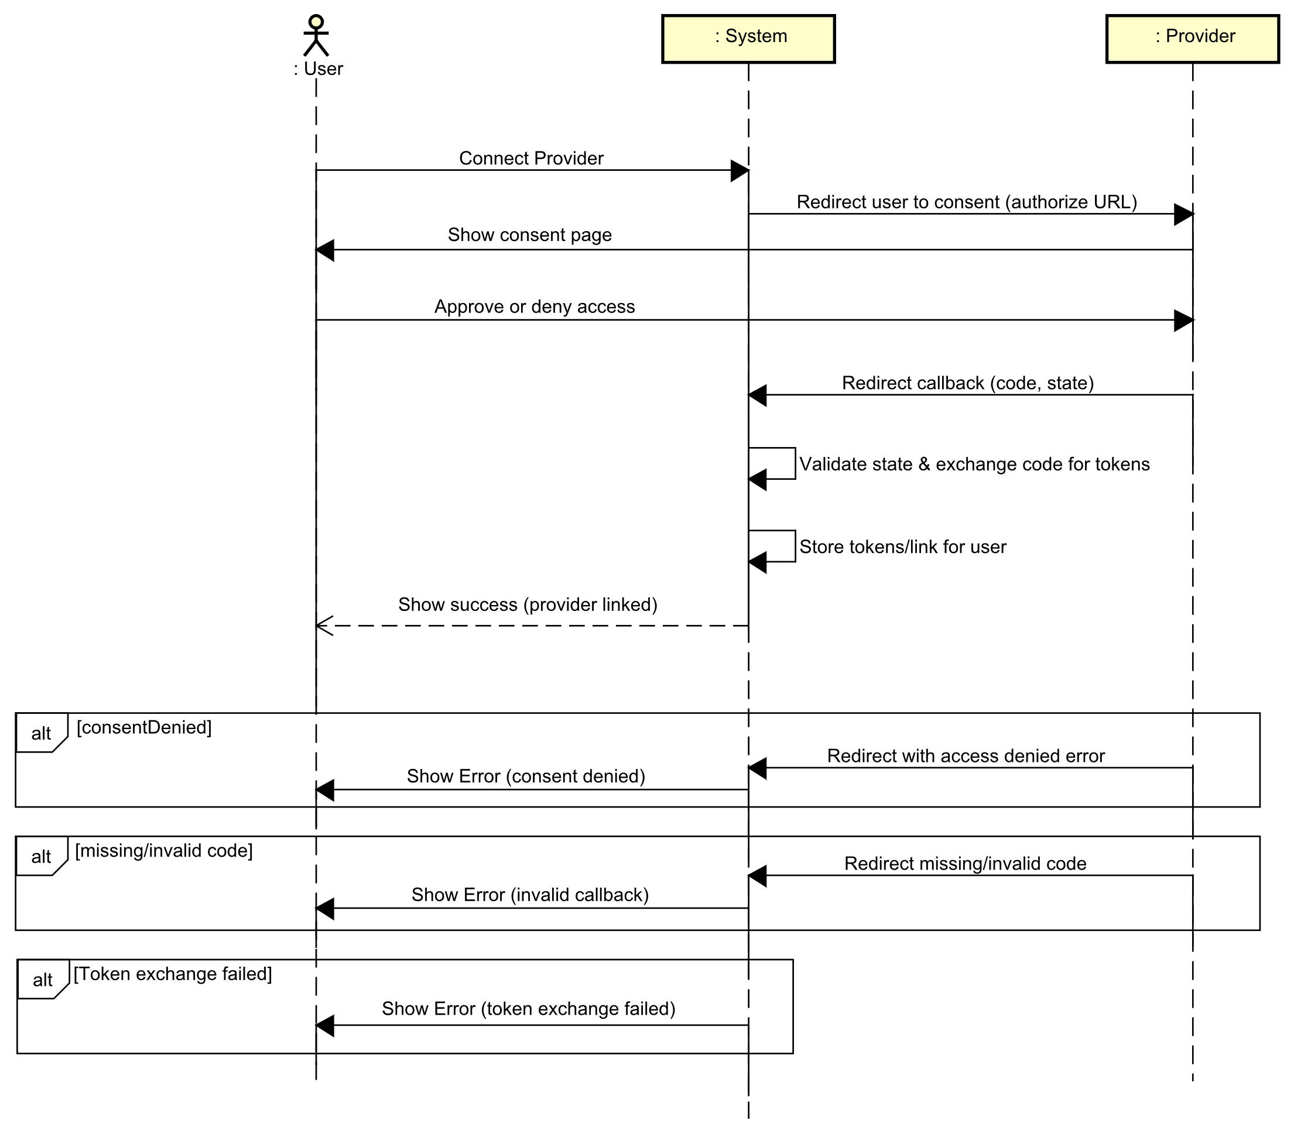

Domain model
The domain model is structured around the User. Each user has time-limited email confirmation and password reset tokens, which are associated with the user and flagged upon use. Users can link a single account for each provider, such as Google or Microsoft. Each linked account stores the provider type, the encrypted refresh token, its expiration time, and the associated scopes. The TokenSet returned by the provider, which includes the access token, refresh token, expiry, and scopes, is temporary and not stored directly. Only the refresh token, expiry, and scopes are stored in the linked account. ProviderType is an enumeration indicating whether the link corresponds to Google or Microsoft.
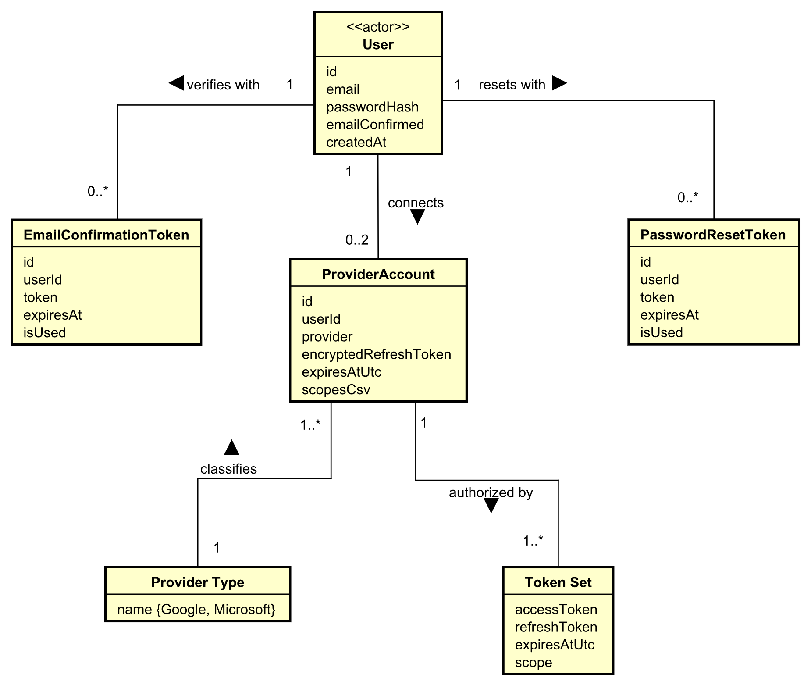
Figure 3: Domain model

Entity Relationship Diagram
The Entity Relationship Diagram reflects the domain model while incorporating a storage perspective. The User entity serves as the primary table, with EmailConfirmationToken and PasswordResetToken represented as time-limited, user-scoped rows, each defined by primary and foreign keys. Each provider association is modelled as a ProviderAccount row, keyed to both the user and a provider enumeration, and stores only the encrypted refresh token, expiry, and scopes. ProviderType is maintained as an enumeration. TokenSet is depicted as a transient OAuth value that is not stored; only its refresh token, expiry, and scopes are stored within ProviderAccount.
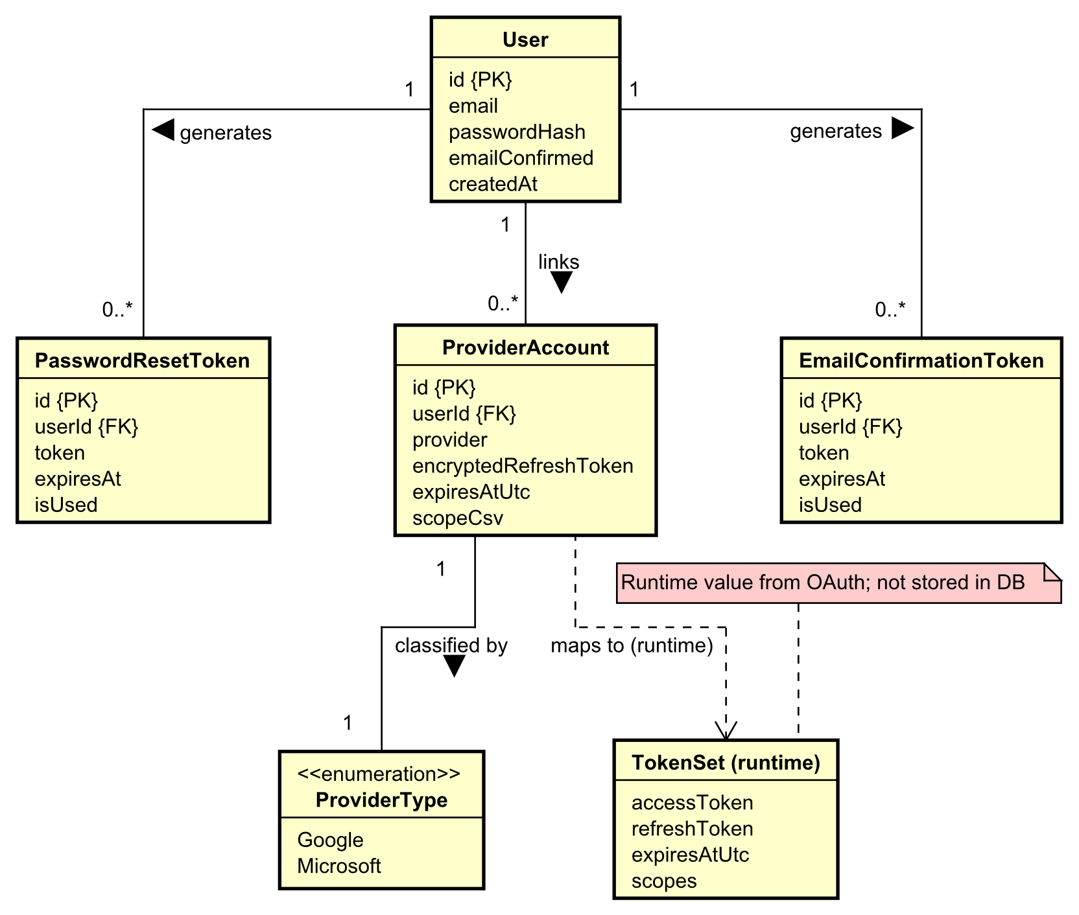
Figure 4: Entity relationship diagram

Security
The security strategy for this project addresses key threats, including credential theft, brute force attacks on authentication flows, OAuth token theft or replay, man-in-the-middle attacks on API and OAuth callbacks, authorization bypass using stolen tokens, denial of service targeting the gateway or services, and cross-tenant data access. The objectives follow confidentiality, integrity, and availability plus strong authentication, authorization, and compartmentalization. We protect credentials, tokens, and user data in transit and at rest, prevent tampering with accounts and linked providers, keep the system responsive during failures or hostile traffic, ensure only authorized users and services reach their own data, and isolate services and data stores to contain incidents. Risk assessment highlights that man-in-the-middle is medium likelihood and high impact if plain HTTP were allowed, brute force on authentication endpoints is medium likelihood with medium to high impact, token replay or theft is low to medium likelihood with high impact, denial of service on gateway or services is medium likelihood with medium impact, and cross-tenant access is low likelihood with high impact. Planned controls enforce TLS-only communication, rate limiting on sensitive endpoints, a strong authentication lifecycle with hashed passwords and time-limited single-use confirmation and reset tokens, careful token management with short-lived JWTs, PKCE for OAuth, and no long-term storage of access tokens, per-user authorization at service boundaries, isolation of services and databases, resilience patterns such as health checks and bounded retries to limit cascading failures, and correlation IDs with logging to aid detection and investigation.

Design

Architectural overview
The system architecture consists of two bounded services: IdentityService, which handles authentication and user lifecycle management, and LinkingService, which manages provider connections and unified file access. Both services are accessed through a single API Gateway and are utilized by a web client. Each service maintains ownership of its domain logic and data, operates independently, and can be modified or scaled without affecting the other services. The API Gateway functions as the sole external entry point, offering a stable, versioned API, routing requests to the appropriate service, and enforcing shared cross-cutting policies such as authentication validation, routing, and resilience. This architectural separation increases cohesion, minimizes coupling, and localizes failures within individual components.

Client
The client is a single-page web application that supports workflows including sign-up, sign-in, account confirmation, account recovery, provider linking, and file browsing. These workflows are organized into dedicated pages, and shared user interface components are used to maintain consistency. Navigation is handled exclusively on the client side. All data interactions are handled through gateway-facing API calls, separating backend modifications from the user interface. Lightweight client-side state management maintains session context and tracks request outcomes. The user interface consistently communicates loading states, errors, and successful operations, ensuring clarity throughout authentication, provider linking, and file browsing workflows. 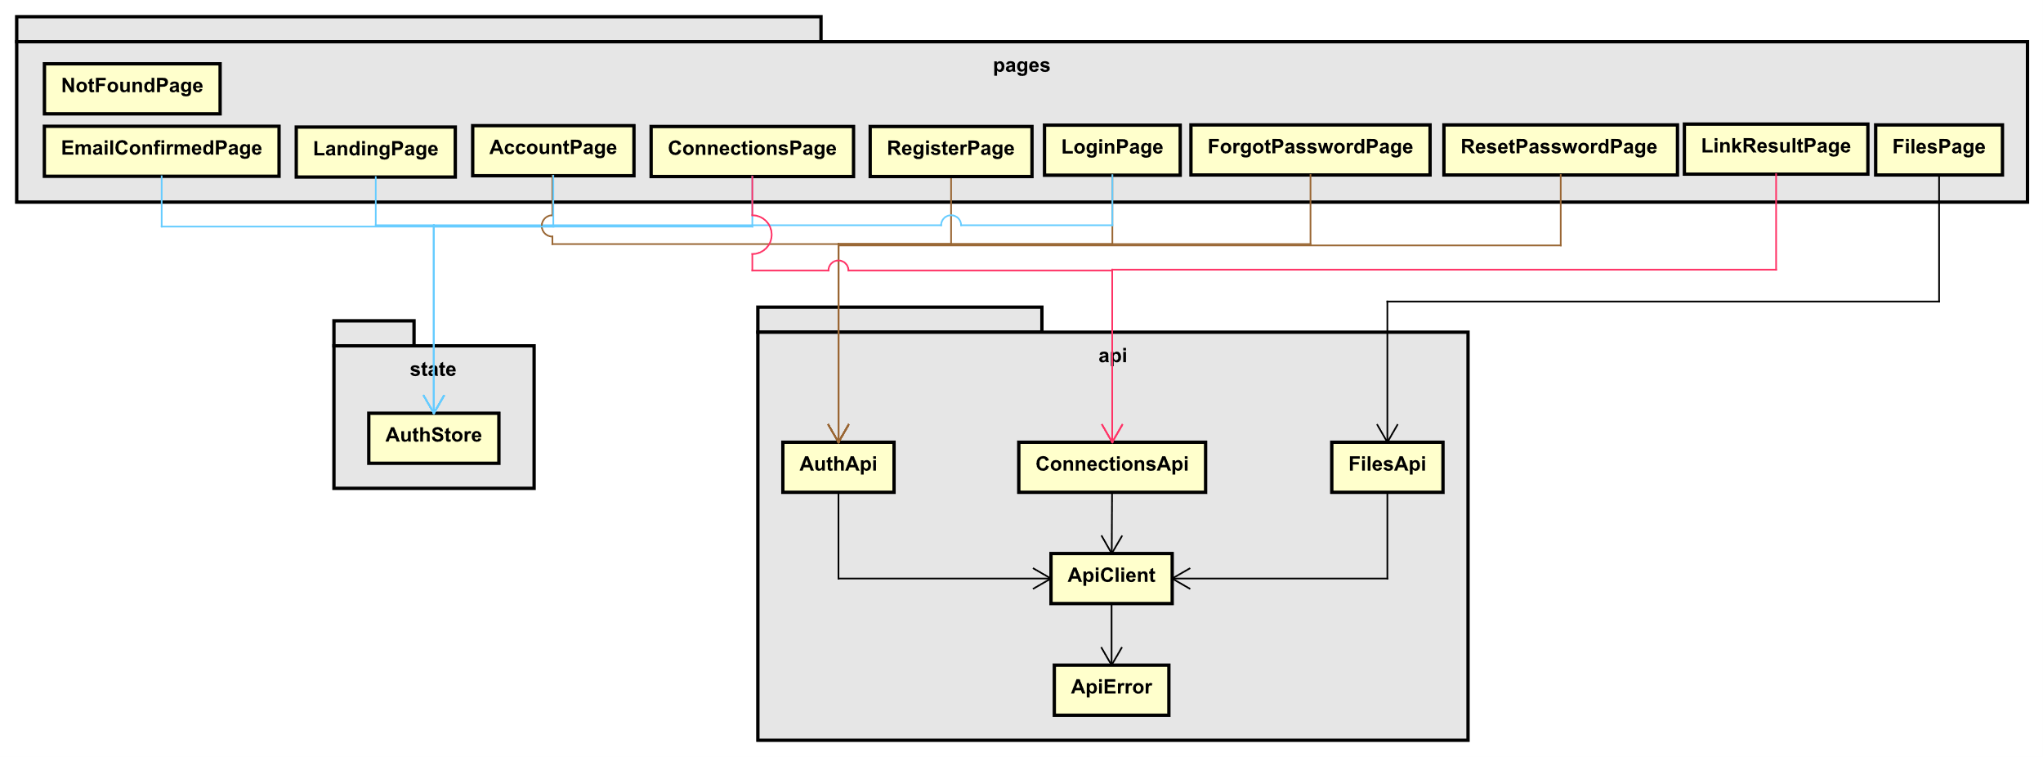
Figure 5: Simplified frontend class diagram

Gateway
The gateway is the single-entry point for all client traffic, providing a stable and versioned API while efficiently routing requests to backend services. At the network edge, it applies policies including authentication, Cross-Origin Resource Sharing (CORS), security headers, and logging, as well as resilience mechanisms such as timeouts, retries, and circuit breakers. Employing a single reverse proxy for clients hides internal services, simplifies connections, and centralizes the management of policy and routing modifications.

Services
Each service is defined by its domain boundaries. The IdentityService manages authentication and user lifecycle, while the LinkingService is responsible for provider connections and unified file access. Services maintain ownership of their logic and data, operate independently, and can scale or evolve without affecting one another. Service interfaces use RESTful protocols and are validated on every call to ensure authorization and enforcement of domain rules at their boundaries.

Persistence
Data is partitioned by service to align with domain ownership. The IdentityService stores user accounts along with their confirmation and reset tokens, while the LinkingService manages provider account links, including provider type, encrypted refresh tokens, expiry, and scopes. Utilizing separate databases enables independent schema modifications and scaling. Consistency across services is ensured through well-defined API contracts instead of shared schemas.

Security
Security measures are implemented at both the network edge and within individual services. The gateway performs token validation and enforces origin restrictions, while each service independently re-validates tokens for every request. OAuth authorization flows utilize Proof Key for Code Exchange (PKCE), and only essential token information, such as refresh tokens, expiry times, and scopes, is retained. Access tokens function as short-lived credentials. Sensitive configurations, including secrets and cryptographic keys, are not stored in source control repositories. Planned enhancements include implementing rate limiting on sensitive endpoints, enforcing HTTPS-only communication, and establishing correlation and logging mechanisms to mitigate common attacks and support monitoring and incident response.

Implementation

Gateway edge (routing, authentication, resilience)
The API Gateway validates JWTs, applies CORS/security headers, adds resilience (retry/circuit breaker), exposes health endpoints, and hides internal service URLs. The appsettings.json declares CORS origins, reverse-proxy routes, and cluster destinations. The Program.cs reads that configuration, wires JWT/CORS and correlation, and maps health checks and the reverse proxy. In short, The appsettings.json defines what to forward and where, while The Program.cs enforces security/resilience and activates those routes.

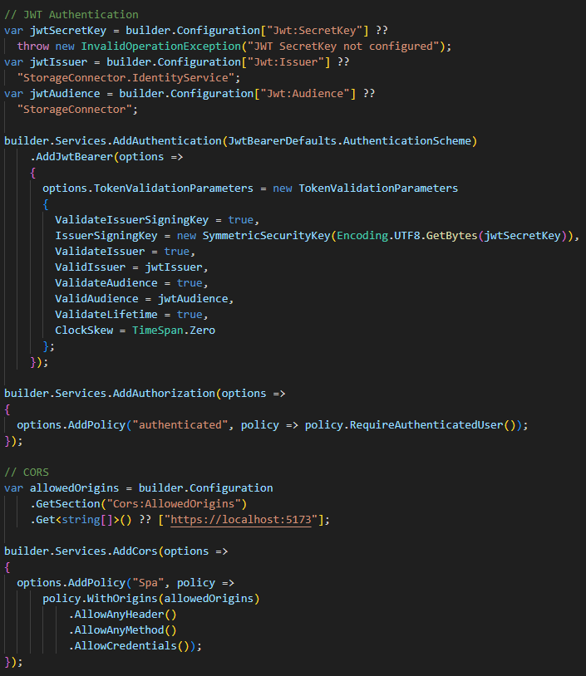
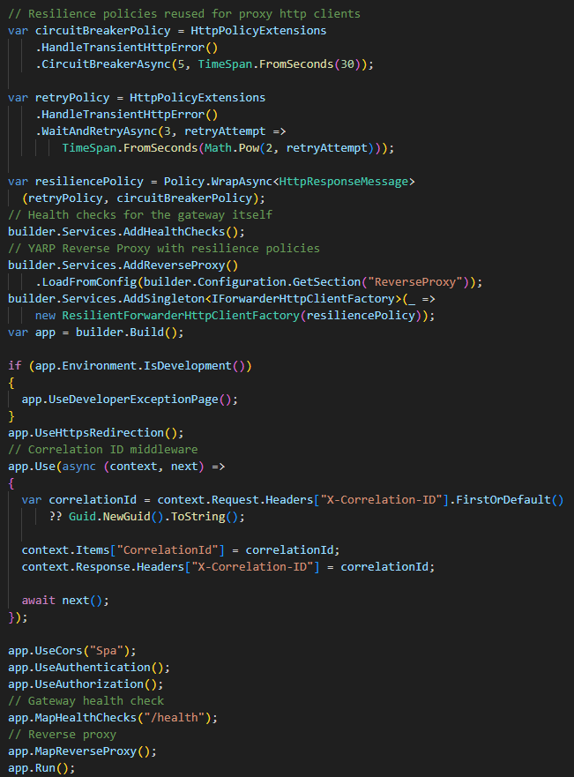
Figure 6: Gateway - JWT, CORS
Figure 7: Gateway - Resilience, YARP

LinkingService API
The linking API exposes two endpoints for the OAuth flow. The “start” endpoint is called by the client after the user clicks “connect”. It generates PKCE state and verifier, builds the provider’s authorize URL with the callback pointing back to this controller, and returns that URL for the client to redirect to. The “callback” endpoint is invoked by the provider after the user approves access. It validates the returned state, exchanges the code for tokens, stores the linked account (encrypted refresh token, expiry, scopes), and then redirects the user to the frontend success page (or an error page if validation fails).
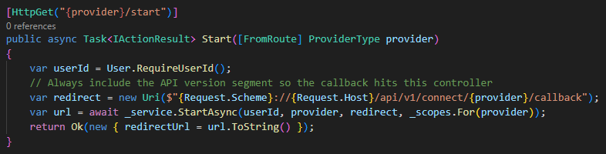
Figure 8: ConnectController - start
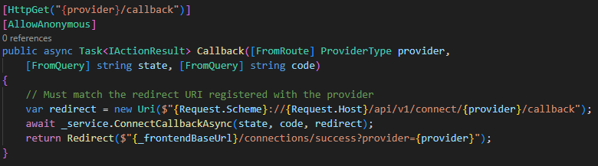
Figure 9: ConnectController – callback

LinkingService core
This core flow covers state/PKCE, callback handling, and secure token persistence. StartAsync generates a PKCE verifier/challenge and random state, saves the tuple (state, userId, provider, verifier) in CacheStateStore with a short TTL, and returns the provider authorize URL. On callback, ConnectCallbackAsync consumes and validates the stored state/verifier, exchanges the code, and hands the resulting tokens to EfTokenStore to upsert the user’s provider account. EfTokenStore encrypts the refresh token, stores expiry and scopes, and ensures one record per user/provider. Together, the state store prevents replay, and the token store keeps provider credentials safe at rest.
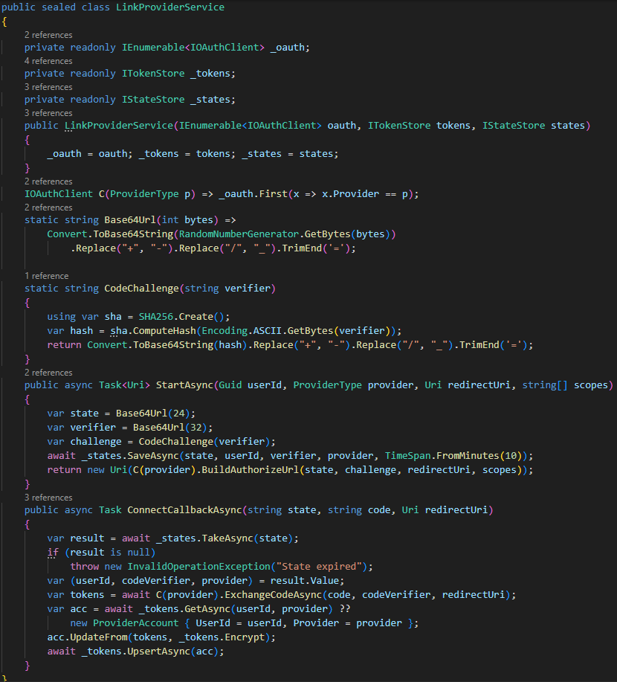
Figure 10: LinkProviderService
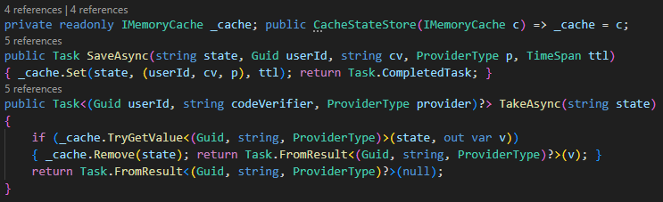
Figure 11: CacheStateStore
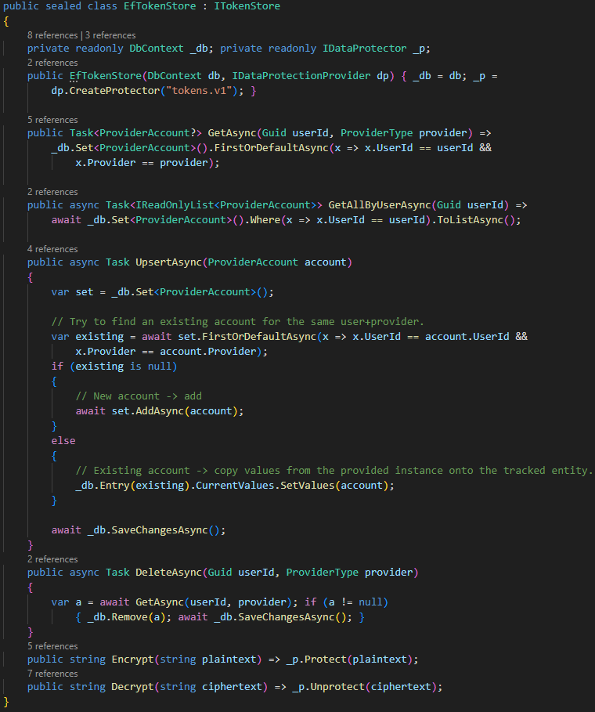
Figure 12: EfTokenStore

OAuth clients and refresh
MicrosoftOAuthClient handles the PKCE code exchange and refreshes tokens as needed, while MicrosoftFileProvider consumes those tokens to serve file operations. The file provider decrypts the stored refresh token, refreshes the access token when required, updates the saved refresh token/expiry/scopes, and then returns the provider’s view URL for the requested file. Together they cover the token lifecycle: exchange, refresh, use, without storing access tokens at rest.
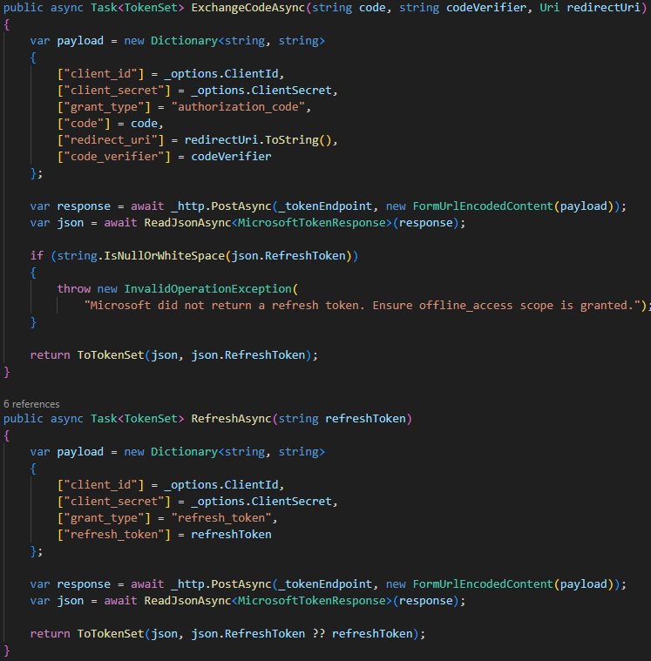
Figure 13: MicrosoftOAuthClient
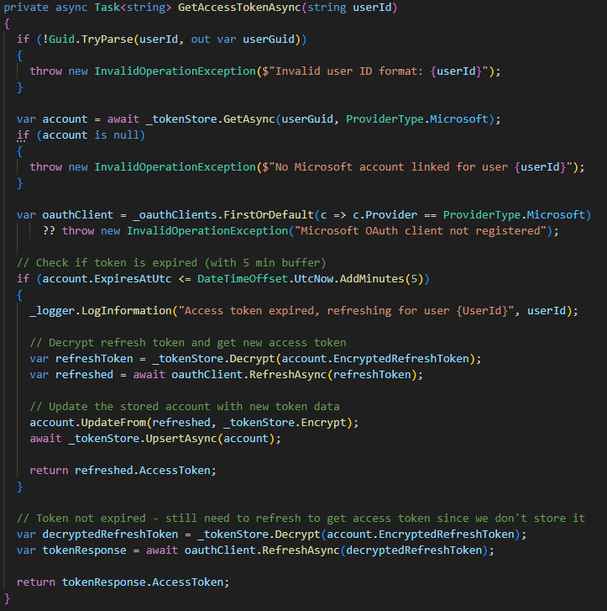
Figure 14: MicrosoftFileProvider

File aggregation
FilesController exposes a unified file surface: GetAllFiles pulls every linked provider for the current user and returns a merged list; GetFilesByProvider supports per-provider listing with folder and paging; GetFileMetadata fetches details for a single item; and the view endpoints return either a redirect or a JSON view URL. All these delegate to FileService. In FileService, GetFilesFromAllProvidersAsync enumerates the user’s linked accounts, asks the appropriate file provider for each list, flattens and sorts the results by last modified time, and tolerates per-provider errors without breaking the whole aggregation. The per-provider methods GetFilesByProviderAsync, GetFileMetadataAsync, GetFileViewUrlAsync simply forward to the specific provider via the factory, handling pagination, metadata retrieval, and generation of the provider’s view URL.
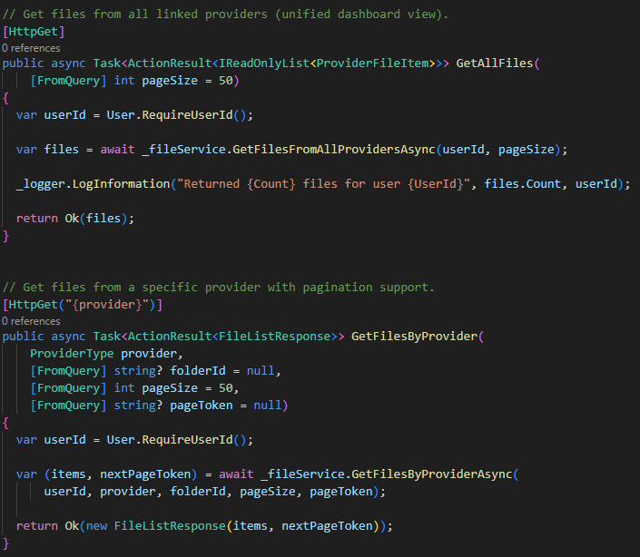
Figure 15: FilesController - GetAllFiels, GetFilesByProvider
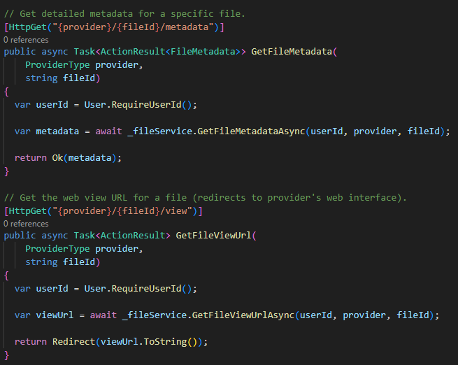
Figure 16: FilesController - GetFileMetadata, GetFileViewUrl
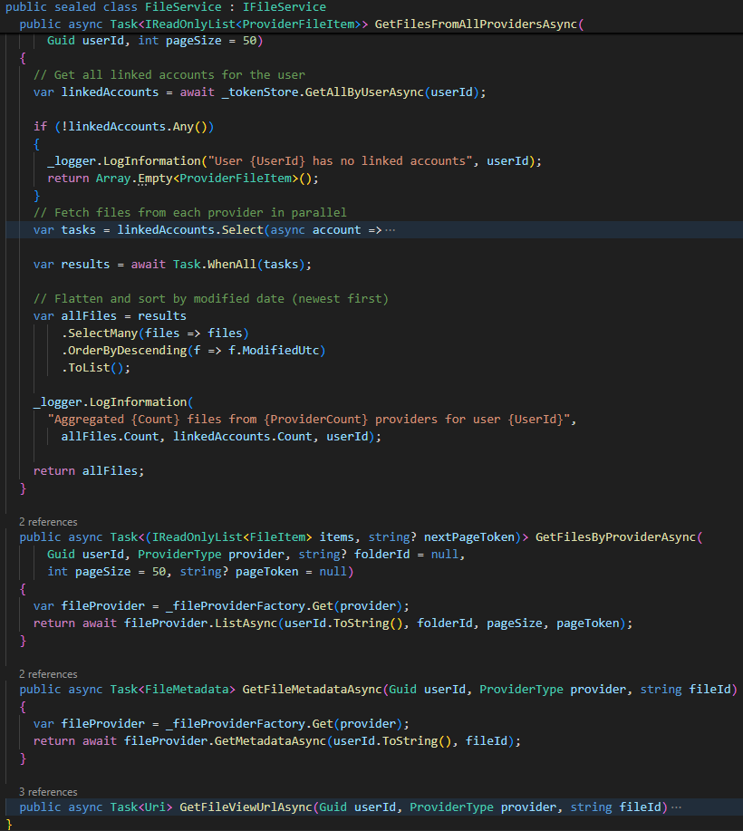
Figure 17 :FileService

Identity touchpoints
AuthController issues and verifies the tokens that guard the linking flow. The register/login endpoints create users, enforce email confirmation, validate credentials, and issue JWTs with the expected issuer/audience/claims. The introspection endpoint allows other services to validate a presented token: it checks signature, issuer/audience/lifetime, extracts the subject/email, and confirms the user still exists. These touchpoints define the token shape and validation contract that the gateway and LinkingService rely on.

Resilience and security
Both services enforce security and resilience at the edge. In their Program file, they configure JWT validation (issuer/audience/secret, zero clock skew), apply IP rate limiting to sensitive endpoints, and add middleware for correlation IDs and security headers. They also expose health checks and wire CORS for the SPA. These settings ensure tokens are revalidated on every call, request origins are controlled, and basic hardening and observability (correlation/logging) are in place alongside controlled retries/limits to reduce abuse.

Testing

Acceptance testing
Each user case was validated through acceptance testing:
- Register an account
- Verify email
- Log in
- Reset password
- Log out
- Link provider’s account
- Manage provider’s connection
- Browse unified files
- Cross-provider search
- See item’s metadata
- Open item in provider

Backend testing
IdentityService is covered by xUnit unit and integration tests for registration/login, email confirmation, password reset, token issuance/introspection, and rate-limit/error handling. LinkingService has unit, integration, and E2E tests for PKCE/state handling, OAuth callback validation, token storage/encryption, connection status/disconnect, file aggregation and view URL generation, and resilience/error handling when a provider fails.

Frontend testing
Unit/component tests with Vitest and React Testing Library cover the register/login/reset/forgot flows, connections page link/disconnect states, and files page loading/error/empty states and search/filter. Lightweight integration checks mock the API clients to verify success/error rendering, token handling, and navigation guards.

Summary of test coverage
All automated backend suites pass, and the frontend suites do as well. Manual acceptance tests across the main user journeys also completed as expected, with proper handling of invalid tokens, denied consent, and provider/API failures.

Discussion and conclusion
The solution met its core aims: a gateway-fronted, two-service architecture that keeps the client insulated from internal topology, with clear ownership of authentication and provider linking/file aggregation. The linking flow proved robust: PKCE/state protected against replay, access tokens remained transient, and file aggregation provided a unified view across providers. Automated tests covered IdentityService’s token lifecycle and LinkingService’s OAuth/state handling, plus frontend flows for auth, linking, and files. Manual acceptance runs matched expected outcomes for both success and error paths.
There trade-offs and gaps to address are that he system is read-only and the UI doesn’t yet surface folder navigation or richer metadata. Transient access tokens require refresh on each operation, and development choices (in-memory state cache and databases) need hardening for production. Gateway resilience is present, but end-to-end load and security testing are pending. Rate limiting needs production tuning, and full browser-based E2E coverage is absent. Next steps include extending the UX (navigation, metadata), adding providers beyond Google/Microsoft, hardening infrastructure (persistent state store, production databases, secret vaulting, observability), and adding automated E2E plus load/security testing to validate behavior at scale.

References
[Insert your text here]
For more information, see “Guidelines - Project Report”.

