PRODUCT PROPOSAL
TaskFlow
A simpler way to guide students, manage work, and see progress
Prepared for a prospective company partner
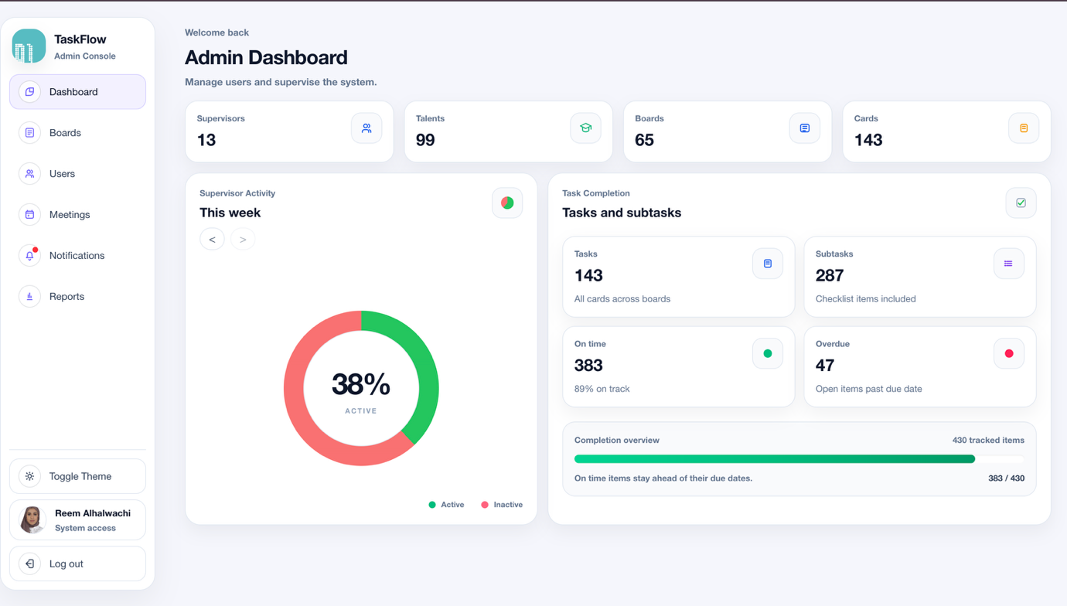
A single dashboard gives management a clear view of students, supervisors, projects, tasks, and overall progress.

Proposal at a glance
TaskFlow is a ready-built web product for organisations that supervise learners or junior team members through project work. It replaces scattered messages and manual follow-up with one organised workspace for assignments, tasks, meetings, reminders, and progress reporting.
Purpose  Make supervision clear, consistent, and easier to manage. | Users  Administrators, supervisors, and students or trainees. | Opportunity  Pilot the product, adapt it to company needs, and prepare it for wider use.

The business need
When supervision depends on spreadsheets, direct messages, and memory, it becomes difficult to know who needs support, what work is late, and whether follow-up happened. TaskFlow creates one shared process without making the experience complicated.
Less manual coordination  Assignments, project boards, meetings, and reminders are managed in one place. | Better visibility  Managers and supervisors can quickly see workload, progress, overdue work, and activity. | More accountability  Every learner knows their tasks, deadlines, supervisor, and next action.

How the product works
1 Assign people — Administrators connect each student or trainee with the right supervisor.
2 Create a workspace — A project board gives the team one organised place for the work.
3 Guide the work — Supervisors add tasks, deadlines, priorities, notes, and checklists.
4 Stay connected — Meetings, notifications, and Discord reminders keep everyone informed.
5 Review progress — Dashboards and reports show what is completed and where support is needed.
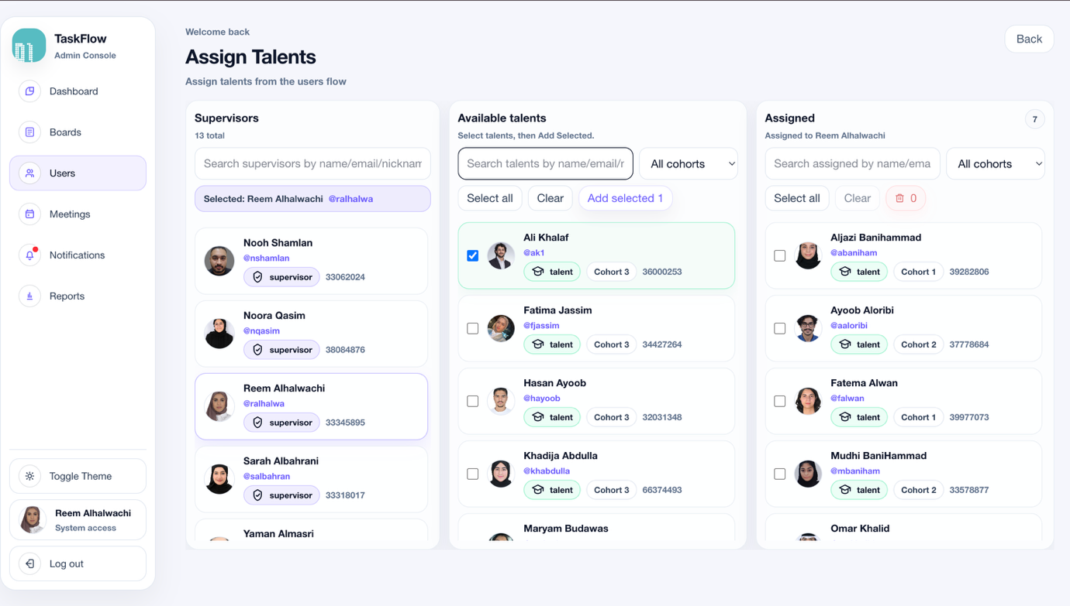
Administrators can see available students and assign them to supervisors through a clear visual workflow.

A clear experience for everyday work
The interface uses familiar boards, lists, and task cards, so users can understand the workflow quickly. Supervisors manage the plan while students focus on their assigned work.
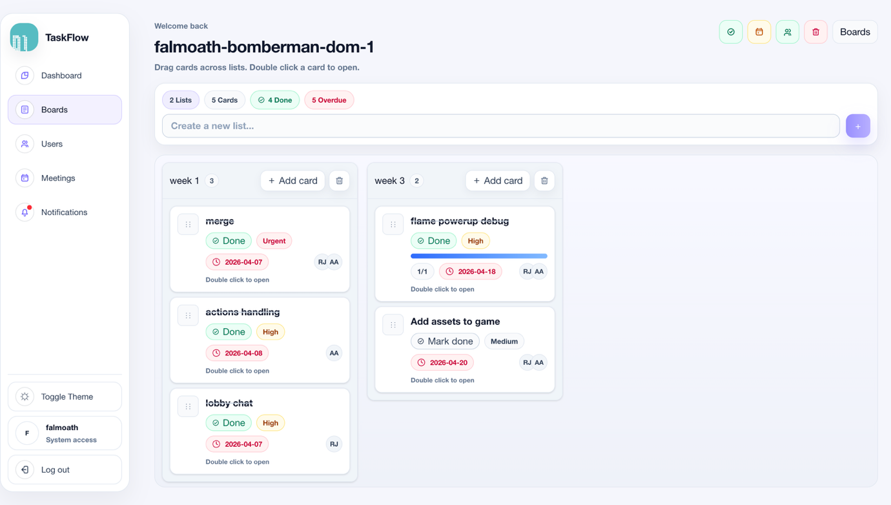
Supervisors organise project work into simple stages and can see task status at a glance.

Each task carries the full context
A task can include a due date, priority, description, assignee, comments, labels, and a checklist. This reduces repeated questions and gives the learner a clear definition of what needs to be done.
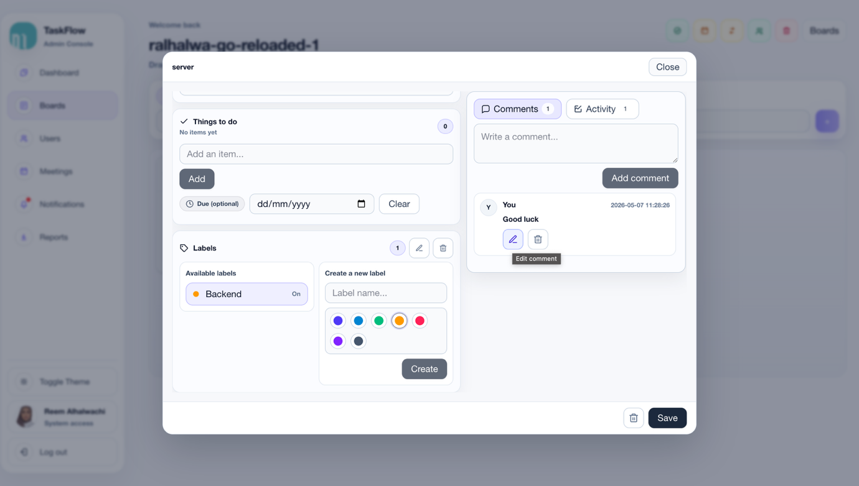
Task details keep instructions, deadlines, ownership, and smaller action items together.

Supervision continues beyond the task board
TaskFlow brings meetings and communication into the same workflow. Supervisors can schedule sessions, record outcomes, and keep participants informed through notifications and linked communication channels.
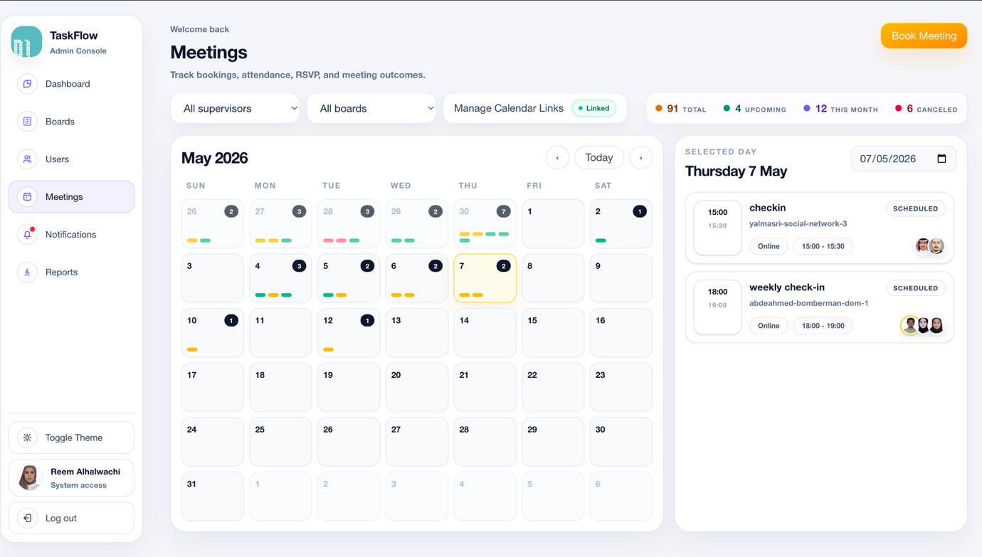
The meeting calendar makes upcoming supervision sessions easy to see and manage.

Automatic reminders reduce missed follow-up
When a task or meeting is created or updated, the product can send a message through Discord. This connects formal tracking with the communication channel users already check.
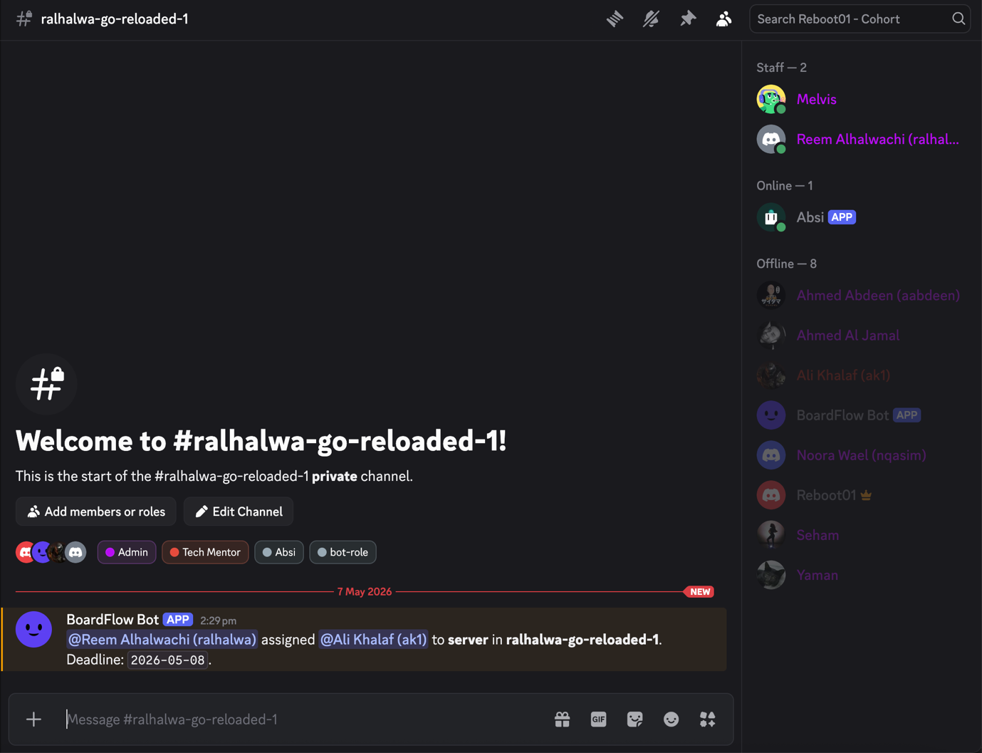
The TaskFlow bot can notify a shared channel when work is assigned.

Value for the company
For management  A reliable overview of activity, workload, completion, and areas requiring attention. | For supervisors  Less time chasing updates and more time supporting people with the right guidance. | For learners  Clear responsibilities, visible deadlines, and a consistent place to ask questions and show progress.

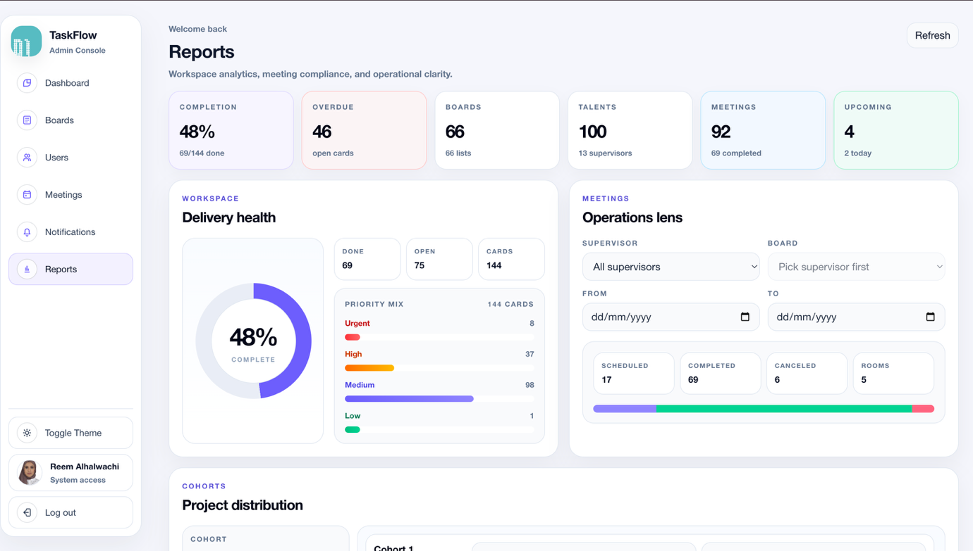
Reports turn everyday activity into a simple management view of completion, delays, and project delivery.

Proposed engagement
The recommended next step is a short company pilot using one team or training group. During the pilot, the product can be configured for the company’s roles, terminology, workflow, and communication preferences.
1 Discovery — Confirm the company’s supervision process and the people who will use TaskFlow.
2 Pilot setup — Prepare users, boards, permissions, reminders, and a small set of active projects.
3 Evaluation — Collect feedback, review adoption and progress visibility, then agree on improvements.
4 Rollout decision — Define the final scope, support model, timeline, and commercial terms.

Requested company input
A pilot sponsor, a small user group, access to the current workflow, and feedback from administrators, supervisors, and learners.
TaskFlow is ready to demonstrate.
Prepared by Reem Alhalwachi

