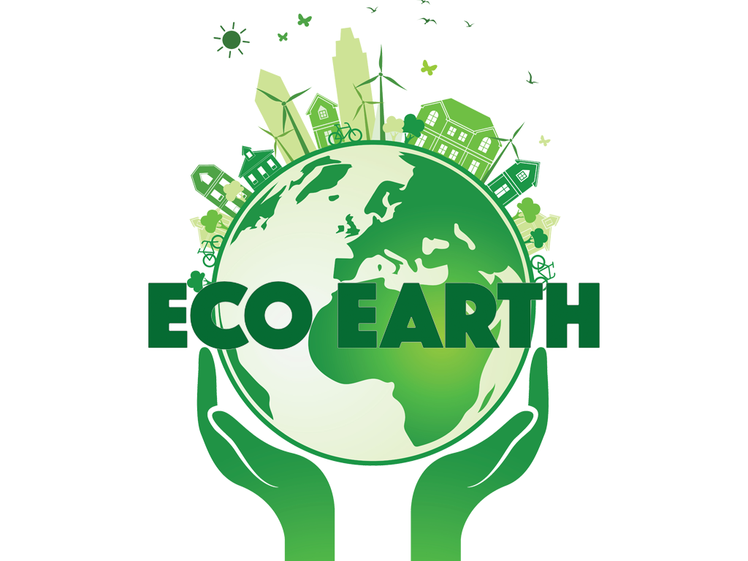

**Game Documentation**

Produced by: Rebecca Nash

06-11-17

**Game Overview**

**I. Introduction**

In this 2D web application game, the players will walk through the greenhouse gas footprint chain for four products; mobile phones, beef, leaving electronic devices on standby and plastic bottles. Along the chain journey players will take ownership of releasing the gases into the atmosphere, and as a result will see and hear about the effect on the four related habitats; the arctic tundra, rainforest, ocean and British countryside. A habitat animal narrator will guide players through the journey providing educational facts for enhanced learning. Players will have the opportunity to participate in mini games during the chain journey to select the animals who reside in the habitats they’re learning about, and to provide a pledge on how they promise to try and help.

**II. Game Objective**

The objective of the game is for each player to learn about, and take ownership of, the greenhouse gas footprint chain for each of the four products, as well as providing a pledge of what they’ll do to reduce greenhouse gas emissions.

**III. Genre**

Interactive, educational puzzle game.

**VI. Features**

* 2D game
* Web application
* Visual feedback
* Educational
* Interactive
* Real-time in-game updates

**V. Intended Audience**

The intended audience of this game is for casual or non-gamers of both genders from the age of 11 to 16, however the primary age range is 11 to 12 years old.

**VI. Language**

The game will only be in English.

**VII. Sound Consideration**

The game play experience is not dependant on sound and as such the game does not require speakers of any kind.

**Story**

**I. Outline**

Production and disposal of mobile phones, beef, leaving electronic devices on standby and plastic bottles are having a detrimental impact on four habitats around the world. An understanding of this process, and a pledge to help, is absolutely vital to the future of these habitats and the animals that live there.

**II. Story Synopsis**

The story relates the greenhouse gas footprint chain of production to disposal of four products to four habitats from around the world. At each stage of the chain, players are presented with a fact and relevant image, and the responsibility to release the emitted gases into the atmosphere. Upon release, the habitat view becomes darker and bleaker as the on-screen greenhouse gas meter rises. An animal narrator for each habitat describes the impact the gases are having on the habitat and once the chain journey is completed, they return to ask for help saving their home giving the players the option to provide select a predefined pledge to help, or not. Players who pledge will witness the on-screen pledge meter rising, which will impact their overall score at the end of the game.

**Meeting Your Requirements**

|  |  |
| --- | --- |
| **Your Requirements** | **The App** |
| School students will construct a greenhouse gas chain for each of the four products | School students will learn the chain for each product from production to disposal through an interactive chain within each habitat |
| The app should be educational, fun and interactive | The app provides detailed chain information accompanied with facts and risks, educational mini-games and questions |
| Targeted to 11-16 year olds (mainly 11-12) | The app design mixes cartoon imagery with real-life scenes; game text is simplified for a younger audience |
| School students should take ownership of the problem | Students will be required to ‘release the gases’ into the atmosphere during each stage of the chain. They’ll witness the impact, and then provide a pledge on how they promise to try and help |
| The app should purely focus on the carbon chain activity | The greenhouse gas chain for each habitat remains on screen for interactive completion |