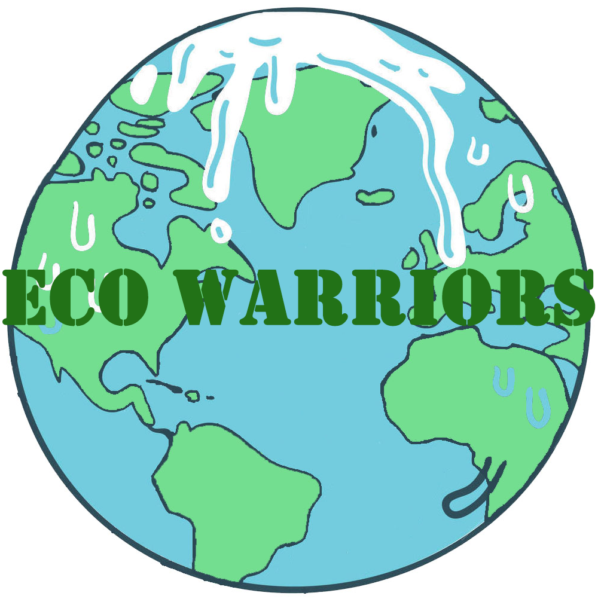

**Eco Warriors**

**Game Design Documentation**

**Version 1.0**

**Produced by: The A Team**

**12/10/17**

**Table of Contents**

**Table of Contents**

**DESIGN HISTORY. 1**

**SECTION 1 – GAME OVERVIEW……………………………………………………………....2**

**I. Introduction…………………………………………………………………………….…..3**

**II. Objective of the Game.………………………………………………………...................3**

**III. Genre……………………………………………………………………………………...3**

**IV. Features. ……………………………………………………………………………….....3**

**V. Platform..…………………………………………………………………………….….…3**

**VI. Intended Audience.…………………………………………………………………….... 3**

**VII. Language. ………………………………………………………………………………...3**

**VIII. Sound Consideration. …………………………………………………………………...3**

**SECTION 2 - STORY.…………………………………………………………………………...4**

**I. Outline.……………………………………………………………………………………...5**

**II. Story Synopsis. ………………………………………………………………………….…5**

**III. Cut Scene Screens.………………………………………………………………………...5**

**SECTION 3 – CORE GAME MECHANICS.……………………………………………………...6**

**I. Camera.……………………………………………………………………………………..6**

**II. Team Play.………………………………………………………………………………….6**

**III. General Movement.……………………………………………………………………....6**

**IV. Initial Set Up.……………………………………………………………………………...6**

**V. Points.……………………………………………………………………………………...6**

**SECTION 4 – INTERFACE FLOWCHART.……………………………………………………….7**

**SECTION 5 – IN-GAME ELEMENTS.…………………………………………………………...7**

**I. Colour Pallet. ……………………………………………………………………………….7**

**II. Fonts.……………………………………………………………………………………….7**

**SECTION 6 – CHARACTERS.…………………………………………………………………...7**

**DESIGN HISTORY**

To start designing we sat down as a group and swapped ideas. We talked about the games appearance, and usability. After discussing how we should proceed, we roughly sketched out a storyboard of what are UI (User Interface) was going to look like. The target audience was 11 to 12-year olds. With this in mind we had to think about what would appeal to are audience. We decided that bright solid colours were the best choice for children, as it was more stimulating. For the assets we were looking for something to fit ZSLs aesthetic, so we went for the below asset design.

We purchased assets from Shutterstock that had a wooden effect. This linked in with the premise of the game, being the conservation of nature. The style of the UI was child friendly, and simplistic in design, which after some research we found was a suitable choice.

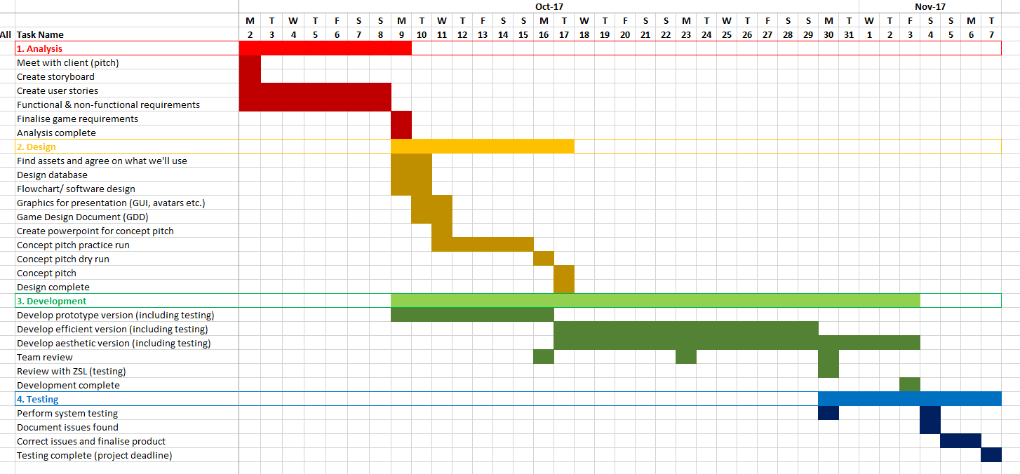

**SECTION 1 – GAME OVERVIEW**

## **I. Introduction**

In this 2D web application game, players will build the greenhouse gas footprint chain for four products; mobile phones, beef, leaving electronic devices on standby and plastic bottles by identifying the next steps in the chain using a tell-tale game method. Players will have three choices on which step they believe comes next in the chain, and will obtain points for every correct answer. A habitat animal narrator will guide players through the journey, providing the correct sequence of events and educational facts for enhanced learning. At the end of the game, players will have the opportunity to provide a pledge on how they promise to try and help.

**II. Objective of the Game**

The objective of the game is for each team to complete the greenhouse gas footprint chain for the four products in a fun and interactive way. Each team must answer the statements correctly, if correctly answered then the team will receive a point if not, no point will be awarded but the answer will be revealed so that they may know what was the next step in the chain

## **III. Genre**

Interactive, educational tell-tale game.

## **IV. Features**

* 2D game
* Team play
* Visual feedback
* Educational
* Interactive
* Tell-tale

## **V. Platform**

This game will be a web-based application, designed for use with on an Apple iPad using iOS 10.3.3.

## **VI. Intended Audience**

The intended audience of this game is for casual or non-gamers of both genders from the age of 11 to 16, however the primary age range is 11 to 12 years old.

## **VII. Language**

The game will only be in English.

## **VIII. Sound Consideration**

The game play experience is not dependant on sound and as such the game does not require speakers of any kind.

**SECTION 2 - STORY**

## **I. Outline**

Production and disposal of mobile phones, beef, leaving electronic devices on standby and plastic bottles are having a detrimental impact on four habitats around the world. An understanding of this process, and a pledge to help, is absolutely vital to the future of these habitats and the animals that live there.

## **II. Story Synopsis**

The story relates the greenhouse gas footprint chain of production to disposal of four products to four habitats from around the world. In each habitat, players are presented with the beginning step of the chain and are prompted by the animal narrator to select one out of three options that they think might come next in the process. The tell-tale game continues until all chains are completed.

## **III. Cut Scene Screens**

The opening scene is the character selection for the character of the game.

Then the launch of the game which opens up in the main map. This shows the world in its best condition and once a player has gone through one of the habitats it then will show on the map how the condition of that habitat has changed as the users have gone through the different stages of the greenhouse gas chain.

The next cutscene shows each section of the tell-tale game which has steps that explain how specific effect of greenhouse gases change the nature of that habitat that the users are on.

Once each habitat has gone through all sections, the next cutscene is the pledge window which shows the users a list of pledges which they can select which ones then will uphold in the future.

The final cutscene is the game end window which says thank you for playing and for selecting a pledge.

**SECTION 3 – CORE GAME MECHANICS**

## **I. Camera**

The camera will be stationary, with a top-down view of the world map, and a side view within each habitat window.

## **II. Team Play**

This game will be played in teams.

## **III. General Movement**

Players will be required to tap for habitat selection and within each habitat window for participation of the tell-tale games and pledges.

## **VI. Initial Set Up**

The web app opens with a request for the team to create a team name and select an animal character of their choice. A ‘start’ button will move them into the Map View, where the world is displayed with four unlocked habitats to select.

## **VII. Points**

Points will be obtained for every correct answer selected during the tell-tale games.

# **SECTION 4 – INTERFACE FLOWCHART**

# **SECTION 5 – IN-GAME ELEMENTS**

## **I. Colour Pallet**

We decided upon bright solid colours because we thought them to be more appealing to are young audience.

## **II. Fonts**

The font that was used was goyang which gives out an animated look and which also suits with the rest of our projects as all our assets are animated.

# **SECTION 6 – CHARACTERS**

Arctic Tundra Characters

Arctic Fox

Moose

Rainforest Characters

Sumatran Tiger

Emerald Tree Boa

Ocean Characters

Hammerhead Shark

Longsnout Seahorse

British Countryside Characters

Red Kite

Red Squirrel

