END_NUM 15 CRITICAL -15.0 maxCutEdge>200 39个模块

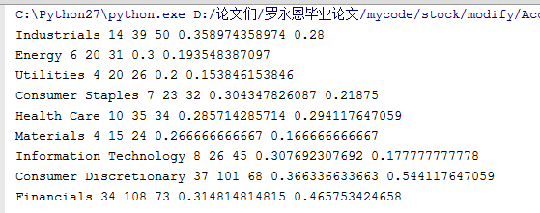

END_NUM 5 CRITICAL -10.0 maxCutEdge>50

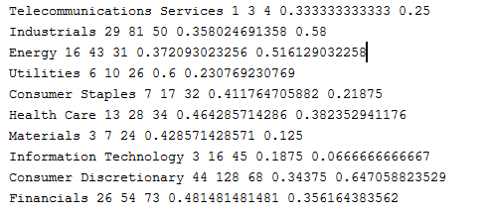

END_NUM 5 CRITICAL -15.0 maxCutEdge>100 **108个社团**

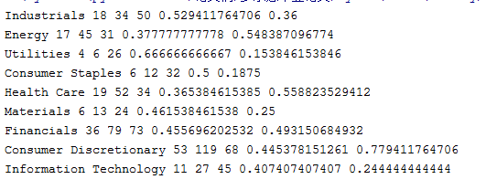

END_NUM 5 CRITICAL -10.0 maxCutEdge>200 122个模块

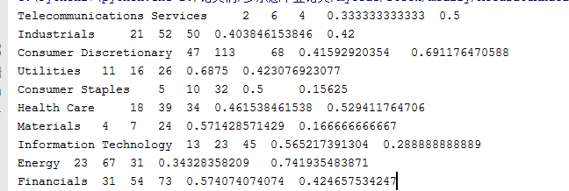

END_NUM 5 CRITICAL -10.0 maxCutEdge>50 87个模块

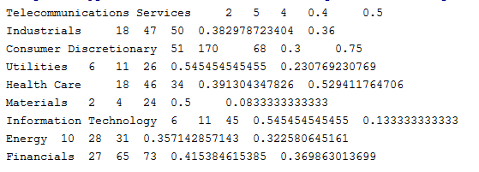

END_NUM 3 CRITICAL -9.0 maxCutEdge>50 170多个社团

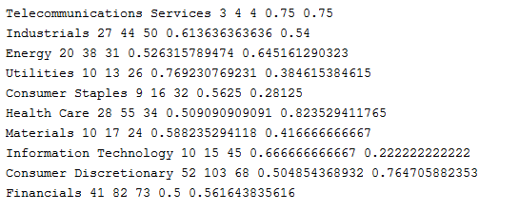

END_NUM 2 CRITICAL -9.0 maxCutEdge>100 321个模块

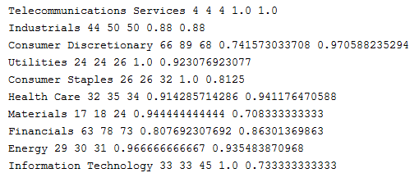

END_NUM 8 CRITICAL -15.0 maxCutEdge>80 64个模块

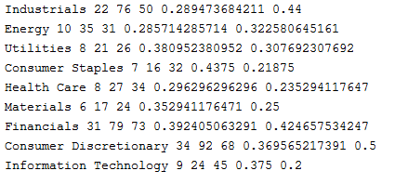

END_NUM 3 CRITICAL -15.0 maxCutEdge>100 203个模块

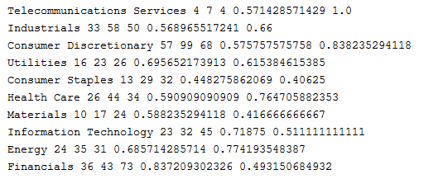

END_NUM 3 CRITICAL -9.0 maxCutEdge>80 191个模块

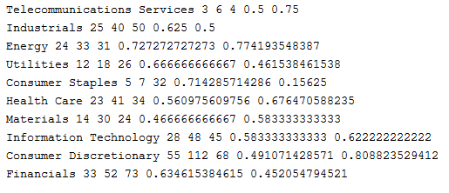

END_NUM 4 CRITICAL -9.0 maxCutEdge>80