Comment Lines 991
Comment to Code Ratio 0.37
Declarative Statements 905
Executable Statements 1,376
Files 59
Functions 191
Inactive Lines 0
Lines 4,488
Preprocessor Lines 603
​ rios代码情况统计表
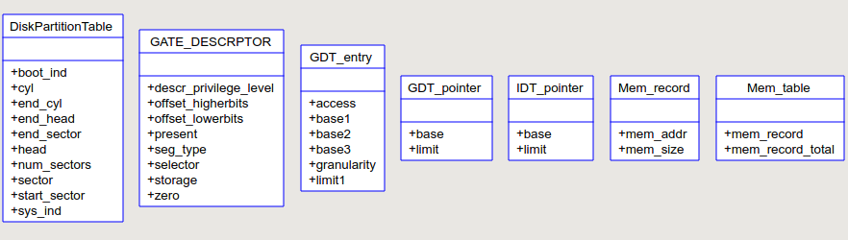
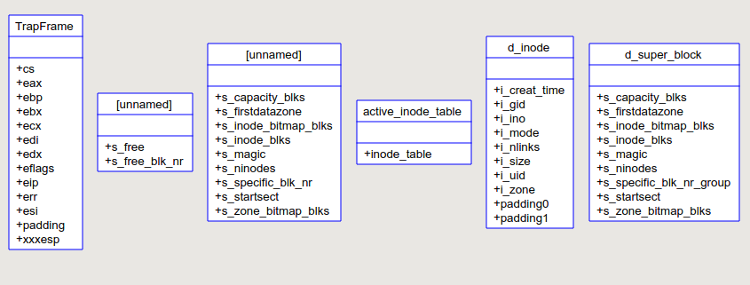
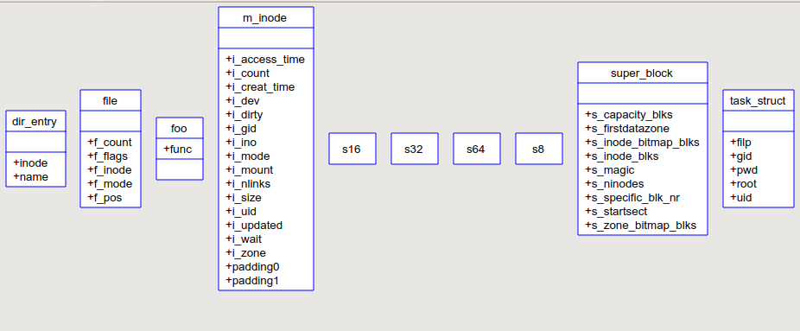
​ UML Class Diagram of RiOS kernel
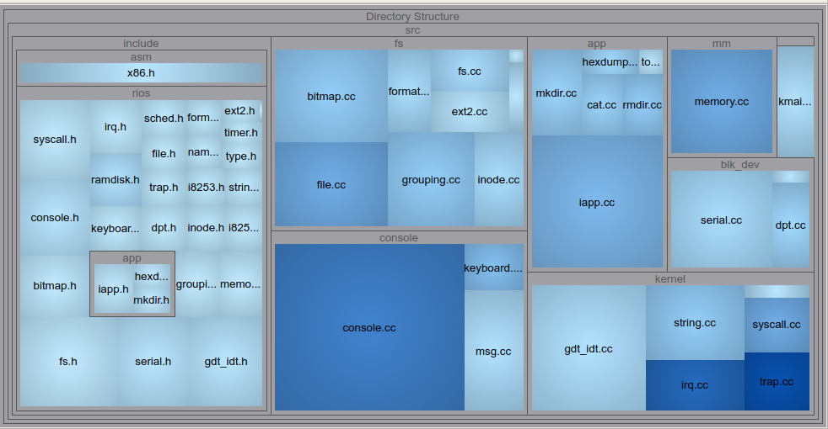
​ RiOS kernel 整体代码分布
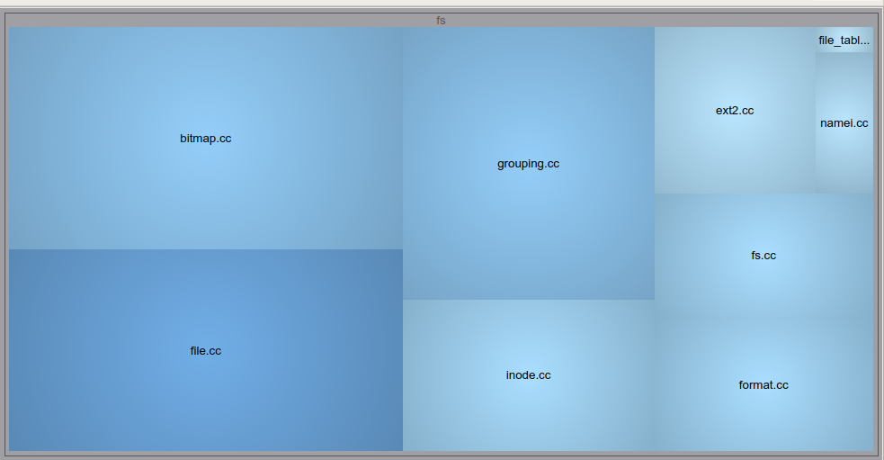
​ RiOS文件系统部分代码分布情况

