Abstract—Considering the more recent availability of live streaming platforms such as Twitch, Smashcast, and YouTube it’s no wonder that streamers are becoming more popular. Live media streaming is already an intensive task when undertaken by any machine, given the need for both video compression and encoding. Given the constraint on streamers a Peer-to-Peer solution requires the streamer to not undertake any more burdens compared to alternatives.
Peer-to-Peer Live Media Streaming Application
Patrick Freel

Index Terms—Stream, Peer-to-peer, Threading, Python, Sockets, Terms of Service (ToS)

INTRODUCTION
Live streaming has become a good medium between live television broadcasts and recorded on demand videos. Streaming in the context pertaining to this paper is performed by an individual wishing to grow their brand, show off some sort of product, or provide entertainment to an audience. Usually it becomes a combination of all three.
While the majority of services today are free they contain ads and you are still restricted to a set of community based guidelines you must adhere to. This is to provide a sense of control over what forms of content are allowed to be shown on their platform and to generate revenue to fund their infrastructure. If a user violates these conditions they are eventually removed and banned from the platform.
Fig 1. Typical process involved in streaming live video to an audience.
Therefore this project provides an alternative that is not bound by Terms of Service (ToS) guidelines. It provides a more diverse and user controlled experience to show off and share what a user may be interested in or expose a viewing user to new forms of media that they would not otherwise be capable of viewing on other platforms. This project comes at an interesting time when some main stream media platforms are banning and censoring their users for expressing an idea or opinion that does not agree with their company’s ideals and values. In such times, it is useful to have an alternative that is available to those effected.

Typical Streaming infrastructure

Overview
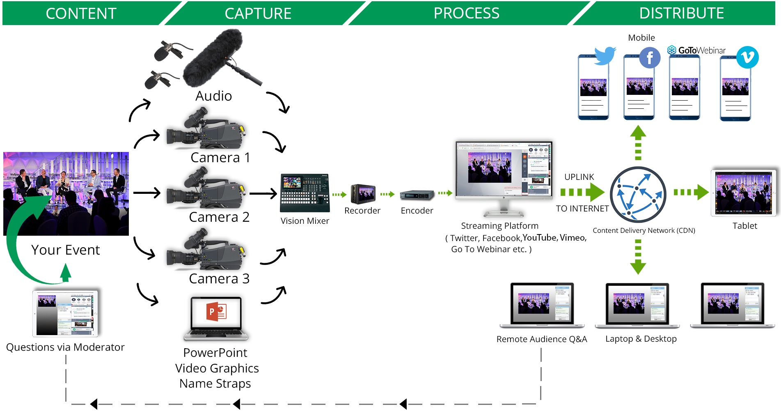
With typical streaming services the streamer will transmit their encoded live view through a routing process to multiple routed servers owned and operated by the service that the streamer has decided to use. At which time users can view the stream by accessing the services website or application. Fig 1 provides a general visualization of the process of a typical live streaming platform.

UDP vs. TCP
During initial research the question was raised whether to use UDP or TCP for live streaming. Unsurprisingly, since it’s the internet, there was some uncertainty and debate between which of the two formats was better suited for live streaming. Ultimately TCP was chosen for the reasons bellow.
UDP arguments facilitate that speed is key when transmitting something as packet heavy as compressed video. UDP is best used for applications that need speed. This is because UDP does not check for errors and does not have many of the fallbacks that TCP has [1].
TCP on the other hand seems to be more reliable, with the capacity to recover data lost during transmission and guarantees receipt of data packets in the correct order [2].

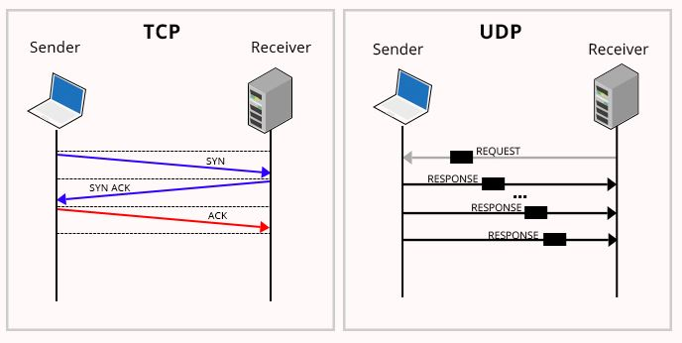

The Streamer class

Overview
Ideally when a user is ready to stream they toggle on their capture and begin transmitting. In its current capacity the streamer is then responsible for transmitting their data to a single peer, keeping track of who all is watching their stream, and redirecting to other peers that have free connections. Each connection is also given an individual thread to handle data distribution and rerouting.

Data Transmissions
In a final product version the program would link in to capture software, such as OBS and Elgato, to provide an encoded packet. Once a connection is established the data is added to a buffer, containing ten to fifteen bits of information, which are then sent in first in first out order.

Redirection
Redirection would occur when a viewer in the chain, portrayed by (3), disconnects for any reason. The streamer would be contacted by the viewer lower in the chain for redirection information. In its current configuration the program is not capable of this feat. Due to limitations discovered during testing.
Figure 3. Redirection process based on initial connection
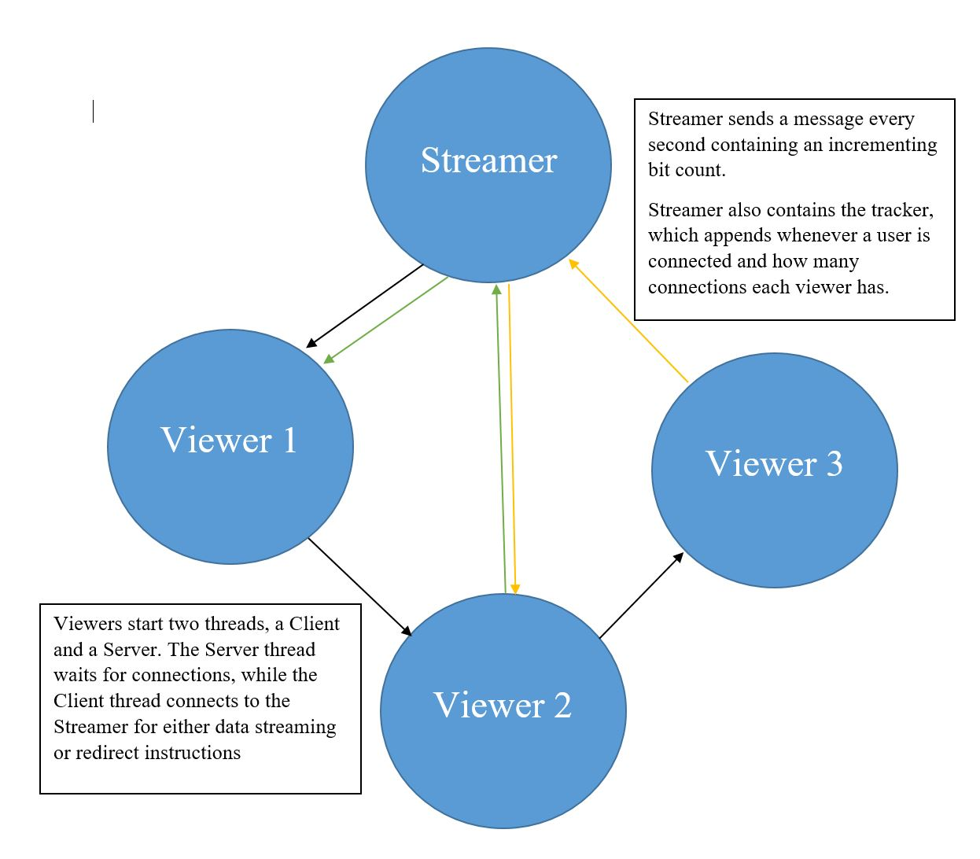
The current major flaw to the streamer keeping a list of active connections is that every time a viewer needs to be rerouted a second time they connect with a different client port. This means that every connection requires a unique IP, and local host testing provided significant issues. Viewing each local connection attempt as new different connections, even if the same connection had already been appended earlier.
Figure 2. Difference in data transfers between TCP and UDP. [2]

Improvements
Improvements to the Streamer class would consist of an improved redirection system based on the scheduling algorithm [3]. This system would be able to better calculate optimum connections based on viewers connection rate and how many connections they are fit to handle.

The Viewer Class

Overview
The viewer class consists of two major parts which can be broken up into a combined Client-Server combo. Upon launching two threads are created, one contains the client side which will connect to the streamer to either receive data or redirection information. The second thread will begin a server instance which awaits connection attempts.

Client Thread
When client thread is initialized it connects to the streamer. If they are the first connection they are appended to the viewer list and start to receive data. That data is displayed and is also appended to a global queue buffer for use by the server thread. The queue operates on a first in first out principle

Server Thread
When server thread initializes it begins by initializing a server instance and listening for connections. Upon receiving a connection request it accepts and connects but will wait for ten seconds in case the buffer is not filled due to the startup times for both viewers being too close together.

References
[1] Gallagher, J., 2020. TCP Vs. UDP: A Guide | Career Karma. [online] Career Karma. Available at: <https://careerkarma.com/blog/tcp-vs-udp/#:~:text=UDP%20is%20best%20used%20for%20applications%20that%20need,quickly%2C%20otherwise%20the%20user%E2%80%99s%20video%20player%20would%20buffer.> [Accessed 25 November 2020].

[2] “Why UDP is preferred for Live Streaming.” https://www.oodlestechnologies.com/blogs/Why-UDP-is-preferred-for-Live-Streaming/ (accessed: Nov. 24, 2020).

[3] Xinyan Zhang, Jiang-chuan Lin, Bo Li, Tak-Shing, and P. Yum, “Coolstreaming/DONet: a data-driven overlay network for peer-to-peer live media streaming.” Proceedings IEEE 24th Annual Joint Conference of the IEEE Computer and Communications Societies., doi: 10.1109/infcom.2005.1498486.

 

