[Your Name]

[Instructor Name]

[Course Number]

[Date]

Test File: Sub title to text file

[Research papers that use MLA format do not include a cover page unless requested by your instructor. Instead, start with the information shown. Do not bold the title or use all capital letters. Capitalise the first and last words of the title, and all principal words. If your paper includes a subtitle, separate it from the title by a colon and space, as shown. For more specific guidance on capitalisation, see the MLA Handbook for Writers of Research Papers, 7th Edition (MLA 7th Edition).]

[All text – including titles, quotations, notes and list of works cited – uses double-line spacing. Body text and note text use a half-inch first-line indent. The list of works cited uses a half-inch hanging indent. Table titles and source text use a quarter-inch indent. To access all of these text formats, have a look at Styles on the Home tab of the ribbon.]

[MLA format discourages extensive use of content notes. But when you need to add notes, you can use either endnotes or footnotes. MLA 7th Edition indicates that you should use a superscript, Arabic numeral at an appropriate place in the text for the note reference. To begin the note text, use the same numeral, not superscript, followed by a full stop.]

[If you use endnotes, they should be on a separate page, at the end of your text and preceding the list of works cited. If you use footnotes, consult your professor for preferred format.]

[For quotations of more than four lines, indent the quote one inch from the left margin and do not use quotation marks. This style is named Quote. Apply this or any text style with just a tap, on the Home tab, under Styles. Note that, for shorter quotations, you can put them in quotation marks and incorporate them directly into text.]

Table 1

[This sample table is formatted to follow MLA guidelines. To add a new table, tap Table on the Insert tab. When you create a new table in this document, it will automatically use MLA formatting.]

|  | Column Heading | Column Heading | Column Heading |
| --- | --- | --- | --- |
| Row Heading |  |  |  |
| Row Heading |  |  |  |
| Row Heading |  |  |  |

Source: [This source text uses a style named Table Source.]

1. [This note text uses a style named Table Note. Table notes use a lowercase letter instead of Arabic numerals to differentiate them from the notes to body content.]

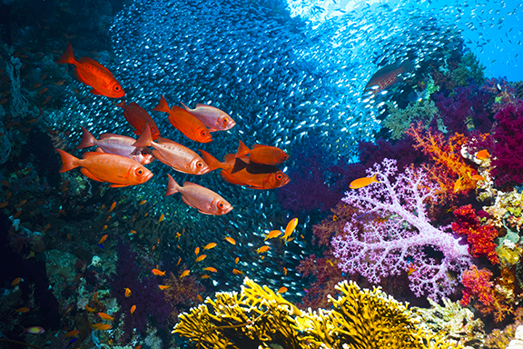

Fig. 1. [This figure caption uses the No Indent style. Label figures with the abbreviation “Fig.” and a figure number.]

[There is a sample Works Cited list that follows. The body content on that page uses the Bibliography style. Note that MLA rules for citations and references are extensive. So it’s a good idea to refer to MLA 7th Edition for further information.] (AuthorSurname Pages)

[To use this template when creating the outline for your paper, tap No Indent in Styles on the Home tab. Then, on the same tab, in the Paragraph group, tap the Multilevel List icon, then tap the MLA Outline style that appears under List Styles. The first six levels of this list style correspond to the outline levels defined in MLA 7th Edition.]

For additional guidance on formatting your research paper, consult MLA 7th Edition as well as your instructor.

Works Cited

AuthorSurname, FirstName. *Title of the Book Being Referenced*. City Name: Name of Publisher, Year. Type of Medium (e.g. Print).

Surname, First, Middle. "Article Title." *Journal Title* (Year): Pages From - To. Print.