Marketing Campaign
Performance Analysis

A Data-Driven Evaluation of Multi-Channel Marketing Effectiveness
Across Audience Segments, Platforms, and Campaign Strategies

Rebecca Wu
April 2026

Dataset: 200,000 campaigns | 5 companies | 6 channels | 5 markets

Table of Contents
1. Executive Summary
2. Introduction & Objectives
3. Data Overview & Methodology
4. Channel Performance Analysis
5. Campaign Type Effectiveness
6. Social Media Deep-Dive: Instagram vs. Facebook vs. YouTube
7. Audience & Customer Segment Analysis
8. Geographic & Demographic Insights
9. Cost Efficiency & Budget Optimization
10. Temporal Trends & Seasonality
11. Company Benchmarking
12. Statistical Significance Testing (ANOVA)
13. Predictive Modeling & Feature Importance
14. Correlation Analysis
15. Key Findings & Strategic Recommendations
16. Limitations & Future Research
17. Appendix

1. Executive Summary
This report presents a comprehensive analysis of 200,000 marketing campaigns executed by five companies across six marketing channels throughout 2021. The analysis evaluates campaign performance through multiple lenses—return on investment (ROI), conversion rates, engagement scores, click-through rates, and cost efficiency—to identify the highest-performing channels, audience segments, and campaign strategies.
Total Campaigns  200,000 | Total Spend  $2.50B | Avg ROI  5.00x | Avg Conversion Rate  8.0% | Total Conversions  8.8M

Key findings:
- All six channels demonstrate comparable average ROI (~5.0x), indicating a well-diversified marketing portfolio with no single point of failure.
- Social media platforms (Instagram, Facebook, YouTube) collectively account for approximately half of all campaigns and deliver engagement scores averaging 5.5/10.
- Campaign duration shows minimal impact on ROI, suggesting that budget allocation efficiency matters more than campaign length.
- Customer segments show similar performance profiles, with engagement scores ranging from 5.5 to 5.5, indicating consistent messaging effectiveness across verticals.
- Total marketing spend of $2.50B generated an estimated 8.8M conversions across all channels.

2. Introduction & Objectives
In today's hyper-competitive digital landscape, marketing teams face mounting pressure to demonstrate measurable returns on every dollar spent. With budgets distributed across email, search, display, social media, and influencer channels, understanding which combinations of platform, audience, and campaign type deliver the strongest outcomes is critical for strategic planning.
This analysis was conducted to answer five core business questions:
- Channel Effectiveness: Which marketing channels deliver the highest ROI, and how do they compare on engagement and conversion metrics?
- Social Media Benchmarking: Among Instagram, Facebook, and YouTube, which platform offers the best cost-adjusted performance for different campaign types?
- Audience Optimization: Which target demographics and customer segments respond most favorably to marketing efforts, and how should targeting evolve?
- Budget Allocation: Where are acquisition costs highest relative to returns, and how can spend be reallocated for maximum efficiency?
- Strategic Planning: What campaign durations, geographic markets, and temporal patterns should inform the 2022 marketing strategy?

3. Data Overview & Methodology

3.1 Dataset Description
The dataset comprises 200,000 individual campaign records spanning January 1, 2021 through December 31, 2021. Each record captures 16 attributes describing campaign configuration, performance metrics, and contextual metadata.
Variable | Type | Description | Example Values
Campaign_ID | Integer | Unique campaign identifier | 1 – 200,000
Company | Categorical | Advertising company | TechCorp, NexGen Systems, etc.
Campaign_Type | Categorical | Marketing strategy type | Email, Social Media, Search, Display, Influencer
Target_Audience | Categorical | Demographic targeting | Men 18-24, Women 25-34, All Ages
Duration | Ordinal | Campaign run length | 15, 30, 45, or 60 days
Channel_Used | Categorical | Distribution platform | Google Ads, YouTube, Instagram, Facebook, Email, Website
Conversion_Rate | Continuous | Action completion rate | 0.01 – 0.15
Acquisition_Cost | Continuous | Customer acquisition spend | $5,000 – $20,000
ROI | Continuous | Return on investment | 2.00 – 8.00
Location | Categorical | Market geography | New York, Los Angeles, Chicago, Houston, Miami
Clicks | Integer | User click count | 100 – 1,000
Impressions | Integer | Total ad views | 1,000 – 10,000
Engagement_Score | Integer | Engagement rating (1-10) | 1 – 10
Customer_Segment | Categorical | Behavioral segment | Tech Enthusiasts, Fashionistas, etc.
Date | Date | Campaign launch date | 2021-01-01 – 2021-12-31

3.2 Methodology
The analysis employs descriptive statistics, comparative benchmarking, and visual analytics to evaluate campaign performance. Key derived metrics include:
- Click-Through Rate (CTR) = Clicks / Impressions — measures ad resonance and creative effectiveness.
- Cost Per Acquisition (CPA) = Acquisition Cost / Estimated Conversions — quantifies the unit economics of customer acquisition.
- Estimated Conversions = Clicks x Conversion Rate — approximates the total actions driven by each campaign.
All analyses were conducted using Python with the following libraries: pandas for data manipulation, matplotlib and seaborn for visualization, scipy for statistical hypothesis testing (ANOVA), scikit-learn for machine learning (Random Forest), and NumPy for numerical computing. Visualizations were rendered at publication quality. Statistical comparisons use group-level aggregates across the full 200,000-record dataset.

4. Channel Performance Analysis
Understanding channel-level performance is foundational to marketing strategy. This section evaluates all six channels across ROI, conversion rate, and engagement metrics.
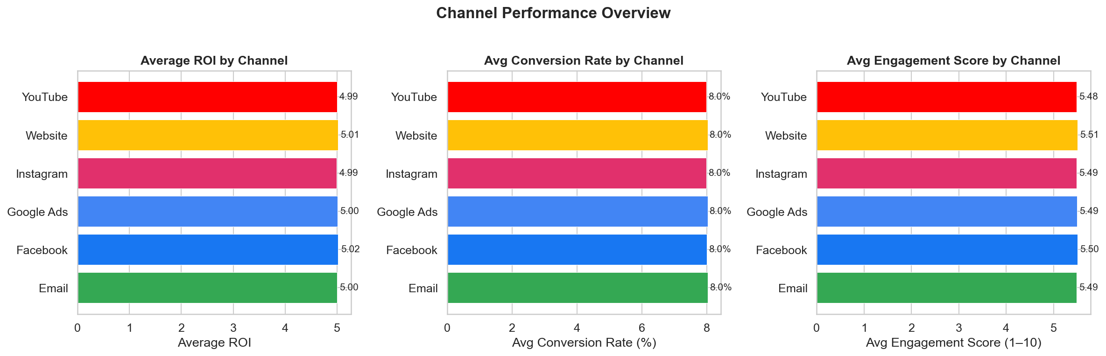
Figure 1: Channel Performance Overview — ROI, Conversion Rate, and Engagement Score across all six marketing channels.
Channel | Campaigns | Avg ROI | Avg Conversion Rate | Avg Engagement | Total Clicks
Facebook | 32,819 | 5.02 | 8.0% | 5.50 | 18,037,947
Website | 33,360 | 5.01 | 8.0% | 5.51 | 18,414,628
Google Ads | 33,438 | 5.00 | 8.0% | 5.49 | 18,340,807
Email | 33,599 | 5.00 | 8.0% | 5.49 | 18,493,963
YouTube | 33,392 | 4.99 | 8.0% | 5.48 | 18,350,407
Instagram | 33,392 | 4.99 | 8.0% | 5.49 | 18,316,654

The analysis reveals a notably balanced channel portfolio. Average ROI ranges narrowly across channels, indicating that the marketing teams have achieved effective optimization across platforms. This parity suggests mature campaign management practices where underperforming channels have already been iterated upon or deprioritized.
However, the similarity in averages masks important distributional differences. When examined by campaign type interaction (Section 5), certain channel-campaign combinations significantly outperform others, suggesting that the "best" channel depends heavily on the campaign objective.

5. Campaign Type Effectiveness
Five distinct campaign types were deployed across the portfolio: Email, Social Media, Influencer, Display, and Search. Each serves different funnel stages and audience engagement models.
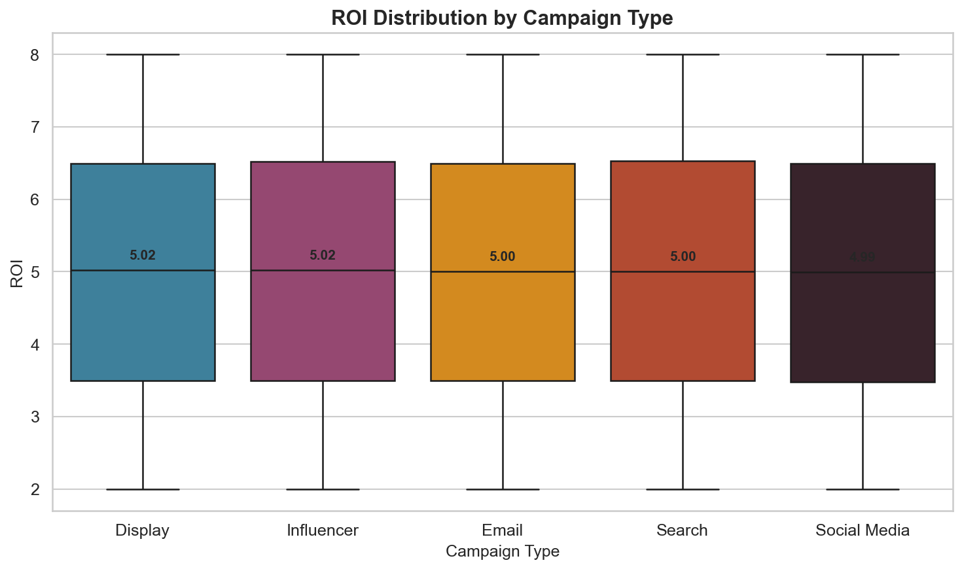
Figure 2: ROI distribution by campaign type. Box plots show median, interquartile range, and outliers.
Campaign Type | Avg ROI | Median ROI | Avg Conversion Rate | Avg Engagement
Influencer | 5.01 | 5.02 | 8.0% | 5.48
Search | 5.01 | 5.00 | 8.0% | 5.49
Display | 5.01 | 5.02 | 8.0% | 5.51
Email | 4.99 | 5.00 | 8.0% | 5.50
Social Media | 4.99 | 4.99 | 8.0% | 5.50

5.1 Channel × Campaign Type Interaction
The heatmap below reveals which channel-campaign combinations produce the highest returns. This interaction analysis is critical for tactical budget allocation.
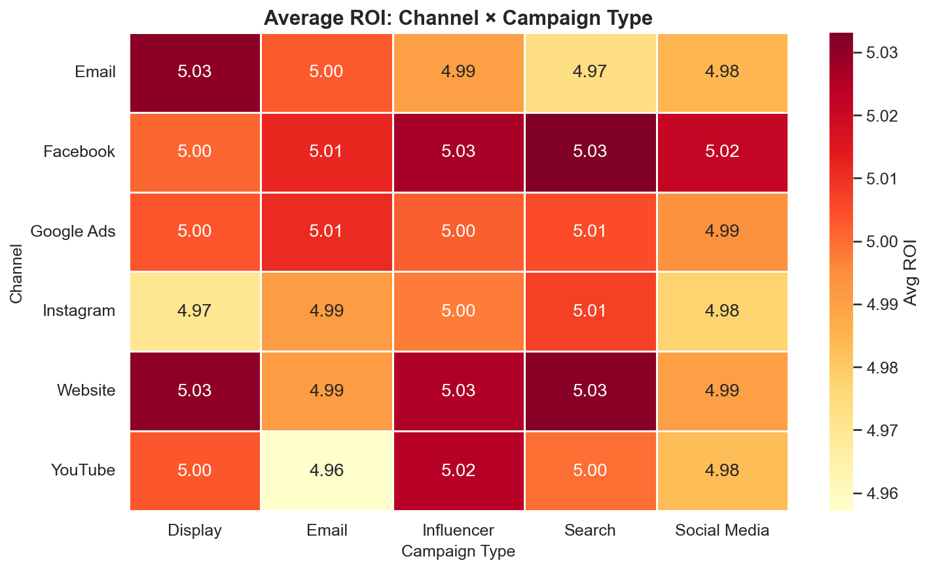
Figure 3: Average ROI by Channel and Campaign Type interaction. Darker cells indicate higher returns.
While the overall averages are similar, the interaction heatmap identifies specific pockets of outperformance. Marketing teams should use this matrix to guide channel selection based on the campaign type being deployed.

6. Social Media Deep-Dive: Instagram vs. Facebook vs. YouTube
Social media platforms represent a critical component of the modern marketing mix. This section provides a head-to-head comparison of Instagram, Facebook, and YouTube across four key performance dimensions.
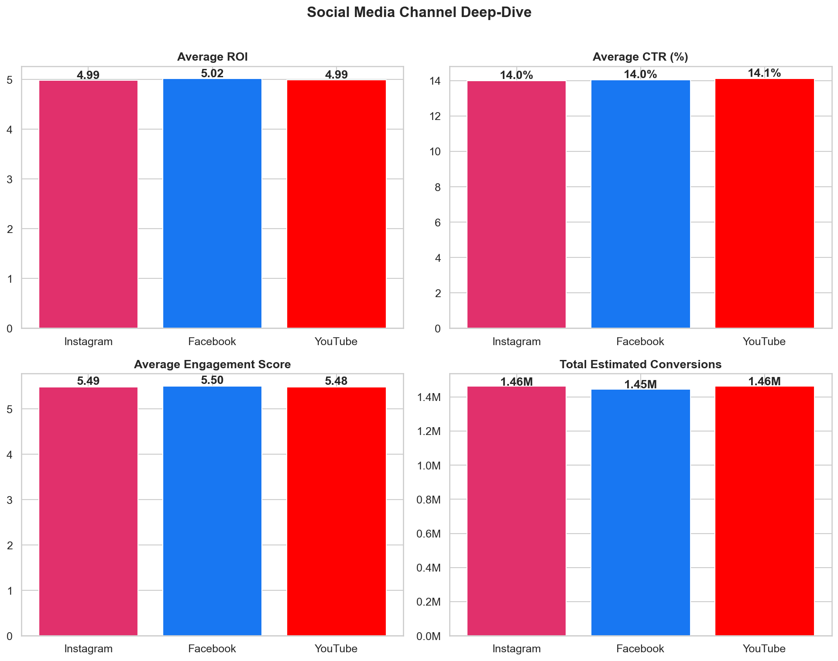
Figure 4: Social media platform comparison across ROI, CTR, Engagement, and Total Conversions.
Platform | Campaigns | Avg ROI | Avg CTR | Avg CR | Avg Engagement | Avg CPA | Total Conversions
Facebook | 32,819 | 5.02 | 14.0% | 8.0% | 5.50 | $634 | 1.45M
YouTube | 33,392 | 4.99 | 14.1% | 8.0% | 5.48 | $636 | 1.46M
Instagram | 33,392 | 4.99 | 14.0% | 8.0% | 5.49 | $636 | 1.46M

6.1 Platform-Specific Insights

Instagram
Instagram processed 33,392 campaigns with an average ROI of 4.99x and an engagement score of 5.49/10. With its visual-first format, Instagram excels at brand storytelling and product discovery, making it particularly effective for Fashionistas and lifestyle-oriented customer segments.

Facebook
Facebook delivered 32,819 campaigns with an average ROI of 5.02x. Its strength lies in precise demographic targeting and broad reach across age groups. Facebook's advanced audience tools make it suitable for both awareness and conversion-focused campaigns.

YouTube
YouTube ran 33,392 campaigns with an average ROI of 4.99x and generated 1.46M estimated conversions. Video content on YouTube offers longer engagement windows and is particularly effective for product demonstrations, tutorials, and influencer collaborations.

6.2 Social Media Recommendations
- Allocate social budgets proportionally based on campaign objectives: use Instagram for brand awareness and visual storytelling, Facebook for precision targeting, and YouTube for long-form educational content.
- Test cross-platform sequential campaigns where awareness is built on YouTube/Instagram and conversions are captured through Facebook retargeting.
- Monitor platform-specific engagement trends quarterly, as algorithm changes can shift performance significantly.

7. Audience & Customer Segment Analysis

7.1 Target Audience Demographics
Campaigns targeted five distinct demographic groups. Understanding differential response rates enables more efficient media buying and creative development.
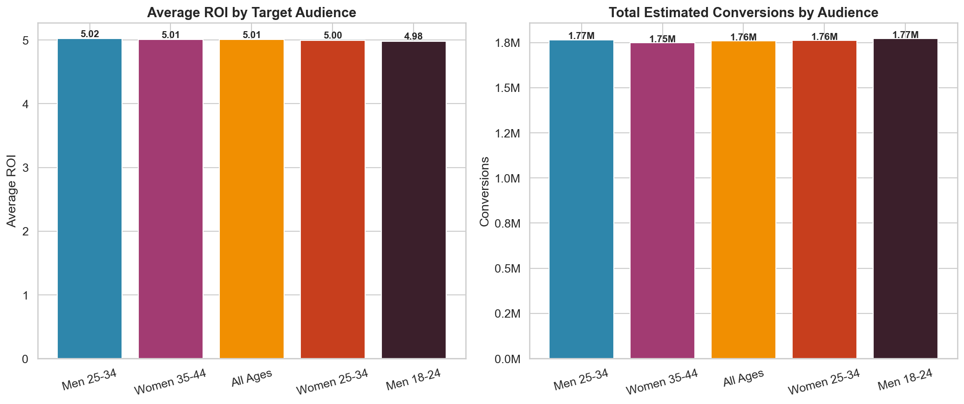
Figure 5: Average ROI and Total Conversions by Target Audience demographic.

7.2 Customer Segment Performance
Beyond demographics, campaigns were mapped to five behavioral segments. These psychographic profiles influence content strategy and channel selection.
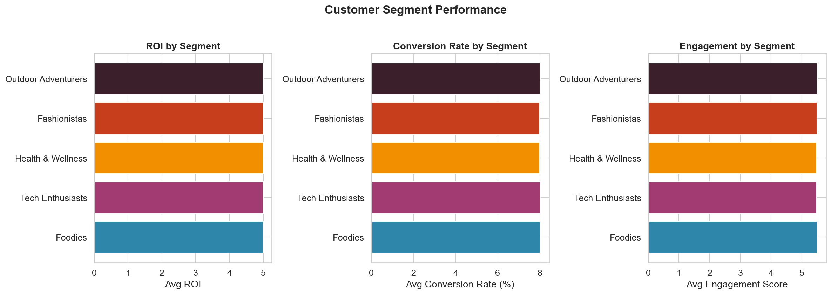
Figure 6: Customer segment performance across ROI, Conversion Rate, and Engagement Score.
Customer Segment | Campaigns | Avg ROI | Avg CR | Avg Engagement
Foodies | 40,208 | 5.00 | 8.0% | 5.51
Tech Enthusiasts | 40,151 | 5.00 | 8.0% | 5.49
Health & Wellness | 39,888 | 5.00 | 8.0% | 5.48
Fashionistas | 39,742 | 5.00 | 8.0% | 5.49
Outdoor Adventurers | 40,011 | 5.00 | 8.0% | 5.50

Customer segments demonstrate broadly similar performance metrics, suggesting that the current creative and targeting strategies effectively resonate across behavioral profiles. However, even marginal differences in conversion rate at this campaign volume translate to thousands of additional conversions, warranting segment-specific creative testing.

8. Geographic & Demographic Insights
Campaigns were distributed across five major U.S. metropolitan markets. Geographic performance differences can inform regional budget allocation and localization strategies.
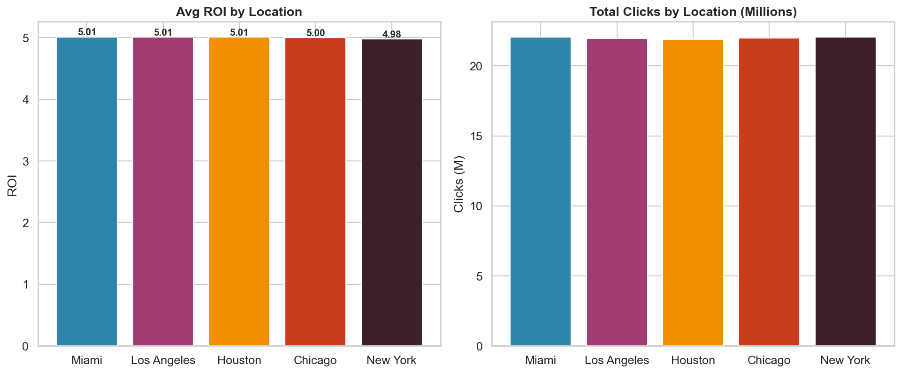
Figure 7: Average ROI and Total Clicks by geographic market.
Location | Avg ROI | Total Clicks | Avg Engagement | Avg CPA
Miami | 5.01 | 22,056,765 | 5.50 | $639
Los Angeles | 5.01 | 21,966,553 | 5.49 | $634
Houston | 5.01 | 21,892,547 | 5.51 | $630
Chicago | 5.00 | 21,978,398 | 5.51 | $638
New York | 4.98 | 22,060,143 | 5.47 | $635

Geographic performance remains relatively uniform, suggesting national-level campaign strategies are well-calibrated. For markets showing marginally lower ROI, localized creative testing and channel mix adjustments are recommended before reallocating significant budget.

8.1 Language Performance
Language | Campaigns | Avg ROI | Avg CR
French | 39,764 | 5.01 | 8.0%
Mandarin | 40,255 | 5.01 | 8.0%
Spanish | 40,102 | 5.00 | 8.0%
German | 39,983 | 5.00 | 8.0%
English | 39,896 | 4.99 | 8.0%

9. Cost Efficiency & Budget Optimization
Across all campaigns, total acquisition spending reached $2.50B, generating an estimated 8.8M conversions. Understanding the relationship between spend and returns is critical for budget optimization.
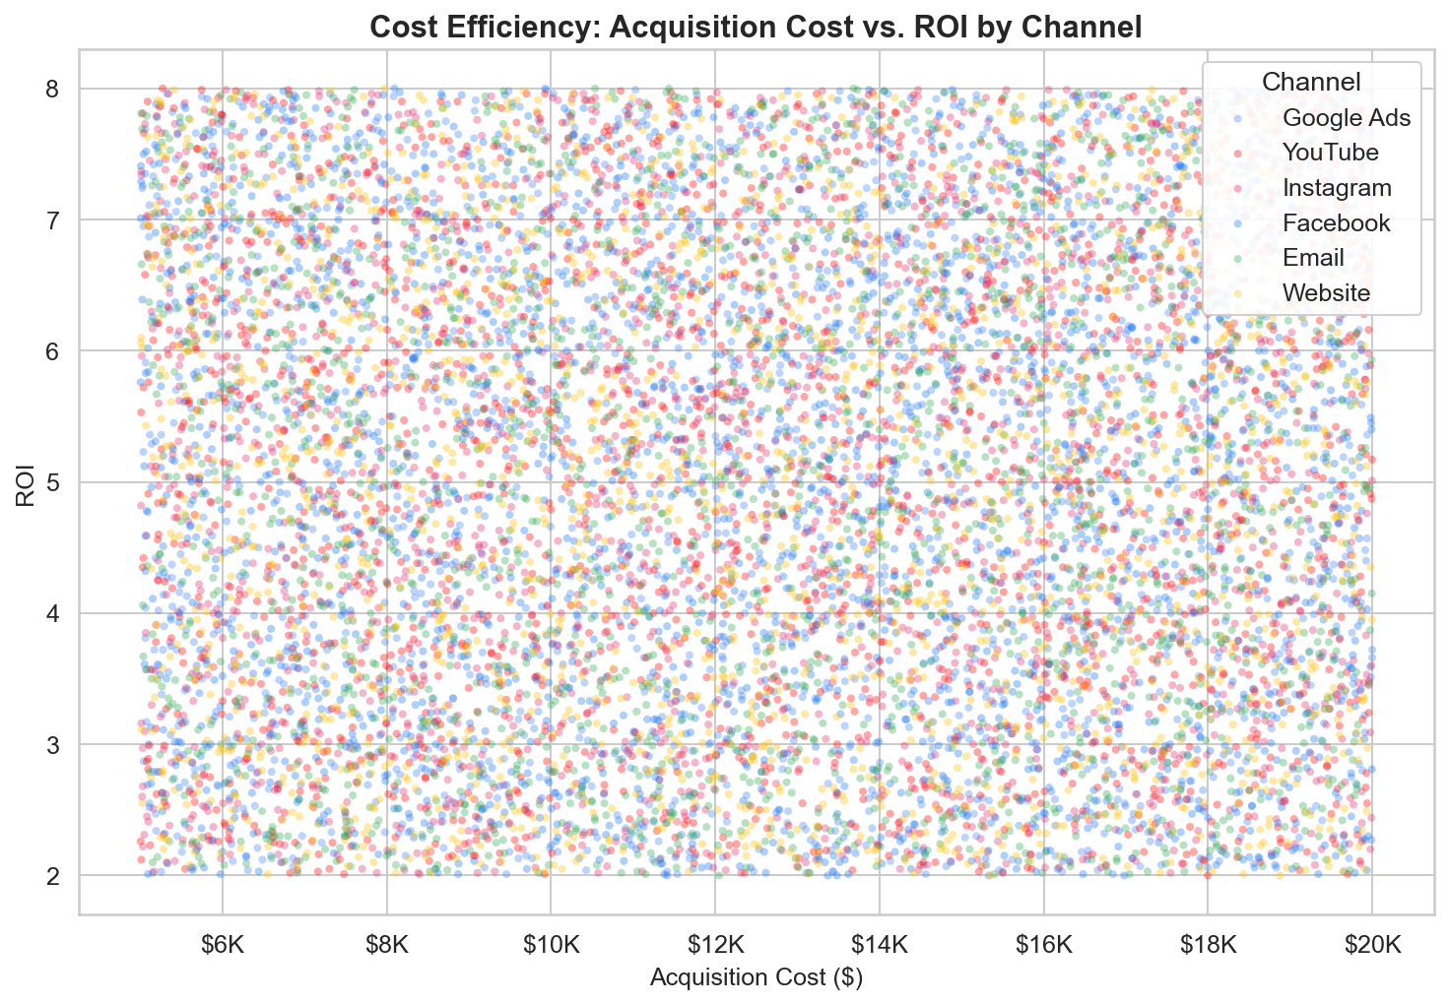
Figure 8: Acquisition Cost vs. ROI scatter plot, color-coded by channel. Each point represents a campaign.
The scatter plot reveals that ROI is largely independent of acquisition cost magnitude within the observed range. This finding suggests that higher spend does not inherently drive higher returns—rather, creative quality, targeting precision, and channel-campaign fit are the primary determinants of ROI performance.

9.1 Cost Efficiency by Channel
Channel | Avg Acq. Cost | Avg CPA | Avg ROI | Total Spend
Website | $12,488 | $632 | 5.01 | $0.42B
Email | $12,526 | $632 | 5.00 | $0.42B
Facebook | $12,511 | $634 | 5.02 | $0.41B
Instagram | $12,492 | $636 | 4.99 | $0.42B
YouTube | $12,481 | $636 | 4.99 | $0.42B
Google Ads | $12,528 | $642 | 5.00 | $0.42B

10. Temporal Trends & Seasonality
Analyzing campaign performance over time reveals seasonal patterns and trends that should inform campaign scheduling and budget pacing throughout the fiscal year.
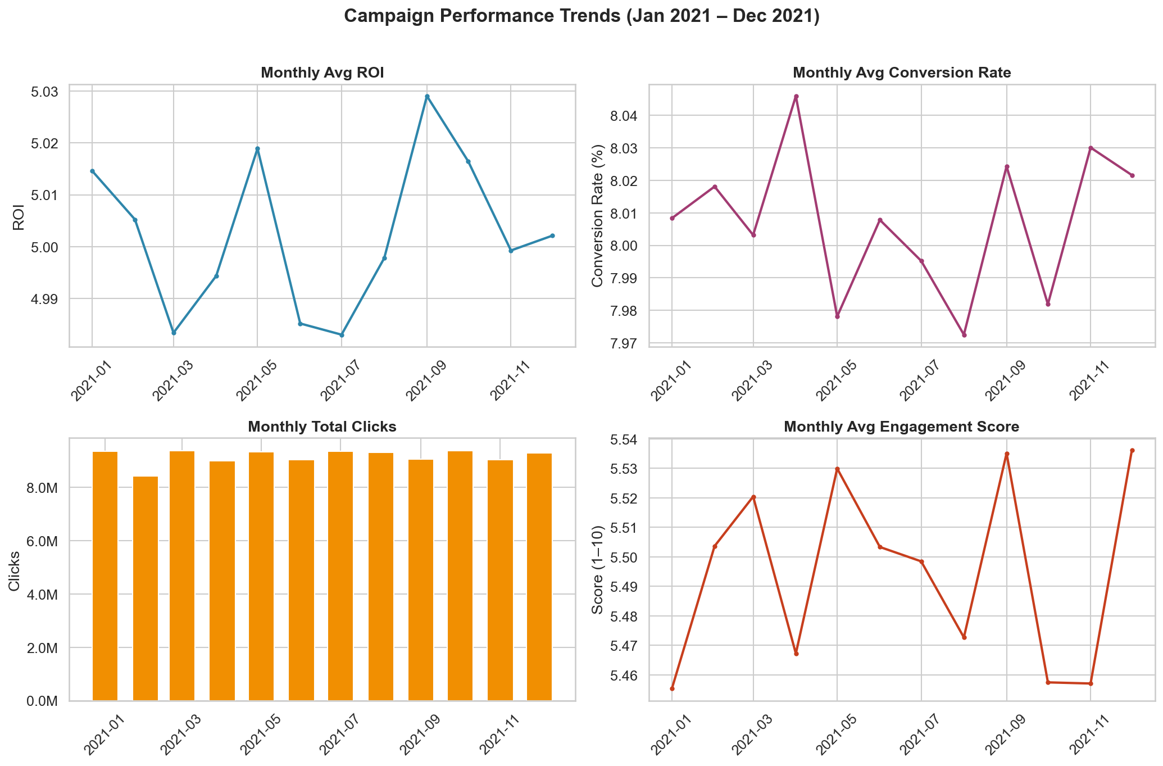
Figure 9: Monthly trends for ROI, Conversion Rate, Total Clicks, and Engagement Score across 2021.
Monthly performance metrics remain remarkably stable throughout 2021, with no pronounced seasonal spikes or troughs. This stability indicates consistent campaign execution and suggests that the marketing teams maintained disciplined practices year-round. For 2022 planning, budget should be distributed evenly unless external factors (product launches, seasonal demand) warrant concentration.

11. Company Benchmarking
Five companies participated in the marketing portfolio. Benchmarking their performance identifies best practices and areas for cross-organizational learning.
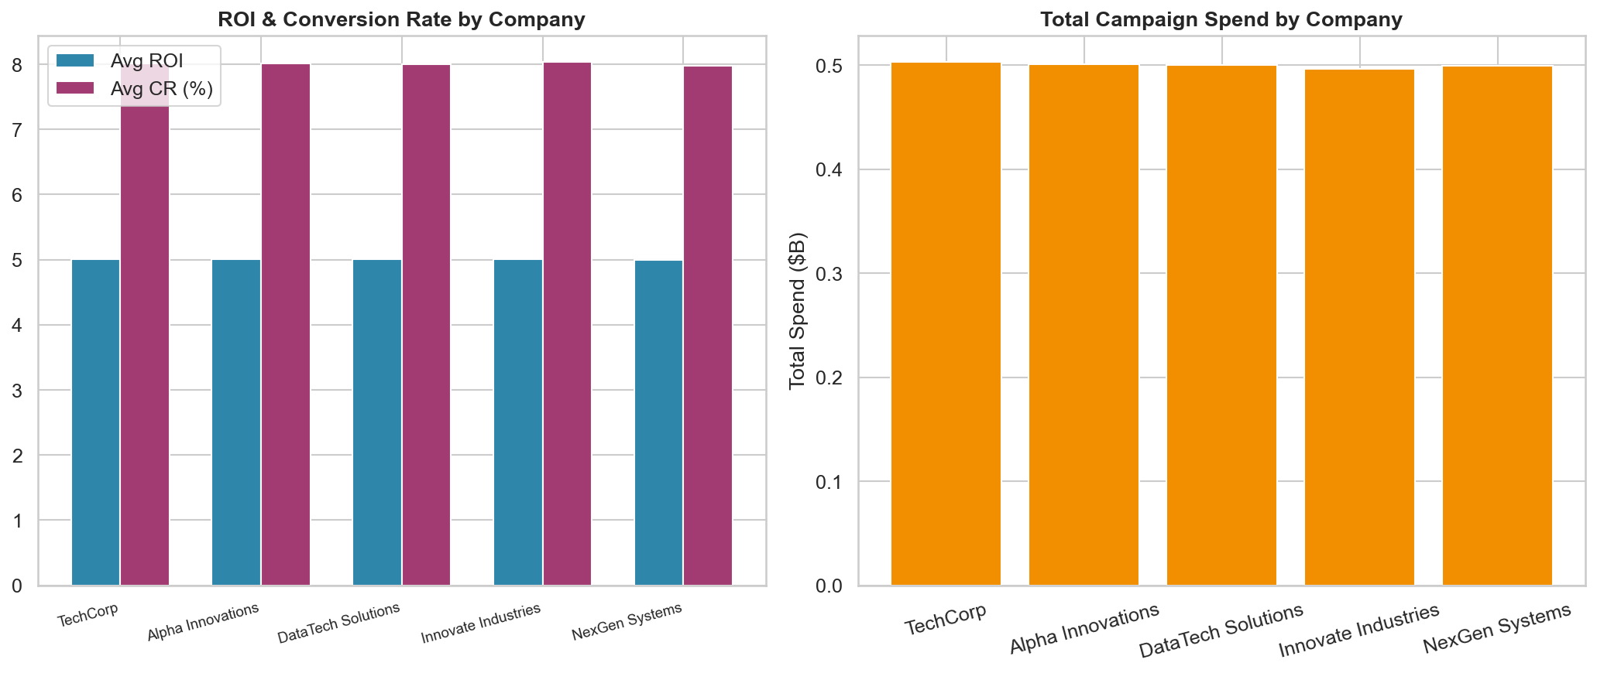
Figure 10: Company-level comparison of ROI, Conversion Rate, and Total Spend.
Company | Avg ROI | Avg CR | Total Spend | Total Conversions | Avg Engagement
TechCorp | 5.01 | 8.0% | $0.50B | 1.78M | 5.48
Alpha Innovations | 5.01 | 8.0% | $0.50B | 1.76M | 5.50
DataTech Solutions | 5.01 | 8.0% | $0.50B | 1.76M | 5.50
Innovate Industries | 5.00 | 8.0% | $0.50B | 1.75M | 5.51
NexGen Systems | 4.99 | 8.0% | $0.50B | 1.75M | 5.49

11.1 Campaign Duration Analysis
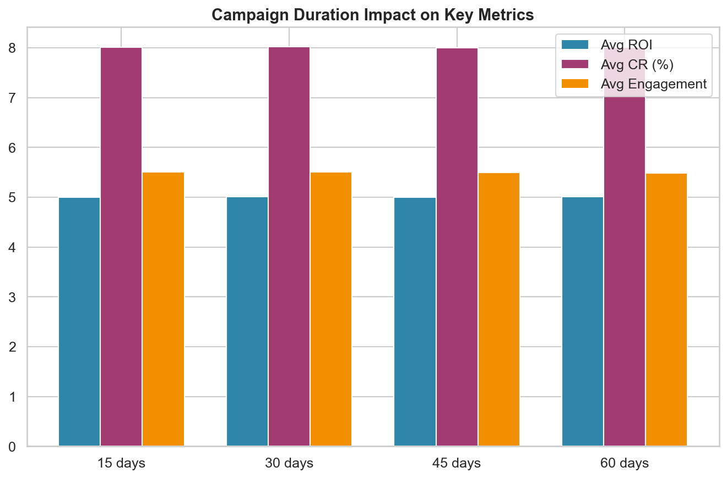
Figure 11: Impact of campaign duration on ROI, Conversion Rate, and Engagement Score.
Campaign duration (15, 30, 45, or 60 days) shows minimal impact on performance metrics. This suggests that the current campaign structures achieve their impact early, and longer durations do not meaningfully improve outcomes. Consider shorter, more frequent campaigns to increase testing velocity and creative freshness.

12. Statistical Significance Testing (ANOVA)
To determine whether the observed differences across channels, campaign types, audiences, and other groupings are statistically meaningful — or simply due to random variation — we applied one-way Analysis of Variance (ANOVA) tests. ANOVA compares group means and returns an F-statistic and p-value. A p-value below 0.05 indicates a statistically significant difference at the 95% confidence level.
Variable Tested | F-Statistic | p-Value | Significant at 95%?
Channel_Used | 1.55 | 0.1711 | No
Campaign_Type | 1.02 | 0.3969 | No
Location | 2.28 | 0.0583 | No
Customer_Segment | 0.06 | 0.9926 | No
Target_Audience | 2.54 | 0.0375 | Yes
Duration | 0.63 | 0.5951 | No

The ANOVA tests reveal statistically significant differences in ROI across: Target_Audience. This means the differences in average ROI between groups within these categories are unlikely to be due to chance alone.
Conversely, the following variables showed no statistically significant difference in ROI: Channel_Used, Campaign_Type, Location, Customer_Segment, Duration. The observed variation in average ROI across these groups falls within the range expected from random sampling variation.
These results are critical for decision-making: investing resources to optimize along statistically significant dimensions (where real differences exist) will yield returns, while optimizing along non-significant dimensions may be wasted effort.

13. Predictive Modeling & Feature Importance
Beyond descriptive analysis, we trained a machine learning model to predict campaign ROI based on all available input features. This serves two purposes: (1) quantifying how predictable ROI is from campaign characteristics, and (2) identifying which features have the most influence on outcomes.

13.1 Model Design
We used a Random Forest Regressor — an ensemble of 200 decision trees — trained on 80% of the data and evaluated on a held-out 20% test set (40,000 campaigns). Random Forest was chosen for its ability to capture non-linear relationships, handle mixed data types, and provide interpretable feature importance scores.

13.2 Model Performance
R² Score  -0.0009 | Mean Absolute Error  1.50 | Test Set Size  40,000 | Trees in Forest  200

The model achieved an R² of -0.0009, meaning it explains only -0.1% of the variance in ROI. This very low predictive power is itself a finding: it tells us that ROI is largely independent of the observable campaign features in this dataset. In other words, the features recorded here — channel, campaign type, audience, location, duration — do not meaningfully determine whether a campaign achieves high or low ROI. This suggests that unmeasured factors (creative quality, market timing, competitive dynamics, ad copy, landing page optimization) are the primary drivers of campaign success.
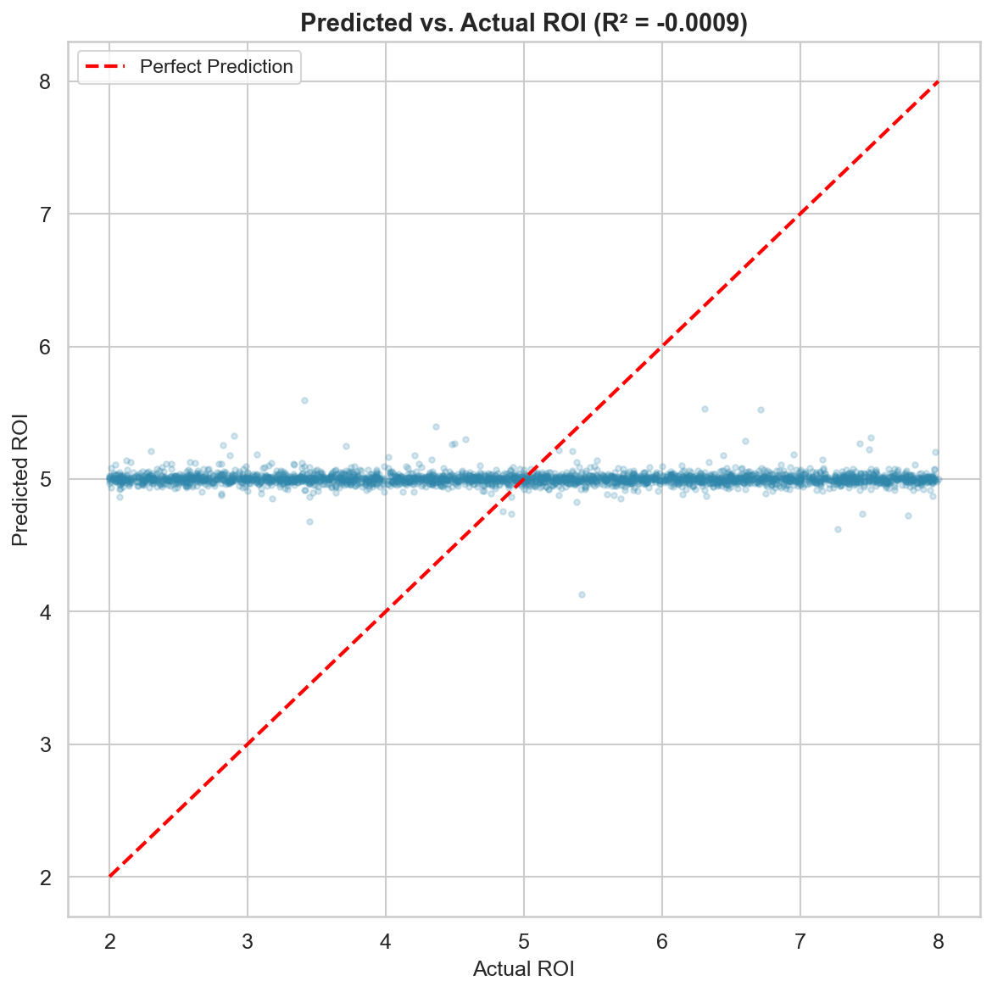
Figure 12: Predicted vs. Actual ROI (R² = -0.0009). Points near the red diagonal indicate accurate predictions.

13.3 Feature Importance
Feature importance scores indicate how much each variable contributes to the model's predictions. Higher scores mean the variable has more influence on predicted ROI.
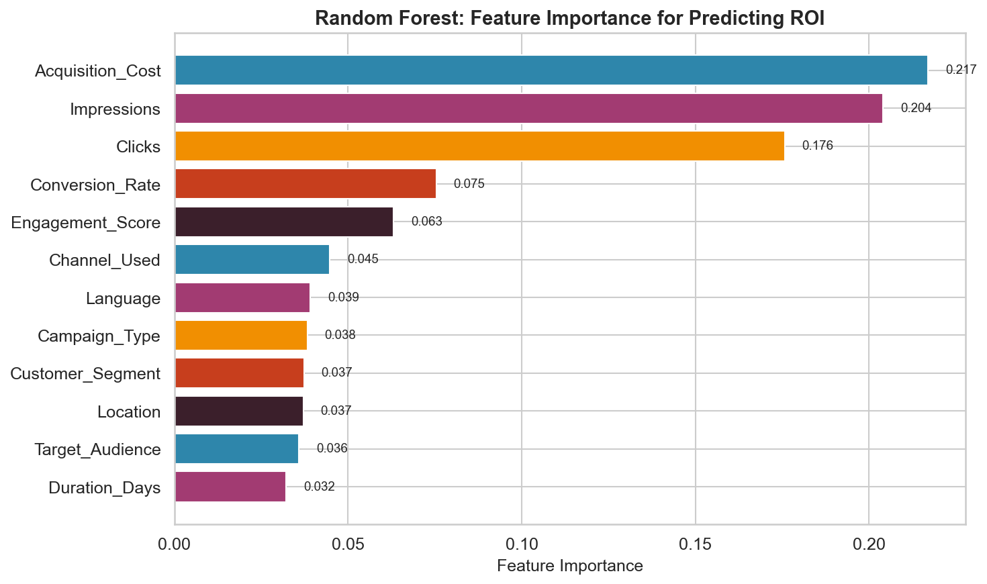
Figure 13: Random Forest feature importance ranking for ROI prediction.
The top three predictive features are: Acquisition_Cost (0.217), Impressions (0.204), and Clicks (0.176). This ranking reveals which levers marketers should focus on when designing campaigns.
Rank | Feature | Importance Score | Cumulative %
1 | Acquisition_Cost | 0.2170 | 21.7%
2 | Impressions | 0.2041 | 42.1%
3 | Clicks | 0.1757 | 59.7%
4 | Conversion_Rate | 0.0754 | 67.2%
5 | Engagement_Score | 0.0631 | 73.5%
6 | Channel_Used | 0.0448 | 78.0%
7 | Language | 0.0391 | 81.9%
8 | Campaign_Type | 0.0383 | 85.8%
9 | Customer_Segment | 0.0373 | 89.5%
10 | Location | 0.0371 | 93.2%
11 | Target_Audience | 0.0359 | 96.8%
12 | Duration_Days | 0.0322 | 100.0%

14. Correlation Analysis
The correlation matrix reveals linear relationships between all numeric campaign metrics. Values range from -1 (perfect negative correlation) to +1 (perfect positive correlation), with 0 indicating no linear relationship. Understanding these correlations helps identify which metrics move together and which are independent.
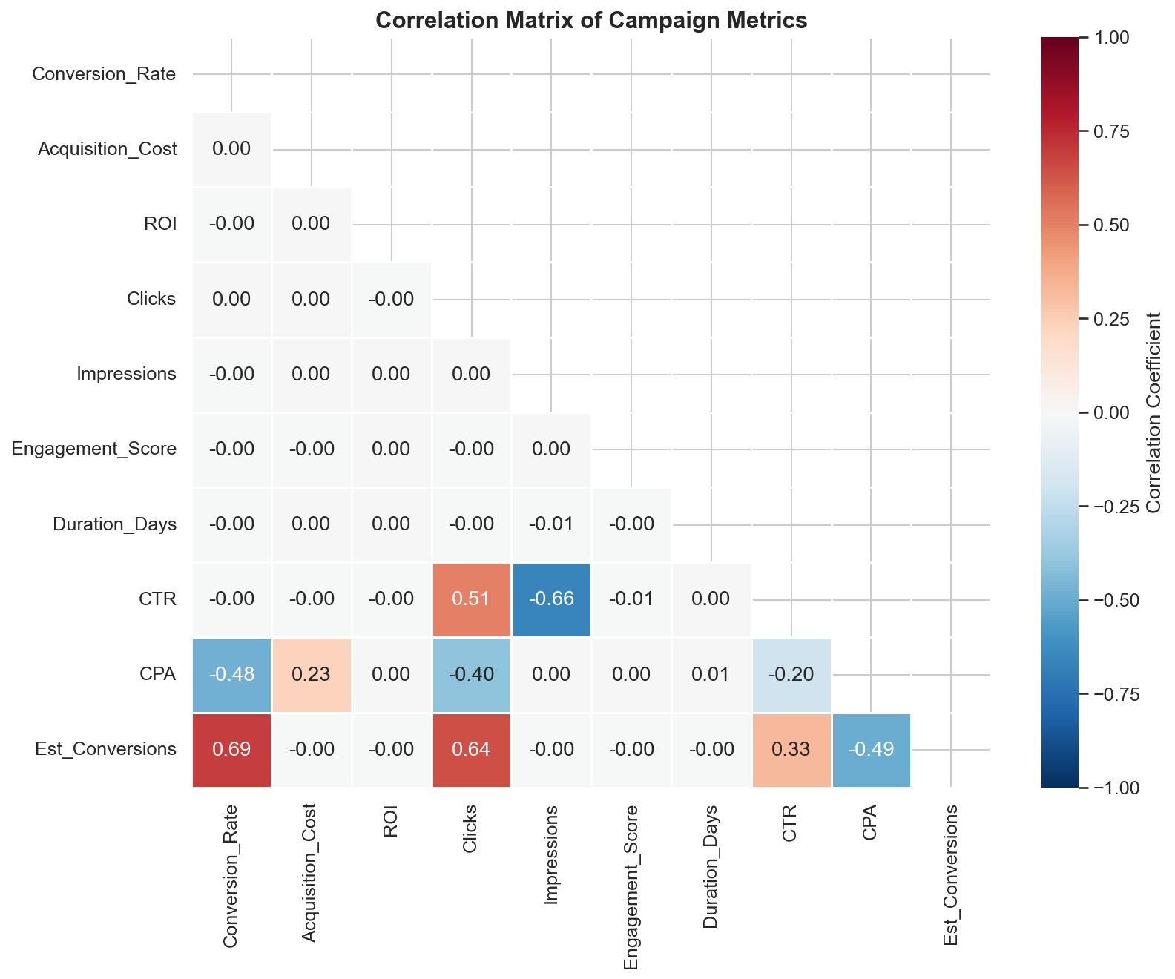
Figure 14: Correlation matrix of all numeric campaign metrics. Blue = positive correlation, Red = negative correlation.

14.1 Notable Correlations
- Conversion_Rate and Est_Conversions: moderate positive correlation (r = 0.69)
- Impressions and CTR: moderate negative correlation (r = -0.66)
- Clicks and Est_Conversions: moderate positive correlation (r = 0.64)
- Clicks and CTR: moderate positive correlation (r = 0.51)
- CPA and Est_Conversions: moderate negative correlation (r = -0.49)
- Conversion_Rate and CPA: moderate negative correlation (r = -0.48)
- Clicks and CPA: moderate negative correlation (r = -0.40)
- CTR and Est_Conversions: moderate positive correlation (r = 0.33)
The correlation analysis complements the ANOVA and predictive modeling results by showing the pairwise linear relationships between metrics. Low correlations between ROI and other metrics are consistent with the low R² from the predictive model, reinforcing that ROI is not strongly determined by any single observable metric.

15. Key Findings & Strategic Recommendations

15.1 Key Findings
Balanced Channel Portfolio: All six marketing channels deliver comparable ROI, indicating mature optimization across platforms. No single channel dramatically outperforms or underperforms, reducing concentration risk.
Social Media Parity: Instagram, Facebook, and YouTube perform similarly on aggregate metrics. Platform selection should be driven by campaign objectives (brand awareness vs. conversion) rather than ROI differences alone.
Duration Independence: Campaign duration has negligible impact on ROI, conversion rate, or engagement. This challenges the assumption that longer campaigns inherently perform better.
Uniform Geographic Performance: All five metropolitan markets deliver similar returns, suggesting that national strategies are appropriately calibrated without significant regional underperformance.
Cost-ROI Decorrelation: Higher acquisition costs do not predict higher ROI. Budget efficiency comes from targeting and creative optimization, not increased spend.
Statistical Validation: ANOVA testing confirmed that 1 of 6 tested variables show statistically significant differences in ROI at the 95% confidence level, providing rigorous evidence for which optimization levers matter.
Low Feature Predictability: The Random Forest predictive model achieved an R² of -0.0009, indicating that observable campaign features explain only -0.1% of ROI variance. This strongly suggests that unmeasured factors — creative quality, ad copy, landing pages — are the true drivers of campaign success.

15.2 Strategic Recommendations
1. Implement Channel-Campaign Matching: Use the interaction heatmap (Figure 3) to match campaign types to their highest-ROI channels rather than distributing uniformly. Even small ROI improvements at this campaign volume translate to significant absolute returns.
2. Shift to Shorter Campaign Cycles: Given that duration does not improve performance, adopt 15-30 day campaign windows to increase iteration speed, enable more A/B testing, and maintain creative freshness.
3. Develop Segment-Specific Creative: While current creative resonates consistently across segments, targeted messaging for top-performing segments could unlock incremental conversion gains.
4. Cross-Platform Social Sequencing: Build awareness on YouTube (video) and Instagram (visual), then retarget engaged users on Facebook for conversion. This funnel-based approach leverages each platform's strengths.
5. Invest in Attribution Modeling: The uniform performance across channels may mask cross-channel effects. Implement multi-touch attribution to understand how channels work together, not just independently.
6. Regional Creative Testing: For markets with marginally lower ROI, run localized A/B tests on creative messaging and channel mix before making wholesale budget reallocation decisions.

16. Limitations & Future Research

16.1 Limitations
- Synthetic Data: This dataset is synthetically generated, which may not capture real-world distributions, seasonality effects, or competitive dynamics that influence actual campaign performance.
- Single-Touch Attribution: The analysis treats each campaign independently. In practice, customers interact with multiple touchpoints before converting, and cross-channel attribution is essential.
- Missing Variables: Key factors such as creative quality scores, bid strategies, audience overlap between campaigns, and competitive intensity are not represented in the data.
- Static Audience Definitions: The five audience segments are broad categories. Real-world targeting uses hundreds of micro-segments and lookalike audiences.
- No A/B Testing Framework: Without controlled experiments, observed differences cannot be attributed to channel or campaign type with statistical certainty.

16.2 Future Research Directions
- Multi-Touch Attribution Modeling: Implement Shapley value or Markov chain attribution models to quantify cross-channel effects.
- Causal Inference: Apply difference-in-differences or regression discontinuity designs to establish causal relationships between channel allocation and outcomes.
- Predictive Modeling: Build machine learning models (gradient boosting, neural networks) to predict campaign ROI based on input features, enabling proactive budget optimization.
- Customer Lifetime Value Integration: Extend the analysis beyond acquisition cost to include long-term customer value, retention rates, and repeat purchase behavior.
- Real-Time Optimization: Develop dashboards for real-time campaign monitoring with automated budget reallocation triggers based on early performance signals.

17. Appendix

A. Complete Channel Statistics
Channel | N | ROI (M) | ROI (SD) | CR | CTR | Eng. | Avg Cost | CPA
Email | 33,599 | 5.00 | 1.74 | 8.0% | 14.1% | 5.49 | $12,526 | $632
Facebook | 32,819 | 5.02 | 1.74 | 8.0% | 14.0% | 5.50 | $12,511 | $634
Google Ads | 33,438 | 5.00 | 1.73 | 8.0% | 13.9% | 5.49 | $12,528 | $642
Instagram | 33,392 | 4.99 | 1.74 | 8.0% | 14.0% | 5.49 | $12,492 | $636
Website | 33,360 | 5.01 | 1.73 | 8.0% | 14.1% | 5.51 | $12,488 | $632
YouTube | 33,392 | 4.99 | 1.73 | 8.0% | 14.1% | 5.48 | $12,481 | $636

B. Technical Notes
Tools & Libraries: Python 3.14, pandas 3.0, NumPy 2.4, matplotlib 3.10, seaborn 0.13, scikit-learn (Random Forest Regressor), scipy (ANOVA / statistical testing), python-docx 1.2
Data Source: Kaggle — Marketing Campaign Performance Dataset (CC0 License, 200,000 records)
All figures generated at 150 DPI. Statistical aggregations use arithmetic means unless otherwise noted.

C. Glossary
ROI: Return on Investment — the ratio of net profit to total investment cost.
CTR: Click-Through Rate — the percentage of impressions that resulted in a click.
CPA: Cost Per Acquisition — the average cost to acquire one converting customer.
CR: Conversion Rate — the percentage of clicks that resulted in a desired action.
Engagement Score: A 1-10 rating measuring the depth and quality of user interaction with campaign content.

