Dino Gironi  
E-mail: 16girodi@wbhs.co.za Tel: 082 266 5811

I have always had a deeply inset interest in technology of all forms, and have often looked at machines, whether mechanical or solid-state, and found myself fascinated with learning more about their functionality.

It is for this reason that 4 years ago, I decided to dedicate as much of my free time as possible to researching and studying the practical and theoretical nature of such systems. It so happened that I found Computer Science, in all layers of its composition, to be particularly engaging.

I have since found myself studying and experimenting with everything from Cybersecurity, to Computer Graphics, to Artificial Intelligence; although have most often stuck to the higher layers of the OSI Model, as the technologies herein more easily integrate with my work at school.

Projects:

**Virtual Reality Sci-Fi Game**:

One of my current VR projects, which I am developing as a matric Visual Arts final, is a VR game with *Job Simulator* style gameplay, in which the player is hired as a teacher in a cartoon-like futuristic world. The player must defend against robotic student-enemies by making use of the futuristic objects at their disposal at the teacher’s desk.

I am developing this project in Unity, making use of the Oculus SDK to link the project to the Oculus Quest. I have modelled and textured all objects and assets used in the game, as well as manually added animations for specific items. All object behaviour is either based off of scripts that I have written myself, or are derived from the Virtual Reality Toolkit [www.vrtk.io] object interaction namespaces.

I also plan to develop a separate VR application that will use the positional tracking features of the Oculus Quest, as well as utilize some Inverse Kinematics, to record motion tracking for the in-game animations.

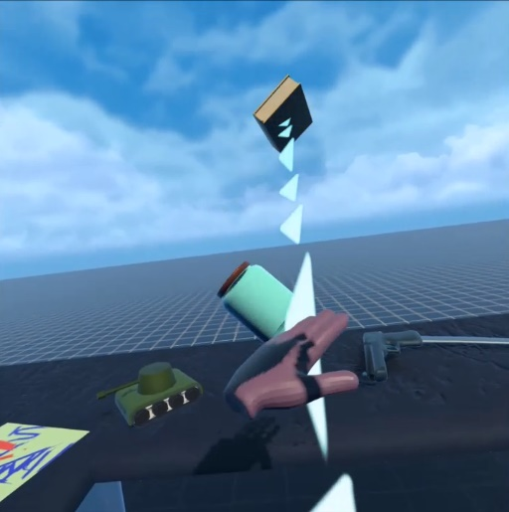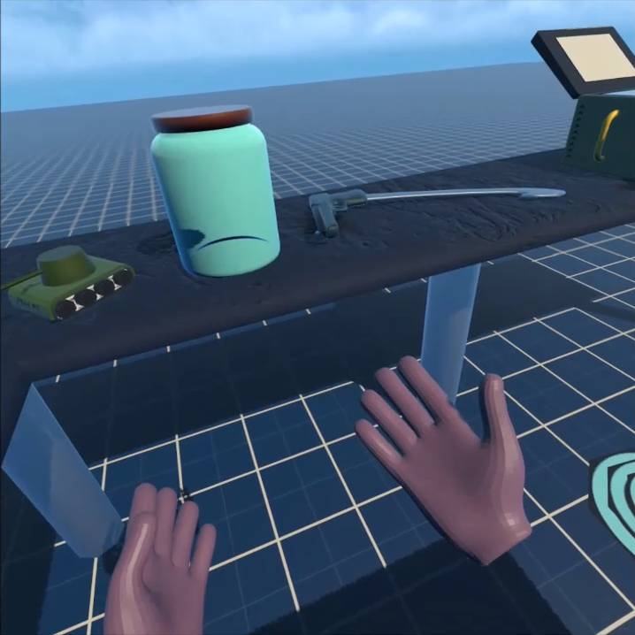

**Processing 3**:

Processing [processing.org] is a high-level Java-based programming environment designed for both 2D and 3D graphical application development. Since discovering Processing, I have used it extensively for dozens of small projects, including prototyping ideas for potential applications, tackling mathematical problems and coding challenges, or just to be creative.

Some of these projects include:



A **Perlin-noise-based lightning-texture generator**, with customizable parameters and effects, which outputs both an Emission map and an Albedo map, for use in video games.

 

My own **curve-plotting algorithm**, created to replace a Bezier algorithm I had been using, which had been too processing-intensive for my intended application.

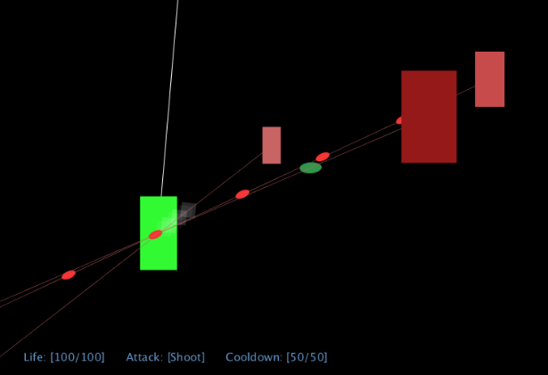

A simple **top-down shooter prototype** with its own 2D Physics and Collision system for Axis-Aligned Bounding Boxes and projectiles.

Find below a list of programming language which I have used on a variety of other independent, as well as interlinked projects.

Programming Languages:

**C#**:  
Unity  
.NET Framework

**Java**:  
Processing 3 [processing.org]  
Android Studio

**Python**:  
TensorFlow  
Blender’s Open Shading Language

**SQL**:  
Particularly with MySQL and Microsoft Access

**Delphi**:  
RAD Studio and Turbo Delphi Lite  
This is the programming language offered in the IT curriculum at my school.

**Terminal**:  
Bash and Command Prompt

**JavaScript**:  
P5 [p5.org]  
Node.js

**Web Languages (HTML, CSS, PHP)**:  
Basic web application development  
WordPress

**C++**:  
Unreal Engine  
OpenFrameworks

**C**:  
Vanilla C with GCC in Linux terminal

Other Interests:

- Ethical Hacking and Penetration Testing  
- Illustration and Graphic Design  
- 3D Modelling  
- Cryptography  
- Quantum Mechanics and Quantum Computing  
- Electronics and Circuitry   
- Computer Hardware and Physical Architecture