Web Applications | Semester II 2026
Workshop 1: Website (only HTML) | William Garzon
 | Prof. Francisco Hidrobo

Report
A website of six interconnected pages built with HTML5 only, served locally by Apache through a virtual host that answers to workshop1.webapp.
Objective
Create a website consisting of at least four interconnected pages, using only HTML5. The site delivered has six pages. No CSS and no JavaScript were used, as the assignment requires: presentation is left for a later stage of the course, so every page is judged on its markup alone.
Because there is no styling to lean on, the work went into structure — semantic elements, a correct heading hierarchy, real table geometry, and form controls that are properly labelled.
Structure
Actividad01_Workshop/
+-- index.html Home page (Activity 1)
+-- README.md Report
+-- assets/ Images
| +-- perfil.jpg
| +-- university.png
| +-- ripconciv-*.png Ripconciv project screenshots
| +-- centinela-*.jpeg Centinela project screenshots
| +-- map/ Campus photographs and official map
+-- pages/
+-- courses.html (Activity 2)
+-- schedule.html (Activity 3)
+-- contact.html (Activity 4)
+-- activities.html (Activity 5)
+-- map.html (Activity 5)

Prerequisites
Step | How it was done
hosts file | Added 127.0.0.1 workshop1.webapp to C:\Windows\System32\drivers\etc\hosts
Resolution test | ping workshop1.webapp answers from 127.0.0.1
Web server | XAMPP (Apache) installed at C:\xampp
Virtual server | Declared in httpd-vhosts.conf, with the full path to the site as its DocumentRoot

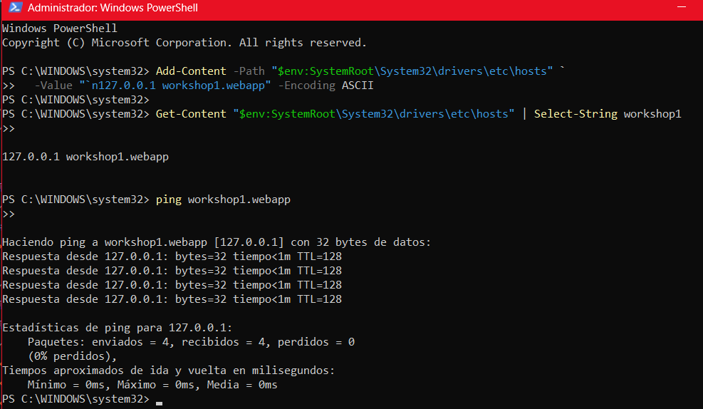
Figure 1. The hosts entry added and verified, and ping workshop1.webapp answering from 127.0.0.1 with 4 packets sent, 4 received, 0% loss.
Virtual host configuration
<VirtualHost *:80>
ServerName workshop1.webapp
DocumentRoot "C:/.../Actividad01_Workshop"
DirectoryIndex index.html

<Directory "C:/.../Actividad01_Workshop">
Options Indexes FollowSymLinks
AllowOverride All
Require all granted
</Directory>
</VirtualHost>

Why a second virtual host. One for localhost was declared before this one. In Apache, as soon as any <VirtualHost> is defined the global DocumentRoot stops applying — without that first block, http://localhost would silently stop working.
httpd.exe -t returns Syntax OK, and every page and asset answers 200 OK.
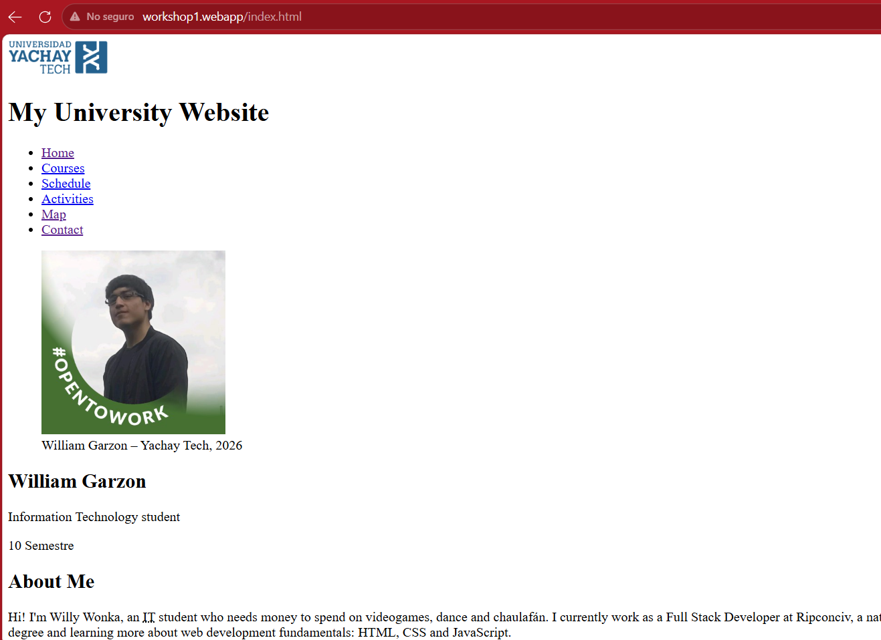
Figure 2. The home page served from the virtual host at workshop1.webapp/index.html. The page renders unstyled, which is the expected result for an HTML-only submission.
Activities completed
Activity 1. Home page index.html
Uses <!DOCTYPE html>, <html>, <head>, <title> and <body>, and inside the body all six required semantic elements: header, nav, main, section, article and footer.
It carries the author's name, degree program, semester, a personal description, a profile photograph wrapped in <figure> with <figcaption>, and a list of academic interests. Two <article> elements present personal software projects with their screenshots.
Activity 2. Courses pages/courses.html
The three courses of the current term, each with its official code, instructor, syllabus topics and three topics the student expects to learn.
Code | Course | Instructor
CA57 | Programación Web | Francisco Javier Hidrobo Torres
CA56-TA24 | Procesos Estocásticos | Diego Hernán Peluffo Ordoñez
TM11 | Física II | Rosa Estefanía Almache Hernández / Julio César Chacón Torres

Uses headings h1–h3, paragraphs, unordered lists for the syllabus topics, ordered lists for the expected topics, and three external links.
Activity 3. Schedule pages/schedule.html
Two tables. The first is the weekly timetable from 07:00 to 18:59, where each class spans its real duration with rowspan and the header groups the five weekdays with colspan. The second lists every session with its day, time, building, room and instructor.
Both use <caption>, <thead>, <tbody> and the deprecated border attribute, which the assignment explicitly allows so the grid stays visible without CSS.
Activity 4. Form pages/contact.html
A student contact form addressed to the university. It has no backend: nothing is submitted when the button is pressed.
It carries every required field — full name, email address, date of birth, degree program, semester, reason for contact, message, acceptance checkbox and submit button — plus national ID, student ID, attachment and urgency.
- Ten input types: text, email, date, tel, number, radio, checkbox, file, submit, reset
- Two <select> elements and one <textarea>
- Five <fieldset> groups, each with its <legend>
- Every <label> bound to its control through for
Activity 5. Additional pages activities.html · map.html
Activities covers student clubs, sport and recreation, and food on campus, organised into categories with <section> and <article>.
Map covers the campus: the official campus map, the academic buildings with the rooms used for each class, heritage buildings and student housing — nine images, each in a <figure> with its <figcaption>.
Both include links that open in a new tab with target="_blank" rel="noopener", and both were added to the navigation menu of every page on the site.
Navigation
Every page carries the same <nav> with six entries:
Home | Courses | Schedule | Activities | Map | Contact

Relative paths differ by level: index.html points into pages/, while pages inside pages/ point back to ../index.html and reach their siblings directly. Getting this wrong is the most common way a multi-page site of this kind breaks.
Verification
Every claim above was checked mechanically rather than by eye. The results below are the output of those checks.
Check | Result
Tag balance | No unbalanced tags
Internal links | 0 broken
Image references | 22 img elements, all resolve
Table geometry | Both tables consistent at 6 columns per row
label / for bindings | 0 orphan labels
HTTP response | 200 OK on every page and asset

On table geometry. This was verified with a script that simulates the browser's rendering, counting colspan and rowspan row by row. A wrong rowspan produces a misaligned table that is easy to miss when reading the markup, and easy to miss again when the table has no CSS to make the misalignment obvious.
Notes on the material used
- Campus photographs and the official campus map are material published by Yachay Tech University, reproduced here for an academic assignment.
- Screenshots of the Ripconciv and Centinela projects correspond to software developed by the author.

