Web Applications | Semester II 2026
Workshop 2: Website (HTML + CSS) | William Garzon
 | Prof. Francisco Hidrobo

Report
The same six-page site of Workshop 1, now with a stylesheet. The markup barely changed; what changed is that presentation moved out of the document and into css/style.css.
Why the change
Workshop 1 required HTML only. That constraint was not an arbitrary restriction: it forced every decision to be about meaning rather than appearance. A table had to be a table because the data was tabular, not because it lined things up on screen.
Workshop 2 adds CSS, and the point of doing it in this order is that the separation becomes visible. The HTML written for Workshop 1 was almost entirely reusable: the stylesheet attaches to the structure that was already there. Only two structural edits were needed in the whole site.
The HTML-only state is preserved. The commit that closed Workshop 1 is tagged workshop-1 in the repository, so that submission can still be read exactly as it was delivered, without the stylesheet.
What was done
The stylesheet css/style.css
A single stylesheet, roughly 500 lines, organised in sections: reset, typography, design tokens, dark theme, base elements, the welcome screens, header and navigation, content layout, lists, figures, project cards, tables, form, footer, responsive rules and reduced motion.
- Design tokens as custom properties. Every colour, measure and duration is declared once in :root and referenced by name. Changing the accent means editing one line.
- Institutional red #a4161a as the only accent, taken from the school's colour.
- Self-hosted typeface. Manrope ships with the project instead of being pulled from a CDN, so the site renders identically without an internet connection.
- Dark theme in pure CSS. A @media (prefers-color-scheme: dark) block redefines only the tokens; not a single component rule is duplicated.
Visual direction
The aesthetic is an old terminal, applied only to the accents. Headings, navigation, buttons, labels and captions use a monospaced face, square markers and hard edges with solid offset shadows. Running text stays in Manrope, because the Courses and Map pages carry long paragraphs and monospaced type is tiring at that length.
Section headings are prefixed with a “>” generated in CSS, not written in the HTML: decoration does not pollute the markup.
The welcome sequence
On arrival the visitor meets a single large PRINT button. Pressing it shows the greeting, which types itself out character by character, and after a few seconds the screen fades on its own and leaves the site at its home section.
This runs without a single line of JavaScript. The button is an anchor pointing to #hello; the greeting screen is hidden by default and revealed by the :target pseudo-class, which is the one CSS selector that reacts to a click. The typing effect animates the element's width in discrete steps(), one per character, which only works in a monospaced face because the ch unit assumes every character is the same width. The screen then removes itself with an animation that ends in visibility: hidden.
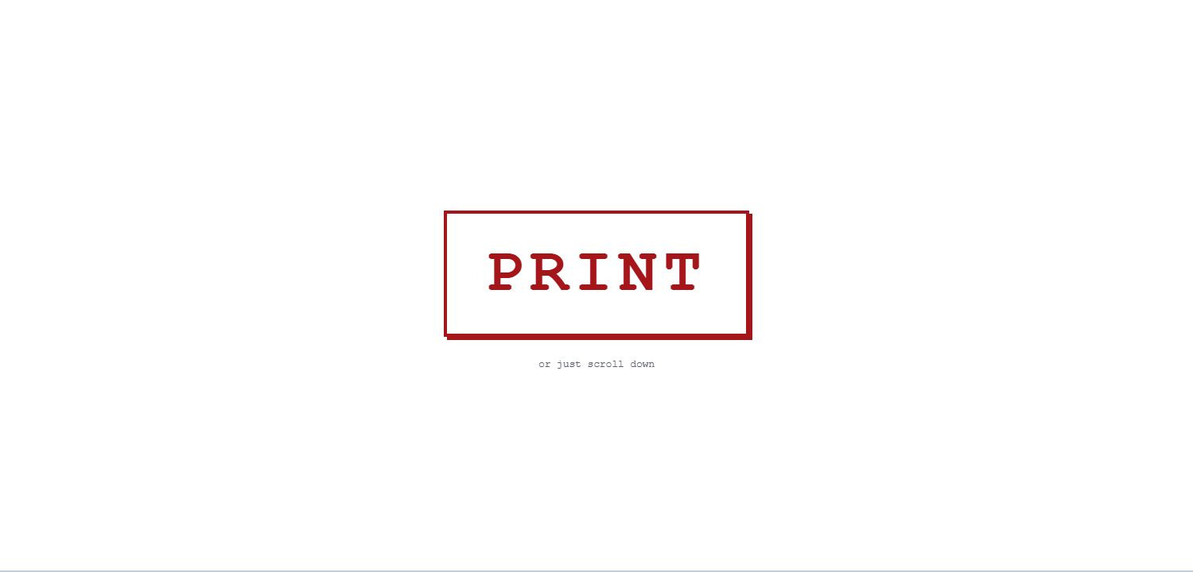
Figure 1. First screen: the PRINT button on its own.
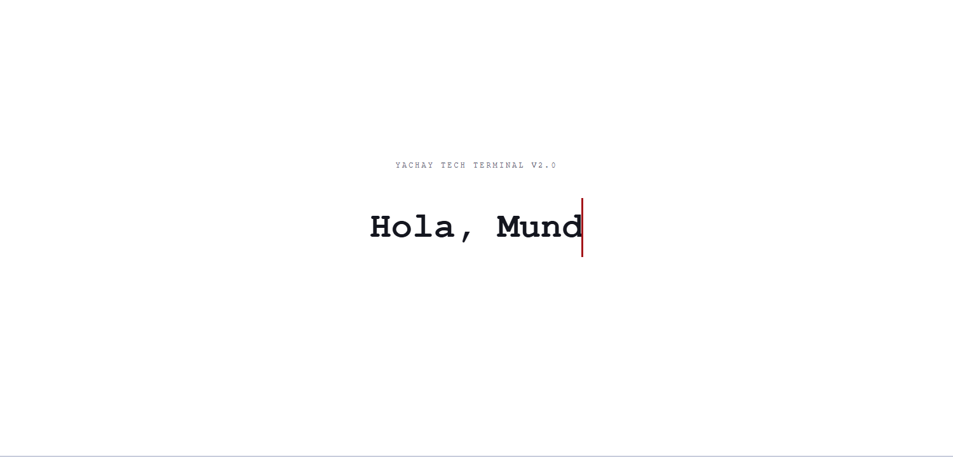
Figure 2. After pressing PRINT: the greeting types itself out.
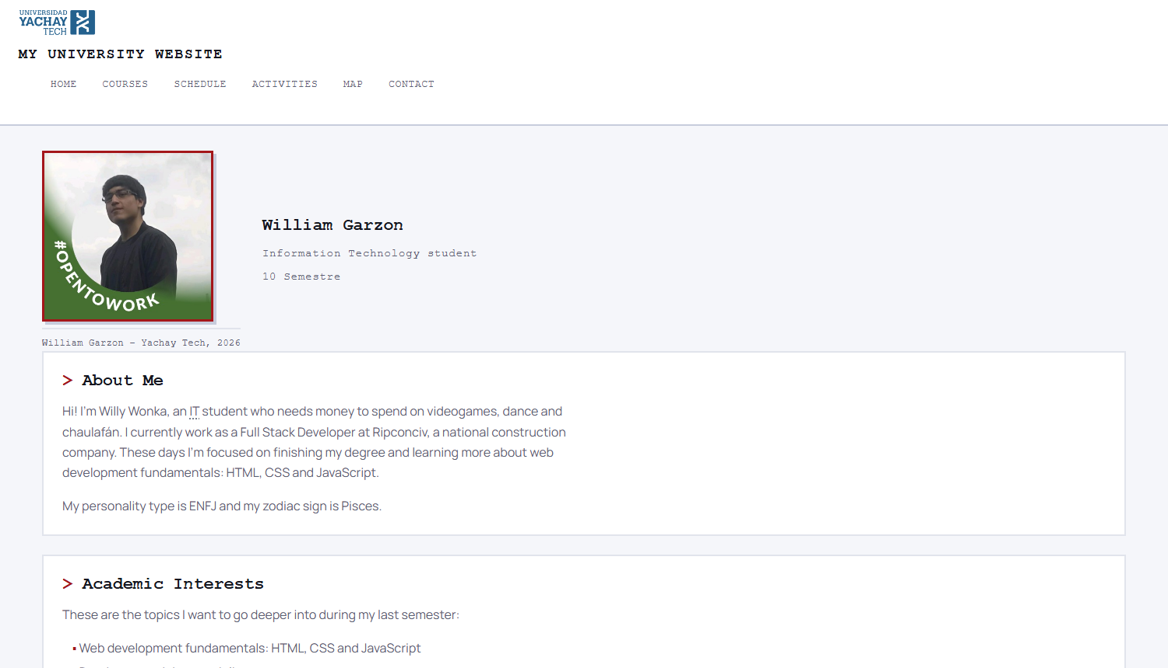
Figure 3. A few seconds later the screen fades on its own and the site is at its home section.
Projects with hover previews
A projects section was added, carried over from the Class 01 portfolio. Each card holds a screenshot that is invisible until the pointer enters the card. The image is positioned absolutely, so revealing it moves nothing: there is no layout shift.
Each project title is a link to the live system. That also solves keyboard access: with a real link inside the card, :focus-within fires when the link receives focus, so the preview appears for someone tabbing through the page exactly as it does with a mouse. An earlier version used tabindex="0" on the card, which created a tab stop that led nowhere.
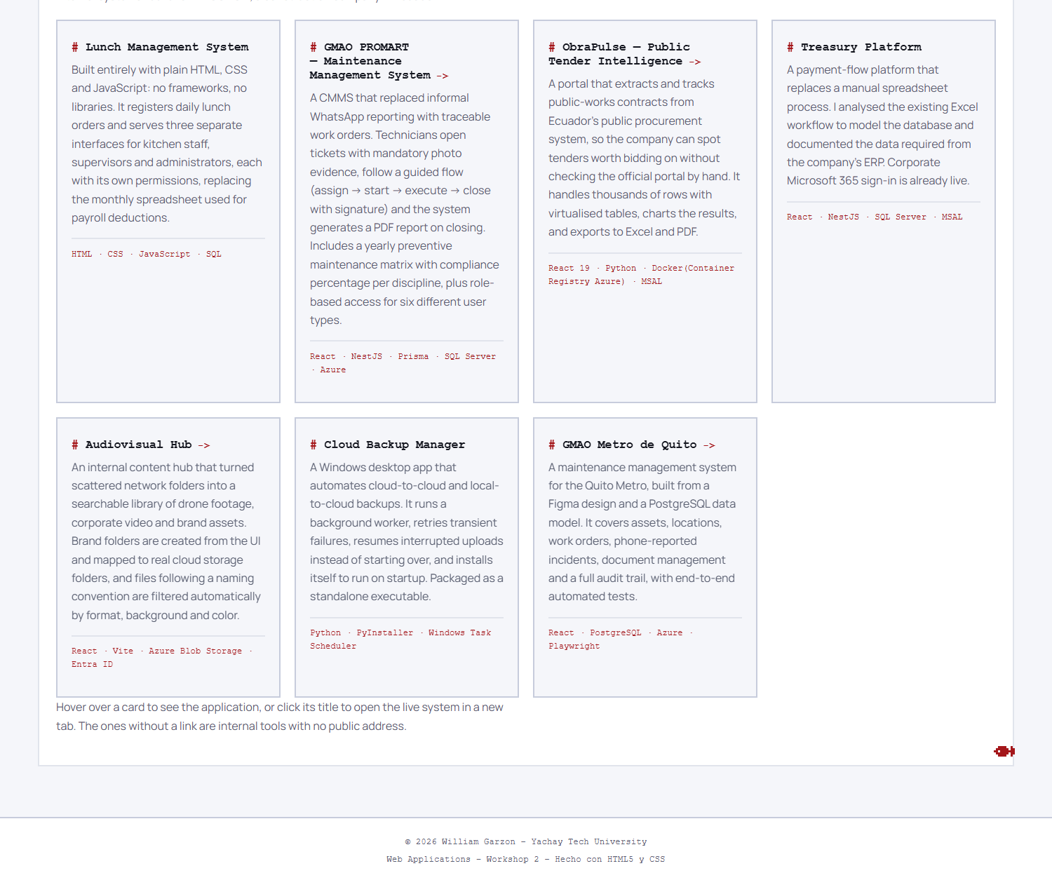
Figure 4. The projects grid. The layout reflows by itself with repeat(auto-fit, minmax(290px, 1fr)) and no media queries.
Pixel sprites
Small pixel animals are distributed across the site, one every few sections rather than on every box. They are drawn in pure CSS: a single element three pixels wide with dozens of stacked box-shadows, one per lit pixel. No images, no icon font, no SVG. They are decorative, so they carry aria-hidden and a screen reader skips them entirely.
Changes to the HTML
The markup barely moved. Beyond linking the stylesheet, only three edits were needed across the six pages:
Change | Reason
Removed border="1" from the tables | Workshop 1 allowed it so the grid was visible without CSS. The stylesheet now draws the table properly.
Added the two welcome screens | The PRINT button and the greeting. The greeting comes first in the document so it can hide the button with the sibling combinator.
Added the projects section | Seven cards with hover previews and links to the live systems.

Everything else — the semantic elements, the schedule with its rowspan and colspan, the form with its ten input types — was written for Workshop 1 and did not need a single change. That is the practical proof that the structure was sound.
Verification
Check | Result
Tag balance, six pages | No unbalanced tags
Internal links | 0 broken
Image references | All resolve
Text contrast, light theme | 5.79:1 minimum (WCAG AA needs 4.5:1)
Text contrast, dark theme | 5.74:1 minimum (WCAG AA needs 4.5:1)
alt attributes | 0 images without useful alt text
Heading hierarchy | One h1 per page, no skipped levels
Keyboard access to previews | All cards reachable by Tab
HTTP response | 200 OK on every page, stylesheet and font

Contrast was computed for every text-and-background pair in both themes using the WCAG relative luminance formula, including the semi-transparent table headers, which had to be composited over their background first. Reading contrast off a screenshot is not reliable; the numbers above come from the token values themselves.
What would happen if we changed things
The stylesheet was built so that a few specific edits would produce large, predictable changes. This is the part worth understanding, because it is the difference between styling a page and designing a system.
If the accent colour changed
Editing --accent in one place repaints the whole site: headings, links, table headers, buttons, form focus rings, list markers, the caret in the greeting and the pixel sprites. Nothing else needs touching, because no rule contains a literal colour. Without tokens the same change would mean finding and editing it in dozens of places, and missing some.
If the stylesheet were removed
The site would look exactly like the Workshop 1 submission and would still be perfectly usable: every page would read top to bottom in order, the tables would still be tables and the form would still work. That is the reward for putting meaning in the HTML rather than appearance.
The only visible loss would be the welcome sequence, which depends on :target. Even then the site does not break: the greeting screen would simply show as one more section and the visitor could scroll past it.
If JavaScript were allowed
The welcome sequence would be easier to write and easier to control, and the auto-dismiss would not depend on an animation timing out. But the CSS-only version has a property the JavaScript one would lose: it works with scripting disabled, and it cannot break halfway. Every state is either in the URL or in an animation, both of which the browser handles.
If the site had to support more languages
The structure is already prepared: every page declares lang="en" and the Spanish proper nouns are wrapped in <span lang="es">, so a screen reader switches pronunciation mid-sentence. What would need work is the fixed width of the greeting: it is set to 12 characters because that is the length of “Hola, Mundo!”, and a translation of a different length would need both that width and the step count of the animation changed together.
If it had to work on phones
It already does. The layout uses flexible boxes and a grid that reflows by itself, the wide tables scroll inside their own container so the page never scrolls sideways, and a breakpoint at 640 pixels reduces the type scale, tightens the navigation and hides the pixel sprites, which get in the way more than they add on a small screen.
If the visitor prefers reduced motion
They already get a different site. A @media (prefers-reduced-motion: reduce) block cancels the typing effect, the sprite hop and every transition. The greeting still appears, fully typed, with no animation. Motion is treated as an enhancement, not as the only way to reach the content.
Notes
- The design system is adapted from the Class 01 portfolio, which in turn follows the one used at RIPCONCIV, with the institutional blue replaced by the school's red.
- Project screenshots correspond to systems developed by the author. Campus photographs and the campus map are official Yachay Tech material.
- No JavaScript is used anywhere on the site.

