## This is the sample code, and you should import the

## ksoap library first:

|  |
| --- |
| package com.androidclient.ws;    import org.ksoap2.SoapEnvelope;  import org.ksoap2.serialization.SoapObject;  import org.ksoap2.serialization.SoapPrimitive;  import org.ksoap2.serialization.SoapSerializationEnvelope;  import org.ksoap2.transport.HttpTransportSE;  import android.widget.TextView;    import android.app.Activity;  import android.os.Bundle;    public class WSClientActivity extends Activity {      private static final String SOAP_ACTION = "<http://ws.android.com/sayHello>";  private static final String METHOD_NAME = "(This is the name for method in the class you  create with web service)";      private static final String NAMESPACE = "<http://ws.android.com/>";  private static final String URL =  "<http://175.157.229.119:8080/AndroidWSTest/services/PrintMsg?wsdl>";(this is copy  from web service page)      /** Called when the activity is first created. */      @Override      public void onCreate(Bundle savedInstanceState) {          super.onCreate(savedInstanceState);          setContentView(R.layout.main);            SoapObject request = new SoapObject(NAMESPACE, METHOD_NAME);            SoapSerializationEnvelope envelope = new SoapSerializationEnvelope(SoapEnvelope.VER11);            envelope.setOutputSoapObject(request);            HttpTransportSE ht = new HttpTransportSE(URL);          try {           ht.call(SOAP_ACTION, envelope);              SoapPrimitive response = (SoapPrimitive)envelope.getResponse();                TextView tv = new TextView(this);              tv.setText("Message :"+response.toString());              setContentView(tv);            } catch (Exception e) {              e.printStackTrace();          }      }    } |

Here:

SOAP_ACTION in line 14 is "NAMESPACE**/**METHOD_NAME"   
  
METHOD_NAME in line 15 is WSDL operation. You can find something like <wsdl:operation name="sayHello"> in your WSDL sayHello is METHOD_NAME here.

NAMESPACE in line 16 is targetNamespace in the WSDL. Replace that & add a "/" to the end .

URL in line 17 The URL of WSDL file. In my case it is http://175.157.229.119:8088  
/AndroidWSTest/services/PrintMsg?wsdl   
blue colored is the ip of the server replace it with your ip & red colored is the port number  
  
Make appropriate changes  according to your WSDL. Following image will help you.

This is an example image of a WSDL opened using Firefox .

[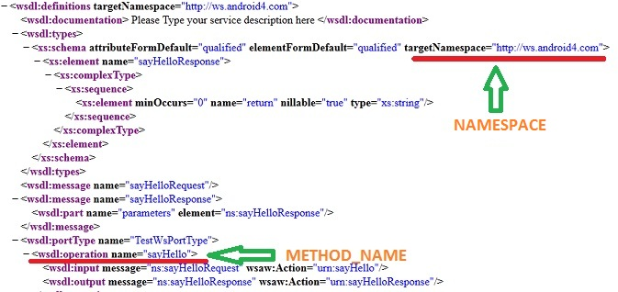](http://3.bp.blogspot.com/-UIoYxwt7GnY/T4VKVQEI0WI/AAAAAAAAAQ4/QBafJPxxv-Y/s1600/Android+web+service+access+tutorial.jpg)