**Create java web service in Eclipse using Axis2 (Part 01)**

This series of tutorials will explain how to create a simple java web service in Eclipse using Axis2. Finally I hope to create a client program for the web service.  
This is the part 01.   
Here I'm going to explain how we can configure Tomcat 7 for Eclipse 4.2 (Juno) because before create a java web service we need to setup development environment and configure the server. Here I use Tomcat 7 server for this tutorial.   
  
**1. Setup the development environment.**   
To setup the development environment you need to download and extract Eclipse EE and Tomcat servlet container.  
1. Eclipse IDE for Java EE Developers - [Download](http://www.eclipse.org/downloads/)  
2. Apache  Tomcat (Download zip archive not the windows service installer) - [Download.](http://tomcat.apache.org/download-70.cgi)  
  
**2. Here is the steps to configure Tomcat 7 in eclipse**  
2.1 Double click to open Eclipse. You should be able to see the Servers tab.

[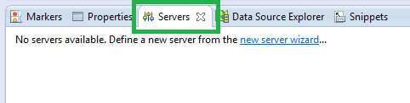](http://3.bp.blogspot.com/--opoGrwVa-g/ULHrne09k1I/AAAAAAAAAIk/UAHKb_6NcI0/s1600/configure+tomcat+in+eclipse01.png)

If you can't see the Servers tab then ;  
 Window >> Show View and select Servers

[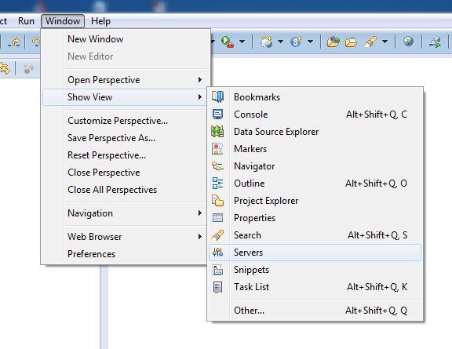](http://3.bp.blogspot.com/-PAAqK31uTUI/ULHseUCrHYI/AAAAAAAAAIs/5j6fmKSU9Xc/s1600/configure+tomcat+in+eclipse02.png)

2.2 Right click on Servers tab   
Select ; New >> Server   
  
[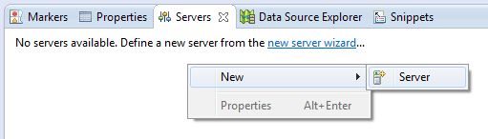](http://1.bp.blogspot.com/-cUREKvYbfmI/ULHwRldnBVI/AAAAAAAAAJA/fKq9fgRum_Q/s1600/configure+tomcat+in+eclipse03.png)   
  
Then from the new server window select ; Apache >> Tomcat v7.0 Server and click next 

[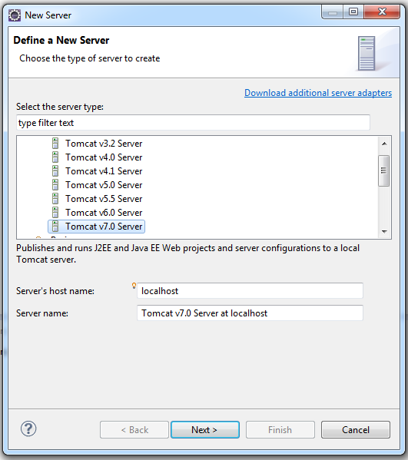](http://4.bp.blogspot.com/-_vUTwI3jTps/ULHw_aFhVNI/AAAAAAAAAJQ/WbCpHKGI8NI/s1600/configure+tomcat+in+eclipse04.png)

In next window browse to extracted Tomcat files, that is Tomcat installation directory and select the jre that installed in your system and click finish to create the new server.

[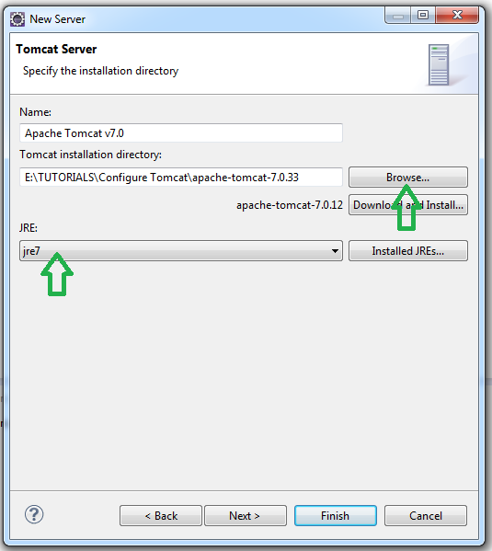](http://3.bp.blogspot.com/-WFW6xdbkMYc/ULHybXTw6kI/AAAAAAAAAJY/uqwMLure7CY/s1600/configure+tomcat+in+eclipse05.png)

2.3 To start the server right click on Tomcatv7 server in Servers tab and select Start.

[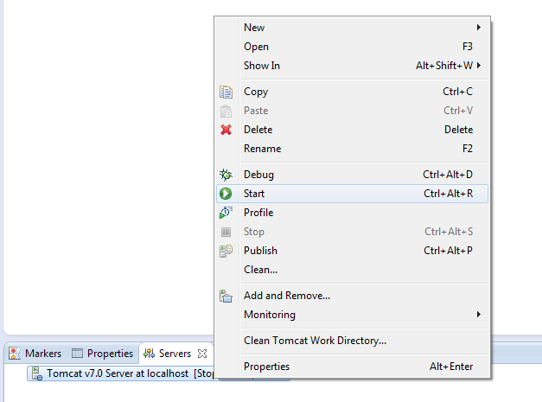](http://3.bp.blogspot.com/-RYJIK0YlCZw/ULHzJRxrGhI/AAAAAAAAAJg/Axal4unY28o/s1600/configure+tomcat+in+eclipse06.png)

2.4 To check the server open Chrome and go to **localhost:8080** you should be able to see Tomcat start page.

[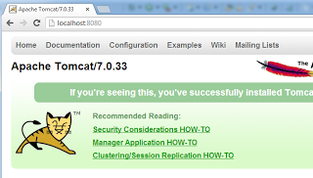](http://2.bp.blogspot.com/-8c0ROuN2bMU/ULH5C3tsnRI/AAAAAAAAAKQ/8tPAw_a6hMc/s1600/configure+tomcat+in+eclipse11.png)

If you are getting "requested resource is not available" error you need to change the file location of the Tomcat.

[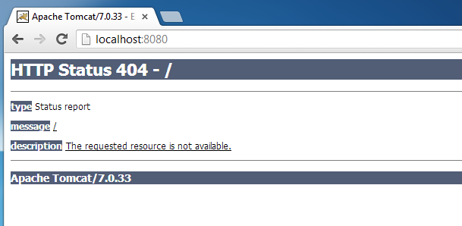](http://2.bp.blogspot.com/-32T6XbkjXZg/ULH1HQeP0VI/AAAAAAAAAJo/eMDFDc7ggMU/s1600/configure+tomcat+in+eclipse07.png)

In order to do that right click on server in the Servers tab and select properties. Then from the server properties window click Switch Location and Apply , OK.

[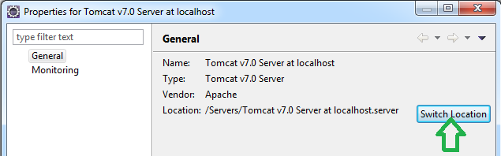](http://2.bp.blogspot.com/-CQnswVqjgX4/ULH1xRq54pI/AAAAAAAAAJw/NyOCbkZXok0/s1600/configure+tomcat+in+eclipse08.png)

Next double click on the server to open Overview.

[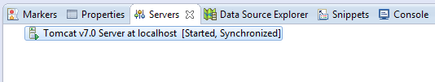](http://4.bp.blogspot.com/-8e_MAuw2nmM/ULH2wMZsarI/AAAAAAAAAJ4/5YUWIUOjHsg/s1600/configure+tomcat+in+eclipse09.png)

 In the Overview window  change Server locations to Use Tomcat installation and save changes. (If you want you can change ports from the Overview window).

[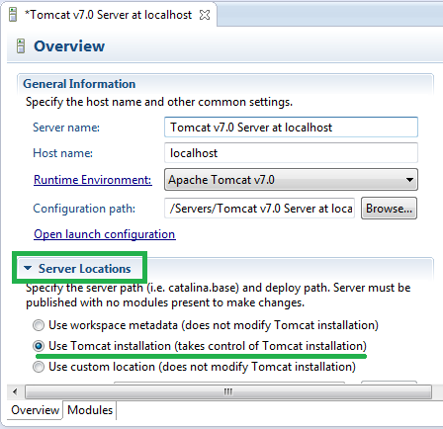](http://1.bp.blogspot.com/-p3AkMcoguG8/ULH4Yfm3HwI/AAAAAAAAAKI/uQA1STPilLU/s1600/configure+tomcat+in+eclipse10.png)

Restart the server and check. Now you should be able to see the default start page.

[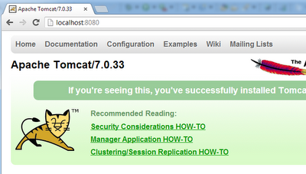](http://2.bp.blogspot.com/-8c0ROuN2bMU/ULH5C3tsnRI/AAAAAAAAAKQ/8tPAw_a6hMc/s1600/configure+tomcat+in+eclipse11.png)

To open Eclipse Internal web browser select ;  
Window >> Show View >> Other >> General >> Internal web Browser

[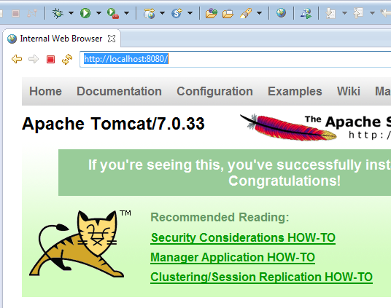](http://2.bp.blogspot.com/-MAS2y1f47JU/ULH6ejLnlbI/AAAAAAAAAKg/FobN9An9ono/s1600/configure+tomcat+in+eclipse12.png)

### Create java web service in Eclipse using Axis2 (Part 02)

This is the second part of create java web service using Axis2 tutorial. In this post I'm going to demonstrate the configuration of Apache Axis2 in Eclipse and create a simple java web service using Apache Axis2 SOAP engine. (If you want to see the first part click [here](http://codeoncloud.blogspot.com/2012/12/create-java-web-service-in-eclipse.html).)  
  
**1. First you need to download and extract Apache Axis2 SOAP engine.**  
  
 Apache Axis2 Binary Distribution - [DOWNLOAD](http://axis.apache.org/axis2/java/core/download.cgi)  
  
**2. Configure Axis2**   
  
In Eclipse go to **Window >> Preferences >> Web Services >> Axis2 Preferences**

[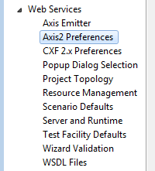](http://3.bp.blogspot.com/-O6JlEhj5jIA/UMOBGdG7rSI/AAAAAAAAAMM/9sOoKwKO9Fo/s1600/Java+webservice+with+Axis2_01.png)

Then Browse to axis2 extracted location. If you configure correctly Eclipse will show this message **"Axis2 runtime loaded successfully"** then click on **Apply** button.

[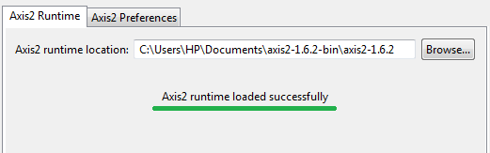](http://3.bp.blogspot.com/-JQR_KdBNm6g/UMOBZ2ueFFI/AAAAAAAAAMU/wSTFBl090_4/s1600/Java+webservice+with+Axis2_02.png)

To set server & runtime in the same Preferences window click on **Server & Runtime**.

[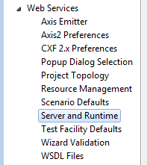](http://2.bp.blogspot.com/-qeAHyR4zXhQ/UMOBsjijkiI/AAAAAAAAAMc/MO3puKqsyAg/s1600/Java+webservice+with+Axis2_03.png)

 Then select Tomcat 7 as **Server runtime &** Axis2as **Web service runtime.**

[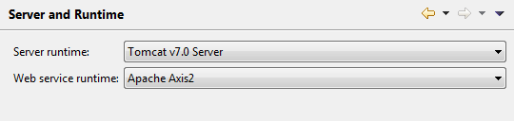](http://2.bp.blogspot.com/-jEBjUSaum10/UMOB8oXnIXI/AAAAAAAAAMk/jezwUWcC3Ow/s1600/Java+webservice+with+Axis2_04.png)

To complete configurations finally click Apply and OK.  
  
**3. Creating the Dynamic web project**   
After completing those configurations we can directly jump in to the web service development part. Here I'm going to implement very simple project. You can change it as you want.  
  
In Eclipse EE create new Dynamic web project. Give project name

[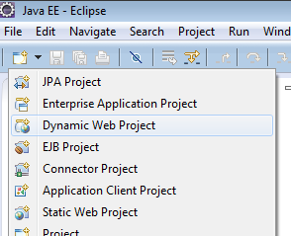](http://1.bp.blogspot.com/-blHOCbUFeOY/UMOCZsqJU7I/AAAAAAAAAMs/ZpKTP9gxz7A/s1600/Java+webservice+with+Axis2_05.png)

- You have to select Tomcat 7 as Target runtime.  
- Select 2.5 in Dynamic web module version drop down menu.  
- Then click Modify... button appears just after the Configuration.  
- I gave the "WebApp" as project name.

[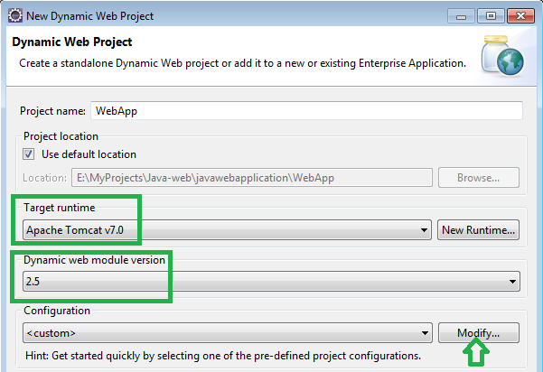](http://4.bp.blogspot.com/-Q-l6w4b8trA/UMODg3iT72I/AAAAAAAAAM0/DMwBxH5_9Do/s1600/Java+webservice+with+Axis2_06.png)

- Select Axis2 web services in opening window.

[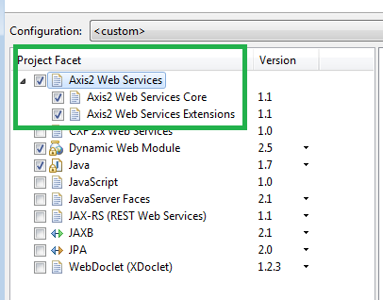](http://3.bp.blogspot.com/-qxBI9OqOR3M/UMOENyp3YtI/AAAAAAAAAM8/5huS0IXHPMo/s1600/Java+webservice+with+Axis2_07.png)

Click Finish to create the Dynamic web project.  
  
Right click on src folder then New >> Class

[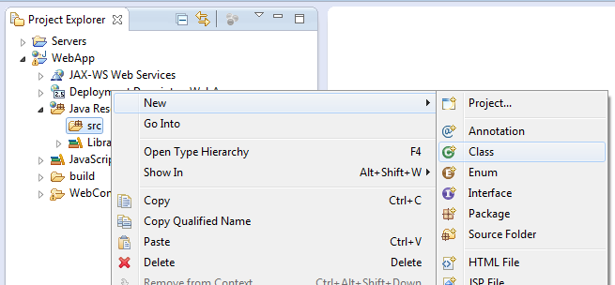](http://1.bp.blogspot.com/-zSV0luuayNM/UMOGPy2lqMI/AAAAAAAAANM/X_fPIhq6KLw/s1600/Java+webservice+with+Axis2_08.png)

- Give class name as well as package name   
- I gave package name as "org.webapp.ws" and class name as "Hello"

[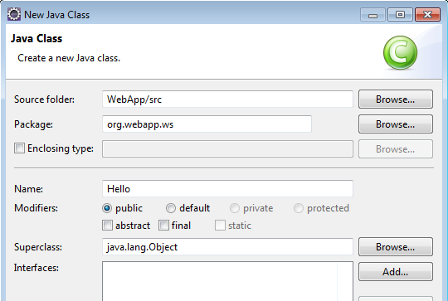](http://4.bp.blogspot.com/-z3yNWRuivNc/UMOHI0UtWZI/AAAAAAAAANU/bJNbbAvHXvw/s1600/Java+webservice+with+Axis2_09.png)

- Then click finish to crate the class.  
  
Add following code to the class

[?](http://codeoncloud.blogspot.ca/2012/12/create-java-web-service-in-eclipse_8.html)

|  |  |
| --- | --- |
| 1  2  3  4  5 | public class Hello {   public String sayHello(String name) {      return "Hello !!! " + name;   }  } |

**4. Creating the web service**  
  
Right click on your service class (not the project).  
Select **Web Services >> Create Web Service**

[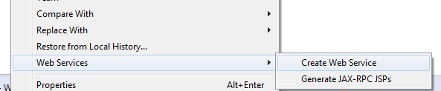](http://1.bp.blogspot.com/-5YSkiR_LuLg/UMOMQ6YLbLI/AAAAAAAAAOE/pQBWRCSqWuo/s1600/Java+webservice+with+Axis2_10.png)

In Web Service window tick to the Monitor the Web service check box. Other default settings are OK. No need to change those to this web service.

[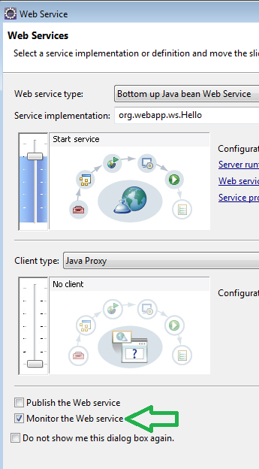](http://4.bp.blogspot.com/-h4Ux7YufN1o/UMOJfBl4BYI/AAAAAAAAANk/5jxQfpPxhBM/s1600/Java+webservice+with+Axis2_11.png)

Click Next.  
Next window, select Generate a default services.xml file.

[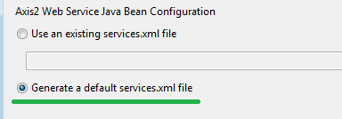](http://3.bp.blogspot.com/-SWAqCoD_yDw/UMOJ4FIVj9I/AAAAAAAAANs/dcnmpI9w_P4/s1600/Java+webservice+with+Axis2_12.png)

Then click Next and finally click **Finish**.  
  
**4. Testing the project**  
Perfect...... Now you should have a web service. To set the service Right click on your project and select **Run As >> Run on Server**.

[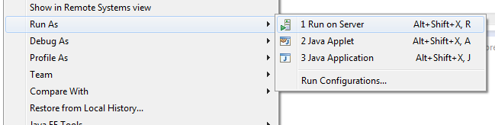](http://1.bp.blogspot.com/-soh_9xRB2YY/UMOKgfrkycI/AAAAAAAAAN0/4UT_qObwHu8/s1600/Java+webservice+with+Axis2_13.png)

Click next & click Finish.  
  
If everything went fine you should see following page in Eclipse internal web browser.

[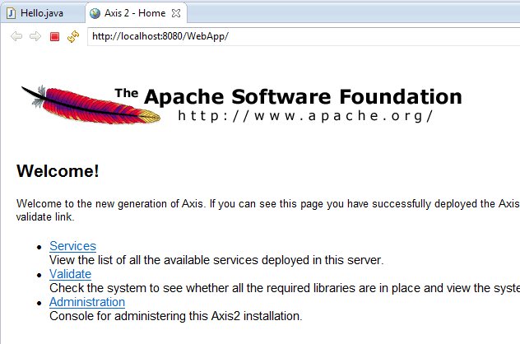](http://4.bp.blogspot.com/-gGD2dnMP7sM/UMOLL-4o8NI/AAAAAAAAAN8/AGS5m97e4K8/s1600/Java+webservice+with+Axis2_14.png)