ENGPHYS253

Lab 7: Electrical Resonance

2017-04-15

Viraj Bangari

**1.0 Results and Analysis**

The inverse square frequency and capacitance data from table 1 was plotted onto figure 1. Using a linear regression with equation 1, the inductance of the circuit was determined to be (837 +/- 5)*10^(-4)H, and its capacitance was determined as (11 +/- 3)*10^(-12) F. Using the data in table 2, the experimental value of VL/VR at 9.63 +/- 0.02 kHz was calculated as 102 +/-5 with phase shift 93°, while the theoretical value was calculated as 94.2 +/- 0.02 kHz. The data points are qualitatively close, but do not overlap. Using table 3, the experimental VL/VC was determined as 0.996 +/- 0, while the theoretical ratio is 1 with phase shift 0°.

The VR/VT and frequency values from table 2 and table 5 were plotted onto figure 2. When a second resistor is added to the circuit, the plot of VR/VT against frequency appears to scale downwards, though their respective maximum VR/VT values still occur at the resonance frequency. On figure 3, the theoretical amplitude ratio was plotted using equation 3 with the plot of the ratio of the experimental (VR/VT)/(VR/VT)0 values. The quality factor was determined to be 20.6 +/- 0.2. Using equation 4, the theoretical phase shifts were plotted onto figure 4 with the data in table 2.

**2.0 Discussion**

The plot in figure one is consistent with equation 1, as the graph appears linear and has a positive y intercept. All of the experimental values lie within error on the regression line. The values of the capacitance and inductance derived from the intercept and slope are within the same order of magnitude of the expected values as well.

The experimental VL/VR value of 102 +/-5 does not coincide with the theoretical value of 94.2 +/- 0.02 kHz. The discrepancy in these values may be due to the fact that the resonance frequency was visually determined, meaning that the uncertainty in the VL and VR measurements were understated. These understated uncertainties could explain why the theoretical and experimental values are qualitatively close to either, but do not overlap. Since it was difficult to visually differentiate the resonance frequency, the better strategy would be to measure VL and VR on various frequencies that appear to be candidates for resonance frequency and then to the mean and standard error on those measurements. The VL/VC value agreed with the theoretical value of 0, but the phase shift of 3.9 +/- 0.05° did not agree with the theoretical value of 0°. As with the VL and VR measurements, the discrepancy is due to the difficulty in visually finding the resonance frequency.

Figure 2 shows the VR/VT values with varying input frequencies. The shape of the experimental plot matched the expected theoretical shape: a symmetrical exponential decay where a global maximum occurs at the resonance frequency. This shape is prevalent in the plot with a single resistor and in the plot with two resistors. The reason that the peak is reduced in the plot with two resistors is because these resistors cause a damping to the oscillation.Figure 3 compares the ratio of the experimental amplitude to the resonance amplitude ratio with theoretical amplitude ratio. The plot is consistent with the fact that the amplitude divided by the resonance amplitude would approach reach a maximum value of 1 at when the logarithm of frequency and resonance frequency is equal to 0. This coincides with the findings in Figure 2, where the maximum amplitude occurs at the resonance frequency, as log(1) is zero.

Figure 4 compares the theoretical phase curve as a function of the log of the frequency divided by the resonant frequency to the experimental measurements of phase.The experimental points lie very close to the theoretical values closer to the resonance frequency before starting to diverge.The inaccuracy of the far points is probably due to dampening effect of background noise. As the frequency diverges farther from the resonance frequency the phase decreases very quickly, but the noise stays constant. This causes the error in phase to increase just as quickly. The solution to this systematic would be to take more data points closer to the frequency or to find a more precise oscilloscope.

The overall experimental design is of this lab is good, as the many of measured data points closely resemble the theoretical points for every plot with small margins of error. The largest discrepancies in the measurements were the VL/VR ratios, and the phase shifts of VL/VC, and the phase graph. The issue common to all three of these measurements is that their uncertainty values were actually much higher than originally thought. Had the uncertainties been more accurate, it is possible that there would have been more overlap between the theoretical and actual measurements.

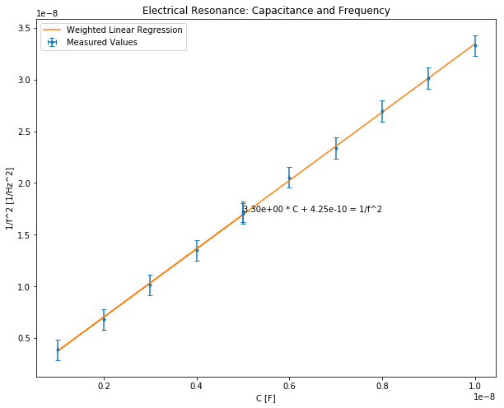

Figure 1 Resonance Frequency of RLC circuit with R = 0.0511 +/- 0.0002 kOhm, RL = 0.1802 +/- 0.0008kOhm

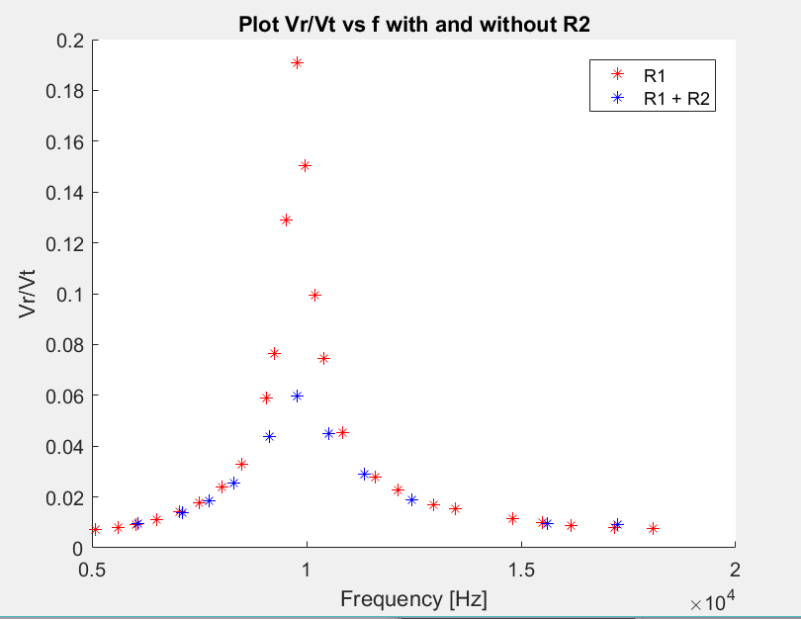

Figure 2 VR and VT of RLC circuit with R1 = 0.0511 +/- 0.0002 kOhm, R2 = 0.5617 +/- 0.003kOhm, RL = 0.1802 +/- 0.0008kOhm, C = 3nF

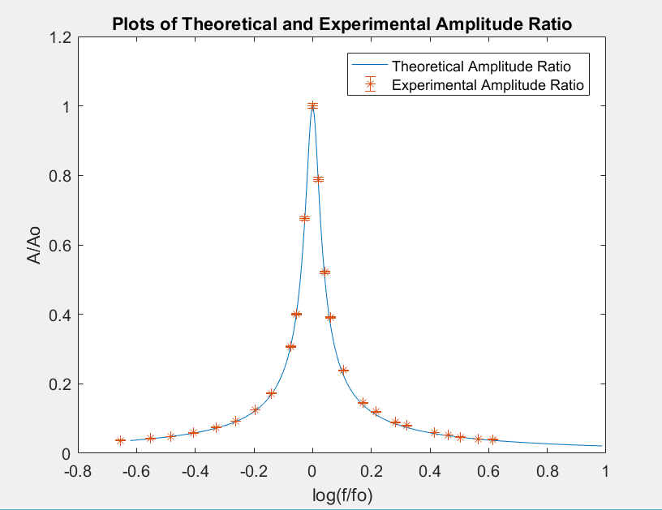

Figure 3 Theoretical and Experimental Amplitude ratio for RLC with R1 = 0.0511 +/- 0.0002 kOhm, R2 = 0.5617 +/- 0.003kOhm, RL = 0.1802 +/- 0.0008kOhm, C = 3nF

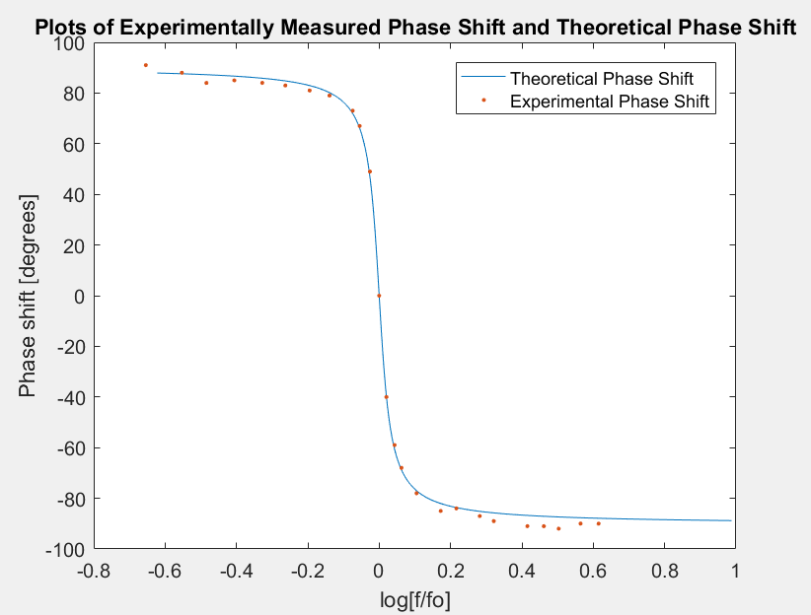

Figure 4 Theoretical and experimental phase shift for varying frequency ratio for RLC with R1 = 0.0511 +/- 0.0002 kOhm, R2 = 0.5617 +/- 0.003kOhm, RL = 0.1802 +/- 0.0008kOhm, C = 3nF

**3.0 Appendix**

**3.1 Raw Data**

**Table 1: Resonance Frequency of RLC circuit with R = 0.0511 +/- 0.0002 kOhm, RL = 0.1802 +/- 0.0008kOhm**

|  |  |  |
| --- | --- | --- |
| Resonant Frequency [KHz] +- 0.02 | Capacitance [microFarads]+- 0.5% | External Voltage [V] +- 0.02 |
| 5.48 | 0.01 | 1.47 |
| 5.76 | 0.009 | 1.46 |
| 6.09 | 0.008 | 1.46 |
| 6.54 | 0.007 | 1.45 |
| 6.98 | 0.006 | 1.42 |
| 7.62 | 0.005 | 1.42 |
| 7.66 | 0.005 | 1.41 |
| 8.61 | 0.004 | 1.41 |
| 9.92 | 0.003 | 1.35 |
| 12.11 | 0.002 | 1.31 |
| 16.1 | 0.001 | 1.25 |

**Table 2: VR and VT of RLC circuit with R = 0.0511 +/- 0.0002 kOhm, RL = 0.1802 +/- 0.0008kOhm, C = 3nF**

|  |  |  |  |
| --- | --- | --- | --- |
| Frequency [kHz] +- 0.02 | VR [V] +- 0.002 | VT [V] +- 0.01 | Phase Shift VR to VT [Degrees] +- 1 |
| 5.08 | 0.054 | 7.59 | 91 |
| 5.62 | 0.061 | 7.59 | 88 |
| 6.02 | 0.07 | 7.59 | 84 |
| 6.51 | 0.085 | 7.59 | 85 |
| 7.04 | 0.108 | 7.59 | 84 |
| 7.51 | 0.133 | 7.59 | 83 |
| 8.04 | 0.181 | 7.59 | 81 |
| 8.5 | 0.249 | 7.59 | 79 |
| 9.07 | 0.446 | 7.59 | 73 |
| 9.25 | 0.58 | 7.59 | 67 |
| 9.52 | 0.978 | 7.58 | 49 |

**Table 2: VR and VT of RLC circuit with R = 0.0511 +/- 0.0002 kOhm, RL = 0.1802 +/- 0.0008kOhm, C = 3nF (Continued)**

|  |  |  |  |
| --- | --- | --- | --- |
| Frequency [kHz] +- 0.02 | VR [V] +- 0.002 | VT [V] +- 0.01 | Phase Shift VR to VT [Degrees] +- 1 |
| 9.77 | 1.37 | 7.18 | 0 |
| 9.97 | 1.07 | 7.11 | -40 |
| 10.2 | 0.723 | 7.27 | -59 |
| 10.4 | 0.546 | 7.31 | -68 |
| 10.85 | 0.339 | 7.45 | -78 |
| 11.61 | 0.208 | 7.49 | -85 |
| 12.13 | 0.171 | 7.5 | -84 |
| 12.95 | 0.128 | 7.53 | -87 |
| 13.47 | 0.115 | 7.54 | -89 |
| 14.8 | 0.086 | 7.54 | -91 |
| 15.5 | 0.075 | 7.53 | -91 |
| 16.16 | 0.067 | 7.53 | -92 |
| 17.18 | 0.06 | 7.54 | -90 |
| 18.07 | 0.057 | 7.54 | -90 |

**Table 3: VR and VL at Resonance Frequency of RLC Circuit Grounded at Midpoint with R = 0.0511 +/- 0.0002 kOhm, RL = 0.1802 +/- 0.0008kOhm, C = 3nF.**

|  |  |  |  |
| --- | --- | --- | --- |
| Resonant Frequency [kHz] +- 0.02 | VC [V] +- 0.01 | VL [V] +- 0.01 | Phase Shift [Degrees] +- 0.1 |
| 9.47 | 12.99 | 12.94 | 3.9 |

**Table 4: VL and VC at Resonance Frequency of RLC Circuit Grounded at Midpoint with R = 0.0511 +/- 0.0002 kOhm, RL = 0.1802 +/- 0.0008kOhm, C = 3nF.**

|  |  |  |  |
| --- | --- | --- | --- |
| Resonant Frequency [kHz] +- 0.02 | VR1 [V] +- 0.001 | VL1 [V] +- 0.01 | Phase Shift [Degrees] +- 1 |
| 9.63 | 0.139 | 14.23 | 93 |

**Table 5: VR1 and VT1 of RLC Circuit with R1 = 0.0511 +/- 0.0002 kOhm, R2 = 0.5617 +/- 0.003kOhm, RL = 0.1802 +/- 0.0008kOhm, C = 3nF**

|  |  |  |  |
| --- | --- | --- | --- |
| Frequency [kHz] +- 0.02 | VR1 [V] +- 0.001 | VT1 [V] +- 0.01 | Phase Shift [Degrees] +- 1 |
| 6.07 | 0.071 | 7.59 | 81 |
| 7.1 | 0.104 | 7.59 | 78 |
| 7.73 | 0.141 | 7.59 | 72 |
| 8.31 | 0.192 | 7.58 | 66 |
| 9.13 | 0.335 | 7.62 | 44 |
| 9.78 | 0.448 | 7.48 | 3 |
| 10.51 | 0.336 | 7.46 | -40 |
| 11.35 | 0.216 | 7.49 | -60 |
| 12.45 | 0.142 | 7.51 | -70 |
| 15.6 | 0.073 | 7.52 | -78 |
| 17.25 | 0.06 | 6.52 | -83 |

**3.2 Equation List**

$\frac{1}{f_{0}^{2}}=4π^{2}L\left(C+C_{s}\right) \left(1\right)$

$ω_{0}=\sqrt{\frac{1}{L\left(C+C_{s}\right)}} (2)$

$\frac{A}{A_{0}}={\left(1+Q^{2}{\left(\frac{ω}{ω_{0}}-\frac{ω_{0}}{ω}\right)}^{2}\right)}^{-0.5}\left(3\right)$

$\tan\left(ϕ\right)=Q\left(\frac{ω}{ω_{0}}-\frac{ω_{0}}{ω}\right)\left(4\right)$

$Q=ω_{0}L/R(5)$

**3.3 Sample Calculations**

1. Resonant Frequency

wo = sqrt(1/(L*(0.003e-6 + Cs)))

wo_err = errorpropogate(wo,L,L_err,Cs,Cs_err,3e-9,(3e-9)*0.005)

Where w0 is the resonant frequency, L is the inductance and Cs is the calculated from the intercept of Figure 1.

1. Inductor and Capacitor Impedance

ZL = i*wo*L

ZL_err = errorpropogate(ZL,L,L_err,wo,wo_err)

ZC = 1/(j*wo*3e-9)

ZC_err = errorpropogate(ZC,wo,wo_err,3e-9,(3e-9)*0.005)

Where ZL is the inductor impedance, ZC is the capacitor impedance.

1. Theoretical VL/VC and VL/VR

ALR = abs(ZL/R1)

ALR_val = abs(ALR)

ALR_err = abs(errorpropogate(ALR,ZL,ZL_err,R1,dR1))

ALC =abs(ZL/ZC)

ALC_val = abs(ALC)

ALC_err = abs(errorpropogate(ALC,ZL,ZL_err,ZC,ZC_err))

Where ALR_val is VL/VR and ALC_val is VL/VC

1. Quality Factor

R = R1 + RL;

Q = res_w*L/R;

dQ = errorpropogate(Q,res_w,dres_w,L,L_err,R,dR);

Where R is the resistance, res_w is the resonant frequency and Q is the quality factor

1. Theoretical Phi

phi = (-atan(Q.*((w./res_w)-(res_w./w)))).*(180/pi);

dphi = errorpropogate(phi,Q,dQ,res_w,dres_w);

1. Theoretical A/A0

TheoreticalA = (1+((Q^2).*((w./res_w)-(res_w./w)).^2)).^-0.5;

Where TheoreticalA is A/A0

1. Experimental A/A0

ff0 = freq2./freq2(12);

VRVT2_0 = VR2(12)/VT2(12);

dVRVT2_0 = VRVT2_0 * 0.005;

VRVT2 = VR2./VT2;

dVRVT2 = VRVT2 *0.005;

AA0 = VRVT2/VRVT2_0;

dAA0 = errorpropogate(AA0,VRVT2_0,dVRVT2_0,VRVT2,dVRVT2)

Where freq2 is an array of the frequencies from Part 2, ff0 is f/f0 where f0 is resonant frequency, VR2 are is VR for part 2, VT2 is VT for part 2, VRVT2 is VR/VT, VRVT2_0 is VR/VT at resonant frequency, and AA0 is A/A0

function error = errorpropogate(f,x,dx,y,dy,z,dz,w,dw)

N = nargin;

if (N==3)

error = f.*(dx./x);

end

if (N==5)

error = f.*sqrt(((dx./x).^2)+((dy./y).^2));

end

if (N==7)

error = f.*sqrt(((dx./x).^2)+((dy./y).^2)+((dz./z).^2));

end

if (N==9)

error = f.*sqrt(((dx./x).^2)+((dy./y).^2)+((dz./z).^2)+((dw./w).^2));

end

end