# **Analysis Appendix**

**Equation List**

*H = n1(LS)-1Vs* (1)

*B = RC(n2Ac)-1Vs* (2)

*P = AVf (3)*

*V = L * Area of sample face (4)*

B *=*μ0μrH (5)

μ0= 4π * 10-7 (6)

flux density = Hμr (7)

**Apparatus Measurements**

n1 = 160 turns

n2 = 150 turns

S = 0.1 +/- 5% Ohms

R = 1e6 +/- 5% Ohms

C = 0.5e-6 +/- 2% F

**Sample Measurements**

Iron Magnetic Length**:** 333 +/- 5mm

Iron Cross Sectional Area: 759.08 +- 0.5 mm2

Carbon Magnetic Length: 78 mm +/- 0.5 mm

Carbon Cross Sectional Area: 844.32 mm2

Table 1 –Series Resistor Voltage and Capacitor Voltage for Iron Sample with C = 0.5e-6 +/- 2% F and S = 0.1 +/- 5% Ohms (Small sample of full dataset with 2000 points)

|  |  |  |
| --- | --- | --- |
| Time [s] | Vc [V] | Vc [V] |
| -2.50E-02 | 3.42E-01 | -3.40E-01 |
| -2.50E-02 | 3.38E-01 | -3.39E-01 |
| -2.50E-02 | 3.34E-01 | -3.39E-01 |
| -2.49E-02 | 3.31E-01 | -3.39E-01 |
| -2.49E-02 | 3.27E-01 | -3.39E-01 |
| -2.49E-02 | 3.22E-01 | -3.38E-01 |
| -2.49E-02 | 3.18E-01 | -3.38E-01 |
| -2.48E-02 | 3.13E-01 | -3.38E-01 |
| -2.48E-02 | 3.09E-01 | -3.38E-01 |
| -2.48E-02 | 3.06E-01 | -3.37E-01 |
| -2.48E-02 | 3.01E-01 | -3.37E-01 |
| -2.47E-02 | 2.96E-01 | -3.36E-01 |
| -2.47E-02 | 2.91E-01 | -3.36E-01 |
|  |  |  |

Table 2 - Series Resistor Voltage and Capacitor Voltage for Carbon Steel Sample with C = 0.5e-6 +/- 2% F and S = 0.1 +/- 5% Ohms (Small sample of full dataset with 2000 points)

|  |  |  |
| --- | --- | --- |
| Time [s] | Vc [V] | Vc [V] |
| -2.50E-02 | 3.58E-01 | 1.78E-01 |
| -2.50E-02 | 3.56E-01 | 1.78E-01 |
| -2.50E-02 | 3.55E-01 | 1.77E-01 |
| -2.49E-02 | 3.53E-01 | 1.78E-01 |
| -2.49E-02 | 3.51E-01 | 1.77E-01 |
| -2.49E-02 | 3.49E-01 | 1.77E-01 |
| -2.49E-02 | 3.46E-01 | 1.76E-01 |
| -2.48E-02 | 3.44E-01 | 1.76E-01 |
| -2.48E-02 | 3.40E-01 | 1.75E-01 |
| -2.48E-02 | 3.39E-01 | 1.75E-01 |
| -2.48E-02 | 3.35E-01 | 1.73E-01 |
| -2.47E-02 | 3.34E-01 | 1.75E-01 |
| -2.47E-02 | 3.30E-01 | 1.72E-01 |

Table 3 - Hysteresis Saturation Point for Iron Sample with

C = 0.5e-6 +/- 2% F and S = 0.1 +/- 5% Ohms

|  |  |  |  |  |
| --- | --- | --- | --- | --- |
| Variac Voltage [V] | Top-right corner X [mV] | Top-right corner Y [mV] | Error in corner X [mV] | Error in corner Y [mV] |
| 3 | 13.75 | 26.87 | 0.5 | 1 |
| 5 | 18.25 | 43.75 | 0.5 | 2 |
| 7 | 21 | 56.25 | 0.5 | 2 |
| 10 | 25.5 | 72.5 | 0.5 | 2 |
| 13 | 33.5 | 95.3 | 1 | 5 |
| 17 | 42 | 118.8 | 1 | 5 |
| 20 | 50.5 | 139.1 | 1 | 5 |
| 23 | 61.5 | 160.9 | 1 | 5 |
| 25 | 68 | 170.3 | 2 | 5 |
| 30 | 88 | 196.9 | 2 | 10 |
| 35 | 120 | 228.1 | 2 | 10 |
| 40 | 167.5 | 259.4 | 5 | 10 |
| 45 | 227.5 | 284.4 | 5 | 10 |
| 50 | 315 | 303.1 | 10 | 10 |
| 55 | 460 | 318.8 | 10 | 10 |

**Sample Calculations**

H and B Values:

Hi = (n1/(Li*S)).*Vsi;

Bi = (R*C/(n2*Aci)).*Vci;

Hs = (n1/(Ls*S)).*Vss;

Bs = (R*C/(n2*Acs)).*Vcs;

Remanence and Coercive Forces:

remi = [];

coerci = [];

for i=1:length(Hi)-1

if (Hi(i) >= 0 && Hi(i+1) < 0)

remi(end + 1) = Bi(i);

remi(end + 1) = Bi(i + 1);

end

if (Bi(i) >= 0 && Bi(i+1) < 0)

coerci(end + 1) = Hi(i);

coerci(end + 1) = Hi(i + 1);

end

end

Iron Remanence (mean) = 0.838 +/- 0.003 T

Iron Coercive Force (SEM) = -252 +/- 1 A/m

Steel Remanence (mean) = 0.440 +/- 0.002 T

Steel Coercive Force (SEM) = -3390 +/- 10 A/m

Power Dissipated By Steel Sample:

Ps1 = (2.11e-2 - 1.24e-2)*2;

Ps2 = (2.11e-2 - 4.49e-3);

fs = 0.5*((1/Ps1)+(1/Ps2));

Ps_err = Ps * (0.002/Ls + Ac_err/Acs + 2/fs);

P = 100 +/- 6 W

Maximum Relative Permeability and Flux Density: [1]

Uo = 4*pi*(10^-7); %http://physics.info/constants/

Ur = Bi4./Hi4./Uo;

Ur_err = Ur .* (Bi4_err./Bi4 + Hi4_err./Hi4)./2;

Flux = Ur_max*Hi4(ind);

Flux_err = Flux .* (Ur_err(ind)./Ur_max + Hi4_err(ind)./Hi4(ind))

Relative permeability= 1900 +/- 200 H/m

Calculated as: 333000 +/- 6000 N/(Am)

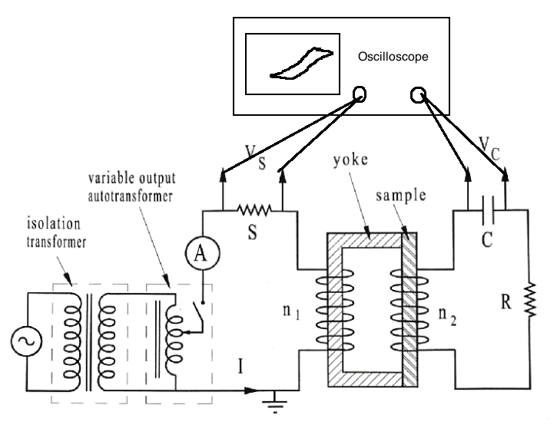

Figure - Diagram of Experimental Apparatus

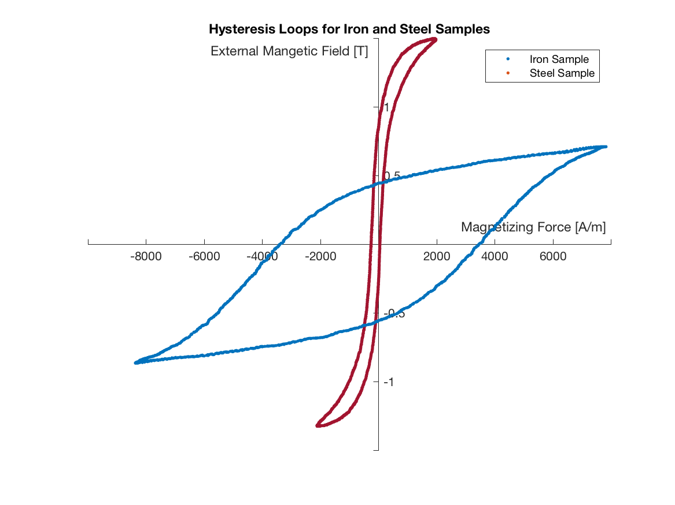

Figure - Hysterisis Loops for Iron and Steel

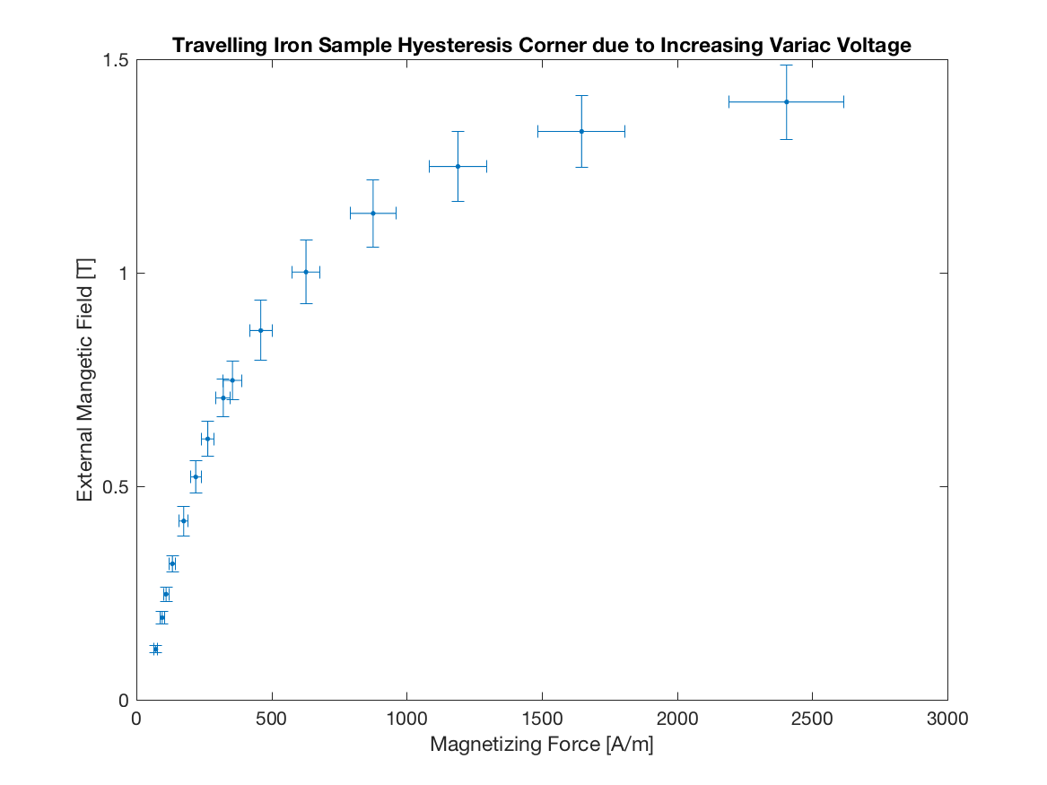

Figure - Hysterisis Loop Coordinates for Iron Sample

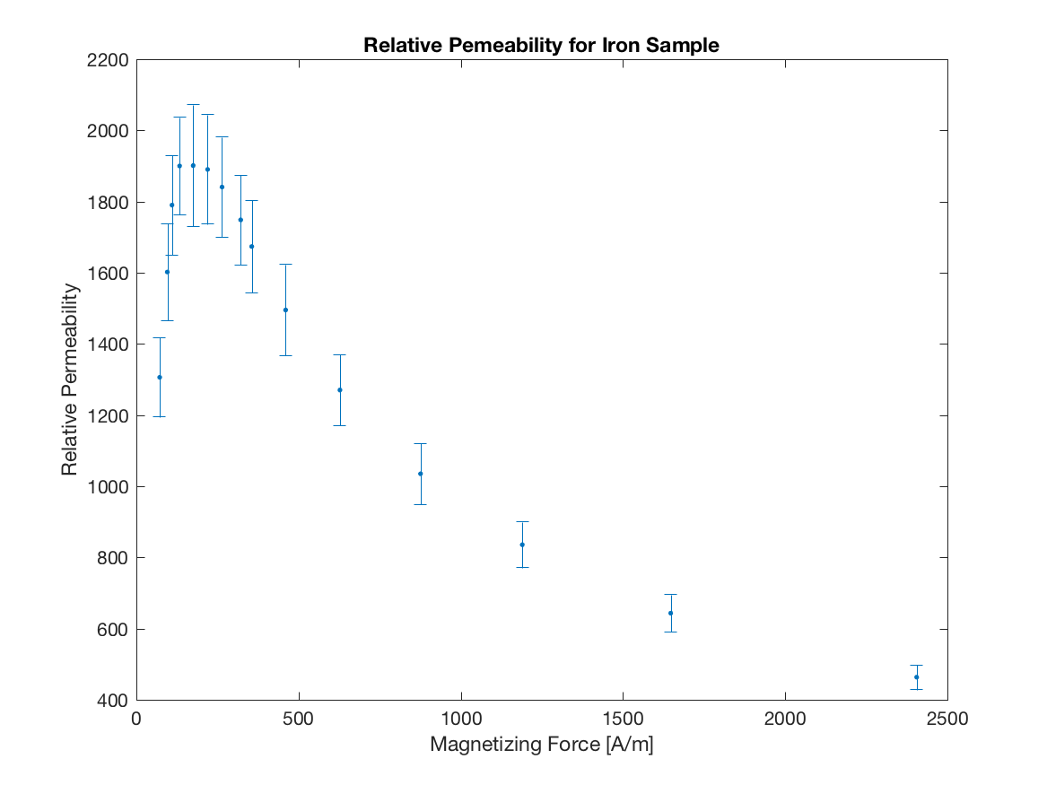

Figure - Relative Permeability for Iron Sample

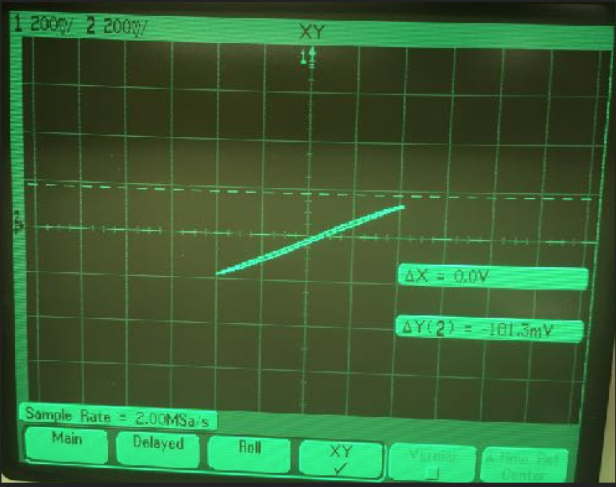

Figure - Hystersis Loop for Plastic Spacer with Iron Sample

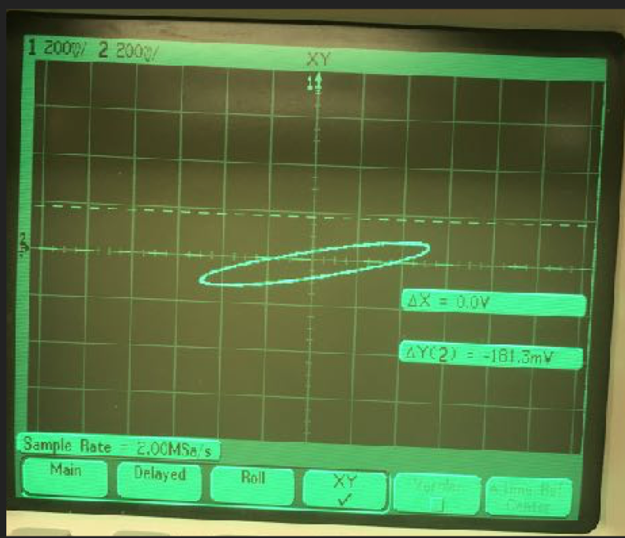

Figure - Hystersis Loop for Copper Spacer with Iron Sample

**Abstract**

The point of this experiment was to plot the hysteresis curves of carbon steel and iron. Derive rel perm for iron, hysteresis corner moving, and power loss. Show how reduced current results in power loss.

**Intro**

Ferromagnetic materials become magnetic when external magnetic field (such as from solenoid) is applied. Can be 100 times stronger that the the external magnetic field because of alignment of electron psins.Explain figure 3 in textbook. Cyclic behaviors is called hysteresis.

**Theory**

Derive equtions 1 to 7

**Procedure**

- Set up Apparatus with Iron. Set oscilloscope to display channel 2 as a function of channel 1. Horizontal and Vertical sensitivity are set 20 200mV/division. Adjust variac voltage until loop spans four division (400mV).

-Put scope to plot both signals against time with 5ms divisions. Get 2000 data points into CSV. Repeat the same for the carbon. Record rough estimate of power loss for carbon.

-Measure carbon and steel samples. Use magnetic length estimates as found in the diagram. Put iron sample back on. Adjust variable voltage for 15 data pts and use cursors to determine XY. Insert copper and steel into sample.

**Analysis**

- Coercive Force and Remanence was done by mean and SEM. Otherwise summarize results.

**Discussion**

**-** Steel is permanent magnet b/c higher coercive.

- Iron is easier to change, good for AC motors**.** 2000000 rel perm for 99.95 pure iron, 5000 for 99.8 purity [2].

-Air dissipates most power because less current. Power dissipated was 100 W +/- 6W estim is less. Copper dissipates some power, but current can still form because of eddy.

**Conclusion**

**-** Reiterate experiment. Main parts are hysteresis curve (coercive/remanence), relative perm & power dissipated. Most of the data was good, matched real life data. If possible, see if can model magnetic length to get a more accurate power dissipation result.

# References

|  |  |
| --- | --- |
| [1] | The Physics Hypertextbook, "Physical Constants," [Online]. |
| [2] | Engineering Toolbox, "Electromagnetism and formation of magnetic fields," [Online]. |