**Creating geometry in Gmsh**

1. GeometryàElementary EntitiesàAddàPoint

A pop will show up. Edit the X and Y co-ordinate and click Add to add point.

Add 4 points (0,0), (1,0), (1,1), and (0,1).

Press **q** to exit.

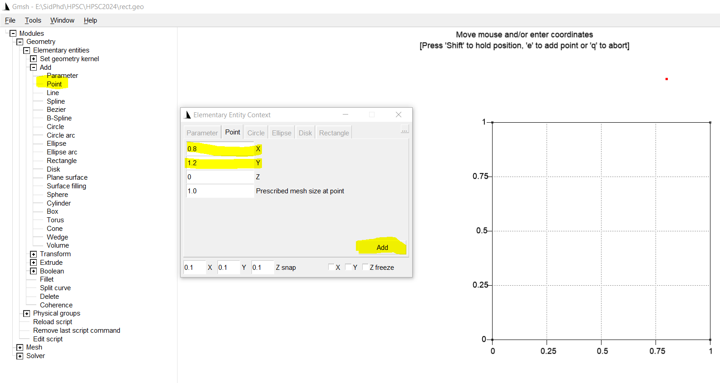

1. GeometryàElementary EntitiesàAddàLine

Click on the added points one after another. i.e. click on (0,0) and then (1,0)

Add for lines and then press **q** to exit.

1. GeometryàElementary EntitiesàAddàPlane Surface

Click on any one the lines of square. Press **e** to create a plane surface and then **q** to exit.

1. GeometryàElementary EntitiesàPhysical GroupsàAddàSurface

Click at the centre of the plane surface. (dashed line forming cross). Press **e** to create a plane surface and then **q** to exit.

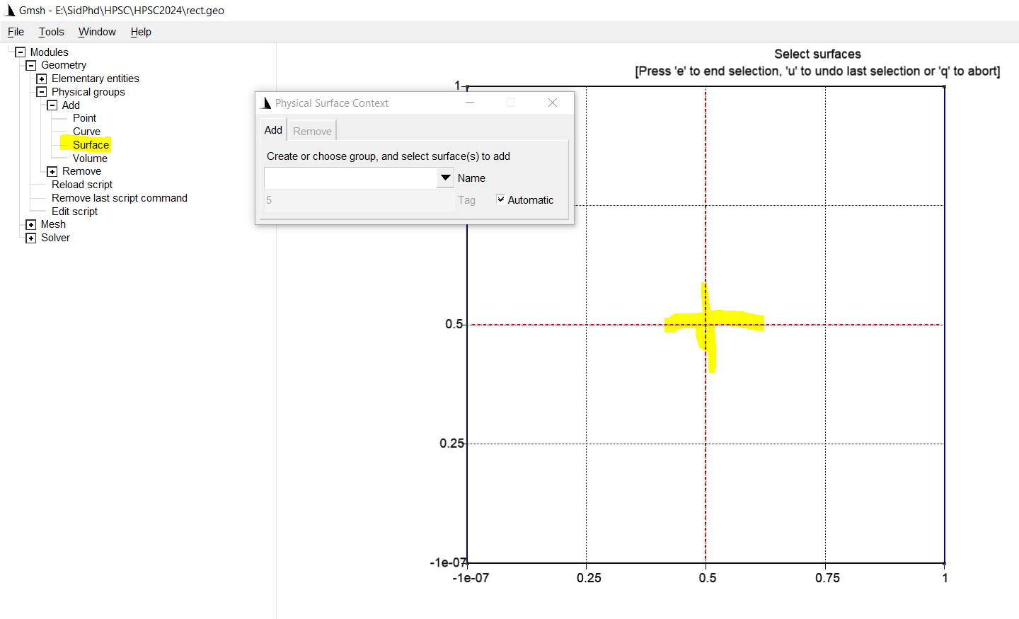

**Creating mesh using Gmsh**

1. Meshà1Dà2DàRecombine2D

1D created 1D elements

2D creates 2D elements in the surface (by default gmsh generated triangular mesh elements)

Recombine 2D will create quad msh. (We need quadrilateral elements for the current code)

1. Double right click on the quad mesh will show a pop. Select Global mesh size factor and put desired value to coarsen (>1) or refine the mesh(<1).
2. Once you have put the mesh size factor. Repeat the meshing process (i.e. Meshà1Dà2DàRecombine2D).

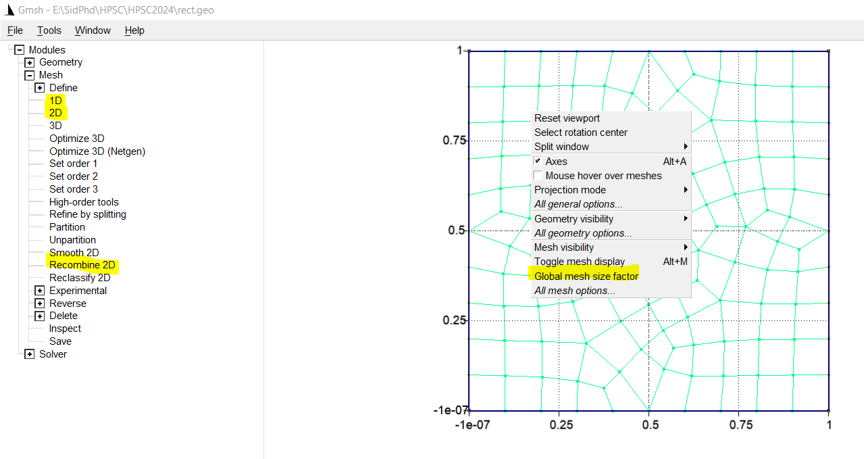

* Export mesh as ‘unstrucquad.msh’. (While exporting take care that to choose ‘Version 2 ASCII’ Format)
* Keep the unstrucquad.msh file in the same folder as that of mshtofem.c and fem.c
* Run the mshtofem.c code first and then fem.c (Do refer to another document named ‘gmsh conditions impose.docx ’ for details regarding modifying the boundary conditions)
* After running fem.c , two matrices will be generated (Kmat.txt - contains the **A** matrix and Fvec.txt will contain the vector **b**)