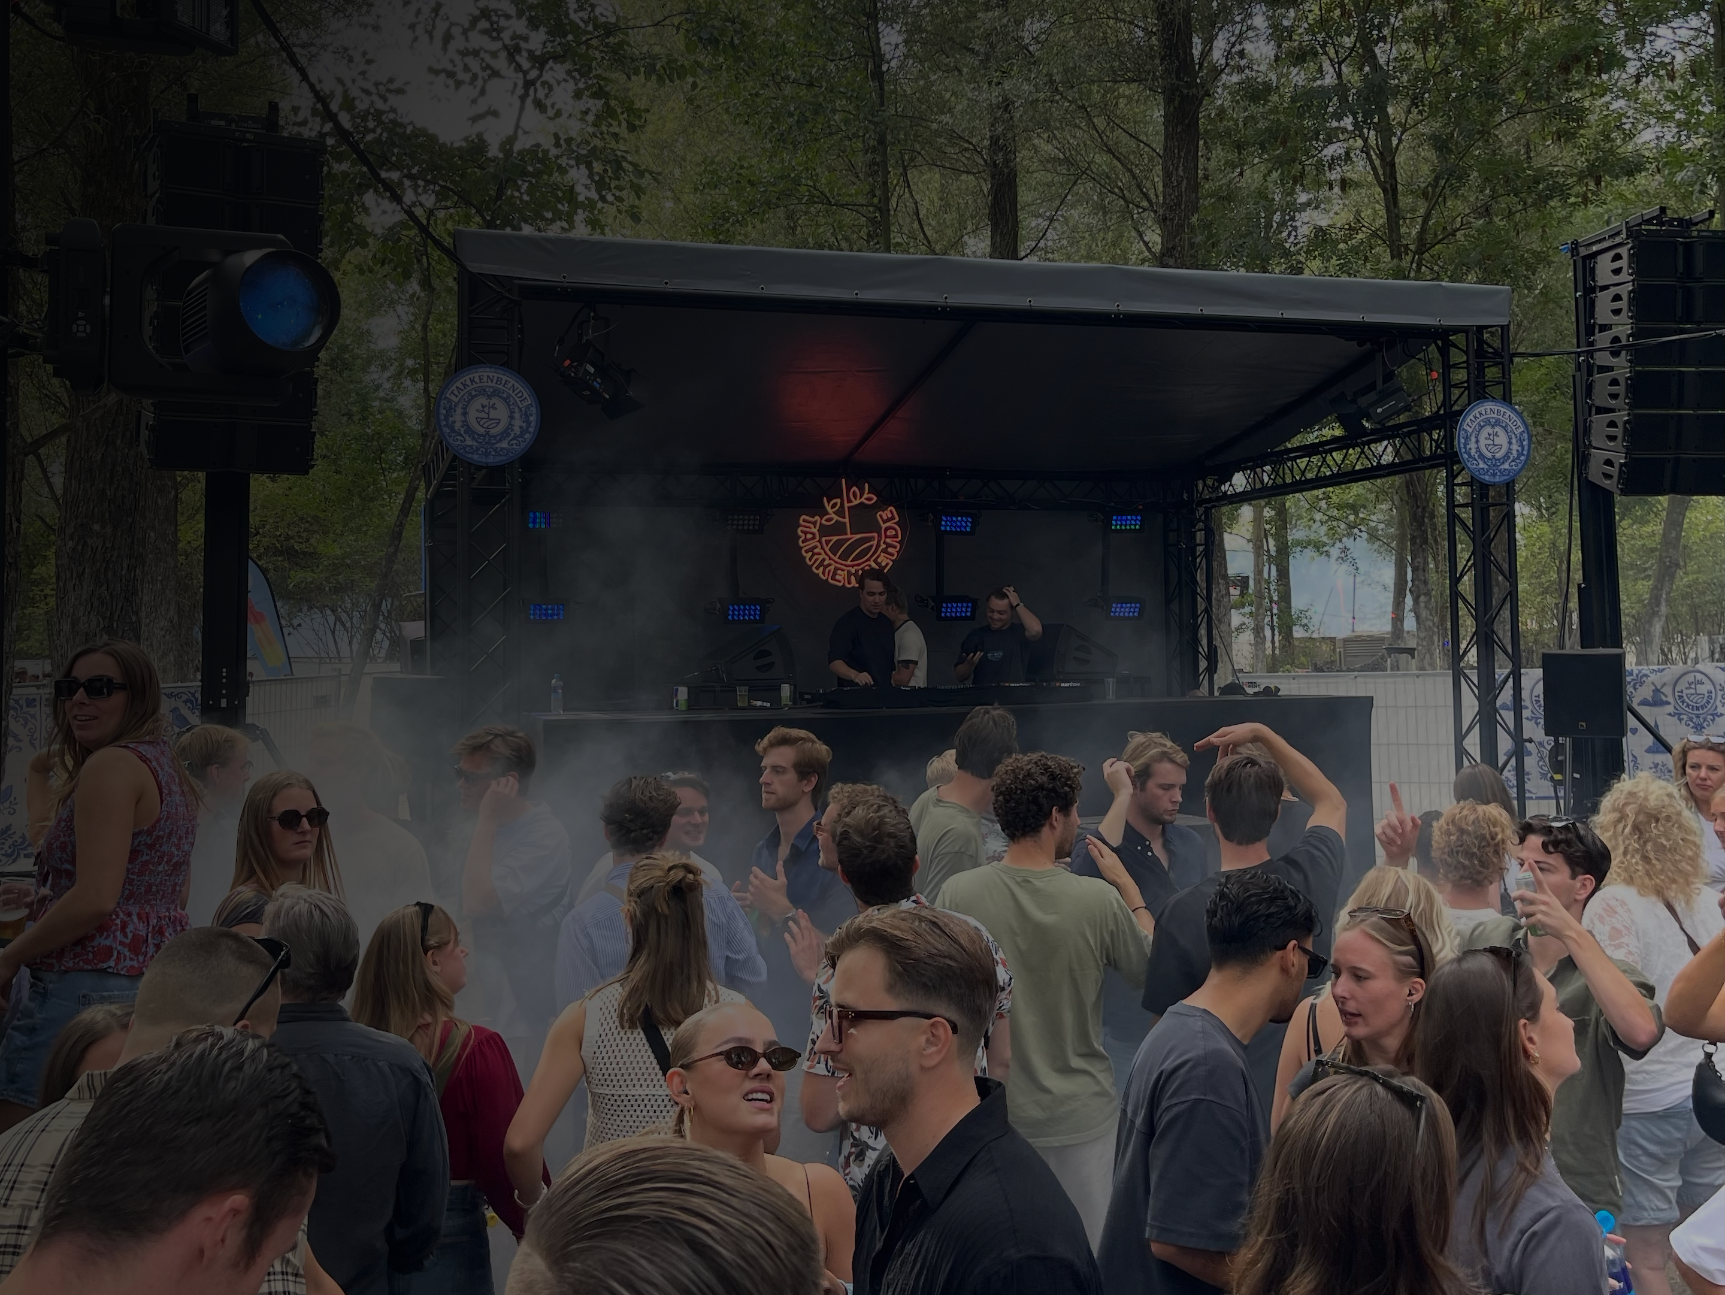


FREE ARTIST GUIDE
The Rise Artist Guide
Your career checklist + key insights from 10 industry professionals on production, branding, bookings, and more.
By the Rise Collective | riseartistacademy.com

How to use this guide
Read this before you start.
The Key Takeaways pages at the back of this guide explain the thinking behind each topic. Read those first. They give you the context for what the checklist asks of you and why each item matters.
Once you are done, come back and work through the checklist honestly. Each item is an action you have either taken or have not. No partial credit.
The seven categories cover everything that separates artists who build real careers from those who stay stuck. Most artists are strong in one or two areas and weak in the rest. This checklist shows you exactly where to focus.
The artists who move fastest do not just read guides. They work with structure, with coaches who have done it before, and within a community that holds them accountable.

YOUR CAREER CHECKLIST
Artist Career Checklist
Work through each category honestly. If you score low in more than one area, start with Identity and Vision. Everything else builds on that foundation.
IDENTITY & VISION – The Beginning of it all
- Define your WHY in one sentence
- Define 3 words that capture your artist energy and use them as a creative filter
- Write your artist origin story
- Create a visual moodboard (20-30 images)
- Build a consistent visual identity across all platforms
- Define your communication formula
PRODUCTION & SOUND
- Build a DAW template with groups, utilities & metering
- Study 3 tracks in your genre and break down their arrangement structure
- Define your signature sound: one recurring element that makes your tracks instantly recognizable
- Test every track at low volume. If the groove does not land there, it needs work
- Apply the 85% rule: release before perfectionism kills the track
- Finish at least 10 tracks completely end-to-end
→ Key Takeaways, Part 1: Production & Sound
MIXING & MASTERING
- Load a reference track at the start of every session
- Mix in 20-minute rounds and switch your monitoring setup between each round
- Gain stage every channel before you start mixing
- Build a mastering chain and export every track to -1dBTP
→ Key Takeaways, Part 2: Mixing & Mastering
MARKETING & SOCIAL MEDIA
- Archive every post that does not reflect who you are as an artist
- Create 3 pinned posts: Hero, Architect, Access
- Organize your Highlights: Start Here, Standard, Validation
- Write a clear, specific bio. No cliches, no filler
- Plan and post 5 cold-entry reels, each addressing one specific micro-problem
- Send a personal voice memo to every new follower within 24 hours
→ Key Takeaways, Part 3: Marketing & Social Media

BOOKINGS & NETWORKING
- Prepare a clean press kit: bio, photos, latest release, and a recorded set
- Write your positioning statement
- Research 3 promoters or bookers you respect and study what they look for
- Ask yourself honestly: would you book yourself right now?
→ Key Takeaways, Part 4: Bookings & Networking
BUSINESS & RIGHTS
- Register with your local PRO (Buma/Stemra)
- Create a split sheet for every collaboration before distribution
- Review every contract for term length and ownership clauses
- Set a release schedule and stick to it
- Block daily studio time in your calendar and treat it as non-negotiable
→ Key Takeaways, Part 5: Business & Rights
MINDSET & FOCUS
- Separate your identity from your output: a bad track does not make you a bad artist
- Identify the artists you compare yourself to most and make a conscious decision to stop
- Set one clear creative goal per month and review it honestly at the end
- Create a go-to routine for creative blocks that gets you back to making without pressure
- Commit to 12 months of consistent output before drawing conclusions about your progress
→ Key Takeaways, Part 6: Mindset & Focus

KEY TAKEAWAYS, PART 1
Production & Sound
Actionable insights you can implement today. Each one comes from the Rise Manual, tested by working artists and industry professionals.
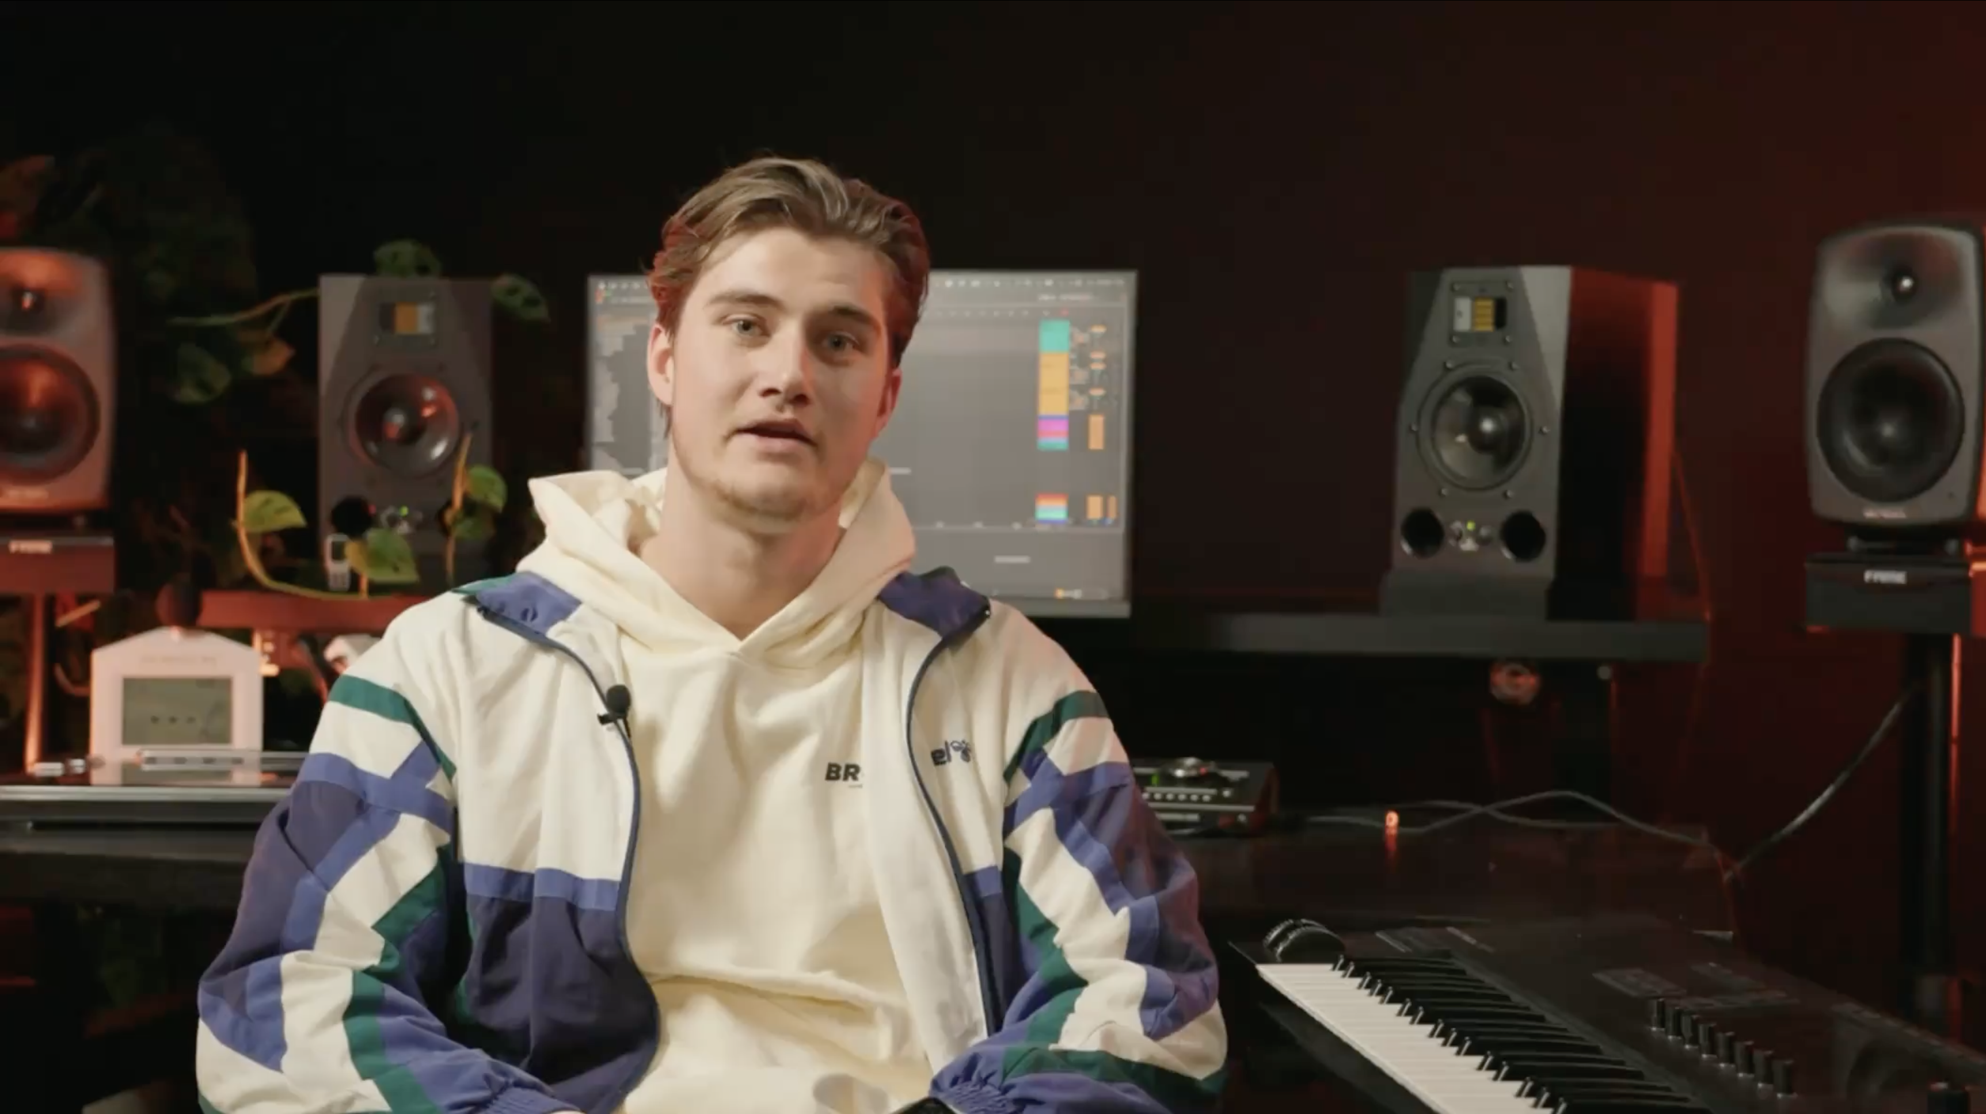
Develop your signature sound
Pick one recurring sonic element across your tracks: a texture, a chord voicing, a rhythmic pattern. Make it yours. The artists people remember have a sound you can identify in 5 seconds.
The 85% rule
When your arrangement works, when groove is tight and structure makes emotional sense, stop. You’re at 85%. That last 15% is where most artists kill their tracks with overthinking.
Study the tracks you want to sound like
Load 3 reference tracks into your DAW and break down their arrangement bar by bar. Note where energy builds, where elements drop, how long the intro is. That is your structural education.
The 20-minute mixing rule
Your ears adapt after 20 minutes. Mix for 20 minutes, break for 5. Switch monitoring: headphones, speakers, phone. Fresh perspective catches what fatigued ears miss.
Low volume reveals the truth
Turn monitors to conversation level. Does the groove still work? If your track only sounds good at high volume, the mix needs work. Every reference check starts at low volume.

KEY TAKEAWAYS, PART 2
Mixing & Mastering
A great mix is not about plugins. It is about decisions. These principles separate tracks that translate from tracks that only sound good in your studio.
Reference tracks do not lie
Load a reference track from the start. Not to copy, but to calibrate. Your ears adapt to your room and your session. A reference breaks that adaptation and shows you where you actually are.
If it does not work at low volume, it does not work
Turn your monitors to conversation level. Does the groove still hit? Does the low end still feel present? If your track only sounds good loud, the mix needs more work.
Gain stage before you touch a plugin
Every channel should peak between -18 and -12 dBFS before any processing. Starting clean means every plugin works as designed. Skip this and you are fighting your own session.
Master your own tracks at least once
Even if you outsource mastering later, run your own tracks through a mastering chain at least once. Understanding the chain from mix to master makes you a better producer, not just a better mixer.
The mix is done when it translates
Test on your phone. Test in your car. Test on cheap earbuds. When it sounds good on all three, you are done. Not when it sounds perfect on your monitors.

KEY TAKEAWAYS, PART 3
Marketing & Social Media
Your music needs to be found. These insights help you build an online presence that attracts the right people without losing your artistic integrity.
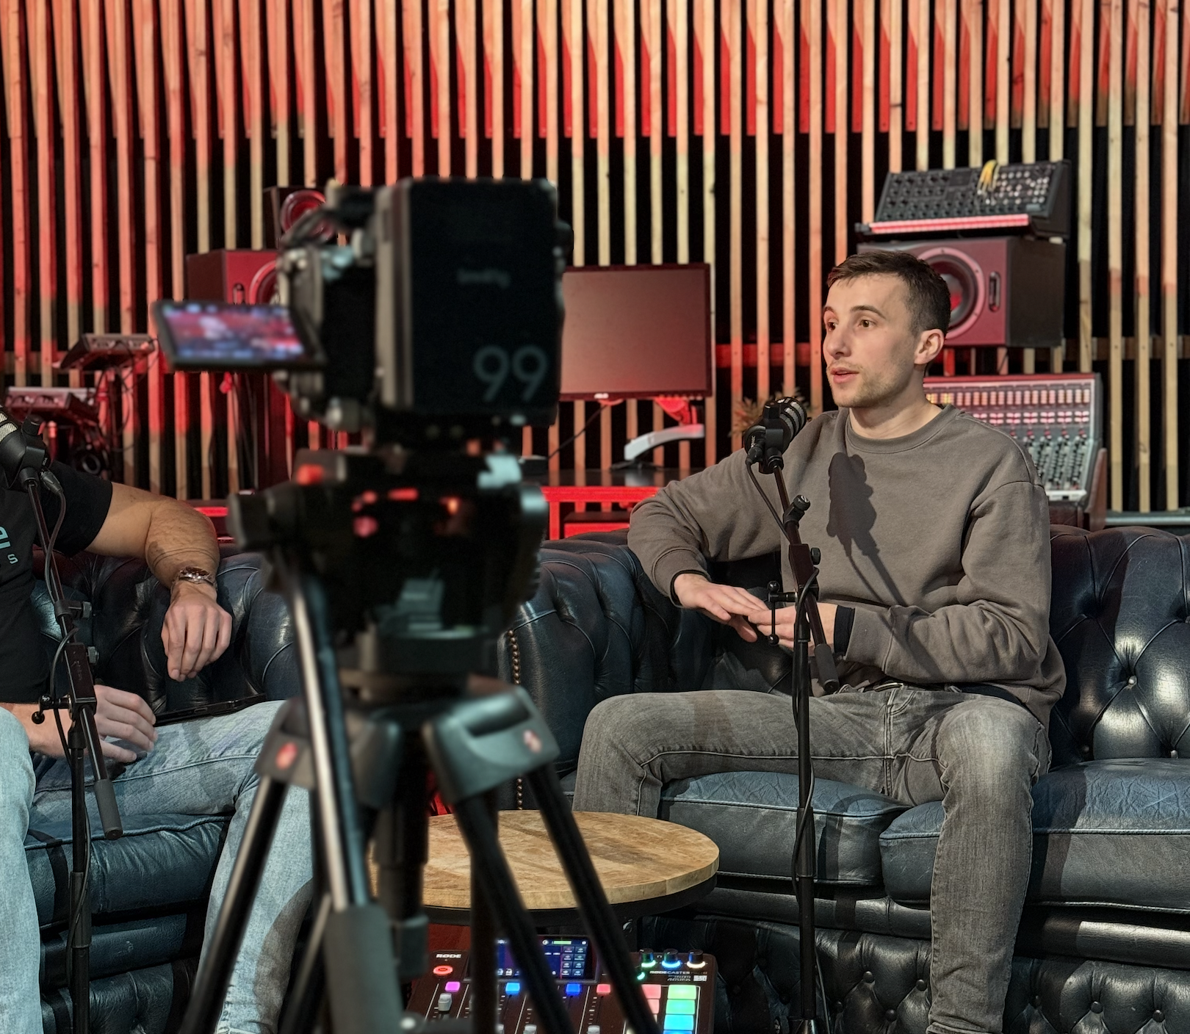
One platform, executed well
Instagram is where the industry judges you. Master one platform before you spread to three. Reels for strangers (micro-problem, quick value), stories for followers (behind-the-scenes, personality). Do that well first.
Archive before you post new
Before you release anything new, audit your current profile. Archive every post that does not reflect who you are as an artist today. Your profile is your first impression. Make it intentional.
Cold-entry reels that convert
Pick one micro-problem your audience has. Solve it in 15 seconds. Your kicks sound flat? Here’s why. Repeat weekly. This is your top-of-funnel. Strangers become followers when you solve real problems.
Write a bio that filters
Your bio is not a resume. It is a filter. It should attract the right people and repel the wrong ones. One sentence on what you make, one on why it matters, one on where to go next. No cliches, no filler.
The communication formula
I make music for [audience], because they have [emotional need], and I deliver that through [my unique approach]. Fill this in. Use it in your bio, your reels, your pitches. Clarity converts.
KEY TAKEAWAYS, PART 4
Bookings & Networking
Talent opens doors, but preparation keeps them open. These insights cover how to position yourself, build relationships, and get booked.
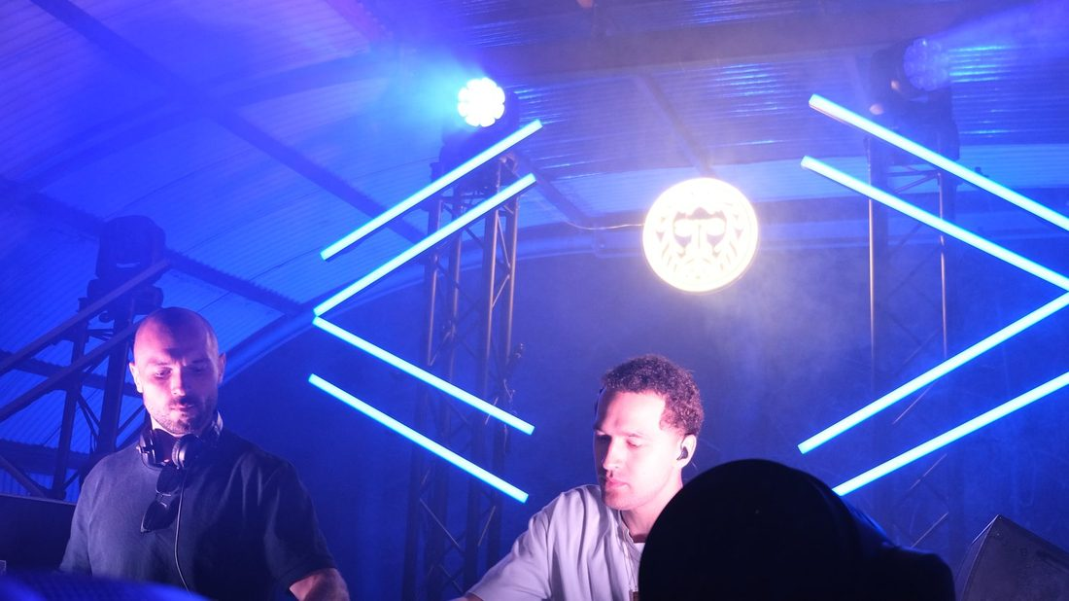
Your press kit is your first impression
One page. Clean photo, 3-sentence bio, latest release with link, social stats if relevant. Promoters decide in 30 seconds. If your kit is unclear or unprofessional, the answer is no before you ask the question.
The positioning statement
I’m [name]. I make [genre/style] for [audience/vibe]. Think [reference 1] meets [reference 2]. Practice saying it out loud until it sounds natural. This is what you say when someone asks what you do.
Research before you reach out
Before you contact a promoter or booker, study 5 shows they have booked. Understand their audience, their venues, their aesthetic. Then write one sentence on why you fit. Generic pitches get ignored. Specific ones get read.
Ask yourself honestly: would you book yourself?
Look at your profile, your press kit, your recorded set. Would you book yourself for the kind of show you want to play? If the answer is no, you know what to fix. If the answer is yes, reach out.
Your first 5 industry contacts matter most
Most bookings come through relationships, not cold emails. Go to shows. Talk to artists on the lineup. Follow up with value, not asks. Your first 5 genuine industry contacts matter more than 50 cold messages.
KEY TAKEAWAYS, PART 5
Business & Rights
The business side of music is not optional. These insights cover the rights, contracts, and systems that protect your work and keep your career running.
Register your music, every track
Register with your local PRO (Buma/Stemra in the Netherlands). Every released track, every collaboration. If your music is playing somewhere and earning royalties, you need to be registered to collect them.
Split sheets before distribution
Create a split sheet for every collaboration before the track goes live. Who wrote what, who produced what, what percentage goes where. A conversation upfront takes 10 minutes. A dispute after the fact takes years.
Read contracts before you sign
Check three things: term (how long the deal lasts), territory (where they can exploit your work), and ownership (who keeps the masters). A bad deal for 5 years is worse than no deal at all.
Set a release schedule and protect it
A release cadence keeps you visible and keeps you working. One track per month, or every 6 weeks. Work backwards from release date. Deadlines create output. Waiting for perfect creates nothing.
Block the time or it does not happen
Daily studio time does not appear on its own. Block it in your calendar and treat it as non-negotiable. An hour a day for a year is 260 hours of practice. That is a career, built one session at a time.

KEY TAKEAWAYS, PART 6
Mindset & Focus
The artists who last are not always the most talented. They are the most consistent, the most self-aware, and the most honest about where they stand.
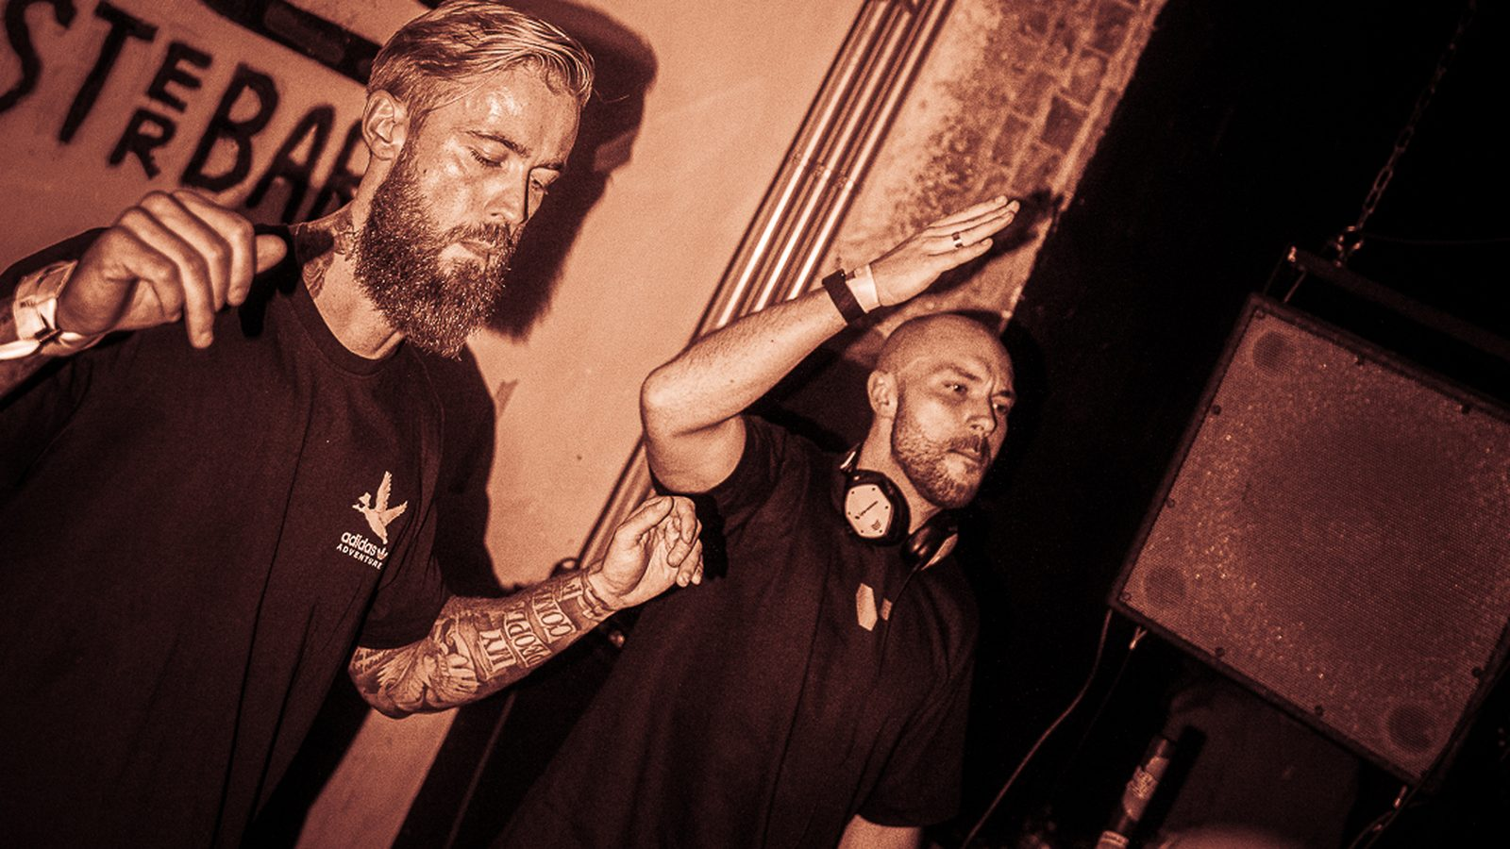
Your output is not your identity
A bad track is not a bad artist. Separate what you make from who you are. The ones who build long careers can take a loss, learn from it, and keep going without making it mean something it does not.
Comparison is information, not truth
When you look at another artist and feel behind, that is information: you care about this. Use it as direction. The moment you treat it as proof you do not belong, it stops being useful.
Consistency over inspiration
You do not need to feel inspired to make something good. One focused hour a day for a year is 260 hours of practice. That is more than most people accumulate in years of waiting for the right moment.
Creative blocks are a signal
When you cannot make anything, ask what you have been making it for. Blocks usually show up when you have been creating for others instead of yourself. Go back to what you made before anyone was watching.
Give your direction a year
Most artists change direction too early, right before things start to compound. Stay in one lane for 12 months before deciding it is not working. Results in music rarely show up in the first few months.

What comes next
You have the map.

This guide gives you the framework. It shows you where you are and what to work on next. Most people who read it will nod along and go back to doing what they were doing.
The ones who move are the ones who work with structure, get feedback on their actual work, and stay inside an environment that keeps them accountable. That is what Rise is built for.
A structured program built around the six areas in this guide. A community of serious artists at the same stage. Coaches who have been there and know what the next step actually looks like.
If you are ready to go further, you know where to find us.

riseartistacademy.com
2026 Rise | Recode Operations B.V. | All rights reserved

