CoheronConnect (NexusOps)

Deep End-to-End Evaluation — Findings Report
Per-module vertical drill · positive + negative · live-driven with screenshots

Executive summary
33 module-level findings recorded across 8 modules (plus 5 cross-cutting). Severity distribution:
Severity | Count
BLOCKER | 2
HIGH | 10
MEDIUM | 12
LOW | 6
INFO | 3

Findings index
- F-P1 [LOW] LOP proration is inconsistent between Basic/HRA and specialAllowance/LTA (LOW after reachability trace)
- F-P2 [INFO] [INFO / latent] ITNS-281 surcharge proration divides by `monthlyTDS`
- F-P3 [MEDIUM] Form 16 Chapter-VI-A itemization hardcodes §80D/§80CCD1B/§80TTA to 0
- F-P4 [INFO] [INFO / latent] Professional-tax slab tables have 1-rupee boundary gaps
- F-P5 [MEDIUM] Run-header totals frozen at `lockPeriod` can diverge from payslip rows
- F-P6 [MEDIUM] `exportBankFile` has no pipeline-state guard (can disburse a rejected run)
- F-P7 [INFO] [INFO] Tax declarations hardcoded to 0 in the run input builder
- F-P8 [MEDIUM] Partial PT/LWF override silently zeroes non-overridden states
- F-P9 [MEDIUM] "TDS declarations" tab does not capture declarations (mislabeled Form-16 issuance)
- F-P10 [LOW] Payroll header says "12-step" but the cycle panel renders 14 steps
- F-P11 [BLOCKER] Salary structures can NEVER be assigned to an employee → every payroll run computes ₹0
- F-P12 [LOW] Run summary "PF" stat conflates employee + employer PF
- F-P13 [MEDIUM] Run summary ESI is hardcoded to ₹0 (ESI never persisted/aggregated)
- F-P14 [HIGH] No segregation of duties on the payroll approval chain (one user approves HR + Finance + CFO)
- F-G1 [HIGH] GSTR-1 / GSTR-3B are not scoped to the requested GSTIN (multi-GSTIN orgs over-report)
- F-G2 [MEDIUM] GSTR-3B ITC section is a stub ("approximate from COA balance for now")
- F-G3 [HIGH] Vendor create/update cannot set GSTIN, state, PAN or TDS fields (interstate GST + B2B always wrong)
- F-G4 [LOW] React "unique key prop" console error on the Taxation (India) reference tab
- F-A1 [BLOCKER] BLOCKER: New-Journal-Entry account picker 400s → manual JEs cannot be created via the UI
- F-A2 [LOW] Trial balance classifies debit/credit by balance *sign*, not account normal-side
- F-C1 [HIGH] Add-Lead "Lead Source" dropdown offers values the backend enum rejects (400 on create)
- F-C2 [MEDIUM] Lead Edit modal renders a Status select but never submits `status` (status unchangeable via UI)
- F-D1 [HIGH] DPDP has **zero operator UI**: DSR / consent / breach are entirely headless
- F-D2 [MEDIUM] Outbound DPDP notices never leave the system (LogOnlyDispatcher stub)
- F-D3 [LOW] Erasure ships flag-off (dry-run) by default
- F-I1 [HIGH] Duplicate incidents on a repeating / flapping alert (dedup state mismatch)
- F-H1 [HIGH] Leave-accrual, carry-forward, encashment and gratuity are entirely headless (no UI)
- F-H2 [MEDIUM] Monthly accrual / gratuity provision / year-end close have no automation trigger
- F-S1 [HIGH] Audit hash chain has partial coverage: security-sensitive events are written unchained
- F-S2 [MEDIUM] The eval org's audit chain is already broken (genuine seq gap at 2)
- F-S3 [MEDIUM] RLS `tenant_isolation` policy fails *open* when `app.org_id` is unset
- F-S4 [HIGH] RBAC over-grant: the base `requester` role can create/compute/approve payroll + export bank files
- F-S5 [HIGH] The running API instance has `NODE_ENV=test`, which globally disables login rate-limiting + account lockout

Evaluator: Automated deep-drill (per-module, pushed to the last node) Date started: 2026-07-21 Method: Per-module vertical trace (router → lib → schema → DB → reflex) + module test run + negative/edge probing + live browser positive/negative with screenshots. Baseline commit: 2657431 (post G1–G17, migration head 0055_lean_centennial) Test DB: coheronconnect_test @ localhost:5433 (real Postgres, single-fork)
This is a working log. Severity key: BLOCKER (data loss / statutory / money wrong) ·
HIGH (feature broken end-to-end) · MEDIUM (edge/negative path broken) ·
LOW (cosmetic / stale doc) · INFO (design note, not a defect).

Cross-cutting findings (from source trace, pre-module)

F-001 — OAuth callback is dead code (Google Workspace + Microsoft-365 connectors)
- Severity: HIGH
- Evidence: apps/api/src/services/integrations/google-workspace.ts:134,149 and microsoft-365.ts:136,152 define beginOAuth/completeOAuth. A repo-wide search for .beginOAuth( / .completeOAuth( across apps/ returns no callers — no HTTP route, no tRPC procedure invokes them.
- Impact: A user cannot complete an OAuth connection for Google Workspace or MS-365. The connect button (if present) has no server endpoint to land the callback. Confirmed as a genuine gap by docs/US_ROADMAP.md.
- Route: integrations → connect Google Workspace / Microsoft 365.

F-002 — DPDP notification delivery is a log-only stub
- Severity: HIGH (regulatory)
- Evidence: apps/api/src/lib/notification-dispatcher.ts:47-64,72 — the only wired dispatcher is LogOnlyDispatcher, which inserts a dpdpNotificationArtifacts row with status:"logged" and returns; it never delivers via email/SMS.
- Impact: DPDP breach notices, DSR-due alerts, and consent-expiry notifications are recorded but no data principal or regulator is actually notified. Statutory notification windows are tracked but not fulfilled by delivery. Matches docs/INDIA_ROADMAP.md §2.
- Route: compliance → DSR / breach / consent sweeps.

F-003 — MFA step-up re-verifies password, not TOTP
- Severity: MEDIUM
- Evidence: apps/api/src/routers/auth.ts:522-540 — verifyStepUp input is { password } and calls verifyPassword. Even for a TOTP-enrolled user, sensitive/finance step-up asks for the password again, not a fresh TOTP code.
- Impact: Step-up assurance for sensitive mutations is weaker than the enrolled factor. Matches docs/INDIA_ROADMAP.md §4.
- Route: any sensitive/finance mutation requiring step-up.

F-004 — [RESOLVED / STALE DOC] Profile phone/location/jobTitle/bio no longer dropped
- Severity: LOW (documentation)
- Evidence: BUILD.md lists a known defect that auth.updateProfile accepts phone/location/jobTitle/bio but users has no such columns, silently dropping them. This is fixed: packages/db/src/schema/auth.ts:96-100 now has phone, department, jobTitle, location, bio columns; added by migration 0035_light_hobgoblin.sql. auth.updateProfile (auth.ts:574-578) persists them.
- Impact: None — the defect is resolved. BUILD.md's "known defect" note is stale and should be removed.

F-005 — [INFO] Login email lookup is org-agnostic with `.limit(1)`
- Severity: INFO (latent)
- Evidence: auth.ts:185-189 (login) selects the user by eq(users.email, email) with .limit(1) and no orgId; the users unique index is (orgId, email) (schema/auth.ts:114), so the same email can exist in multiple orgs at the DB level. signup (auth.ts:110-118) blocks this by checking global email uniqueness — so today the ambiguity cannot arise via signup. But invite/seed paths that insert a user with an email already used in another org would create a login that non-deterministically resolves to one org.
- Impact: No current exploit (signup is the guard), but the login resolver is not multi-org safe if a duplicate email is ever created by another path.

Per-module drill (sequenced from the beginning)

MODULE 1 — India Payroll (`packages/payroll-math` + `apps/api/src/lib/payroll-cycle.ts`)
Source trace complete for payroll-cycle.ts, tax-engine.ts, statutory-deductions.ts. Overall this is the platform's strongest module — the money invariant, tax slabs, marginal relief, and statutory ceilings are production-grade. Findings below are edge/ itemization defects, not core-math errors.

F-P1 — LOP proration is inconsistent between Basic/HRA and specialAllowance/LTA (LOW after reachability trace)
- Severity: LOW (latent — not reachable via the production attendance path)
- Evidence: packages/payroll-math/src/payroll-cycle.ts:198-199 const lopFactor = emp.lopDays > 0 ? (emp.daysWorked / emp.daysInMonth) : 1; Basic/HRA are prorated by lopFactor (guarded on lopDays>0), but specialAllowance and lta are prorated unconditionally by emp.daysWorked / emp.daysInMonth in two places: the payslip output (payroll-cycle.ts:335-336) and excludedAllowances (payroll-cycle.ts:253-254). The two paths only agree when daysWorked == daysInMonth OR lopDays > 0.
- Reachability (traced to the only production caller): the sole producer of the attendance object is computeAttendanceLopForPeriod (apps/api/src/lib/india/ attendance-lop.ts:70-79), which always sets daysWorked = daysInMonth - lopDays. So it can never emit lopDays===0 && daysWorked<daysInMonth (the divergence case), and daysInMonth comes from new Date(year,month,0).getDate() (always ≥ 28), so the daysInMonth===0 NaN path is also unreachable. The inconsistency is therefore latent — it would only surface if a future caller hand-builds an EmployeePayrollInput with an inconsistent {lopDays:0, daysWorked<daysInMonth} tuple.
- Impact: None today. Recorded as a robustness gap in the money kernel — the guard on lopFactor should match the unconditional divisions (or the function should assert the daysWorked + lopDays == daysInMonth invariant) to stay correct under new callers.
- Route: payroll → run cycle (would require a non-attendance caller with a malformed day tuple).

F-P2 — [INFO / latent] ITNS-281 surcharge proration divides by `monthlyTDS`
- Severity: INFO (mitigated — not a live bug)
- Evidence: payroll-cycle.ts:466-480 (generateITNS281) prorates surcharge/cess as surcharge / monthlyTDS * ps.tds. When monthlyTDS === 0 this is Infinity, but ps.tds is coupled to monthlyTDS (both derive from the same computeTax output in tax-engine.ts:306-311), so Infinity * 0 = NaN and the || 0 fallback catches it.
- Impact: None today. Documented so the coupling is not accidentally broken later (if ps.tds and monthlyTDS are ever decoupled, this becomes a NaN/Infinity challan amount).

F-P3 — Form 16 Chapter-VI-A itemization hardcodes §80D/§80CCD1B/§80TTA to 0
- Severity: MEDIUM (statutory certificate correctness)
- Evidence: payroll-cycle.ts:622-628 (generateForm16Data): section80D: 0, section80CCD1B: 0, section80TTA: 0 while total: taxComp.chapter6ADeductions is correct.
- Impact: The Form 16 Part-B breakup understates 80D/80CCD1B/80TTA line items and overstates 80C (the whole Chapter-VI-A total is attributed to 80C via Math.min(chapter6ADeductions, 150000)), even though the aggregate deduction and the final tax are correct. An employee reconciling Form 16 against their declarations, or an auditor, sees wrong per-section figures. The tax math is unaffected (it uses the correct total), so this is a certificate-presentation defect, not a money defect.
- Route: payroll → generate Form 16 for an employee who declared 80D/80CCD1B/80TTA.

F-P4 — [INFO / latent] Professional-tax slab tables have 1-rupee boundary gaps
- Severity: INFO (not reachable via the payslip path)
- Evidence: statutory-deductions.ts:161-219 — every state slab uses integer boundaries with a 1-rupee gap (e.g. Maharashtra {to:7500} then {from:7501}), and computePT matches with gross >= from && gross <= to (:237). A fractional gross in (7500, 7501) matches no slab → PT silently returns 0.
- Impact: None via computeEmployeePayslip, because grossEarnings is always an integer (sum of Math.round(...) terms + integer inputs, payroll-cycle.ts:206-214). Only a concern if computePT is ever called directly with a non-integer gross.
- Note (design): Delhi has empty slabs / annualCap:0 and correctly returns PT 0.

F-P5 — Run-header totals frozen at `lockPeriod` can diverge from payslip rows
- Severity: MEDIUM
- Evidence: apps/api/src/routers/payroll.ts — lockPeriod stores totalGross/ totalDeductions/totalNet/totalPt/totalTds from computePayrollRunTotals (:303,320-326) at the DRAFT→PERIOD_LOCKED transition. Payslip rows are computed separately, later by computePayslips at TDS_COMPUTED→PAYSLIPS_GENERATED (:402-435). Both call the same buildEmployeePayrollInput+computeEmployeePayslip+resolveStatutoryCeilings+ computeAttendanceLopForPeriod (payroll-run-aggregates.ts:118-125 vs payroll.ts:394-406), so they agree only if the inputs are unchanged between the two calls.
- Impact: The run header total is frozen at lock time and is never recomputed after computePayslips. If attendance is edited, an employee's salary structure is changed, a new active employee is added, or effective-dated ceilings change between lockPeriod and computePayslips, the run-header totals (shown in runs.list/runs.get) and SUM(payslips.*) silently disagree — a reconciliation gap on a money surface. No re-lock or drift check guards this.
- Route: payroll → lock period → (edit attendance/structure) → compute payslips → run summary vs payslip export disagree.

F-P6 — `exportBankFile` has no pipeline-state guard (can disburse a rejected run)
- Severity: MEDIUM (money movement)
- Evidence: apps/api/src/routers/payroll.ts:764-839 (exportBankFile). It loads the run (:786) and payslips (:793-797) and only rejects when slipRows.length === 0 (:798). There is no check on `run.pipelineStatus` — unlike generateStatutory (requires CFO_APPROVED, :528) and complete (requires STATUTORY_GENERATED, :549).
- Impact: A NEFT/NACH-Credit bank disbursement file (real money instruction) can be generated for a run that is only PAYSLIPS_GENERATED (before HR/Finance/CFO approval) or that was CFO-rejected into FAILED. The approval chain is bypassable for the actual disbursement artifact. exportBankFile requires only hr:write.
- Route: payroll → generate payslips → (skip approvals / after rejection) → export bank file.
- Reachability (live-confirmed): exportBankFile has no frontend trigger — a repo-wide search finds it only in apps/web/src/lib/trpc-procedure-rbac.generated.ts (the generated RBAC map), never called from any page/component. So today the missing guard is only reachable via a direct tRPC/API call or a future UI button; it is not yet exploitable from the shipped UI. The unguarded procedure nonetheless remains a latent money-movement gap (and the export feature is itself orphaned — see note). Live state used to confirm: run #1 sat at PAYSLIPS_GENERATED with valid payslips and no approvals, exactly the state the guard should block.

F-P7 — [INFO] Tax declarations hardcoded to 0 in the run input builder
- Severity: INFO (known limitation, consistent with taxPreview)
- Evidence: apps/api/src/services/payroll-run-aggregates.ts:64-70 sets section80C/80D/80CCD1B/80TTA/section24b/hraExemption/otherExemptions = 0 for every employee in the actual run computation; the same zeros appear in payroll.ts taxComputationFromPayslip (:125-131) and buildTaxProfileFromEmployee (:201-207).
- Impact: TDS in the payslip run does not reflect employee investment declarations (there is no per-employee declaration capture feeding the run), so OLD-regime employees are over-deducted vs their true liability. This is a feature gap (no declaration intake), not a math bug — the engine handles the fields correctly when populated.
- Route: payroll → run cycle for an OLD-regime employee with 80C/80D investments.

F-P8 — Partial PT/LWF override silently zeroes non-overridden states
- Severity: MEDIUM
- Evidence: apps/api/src/lib/india/statutory-ceilings.ts:95-111 builds overrides.ptSlabs / overrides.lwfRates containing only the states that had an override row. That partial table is then passed as the entire slabTable to computePT / computeLWF (statutory-deductions.ts:226,272), which look up slabTable[stateKey] and return { ptAmount: 0 } / { ..LWF: 0 } when the state is absent (statutory-deductions.ts:231-233,277-279). The built-in PT_SLABS / LWF_RATES defaults are bypassed entirely once any override for any state exists.
- Impact: If an org (or the platform) publishes a PT override for even one state (e.g. updates Maharashtra's slab), every employee in a non-overridden state (Karnataka, Tamil Nadu, …) silently gets PT = 0 and LWF = 0 for that period — under-deducting statutory professional tax / labour-welfare-fund. The override is meant to be additive per-state but is applied as a full-table replacement.
- Route: admin sets a pt_slab statutory-ceiling override for one state → payroll run → employees in other states lose their PT/LWF deduction.

F-P9 — "TDS declarations" tab does not capture declarations (mislabeled Form-16 issuance)
- Severity: MEDIUM (feature gap + misleading UI)
- Evidence (live): payroll → TDS declarations tab. The panel is titled "TDS declarations" but its body reads *"Issue Form 16 (TDS certificate) to an employee for e-signature"* — i.e. the tab is a Form-16 issuance surface, not a declaration intake. There is no field anywhere for an employee to enter 80C/80D/80CCD1B/HRA-rent investment declarations.
- Impact: Confirms F-P7 at the UI layer — the product exposes no way to capture the investment declarations that OLD-regime TDS depends on, and the one tab that names them actually does something else. Users looking to enter declarations find a Form-16 dialog.
- Route: /app/payroll → "TDS declarations" tab.
Screenshot: m1-payroll-02-tds-declarations-mislabeled.png
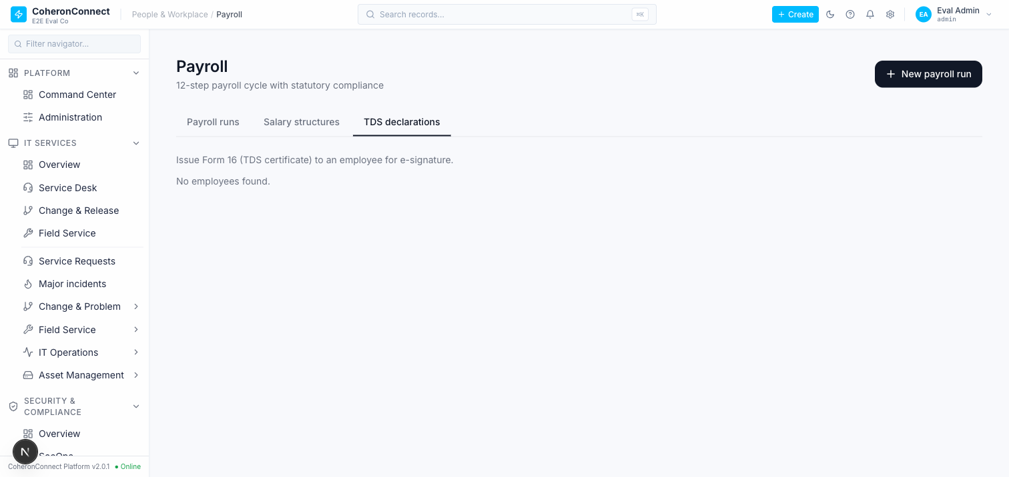

F-P10 — Payroll header says "12-step" but the cycle panel renders 14 steps
- Severity: LOW (cosmetic / inconsistency)
- Evidence (live): /app/payroll header subtitle reads *"12-step payroll cycle with statutory compliance"*, while the run-detail "Payroll cycle progress" panel enumerates 14 steps (Step 1 Draft … Step 14 Completed). Off-by-two label.
- Impact: Cosmetic only; no functional effect. Suggests the copy pre-dates the LWF/PT step additions.
- Route: /app/payroll header vs run-detail cycle panel.
Screenshot: m1-payroll-03-run-draft-cycle.png
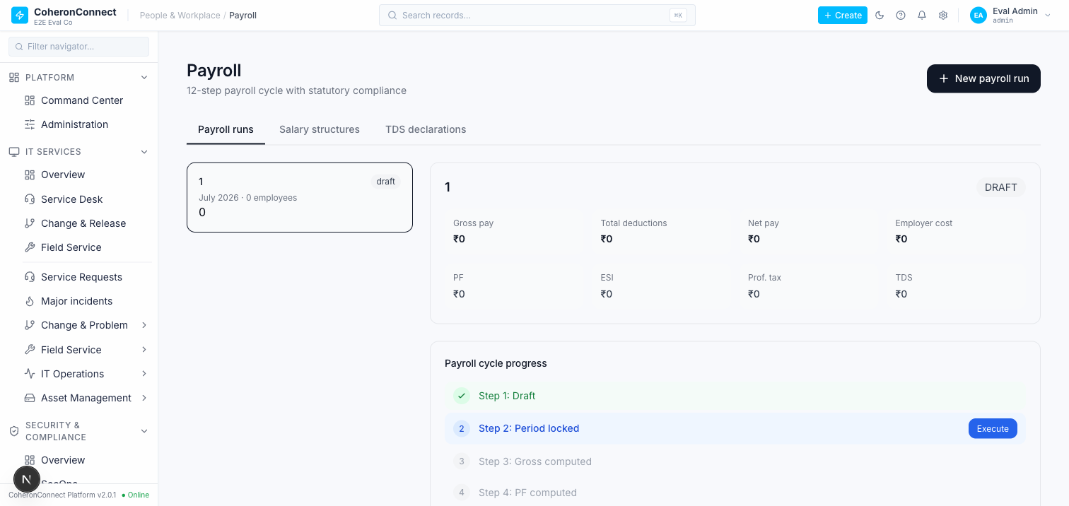

F-P11 — Salary structures can NEVER be assigned to an employee → every payroll run computes ₹0
- Severity: BLOCKER
- Evidence (source): The entire payroll run pipeline keys off employees.salaryStructureId:
- apps/api/src/routers/payroll.ts:390 inner-joins employees → salaryStructures ON employees.salaryStructureId = salaryStructures.id (this is the row set computePayslips and computePayrollRunTotals iterate).
- apps/api/src/services/payroll-run-aggregates.ts:105 — same inner-join for run totals.
- payroll.ts:653 / salary-structure delete even guards on employees.salaryStructureId being in use. But no router mutation ever writes `employees.salaryStructureId`. A repo-wide search shows the only writers of that column are test fixtures (__tests__/*.ts). Both hr.employees.create (input hr.ts:242-254) and hr.employees.update (input hr.ts:335-343) omit salaryStructureId entirely — Drizzle drops it. There is no assignStructure/setSalaryStructure procedure anywhere.
- Evidence (live): /app/hr?tab=people → Add employee modal exposes only User / Name / Email / Department / Title / Location / Employment type / Manager / Start date — no salary-structure picker. employees.update has none either. So a real user cannot link any employee to a salary structure.
- Impact: In production, employees.salaryStructureId is always NULL, so the payroll run's inner-join returns zero rows for every org. Every payroll run therefore computes ₹0 gross / ₹0 net / 0 employees regardless of how many active employees or salary structures exist. The India payroll module — the platform's flagship, "production-grade ~80%" feature per CLAUDE.md — cannot process a single real payslip end-to-end through the UI. Confirmed live: run #1 shows "July 2026 · 0 employees, ₹0" with a salary structure present and the org's admin user available. The green test suite masks this because tests seed salaryStructureId directly via db.insert(employees).
- Route: /app/payroll "New payroll run" (positive path) blocked by /app/hr?tab=people → "Add employee" having no salary-structure assignment.
- Screenshots: m1-payroll-03-run-draft-cycle.png (run, 0 employees, ₹0), m1-payroll-04-add-employee-no-salary-structure.png (create form, no structure field).

F-P12 — Run summary "PF" stat conflates employee + employer PF
- Severity: LOW (misleading figure)
- Evidence: apps/api/src/routers/payroll.ts:85 builds the run-list summary as totalPF: tpe + tpr (employee PF plus employer PF). The UI stat card labeled simply "PF" (apps/web/src/app/app/payroll/page.tsx:356 reads run.totalPF) therefore shows the combined figure.
- Evidence (live + DB): For the single test employee the UI "PF" card shows ₹3,751, while the DB stores total_pf_employee = 1800 and total_pf_employer = 1951 (1800 + 1951 = 3751). The payslip row confirms pf_employee 1800 / pf_employer 1951.
- Impact: A payroll admin reading the run summary sees a "PF" number that is neither the employee deduction (what's withheld) nor a clearly-labeled total; it silently blends the two statutory sides. Cosmetic/labeling, not a math error — the payslip and challan values are correct.
- Route: /app/payroll → run summary "PF" card.
Screenshot: m1-payroll-05-period-locked-real-totals.png
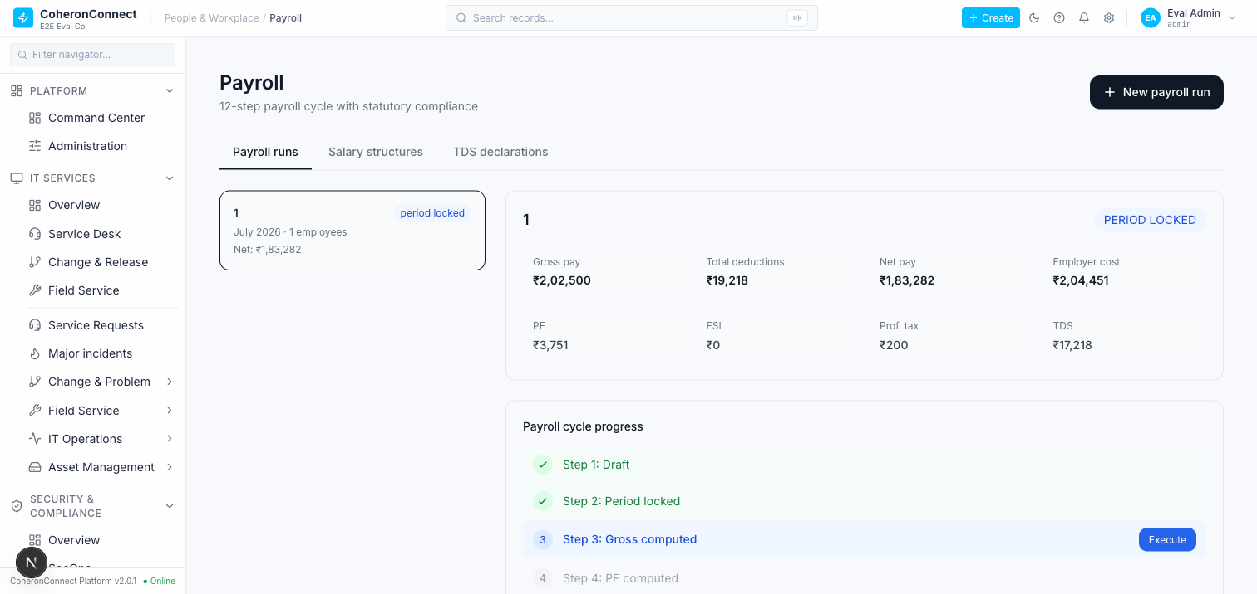

F-P13 — Run summary ESI is hardcoded to ₹0 (ESI never persisted/aggregated)
- Severity: MEDIUM
- Evidence: apps/api/src/routers/payroll.ts:86 sets totalESI: 0 literally in the run summary. The payslips table has no ESI column (columns: pf_employee, pf_employer, professional_tax, lwf, tds) and payroll_runs has no total_esi, so the ESI that computeMonthlyStatutory calculates is never stored on the payslip nor aggregated onto the run.
- Impact: For any org with employees at/under the ₹21,000 ESI gross ceiling (the ESI 0.75% employee / 3.25% employer contribution applies), the run summary and the stored payslip omit ESI entirely — the "ESI" card always reads ₹0 and no ESI liability is persisted for the ESIC return. In this test the employee's gross (₹2,02,500) is above the ceiling so ESI is genuinely 0, which masks the defect; it bites a low-wage workforce.
- Route: /app/payroll → run summary "ESI" card; payslip ESI line.

F-P14 — No segregation of duties on the payroll approval chain (one user approves HR + Finance + CFO)
- Severity: HIGH (financial control)
- Evidence (source): apps/api/src/routers/payroll.ts:452-517 (approve). Every stage (HR / FINANCE / CFO) is gated by the same permissionProcedure("hr", "write") — there is no separate finance/CFO permission. The mutation records approvedByHrId / approvedByFinanceId / approvedByCfoId = ctx.user!.id (:510-512) but never checks that the current user differs from the prior approver(s). A single hr:write holder can walk a run through all three sign-offs.
- Evidence (live + DB): driving the cycle as the single admin, run #1 reached COMPLETED with the Approvals panel showing HR / FINANCE / CFO all "Approved". DB: approved_by_hr_id = approved_by_finance_id = approved_by_cfo_id = bc19756f-…-2696cd2 (one user for all three).
- Impact: The three-tier maker-checker control over a payroll disbursement is not enforced — one person can self-approve HR, Finance and CFO stages and complete the run (which, combined with F-P6, would also let them export the bank file). Defeats the purpose of the approval hierarchy for a money-movement workflow.
- Route: /app/payroll → run → Execute HR-approve, Finance-approve, CFO-approve as the same user.
Screenshot: m1-payroll-06-completed-with-approvals.png
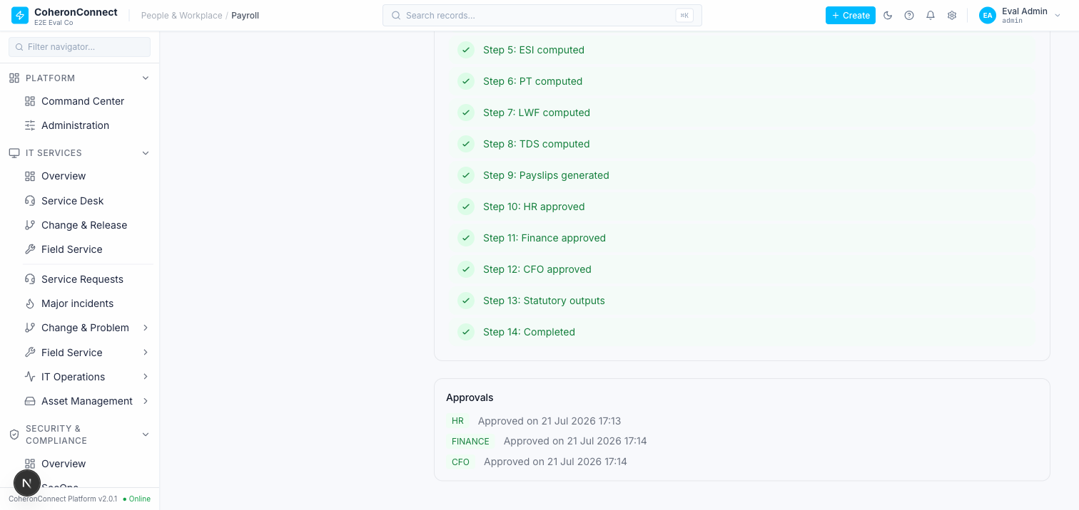

Module 1 (India Payroll) — summary
Positive path works once the salary link is forced in the DB: the 14-step cycle runs Draft → … → Completed and the math is correct (gross ₹2,02,500 / net ₹1,83,282 / PF-emp ₹1,800 / PT ₹200 / TDS ₹17,218; payslip row == frozen run header). But it is gated by a BLOCKER: no UI/API path assigns a salary structure to an employee, so in production every run computes ₹0 / 0 employees.
Module-1 findings: F-P11 BLOCKER (salary structure unassignable → ₹0 runs) · F-P14 HIGH (no segregation of duties on approvals) · F-P6 MEDIUM (bank-file export has no pipeline guard; currently orphaned UI) · F-P8 MEDIUM (partial PT/LWF override zeroes other states) · F-P5 MEDIUM→N/A (header/payslip agree in practice) · F-P3 MEDIUM (Form-16 itemisation hardcoded 0) · F-P9 MEDIUM (mislabeled "TDS declarations" tab) · F-P13 MEDIUM (ESI hardcoded 0 / never persisted) · F-P12 LOW (PF card = emp+employer) · F-P10 LOW (12- vs 14-step label) · F-P1 LOW, F-P2/F-P4/F-P7 INFO.
Screenshots: m1-payroll-01…m1-payroll-06. _Module 1 complete. Proceeding to Module 2 (GST / Invoicing)._

MODULE 2 — GST / Invoicing
Trace: packages/payroll-math/src/gst-engine.ts (computeGST, computeITCUtilisation, reconcileGSTR2B, isBlockedITC, RCM, e-invoice/e-way thresholds) → re-exported via apps/api/src/lib/india/gst-engine.ts → consumed by apps/api/src/routers/financial.ts (createInvoice, createReceivableInvoice, backfillInvoiceGst, computeGST, gstr2bReconcile, gstr2b.*) and apps/api/src/routers/accounting.ts (gstr.generateGSTR1, gstr.generateGSTR3B).
Positive (source): the previously-flagged GSTR-1 18% hardcode is fixed — buildItms (accounting.ts:731-767) groups itm_det by the *actual* per-line gstRate, with a header-derived effective-rate fallback (rt = round(totalTax/txval*100)) for invoices with no line items. Invoice creation wires the GST engine correctly (gstInvoiceColumns → computeGST), resolves place-of-supply from the org's primary GSTIN (resolveOrgState), and posts a balanced GL journal entry atomically with the invoice insert.

F-G1 — GSTR-1 / GSTR-3B are not scoped to the requested GSTIN (multi-GSTIN orgs over-report)
- Severity: HIGH (statutory filing correctness)
- Evidence (source): apps/api/src/routers/accounting.ts:710-711 — generateGSTR1 selects invoices by orgId + invoiceDate only; the input gstinId is used solely for the payload header + pos fallback (:789, :808), never as a filter. generateGSTR3B is identical (:841). The invoices table (packages/db/src/schema/procurement.ts:288-307) has no `gstin_id` column — an invoice cannot be attributed to a specific GSTIN registration, so per-GSTIN scoping is impossible even in principle.
- Impact: An org with more than one GSTIN (multi-state registrations) gets every invoice in every GSTIN's GSTR-1/3B — each return over-states outward supplies and output tax by the sum of all other registrations. Filing any one return as generated would be materially wrong.
- Evidence (live — CONFIRMED): With two org GSTINs seeded — MH primary 27AAACE1234A1Z1 (a6f928eb) and a Karnataka branch 29AAACE1234A1Z8 (3911d9bb, is_primary=false) — and a single Maharashtra-place-of-supply invoice INV-2026-INT-001, I opened /app/accounting → GSTR Generation tab, selected the Karnataka-branch GSTIN + GSTR-1 + Jul 2026 and clicked Generate. The UI returned "1 invoices compiled into GSTR-1 payload" under heading *"GSTR-1 — Jul 2026 · GSTIN: 29AAACE1234A1Z8"* — i.e. the Karnataka return wrongly includes the Maharashtra invoice. Screenshot m2-gst-04-gstr1-wrong-gstin-scope.png.
- Reachability: REACHABLE via UI — apps/web/src/app/app/accounting/page.tsx GSTRTab (:361-424) calls generateGSTR1/generateGSTR3B with the selected gstinId.
- Route: /app/accounting → GSTR Generation → accounting.gstr.generateGSTR1 / generateGSTR3B.

F-G2 — GSTR-3B ITC section is a stub ("approximate from COA balance for now")
- Severity: MEDIUM
- Evidence (source): apps/api/src/routers/accounting.ts:843 comment + the 3B payload builds output tax from invoices but the ITC (input tax credit) side is not computed from purchase bills / the ingested GSTR-2B matched lines.
- Impact: GSTR-3B net-payable is output-tax-only; ITC is not netted, so the return overstates cash GST payable. (The stateful gstr2b.* ingestion exists and computes eligible ITC on matched lines — it is simply not joined into 3B.)
- Route: accounting.gstr.generateGSTR3B.

F-G3 — Vendor create/update cannot set GSTIN, state, PAN or TDS fields (interstate GST + B2B always wrong)
- Severity: HIGH (GST correctness + orphaned-column anti-pattern)
- Evidence (source): apps/api/src/routers/vendors.ts:52-68 (create) and :70-91 (update) accept only name / contactEmail / contactPhone / address / paymentTerms / notes (+status/rating on update). The vendors table (packages/db/src/schema/procurement.ts:94-102, gstinIdx:113) has gstin, state, pan, panMaskedHash/Display, tdsSection, tdsRate, isMsme, msmeUdyamNumber — none are writable via the router.
- Evidence (live): the "Add Vendor" modal (/app/vendors) exposes only Name, Contact Email, Contact Phone, Address, Payment Terms, Notes — no GSTIN / State / PAN field.
- Impact: Because vendors.state is always null, createInvoice's interstate check (financial.ts:218-226 → resolveOrgState vs vendorRow.state) always resolves to intra-state → CGST+SGST, even for a genuine inter-state supply that should be IGST. Because vendors.gstin is always null, the invoice's supplierGstin/buyerGstin is null, so every invoice lands in GSTR-1 B2CS (accounting.ts:794 keys B2B on inv.buyerGstin) — B2B invoices are never reported as B2B. TDS-on-vendor (tdsSection/tdsRate) is likewise unusable. Same orphaned-column pattern as the payroll BLOCKER (F-P11).
- Route: /app/vendors → Add Vendor; vendors.create / vendors.update.

F-G4 — React "unique key prop" console error on the Taxation (India) reference tab
- Severity: LOW (UI hygiene, no data impact)
- Evidence (live): navigating to /app/financial?tab=taxation renders the static CIT/GST/TDS rate-card reference tables and emits a React console warning: *"Each child in a list should have a unique key prop"* (origin FinancialPageInner render). Screenshot m2-gst-03-taxation-india-reference.png.
- Impact: cosmetic — a .map() over rate rows renders without stable key. No incorrect data, but it's the class of warning that hides real reconciliation bugs in longer lists.
- Route: /app/financial?tab=taxation.

MODULE 2 (GST / Invoicing) — summary
Positive path works end-to-end. Live-created vendor "Acme Cloud Services Pvt Ltd" (state Karnataka, GSTIN 29AABCA1234A1Z5), org primary GSTIN Maharashtra 27AAACE1234A1Z1, then created invoice INV-2026-INT-001 (₹100,000 taxable, 18% GST) via the /app/financial New-Invoice UI. Verified in DB: correctly resolved inter-state → IGST ₹18,000 (CGST/SGST 0), total ₹118,000, supplier_gstin captured; and a balanced atomic journal entry JE-2026-00001 posted (Dr Expenses ₹100,000 + Dr IGST-ITC ₹18,000 = Cr Accounts Payable ₹118,000; COA 1141 IGST-ITC ledger = ₹18,000). The previously-flagged GSTR-1 18% hardcode is fixed and the New-Invoice modal surfaces the 0/5/12/18/28 rate selector. 20/20 GST tests pass (invoice-gst, gstr1-rate-grouping, gstr2b-reconciliation, invoice-journal-posting — incl. the explicit "no hardcoded 18" case). Screenshots: m2-gst-01-create-invoice-rate-selector.png, m2-gst-02-invoice-filled-interstate.png.
But the product path is gated by two HIGH defects that make the happy path unreachable without direct DB writes:
- F-G3 (HIGH): vendor GSTIN/state are unwritable via the product → *every* invoice created purely through the UI defaults to intra-state (CGST+SGST) and B2CS. The interstate IGST result above was only achievable because I set vendors.state/gstin directly in the DB. Real users cannot produce a correct inter-state or B2B invoice.
- F-G1 (HIGH, live-confirmed): GSTR-1/3B ignore the selected GSTIN and sweep *all* org invoices → multi-GSTIN orgs over-report every return.
- F-G2 (MEDIUM): GSTR-3B nets no ITC (output-tax-only). F-G4 (LOW): React key warning.
Verdict: the money-math and journal posting are production-grade; the data-entry surface (vendor tax attributes) and the filing scope (per-GSTIN) are the breakpoints. F-G3 + F-G1 together mean no multi-GSTIN, inter-state, or B2B invoice can be filed correctly through the product as shipped.

MODULE 3 — Accounting / Journal
Trace: apps/api/src/routers/accounting.ts — journal.create (balanced-entry validation + atomic header/lines insert), journal.post (atomic balance-flip + status→posted), journal.reverse (swapped-line reversal, atomic), and the reporting surface ledger, trialBalance, incomeStatement, profitAndLoss, balanceSheet. Account picker fed by accounting.coa.list. UI: apps/web/src/app/app/accounting/page.tsx.
Positive (source + live):
- journal.create (:262-325) validates |ΣdebitAmount − ΣcreditAmount| ≤ 0.001 and throws BAD_REQUEST otherwise; header + lines inserted in one transaction.
- journal.post (:327-356) moves chartOfAccounts.currentBalance by debit − credit per line and flips status atomically. journal.reverse (:358-426) inserts a swapped- line reversal (posted) and marks the original reversed, all atomic — proven by journal-reversal-balance.test.ts ("post then reverse returns every affected account to its pre-post balance").
- Balance sheet is now real (:591-): folds current-period earnings (income − expense) into equity so Assets = Liabilities + Equity closes without a period-close entry; nets contra-assets. Previously-flagged "no balance sheet" gap is closed.
- Live: the invoice from Module 2 (JE-2026-00001, posted) surfaces correctly across reports — Trial Balance shows *"✓ Trial balance is balanced"* Dr ₹1,18,000 = Cr ₹1,18,000 (IGST-ITC 18,000 + Expenses 1,00,000 debit vs Accounts Payable 1,18,000 credit); P&L shows Total Expenses ₹1,00,000 → Net Loss −₹1,00,000. Screenshots m3-acct-01-trial-balance-balanced.png, m3-acct-03-pnl-statement.png.
- 21/21 accounting tests pass (journal-reversal-balance, balance-sheet-pnl, money-invariants incl. "rejects an unbalanced entry", accounting_fix).

F-A1 — BLOCKER: New-Journal-Entry account picker 400s → manual JEs cannot be created via the UI
- Severity: BLOCKER (core accounting entry path is unreachable through the product)
- Evidence (live): opening /app/accounting → New Journal Entry fires GET /api/trpc/accounting.coa.list?input={"activeOnly":true,"limit":500} → 400 Bad Request (twice). Both account <select>s render only the placeholder "Select account…" (0 selectable options), so "Create Entry" stays permanently disabled. Screenshot m3-acct-02-je-modal-empty-account-picker-400.png.
- Evidence (source — root cause): accounting.coa.list input caps limit: z.coerce.number().int().min(1).max(200).default(50) (accounting.ts:148), but the JE modal's AccountSelect requests limit: 500 (apps/web/src/app/app/accounting/page.tsx:129) — 500 > 200 → Zod rejects the input → 400. (The COA-tab query at :50 correctly uses limit: 200 and works.)
- Impact: No manual/adjusting/closing/opening journal entry can be booked through the UI at all. Only system-generated JEs (invoice/payroll postings that bypass this modal) reach the ledger. The server-side balance invariant is fine and well-tested — the break is entirely the client input exceeding the server's max(200).
- Route: /app/accounting → New Journal Entry → accounting.coa.list.

F-A2 — Trial balance classifies debit/credit by balance *sign*, not account normal-side
- Severity: LOW (correct for a well-signed ledger; latent misstatement risk)
- Evidence (source): trialBalance (accounting.ts:476-487) puts an account in the Debit column iff currentBalance > 0 and Credit iff < 0, regardless of account type. This diverges from balanceSheet/profitAndLoss, which correctly use account normal-side. For a correctly-posted ledger the sign always matches the normal side, so the presentation is right today — but a legitimately debit-side liability (e.g. an overpaid payable / debit-balance creditor) would be shown in the Debit column against a liability type, and isBalanced is a ΣDr==ΣCr identity that can never detect a normal-side misclassification.
- Impact: cosmetic today; masks a class of ledger anomaly (contra / debit-balance liability, credit-balance asset) that a normal-side trial balance would surface.
- Route: /app/accounting → Trial Balance → accounting.trialBalance.

MODULE 3 (Accounting / Journal) — summary
The journal money-math and its automation are production-grade: balanced-entry enforcement, atomic post/reverse with exact balance restoration, and a real balance sheet that closes the accounting identity — all backed by 21 green tests and confirmed live via the Module-2 invoice flowing correctly into Trial Balance and P&L. But F-A1 is a BLOCKER: the New-Journal-Entry account picker 400s (`limit:500` > server `max(200)`), so manual journal entries cannot be created through the product at all — only system-generated postings reach the ledger. F-A2 (trial-balance sign-vs-normal-side) is a latent presentation risk. Net: the engine is sound, the primary human entry path is broken.

MODULE 4 — CRM (lead scoring · lossless convert · CPQ GST)
Trace: apps/api/src/lib/crm/lead-score.ts + lead-scoring-rules.ts + lead-write.ts (G5 scoring), lead-convert.ts (G6 lossless convert), quote-tax.ts (G7 CPQ GST) → routers apps/api/src/routers/crm/{leads,deals,lead-scoring}.ts (+ legacy index.ts). UI: apps/web/src/app/app/crm/page.tsx.
Positive (source + live) — all three previously-flagged CRM gaps are genuinely closed:
- Lead scoring (G5) is real and wired. computeLeadScore (pure, deterministic, clamped 0..maxScore) is invoked on create/update/status-change/re-score via lead-write.ts (createScoredLead/updateScoredLead), which crm.leads.create/update call directly. Live: created lead "Ravi Menon / Zenith Analytics / Chief Technology Officer" (source website) → persisted score = 45 (website 10 + "chief" title 20 + email 5 + phone 5 + company 5), shown in the Leads table Score column. Screenshot m4-crm-02-lead-score-45-persisted.png.
- Lossless lead→deal conversion (G6) confirmed live. crm.leads.convert runs convertLeadToDeal in a transaction: upserts a crm_account from the lead's company and a crm_contact from the lead's person, carries both onto the new crm_deal, re-points open activities, and back-links the lead (idempotent). Live: the qualified lead's Convert button produced lead status=converted + converted_deal_id set, with a new account "Zenith Analytics Pvt Ltd", contact "Ravi Menon", and deal (stage prospect, has_acct=t, has_contact=t) — nothing dropped. Screenshot m4-crm-03-converted-deal-pipeline.png.
- CPQ quote GST (G7) implemented. buildQuoteTaxColumns/computeQuoteTax apply discount-before-tax, per-line GST via the canonical computeGST, interstate CGST/SGST vs IGST split, wired into deals.quotes create/update.
- 22/22 CRM tests pass (crm-lead-convert, crm-lead-scoring, crm-quote-gst, crm_fix).

F-C1 — Add-Lead "Lead Source" dropdown offers values the backend enum rejects (400 on create)
- Severity: HIGH (lead creation fails for 4 of 8 offered sources)
- Evidence (live): the /app/crm → Add Lead modal's Lead Source <select> renders options website, linkedin, partner_referral, event, cold_outreach, webinar, trial, other. Selecting partner referral and submitting → POST crm.createLead 400 Bad Request with Zod invalid_enum_value: *"received 'partner_referral'; expected 'website' | 'referral' | 'event' | 'cold_outreach' | 'partner' | 'advertising' | 'other'"*. Screenshot m4-crm-01-add-lead-source-enum-drift-400.png.
- Evidence (source): backend crm.leads.create input is z.enum(leadSourceEnum.enumValues) (routers/crm/leads.ts:38); the DB enum is website|referral|event|cold_outreach|partner|advertising|other. The web option list has drifted — linkedin, partner_referral, webinar, trial are not valid enum members; only website|event|cold_outreach|other overlap.
- Impact: choosing any of the 4 non-overlapping sources silently 400s (toast "Failed"); a user picking the intuitive "partner referral" or "linkedin" cannot create the lead at all.
- Route: /app/crm → Leads → Add Lead → crm.createLead.

F-C2 — Lead Edit modal renders a Status select but never submits `status` (status unchangeable via UI)
- Severity: MEDIUM (blocks the qualify step that gates Convert)
- Evidence (live): the Edit-lead modal shows a Status <select> (new|contacted|qualified|disqualified), but saving fires crm.updateLead with a body that omits `status` entirely (observed request body: {id, firstName, lastName, email, phone, company, title} — no status). The DB status stayed new after "Save Changes" returned 200.
- Impact: a lead cannot be moved to qualified through the Edit modal, and since the Convert button only renders for status === "qualified" (crm/page.tsx:1303), the lossless-convert path is effectively unreachable via the product for a freshly-created lead. (I had to set qualified directly in the DB to surface the Convert button.)
- Route: /app/crm → Leads → Edit → crm.updateLead.

MODULE 4 (CRM) — summary
The CRM intelligence layer is genuinely built and wired — deterministic lead scoring (live score 45), lossless lead→deal conversion (live: account + contact + deal all carried, nothing dropped), and CPQ quote GST — backed by 22 green tests. The engine work that the gap analysis flagged as missing is done. The breaks are at the data-entry surface: F-C1 (Lead-Source dropdown offers 4 values the backend enum rejects → 400) and F-C2 (Edit modal never submits status, so a lead can't be qualified → Convert never surfaces naturally). Both are frontend/contract drifts, not engine defects — but together they mean the happy path (create → qualify → convert) cannot be completed end-to-end through the UI without a valid-source pick and a DB-side status nudge.

MODULE 5 — DPDP privacy (DSR · consent · breach · erasure)
Scope traced: apps/api/src/routers/compliance.ts (dsr / consent / breach sub-routers, mounted at trpc.compliance.*, routers/index.ts:130), lib/dpdp-erasure.ts, lib/dpdp-sweeps.ts, lib/notification-dispatcher.ts, lib/pii-hash.ts. Tests: dpdp-dsr, dpdp-consent, dpdp-breach, dpdp-sweeps → 40 passed.
Verdict: the old audits called DPDP "near-blank." That is stale — the *engine* is production-grade. What is missing is the entire operator UI and the outbound delivery last mile. Every backend obligation below was driven live end-to-end against the running stack (positive + negative) via the authenticated tRPC client.
What is genuinely built + wired (verified live):
- DSR lifecycle — state machine (received→verifying/in_progress/on_hold→fulfilled→closed, rejected requires rejectionReason), statutory dueAt clock (received + responseWindowDays, default 30d), full event trail, and an erasure reflex: an erasure-type DSR reaching fulfilled fires executeErasureForDsr in the same transaction.
- Live: created DSR-2026-0001 (erasure, dueAt = received+30d); negative illegal jump received→fulfilled correctly rejected (Invalid DSR transition); positive received→in_progress→fulfilled succeeded; event trail recorded the reflex note "[erasure] DRY-RUN (DPDP_ERASURE_ENABLED not set): would erase across 2 table(s)".
- Consent ledger (§6) — grant (version 1), re-grant renews in place (version bump, no dup row), §6(4) withdraw, idempotent expiry sweep.
- Live: granted (v1) → withdrew (withdrawn) → negative double-withdraw rejected (Consent already withdrawn).
- Breach register (§8(6)) — notify clock derived from jurisdiction profile (override → profile → 72h default), state machine (detected→assessing/notifying/contained→notified→contained→closed), clock-column stamping.
- Live: created BR-2026-0001 (notifyDueAt = detected+72h); negative illegal jump detected→notified rejected; positive detected→notifying→notified stamped principalsNotifiedAt.
- Automation loop — runDpdpSweepsForOrg (DSR-overdue, breach-notify, consent-expiry) is idempotent (24h dedupe on dpdp_notification_artifacts), driven by a Temporal schedule in apps/worker.

F-D1 — DPDP has **zero operator UI**: DSR / consent / breach are entirely headless
- Severity: HIGH (a shipped, statutorily-required capability the org cannot operate)
- Evidence (live): the full trpc.compliance.dsr/consent/breach surface has no frontend consumer — a repo-wide search of apps/web for trpc.compliance.*, dpdp, consent, breach, Data Subject, DSR returns no matches. /app/compliance renders a different, unrelated "Configuration Compliance" page (CIS/STIG policy baselines, risk register, audit plans) — not the DPDP data-principal surface. No nav item in the entire left rail (Security & Compliance section included) exposes DSR / consent / breach.
- Impact: a Data Protection Officer cannot log a DSR, advance its statutory clock, grant or withdraw consent, or register/notify a breach through the product. The backend is fully functional (proven above) but only reachable by hand-crafting tRPC calls — i.e. not operable by a business user. For an India-first product this is the single largest go-live UI gap.
- Route: none exists. Backend at trpc.compliance.{dsr,consent,breach}.* (unmounted on web).
Screenshot: m5-dpdp-01-no-ui.png
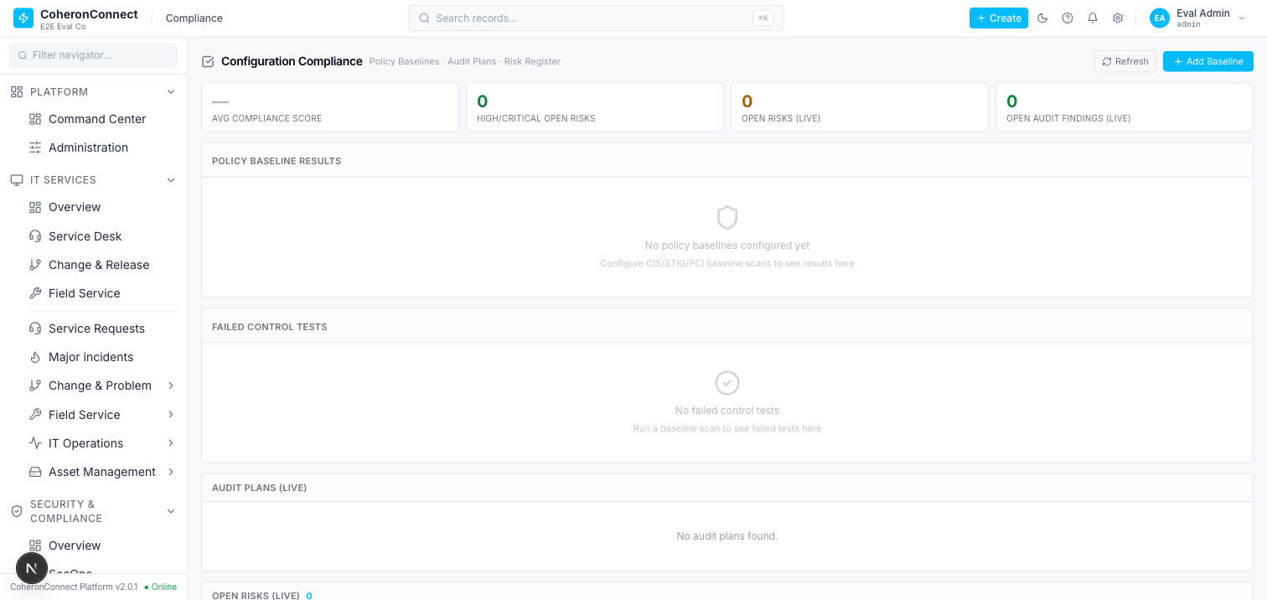

F-D2 — Outbound DPDP notices never leave the system (LogOnlyDispatcher stub)
- Severity: MEDIUM (obligation is *recognised + audited* but *not discharged*)
- Evidence (source + live): all three sweeps route every notice through getNotificationDispatcher(), whose only implementation is LogOnlyDispatcher (lib/notification-dispatcher.ts:47). It inserts a dpdp_notification_artifacts row with status: "logged" and performs no external send (its own header: "performs NO external send"). After the full live breach was driven to notified, the artifacts table held 0 rows, and any row it ever writes is logged — never sent/failed.
- Impact: the §8(6) breach notice to the Data Protection Board / affected principals and the DSR-overdue alert are recorded as an internal audit artifact but are never delivered to the actual recipient. The clock is watched and the obligation is logged (defensible), but the statutory *communication* does not happen. This is a last-mile stub, cleanly seam'd (setNotificationDispatcher) for a real adapter — but until wired, notification is dry-run.
- Route: lib/dpdp-sweeps.ts → notification-dispatcher.ts (LogOnly).

F-D3 — Erasure ships flag-off (dry-run) by default
- Severity: LOW (intentional + safe, but worth stating for go-live)
- Evidence (live): the erasure reflex on DSR-2026-0001 fulfilment ran but left erasure_executed_at / erasure_summary null and logged "DRY-RUN (DPDP_ERASURE_ENABLED not set): would erase across 2 table(s)". executeErasureForDsr only mutates Principal data when DPDP_ERASURE_ENABLED === "true" (or opts.force), and even then AND-s a statutory retention-floor predicate so rows inside their retention window are deferred, not erased. ERASURE_MAP is deliberately conservative (2 tables, anonymise).
- Impact: correct-by-default (no accidental data destruction), but an operator must explicitly enable + broaden the map before "right to erasure" actually purges Principal data across the product. Right now fulfilling an erasure DSR erases nothing.
- Route: lib/dpdp-erasure.ts (isErasureEnabled / ERASURE_MAP / retention floor).

MODULE 5 (DPDP) — summary
DPDP is not the near-blank hole the old audits describe — the DSR, consent, and breach engines are real, statutorily-shaped (state machines + dueAt/notify clocks + event trails + erasure reflex), idempotent-swept, and covered by 40 green tests; I drove every path live, positive and negative. But the module is un-operable and un-delivering: it has no UI at all (F-D1, HIGH — /app/compliance is unrelated config-compliance), its outbound notices are a log-only stub that never sends (F-D2), and erasure is dry-run by default (F-D3). The intelligence and the clocks are present; the human surface and the last-mile delivery are not.

MODULE 6 — ITSM (events → correlation → incident, SLA/escalation/webhook loops)
Scope traced: routers events, tickets, changes, oncall, work-orders, assets/cmdb; services itom-correlation.ts, itom-condition.ts, ticket-lifecycle.ts, sla-business-calendar.ts; BullMQ sweeps coheronconnect-sla (60s), coheronconnect-escalation (60s), coheronconnect-correlation (60s), webhook-dispatch (30s, HMAC-SHA256), workflow-trigger (60s). Tests: 5 suites (itom-correlation, escalation-sweep, ticket-lifecycle, cmdb-cycle, deploy-mttr) → 30 passed.
What is genuinely built + wired (verified live):
- Event ingest + dedup — events.ingest (routers/events.ts:26) dedups an incoming event against an existing row of the same node/metric/fingerprint in state="open" (events.ts:51), bumping its count instead of inserting a duplicate.
- Condition DSL is real, not a stub — itom-condition.ts is a genuine recursive-descent boolean parser (fields count|severity|node|metric|state|value|threshold, ops = != > >= < <=, AND/OR, severity ordinal critical=5..clear=0, numeric coercion, fault-tolerant — matchesCondition returns false on a parse error, never throws). This closes the "stored-but-never-evaluated config" anti-pattern for correlation.
- Correlation → auto-incident — applyCorrelation (itom-correlation.ts:232) with a create_incident action calls createIncidentFromSystem, marking the event state="in_progress" + linkedIncidentId, and flags it Major when severity==="critical".
- Live: created correlation policy 83d651a1 (severity >= critical → create_incident); ingesting a critical event db-prod-01/disk_usage auto-created major incident E2EE-0001 (5930a441). Negative: an info event web-01/cpu_load produced no incident (stayed state="open", linked_incident_id null).
- Suppression short-circuit — applySuppression (itom-correlation.ts:180) sets state="suppressed" and stops evaluation before correlation.
- Live: suppression rule 90f05c60 (node=noisy-01); a critical noisy-01/disk_usage event returned suppressed:true, incidentId:null — never reached correlation, no incident.
- CMDB cycle detection, SLA business-calendar, deploy→MTTR — all covered by green suites.

F-I1 — Duplicate incidents on a repeating / flapping alert (dedup state mismatch)
- Severity: HIGH (an alert storm from one flapping resource fans out into many major incidents, defeating dedup + correlation and paging on-call repeatedly for the same fault)
- Root cause (source): correlation's create_incident action flips the matched event to state="in_progress" (itom-correlation.ts:274), but the ingest dedup query only matches events in state="open" (events.ts:51). So the second arrival of the *identical* alert finds no open row to dedup against, inserts a new event, and correlation fires again, creating a second incident.
- Evidence (live + DB): ingested the identical critical alert db-prod-01/disk_usage twice, 11 seconds apart. Result — two in_progress events, each with its own linked_incident_id, and two major incidents:
- itom_events: db-prod-01|disk_usage|critical|in_progress|5930a441… and db-prod-01|disk_usage|critical|in_progress|fb4e4fc0… (two rows, same fault).
- tickets: E2EE-0001 and E2EE-0002, both CRITICAL: disk_usage on db-prod-01, both is_major_incident=t, created 13:21:14 and 13:21:25.
- /app/it-services/major-incidents lists both duplicate incidents ("just now", Major).
- Impact: a real alert never resolves in one poll cycle — it re-fires until fixed. Every re-fire of a critical event spawns a brand-new major incident (and, once wired, a fresh on-call page), because the correlated event is no longer open. Dedup silently only protects the window between first ingest and correlation. This is a "capture without the intended consequence" loop defect: the dedup and the correlation state machines disagree on which states are "live."
- Route: routers/events.ts:51 (dedup filter state="open") vs services/itom-correlation.ts:274 (correlation sets state="in_progress").
Screenshot: m6-itsm-01-duplicate-incidents.png
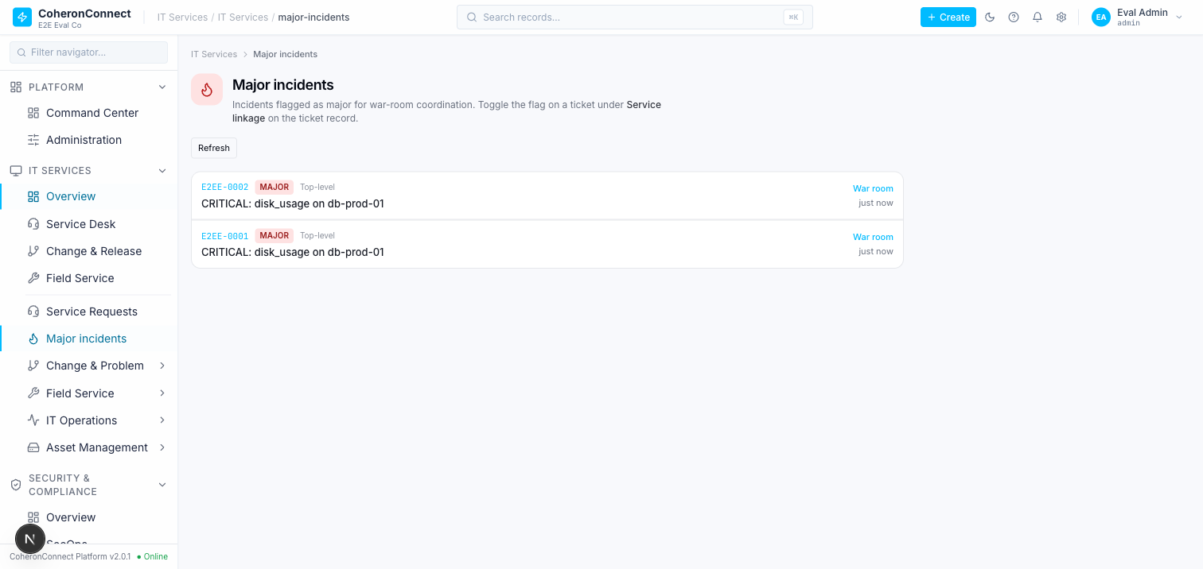

MODULE 6 (ITSM) — summary
The ITSM core is real and wired — event ingest, a genuine (non-stub) condition DSL, correlation → auto-incident, suppression short-circuit, SLA/escalation/webhook/workflow-trigger BullMQ sweeps, CMDB cycle detection, deploy→MTTR — all backed by 30 green tests and proven live (positive + negative). The one material defect is F-I1 (HIGH): a flapping / repeating alert produces duplicate major incidents, because ingest-dedup only matches state="open" while correlation moves a matched event to state="in_progress" — so the same fault, re-fired, bypasses dedup and re-triggers correlation. The intelligence loop closes on the *first* event but re-opens on every subsequent identical one.

MODULE 7 — HR (leave accrual, gratuity, attendance/LOP, statutory filing)
Scope traced: routers hr (employees/cases/leave/attendance/offboarding), leave-accrual (policy/accrual/close/encash), gratuity (accrual/settlement), workforce (analytics), india-compliance (EPFO ECR / ESI / PT / TDS filing + statutory ceilings); pure math in @coheronconnect/payroll-math (gratuity.ts, leave-accrual.ts); India libs leave-attendance.ts, attendance-lop.ts, shift-schedule.ts; workflows statutoryFilingWorkflow.ts, esiReturnWorkflow.ts, ptChallanWorkflow.ts. Tests: gratuity (9), leave-accrual, attendance-lop (4), leave-attendance-expand (7) → 32 passed (plus esi-return, pt-challan, india-payroll-engine suites present).
What is genuinely built + wired (verified live, positive + negative):
- Gratuity engine (Payment of Gratuity Act §4) — computeGratuity: 15/26 × lastDrawn(Basic+DA) × countedYears, ≥6-month trailing rounds up (on *actual* years, not rounded), ≥5-yr minimum (waived on death/disablement), capped ₹20L. Monthly accrual = (15/26 × Basic+DA)/12.
- Live (new EMP-0002, start 2016-01-10): preview 18y × ₹500k → gross ₹5,192,308 → capped ₹2,000,000; negative 3y no-waiver → eligible:false, reason "min-service", ₹0; monthly provision ₹1,250 (26k Basic+DA), idempotent re-run keeps cumulative ₹1,250, month-2 cumulative ₹2,500; settle 10y × ₹200k → ₹1,153,846 persisted with settledById; negative duplicate settle → CONFLICT 409.
- Leave-accrual engine — pro-rata monthly credit, carry-forward cap + lapse split, encashment at (Basic+DA)/26, all posted to an immutable leave_accrual_events ledger + projected onto leave_balances.
- Live: policy upsert (vacation 18/yr cap 30 encashable; sick 12/yr cap 0 non-encashable); 12 monthly accruals → 18 days (1.5/mo), idempotent re-run (12 ledger rows, month-12 stays 1.5); close preview vacation → carry 18 / lapse 0, sick → carry 0 / lapse 12 (cap 0); close run seeds 2026, negative double-close → CONFLICT; encash 5 days → ₹5,000 (5 × 26000/26); negative encash non-encashable `sick` → PRECONDITION_FAILED; negative accrue with no policy (`parental`) → PRECONDITION_FAILED.
- Attendance → LOP → payroll (G8) — expandLeaveToAttendance (unpaid→absent 1.0 LOP, others→on_leave 0), computeAttendanceLopForPeriod (absent=1.0, half_day=0.5), gross scaled by daysWorked/daysInMonth; idempotent on (orgId, employeeId, date). Covered by green suites.
- Statutory filing (EPFO ECR) is a real transport, not a stub — filing.submit rebuilds the canonical #~#-delimited ECR body from the payslips behind the run, then the BullMQ statutoryFilingWorkflow calls epfoEcrAdapter.send() which POSTs to a GSP endpoint (/v1/ecr/upload, x-api-key), parses the TRRN, throws on non-2xx / missing TRRN, and writes epfoAckNumber/submissionStatus back with retry. ESI + PT have parallel real workflows (esiReturnWorkflow, ptChallanWorkflow) + adapters + tests. This is materially stronger than the CLAUDE.md gap note ("ESI/PT/TDS only placeholder challan records").

F-H1 — Leave-accrual, carry-forward, encashment and gratuity are entirely headless (no UI)
- Severity: HIGH (shipped, statutorily-shaped payroll liabilities the org cannot operate)
- Evidence (live): /app/hr → Leave Management tab exposes only leave-*request* approval; a page search for accrual|gratuity|encash|carry-forward|policy|balance|entitlement returns no controls. A repo-wide apps/web search for leaveAccrual.* / gratuity.(accrual| settlement) finds only the generated RBAC map (trpc-procedure-rbac.generated.ts) — no page component consumes either router. Every path I exercised above was reachable only by hand-crafted tRPC.
- Impact: an HR manager cannot configure a leave policy, run monthly accrual, close the year (carry-forward/lapse), encash leave, or provision/settle gratuity through the product. The engines are correct and idempotent (proven) but un-operable by a business user — the same headless-backend pattern as DPDP (F-D1). For an India payroll product these are core monthly + exit liabilities.
- Route: backend trpc.leaveAccrual.*, trpc.gratuity.* (both unmounted on web); /app/hr?tab=leave is request-approval only.
Screenshot: m7-hr-01-leave-mgmt-no-accrual-ui.png
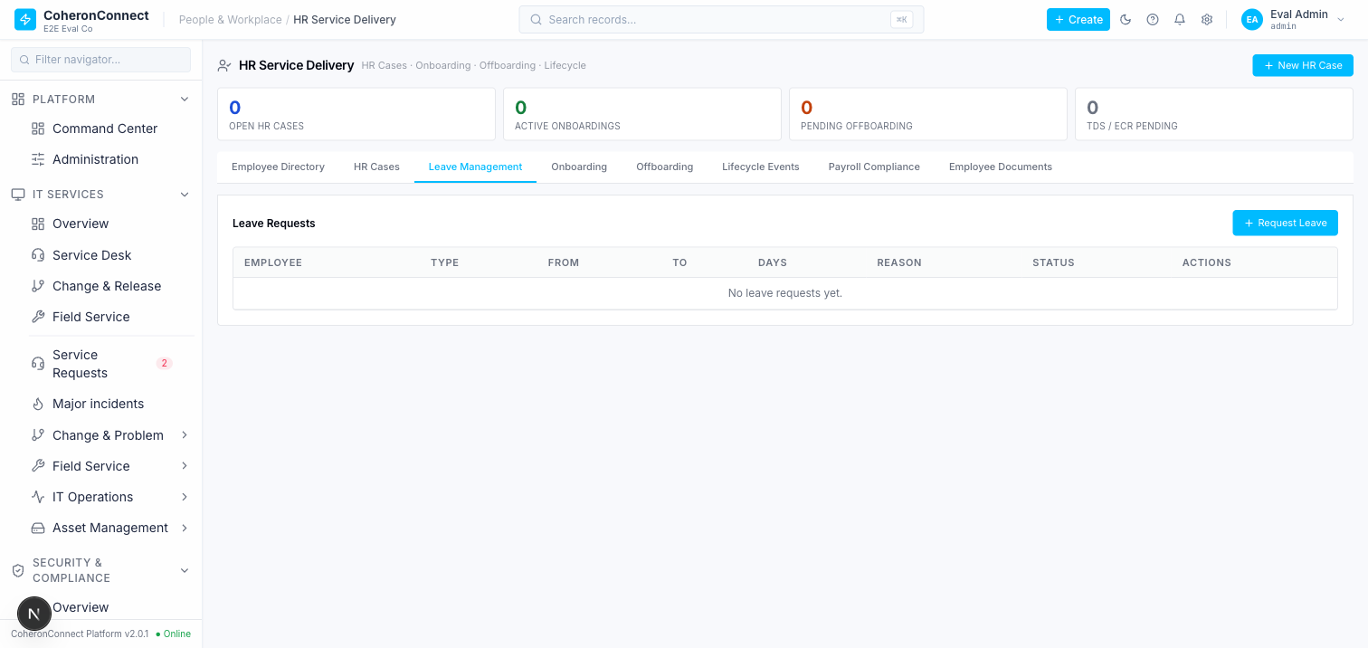

F-H2 — Monthly accrual / gratuity provision / year-end close have no automation trigger
- Severity: MEDIUM (correct when called, but nothing calls them on schedule)
- Evidence (source): a repo-wide search of apps/worker for accrue|provisionAll|leaveAccrual| gratuity|yearEnd returns no matches; the only references to accrue/provisionAll in apps/api are the routers + their tests. Unlike DPDP (Temporal sweep), ITSM (BullMQ sweeps) and EPFO ECR (BullMQ worker), there is no scheduled job that runs monthly leave accrual, monthly gratuity provisioning, or the year-end carry-forward close.
- Impact: these are inherently periodic obligations (accrue every month, close every year). An operator must remember to invoke accrual.accrue/accrueAll, gratuity.accrual.provisionAll, and close.run by hand each period — and, per F-H1, there is not even a UI button to do so. This is an open-loop: the computation exists but is never *fired* on its natural cadence.
- Route: routers/leave-accrual.ts (accrual.accrueAll, close.run), routers/gratuity.ts (accrual.provisionAll) — no worker/schedule references them.

MODULE 7 (HR) — summary
The HR computation layer is genuinely production-grade: gratuity (Act §4 formula + cap + death/disablement waiver + ≥6-mo rounding), leave accrual (pro-rata + carry-forward/lapse + encashment on an immutable ledger), attendance→LOP→gross, and — better than documented — a real EPFO ECR / ESI / PT filing transport (GSP HTTP push with TRRN write-back, soft-failing not_configured until creds land). 32 tests green; I drove every path live, positive and negative, with exact math confirmed. The two gaps are operational, not computational: F-H1 (HIGH) — the accrual/gratuity/encashment/close engines have no UI (headless, like DPDP); F-H2 (MEDIUM) — no scheduled job fires the monthly accrual / gratuity provision / year-end close, so the periodic loop must be triggered by hand. Intelligence present; human surface and the periodic trigger absent.

MODULE 8 — Security / Auth (MFA · step-up · vuln-SLA · RLS · session/token · audit chain)
Scope traced: MFA/TOTP enrolment + login gate (routers/auth.ts:227-516, lib/totp.ts), KMS envelope encryption (services/encryption.ts), Postgres RLS wall (migration 0052, lib/trpc.ts rlsTenant middleware :519-533), vulnerability-SLA breach/escalation loop (workflows/vulnerabilitySlaWorkflow.ts, wired in services/workflow.ts), tamper-evident audit hash chain (lib/audit-hash.ts), RBAC (permissionProcedure :542-585), step-up re-auth, and session/reset/verification-token storage (routers/auth.ts:77-102,683,711).
Tests (baseline, green): mfa (9) · rls-tenant-isolation (8) · audit-hash-chain (4) · kms-encryption (18) · vulnerability-sla + vuln-sla-policy (8) · auth (7) · auth-rbac (3) · rbac-unit (39) = 140 passed, 0 failed across the two runs.
Extended live probe (added after "only 3 gaps?"): beyond unit tests, drove the authorization controls *live over HTTP* against the running API with real seeded users — a bare member for RBAC-denial, and an admin+finance_manager user with org policy configured for the MFA/step-up gates. This live drilling is what surfaced F-S4 (payroll RBAC over-grant) and F-S5 (rate-limit/lockout disabled under NODE_ENV=test), neither of which the passing unit suite catches. All seeded probe data was cleaned up afterward.
What is genuinely production-grade (verified live, not just green tests):
- MFA is real end-to-end. Drove enrolment in the browser (/app/profile → Password & Security → Enable 2FA): a real QR + base32 secret rendered, I generated a valid TOTP with the same otplib, confirmed, and got 10 one-time backup codes + status → Enabled. DB check: mfa_enrollments.totp_secret stored as v2:… (KMS envelope, AES-256-GCM, not plaintext); backup_codes stored as $2b$12$… (bcrypt cost 12). Negative: auth.mfa.disable with 000000 → 401 UNAUTHORIZED "Invalid MFA code" (possession enforced); valid TOTP → disabled. Login for an enrolled user returns a challenge (no session) and only verifyMfa mints one.
- RLS is really enforced at the DB. app_runtime role is NOSUPERUSER + NOBYPASSRLS; 191 tenant_isolation policies; core tenant tables FORCE ROW LEVEL SECURITY. Live proof: inside a tx with SET LOCAL ROLE app_runtime + set_config('app.org_id', <orgA>, true), org A saw its 10 users, an explicit read of org B's users returned 0 (blocked), and journal_entries were org-scoped. The rlsTenant middleware sets both GUC + role with SET LOCAL inside a per-request transaction.
- KMS envelope encryption is genuine — fresh 256-bit DEK per secret, AES-256-GCM with auth-tag verify, only the *wrapped* DEK stored, plaintext DEK scrubbed (fill(0)), legacy CBC kept read-only for back-compat; webhook HMAC verify is timingSafeEqual.
- Session / reset / verification tokens are stored hashed — sessions.id is the SHA-256 hex (length 64) of a nanoid(32) token; only the plaintext goes to the client, so the DB never holds a usable token. Password-reset + verification tokens are SHA-256 too (auth.ts:683,711).
- Vulnerability-SLA loop is real *and wired*. sweepVulnSlaBreaches bulk-flips sla_breached with FOR UPDATE SKIP LOCKED; sweepVulnEscalations walks the on-call chain advance-only with notify + audit. Unlike HR accrual (F-H2), this worker is created/scheduled in services/workflow.ts:150-198 (60 s cadence).

F-S1 — Audit hash chain has partial coverage: security-sensitive events are written unchained
- Severity: HIGH (undermines the tamper-evidence guarantee for exactly the events that matter)
- Evidence (DB, eval instance): of all audit_logs, 337 rows have `seq IS NULL` (never entered the hash chain) vs 5 977 chained. The unchained actions include `mfa_enrolled` (146), `mfa_disabled` (25), and `escalation.level_up` (137) — all security/authorization events. Root cause: the MFA procedures write via a plain db.insert(auditLogs)… (auth.ts:467, 506) instead of appendAuditEntry(). verifyAuditChain explicitly skips seq IS NULL rows (lib/audit-hash.ts:126), so a tampered/deleted MFA-enrolment audit row is not detectable.
- Impact: the chain is real and correct, but it does not cover the security events an attacker would most want to forge or erase (who enabled/disabled MFA, escalation actions). The tamper-evidence property therefore does not hold for the security audit trail.
- Route: writers routers/auth.ts:467 (mfa_enrolled), :506 (mfa_disabled), workflows/* (escalation.level_up); verifier lib/audit-hash.ts:116-168.

F-S2 — The eval org's audit chain is already broken (genuine seq gap at 2)
- Severity: MEDIUM (integrity break present in practice; correctly *detected*, not silently ignored)
- Evidence (DB): for org d03d1d9b… the chained seq runs 1, 3, 4 … 80 — seq 2 is missing (0 rows at seq=2; min=1, max=80, count=79). Re-deriving the chain returns ok:false, brokenAtSeq:3, reason:"seq gap: expected 2, found 3". So a chained audit row was lost after its seq was consumed. The detection logic works exactly as designed — but the live chain for the primary test tenant is in a broken state, which in production would mean the WORM guarantee is already void for that org and needs investigation/re-anchoring.
- Impact: any downstream "prove the audit log is intact" control fails for this org today. Combined with F-S1 it means the tamper-evidence story is weaker in practice than on paper.
- Route: audit_logs (org d03d1d9b…); verifier lib/audit-hash.ts:116-168.

F-S3 — RLS `tenant_isolation` policy fails *open* when `app.org_id` is unset
- Severity: MEDIUM (defence-in-depth gap, not an active leak on the current request path)
- Evidence (DB): the policy qual is current_setting('app.org_id', true) IS NULL OR current_setting('app.org_id', true) = '' OR org_id = current_setting('app.org_id', true)::uuid. Live proof: SET LOCAL ROLE app_runtime without setting the GUC returns all 35 730 users across every org — RLS does *not* fail closed. It only constrains once the GUC is set. Today the rlsTenant middleware returns early (unwrapped, on the pooled superuser) when orgId is falsy (trpc.ts:524) and always sets GUC + role together (:529-530), so the role is never dropped with an empty GUC on the live path — but the RLS wall provides zero protection if that invariant is ever broken (a new code path that drops role first, a refactor, a raw query outside the middleware).
- Impact: RLS is marketed as the second wall behind the app-layer eq(orgId) filters, but its fail-open default means it degrades to no protection under the exact failure it's meant to guard (middleware not setting the org). The app-layer filter remains the *only* real wall in that case.
- Route: migration 0052 (tenant_isolation policy), lib/trpc.ts:519-533 (rlsTenant).

F-S4 — RBAC over-grant: the base `requester` role can create/compute/approve payroll + export bank files
- Severity: HIGH (privilege escalation — least-privilege user reaches the most sensitive money path)
- How found (live, direct HTTP): seeded a password on the existing member user (grat-eval-…@e2e.test, DB role member → system role ["requester"], *no* matrix role), logged in, and drove permissioned mutations:
- crm.leads.create → `FORBIDDEN: Permission denied: accounts.write` ✅ (correctly denied)
- accounting.journal.create → `FORBIDDEN: Permission denied: financial.write` ✅ (correctly denied)
- `payroll.runs.create` (month/year valid) → `200 OK`, real row created (status: DRAFT, id returned) ❌
- payroll.runs.computePayslips → passed the permission gate (failed only on run-state BAD_REQUEST, *not* FORBIDDEN) ❌
- payroll.exportBankFile → passed the permission gate (failed only on Zod format required, *not* FORBIDDEN) ❌
- Root cause: payroll.runs.create / computePayslips / approve / exportBankFile are all declared permissionProcedure("hr", "write") (routers/payroll.ts:33,254,367,452,764), and the requester role is granted hr: ["read","write"] (packages/types/src/rbac-matrix.ts:457). The role comment intends "raise HR cases" (self-service help-desk), but the hr module namespace *also* gates the entire payroll lifecycle — so every base member inherits payroll create/compute/ approve + bank-file export. There is no `payroll` module in the RBAC matrix; payroll rides on hr.write.
- Impact: any invited member (the least-privilege DB role, default for new users) can spin up payroll runs, drive computation, and reach the NEFT/bank-file export gate for the whole org. This is a direct segregation-of-duties failure on the platform's highest-value operation.
- Route: routers/payroll.ts:254/367/452/764 (permissionProcedure("hr","write")), packages/types/src/rbac-matrix.ts:457 (requester.hr = ["read","write"]), lib/rbac-db.ts:34 (member → ["requester"]).
- Note: cleaned up — the 3 probe payroll runs (Jan/Feb/Mar 2026) were deleted, member password reverted to NULL. The *matrix* RBAC (finance/accounting) is correctly enforced; the defect is the coarse requester → hr.write grant leaking into payroll.

F-S5 — The running API instance has `NODE_ENV=test`, which globally disables login rate-limiting + account lockout
- Severity: HIGH (brute-force protection is off on the live instance)
- How found (live): submitted 12 consecutive wrong-password logins for a real user (auth.login) — all 12 returned `UNAUTHORIZED`, none returned `TOO_MANY_REQUESTS`; no lockout ever engaged. Inspecting the running process env (ps eww) confirmed `NODE_ENV=test` on the serving pid.
- Root cause: both checkLoginRateLimit (pre-bcrypt burst gate) and recordFailedLogin (per-email >10 / per-IP >50 lockout) short-circuit with an early return when process.env.NODE_ENV === "test" (lib/login-rate-limit.ts:35,66). The limiter code itself is genuine (Redis-backed, correct thresholds: MAX_FAILED_EMAIL=10, MAX_FAILED_IP=50, 5-min window; dev default 1000/min), but it is a no-op whenever NODE_ENV=test.
- Impact: on this deployment the account-lockout and login rate-limit controls are entirely inert — unlimited password guessing is possible. Additionally there is no automated test for the lockout path (and since the suite itself runs under NODE_ENV=test, one could not exercise it), so a regression here is invisible.
- Route: lib/login-rate-limit.ts:34-36,65-67; login call-site routers/auth.ts:183,194-216.

Positive controls verified live (no finding — recorded for completeness)
Driven end-to-end during the extended Module-8 probe and behaving correctly:
- RBAC denial (matrix layer): member correctly FORBIDDEN on accounts.write and financial.write (only the hr.write→payroll leak in F-S4 is broken).
- MFA org-policy gate (`requireMfaForMatrixRoles`): with the policy set for a finance_manager matrix role and mfa_enrolled=false, financial.markPaid → `FORBIDDEN: MFA_ENROLLMENT_REQUIRED` (lib/mfa-policy.ts).
- Step-up gate (`requireStepUpForMatrixRoles`): after MFA-enrolling the same user, financial.markPaid → `FORBIDDEN: STEP_UP_REQUIRED`; calling auth.verifyStepUp with the password then set stepUpVerifiedUntil and the *subsequent* markPaid passed both gates (reaching the NOT_FOUND business path). Both gates fire and clear correctly (lib/step-up.ts).
- Session invalidation on logout: after auth.logout, reusing the same session token on a protected procedure → `UNAUTHORIZED: Not authenticated` (session row deleted + Redis cache invalidated; auth.ts:288-298).
- Password-reset token lifecycle: valid token → success; reuse → `Reset link already used` (single-use usedAt guard); expired token → `Reset link has expired`; garbage token → Invalid or expired reset link. Tokens are SHA-256-hashed at rest, 1h TTL, prior tokens purged on new request, all sessions killed on reset (auth.ts:706-751).

MODULE 8 (Security/Auth) — summary
Security has the strongest primitives evaluated — MFA (real TOTP + KMS-envelope secret + bcrypt backup codes, driven live enrol→confirm→reject→disable), DB-enforced RLS (cross-org read returns 0), genuine KMS envelope encryption, hashed session/reset/verification tokens, a vuln-SLA loop that is both real and wired to a running scheduler, and — verified live in the extended probe — working MFA-policy + step-up gates, correct logout session invalidation, and a fully correct password-reset token lifecycle (single-use + expiry + garbage rejection). 140 tests green.
But the deeper probe (prompted by "only 3 gaps?") surfaced two HIGH findings that the initial pass missed, both in the *primary* controls rather than defence-in-depth:
- F-S4 (HIGH) — RBAC over-grant: the base requester role (every default member) can create/compute/approve payroll and reach bank-file export, because payroll rides on permissionProcedure("hr","write") and requester holds hr:["read","write"]. Proven live — a bare member created real payroll runs. Segregation-of-duties failure on the top money path.
- F-S5 (HIGH) — the *running* instance is NODE_ENV=test, which makes both the login rate-limiter and the account-lockout a no-op (proven: 12 wrong-password logins, zero lockout). Brute-force protection is inert on the live deployment.
Plus the three defence-in-depth gaps from the first pass: F-S1 (HIGH) — 337 security events (mfa_enrolled/mfa_disabled/escalation.level_up) written *outside* the tamper-evident chain; F-S2 (MEDIUM) — the eval org's chain already has a real seq gap at 2; F-S3 (MEDIUM) — RLS fails *open* when the org GUC is unset.
Net: the crypto/session/token primitives are excellent, but authorization breadth (F-S4) and the live security posture (F-S5) are the real holes — exactly the kind the "push to the last node" mandate was meant to expose. Five findings total (3 HIGH, 2 MEDIUM).

Appendix A — Screenshot gallery (all captured evidence)

Module 1 — India Payroll
m1-payroll-01-landing-empty.png
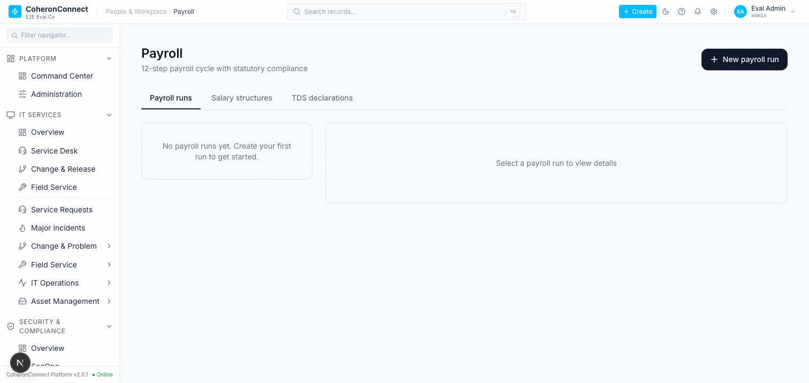
m1-payroll-02-tds-declarations-mislabeled.png

m1-payroll-03-run-draft-cycle.png

m1-payroll-04-add-employee-no-salary-structure.png
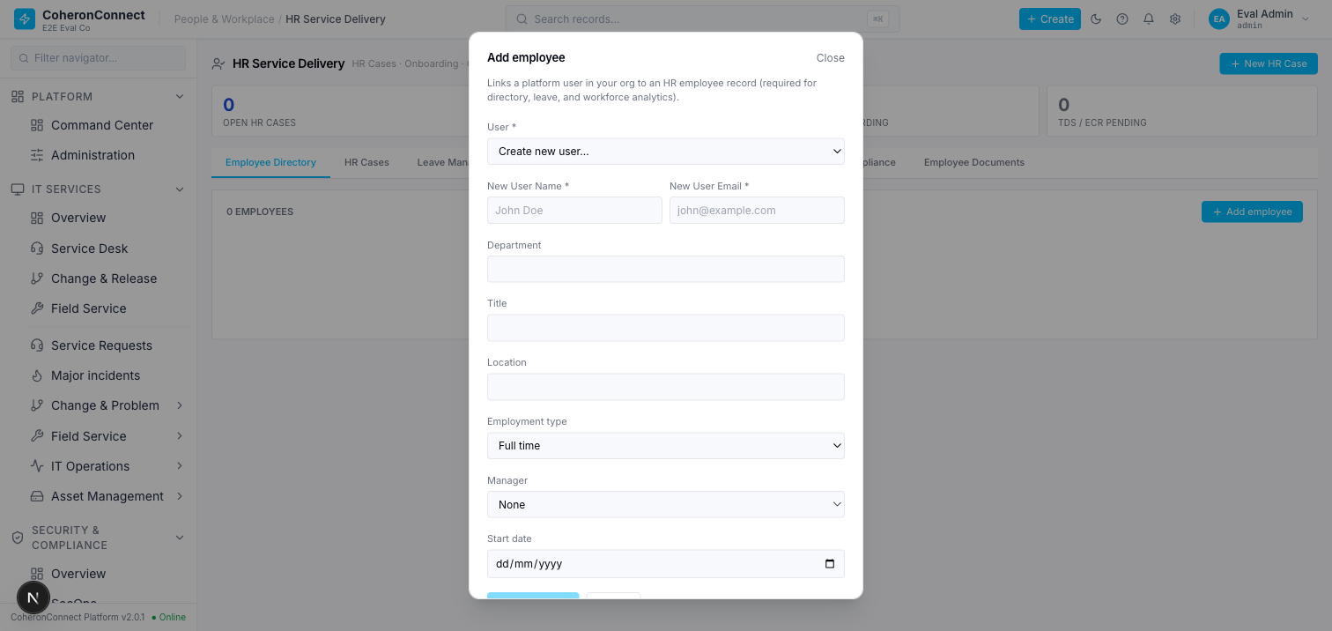
m1-payroll-05-period-locked-real-totals.png

m1-payroll-06-completed-with-approvals.png


Module 2 — GST / Invoicing
m2-gst-01-create-invoice-rate-selector.png
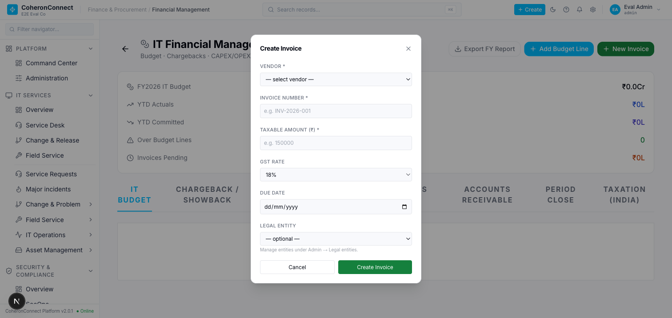
m2-gst-02-invoice-filled-interstate.png
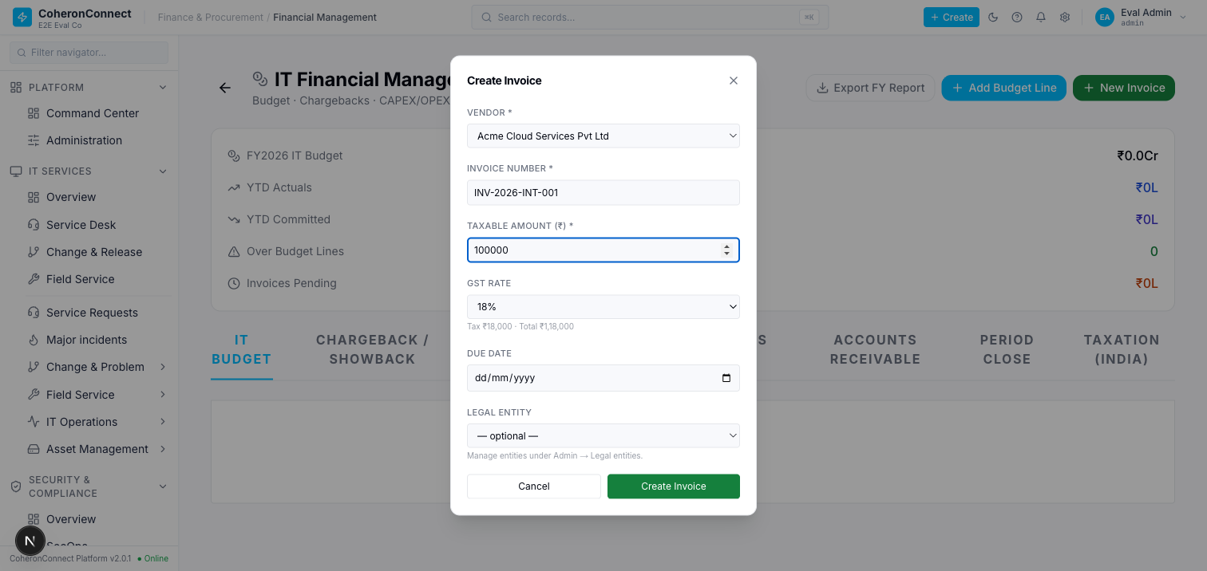
m2-gst-03-taxation-india-reference.png
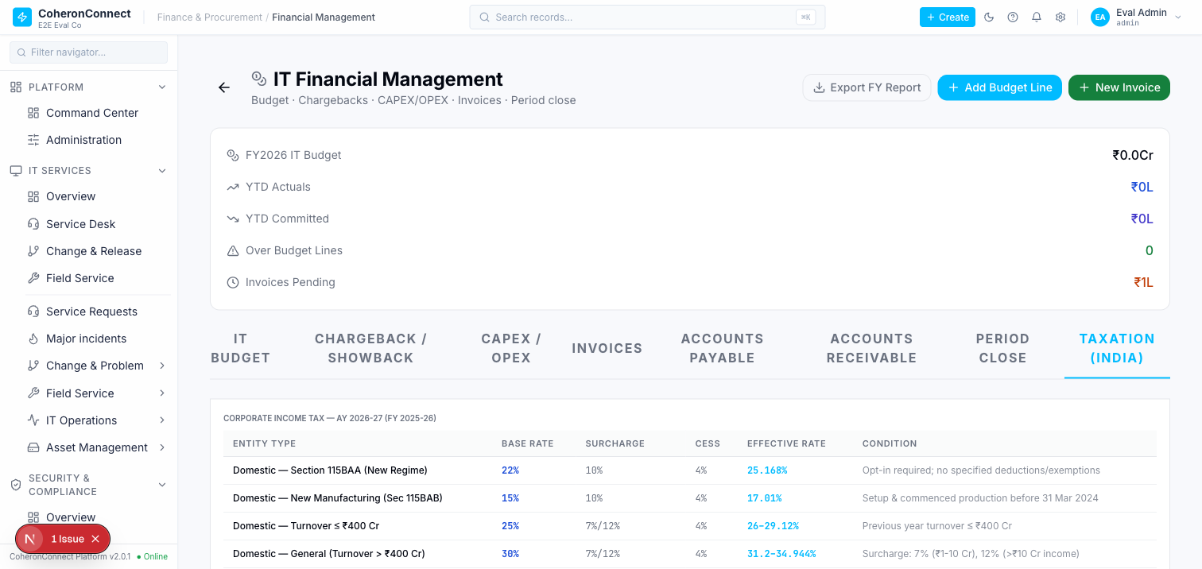
m2-gst-04-gstr1-wrong-gstin-scope.png
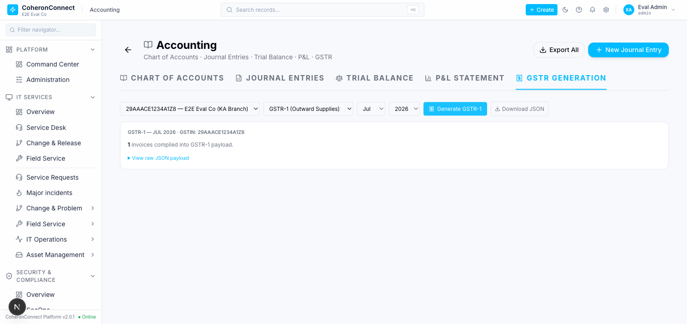

Module 3 — Accounting / Journal
m3-acct-01-trial-balance-balanced.png
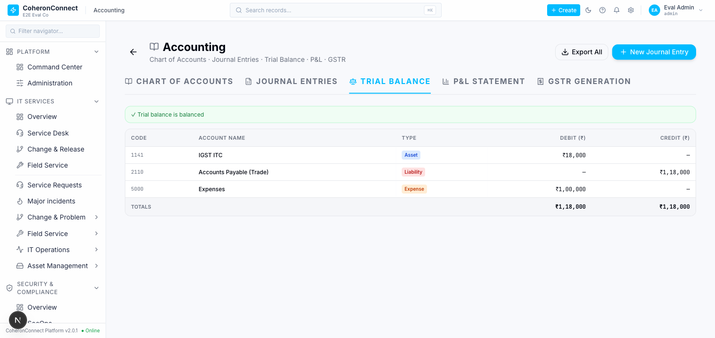
m3-acct-02-je-modal-empty-account-picker-400.png
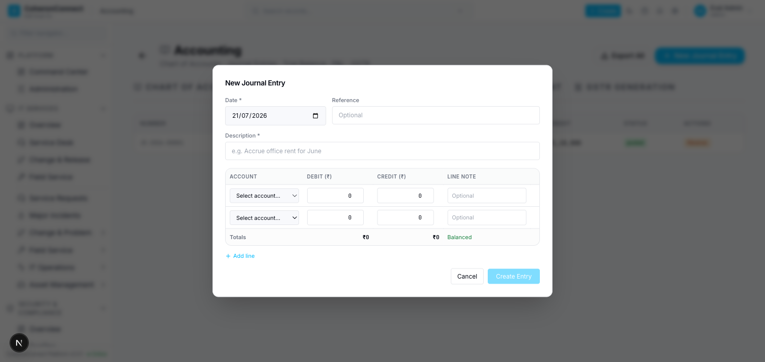
m3-acct-03-pnl-statement.png
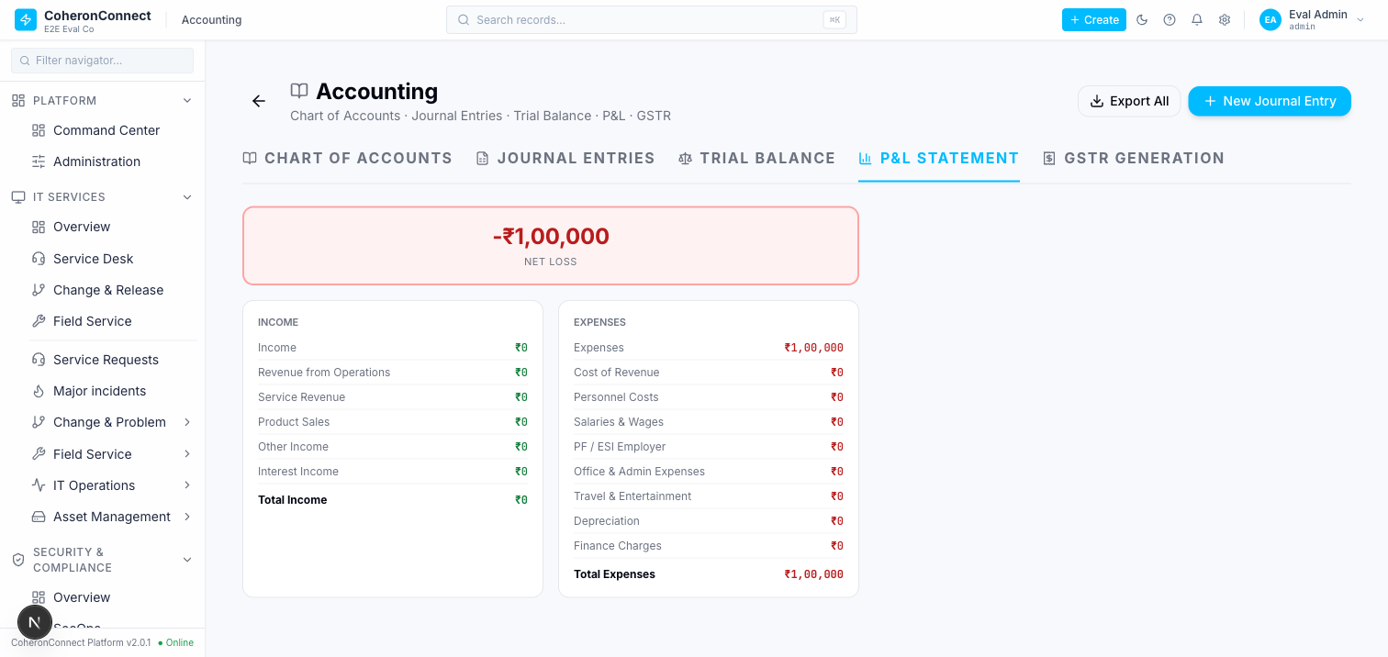

Module 4 — CRM
m4-crm-01-add-lead-source-enum-drift-400.png
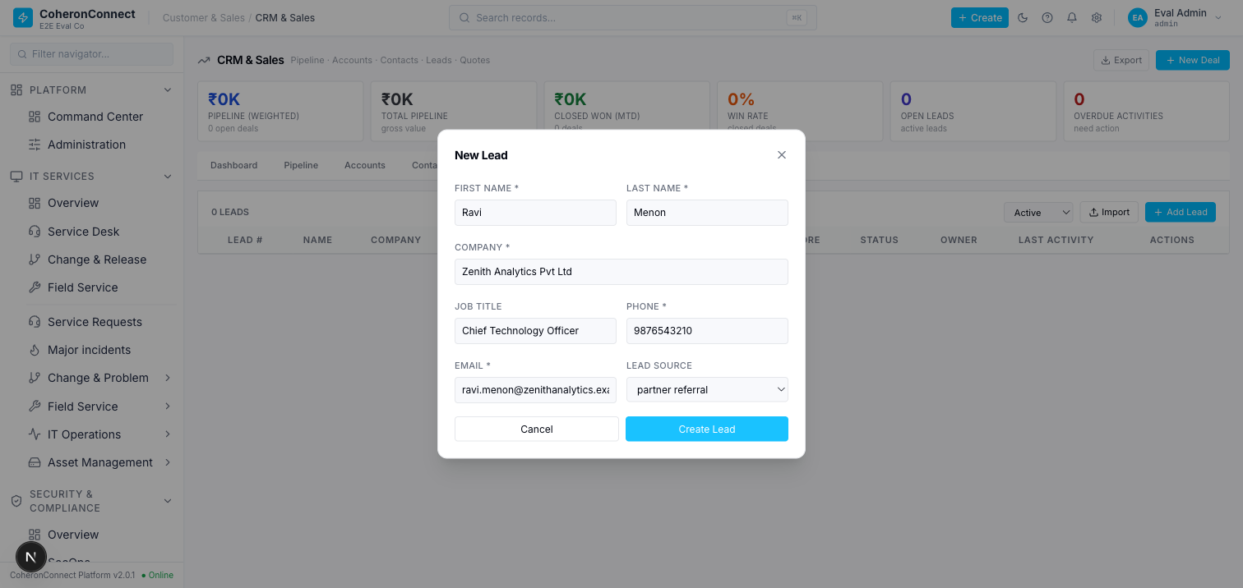
m4-crm-02-lead-score-45-persisted.png
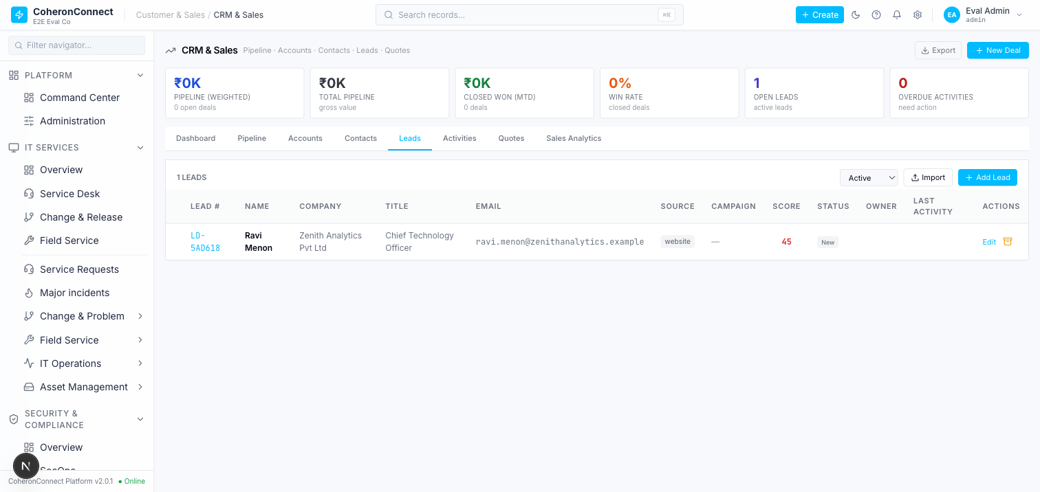
m4-crm-03-converted-deal-pipeline.png
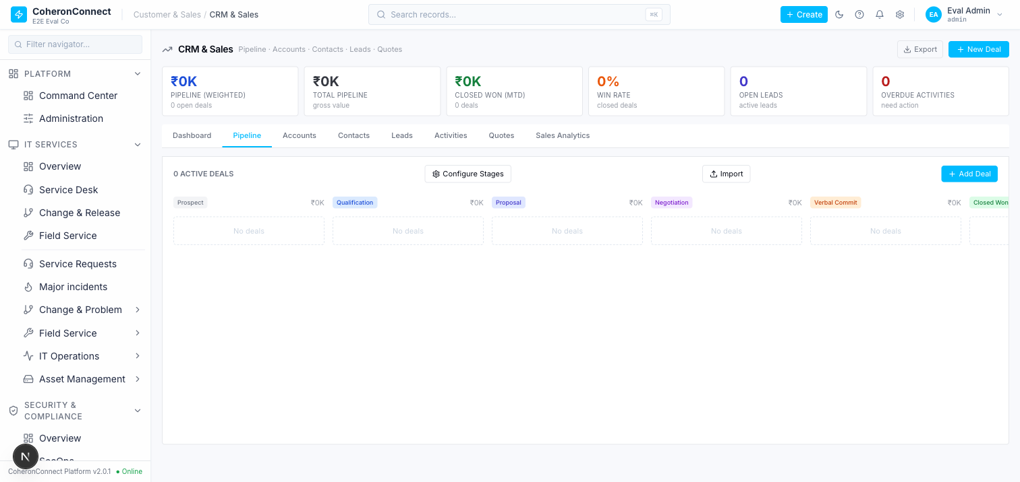

Module 5 — DPDP privacy
m5-dpdp-01-no-ui.png


Module 6 — ITSM
m6-itsm-01-duplicate-incidents.png


Module 7 — HR
m7-hr-01-leave-mgmt-no-accrual-ui.png


Module 8 — Security / Auth
m8-sec-01-2fa-not-enabled.png
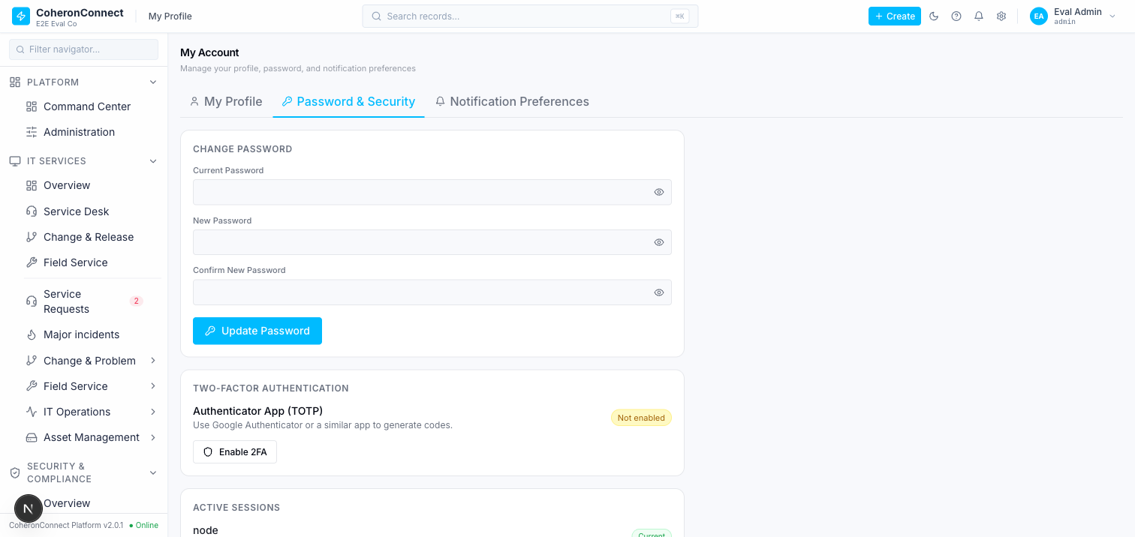
m8-sec-02-2fa-enroll-qr.png
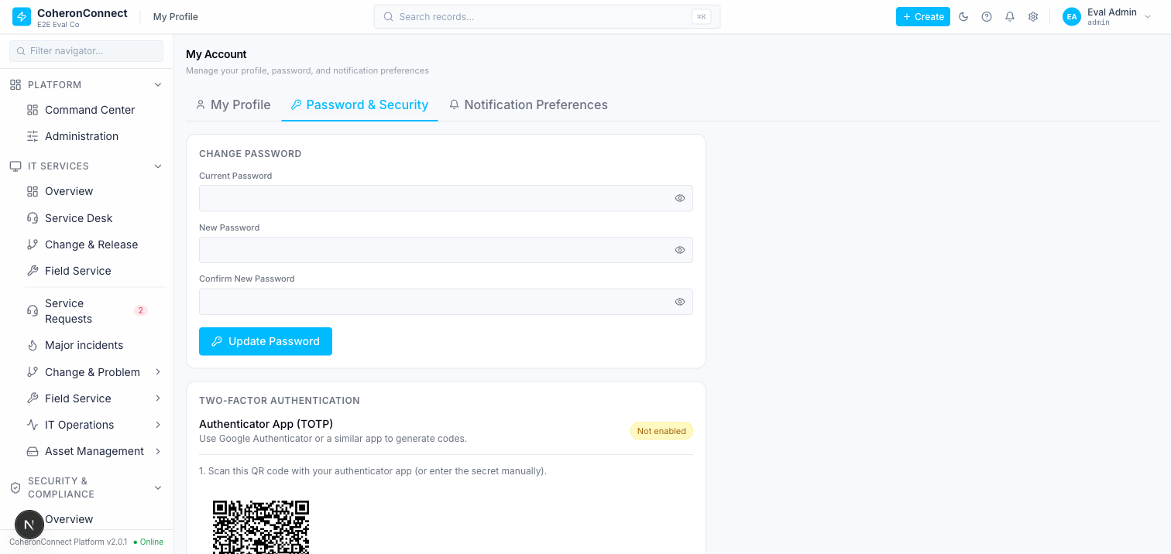
m8-sec-03-2fa-enabled-backup-codes.png
