Monitoring and Security Lab Report
Ubuntu + Windows
Student: Miguel Guadalupe
Course: Cybersecurity Lab
Instructor: ———
Date: ———

Contents
Section 1: Ubuntu Monitoring and Security Lab 3
System Setup 3
Section 2: Monitoring Tools 3
2.1 Using the top Command 3
2.2 Using the htop Command 4
2.3 Viewing Logs with journalctl -xe 5
2.4 Checking Memory Usage with free -h 6
2.5 Checking Disk Usage with df -h 7
2.6 Viewing Active Services with systemctl 7
Section 3: Security Tools in Ubuntu 8
3.1 ClamAV Antivirus 8
3.2 Fail2ban – Brute Force Protection 9
3.3 Understanding Linux File Permissions 10
Section 4: Reflection and What I Learned 11
Section 5: Windows Monitoring and Security Lab 11
Section 6: Monitoring Tools in Windows 12
6.1 Viewing Processes with Task Manager 12
Figure 10 — Task Manager showing running processes and system resource usage 13
6.2 Monitoring Processes Using PowerShell 13
6.3 Viewing System Services 13
6.4 Why Monitoring Tools Matter 14
Section 7: Security Tools and Logs in Windows 15
7.1 Observing Ransomware-Encrypted Files 15
7.2 Collecting Baseline and Activity Logs 15
7.3 Reviewing Sysmon Logs in Event Viewer 16
7.4 Verifying File Integrity Using Hash Comparison 17
7.5 Why Logs Are Important for Security 18
Section 8: Reflection and What I Learned 19

Monitoring and Security Labs: Ubuntu and Windows
This report documents the monitoring and security exercises I completed using both Ubuntu Linux and Microsoft Windows.
The goal of these labs was to learn how operating systems monitor performance, detect suspicious activity, and protect files from malware such as ransomware.

Section 1: Ubuntu Monitoring and Security Lab
The purpose of this lab was to learn how to monitor a Linux system and use basic security tools in Ubuntu. Using a virtual machine allowed me to safely practice commands that system administrators and cybersecurity professionals use every day.
This lab focused on understanding how to:
- check CPU, memory, and disk usage
- view system logs
- see which services are running
- verify antivirus and login protection tools
- understand Linux file permissions

System Setup
For this lab, I used an Ubuntu desktop virtual machine running inside VirtualBox.
The system had approximately 4 GB of RAM and provided a graphical GNOME desktop environment.
Using a virtual machine made it possible to experiment with monitoring and security tools without risking damage to the host computer.

Section 2: Monitoring Tools
In this part of the lab, I learned how to monitor the health and performance of the Ubuntu operating system. Monitoring tools are important because they help administrators quickly identify high CPU usage, memory problems, full disks, or failing services before they become serious issues.

2.1 Using the top Command
The top command shows real-time information about system processes, CPU usage, and memory usage.
It is useful for finding programs that are consuming too many resources.
Key things I observed:
- the system was mostly idle, with high CPU availability
- memory usage was normal
- processes such as gnome-shell and systemd were running normally
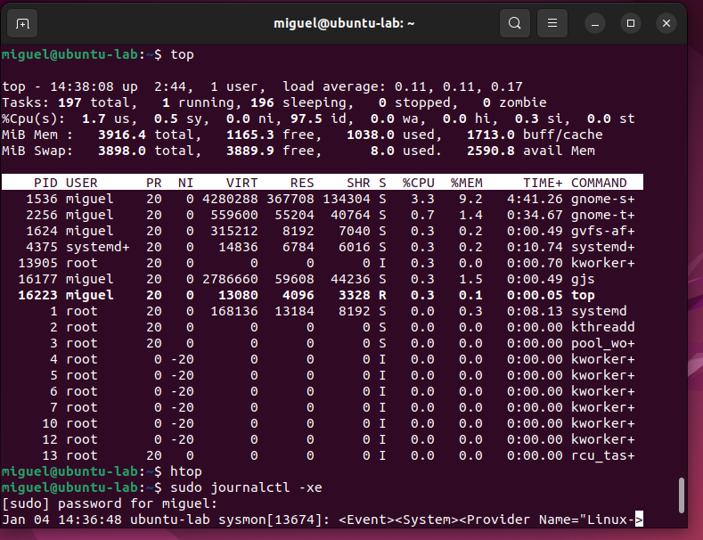

Figure 1 — Output of the ‘top’ command showing system processes and CPU usage

2.2 Using the htop Command
htop is an improved and more user-friendly version of top.
It displays color graphs and allows scrolling through processes.
This tool makes it easier to visually understand what is happening in the system.

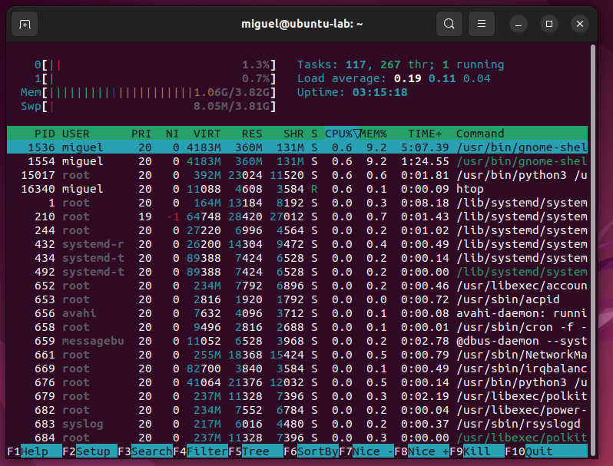

Figure 2—Output of the ‘htop’ command displaying system usage graphs

2.3 Viewing Logs with journalctl -xe
System logs record warnings, authentication activity, failures, and system events.
The command:
journalctl -xe
shows recent events, including service messages and security logs.
In my system, the logs mostly showed normal activity such as sudo commands and Sysmon events. No major system errors were detected.

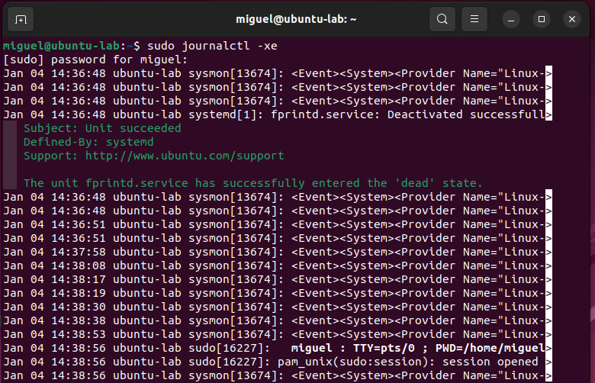

Figure 3—Viewing system logs using the ‘journalctl -xe’ command

2.4 Checking Memory Usage with free -h
The free -h command displays how much RAM and swap memory the system is using.
From the output, I observed:
- around 1 GB of RAM in use
- almost no swap space being used
- plenty of memory available for normal operation

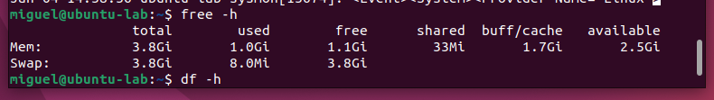
Figure 4—Memory usage displayed using the ‘free -h’ command

2.5 Checking Disk Usage with df -h
The df -h command shows how much disk space is being used on the mounted filesystems.
My system had plenty of free storage, with only about 28% of the main partition used.

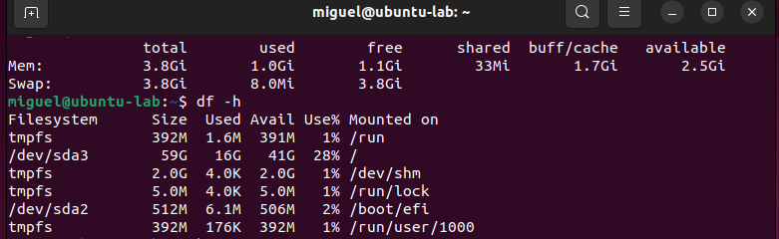

Figure 5—Disk usage results using the ‘df -h’ command

2.6 Viewing Active Services with systemctl
The command:
systemctl list-units --type=service --state=running
shows all services that are currently active and running.
This allowed me to confirm that important system services were operating correctly.
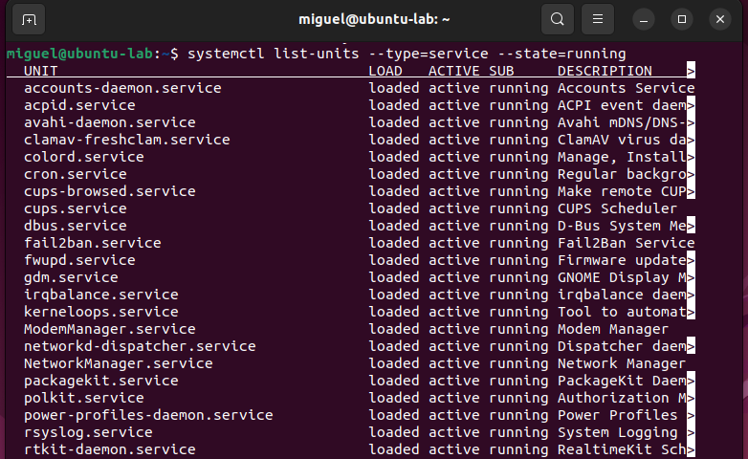

Figure 6—List of active services using systemctl

Section 3: Security Tools in Ubuntu
In this part of the lab, I explored several basic Linux security tools. These tools help protect the system, detect malicious activity, and control who has access to files. Understanding how they work is important for cybersecurity and system administration.

3.1 ClamAV Antivirus
ClamAV is an open-source antivirus tool used to detect viruses, malicious files, and suspicious activity on Linux systems.
The service clamav-freshclam automatically downloads and updates the virus signature database. Keeping virus definitions updated ensures that new threats can be detected.
I verified the service using:
systemctl status clamav-freshclam
The output showed that the service was active and running, and the database test passed successfully.

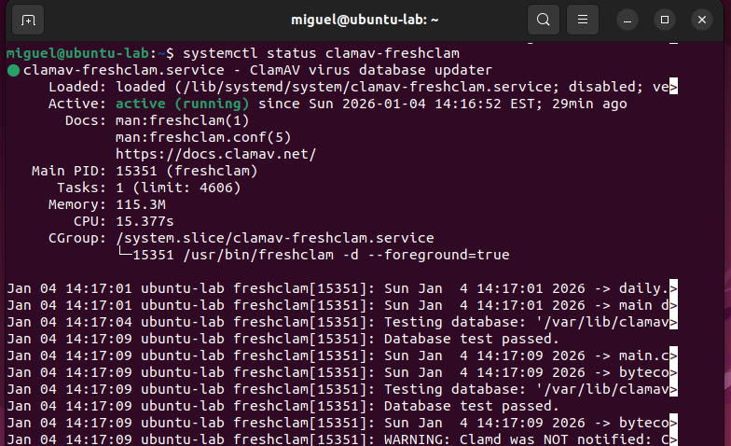

Figure 7—ClamAV service running and virus database successfully updated

3.2 Fail2ban – Brute Force Protection
Fail2ban helps protect systems from repeated failed login attempts.
It monitors authentication logs and automatically bans suspicious IP addresses that repeatedly try to guess passwords.
I checked its status using:
sudo systemctl status fail2ban
The service was active and ready, meaning the system is protected against common brute-force attacks.

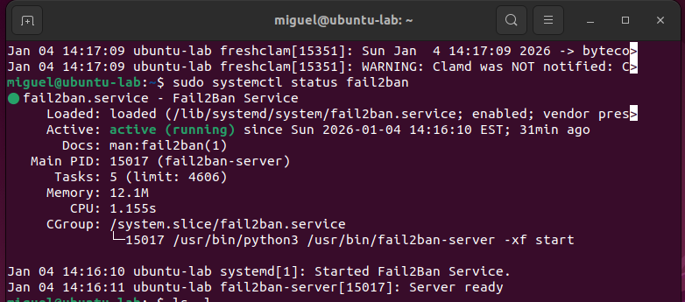

Figure 8—Fail2ban service active and monitoring authentication logs

3.3 Understanding Linux File Permissions
Linux uses file permissions to control who can read, write, or execute files.
I listed file permissions using:
ls -l
Each file entry displays permission values such as:
drwxr-xr-x
-rw-r--r--
These mean:
- r = read
- w = write
- x = execute
- first group = owner permissions
- second group = group permissions
- third group = permissions for all other users
This security model prevents unauthorized users from modifying or accessing sensitive files.

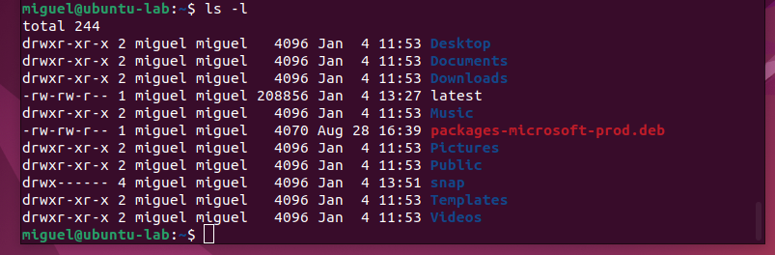

Figure 9—File and directory permissions displayed using the ls -l command

Section 4: Reflection and What I Learned
This lab helped me better understand how Linux systems are monitored and secured. By working inside Ubuntu, I was able to practice real administrative commands instead of just reading about them. I learned how to check CPU, memory, disk space, and running services, and how to review system logs when something goes wrong.
I also learned that Linux includes several important security features. Tools such as ClamAV and Fail2ban help protect the system against viruses and repeated login attacks, while file permissions control who can access or modify files. These skills are important because system monitoring and security go hand-in-hand. Being able to recognize unusual activity is one of the first steps in detecting security issues.
Overall, this lab gave me confidence using the terminal and showed me how powerful Linux tools are for both system administration and cybersecurity.

Section 5: Windows Monitoring and Security Lab
The purpose of this lab was to learn how to monitor and secure a Windows system using built-in tools and logging features. Windows is widely used in homes, businesses, and enterprise environments, so knowing how to check performance, review logs, and understand security alerts is important for cybersecurity.
In this lab, I learned how to:
- monitor CPU, memory, and running processes
- view and manage system services
- review system and security logs
- observe how ransomware activity is recorded by the system
- collect and analyze logs for forensic investigation
I performed this lab using a Windows virtual machine. Using a virtual machine allowed me to safely experiment without risking damage to the host computer.

Section 6: Monitoring Tools in Windows
In this part of the lab, I learned how to monitor system performance and activity in Windows. Monitoring tools allow administrators to see what processes are running, how much CPU and memory are being used, and whether something suspicious is consuming system resources.
These tools are important because they help detect problems early, such as malware, frozen programs, or performance issues.

6.1 Viewing Processes with Task Manager
Task Manager is one of the main monitoring tools in Windows. It shows information about CPU usage, memory usage, disk activity, and running applications.
With Task Manager, I was able to see which programs were using the most system resources and verify that normal background processes were running.
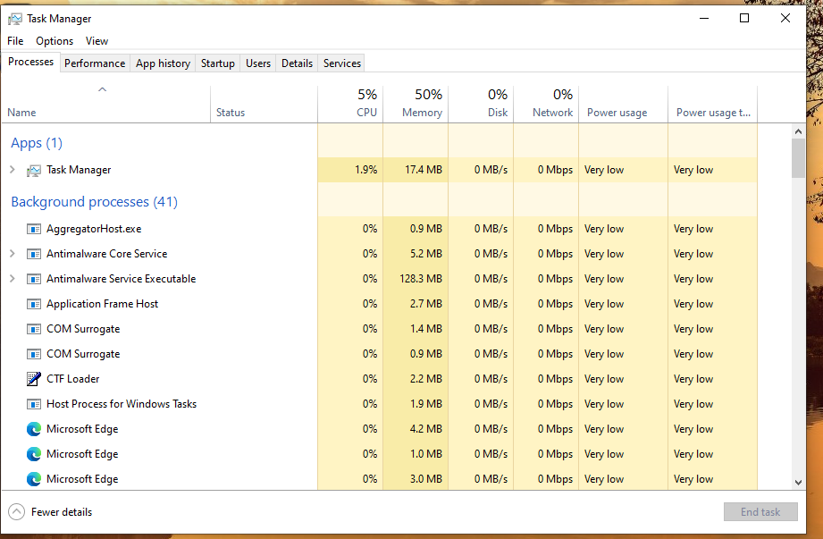

Figure 10 — Task Manager showing running processes and system resource usage

6.2 Monitoring Processes Using PowerShell
Windows also allows process monitoring through PowerShell, which provides more detailed and scriptable control. I used the following command to display the top processes by CPU usage:
Get-Process | Sort-Object CPU -Descending | Select-Object -First 5
This made it easy to identify which processes were consuming the most CPU. This is helpful when investigating suspicious or unknown programs.

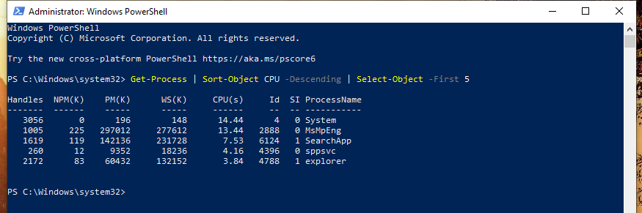

Figure 11 — Viewing top CPU processes using PowerShell

6.3 Viewing System Services
Windows services are background programs that run automatically and control system features such as networking, printing, logging, and security.
By opening the Services management console, I could see:
- which services were running
- which services were stopped
- whether services were set to start automatically or manually
Understanding services is important because malware often tries to install itself as a service to stay hidden.
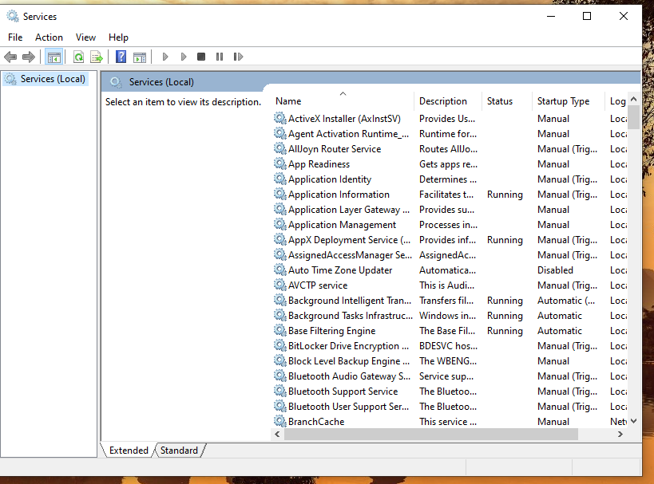

Figure 12 — Windows Services showing running and automatic services

6.4 Why Monitoring Tools Matter
From using these tools, I learned that monitoring systems helps:
- detect unusual CPU or memory usage
- identify suspicious background processes
- troubleshoot slow performance
- understand how the operating system works internally
Monitoring is the first step toward security, because you cannot protect what you cannot see.

Section 7: Security Tools and Logs in Windows
In this part of the lab, I focused on how Windows records security activity and how investigators can use logs to detect ransomware or suspicious behavior. Windows keeps detailed records of what happens on the system, including file changes, process execution, and login events.
Understanding how to read logs is critical for cybersecurity, incident response, and digital forensics.

7.1 Observing Ransomware-Encrypted Files
As part of the lab, I simulated ransomware behavior. After the ransomware executed, several files were renamed with the .locked extension. This indicates that the files were encrypted and could no longer be opened normally.
Ransomware often renames and encrypts files to force users to pay money to recover them.

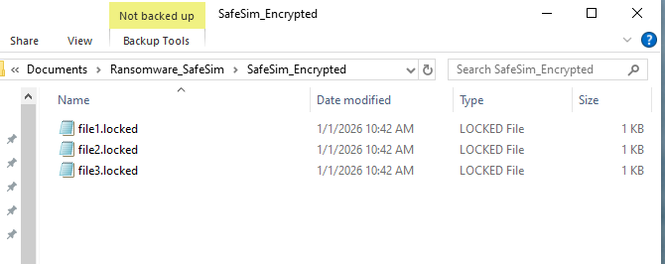

Figure 13 — Files encrypted and renamed with the .locked extension

7.2 Collecting Baseline and Activity Logs
Before running the ransomware simulation, I collected baseline logs so I could compare what changed afterward. The Logs directory contained:
- baseline_hashes.txt – file integrity before ransomware
- baseline_sysmon.txt – normal Sysmon events
- run01_sysmon.txt – logs captured during ransomware execution
These logs are useful for investigators because they help prove when files changed and which processes were responsible.
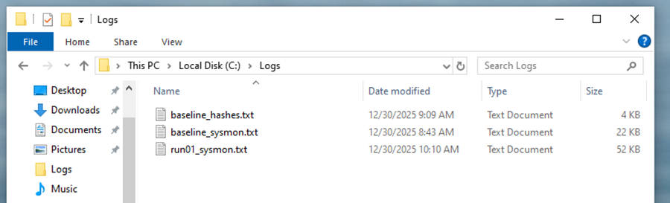

Figure 14 — Log files used for baseline comparison and ransomware analysis

7.3 Reviewing Sysmon Logs in Event Viewer
Sysmon (System Monitor) records detailed system activity that normal Windows logs do not capture. I opened Event Viewer and reviewed the Sysmon Operational log.
I observed events showing:
- file creation
- process execution
- other system behavior
These events are extremely useful when investigating malware or suspicious activity.
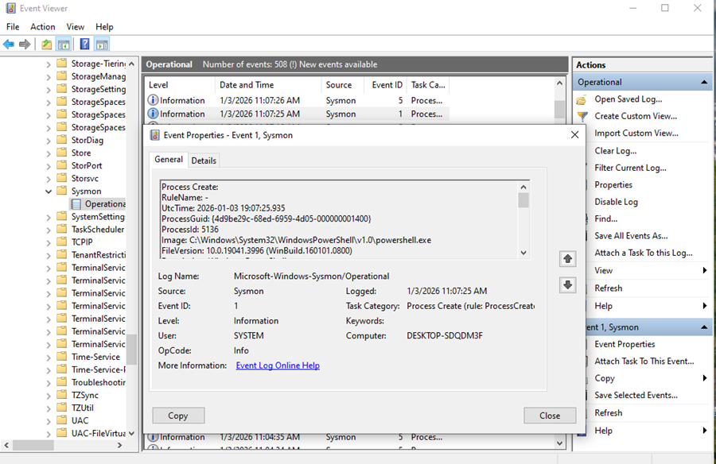

Figure 15 — Sysmon recording detailed system and security events in Event Viewer

7.4 Verifying File Integrity Using Hash Comparison
To confirm that files were modified during the ransomware simulation, I compared the original file hashes with new ones after encryption.
Using the diff command, I could easily see which files had changed. If the hash is different, it means the contents of the file are not the same anymore.
This technique is commonly used in digital forensics.
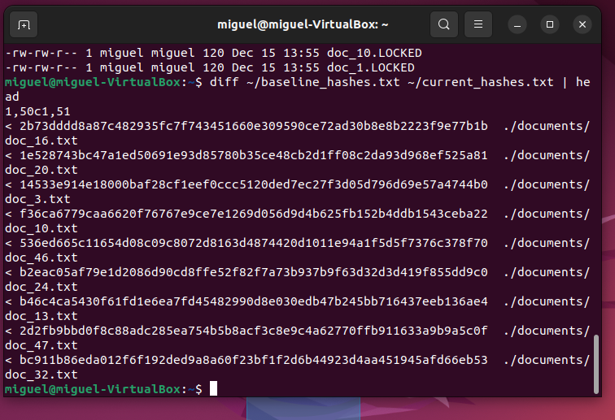

Figure 16 — Comparing baseline and current file hashes to detect altered data

7.5 Why Logs Are Important for Security
From this lab, I learned that Windows logs help:
- detect ransomware and malicious software
- identify when files were changed
- track which processes were involved
- support investigations with evidence
Logs are essential for cybersecurity professionals because they tell the story of what happened on a system.

Section 8: Reflection and What I Learned
This lab helped me understand how Windows systems can be monitored and how security events are recorded. I learned that Windows provides several different tools to watch what the system is doing, including Task Manager, PowerShell, Event Viewer, and Sysmon. These tools make it possible to see which processes are running, how resources are being used, and whether anything suspicious is happening.
I also learned how ransomware activity can be detected. Encrypted files, log entries, and hash changes all provide evidence that something on the system has been altered. Collecting baseline data before changes occur is important, because it makes it easier to compare results and identify what is different afterward.
Overall, this lab showed me how monitoring and security logging work together. Monitoring tools help identify unusual behavior, and logs provide the details needed to investigate an incident. These skills are important for cybersecurity, digital forensics, and system administration.

