SECTION 1 — Introduction
Title:
Machine Learning Detection of Ransomware Using Static Features
Introduction:
Ransomware is a type of malware that encrypts files and demands payment from the victim. Detecting ransomware quickly is critical in order to protect data, prevent damage, and assist digital forensics investigations.
In this project, I used supervised machine learning models to classify files as Benign or Malware (Ransomware) using the Ransomware Dataset 2024. The dataset contains static features extracted from executable files, such as header fields, PE structure information, and behavioral counters.
In this report, I describe how I prepared the data, trained two different models (Logistic Regression and Random Forest), and evaluated their performance for ransomware detection.
Background concepts and terminology were guided by course textbooks, including Machine Learning: A First Course for Engineers and Scientists and Murphy’s Probabilistic Machine Learning.
The goals of this project were to:
- Load and preprocess the dataset
- Train different machine learning models
- Compare performance
- Identify strengths and weaknesses of each approach
SECTION 2 — Dataset and Preprocessing
The dataset used in this project is the Ransomware Dataset 2024, which contains static features extracted from Windows PE (Portable Executable) files.
Each file is labeled as:
- Benign (normal software), or
- Malware (Ransomware)
The dataset includes:
- PE header values
- section metadata
- registry activity counters
- API and DLL counts
- network-related statistics
These values describe file behavior without needing to run the malware.

Data Cleaning
Before training, I removed:
- non-numeric fields (file names, hashes)
- duplicate records
- unused identifiers
Then I converted any hexadecimal values (such as 0x1000) into integers so the models could read them.

Class Balance
The dataset was balanced:
- 10,876 benign samples
- 10,876 ransomware samples
Balanced classes help prevent model bias.

Train / Test Split
The dataset was split:
- 75% training data
- 25% testing data
The split was stratified, meaning both sets kept the same malware/benign ratio.

Why preprocessing matters
Effective preprocessing ensures the model receives clean, meaningful information and improves overall accuracy and reliability.
- Avoid bias in training
- Handle differences in feature scale
- Ensure only meaningful information is used
- Improve training efficiency
- Improve prediction accuracy

SECTION 3 — Model Training

Overview
Two machine-learning models were trained:
- Logistic Regression
- Random Forest Classifier
Both models were trained using the cleaned dataset and evaluated on the test set.

Logistic Regression
Logistic Regression is a simple baseline classifier used to predict whether a file is Benign or Malware.
Logistic regression is commonly introduced as a baseline classification method in standard machine learning texts (Alpaydin, 2020).
To prevent convergence warnings, I increased the optimization limit:

max_iter = 500
This model is:
- fast
- easy to interpret
- good as a baseline comparison
However, it may struggle with complex non-linear patterns.

Random Forest
Random Forest builds many decision trees and combines their results.
Model parameters used:
n_estimators = 300
random_state = 42
n_jobs = -1
Advantages:
- handles complex patterns
- resistant to noise
- works well with many features
- provides feature-importance ranking
Because ransomware has complicated behavior patterns, Random Forest was expected to perform better.

SECTION 4 — Results

4.1 Model Accuracy
Both models were evaluated using the test dataset.
The Random Forest model achieved the highest accuracy:
- Logistic Regression: 0.74 (74%)
- Random Forest: 0.95 (95%)
Random Forest clearly performs better for ransomware detection.
The overall accuracy is shown in Figure 2.
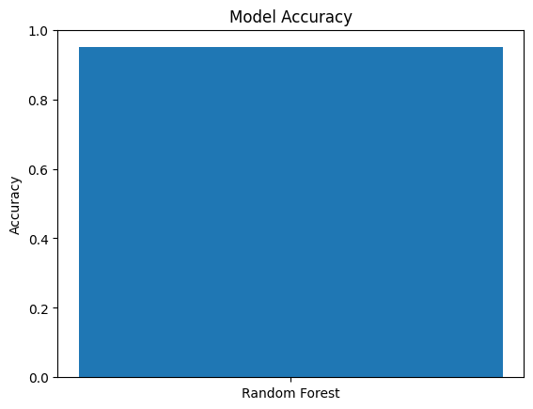

Figure 2. Overall accuracy of the Random Forest ransomware classifier.

4.2 Confusion Matrix
To better understand the model performance, a confusion matrix was generated.
This matrix shows:
- True Positives (correctly identified ransomware)
- True Negatives (correctly identified benign files)
- False Positives (benign flagged incorrectly)
- False Negatives (missed ransomware)
For the Random Forest model:
[[2559 160]
[ 104 2615]]

This means:
- 2,559 benign files were correctly classified
- 2,615 ransomware samples were correctly identified
- 160 benign samples were misclassified as ransomware
- 104 ransomware samples were not detected
The confusion matrix is shown in Figure 1.
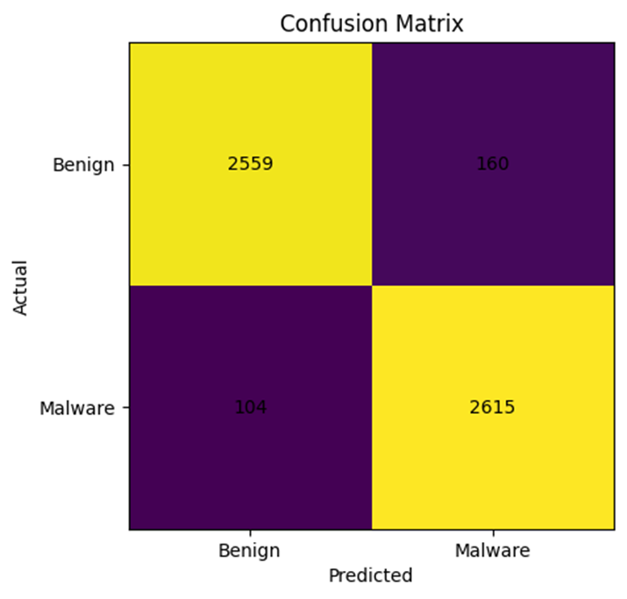

Figure 1. Confusion matrix showing correct detections and misclassifications.

4.3 Feature Importance (Optional but Powerful)
Random Forest allows us to see which features contributed the most to the classification.
Some of the highest-ranked features were:
- registry_total
- registry_read
- total_processes
- network_dns
- EntryPoint
This suggests that registry activity and process behavior are strong indicators of ransomware.
The feature-importance chart is shown in Figure 3.

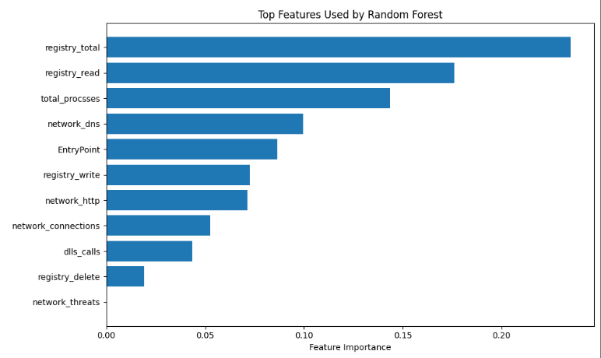

Figure 3. Feature importance results showing the most influential static features.

These features show which characteristics most influenced whether a file was classified as ransomware or benign. Registry activity, process counts, and network behavior were among the most important.

4.4 Interpretation
Overall, the results show:
- Random Forest significantly outperforms Logistic Regression
- The model detects ransomware with high accuracy
- Most misclassifications occur between closely similar files
- Static features alone can still provide strong predictive power

These findings provide useful insight into how static machine learning models behave when detecting ransomware, and they lead directly into the discussion of strengths and limitations in the next section.

SECTION 5 — Discussion

5.1 Strengths of the Approach
The Random Forest model demonstrated strong performance, achieving approximately 95% accuracy and correctly identifying most ransomware samples. The model handled many features without needing heavy preprocessing and showed resilience to noise in the dataset.
Feature importance analysis also helped confirm that the model relied on meaningful ransomware indicators, such as registry changes, process creation, and network behavior.
These results suggest that machine learning can support early ransomware detection and assist analysts in identifying suspicious software more quickly.

5.2 Limitations
Although the model performed well, there are still important limitations.
First, the model relies only on static features. Some ransomware families use packing, obfuscation, or encryption to hide these indicators. In such cases, static detection may fail.
Second, the dataset is labeled and balanced. Real-world environments are often imbalanced, meaning benign software greatly outnumbers malware. Accuracy may decrease when deployed in practice.
Finally, false negatives remain concerning. A missed ransomware detection could allow an attack to execute, encrypt data, and spread across a network. For these reasons, results from academic datasets should always be validated in real-world environments before deployment.

5.3 Future Work
Several extensions could improve the model:
- Include dynamic behavior features (e.g., what files, processes, and network activity occur while the program runs).
- Experiment with additional models, such as Gradient Boosting, XGBoost, or deep learning approaches.
- Evaluate detection performance on new ransomware datasets from different years.
- Investigate threshold tuning to reduce false negatives.
Exploring these ideas may lead to more robust ransomware detection systems.

SECTION 6 — Conclusion
This project demonstrated that machine learning can be an effective tool for detecting ransomware using static PE file features. By comparing Logistic Regression and Random Forest models, it became clear that ensemble-based methods offer significantly higher accuracy and robustness for this task.
The Random Forest model achieved approximately 95% accuracy and was able to correctly classify most ransomware and benign samples. Feature importance analysis showed that registry activity, process behavior, and network indicators were among the most influential predictors, supporting the idea that ransomware leaves detectable traces in static metadata.
Although the results are promising, static analysis alone is not sufficient for complete protection. Advanced ransomware can hide or obfuscate key features, and real-world environments often differ from academic datasets. Machine learning solutions should therefore be combined with traditional security controls and dynamic analysis approaches.
Overall, this project provides evidence that machine learning techniques can meaningfully enhance ransomware detection and may serve as a foundation for more advanced research and practical security tools.

SECTION 7 — References
- E. Alpaydin, Machine Learning: A First Course for Engineers and Scientists, Cambridge University Press, 2020.
- A. Gut, Introduction to Probability for Computing, Springer, 2013.
- K. P. Murphy, Probabilistic Machine Learning: An Introduction, MIT Press, 2022.

