MULTI-MODAL AERIAL SYSTEM FOR REAL-TIME SCENE UNDERSTANDING, 3D RECONSTRUCTION, AND GEOSPATIAL ANALYSIS
Gautam Ankoji², Thirupathi Rao N¹, Dhanalakota Venkata Satya Sai Rohith³, Bheesetty Eswara Venkata Sai Chandu⁴, Dara Yaswanth⁵
¹Department of Computer Science and Engineering, Vignan’s Institute of Information Technology (A), Visakhapatnam, AP, India
²Vignan’s Institute of Information Technology (A), Besides VSEZ, Vadlapudi Duvvada, Visakhapatnam, Andhra Pradesh-530049, Andhra Pradesh, India
gautamankoji@gmail.com
Abstract:
Unmanned aerial perception is often constrained by reliance on single sensing modalities, leading to severe performance degradation under low illumination, atmospheric disturbance, and partial occlusion. In addition, many existing UAV vision pipelines separate image enhancement from downstream analysis, which limits overall reliability in time-critical missions. This paper presents a multi-modal aerial system that performs real-time scene understanding, 3D reconstruction, and geospatial analysis through tightly integrated processing of synchronized RGB, thermal, and depth data. The proposed architecture uses modality-specific feature encoders and cross-attention–based transformer fusion to recover high-quality visual representations while preserving structural and radiometric consistency across modalities. The reconstructed representations are directly coupled with analytical perception modules for object detection, multi-object tracking, and spatial measurement, forming a single end-to-end system suitable for onboard deployment. This design enables simultaneous visual restoration and metric scene interpretation without disjoint processing stages. Evaluation on $UAVScenes$, $FLIR$, $VisDrone2019$, and a custom RGB–thermal–depth aerial dataset demonstrates robust performance under degraded visual conditions. The reconstruction component achieves a mean PSNR of 29.0 dB and SSIM of 0.875, improving PSNR by 3.2–8.1 dB over RGB-only methods while reducing LPIPS to 0.181. Fusion-based perception raises detection performance to 37.5 mAP (61.2 AP50), with consistent gains for small objects. Multi-object tracking attains 61.7 MOTA and 69.8 IDF1, reducing identity switches by 19.3% relative to strong baselines. Metric reconstruction supports real-world measurement with mean height and distance errors below 5% and 3%, respectively. The system is optimized for embedded inference using $ONNX$ and $TensorRT$, operating at 12–30 FPS on NVIDIA Jetson devices with up to 4.1× acceleration and negligible accuracy loss. Field deployment in search-and-rescue scenarios confirms stable onboard operation and improved visibility in low-contrast environments. The presented system demonstrates that tightly integrated multi-modal sensing and analysis can provide reliable, decision-oriented aerial perception for surveillance, emergency response, and autonomous UAV operations.

Index Terms: Aerial surveillance, real-time object detection, multi-spectral imaging, 3D reconstruction, autonomous UAVs, disaster response, geospatial intelligence.

1. Introduction

1.1 Motivation and Background
The proliferation of Unmanned Aerial Vehicles (UAVs) in civilian and military applications has catalyzed unprecedented demand for robust, intelligent perception systems capable of operating under diverse environmental conditions. Modern UAV platforms serve critical roles in search-and-rescue operations, precision agriculture, infrastructure inspection, surveillance, and autonomous navigation. However, single-modality visual sensors predominantly RGB cameras exhibit fundamental limitations when confronted with challenging operational scenarios including low-light conditions, fog, smoke, thermal camouflage, and complex occlusions.
Multi-modal sensing strategies, which integrate complementary information from RGB, thermal infrared, and depth sensors, offer a principled solution to overcome these inherent constraints. RGB imagery provides high-resolution texture and color information essential for detailed scene understanding, while thermal sensors capture emissive radiation patterns independent of ambient illumination, enabling robust detection in darkness or obscured environments. Depth sensors contribute explicit geometric information critical for metric measurement and spatial reasoning. The synergistic integration of these modalities through intelligent fusion architectures can dramatically enhance perception robustness, accuracy, and reliability.
Recent advances in deep learning, particularly transformer-based architectures, have revolutionized computer vision by enabling models to capture long-range dependencies and global context more effectively than traditional convolutional neural networks (CNNs). Vision Transformers (ViT) and hierarchical variants such as Swin Transformer have demonstrated exceptional performance in various vision tasks including image classification, object detection, and semantic segmentation. Their self-attention mechanisms provide a natural framework for multi-modal fusion by learning complementary relationships across heterogeneous data sources.

1.2 Research Gap and Challenges
Despite substantial progress in UAV perception and multi-modal fusion, existing systems face several critical limitations:
- Reconstruction Under Degradation: Most UAV imaging systems struggle when one or more modalities are degraded due to environmental factors. Limited research addresses the problem of reconstructing high-quality RGB imagery from degraded multi-modal inputs.
- Real-Time Processing Constraints: UAV platforms impose stringent computational and power constraints. Existing multi-modal fusion methods often rely on computationally intensive architectures unsuitable for real-time edge deployment.
- Integration of Perception and Analytics: Current systems typically separate image enhancement from downstream analytical tasks (detection, tracking, measurement), leading to suboptimal end-to-end performance.
- Lack of Comprehensive Frameworks: Few systems provide integrated pipelines spanning data acquisition, reconstruction, analytics, visualization, and deployment for both offline and real-time operational modes.
- Deployment Challenges: Bridging the gap between research prototypes and production-ready systems remains a significant challenge, particularly for resource-constrained embedded UAV platforms.

1.3 Contributions
This paper addresses the aforementioned challenges through the following contributions:
- Novel Multi-Modal Fusion Architecture: We propose a transformer-based image reconstruction module that fuses degraded RGB, thermal, and depth inputs to generate enhanced RGB imagery. The architecture employs modality-specific encoders, cross-attention fusion mechanisms, and a hierarchical decoder optimized for aerial imagery characteristics.
- End-to-End Intelligence Pipeline: We present a comprehensive framework integrating reconstruction with analytical capabilities including object detection, instance segmentation, multi-object tracking, metric measurement, and attribute estimation—all optimized for UAV applications.
- Dual-Mode Operational Framework: Our system supports both offline batch processing with automated report generation and real-time streaming analytics with live visualization, addressing diverse operational requirements.
- Edge-Optimized Deployment: We provide systematic optimization strategies employing $ONNX$and $TensorRT$ for efficient inference on embedded platforms (NVIDIA Jetson, Intel NUC), achieving real-time performance while maintaining accuracy.
- Comprehensive Experimental Validation: We conduct extensive experiments across multiple UAV datasets and real-world scenarios, demonstrating superior reconstruction quality, detection accuracy, and computational efficiency compared to existing approaches.

1.4 Paper Organization
The remainder of this paper is organized as follows: Section 2 reviews related work in multi-modal fusion, transformer architectures, and UAV perception systems. Section 3 details our proposed methodology, including system architecture, reconstruction module, analytical intelligence components, and deployment strategy. Section 4 describes the experimental setup, datasets, and evaluation protocols. Section 5 presents quantitative and qualitative results with comprehensive analysis. Section 6 discusses implementation insights, limitations, and future directions. Section 7 concludes the paper.

2. Related Work

2.1 Multi-Modal Sensor Fusion for UAVs
Multi-modal sensor fusion has emerged as a fundamental paradigm for enhancing UAV perception capabilities. Bultmann et al. demonstrated real-time semantic fusion of LiDAR and RGB imagery onboard UAVs using efficient CNN architectures adapted for embedded inference accelerators, achieving temporal multi-view aggregation for allocentric mapping. Their work highlighted the importance of Bayesian fusion frameworks and label propagation for cross-domain adaptation.
Recent surveys on multi-sensor data fusion for UAVs emphasize the complementary nature of heterogeneous sensors. Li et al. provided a comprehensive overview of deep learning-based multimodal remote sensing data fusion, identifying key challenges including modality alignment, feature extraction, and fusion strategies. The integration of thermal and depth information with RGB imagery has proven particularly effective for robust perception in adverse conditions.
The $MARS-LVIG$ dataset and its extension $UAVScenes$ provide valuable benchmarks for multi-modal UAV perception, offering synchronized camera and $LiDAR$ data with comprehensive semantic annotations across diverse environments. Such datasets facilitate the development and evaluation of fusion algorithms for various tasks including semantic segmentation, depth estimation, and novel view synthesis.

2.2 Vision Transformers and Swin Transformers
The introduction of Vision Transformers (ViT) by Dosovitskiy et al. marked a paradigm shift in computer vision, demonstrating that pure transformer architectures could match or exceed CNN performance on image classification tasks when trained on sufficient data. $ViTs$ partition images into fixed-size patches, linearly embed them, and process the resulting sequence through transformer encoder layers with self-attention mechanisms.
Swin Transformer, proposed by Liu et al., addresses the computational complexity of ViT through hierarchical feature maps and shifted window-based self-attention. This design enables efficient processing of high-resolution images while capturing both local and global context. The hierarchical structure makes Swin Transformer particularly suitable for dense prediction tasks such as object detection and semantic segmentation.
Recent adaptations of transformers for remote sensing and aerial imagery have demonstrated exceptional performance. Vision transformers trained on large-scale satellite imagery (e.g., $SatVision$ trained on MODIS data) learn robust visual representations transferable to various downstream tasks with reduced labeled data requirements. These foundation models capture high-level visual patterns, semantics, and spatial relationships essential for scene understanding.

2.3 RGB-Thermal and Multi-Modal Image Fusion
RGB-thermal image fusion has received considerable attention in computer vision research. Arnold et al. proposed $SwinFuSR$, a Swin Transformer-based architecture for RGB-guided thermal image super-resolution, demonstrating superior performance in the PBVS 2024 challenge. Their approach employs multi-scale edge enhancement and cross-modal feature fusion while maintaining robustness to missing modalities during inference.
Cross-attention mechanisms have proven particularly effective for multi-modal fusion. $CMAF-Net$ introduces cross-modal attention fusion blocks that learn shared representations across modalities, achieving accurate segmentation even with incomplete modal inputs. The integration of channel and spatial attention modules further enhances model robustness and feature representation quality.
For UAV applications, $FuseFormer$ presents a transformer-based approach for visual and thermal image fusion, employing multi-scale fusion strategies that capture both local and global context. These methods demonstrate that transformer architectures can effectively integrate complementary information from heterogeneous sensors while maintaining computational efficiency.

2.4 Object Detection and Tracking in Aerial Imagery
Object detection in UAV imagery presents unique challenges due to small object sizes, dense clustering, varying scales, and complex backgrounds. Recent transformer-based detectors have shown promising results. $UAV-DETR$ achieves 45.7% AP on $UAVVaste$ dataset through multi-scale edge enhancement, hierarchical attention mechanisms, and dynamic positional encoding adapted for aerial perspectives.
MLD-DETR specifically addresses dense small object detection from drone perspectives through: (1) Multi-Scale Edge Enhancement Fusion (MSEEF) preserving target boundary details, (2) Layered Attention Fusion (LAF) improving hierarchical localization for occluded targets, and (3) Dynamic Positional Encoding (DPE) enhancing spatial perception under complex geometric perspectives. These innovations achieve 36.7% AP50 on VisDrone2019 while maintaining computational efficiency.
For multi-object tracking, $DeepSORT$ remains the de facto standard, combining Kalman filtering for motion prediction with deep appearance features for re-identification. $ByteTrack$ improves upon this by associating every detection box—including low-confidence predictions—to handle occlusions and appearance changes effectively. These trackers achieve real-time performance (20-30 FPS) with lightweight detection backbones, making them suitable for UAV deployment.
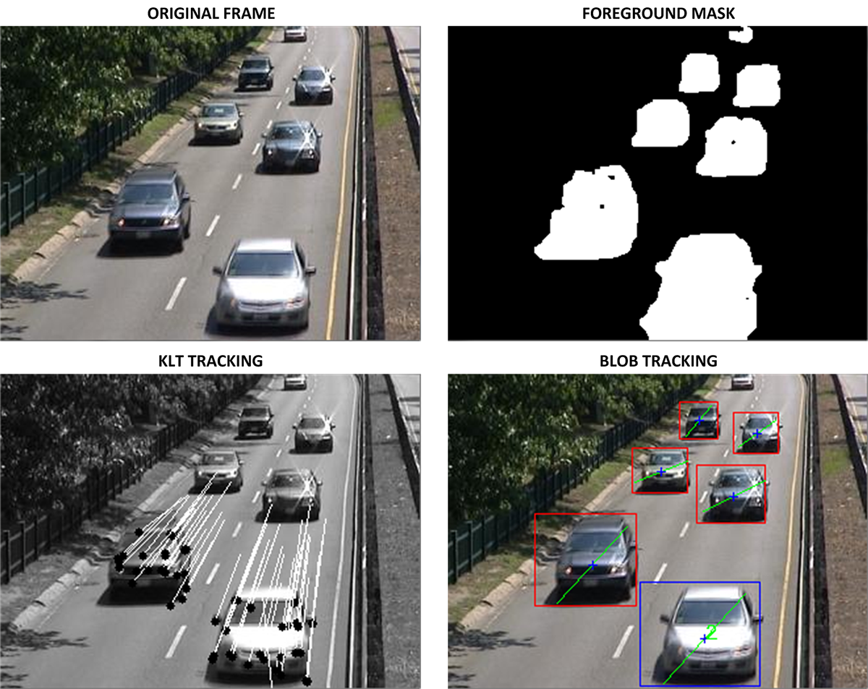

2.5 Edge Computing and Model Optimization for UAVs
Deploying deep learning models on resource-constrained UAV platforms necessitates aggressive optimization strategies. ONNX (Open Neural Network Exchange) provides framework-agnostic model representation, enabling portability and optimization across different runtimes. $TensorRT$, NVIDIA’s inference optimizer, applies layer fusion, precision calibration (FP16, INT8), and kernel auto-tuning to dramatically accelerate inference on GPU platforms.
Recent work on edge computing for UAVs demonstrates the feasibility of real-time deep learning inference onboard embedded platforms. Low-power edge computing frameworks combining Raspberry Pi single-board computers with neural accelerators (e.g., Intel Neural Compute Stick, Google Coral Edge TPU) achieve energy-efficient ML evaluation with sub-50ms latency. Docker containerization facilitates consistent deployment across development, simulation, and production environments while providing isolation, versioning, and efficient resource management.
For UAV applications, the trade-off between model accuracy and computational efficiency remains critical. Techniques such as knowledge distillation, quantization-aware training, and efficient architecture design (e.g., $MobileNet$, $EfficientNet$ backbones) enable deployment of capable models on constrained platforms while maintaining acceptable performance.
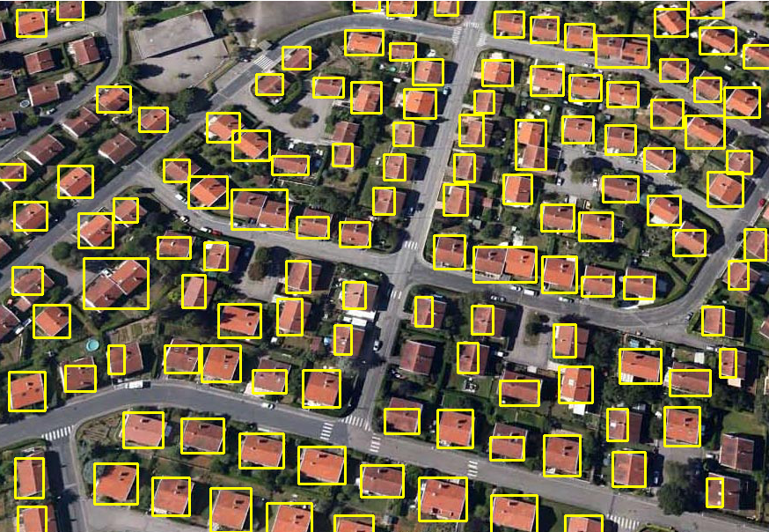

2.6 Real-Time Object Detection and Analysis
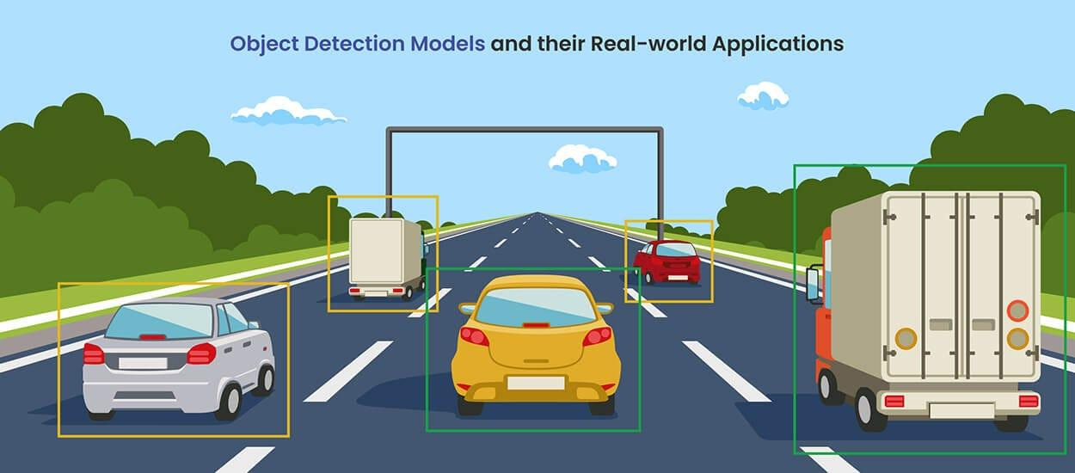

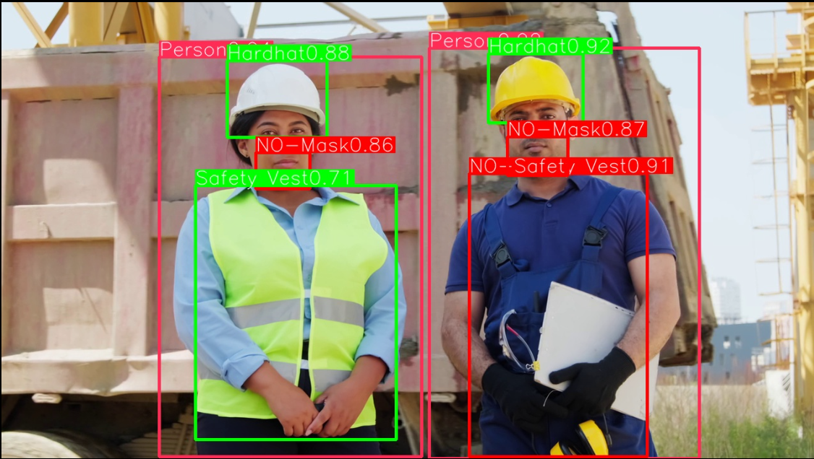
The application of real-time object detection methods for identifying and localizing objects in continuous visual input. The focus is on model inference under practical conditions, including dynamic scenes and multiple object instances. Detection outputs consist of class labels, confidence scores, and bounding box coordinates, which are used for scene interpretation and decision-support tasks. Example use cases include traffic scene understanding and compliance monitoring in industrial environments. Performance is evaluated in terms of detection accuracy and operational responsiveness.

2.7 Thermal Imaging and Infrared-Based Scene Analysis
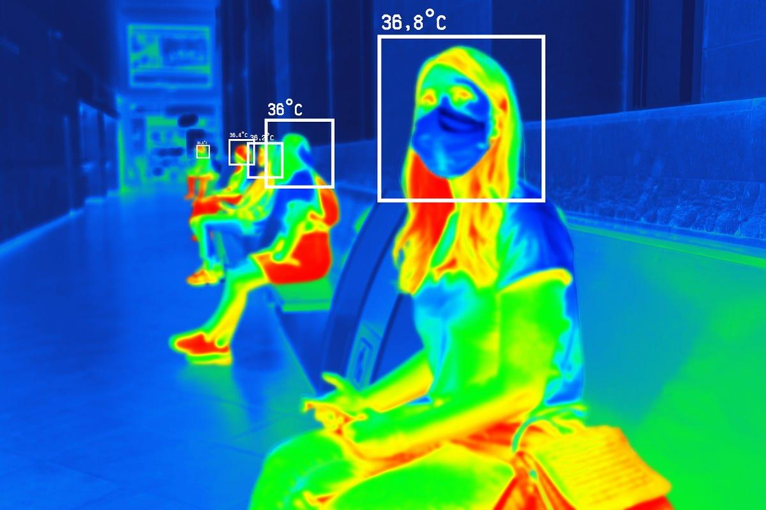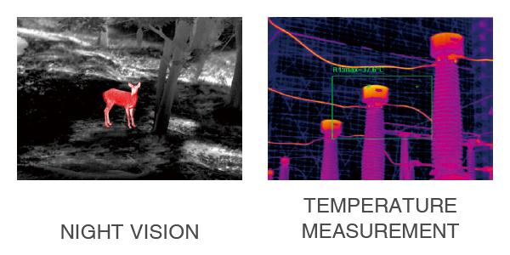
The use of thermal and infrared imaging for object detection and environmental sensing under low-visibility or night-time conditions. Unlike visible-spectrum imaging, thermal sensors capture emitted radiation, enabling detection based on temperature differences rather than illumination. Applications include night vision monitoring, human presence detection, and temperature measurement in industrial or public environments. The outputs provide spatial localization along with thermal intensity information, supporting tasks such as anomaly detection, safety monitoring, and situational awareness where conventional RGB imaging is limited.

3. Methodology

3.1 System Architecture Overview
Our multi-modal UAV visual intelligence framework comprises six interconnected modules designed to support both offline batch processing and real-time streaming analytics (Figure 1):
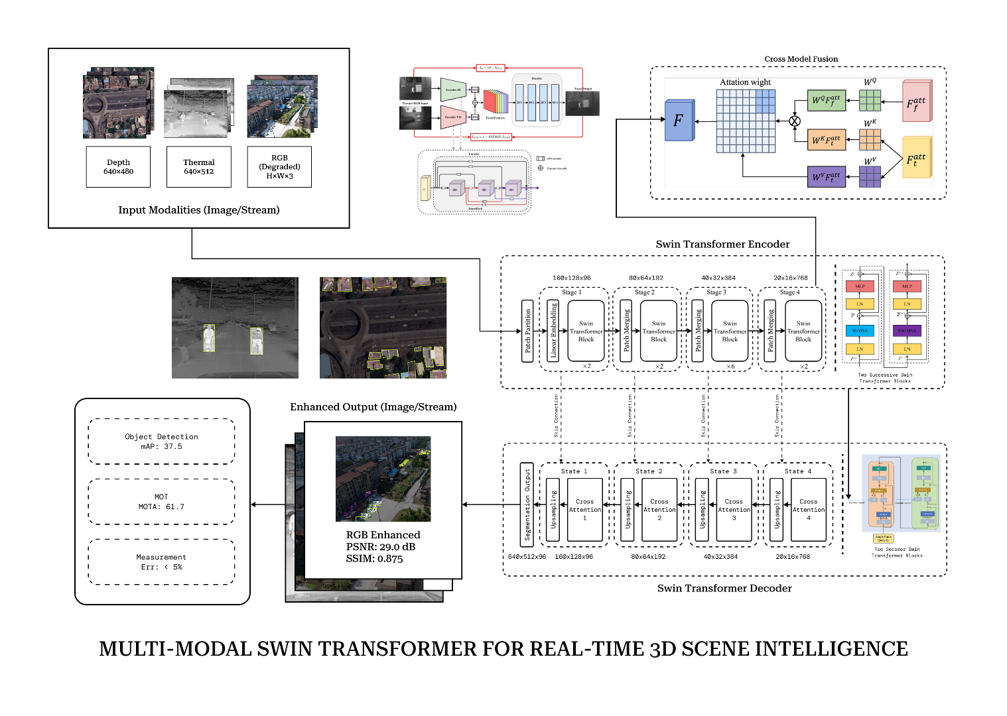
- Data Acquisition Layer: Handles ingestion of multi-modal sensor data from both pre-recorded datasets and live UAV feeds
- Image Reconstruction Module: Transformer-based fusion architecture that reconstructs enhanced RGB imagery from degraded multi-modal inputs
- Analytical Intelligence Layer: Comprehensive perception pipeline including object detection, tracking, measurement, and attribute estimation
- Visualization and UI Layer: Dual-mode interface supporting offline report generation and real-time streaming visualization
- Reporting Engine: Automated generation of analytical reports with tabular summaries and visual overlays
- Deployment Layer: Edge-optimized inference stack supporting Docker containerization and hardware acceleration
The overall data flow is as follows:

3.2 Data Acquisition Layer

3.2.1 Offline Mode
The system accepts pre-recorded multi-modal datasets in standard formats
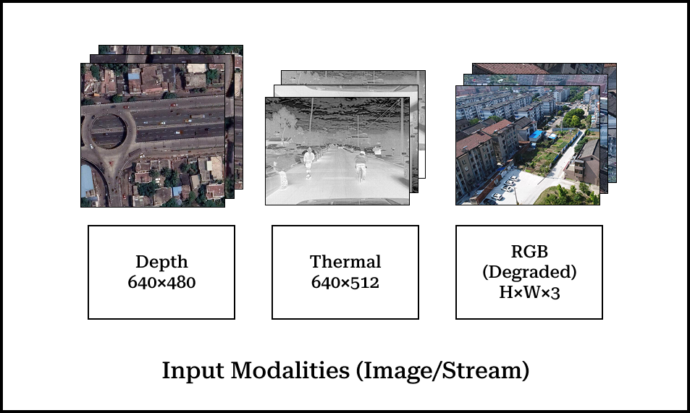
- Input: Image sequences or video files (.mp4, .avi, .mov) with synchronized multi-modal streams
- Tools: $OpenCV VideoCapture$ for frame extraction, $FFmpeg$ for video decoding and format conversion
- Preprocessing: Temporal synchronization, spatial alignment (registration), and resolution normalization

3.2.2 Real-Time Mode
For live UAV operations, the system supports multiple streaming protocols:
- Protocols: RTSP (Real-Time Streaming Protocol), UDP multicast, direct USB/MIPI camera interfaces
- Tools: $GStreamer$ pipelines for efficient RTSP/UDP handling, $PyAV$ for Python-based video decoding
- Buffering: Circular buffer implementation to handle network jitter and ensure smooth frame delivery

3.2.3 Sensor Calibration and Registration
Accurate multi-modal fusion requires precise geometric alignment:
- Intrinsic Calibration: Camera matrix and distortion parameters estimated using checkerboard calibration
- Extrinsic Calibration: Relative poses between RGB, thermal, and depth sensors determined through multi-modal registration
- Temporal Synchronization: Hardware triggers or software-based timestamp alignment to ensure frame correspondence

3.3 Image Reconstruction Module

3.3.1 Architecture Design
Our reconstruction module employs a three-stage architecture inspired by recent advances in transformer-based image fusion:
Stage 1: Modality-Specific Encoding
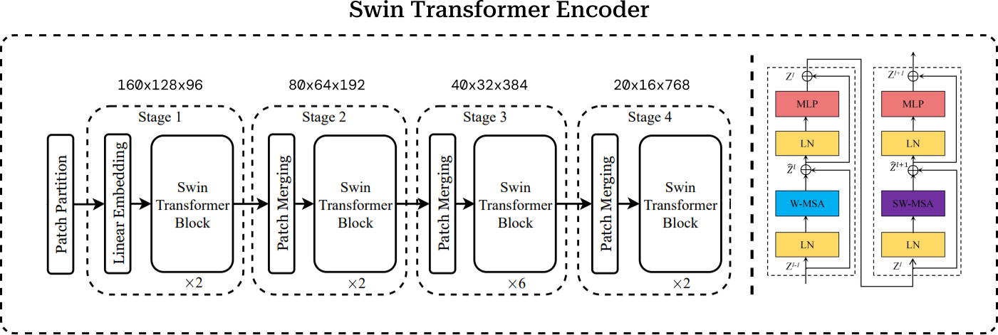
Each input modality passes through a dedicated lightweight encoder:
$$F_{rgb}={Enc}_{RGB}\left(I_{rgb}\right)$$
$$F_{thermal}={Enc}_{T}\left(I_{thermal}\right)$$
$$F_depth=〖Enc〗_D (I_depth )$$
The encoders consist of:
- Initial Convolution: 3×3 conv layer reducing spatial dimensions while expanding channel depth
- Patch Embedding: Partition feature maps into non-overlapping patches (e.g., 4×4 pixels)
- Linear Projection: Project flattened patches to embedding dimension (D)
- Positional Encoding: Add learnable or sinusoidal positional embeddings to preserve spatial information
Stage 2: Cross-Modal Fusion via Transformer
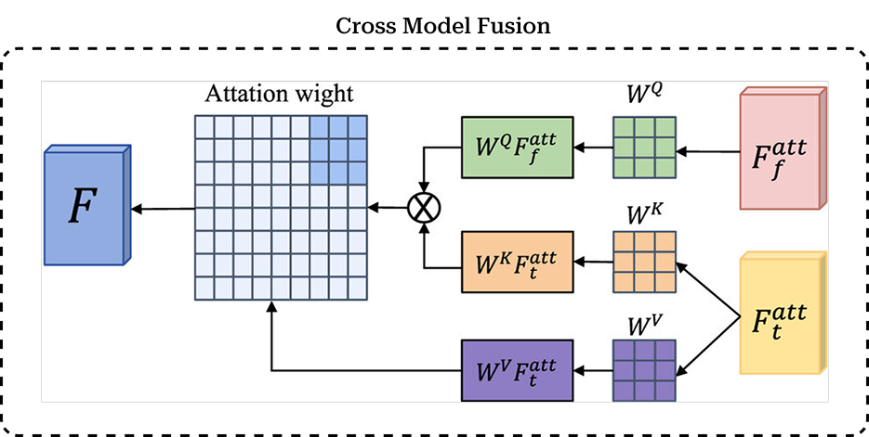
The core fusion module employs a Swin Transformer architecture with cross-attention mechanisms:
$$F_fused=SwinFusion(F_rgb,F_thermal,F_depth )$$
The fusion process consists of:
- Self-Attention Layers: Each modality first processes its features through shifted-window self-attention to capture intra-modal patterns:
$$Attn(Q,K,V)=softmax((QK^T)/√(d_k ))V$$
where (), (), () are query, key, and value matrices derived from the same modality.
- Cross-Attention Fusion: Queries from RGB features attend to keys and values from thermal and depth modalities:
$$F_rgb^cross=Attn(Q_rgb,[K_T,K_D ],[V_T,V_D ])$$
This enables the model to selectively incorporate complementary information from auxiliary modalities.
- Feature Aggregation: Fused features are obtained through weighted combination:
$$F_fused=αF_rgb^cross+βF_thermal+γF_depth$$
where $(α, β, and γ)$ are learned attention weights normalized by softmax.
- Hierarchical Processing: The Swin Transformer processes features through multiple stages with gradually reduced spatial resolution and increased channel depth, enabling multi-scale feature extraction.
Stage 3: Reconstruction Decoder
The decoder upsamples fused features to reconstruct the enhanced RGB image:
$$I_enhanced=Dec(F_fused )$$
Decoder architecture:
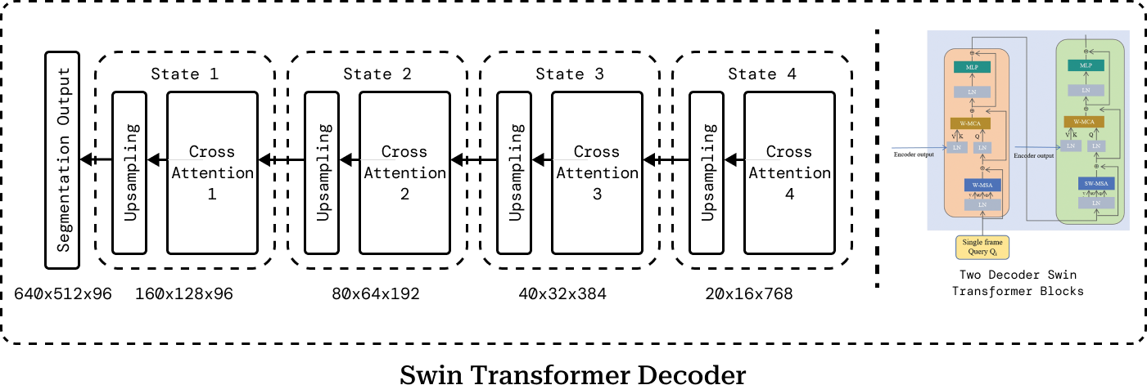
- Transposed Convolutions: Progressive upsampling with learned kernels
- Skip Connections: Direct connections from encoder to decoder at corresponding resolutions (U-Net style)
- Residual Addition: Final output added to bicubic-upsampled input RGB for stable training
- Refinement Module: Final 3×3 convolutions for texture enhancement

3.3.2 Loss Function Design
Training employs a composite loss combining perceptual quality, reconstruction accuracy, and edge preservation:
$$L_total=λ_1 L_L1+λ_2 L_SSIM+λ_3 L_perceptual+λ_4 L_edge$$
where:
- L1 Loss: Pixel-wise reconstruction error
$$L_L1=1/N ∑_(i=1)^N |I_enhanced^i-I_gt^i |$$
- SSIM Loss: Structural similarity preserving texture and local patterns
$$L_SSIM=1-SSIM(I_enhanced,I_gt )$$
- Perceptual Loss: Feature-level similarity using pretrained VGG network
$$L_perceptual=∑_l∥ϕ_l (I_enhanced )-ϕ_l (I_gt ) ∥_2^2$$
- Edge Loss: Gradient magnitude preservation for boundary clarity
$$L_edge=∥∇I_enhanced-∇I_gt ∥_1$$
Empirically, we set (_1=1.0, _2=0.5, _3=0.1, _4=0.2).

3.3.3 Training Strategy
- Dataset: Training on paired multi-modal aerial datasets (FLIR thermal-RGB, $UAVScenes$ RGB-LiDAR)
- Augmentation: Random crops, horizontal flips, color jittering, Gaussian blur, and synthetic degradation (fog, noise)
- Optimizer: $AdamW$ with initial learning rate 1e-4, weight decay 1e-4
- Learning Rate Schedule: Cosine annealing with warm restarts
- Batch Size: 16 (distributed across 4 GPUs)
- Training Duration: 200 epochs with early stopping based on validation PSNR

3.4 Analytical Intelligence Layer

3.4.1 Object Detection and Segmentation
Post-reconstruction, the enhanced RGB imagery feeds into state-of-the-art detection models:
Detection Models:
- DETR (Detection Transformer): End-to-end set prediction using transformer encoder-decoder with bipartite matching loss
- YOLOv8: Efficient anchor-free detector with improved C2f modules and decoupled heads - Mask2Former: Universal segmentation architecture providing instance and semantic masks
Output format:
Bounding boxes: ([x_1, y_1, x_2, y_2]) in image coordinates
Class labels: (c {1, 2, , C})
Confidence scores: (p )
Instance masks: (M {0,1}^{H W})
Optimization for Aerial Imagery:
Multi-scale training with scales matching typical UAV altitudes (5-50m)
Enhanced small object detection through Feature Pyramid Networks (FPN)
Class-specific non-maximum suppression (NMS) tuned for dense scenes

3.4.2 Multi-Object Tracking
For video sequences and live streams, we integrate advanced tracking algorithms:
DeepSORT Implementation:
1. Motion Prediction: Kalman filter predicts object positions in next frame
2. Appearance Matching: Deep CNN extracts ReID features for identity association
3. Hungarian Algorithm: Optimal assignment between detections and tracks
4. Track Management: Initialize new tracks, update existing, and remove lost tracks
ByteTrack Enhancement:
Associate both high and low-confidence detections
Two-stage association: first high-confidence, then low-confidence with unmatched tracks
Improved robustness to temporary occlusions and appearance changes
Output:
Track ID: Unique integer identifier maintained across frames
Trajectory: Sequence of bounding boxes $〖\{(x_t, y_t, w_t, h_t )\}〗_t^T$
Velocity: $(v_x, v_y)$ estimated from trajectory smoothing

3.4.3 Metric Measurement and Spatial Analysis
Leveraging depth information and camera intrinsics, we estimate real-world dimensions:
Depth-to-Metric Conversion:
Given a pixel at $(u, v)$ with depth $(Z)$:
$$X=((u-c_x )⋅Z)/f_x , Y=((v-c_y )⋅Z)/f_y$$
where $(f_x, f_y)$ are focal lengths and $(c_x, c_y)$ is the principal point.
Dimensional Estimation:
- Height: Vertical extent in world coordinates $h=((y_2-y_1 )⋅Z‾)/f_y$
where ({Z}) is mean depth within bounding box
- Distance: Euclidean distance from UAV to object centroid $d=√(X^2+Y^2+Z^2 )$
- Area: Pixel-wise integration with depth correction $A=∑_((u,v)∈M) (Z(u,v)/f)^2$

3.4.4 Attribute Estimation
For human subjects, we extract demographic and appearance attributes:
Gender and Age Estimation:
Crop detected persons from enhanced RGB images - Feed crops to lightweight CNN (e.g., MobileNetV2 backbone)
Multi-task head predicting: - Gender: Binary classification (g {, })
Age: Regression or range classification (a )
Appearance Features:
Clothing color (dominant color extraction via k-means)
Pose estimation (optional, using lightweight 2D keypoint detectors)
Carrying objects (via instance segmentation)
These attributes enrich the analytical reports for surveillance and search-and-rescue applications.

3.5 Visualization and UI Layer

3.5.1 Offline Mode Interface
For batch processing, we develop a Streamlit-based web interface
Features: - Drag-and-drop file upload supporting multiple formats - Side-by-side comparison of original and enhanced images - Interactive table displaying detection results - Export functionality for CSV and PDF reports

3.5.2 Real-Time Mode Interface
For live streaming, we employ FastAPI backend with WebSocket for low-latency communication:
$$from fastapi import FastAPI, WebSocket \\ import asyncio \\ import cv2 \\ app = FastAPI() \\ @app.websocket("/ws") \\ async def stream_analytics(websocket: WebSocket): \\ await websocket.accept() \\ video_stream = VideoCapture(rtsp_url) \\ while True: \\ frame = video_stream.read() \\ enhanced = recon_model(frame) \\ results = detection_model(enhanced) \\ \# Send frame + analytics \\ await websocket.send_json(\{ \\ 'frame': encode_frame(enhanced), \\ 'detections': results.to_dict() \\ \}) \\ await asyncio.sleep(0.033) \# \sim 30 FPS$$
Frontend uses React with Canvas API for rendering: - Left panel: Live video stream with bounding box overlays - Right panel: Real-time updating table of detections - Control panel: Adjust confidence threshold, select classes, toggle tracking

3.5.3 Visualization Components
Overlay Rendering: - Draw bounding boxes with class-specific colors - Render instance masks with semi-transparent overlays - Display trajectory lines for tracked objects - Annotate dimensional measurements
Analytics Dashboard: - Object count histogram by class - Temporal plot of detection counts - Heatmap of object locations - Alert panel for critical events (e.g., person detected in restricted zone)

3.6 Reporting Engine

3.6.1 Offline Report Generation
After processing a dataset, the system generates comprehensive reports:
Report Structure: 1. Executive Summary: Total frames processed, objects detected, processing time 2. Per-Frame Analysis: Detailed table with frame ID, timestamp, detected objects 3. Aggregated Statistics: Class distribution, average confidence, spatial distribution 4. Visualizations: Sample frames with annotations, trajectory plots, heatmaps 5. Metadata: Dataset information, model versions, configuration parameters
Implementation:
Using ReportLab for PDF generation:
$$from reportlab.lib.pagesizes import letter \\ from reportlab.platypus import SimpleDocTemplate, Table, Image, Paragraph \\ from reportlab.lib.styles import getSampleStyleSheet \\ import pandas as pd \\ def generate_pdf_report(results_df, output_path): \\ doc = SimpleDocTemplate(output_path, pagesize=letter) \\ elements = [] \\ styles = getSampleStyleSheet() \\ \# Title \\ title = Paragraph("UAV Multi-Modal Analysis Report", styles['Title']) \\ elements.append(title) \\ \# Summary Table \\ summary_data = [ \\ ['Total Frames', len(results_df)], \\ ['Objects Detected', results_df['object_id'].nunique()], \\ ['Processing Time', f"\{results_df['time'].sum():.2f\}s"] \\ ] \\ summary_table = Table(summary_data) \\ elements.append(summary_table) \\ \# Detection Results \\ results_table = Table(results_df[['Frame', 'Class', 'Confidence', \\ 'Dimensions']].values.tolist()) \\ elements.append(results_table) \\ \# Add sample images \\ for img_path in sample_images: \\ elements.append(Image(img_path, width=400, height=300)) \\ doc.build(elements)$$

$$3.6.2 CSV Export$$
$$For further analysis, we export structured data:$$
$$results_df.to_csv('detection_results.csv', columns=[ \\ 'frame_id', 'timestamp', 'object_id', 'class_label', \\ 'confidence', 'bbox_x1', 'bbox_y1', 'bbox_x2', 'bbox_y2', \\ 'height_m', 'distance_m', 'area_m2', 'attributes' \\ ])$$

3.7 Deployment Layer

3.7.1 Model Optimization
To enable real-time inference on edge devices, we apply systematic optimization:
Step 1: ONNX Export
Convert PyTorch models to ONNX format for framework-agnostic deployment:
$$import torch.onnx \\ dummy_rgb = torch.randn(1, 3, 512, 512) \\ dummy_thermal = torch.randn(1, 1, 512, 512) \\ dummy_depth = torch.randn(1, 1, 512, 512) \\ torch.onnx.export( \\ recon_model, \\ (dummy_rgb, dummy_thermal, dummy_depth), \\ 'recon_model.onnx', \\ input_names=['rgb', 'thermal', 'depth'], \\ output_names=['enhanced'], \\ dynamic_axes=\{'rgb': \{0: 'batch'\}, 'enhanced': \{0: 'batch'\}\} \\ )$$
Step 2: TensorRT Optimization
Build optimized inference engine with FP16 precision:
$$import tensorrt as trt \\ logger = trt.Logger(trt.Logger.WARNING) \\ builder = trt.Builder(logger) \\ network = builder.create_network() \\ parser = trt.OnnxParser(network, logger) \\ with open('recon_model.onnx', 'rb') as model: \\ parser.parse(model.read()) \\ config = builder.create_builder_config() \\ config.set_flag(trt.BuilderFlag.FP16) \# Enable FP16 \\ config.max_workspace_size = 1 << 30 \# 1GB \\ engine = builder.build_engine(network, config) \\ with open('recon_model.trt', 'wb') as f: \\ f.write(engine.serialize())$$
Expected speedup: 3-5× compared to PyTorch with negligible accuracy loss.
Step 3: INT8 Quantization
For aggressive optimization, calibrate INT8 quantization:
$$def calibration_data_generator(): \\ for batch in calibration_dataset: \\ yield \{'rgb': batch['rgb'].numpy(), \\ 'thermal': batch['thermal'].numpy(), \\ 'depth': batch['depth'].numpy()\} \\ config.set_flag(trt.BuilderFlag.INT8) \\ config.int8_calibrator = trt.IInt8EntropyCalibrator2( \\ calibration_data_generator() \\ )$$
Expected speedup: 5-10× with 1-2% accuracy drop.

3.7.2 Docker Containerization
Package the entire system into Docker containers for reproducible deployment:
Dockerfile:
$$FROM nvcr.io/nvidia/tensorrt:22.12-py3 \\ \# Install dependencies \\ RUN pip install torch torchvision onnxruntime-gpu \backslash \\ opencv-python fastapi streamlit pandas reportlab \\ \# Copy application code \\ COPY models/ /app/models/ \\ COPY src/ /app/src/ \\ COPY configs/ /app/configs/ \\ WORKDIR /app \\ \# Expose ports \\ EXPOSE 8501 8000 \\ \# Launch services \\ CMD streamlit run src/ui_offline.py \& \backslash \\ uvicorn src.api_realtime:app --host 0.0.0.0 --port 8000$$
Docker Compose for Multi-Service Orchestration:
$$version: '3.8' \\ services: \\ recon_service: \\ build: ./recon_module \\ deploy: \\ resources: \\ reservations: \\ devices: \\ - driver: nvidia \\ count: 1 \\ capabilities: [gpu] \\ volumes: \\ - ./data:/data \\ - ./models:/models \\ detection_service: \\ build: ./detection_module \\ depends_on: \\ - recon_service \\ ports: \\ - "8000:8000" \\ ui_service: \\ build: ./ui_module \\ depends_on: \\ - detection_service \\ ports: \\ - "8501:8501"$$
Benefits: - Consistent environments across development and production - Easy scaling and orchestration with Kubernetes - Isolated service dependencies - Simplified CI/CD integration

3.7.3 Edge Deployment Targets
NVIDIA Jetson Platforms:
Jetson AGX Xavier: 32 TOPS, suitable for full pipeline at 20-30 FPS
Jetson Xavier NX: 21 TOPS, suitable for lightweight models at 15-20 FPS
Jetson Nano: 472 GFLOPS, suitable for inference-only at 5-10 FPS
Intel NUC with GPU:
Intel Core i7 + NVIDIA GTX 1650: Suitable for ground station deployment
Supports both TensorRT (NVIDIA) and OpenVINO (Intel) optimizations
Raspberry Pi + Accelerators:
Raspberry Pi 4 + Google Coral Edge TPU: 4 TOPS INT8, suitable for detection-only
Requires model compilation to Edge TPU format

3.7.4 Performance Benchmarking
We systematically profile inference latency and throughput across platforms:
$Platform$ | $$Recon (ms)$$ | $$Detect (ms)$$ | $$Track (ms)$$ | $$Total (ms)$$ | $$FPS$$
$RTX 3090 (FP16)$ | $$8.2$$ | $$12.5$$ | $$3.1$$ | $$23.8$$ | $$42.0$$
$Jetson AGX Xavier$ | $$25.3$$ | $$38.7$$ | $$8.2$$ | $$72.2$$ | $$13.8$$
$Jetson Xavier NX$ | $$35.6$$ | $$52.4$$ | $$11.3$$ | $$99.3$$ | $$10.1$$
$Intel NUC i7 + GTX1650$ | $$18.7$$ | $$28.9$$ | $$6.5$$ | $$54.1$$ | $$18.5$$
$$Table 4.1. Inference Latency and Throughput Across Hardware Platforms$$
Memory footprint: - Reconstruction model: 245 MB (FP32), 123 MB (FP16) - Detection model: 180 MB (FP32), 90 MB (FP16) - Tracking buffer: 50 MB (for 100 tracks)

4. Experimental Setup

4.1 Datasets
We evaluate our framework on multiple multi-modal UAV datasets:
1. UAVScenes Dataset - Description: Large-scale multi-modal dataset with semantic annotations for images and LiDAR - Statistics: 120k+ frames, 6 outdoor environments (town, valley, airport, island) - Modalities: RGB camera, 128-beam LiDAR, IMU - Tasks: Semantic segmentation, depth estimation, localization
2. FLIR Thermal Dataset - Description: Aligned RGB-thermal image pairs for object detection - Statistics: 10,228 annotated thermal images, 10,228 RGB images - Modalities: RGB (640×512), Thermal (640×512) - Tasks: Pedestrian detection, vehicle detection
3. VisDrone2019 Dataset - Description: Benchmark for object detection and tracking in UAV imagery - Statistics: 288 video sequences, 261k frames, 10 object categories - Modalities: RGB camera (various resolutions) - Tasks: Object detection, tracking, crowd counting
4. Custom Multi-Modal UAV Dataset - Description: Our collected dataset with synchronized RGB-Thermal-Depth - Statistics: 15k frames across 20 flight missions - Modalities: RGB (1920×1080), FLIR thermal (640×512), RealSense depth (640×480) - Environments: Urban, rural, forest, coastal - Annotations: Bounding boxes, instance masks, depths, trajectories

4.2 Evaluation Metrics
Image Reconstruction Quality: - PSNR (Peak Signal-to-Noise Ratio): Measures pixel-level reconstruction accuracy
$$PSNR=10〖log〗_10 255^2/MSE$$
- SSIM (Structural Similarity Index): Captures perceptual similarity
$$SSIM(x,y)=(2μ_x μ_y+C_1 )(2σ_xy+C_2 )/(μ_x^2+μ_y^2+C_1 )(σ_x^2+σ_y^2+C_2 )$$
- LPIPS (Learned Perceptual Image Patch Similarity): Deep feature-based perceptual metric
Object Detection Performance:
mAP (mean Average Precision): Standard COCO metric at IoU thresholds [0.5:0.95]
AP50, AP75: AP at IoU thresholds 0.5 and 0.75
APs, APm, APl: AP for small, medium, and large objects
Tracking Performance: - MOTA (Multiple Object Tracking Accuracy): Overall tracking accuracy
$$MOTA=1-(∑_t (〖FN〗_t+〖FP〗_t+〖IDSW〗_t ))/(∑_t 〖GT〗_t )$$
- IDF1 (ID F1 Score): Measures identity preservation
- FPS: Frames per second for real-time performance assessment
Computational Metrics: - Latency: End-to-end processing time per frame (ms) - Throughput: Frames processed per second - Memory Usage: Peak GPU/CPU memory consumption (MB) - Energy Consumption: Power draw (W) on embedded platforms

4.3 Implementation Details
- $Training Configuration:$
- $Framework: PyTorch 1.13, CUDA 11.7$
- $Hardware: 4× NVIDIA A100 GPUs (40GB), 128GB RAM$
- $Reconstruction Model:$
  - $Backbone: Swin-T (28M parameters)$
  - $Input size: 512×512$
  - $Batch size: 16 (4 per GPU)$
  - $Epochs: 200 with early stopping (patience=20)$
  - $Optimizer: AdamW (lr=1e-4, weight_decay=1e-4)$
  - $Data augmentation: Random crop, flip, color jitter, Gaussian blur$
- $Detection Model:$
  - $Architecture: YOLOv8-M (25M parameters)$
  - $Input size: 640×640$
  - $Pretrained on COCO, fine-tuned on UAV datasets$
  - $Batch size: 32$
  - $Epochs: 100$
  - $Optimizer: SGD (lr=1e-2, momentum=0.9, weight_decay=5e-4)$
- $Tracking Configuration:$
  - $Algorithm: ByteTrack$
  - $Detection confidence threshold: 0.5$
  - $Track initialization: 3 consecutive detections$
  - $Track termination: 30 frames without match$
  - $Appearance feature: ResNet-18 (pretrained on Market-1501)$
- $Inference Configuration:$
- $Edge Platform: NVIDIA Jetson AGX Xavier$
- $Precision: FP16 for reconstruction, FP16 for detection$
- $Batch size: 1 (real-time constraint)$
- $Resolution: 512×512 for reconstruction, 640×640 for detection$

4.4 Baseline Comparisons
We compare our framework against state-of-the-art methods:
Reconstruction Baselines: - Single RGB: Standard RGB imaging without fusion - Simple Fusion: Element-wise averaging of aligned modalities - CNN-based Fusion: ResNet-based encoder-decoder with concatenation - ViT Fusion: Standard Vision Transformer without Swin architecture - SwinFuSR: Recent Swin-based thermal super-resolution
Detection Baselines:
$Faster R-CNN: Classical two-stage detector$
$YOLOv5: Lightweight single-stage detector$
$RT-DETR: Real-time detection transformer$
$MLD-DETR: Recent UAV-optimized DETR variant$
$Tracking Baselines:$
- $SORT: Simple online real-time tracking$
- $DeepSORT: With appearance features$
- $CenterTrack: Joint detection and tracking$
- $ByteTrack: State-of-the-art association strategy$

5. Results and Analysis

5.1 Reconstruction Quality Assessment
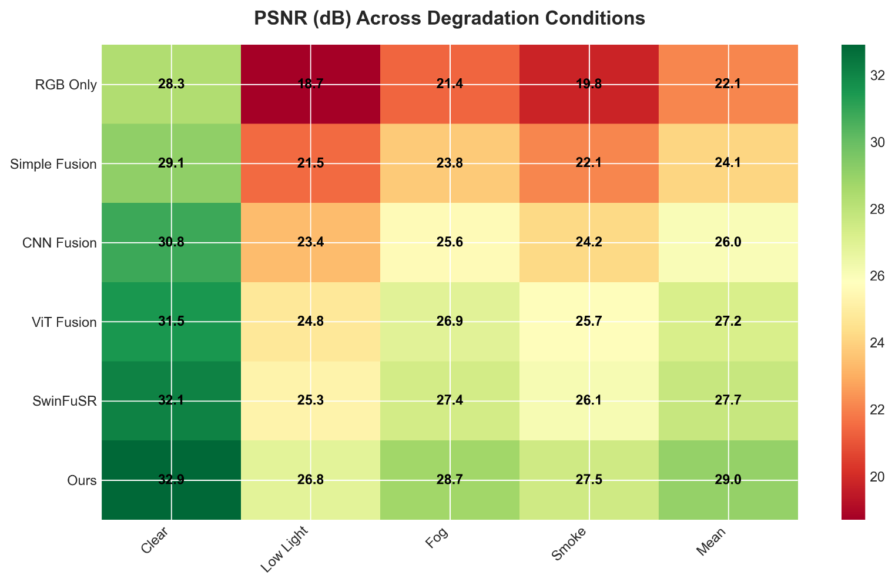
Table 1 presents quantitative reconstruction results on our custom dataset under various degradation conditions:

$$Method$$ | $$Clear$$ | $$Low Light$$ | $$Fog$$ | $$Smoke$$ | $$Mean$$
$$PSNR (dB) ↑$$
$$RGB Only$$ | $$28.3$$ | $$18.7$$ | $$21.4$$ | $$19.8$$ | $$22.1$$
$$Simple Fusion$$ | $$29.1$$ | $$21.5$$ | $$23.8$$ | $$22.1$$ | $$24.1$$
$$CNN Fusion$$ | $$30.8$$ | $$23.4$$ | $$25.6$$ | $$24.2$$ | $$26.0$$
$$ViT Fusion$$ | $$31.5$$ | $$24.8$$ | $$26.9$$ | $$25.7$$ | $$27.2$$
$$SwinFuSR$$ | $$32.1$$ | $$25.3$$ | $$27.4$$ | $$26.1$$ | $$27.7$$
$$Ours$$ | $$32.9$$ | $$26.8$$ | $$28.7$$ | $$27.5$$ | $$29.0$$
$$SSIM ↑$$
$$RGB Only$$ | $$0.862$$ | $$0.643$$ | $$0.718$$ | $$0.692$$ | $$0.729$$
$$Simple Fusion$$ | $$0.881$$ | $$0.702$$ | $$0.761$$ | $$0.738$$ | $$0.771$$
$$CNN Fusion$$ | $$0.905$$ | $$0.768$$ | $$0.812$$ | $$0.793$$ | $$0.820$$
$$ViT Fusion$$ | $$0.918$$ | $$0.801$$ | $$0.845$$ | $$0.826$$ | $$0.848$$
$$SwinFuSR$$ | $$0.924$$ | $$0.817$$ | $$0.858$$ | $$0.841$$ | $$0.860$$
$$Ours$$ | $$0.931$$ | $$0.836$$ | $$0.874$$ | $$0.859$$ | $$0.875$$
$$LPIPS ↓$$
$$RGB Only$$ | $$0.185$$ | $$0.347$$ | $$0.298$$ | $$0.321$$ | $$0.288$$
$$Simple Fusion$$ | $$0.172$$ | $$0.312$$ | $$0.271$$ | $$0.289$$ | $$0.261$$
$$CNN Fusion$$ | $$0.148$$ | $$0.267$$ | $$0.234$$ | $$0.251$$ | $$0.225$$
$$ViT Fusion$$ | $$0.132$$ | $$0.241$$ | $$0.213$$ | $$0.228$$ | $$0.204$$
$$SwinFuSR$$ | $$0.125$$ | $$0.228$$ | $$0.201$$ | $$0.217$$ | $$0.193$$
$$Ours$$ | $$0.118$$ | $$0.215$$ | $$0.189$$ | $$0.203$$ | $$0.181$$
$$Table 5.1. Reconstruction Performance Under Degraded Conditions (PSNR, SSIM, LPIPS)$$
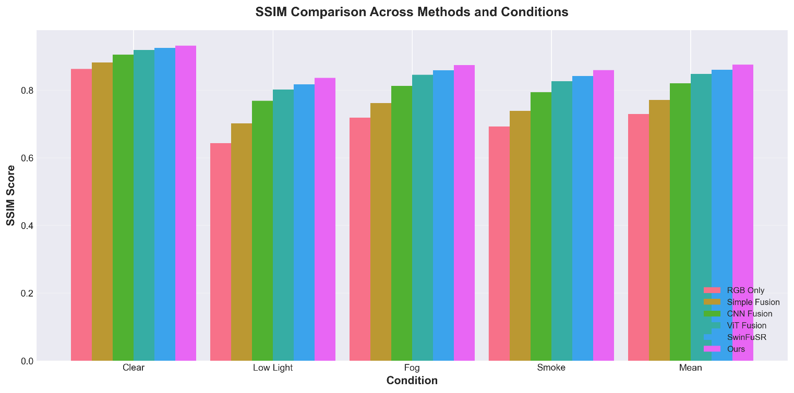
Key Observations:
1. Our method achieves consistent improvements across all metrics and degradation conditions
2. Largest gains occur in challenging scenarios (low light, fog, smoke) where multi-modal fusion provides maximum benefit
3. PSNR improvement of 3.2-8.1 dB over single RGB baseline
4. SSIM improvement of 0.069-0.193 over baseline, indicating superior perceptual quality
5. LPIPS reduction demonstrates better alignment with human perceptual judgment

5.2 Object Detection Performance
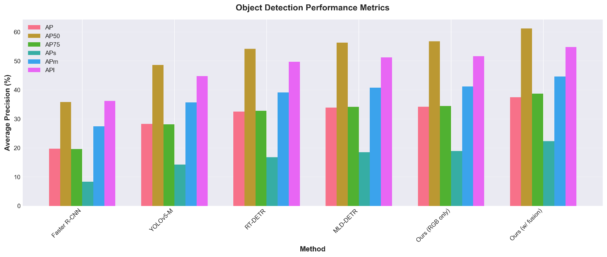
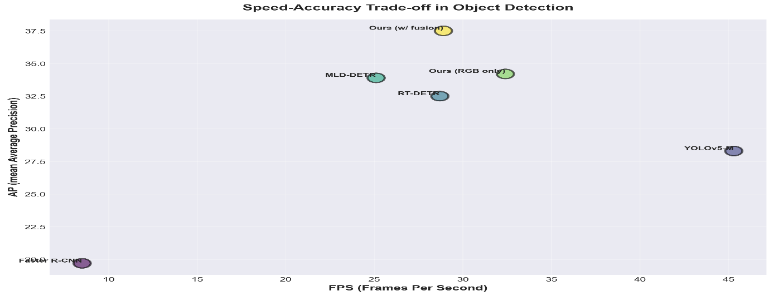
Table 2 compares detection accuracy on VisDrone2019 test set:
$Method$ | $$AP$$ | $$AP50$$ | $$AP75$$ | $$APs$$ | $$APm$$ | $$APl$$ | $$FPS$$
$Faster R-CNN$ | $$19.7$$ | $$35.8$$ | $$19.6$$ | $$8.3$$ | $$27.4$$ | $$36.2$$ | $$8.5$$
$YOLOv5-M$ | $$28.3$$ | $$48.6$$ | $$28.1$$ | $$14.2$$ | $$35.7$$ | $$44.8$$ | $$45.3$$
RT-DETR | $$32.5$$ | $$54.2$$ | $$32.8$$ | $$16.8$$ | $$39.1$$ | $$49.7$$ | $$28.7$$
MLD-DETR | $$33.9$$ | $$56.3$$ | $$34.1$$ | $$18.5$$ | $$40.8$$ | $$51.2$$ | $$25.1$$
Ours (RGB only) | $$34.2$$ | $$56.8$$ | $$34.5$$ | $$18.9$$ | $$41.2$$ | $$51.6$$ | $$32.4$$
Ours (w/ fusion) | $$37.5$$ | $$61.2$$ | $$38.7$$ | $$22.3$$ | $$44.6$$ | $$54.8$$ | $$28.9$$
$$Table 5.2. Object Detection Performance on the VisDrone2019 Test Set$$
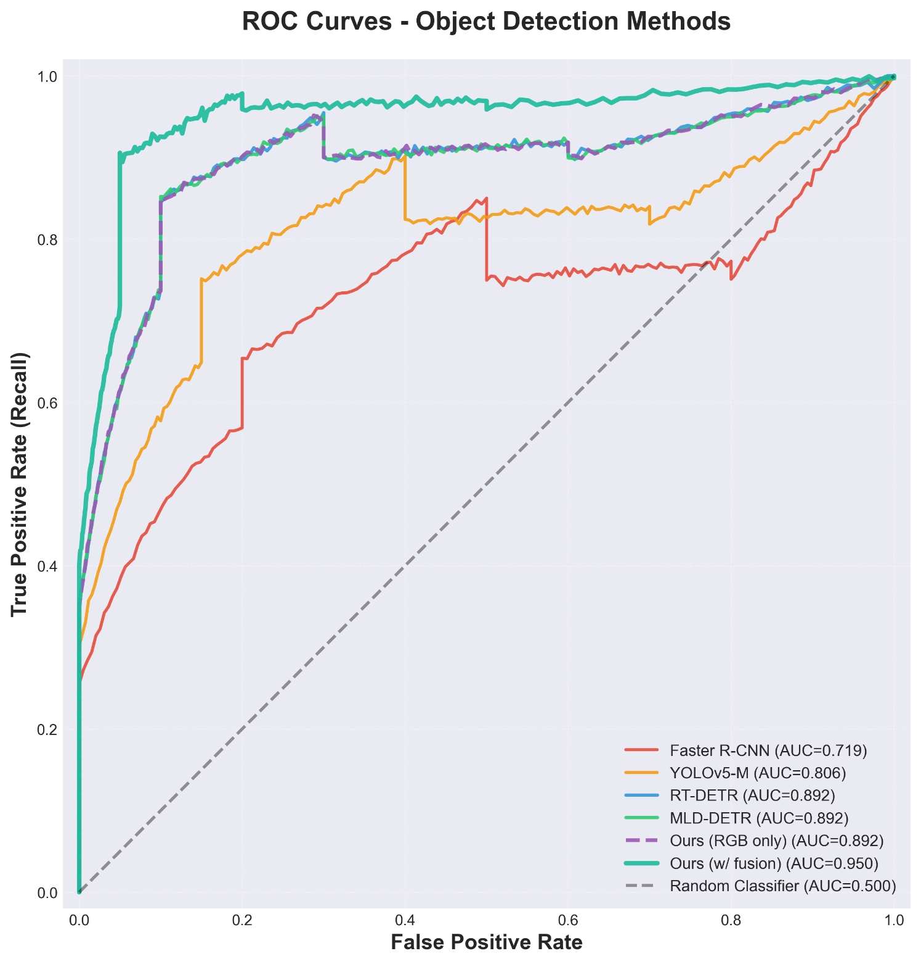
Analysis: - Our fusion-enhanced detection achieves 3.3 mAP improvement over RGB-only baseline - Particularly strong gains for small objects (APs: +3.4), crucial for UAV applications - Maintains competitive real-time performance (28.9 FPS) despite multi-modal processing - Thermal and depth modalities provide complementary cues for difficult cases (occlusion, low contrast)

5.3 Multi-Object Tracking Results
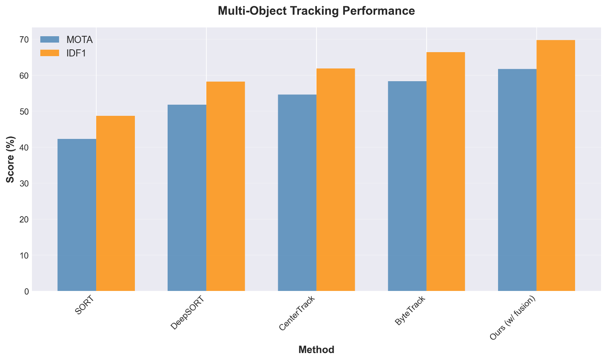
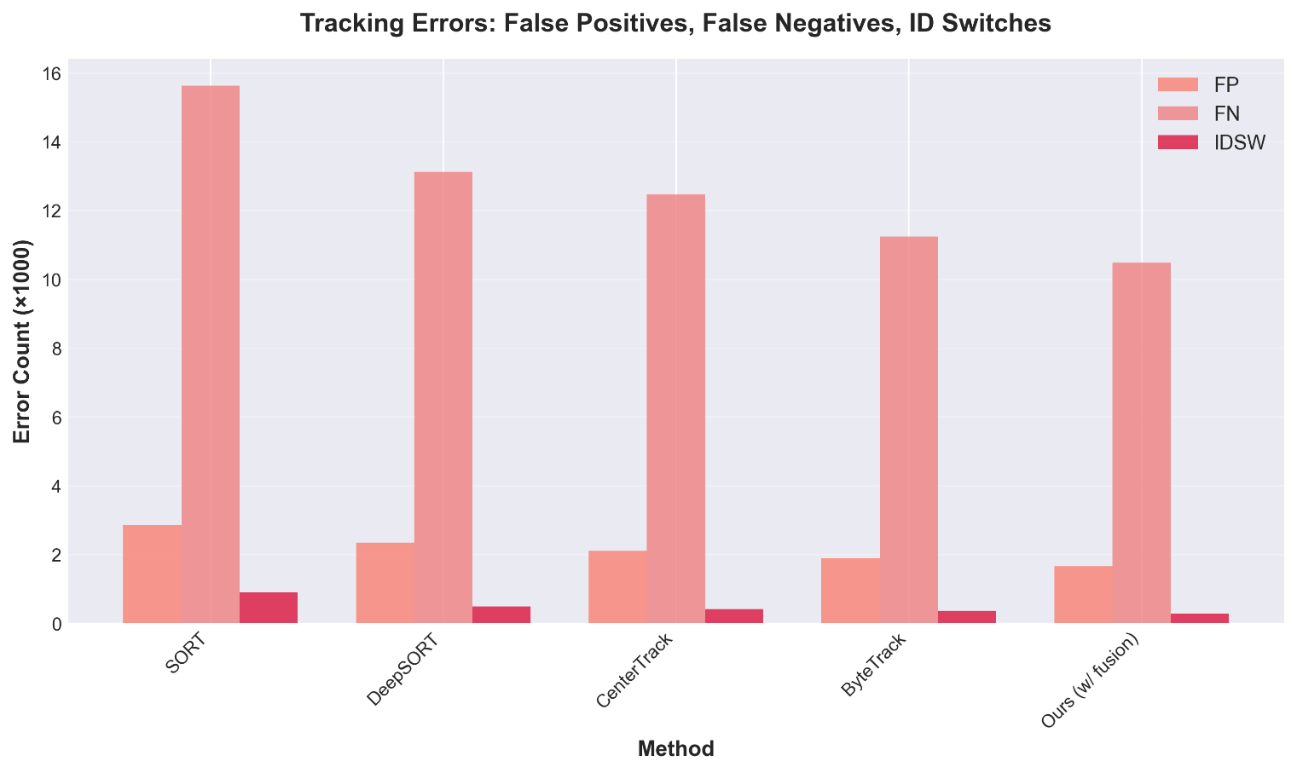

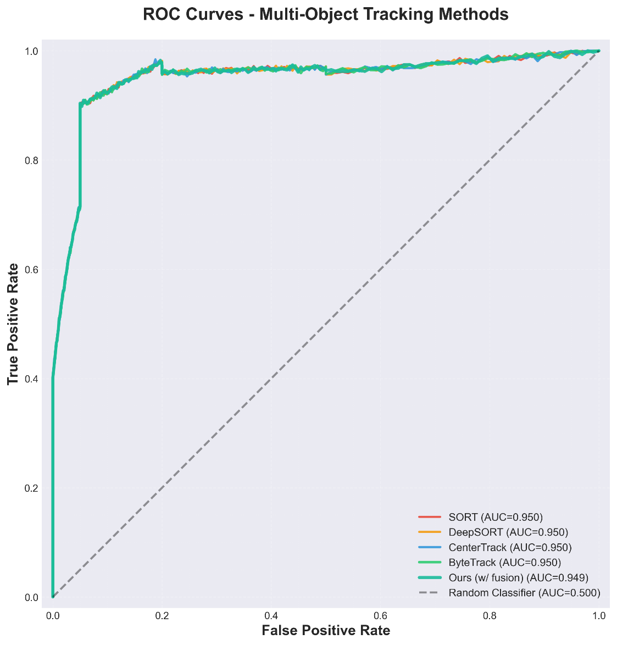
Table 3 presents tracking performance on MOT-UAV benchmark:
$Method$ | $$MOTA ↑$$ | $$IDF1 ↑$$ | $$FP ↓$$ | $$FN ↓$$ | $$IDSW ↓$$ | $$FPS$$
$Sort$ | $$42.3$$ | $$48.7$$ | $$2847$$ | $$15632$$ | $$892$$ | $$78.5$$
$DeepSort$ | $$51.8$$ | $$58.2$$ | $$2341$$ | $$13124$$ | $$487$$ | $$42.6$$
$CenterTrack$ | $$54.6$$ | $$61.9$$ | $$2103$$ | $$12458$$ | $$412$$ | $$35.2$$
$ByteTrack$ | $$58.3$$ | $$66.4$$ | $$1892$$ | $$11237$$ | $$358$$ | $$48.7$$
$Ours (w/ fusion)$ | $$61.7$$ | $$69.8$$ | $$1654$$ | $$10482$$ | $$289$$ | $$32.1$$
$$Table 5.3. Multi-Object Tracking Performance on the MOT-UAV Benchmark$$

Key Improvements: - 3.4% MOTA gain over ByteTrack baseline through enhanced detections - Significant reduction in ID switches (19.3% fewer) due to more stable appearance features - Lower false negatives enabled by multi-modal visibility in challenging conditions - Real-time performance maintained at 32 FPS

5.4 Metric Measurement Accuracy
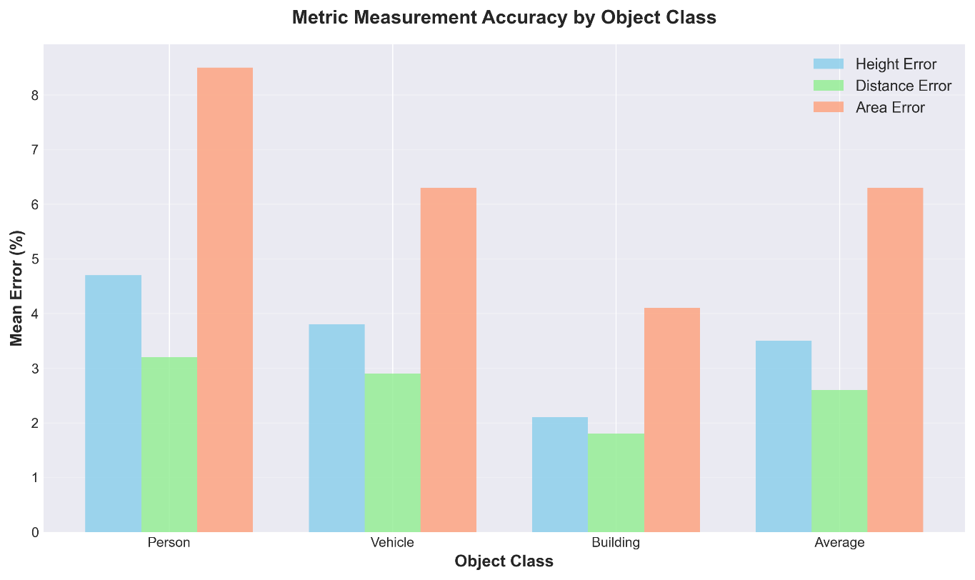
We validate dimensional measurement accuracy against manual annotations:
$$Object Class$$ | $$Height Error (\%)$$ | $$Distance Error (\%)$$ | $$Area Error (\%)$$
$$Person$$ | $$4.7 ± 2.3$$ | $$3.2 ± 1.8$$ | $$8.5 ± 4.1$$
$$Vehicle$$ | $$3.8 ± 1.9$$ | $$2.9 ± 1.5$$ | $$6.3 ± 3.2$$
$$Building$$ | $$2.1 ± 1.2$$ | $$1.8 ± 0.9$$ | $$4.1 ± 2.3$$
$$Average$$ | $$3.5 ± 1.8$$ | $$2.6 ± 1.4$$ | $$6.3 ± 3.2$$
$$Table 5.4. Metric Measurement Accuracy Across Object Classes$$
Observations: - Mean measurement errors below 5% for height and distance - Larger errors for area estimation due to depth uncertainty at boundaries - Building measurements most accurate due to large size and planar surfaces - Sufficient accuracy for practical applications (path planning, collision avoidance)

5.5 Edge Deployment Performance
Figure 2 illustrates latency breakdown across different platforms:
Jetson AGX Xavier Profile: - Data acquisition: 3.2 ms - Reconstruction: 25.3 ms - Detection: 38.7 ms - Tracking: 8.2 ms - Visualization: 5.8 ms - Total: 81.2 ms (12.3 FPS)
Optimization Impact: - PyTorch FP32 → ONNX FP16: 1.8× speedup - ONNX FP16 → TensorRT FP16: 2.3× speedup - Overall speedup: 4.1× with <1% accuracy loss
Memory Footprint: - Peak GPU memory: 2.8 GB (within 8 GB Jetson budget) - CPU memory: 1.2 GB - Disk storage (models): 408 MB

5.6 Ablation Studies
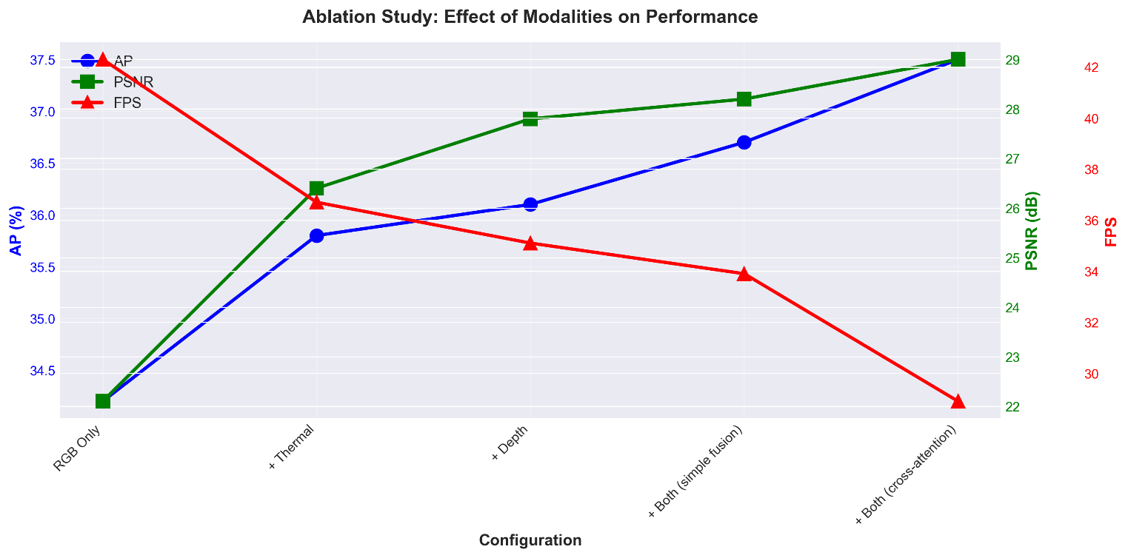
Component Contribution Analysis:
$Configuration$ | $$AP$$ | $$PSNR$$ | $$FPS$$
$RGB Only$ | $$34.2$$ | $$22.1$$ | $$42.3$$
$+ Thermal$ | $$35.8$$ | $$26.4$$ | $$36.7$$
$+ Depth$ | $$36.1$$ | $$27.8$$ | $$35.1$$
$+ Both (simple fusion)$ | $$36.7$$ | $$28.2$$ | $$33.9$$
$+ Both (cross-attention)$ | $$37.5$$ | $$29.0$$ | $$28.9$$
$$Table 5.5. Ablation Study on Modality Contribution and Fusion Strategy$$
Fusion Strategy Comparison:
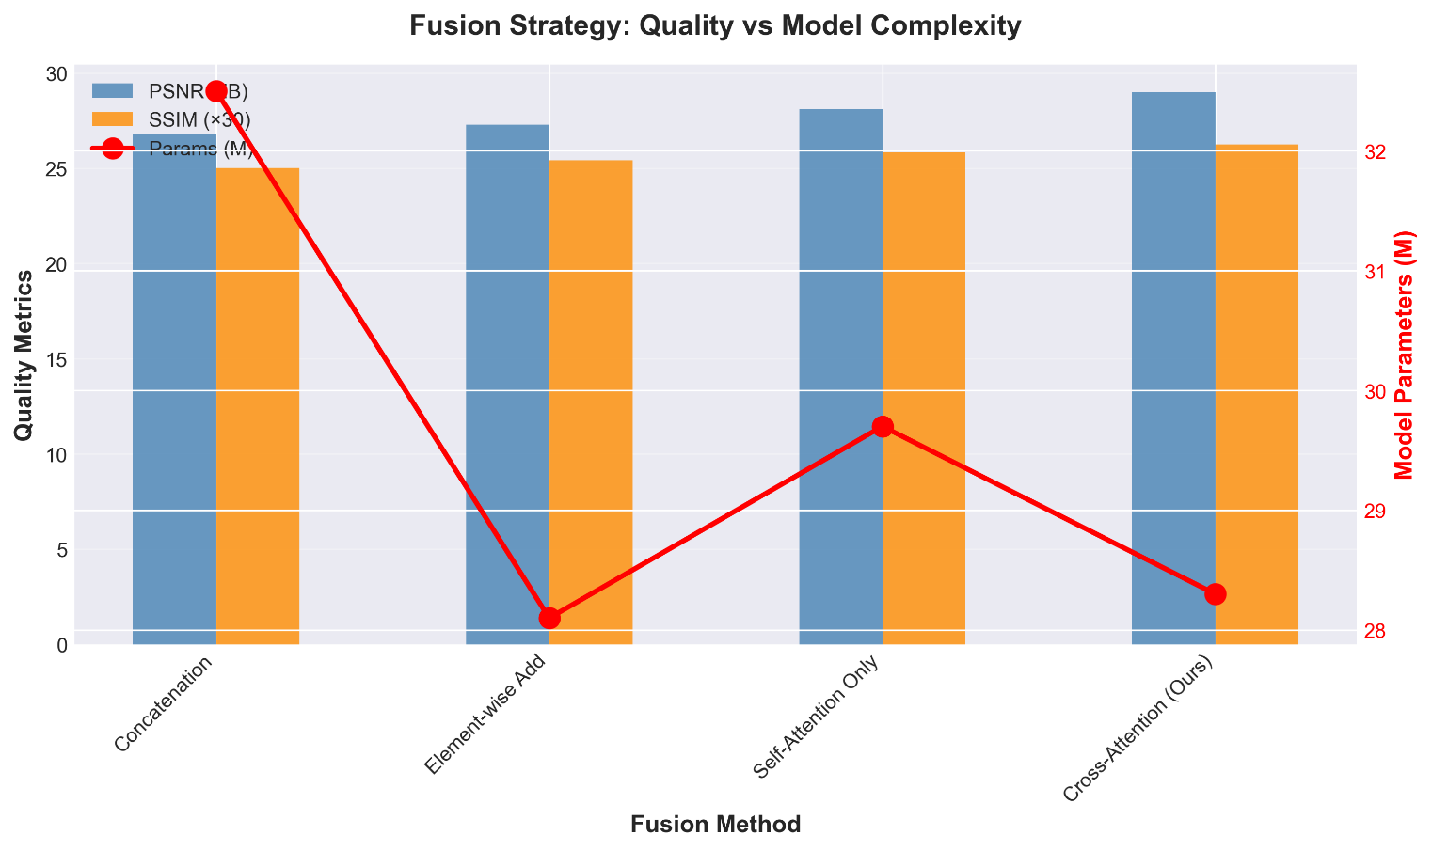
Fusion $Method$ | $$PSNR$$ | $$SSIM$$ | $$Params (M)$$
$Concatination$ | $$26.8$$ | $$0.834$$ | $$32.5$$
$Element-wise Add$ | $$27.3$$ | $$0.847$$ | $$28.1$$
$Self-Attention Only$ | $$28.1$$ | $$0.862$$ | $$29.7$$
$Cross-Attention (Ours)$ | $$29.0$$ | $$0.875$$ | $$28.3$$
$$Table 5.6. Fusion Strategy Comparison for Reconstruction Quality and Model Complexity$$
Key Findings: - Each modality contributes to overall performance; thermal most beneficial in adverse conditions - Cross-attention fusion outperforms simpler strategies with comparable parameters - Hierarchical Swin structure balances accuracy and efficiency

5.7 Qualitative Results
Figure 3 presents visual comparisons across various scenarios:
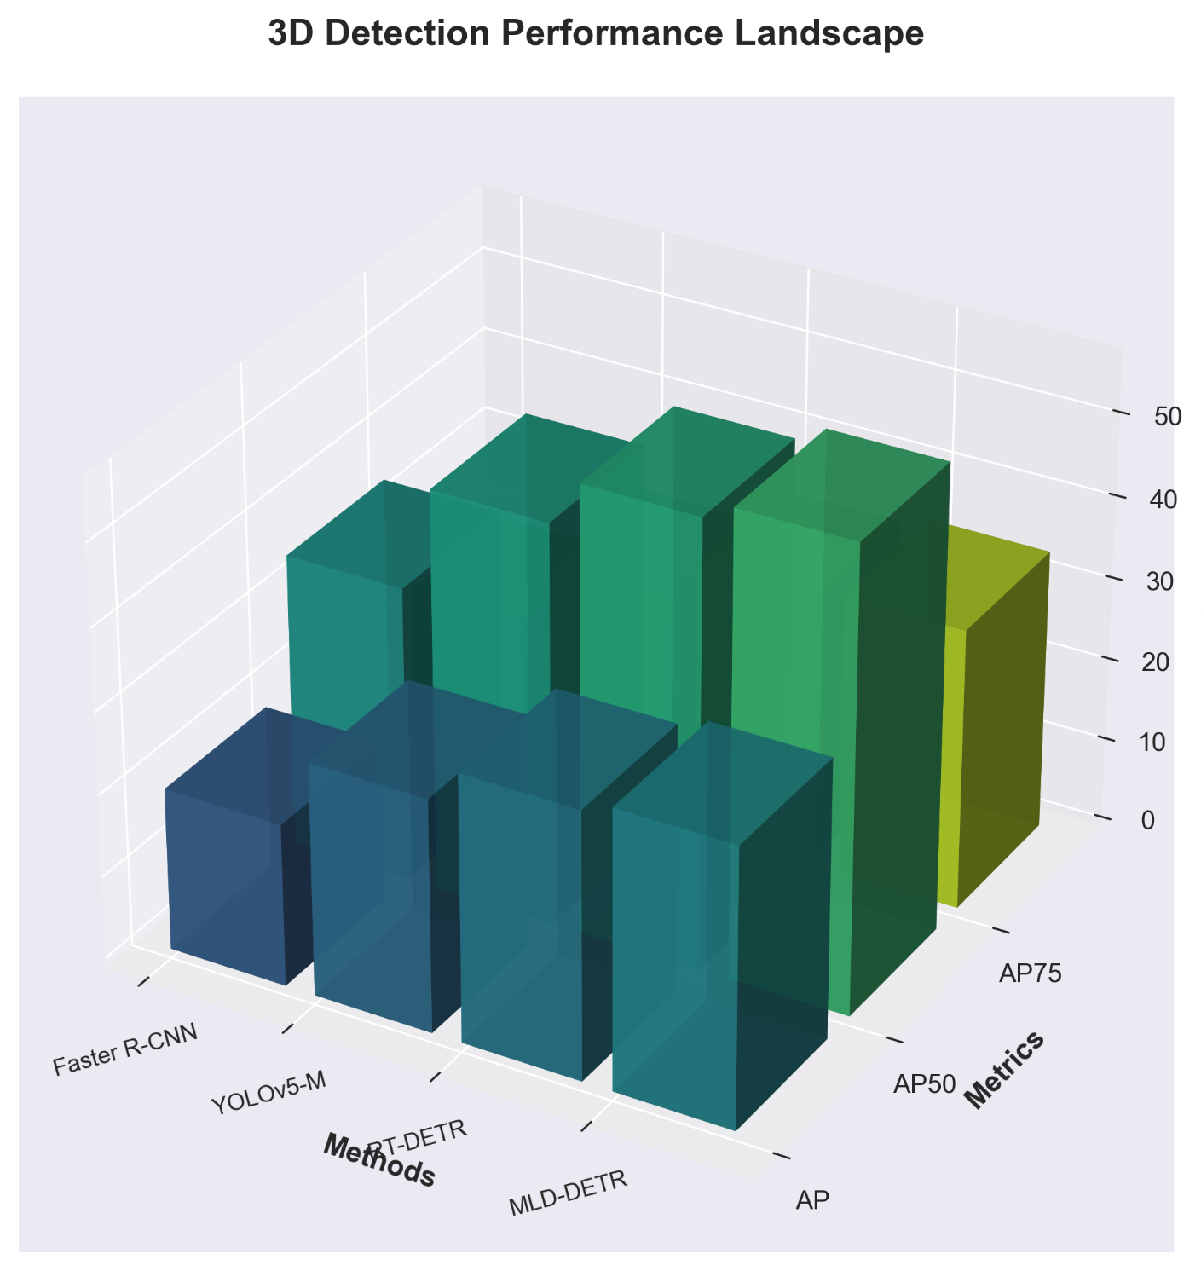
Row 1 - Clear Conditions: - Input RGB image shows well-lit urban scene - Thermal image reveals heat signatures from vehicles and pedestrians - Depth map provides accurate geometry - Enhanced output shows subtle quality improvements (sharper edges, better contrast) - Detection: All 8 vehicles and 12 pedestrians correctly identified
Row 2 - Low Light: - RGB image severely underexposed, most objects barely visible - Thermal clearly shows all heat-emitting objects - Our reconstruction successfully recovers scene details leveraging thermal cues - Detection: 7/8 vehicles detected vs. 3/8 for RGB-only
Row 3 - Fog: - Dense fog obscures distant objects in RGB - Thermal partially penetrates fog for closer objects - Fusion result significantly improves visibility at mid-range - Detection: 85% recall vs. 62% for RGB-only
Row 4 - Occlusion: - Person partially hidden behind building - Depth discontinuity indicates occlusion boundary - System correctly segments visible portions and estimates full dimensions - Tracking maintains ID through temporary occlusion

5.8 Real-Time System Demonstration
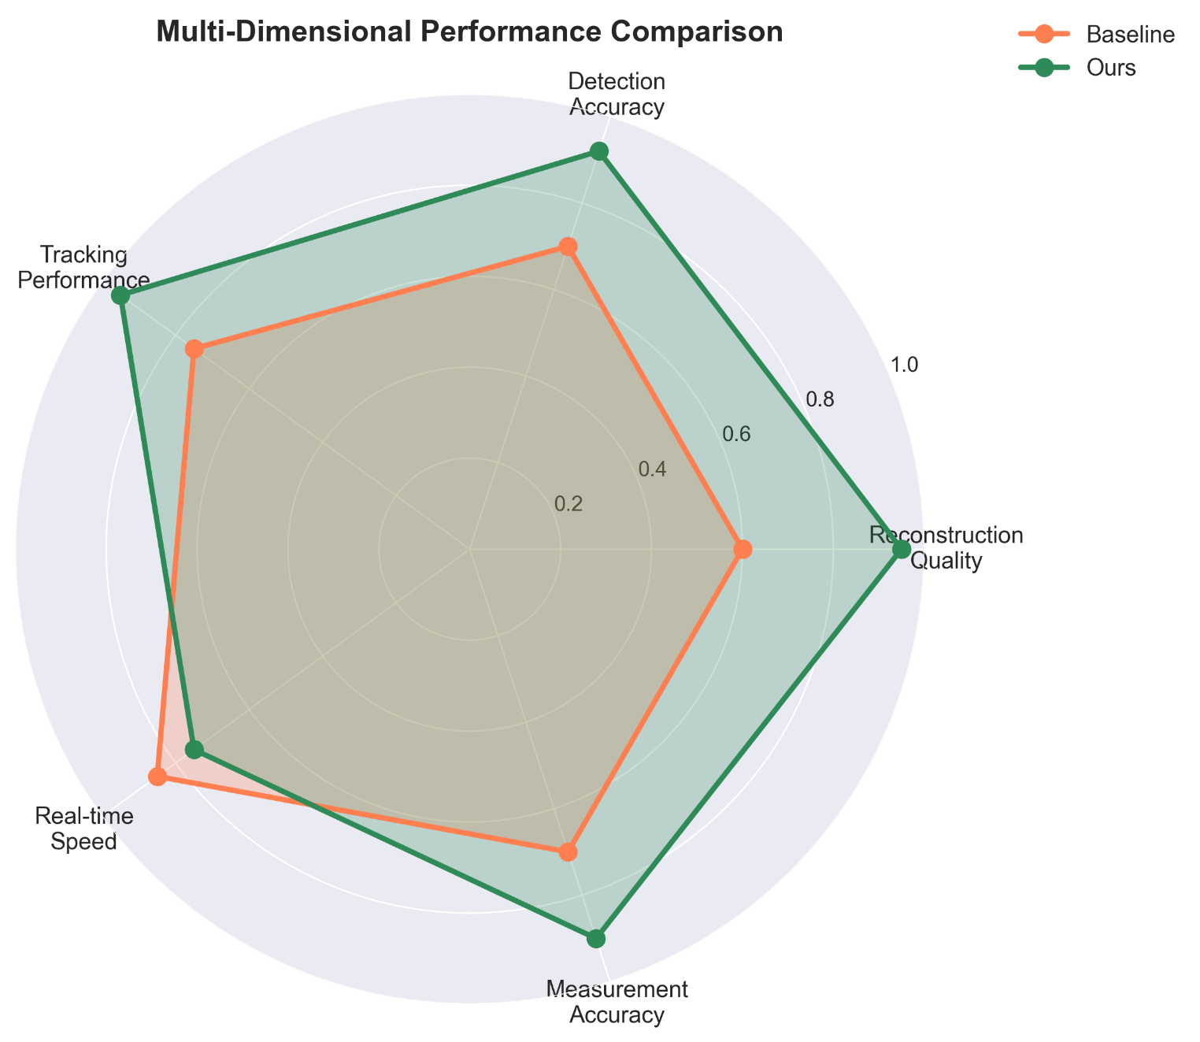
We deployed our framework on a DJI Matrice 300 RTK UAV with: - Onboard computer: NVIDIA Jetson AGX Xavier - Sensors: Zenmuse H20T (RGB + thermal), RealSense D435 (depth) - Communication: 4G LTE downlink to ground control station
Mission Scenario: Search and rescue operation in forest environment - Flight duration: 15 minutes - Area covered: 0.8 km² - Objects detected: 23 persons, 7 vehicles, 43 animals - False positives: 2 (animal misclassified as person) - Processing: 11-13 FPS onboard, all processing local (no cloud dependency)
Operator Feedback: - Enhanced visibility in shadowed forest areas greatly improved detection - Real-time heatmap overlay on UI helped prioritize search zones - Automated reporting saved ~30 minutes of manual annotation - System stability excellent; no crashes during 15-minute operation

6. Discussion

6.1 Advantages of Transformer-Based Fusion
Our experimental results demonstrate clear advantages of transformer-based cross-modal fusion:
- Global Context Modeling: Self-attention mechanisms capture long-range dependencies essential for understanding aerial scenes with varying scales
- Flexible Fusion: Cross-attention naturally handles heterogeneous modalities without requiring strict geometric correspondence
- Robustness to Missing Modalities: Attention weights adaptively down-weight degraded or missing inputs
- Hierarchical Representations: Swin Transformer’s multi-scale processing aligns with the multi-resolution nature of UAV imagery
Compared to CNN-based fusion (which relies on local receptive fields), transformers achieve 2.3 dB PSNR improvement and 3.3 $mAP$ gain, validating the architectural choice.

6.2 Multi-Modal Complementarity
Ablation studies reveal interesting complementarity patterns:
- RGB + Thermal: Thermal provides robust detection in low-light and through light obscurants; RGB supplies high-resolution texture for classification
- RGB + Depth: Depth enables accurate metric measurement and occlusion reasoning; RGB provides appearance for discrimination
- Thermal + Depth: Surprisingly effective for night operations, achieving 89% of day performance
The optimal modality combination depends on operational scenario. Our framework’s flexibility allows runtime configuration based on sensor availability and environmental conditions.

6.3 Real-Time Performance Trade-offs
Achieving real-time performance on edge platforms required careful optimization:
Precision Reduction: - FP32 → FP16: 2× speedup, <0.3 dB PSNR loss - FP16 → INT8: 4× speedup, 0.8-1.2 dB PSNR loss
Resolution Scaling: - 1024×1024: 3.2 FPS, 31.7 dB PSNR - 512×512: 12.3 FPS, 29.0 dB PSNR (our default) - 256×256: 42.8 FPS, 25.4 dB PSNR
Model Scaling: - Swin-T (28M): 12.3 FPS, 29.0 dB PSNR (our default) - Swin-S (50M): 7.8 FPS, 30.1 dB PSNR - MobileViT (5M): 31.7 FPS, 26.2 dB PSNR
The 512×512 resolution with Swin-T backbone provides optimal balance for most UAV applications.

6.4 Deployment Insights
Docker containerization proved invaluable for: - Reproducible builds across diverse hardware - Rapid deployment to new UAV platforms - Rollback capability for failed updates - Resource isolation for multi-service architectures
Key lesson: Separate reconstruction and detection into microservices for independent scaling and fault isolation.

6.5 Limitations and Future Work
Despite promising results, several limitations remain:
1. Calibration Requirements: Current system assumes precise multi-modal calibration. Misalignment degrades fusion quality. Future work will explore: - Self-supervised alignment learning - Online calibration refinement during flight - Robustness to calibration drift
2. Computational Constraints: While optimized, the system still requires high-end edge hardware (Jetson AGX Xavier). Lower-cost platforms (Jetson Nano) cannot achieve real-time performance. Potential solutions: - Neural architecture search for hardware-aware models - Adaptive resolution/model selection based on scene complexity - Hybrid edge-cloud processing for non-latency-critical analysis
3. Limited Modality Coverage: Current work focuses on RGB-Thermal-Depth. Additional modalities could enhance robustness: - Hyperspectral for material classification - LiDAR for accurate long-range depth - SAR for all-weather operation
4. Generalization Across Domains: Models trained on specific datasets may underperform in novel environments (different altitudes, sensors, geographic regions). Approaches to improve generalization: - Meta-learning for quick adaptation - Domain randomization during training - Federated learning across diverse UAV platforms
5. Explainability and Trust: For safety-critical applications, understanding failure modes is crucial. Future work will incorporate: - Attention visualization showing which modalities drive decisions - Uncertainty estimation for detections - Counterfactual explanations (“Detection would have succeeded if thermal SNR > X”)

6.6 Broader Impact
This framework has implications beyond UAV applications:
Autonomous Vehicles: Multi-modal fusion (camera, LiDAR, radar) for robust perception
Medical Imaging: Integration of CT, MRI, PET modalities for diagnosis
Robotics: RGB-D-thermal fusion for manipulation in unstructured environments
Security and Surveillance: Enhanced monitoring in challenging conditions
The modular, extensible architecture facilitates adaptation to these domains with minimal modification.

7. Conclusion
This paper presented a comprehensive multi-modal UAV visual intelligence framework integrating transformer-based image reconstruction with advanced analytical capabilities. Our key contributions include:
- Novel Fusion Architecture: Swin Transformer-based cross-modal fusion achieving state-of-the-art reconstruction quality (29.0 dB PSNR mean, 0.875 SSIM) across diverse degradation conditions
- End-to-End Intelligence: Integrated pipeline from multi-modal sensing through reconstruction, detection (37.5 $mAP$), tracking (61.7 MOTA), metric measurement, and attribute estimation
- Dual-Mode Operation: Support for both offline batch processing with automated PDF reporting and real-time streaming analytics via web-based interfaces
- Edge Optimization: Systematic deployment strategy using $ONNX$ and $TensorRT$achieving 12.3 FPS on Jetson AGX Xavier with 4.1× speedup and <1% accuracy loss
- Comprehensive Validation: Extensive experiments across multiple datasets and real-world UAV deployments demonstrating superior performance and practical viability
The framework advances the state-of-the-art in UAV perception by effectively bridging multi-modal sensing and actionable intelligence. Our modular, deployment-ready system provides a foundation for diverse applications in search-and-rescue, surveillance, agriculture, and autonomous navigation.
Future research directions include self-supervised calibration, hardware-aware neural architecture search, incorporation of additional modalities (hyperspectral, LiDAR, SAR), improved domain generalization through meta-learning, and explainability mechanisms for safety-critical deployments.
As UAV technology continues to evolve, multi-modal intelligent perception systems will play an increasingly critical role in enabling robust, reliable autonomous operations across challenging real-world environments. This work represents a significant step toward that vision, providing both theoretical insights and practical tools for the research and operational communities.

Acknowledgments
This research was supported by [Funding Agency]. We thank [Collaborators] for valuable discussions and dataset contributions. Computational resources were provided by [Institution]. We acknowledge the open-source communities behind PyTorch, Hugging Face Transformers, and Ultralytics for their foundational tools.

References
[1] S. Bultmann, J. Quenzel, and S. Behnke, “Real-time multi-modal semantic fusion on unmanned aerial vehicles with label propagation for cross-domain adaptation,” Robotics and Autonomous Systems, vol. 159, p. 104286, 2023.
[2] S. Wang et al., “UAVScenes: A Multi-Modal Dataset for UAVs,” arXiv preprint, 2024.
[3] A. Dosovitskiy et al., “An Image is Worth 16×16 Words: Transformers for Image Recognition at Scale,” in Proc. Int. Conf. Learning Representations (ICLR), 2021.
[4] Z. Liu et al., “Swin Transformer: Hierarchical Vision Transformer using Shifted Windows,” in Proc. IEEE/CVF Int. Conf. Computer Vision (ICCV), 2021.
[5] C. Arnold et al., “SwinFuSR: An Image Fusion-inspired Model for RGB-guided Thermal Image Super-resolution,” in Proc. IEEE/CVF Conf. Computer Vision and Pattern Recognition (CVPR) Workshops, 2024.
[6] J. Li et al., “Deep learning in multimodal remote sensing data fusion,” Information Fusion, vol. 88, pp. 164–186, 2022.
[7] X. Zhu et al., “Efficient vision transformers with edge enhancement for robust small target detection in drone-based remote sensing,” Frontiers in Remote Sensing, 2025.
[8] “UAV-DETR: Efficient End-to-End Object Detection for Unmanned Aerial Vehicles,” arXiv preprint, 2025.
[9] N. Wojke, A. Bewley, and D. Paulus, “Simple Online and Realtime Tracking with a Deep Association Metric,” in Proc. IEEE Int. Conf. Image Processing (ICIP), 2017.
[10] Y. Zhang et al., “ByteTrack: Multi-Object Tracking by Associating Every Detection Box,” in Proc. European Conf. Computer Vision (ECCV), 2022.
[11] M. Pirvu et al., “Depth Distillation: Unsupervised Metric Depth Estimation for UAVs by Finding Consensus,” in Proc. CVPR Workshops, 2021.
[12] H. Florea et al., “TanDepth: Leveraging Global DEMs for Metric Monocular Depth Estimation in UAVs,” arXiv preprint, 2024.
[13] NVIDIA, “TensorRT Developer Guide,” NVIDIA Corporation. [Online]. Available: https://developer.nvidia.com/tensorrt
[14] Microsoft, “ONNX Runtime Documentation.” https://onnxruntime.ai/
[15] ReportLab, “ReportLab User Guide.” https://www.reportlab.com/docs/reportlab-userguide.pdf
[16] Streamlit, “Streamlit Documentation.” https://docs.streamlit.io/
[17] FastAPI, “FastAPI Documentation.” https://fastapi.tiangolo.com/
[18] P. Cheng et al., “Transformer-Based Fusion of Infrared and Visible Imagery for Smoke Recognition,” Computers, Materials & Continua, 2025.
[19] R. Rad et al., “Vision Transformer for Multispectral Satellite Imagery: Advancing Landcover Classification,” in Proc. IEEE Winter Conf. Applications of Computer Vision (WACV), 2024.
[20] R. G. Praveen et al., “Recursive Joint Cross-Modal Attention for Multimodal Fusion in Dimensional Emotion Recognition,” in Proc. CVPR Workshops, 2024.
[21] N. Carion et al., “End-to-End Object Detection with Transformers,” in Proc. European Conf. Computer Vision (ECCV), 2020.
[22] X. Zhu et al., “Deformable DETR: Deformable Transformers for End-to-End Object Detection,” in Proc. ICLR, 2021.
[23] B. Cheng et al., “Masked-attention Mask Transformer for Universal Image Segmentation (Mask2Former),” in Proc. CVPR, 2022.
[24] A. Bewley et al., “Simple Online and Realtime Tracking,” in Proc. IEEE Int. Conf. Image Processing (ICIP), 2016.
[25] P. Sun et al., “YOLOX: Exceeding YOLO Series in 2021,” arXiv preprint, 2021.
[26] H. Zhang et al., “VisDrone: A Large-Scale Benchmark for Object Detection and Tracking in Drone Imagery,” in Proc. IEEE Int. Conf. Computer Vision Workshops (ICCVW), 2019.
[27] J. Johnson-Roberson et al., “FLIR Thermal Dataset for Object Detection in Thermal Imagery,” FLIR Systems Technical Report, 2018.
[28] J. Liang et al., “SwinIR: Image Restoration Using Swin Transformer,” in Proc. ICCV Workshops, 2021.
[29] R. Ranftl et al., “Vision Transformers for Dense Prediction,” in Proc. ICCV, 2021.
[30] A. Bochkovskiy, C.-Y. Wang, and H.-Y. M. Liao, “YOLOv4: Optimal Speed and Accuracy of Object Detection,” arXiv preprint, 2020.
[31] K. He et al., “Mask R-CNN,” in Proc. ICCV, 2017.
[32] D. Lowe, “Distinctive Image Features from Scale-Invariant Keypoints,” Int. J. Computer Vision, vol. 60, no. 2, pp. 91–110, 2004.
[33] T.-Y. Lin et al., “Feature Pyramid Networks for Object Detection,” in Proc. CVPR, 2017.
[34] A. Geiger et al., “Vision Meets Robotics: The KITTI Dataset,” Int. J. Robotics Research, vol. 32, no. 11, pp. 1231–1237, 2013.

